Josh Harper & Jordan Harper

**1.**

|  |  |  |  |  |  |  |  |
| --- | --- | --- | --- | --- | --- | --- | --- |
| **Name** | **Resources** | **Guidance** | **Network** | **Dependence upon stakeholders** | **Their Power** | **Your Power** | **Total Power** |
| Client | 2 | 7 | 5 | 14 | 70 | 60 | -10 |
| Sponsor | 9 | 2 | 8 | 19 | 80 | 70 | -10 |
| Faculty Advisors | 8 | 10 | 9 | 27 | 40 | 70 | 30 |
| Review Board Members | 2 | 3 | 6 | 11 | 50 | 50 | 0 |
| Team Members | 9 | 7 | 8 | 24 | 70 | 75 | 5 |
| Hotel Managers | 6 | 6 | 7 | 19 | 20 | 80 | 60 |
| Bank Testers | 5 | 3 | 3 | 11 | 10 | 80 | 70 |
| Faculty Audience | 3 | 3 | 2 | 8 | 1 | 100 | 100 |

**2.**

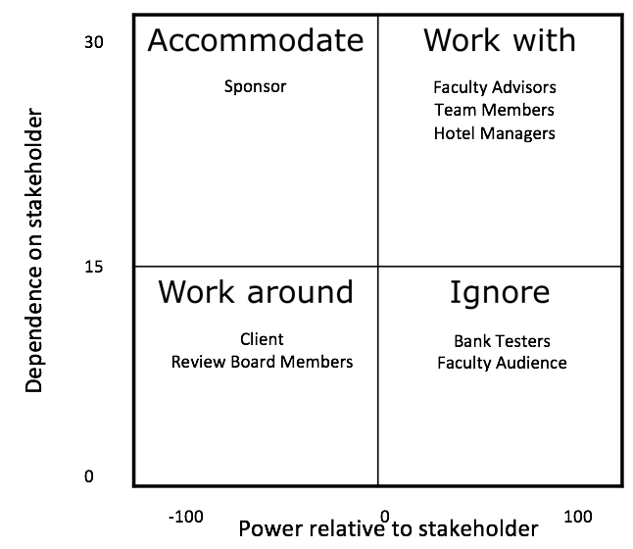

**3.**

|  |  |  |  |  |  |  |  |  |
| --- | --- | --- | --- | --- | --- | --- | --- | --- |
| **Name** | **Interest** | **Agreement** | **Support** | **Overall support** | **Integrity** | **Trust** | **Influence** | **Relationship quality** |
| Client | 10 | 10 | 8 | 28 | 80 | 80 | 90 | 250 |
| Sponsor | 9 | 10 | 9 | 28 | 80 | 90 | 70 | 240 |
| Faculty Advisors | 9 | 9 | 8 | 26 | 90 | 80 | 80 | 250 |
| Review Board Members | 7 | 6 | 4 | 17 | 70 | 60 | 60 | 190 |
| Team Members | 10 | 10 | 9 | 29 | 100 | 100 | 90 | 290 |
| Hotel Managers | 7 | 7 | 6 | 20 | 70 | 70 | 60 | 200 |
| Bank Testers | 4 | 2 | 5 | 11 | 90 | 100 | 20 | 210 |
| Faculty Audience | 1 | 2 | 0 | 3 | 70 | 20 | 0 | 90 |

**4.**

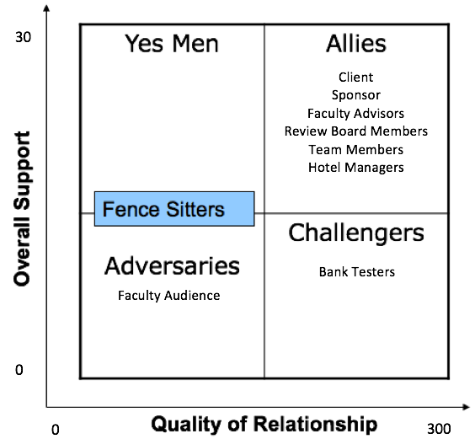

**5.**

|  |  |  |  |  |  |  |
| --- | --- | --- | --- | --- | --- | --- |
| **Stakeholder’s Name** | **Functions** | **Interests** | **Email/Phone** | **Ally?** | **Comm Freq** | **Last Comm** |
| Client | Client | Business | client@gmail.com | Yes | Weekly | 12/9/15 |
| Sponsor | Provide funding for the booking system | Investing | sponsor@gmail.com | Yes | Biweekly | 12/2/15 |
| Faculty Advisors | Provide technical advice | Consulting | advisor@iastate.edu | Yes | Biweekly | 12/10/15 |
| Review Board Members | Listen to the final presentation | Final Product | NA | No | 1 time | NA |
| Team Members | Build the system | Development | [jharper@iastate.edu](mailto:jharper@iastate.edu), jlharper@iastate.edu | Yes | Every other day | 12/15/15 |
| Hotel Managers | Test the system | Testing | john@hilton.com | Yes | Last 2 weeks | 12/6/15 |
| Bank Testers | Test the financial side of the system | Security | bank@gotmoney.com | Yes | Last 2 weeks | 12/11/15 |
| Faculty Audience | Attend the presentation | Final Product | NA | No | 1 time | NA |