James D. Harris

IST 664

Homework 3

**Part 1: Writing grammar rules**

The following is a list of tags I used to replace the miscellaneous tags in the provided grammar:

Misc2 🡪 Conj

Misc3 🡪 Numb

Misc6 🡪 Modal

Misc7 🡪 Adj

Misc8 🡪 AdjComp

Misc9 🡪 AdjSuper

Misc10 🡪 Noun2

Misc11 🡪 NounPropThing

Misc12 🡪 NounProp2

Misc13 🡪 PronounPers

Misc15 🡪 Adv

Misc16 🡪 VerbBF

Misc17 🡪 VerbPT

Misc18 🡪 VerbPresPart

Misc19 🡪 VerbPastPart

Misc20 🡪 VerbSing3

Misc21 🡪 VerbPlur3

Misc22 🡪 Whdeter

Misc25 🡪 Whadverb

The following is the list of sentences from sentences.txt that did not parse with the default settings:

***Arthur rides the plodding horse near the castle.***

* *Misc7 🡪 Adj*
* *Added |Adj NP| to NP*

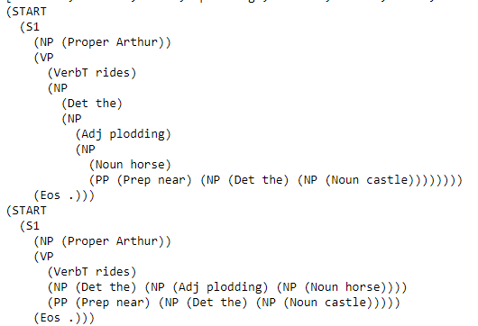

Adding |Adj NP| as a new potential noun phrase accounted for “plodding horse,” which was what was keeping this sentence from being parsed earlier.

***The Holy Grail is a chalice.***

***The sensational Holy Grail is a sacred chalice.***

* *Misc11 🡪 NounPropThing*
* *Added |NounPropThing| to NP*

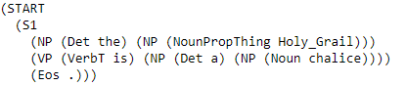

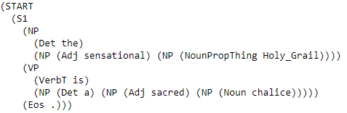

Adding |NounPropThing| allowed the parser to use non-person proper nouns such as Holy Grail as a noun phrase.

***Every coconut was carried to the hottest mountains.***

* *Misc17 🡪 VerbPT*
* *Misc9 🡪 AdjSuper*
* *Misc10 🡪 Noun2*
* *Added |AdjSuper NP| to NP*
* *Added |VerbPT VerbPT PP| to VP*
* *Added ‘to’ to list of prepositions*

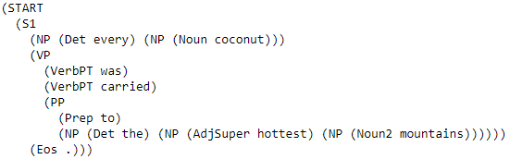

Adding |Noun2| to noun phrases accounted for “mountains,” and adding |AdjSuper NP| caught “hottest mountains.” Additionally, I added the pattern |VerbPT VerbPT PP| to verb phrases, which caught “was carried” plus a prepositional phrase.

***Sixty strangers are at the Round Table.***

* *Misc3 🡪 Numb*
* *Misc21 🡪 VerbPlur3*
* *Added |Numb NP| to NP*
* *Added |VerbPlur3 PP| to VP*

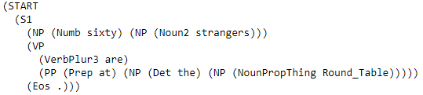

Adding |Numb NP| caught “sixty strangers” and adding |VerbPlur3 PP| allowed the parser to see third person plural nouns like “are” and a prepositional phrase.

***Sir Lancelot might have spoken.***

* *Misc6 🡪 Modal*
* *Misc19 🡪 VerbPastPart*
* *Added |VerbBF VerbPastPart| to VP*
* *Added |Modal VP| to VP*

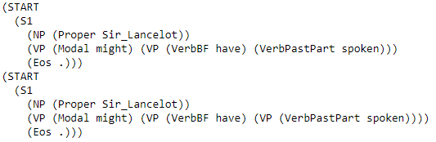

I added |VerbBF VerbPastPart| to verb phrases, which caught “have spoken,” and |Modal VP|, which caught “might have spoken.”

***Guinevere had been riding with Patsy for five weary nights.***

* *Added |VerbPT VP| to VP*
* *Added |VerbPastPart VP| to VP*
* *Added |VerbPresPart PP PP| to VP*

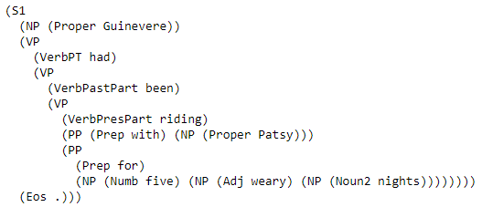

The phrase “had been riding” has a past tense verb, a past participle verb, and a present participle verb, all followed by two prepositional phrases. This was enough to successfully parse this sentence, but it took a lot of trial and error, and it resulted in eight different parses.

***Sir Bedevere might have been suggesting this quest.***

* *Added |VerbBF VP| to VP*
* *Added |VerbPresPart NP| to VP*

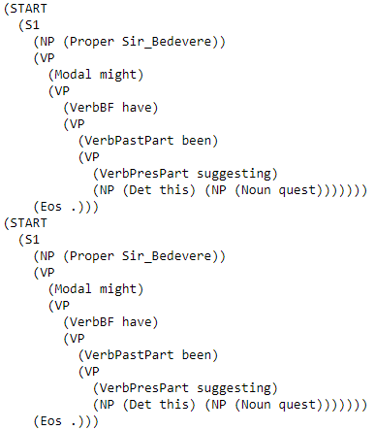

Adding |VerbPresPart NP| to verb phrases caught “suggesting this quest,” and adding |VerbBF VP| allowed the parser to catch “have been suggesting.”

***The Britons migrate south frequently.***

* *Added |VerbBF Adv Adv| to VP*
* *Added |NounProp2| to NP*

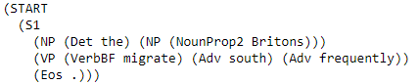

I added |NounProp2| to noun phrases to catch plural proper nouns, for “Britons.” I added |VerbBF Adv Adv| to verb phrases to catch a base form verb followed by two adverbs, such as “migrate south frequently.”

***Arthur and Guinevere ride frequently near the castle.***

* *Misc2 🡪 Conj*
* *Added |Proper Conj Proper| to NP*
* *Added |VerbBF Adv PP| to VP*

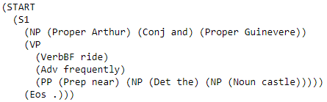

I added |Proper Conj Proper| to noun phrases to catch “Arthur and Guinevere.”

***He suggests to grow fruit at home.***

* *Misc20 🡪 VerbSing3*
* *Misc13 🡪 PronounPers*
* *Added |PronounPers| to NP*
* *Added |VerbSing3 TO VerbBF Noun PP| to VP*

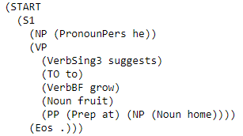

This was an awkward sentence to begin with; instead of the infinitive “to grow,” it would seem more likely to use the gerund “growing.” I added |PronounPers| to noun phrases to catch personal pronouns, and the specific pattern |VerbSing3 TO VerbBF Noun PP| to verb phrases to catch “suggests to grow fruit at home.”

***Riding to Camelot is not hard.***

* *Added |VerbPresPart| to NP (as a gerund)*
* *Added |VerbPresPart PP| to NP (as a gerund)*
* *Added |VerbT NOT Adj| to VP*
* *Added |DO NOT VP| to VP*
* *Added |VerbBF Adv| to VP*

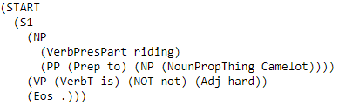

Since gerunds serve as nouns, I chose to add |VerbPresPart| and |VerbPresPart PP| to noun phrases to catch “Riding to Camelot,” and |VerbT NOT Adj| to verb phrases to catch “is not hard.”

***Do coconuts speak?***

* *Added VP Eos to Sentences*
* *Added |DO NP VerbBF| to VP*



This sentence does not have a defined subjective noun, so I added VP Eos to the sentence options. I also used the specific pattern |DO NP VerbBF| to capture the entire sentence.

***Why does England have a king?***

* *Misc25 🡪 Whadverb*
* *Added |Whadverb DO NP VerbBF NP| to VP*

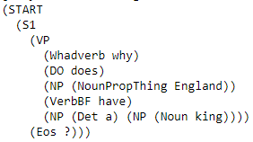

I added the specific pattern |Whadverb DO NP VerbBF NP| to verb phrases to capture the entire sentence.

The following is two sentences I chose from challenge.sentences.txt:

***What horse does Arthur ride?***

* *Misc22 🡪 Whdeter*
* *Added |Whdeter NP| to NP*
* *Added |DO NP VerbBF| to VP*

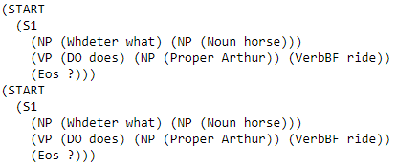

Adding |Whdeter NP| to noun phrases enabled the parser to catch “What horse,” and adding |DO NP VerbBF| to verb phrases allowed the parser to catch “does Arthur ride.”

***Do not speak again!***

* *Added |DO NOT VP| to VP*
* *Added |VerbBF Adv| to VP*



Adding |VerbBF Adv| to verb phrases caught “speak again,” and adding |DO NOT VP| allowed the parser to catch “Do not” and that verb phrase.

**Part 1: Exemplar sentences**

***That horse drank and grew.***



The parser would catch “That horse,” under the rule |Whdeter noun|, but there was no rule in my grammar file to catch any combination of verbs separated by a coordinating conjunction.

***Guinevere rode do not be again.***

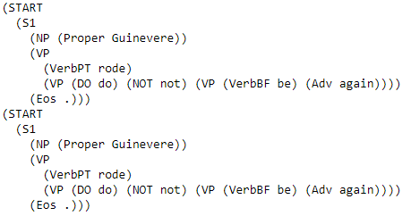

This sentence does not make sense, but the parser was able to use the grammar rules to parse it. The rule |VerbBF Adv| catches “be again.” The rule |DO NOT VP| recognizes “do not” along with the aforementioned verb phrase. The rule |VerbBF VP| catches “rode” with the verb phrase “do not be again.