Operating Systems

**Lab Exercise #5**

*I pulled a thread out of the air  
Golden and shining as thin as a hair  
I couldn't do anything but hold it and stare  
I don't know why it was hovering there*

* Phish

**Name: JaVonne Harrison / 6**

**Goals:** The intention of this lab is to better understand how a Linux threads and the Pthread library works.

**Environment:** The GNU GCC C compiler on your Ubuntu virtual machine.

**Slack Channel:** All questions and problems for this lab should be directed to the course’s Lab 5 discussion forum on Blackboard.

**Submission:** All files, including this document with the required screenshots, should be submitted via Blackboard and GitLab as indicated. ***Lab submissions not following this convention may not be graded.***

**Contents:** Submitted via GitLab with all source code and development files checked into your repository. Create a new project (repository) named *cosc439-lastname-lab5* where *lastname* is your last name and add me ([ctessler@towson.edu](mailto:ctessler@towson.edu)) as a developer. Do **not** add object (.o) or executable files to your repository

**Pthreads:** (6 points) The POSIX thread (Pthread) libraries are a standards-based thread API for C/C++ (see full Pthreads tutorial at <http://www.yolinux.com/TUTORIALS/LinuxTutorialPosixThreads.html>). It allows you to spawn a new concurrent process flow. It is most effective on multi-processor or multi-core systems where the process flow can be scheduled to run on another processor, thus gaining speed through parallel or distributed processing.

Threads require less overhead than "forking" a new process because the system does not initialize a new system virtual memory space and environment for the process. While most effective on a multiprocessor system, gains are also found on single processor systems which exploit latency in I/O and other system functions which may halt process execution. (One thread may execute while another is waiting for I/O or some other system latency).

Parallel programming technologies, such as [MPI](https://searchenterprisedesktop.techtarget.com/definition/message-passing-interface-MPI) and [PVM](https://en.wikipedia.org/wiki/Parallel_Virtual_Machine), are used in a distributed computing environment while threads are limited to a single computer system. All threads within a process share the same address space. A thread is spawned by defining a function and its arguments which will be processed in the thread.

# *Thread Basics*

Thread operations include thread creation, termination, synchronization (joins, blocking), scheduling, data management and process interaction. Specifically:

* A thread does not maintain a list of created threads, nor does it know the thread that created it.
* All threads within a process share the same address space.
* Threads in the same process share (see Figure 1):
  + Process instructions
  + Most data
  + Open files (descriptors)
  + Signals and signal handlers
  + Current working directory
  + User and group id
* Each thread has a unique (see Figure 1):
  + Thread ID
  + Set of registers
  + Stack pointer
  + Stack for local variables and return addresses
  + Signal mask
  + Priority
  + Return value: errno (Pthread functions return "0" if OK)

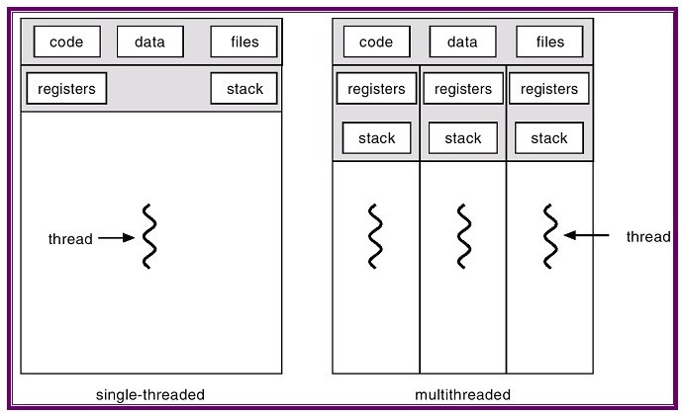

**Figure 1.** Concept of multithreading

# To create a new thread, the pthread_create function defined in pthread.h is used, as follows:

int pthread_create(pthread_t * thread, const pthread_attr_t * attr,

void * (*start_routine)(void *), void *arg);

Arguments:

* *thread* - returns the thread id. (unsigned long int defined in bits/[pthreadtypes.h](https://pubs.opengroup.org/onlinepubs/7908799/xsh/pthread.h.html)).
* *attr* - Set to NULL if default thread attributes are used.
* *void * (*start_routine)* - pointer to the function to be threaded. Function has a single argument: pointer to void.
* \**arg* - pointer to argument of function. To pass multiple arguments, send a pointer to a structure.

# To terminate a thread, the pthread_exit function is used, as follows:

void pthread_exit(void *retval);

Arguments:

* *retval* - Return value of thread.

This routine kills the thread. The pthread_exit function never returns. If the thread is not detached, the thread id and return value may be examined from another thread by using pthread_join.

With this, **develop a C program, named hellothread.c, that takes an integer, *n,* at the command line that must be between 1-10 and uses Pthreads and implements 2 functions that do the following:**

* **main()**
  + **Checks the parameter to ensure the integer is between 1-10, if not it prints an error message and quits.**
  + **Creates *n* threads**
  + **Each thread is identified by an integer from 1-*n*, named *id***
  + **Upon creation, each thread is passed its *id***
  + **The main thread outputs “Creating thread #*id*” for each thread *id***
  + **For each thread, the entry point is the worker() function.**
* **worker()**
  + **Receives a thread *id* as a parameter and prints “Hello world! I am thread #*id*”**
  + **The thread then terminates indicating success or failure**

To implement this, don’t forget to terminate the threads after they are finished. To compile a C program using Pthreads, you need to use the -pthread flag. For example, to compile a hellothread.c program using Pthreads, you would issue the following at the command line:

gcc -pthread -o hellothread hellothread.c

**Include a screenshot of your output here.**

*

The threads library provides three synchronization mechanisms:

* *mutexes* - Mutual exclusion lock: Block access to variables by other threads. This enforces exclusive access by a thread to a variable or set of variables.
* *joins* - Make a thread wait till others are complete (terminated).
* *condition variables* - data type pthread_cond_t

# *Mutexes*

Mutexes are used to prevent data inconsistencies due to race conditions. A race condition often occurs when two or more threads need to perform operations on the same memory area, but the results of computations depends on the order in which these operations are performed. Mutexes are used for serializing shared resources. Anytime a global resource is accessed by more than one thread the resource should have a mutex associated with it. One can apply a mutex to protect a segment of memory ("critical region") from other threads. Mutexes can be applied only to threads in a single process and do not work between processes, as do semaphores. See [this](http://www.yolinux.com/TUTORIALS/LinuxTutorialPosixThreads.html#SYNCHRONIZATION) tutorial for more information.

# *Joins*

A join is performed when one wants to wait for a thread to finish. A thread calling routine may launch multiple threads then wait for them to finish to get the results. One wait for the completion of the threads with a join.

int pthread_join(pthread_t thread, void **retval);

The pthread_join() function waits for the thread specified by thread to terminate. If that thread has already terminated, then pthread_join() returns immediately. The thread specified by thread must be joinable.

# *Mutex Functions*

int pthread_mutex_init (pthread_mutex_t *mutex,   
const pthread_mutexattr_t *attr);

The pthread_mutex_init() function initializes the mutex referenced by mutex with attributes specified by attr. If attr is NULL, the default mutex attributes are used; the effect is the same as passing the address of a default mutex attributes object. Upon successful initialization, the state of the mutex becomes initialized and unlocked.

int pthread_mutex_lock (pthread_mutex_t *mutex);

The mutex object referenced by mutex is locked by calling pthread_mutex_lock(). If the mutex is already locked, the calling thread blocks until the mutex becomes available. This operation returns with the mutex object referenced by mutex in the locked state with the calling thread as its owner.

int pthread_mutex_unlock (pthread_mutex_t *mutex);

The pthread_mutex_unlock() function releases the mutex object referenced by mutex. The manner in which a mutex is released is dependent upon the mutex's type attribute. If there are threads blocked on the mutex object referenced by mutex when pthread_mutex_unlock() is called, resulting in the mutex becoming available, the scheduling policy is used to determine which thread shall acquire the mutex.

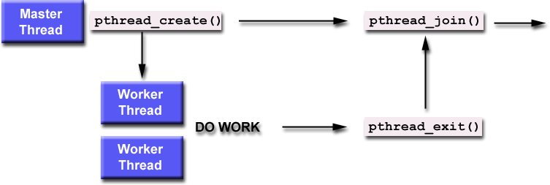

**Figure 2.** Pthread functions implementation.

With this, **compile and run (several times) the provided** [**votecounter**](https://bostonglobe-prod.cdn.arcpublishing.com/resizer/Q-IjWDFmFoq_7KcA8U7ksTgZNAE=/820x0/arc-anglerfish-arc2-prod-bostonglobe.s3.amazonaws.com/public/4DSKQCHGUQI6RGRY4CQIDD275I.jpg)**.c program. You should get an output that varies the vote count output (as shown below), even though it should always produce 5,000,000.**

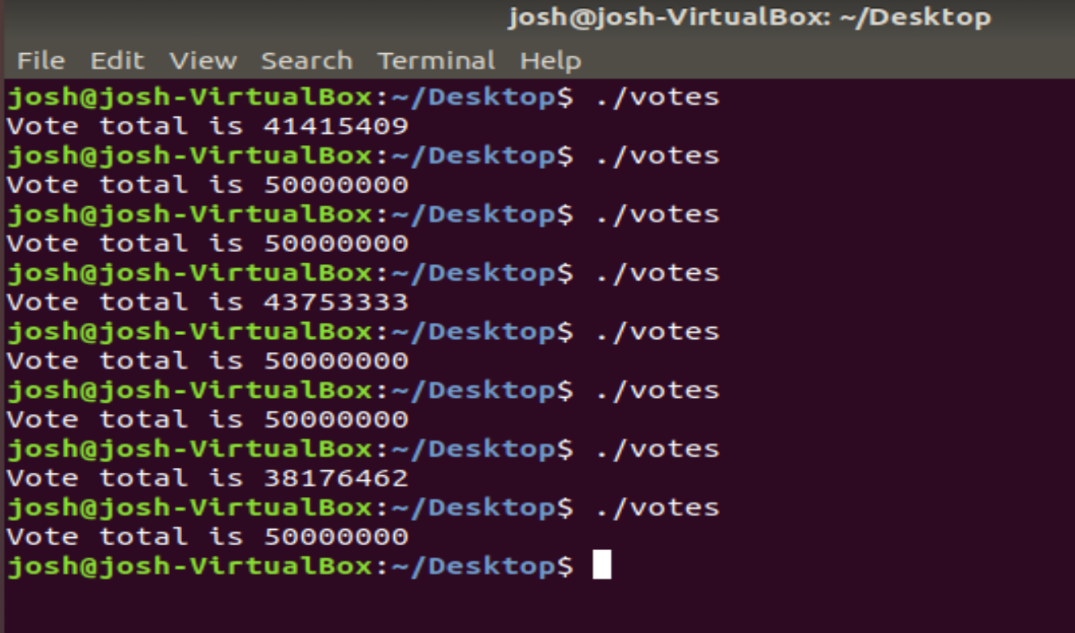

The reason for this difference is that the 5 created threads share the global variable *votes* and can read/write/modify it unchecked – this is not a good idea for critical data (like counting votes)! **Using pthread mutexes, modify the votecounter.c program to ensure that the correct vote count is *always* produced by the program.**

Once you have it working, **include a screenshot of several runs of your output here and include the modified votecounter.c program in your repository.**

Your repository should contain the following files, and no others (including subdirectories).

makefile

hellothread.c

votecounter.c

Typing make in the top level directory of your project must create the hellothread and votecounter executables.