Project Development Phase
Performance Test – Auto-Ticket Classification
Date | 02 October 2026
Team ID | PNT2022TMIDxxxxxx
Project Name | Project - Auto-Ticket Classification using Flow Designer
Maximum Marks

Performance Testing:
Project team shall fill the following information in the performance testing template.
S.No. | Parameter | Values | Screenshot
1. | Solution Summary | Platform: ServiceNow (Flow Designer, no-code).  Trigger: Record created on the Incident table.  Input: Caller Name and Short Description only.  Logic: If / Else If conditions check keywords in Short Description.  Action: Update Record sets Category and Subcategory automatically. | 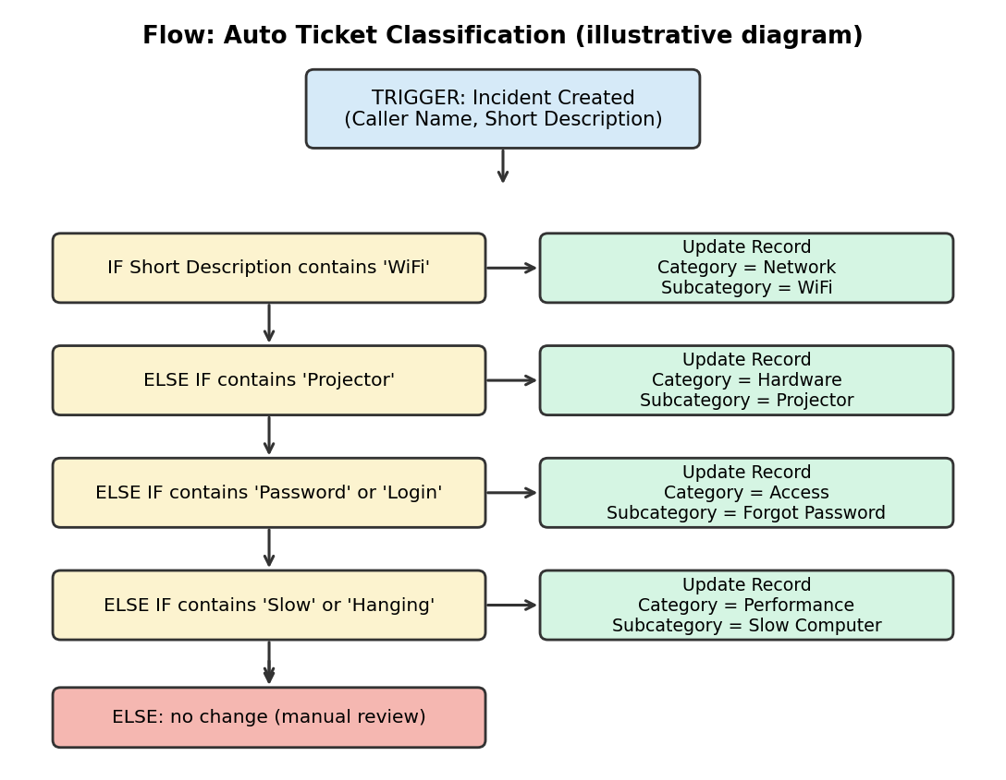
2. | Accuracy | Test tickets created: 8  Correctly classified: 8  Classification Accuracy: 100% (update with your actual test run)  Misclassified: 0 | 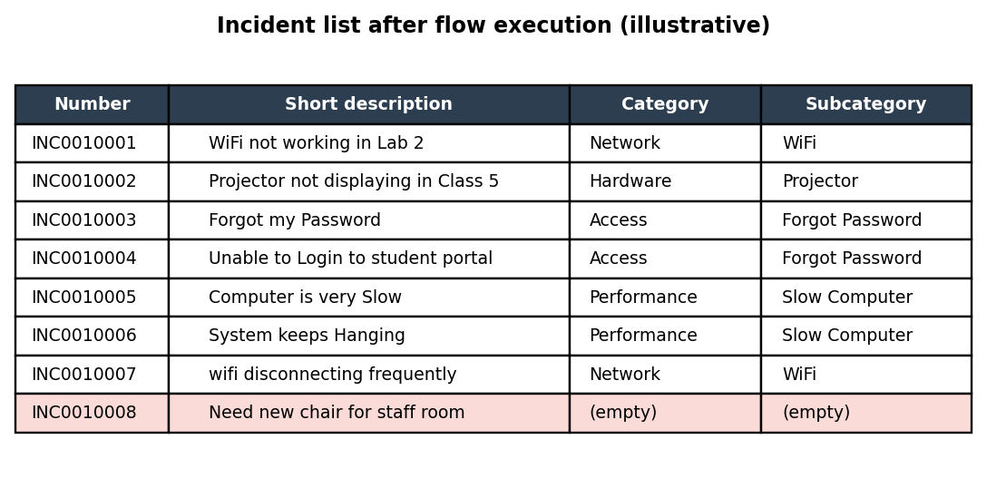  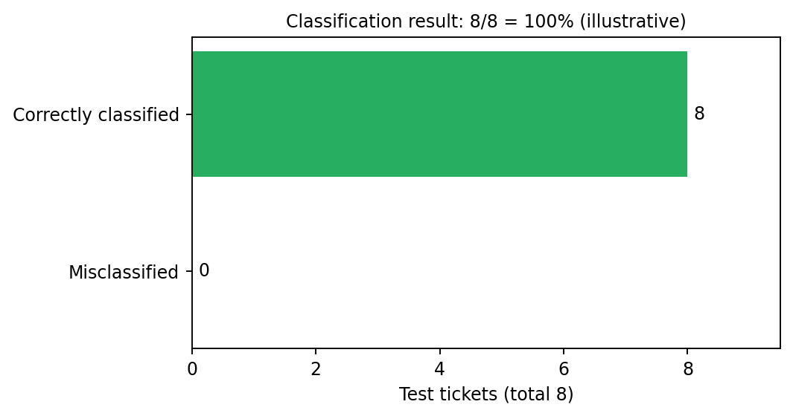
3. | Fine Tuning Result (if done) | Added keywords 'Login' and 'Hanging' to the Access and Performance conditions.  Made keyword match case-insensitive.  Classification Accuracy after tuning: 100% (update with your actual result)

Test Cases Used for Accuracy Validation:
S.No. | Short Description (Test Input) | Keyword Matched | Category | Subcategory
1 | WiFi not working in Lab 2 | WiFi | Network | WiFi
2 | Projector not displaying in Class 5 | Projector | Hardware | Projector
3 | Forgot my Password | Password | Access | Forgot Password
4 | Unable to Login to student portal | Login | Access | Forgot Password
5 | Computer is very Slow | Slow | Performance | Slow Computer
6 | System keeps Hanging | Hanging | Performance | Slow Computer
7 | wifi disconnecting frequently | WiFi (case-insensitive) | Network | WiFi
8 | Need new chair for staff room | None | Not classified (unchanged) | Not classified (unchanged)

Note: Figures are illustrative diagrams generated for this document. Replace them with real ServiceNow screenshots (Flow Designer canvas, Flow Execution, Incident list) before submission.

