Project Design Phase-II
Data Flow Diagram & User Stories
Date | 03 October 2026
Team ID | SWTID-2026-9610
Project Name | Auto Ticket Classification
Maximum Marks | 4 Marks

Data Flow Diagram
The flowchart below represents the Auto Ticket Classification process using ServiceNow Flow Designer. It shows ticket creation, predefined keyword classification, Category/Subcategory update, ticket storage, and email notification.
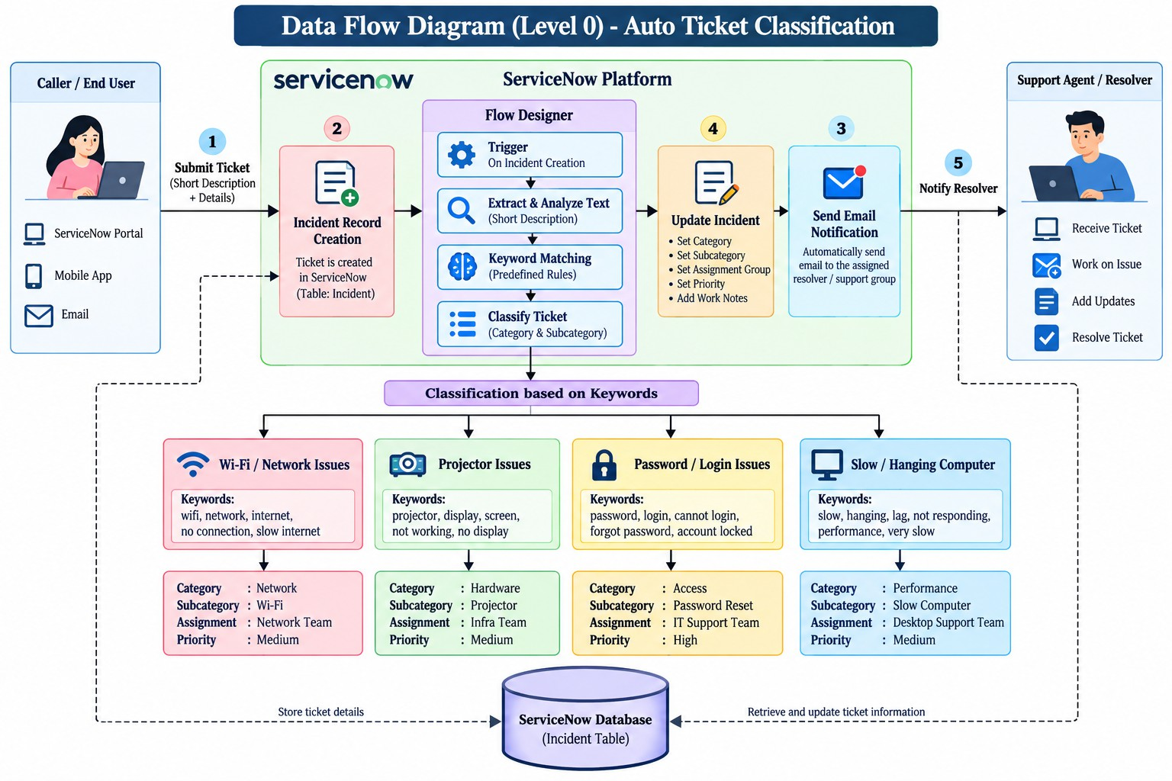

Project-specific classification: WiFi/Network → Network / Wi-Fi; Projector → Hardware / Projector; Password/Login → Access / Forgot Password; Slow/Hanging → Performance / Slow Computer.

User Stories
Use the template structure to list the user stories for the Auto Ticket Classification product.

User Type | Functional Requirement (Epic) | User Story Number | User Story / Task | Acceptance Criteria | Priority | Release
Student / Teacher | Ticket Creation | US-1 | As a user, I can create an IT support ticket by providing the caller and issue short description. | A new ticket record is created with an auto-generated ticket number. | High | Release-1
Student / Teacher | Ticket Creation | US-2 | As a user, I can provide a short description such as a WiFi, projector, password/login, or slow/hanging issue. | The submitted ticket contains the entered issue description. | High | Release-1
IT Helpdesk | Automatic Classification | US-3 | WiFi or Network keywords are automatically classified as Network / Wi-Fi. | Category = Network; Subcategory = Wi-Fi. | High | Release-1
IT Helpdesk | Automatic Classification | US-4 | Projector keywords are automatically classified as Hardware / Projector. | Category = Hardware; Subcategory = Projector. | High | Release-1
IT Helpdesk | Automatic Classification | US-5 | Password or Login keywords are automatically classified as Access / Forgot Password. | Category = Access; Subcategory = Forgot Password. | High | Release-1
IT Helpdesk | Automatic Classification | US-6 | Slow or Hanging keywords are automatically classified as Performance / Slow Computer. | Category = Performance; Subcategory = Slow Computer. | High | Release-1
Caller | Email Notification | US-7 | The caller receives an automated email after ticket creation. | Confirmation email is sent to caller email. | High | Release-1
IT Helpdesk | Ticket Data | US-8 | View ticket number, caller, category, subcategory, description, and state. | Configured ticket fields are visible. | High | Release-1
IT Helpdesk | Ticket Data | US-9 | View Assigned Group and Assigned To when populated. | Reference fields display assignment information. | Medium | Release-1
Administrator | Flow Maintenance | US-10 | Maintain Flow Designer conditions when keywords or categories change. | Classification branches can be updated. | Medium | Release-2
Administrator | Deployment | US-11 | Store project configuration in an update set for transfer. | Project Update Set can be completed/exported as XML. | Medium | Release-2
IT Helpdesk | Validation | US-12 | Test representative issue descriptions and verify classification and email. | Expected classification and email are produced. | High | Release-1

