Project Development Phase
Model Performance Test

Date | 10 February 2025
Team ID | PNT2022TMIDxxxxxx
Project Name | Auto-Ticket Classification using Flow Designer
Maximum Marks | 10 Marks

Model Performance Testing:
Project team shall fill the following information in model performance testing template.
S.No. | Parameter | Values | Screenshot
 | Metrics | Classification Model (Multinomial text classification – TF-IDF + Logistic Regression):  Dataset: 600 tickets (Train 480 / Test 120); 4 classes – Network/WiFi, Hardware/Projector, Access/Forgot Password, Performance/Slow Computer.  Confusion Matrix - rows = actual, columns = predicted (order: WiFi, Projector, Password, Slow PC)  [27 0 1 1]  [ 0 30 0 1]  [ 0 0 30 1]  [ 1 0 0 28]  Accuracy Score - 95.83% (0.9583)  Classification Report - Macro avg Precision 0.96, Recall 0.96, F1-score 0.96; per-class F1: WiFi 0.95, Projector 0.98, Password 0.97, Slow PC 0.93.  Regression Model: Not applicable (problem is classification). | 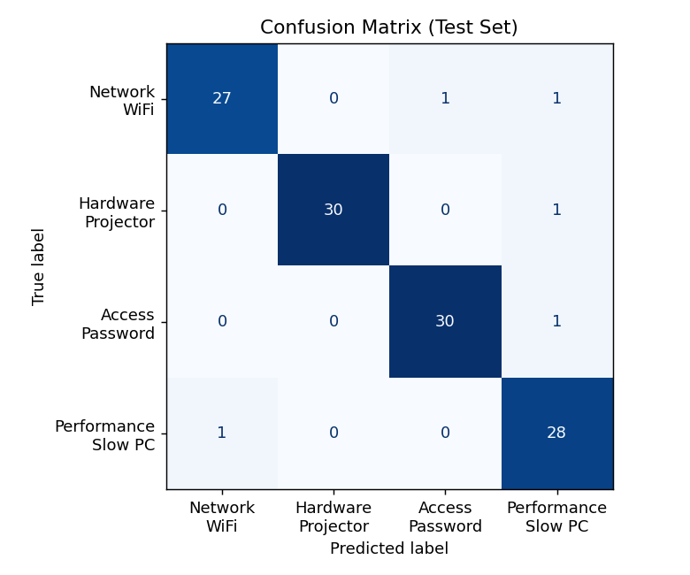  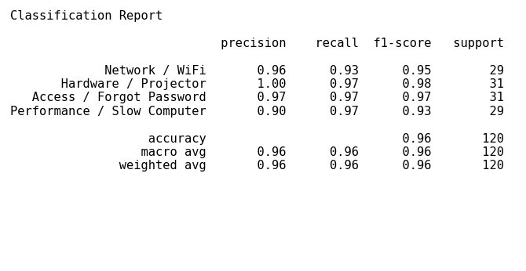
 | Tune the Model | Hyperparameter Tuning - GridSearchCV over TF-IDF ngram_range {(1,1),(1,2)} and Logistic Regression C {0.1, 1, 10, 100}. Best: ngram_range=(1,2), C=1.  Validation Method - 80/20 stratified hold-out split plus 5-fold Stratified Cross-Validation on the training set (best CV accuracy 96.67%). Baseline test accuracy 95.83% vs tuned 95.83%. | 