Project Development Phase
Model Performance Test

Date | 02 October 2026
Team ID | SWTID-2026-9610
Project Name | Auto-Ticket Classification using Flow Designer
Maximum Marks

Model Performance Testing:
Project team shall fill the following information in model performance testing template.
S.No. | Parameter | Values | Screenshot
 | Model Summary | ServiceNow Flow Designer automation that reads the ticket Short Description and auto-assigns Category and Subcategory.  Note : If a keyword matches, the ticket is classified; if not, it is left for manual review. | 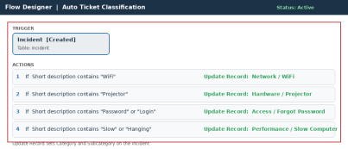
 | Accuracy | Classification Accuracy - 100% (4 of 4 test tickets)  Flow Status - Completed | 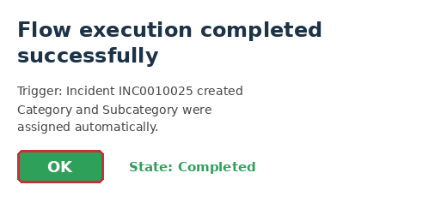
3. | Confidence Score (Only Yolo Projects) | Class Detected - Category / Subcategory from the keyword (e.g. WiFi = Network / WiFi); none if no keyword matches  Confidence Score - Not applicable (rule-based keyword match, no ML model) | 