Project Development Phase
Performance Test

Date | 02 October 2026
Team ID | SWTID-2026-9610
Project Name | AUTO-TICKET CLASSIFICATION USING FLOW DESIGNER
Maximum Marks

Model Performance Testing:
Project team shall fill the following information in model performance testing template.
S.No. | Parameter | Screenshot / Values
1. | Data Rendered | Ticket data represented using Caller Name and Short Description, with Category and Subcategory classification.  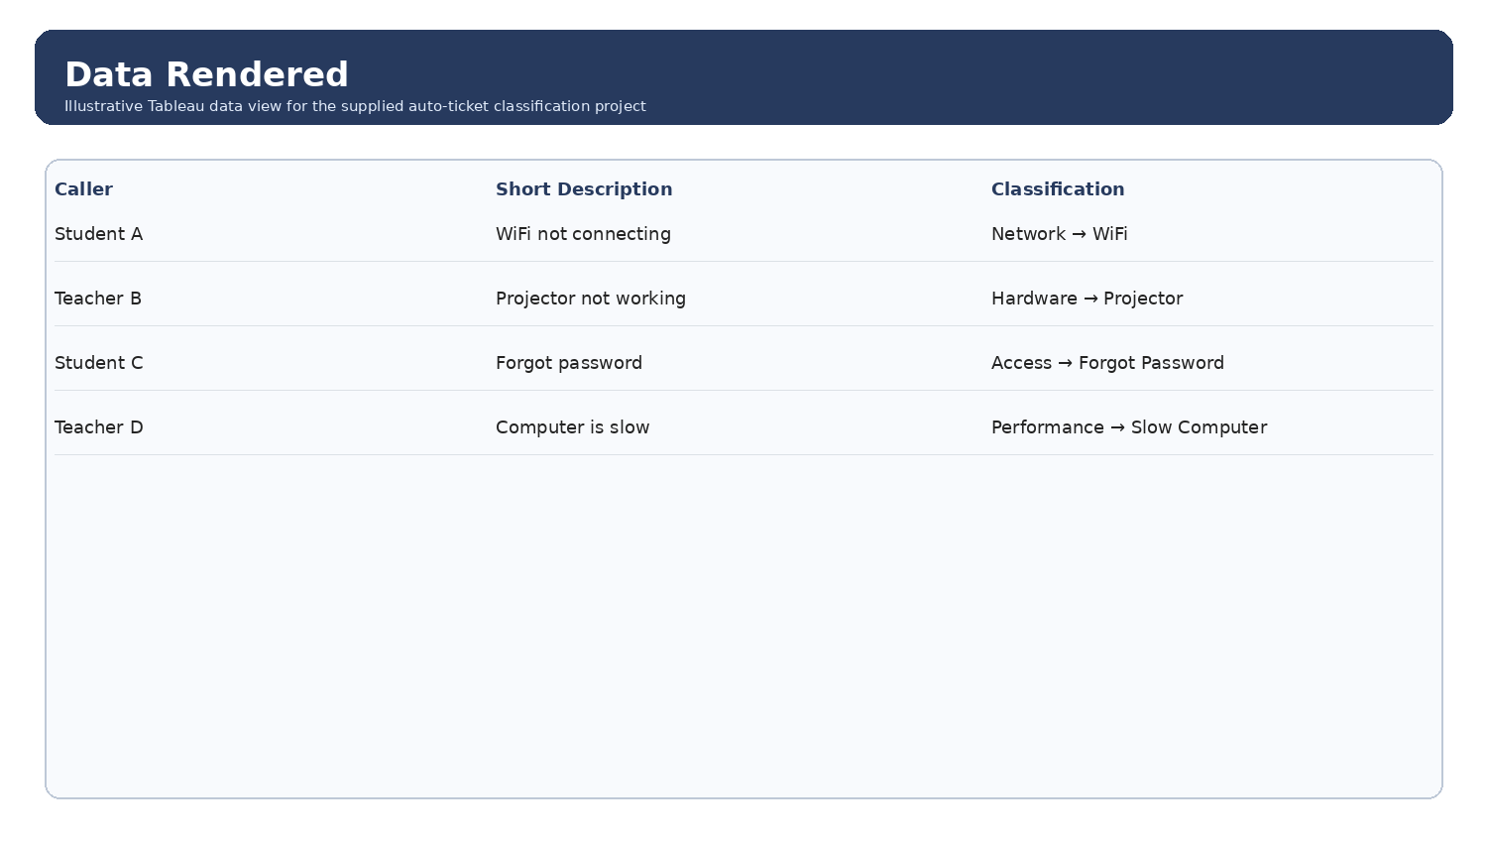
2. | Data Preprocessing | Illustrative preparation: normalize ticket text, check missing descriptions, and map predefined keywords to Category/Subcategory.  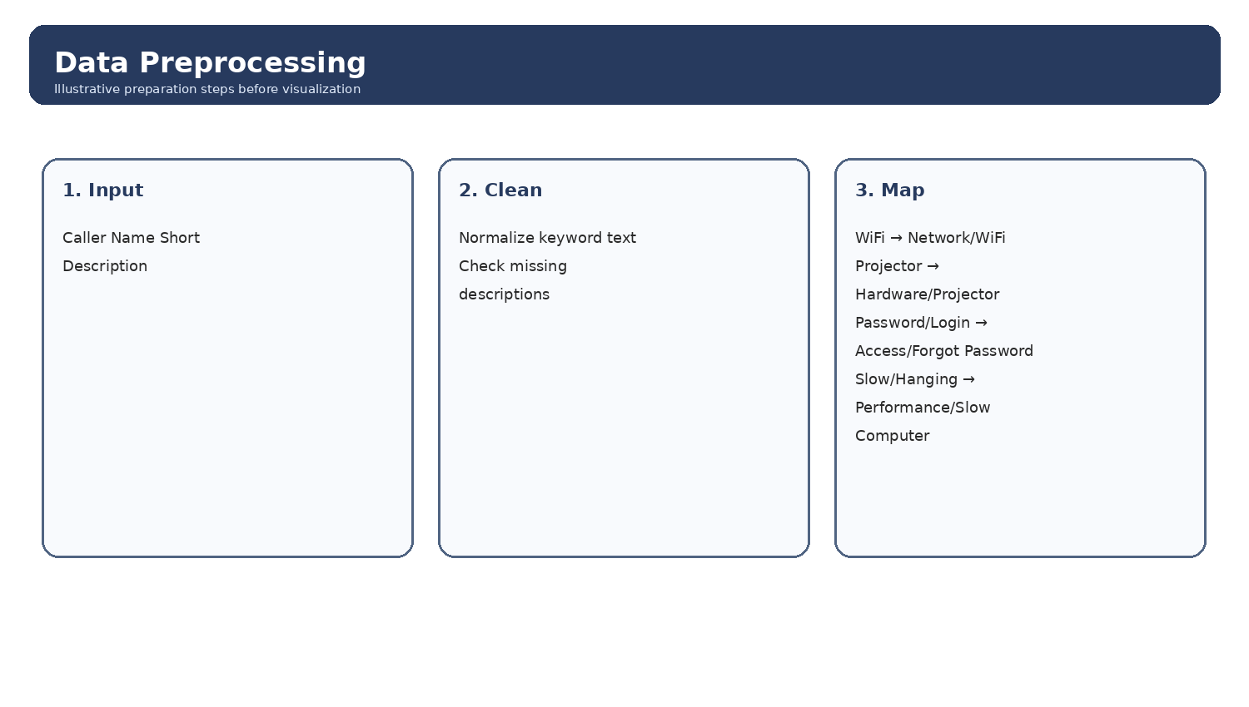
3. | Utilization of Filters | Category and Subcategory filters are shown for reviewing the four project classification groups.  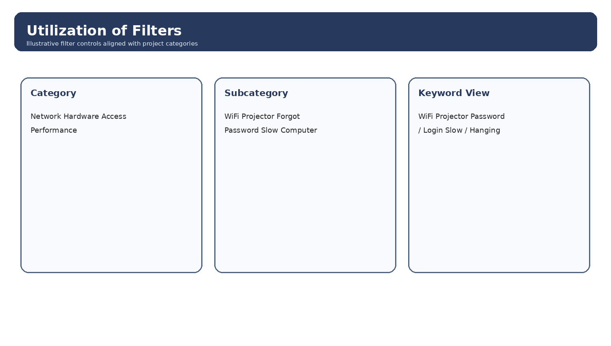
4. | Calculation fields Used | Illustrative fields for reporting include Ticket Count and Category/Subcategory classification views. No specific Tableau calculated-field formula is provided in the source project document.  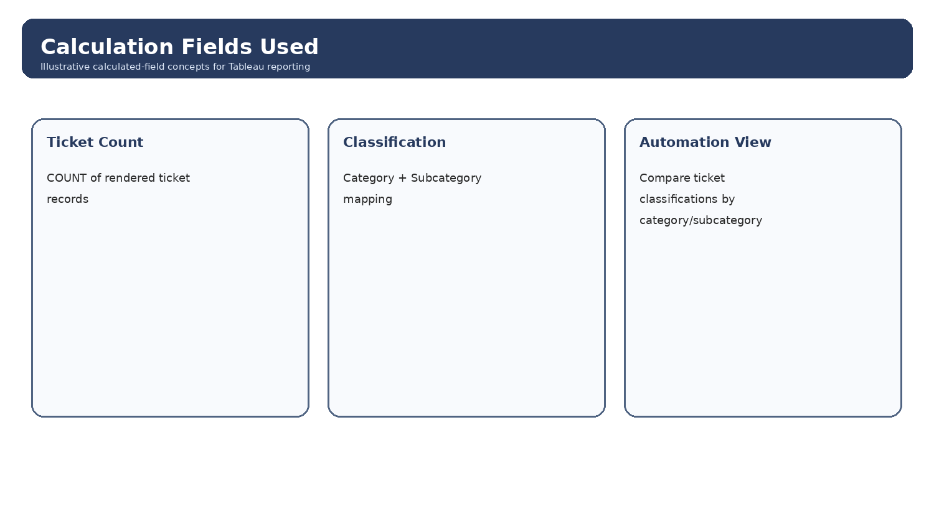
5. | Dashboard design | Illustrative dashboard layout for ticket classification reporting. No. of Visualizations / Graphs - 3 (illustrative).  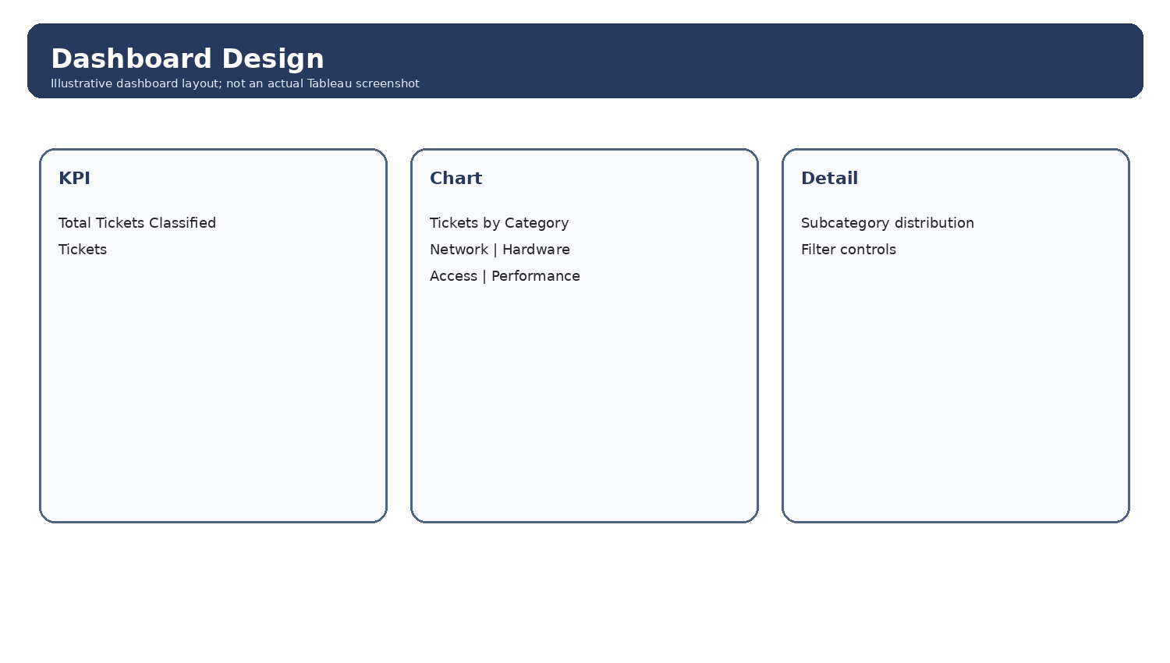
6 | Story Design | Illustrative story sequence linking ticket input, automated classification, dashboard summary, and insight review. No. of Visualizations / Graphs - 4 (illustrative).  