Joel Hartung

WEB 335

Assignment 1.4 Data Models

3/18/2022

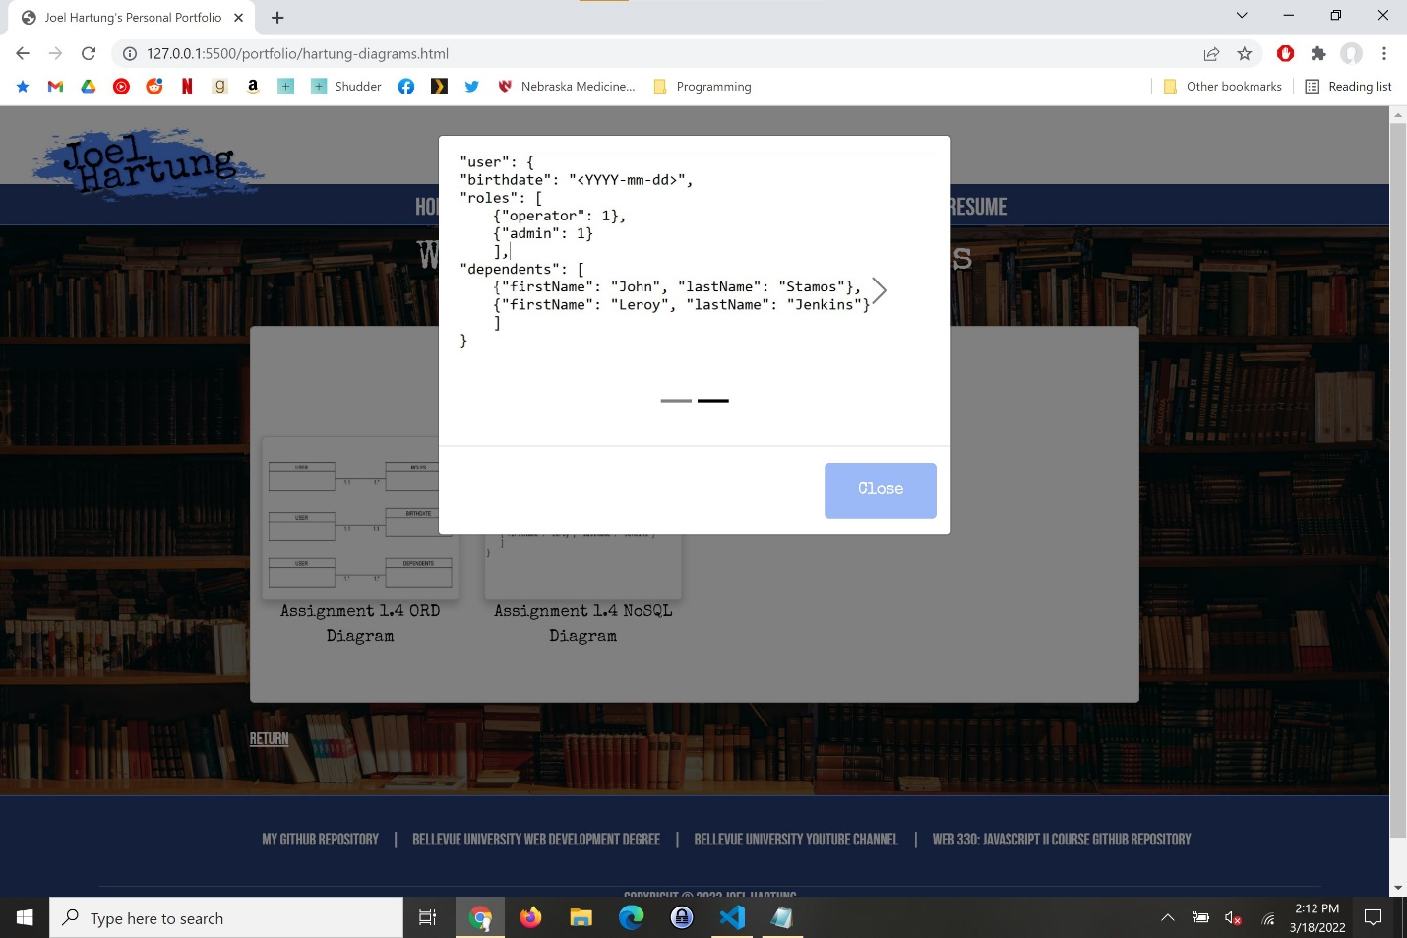

**ORD Diagram:**

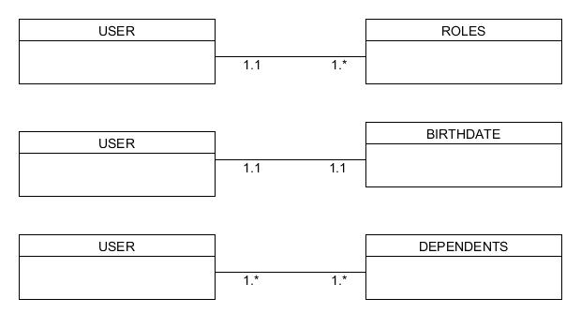

**NoSQL Data Diagram:**

