Joel Hartung

WEB 335

Assignment 2.2

3/24/2022

Assignment 2.2 ORD Diagram

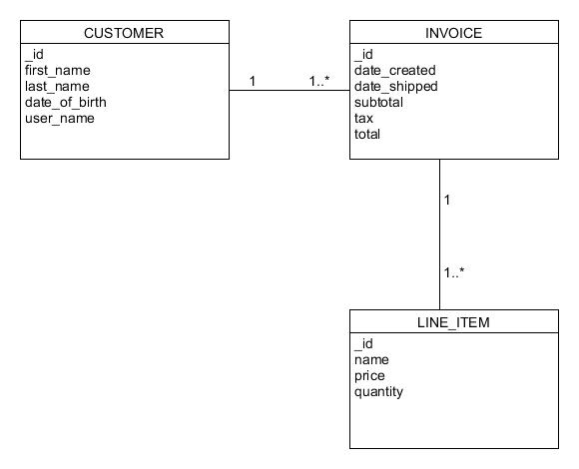

Assignment 2.2 NoSQL Data Structure:

