Address will be refreshed regularly to preserve financial privacy. Updates forthcoming!
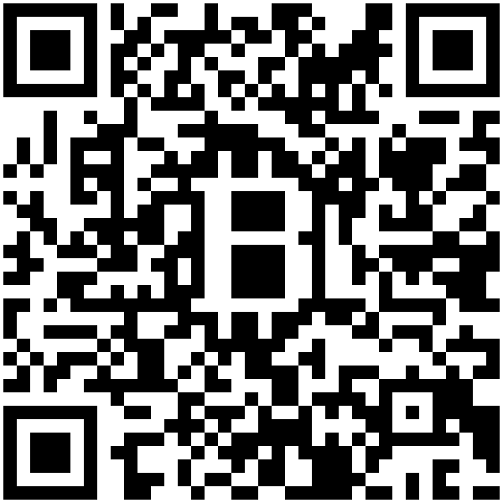
Bugs? Questions? Requests for items to stock? Email jharveyb@mit.edu
Many thanks to Tal, Jeremy, Joi, Jessica, & Kevin :)

