Address will be refreshed regularly to preserve financial privacy. Updates forthcoming!
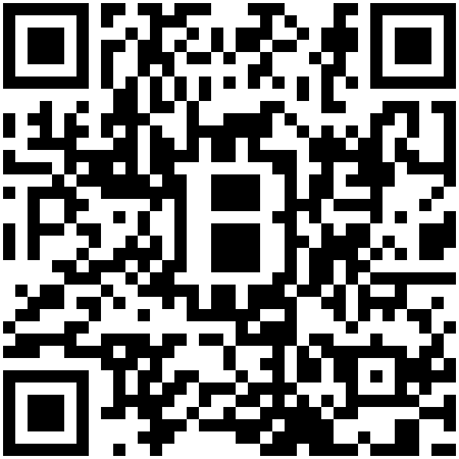
Pharmaceuticals in Row E are from nootrobox.com
Bugs? Requests for items? Email jharveyb@mit.edu
Many thanks to Tal, Jeremy, Joi, Jessica, & Kevin :)

