Fig. 1: Narrowband spectrogram: ‘Yorobôsi ga tune wa minaresi kyôgai nareba’

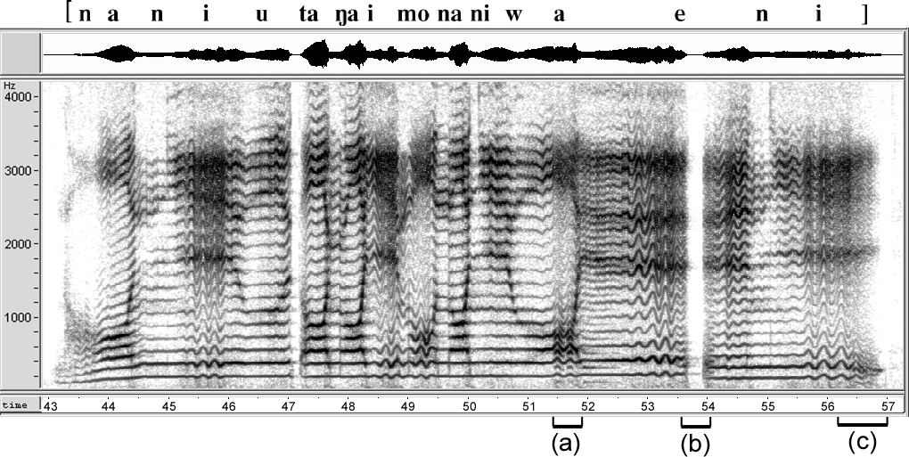

Fig. 2: Narrowband spectrogram: ‘nani utagai mo naniwae ni’

Fig. 3: Narrowband spectrogram: ‘sumiyosi no’
Note the apparent glottal stop in the middle of the short syllable /yo/ is phonologically irrelevant.

Fig. 4. XSX candidate frequency display (TANDEM-STRAIGHT):
An amplitude-modulated pulse train with continuously varied modulation depth from zero to 100%. The pulse amplitude is reduced for every other pulse (see waveform at top panel). The thickness of each plot (the line formed by individual points) shows the computed salience of each candidate for predicted pitch sensation. The likeliness of subharmonic pitch increases graudally.

Fig. 5. XSX candidate frequency display: A frequency-modulated pulse train with continuously varied modulation depth. The pulse interval is reduced for every other pulse and the depth of reduction increases continuously (See waveform). Half-frequency subharmonic perception is predicted except in the beginning when the FM modulation is negligible.

Fig. 6. XSX candidate frequency display: A portion of the vowel [o] in ‘kyôgai nareba’ (cf. (b) in Fig. 1). Pitch perception is predicted to be around 100 Hz in the middle region of this interval (bracketed at bottom with the label (b) in Fig. 1) except the beginning and ending parts in this figure, which are perceptually likely to be vague and unstable. Four candidate frequencies are shown, part of which are split into two tracks (top two traces). Strong frequency modulation and salience instability are indicated in the frequency region below the first formant (upper parts of this figure) predicting confused pitch sensation, while in the middle of the time interval selected in this display, a relatively clear pitch perception around 100 Hz is predicted for a time span of about 10 glottal cycles. “Joyful style”.

Fig. 7. XSX candidate frequency display: Toward the end of the phrase-final [i] in ‘naniwae ni’ (cf. Fig. 2, bracketed with label (c)) in “joyful style”.

Fig. 8. XSX display for the final [o] with pitch rise in ‘sumiyosi no’ (cf. (a) in Fig. 3). Note in Fig. 3, for the same sample, it is difficult to identify pitch rise toward the end of the utterance.

