EXPERIMENT-1
OBJECTIVE:
To accept a number from one text field in the range of 0 to 999 and shows it in another text field in words. If the number is out of range, it should show “out of range” and if it is not a number, it should show “not a number” message in the result box.
PROGRAM LOGIC:
1.Create a HTML file.
2.Read a number in one text field and display that number name in another text field. 3. Include the JavaScript to convert number into words.
PROCEDURE:
To execute a PHP program:
1.Open XAMPP control Panel then start Apache Server and Mysql.
2.Open Notepad and Save the php program in htdocs folder of XAMPP.
3. To run the php file open the browser and type the following URL localhost:3306/directory name/filename
SOURCE CODE:
<html>
<head>
<script type="text/javascript">
var th = ['','thousand','million', 'billion','trillion'];
var dg=['zero','one','two','three','four','five','six','seven','eight','nine']; var
tn=['ten','eleven','twelve','thirteen','fourteen','fifteen','sixteen','seventeen','eighteen','nineteen']; var tw=['twenty','thirty','forty','fifty','sixty','seventy','eighty','ninety'];
function change()
{
var numString=document.getElementById('anumber').value; var output=towords(numString); document.getElementById('aresult').value=output;
}
function towords(s)
{
s = s.toString();
if (s != parseFloat(s))
return 'not a number'; var x = s.indexOf('.');
if (x == -1)
x = s.length;
if (x > 3)
return 'too big'; var n = s.split('');
var str = ''; var sk = 0;
for (var i=0; i < x; i++)
{
if ((x-i)%3==2)
{
if (n[i] == '1')
{
str += tn[Number(n[i+1])] + ' '; i++; sk=1;
}
else if (n[i]!=0)
{
str += tw[n[i]-2] + ' '; sk=1;
}
}
else if (n[i]!=0)
{
str += dg[n[i]] +' '; if ((x-i)%3==0)
str += 'hundred ';
sk=1;
}
if ((x-i)%3==1)
{
if (sk)
str += th[(x-i-1)/3] + ' ';
sk=0;
}
}
return str;
}
</script>
</head>
<body>
<form>
enter a number<input type="text" id="anumber">
<input type="button" value='convert to words' onClick="change()"> <input type="text" size="40" id="aresult">
</form>
</body>
</html>

OUTPUT
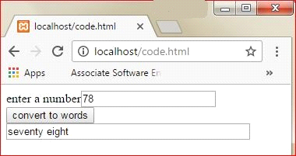
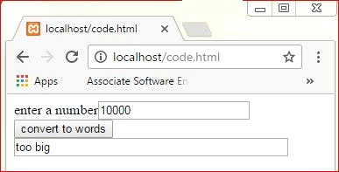
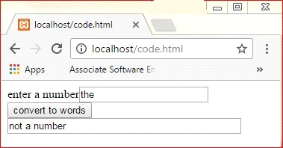
PRE LAB VIVA QUESTIONS:
1. What is an example of client side scripting language?
2. What are JavaScript data types?
3. How do we submit the form in JavaScript?
4. What is JavaScript?

POST LAB VIVA QUESTIONS:
1. How to create the text field?
2. How to retrieve the form data?
3. What is the purpose of writing document.getElementById ('anumber').value?
4. How to create an array in JavaScrip

EXPERIMENT-2
OBJECTIVE:
To display the number lines ,words and characters from an HTML page that has one input, which can take multi-line text and a submit button. Once the user clicks the submit button, it should show the number of characters, words and lines in the text entered using an alert message. Words are separated with a white space and lines are separated with new line character.
PROGRAM LOGIC:
1. Create an HTML File to read the multi-line text using text area field.
2.Once the user clicks the submit button it should show the number of characters ,words and lines entered in the text area.
3.Include the JavaScript code to count the number of characters, words and lines.
PROCEDURE:
To execute a PHP program:
1.Open XAMPP control Panel then start Apache Server and Mysql.
2.Open Notepad++ and Save the php program in htdocs folder of XAMPP.
3.To run the php file open the browser and type the following URL localhost:3306/directory name/filename
SOURCE CODE:
<html>
<head>
<script type="text/JavaScript"> function count()
{
var str=document.getElementById('atext').value; var result='';
result+='The number of characters are '+str.length+'\n';
var arr=str.split(' ');
result+='The number of words are '+arr.length+'\n';
var a=str.split('\n');
result+='The number of lines are '+a.length; alert(result);
}
</script>
</head>
<body>
<form>
<textarea rows='7' cols='70' id='atext'> </textarea> <input type="submit" value="submit" onclick="count()">
</form>
</body>
</html>
OUTPUT
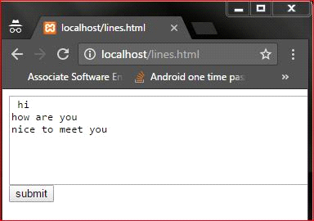

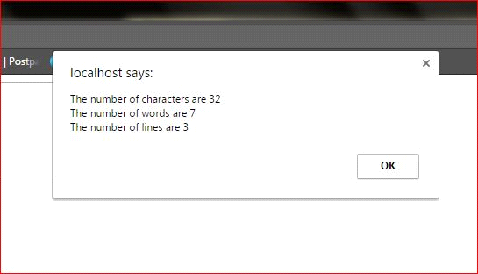
PRE LAB VIVA QUESTIONS:
1. How to create the HTML document?
2. How to create the text area in an HTML document?
3. How to create the submit button in an HTML document?
4. How to create function in an HTML document?
POST LAB VIVA QUESTIONS:
1. What is the purpose of str.split(' ')?
2. What is the purpose of str.split('\n')?
3. How to find the length of the array?
4. How to create the alert message?

EXPERIMENT-3
OBJECTIVE:
To print the capital of country from HTML page that contains a selection box with a list of 5 countries. When the user selects a country, its capital should be printed next to the list. Add CSS to customize the properties of the font of the capital (color, bold and font size)
PROGRAM LOGIC:
1.Create an HTML file from which select the country from the selection box.
2.Once the user selects the country it should display the selected country’s capital.
3.Include the JavaScript display the capital for selected country.
4.Create the CSS file which includes the properties like color, bold and font size.
PROCEDURE:
To execute a PHP program:
1.Open XAMPP control Panel then start Apache Server and Mysql.
2.Open Notepad++ and Save the php program in htdocs folder of XAMPP.
3.To run the php file open the browser and type the following URL localhost:3306/directory name/filename
SOURCE CODE:
<html>
<title>Fourth Program</title>
<head>
<script type="text/JavaScript">
function OnDropDownChange(dropDown)
{
var selectedValue = dropDown.options[dropDown.selectedIndex].value;
document.getElementById("txtSelectedCapital").innerHTML = selectedValue;
}
</script>
</head>
<body>
95 | P a g e
<form action = "">
<select name = "Countries" onChange="OnDropDownChange(this);">
<option value="">--Select a country--</option>
<option value="New Delhi">India</option>
<option value="Wellington">New Zealand</option>
<option value="Paris">France</option>
<option value="Athens">Greece</option>
<option value="Madrid">Spain</option>
</select>
<h1 style="color:blue;font-family:verdana;font-size:300%;" id="txtSelectedCapital"
type="text"></h1>
</form>
</body>
</html>
OUTPUT
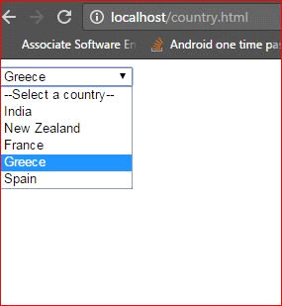

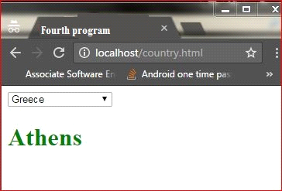
PRE LAB VIVA QUESTIONS:
1. How do you insert a comment in html?
2. What are some of the common lists that can be used when designing a page?
3. How do you create links to sections within the same page?
4. Does a hyperlink apply to text only?

POST LAB VIVA QUESTIONS:
1. If the user’s operating system does not support the needed character, how can the symbol be represented?
2. How do you change the number type in the middle of a list?
3. Is it possible to set specific colors for table borders?
4. How do you create a link that will connect to another web page when clicked?
EXPERIMENT-4
OBJECTIVE:
To write a program that parses an XML document using DOM and SAX parsers.
PROGRAM LOGIC:
1.Create a .xml file that has to be parsed.
2.Using DOM parser
a.Get a document builder using document builder factory and parse the xml file to create a DOM object
b.Get a list of User elements from the DOM
c.For each User element id get the name, age and qualification.
3.Using SAX Parser
a.Create a Sax parser and parse the xml
b.In the event handler create the User object
c.Print out the data
PROCEDURE:
To execute a java program we require setting a class path: 1.C:\set path= C:\Program Files\Java\jdk1.6.0\bin;.; 2.C:\javac Parse.java
C:\java Parse
SOURCE CODE:
DOM:
Student.xml:
<company>
<staff id="101">
<firstname>john</firstname>
<lastname>girisham</lastname>
<salary>27000</salary>
</staff>

<staff id="102">
<firstname>suvi</firstname>
<lastname>sharma</lastname>
<salary>25000</salary>
</staff>

<staff id="103">
<firstname>john</firstname>
<lastname>green</lastname>
<salary>600000</salary>
</staff>
<staff id="104">
<firstname>robert</firstname>
<lastname>davidson</lastname>
<salary>50000</salary>
</staff>
<staff id="105">
<firstname>ravindra</firstname>
<lastname>singh</lastname>
<salary>40000</salary>
</staff>
</company>
Parse.java
import java.io.File;
import javax.xml.parsers.*;

import org.w3c.dom.*;

public class dom
{
public static void main(String[] args)
{

try {
File fXmlFile = new File("file:///C:/Users/wt programs/Student.xml");
DocumentBuilderFactory dbFactory
= DocumentBuilderFactory.newInstance();
DocumentBuilder dBuilder = dbFactory.newDocumentBuilder();
Document doc = dBuilder.parse( fXmlFile);
doc.getDocumentElement().normalize();
System.out.println("Root element :" +doc.getDocumentElement().getNodeName());
NodeList nList = doc.getElementsByTagName("staff");
System.out.println("----------------------------");
for (int temp = 0; temp < nList.getLength(); temp++)
{
Node nNode = nList.item(temp);
System.out.println("\nCurrent Element :" + nNode.getNodeName());
if (nNode.getNodeType() == Node.ELEMENT_NODE)
{
Element eElement = (Element) nNode;
System.out.println("staff id : " + eElement.getAttribute("id"));
System.out.println("First Name : " + eElement.getElementsByTagName("firstname")
.item(0).getTextContent());
System.out.println("Last Name : "+ eElement.getElementsByTagName("lastname")
.item(0).getTextContent());
System.out.println("Nick Name : " + eElement.getElementsByTagName("nickname")
.item(0).getTextContent());
System.out.println("salary : " + eElement.getElementsByTagName("salary")
.item(0).getTextContent());
}
}
} catch (Exception e) {
e.printStackTrace();
}
}
}
OUTPUT
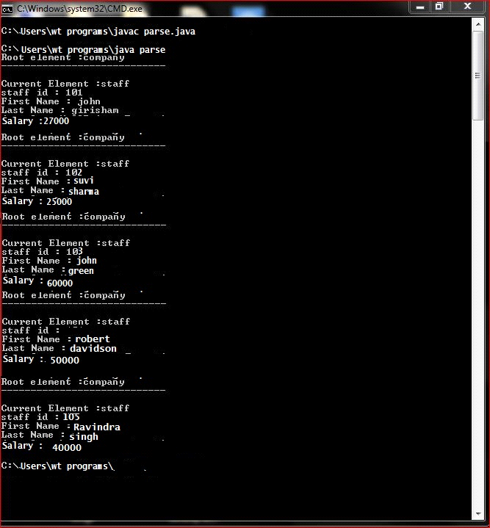

SAX:
EmployeeDetail.xml:
<company>
<staff id="101">
<firstname>john</firstname>
<lastname>girisham</lastname>
<salary>27000</salary>
</staff>

<staff id="102">
<firstname>suvi</firstname>
<lastname>sharma</lastname>
<salary>25000</salary>
</staff>

<staff id="103">
<firstname>john</firstname>
<lastname>green</lastname>
<salary>600000</salary>
</staff>
<staff id="104">
<firstname>robert</firstname>
<lastname>davidson</lastname>
<salary>50000</salary>
</staff>
<staff id="105">
<firstname>ravindra</firstname>
<lastname>singh</lastname>
<salary>40000</salary>
</staff>
</company>
SAXParserCheck.java:
import javax.xml.parsers.SAXParser;
import javax.xml.parsers.SAXParserFactory;
import org.xml.sax.Attributes;
import org.xml.sax.SAXException;
import org.xml.sax.helpers.DefaultHandler;
public class ReadXMLFilesax
{
public static void main(String argv[]){
try
{
SAXParserFactory factory=SAXParserFactory.newInstance();
SAXParser saxParser=factory.newSAXParser();
DefaultHandler handler=new DefaultHandler()
{
boolean bfname = false;
boolean blname = false;
boolean bnname = false;
boolean bsalary = false;

public void startElement(String uri, String localName, String qname, Attributes attributes)
throws SAXException {
System.out.println("Start Element:"+qname);
if (qname.equalsIgnoreCase("FIRSTNAME"))
{
bfname=true;
}
if (qname.equalsIgnoreCase("LASTNAME"))
{
blname=true;
}
if (qname.equalsIgnoreCase("NICKNAME"))
{
bnname=true;
}
if (qname.equalsIgnoreCase("SALARY"))
{
bsalary=true;
}
}

public void endElement(String uri, String localName, String qName) throws SAXException {

System.out.println("End Element :" + qName);
}

public void characters(char ch[], int start, int length) throws SAXException {
if (bfname)
{
System.out.println("First Name: " + new String(ch, start, length));
bfname = false;
}
if (blname)
{
System.out.println("Last Name: " + new String(ch, start, length));
blname = false;
}
if (bnname)
{
System.out.println("Nick Name: " + new String(ch, start, length));
bnname = false;
}

if (bsalary)
{
System.out.println("salary: " + new String(ch, start, length));
bsalary = false;
}
}
};
saxParser.parse("file:///C:/Users/wt programs/EmployeeDetail.xml",handler);
}
catch(Exception e)
{
e.printStackTrace();
}
}
}
OUTPUT
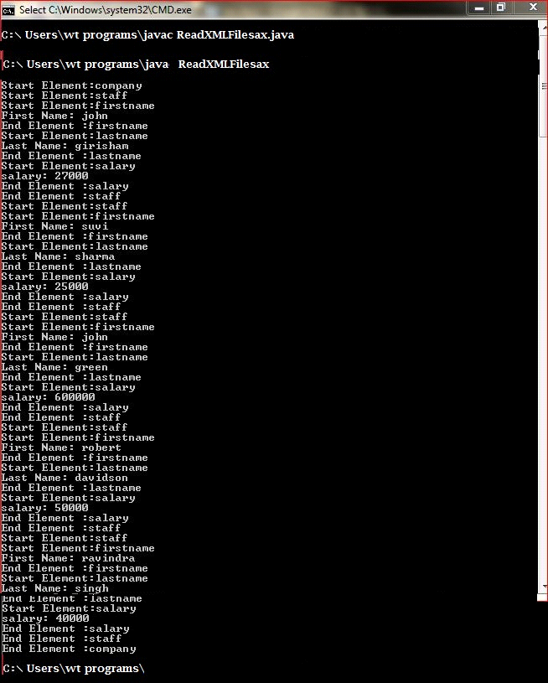

PRE LAB VIVA QUESTIONS:
1. Is Java purely object oriented language?
2. How to create an object in java language?
3. How to display the string in java language?
4. What is the purpose of java.io.* package?
POST LAB VIVA QUESTIONS:
1. How to handle the exceptions in java?
2. How to catch exceptions using java language?
3. How to read the XML file using java language?
4. How many types of parsers we have in XML?

EXPERIMENT-5
OBJECTIVE:
To validate the user login using PHP and database.
PROGRAM LOGIC:
1.Create the user database and table along with the user name and password as the attributes.
2.Create an HTML File to retrieve user name and password.
3.Create PHP file to retrieve the data from the database and HTML File.
4.Authenticate the user name and password if it is the valid user the display as successful login otherwise display failure message.
PROCEDURE:
To execute a PHP program:
1.Open XAMPP control Panel then start Apache Server and Mysql.
2.Open Notepad and Save the php program in htdocs folder of XAMPP.
3.To run the php file open the browser and type the following URL
localhost:3306/directory name/filename
SOURCE CODE:
Login.html
<html>
<body>
<form enctype="multipart/form-data" action="database.php" method="post"> username:<input type="text" name="username"> <br>
password:<input type="password" name="password" maxlength="10"> <br> <input type="submit" name="submit">
</form>
</body>
</html>
database.php
<?php $name=$_REQUEST['username']; $pass=$_REQUEST['password']; $dbhost = 'localhost';
$dbuser = 'root'; $dbpass = 'root';
$conn = mysql_connect($dbhost, $dbuser, $dbpass); if(! $conn )
{
die('Could not connect: ' . mysql_error());
}
$sql = 'SELECT username, password FROM user_detail'; mysql_select_db('user_login');
$retval = mysql_query( $sql, $conn )

if(! $retval )
{
die('Could not get data: ' . mysql_error());
}
while($row = mysql_fetch_array($retval, MYSQL_ASSOC))
{
if($name==$row['username'] && $pass==$row['password'])
{
echo("login sucesses"); return true;
}
else
{
echo("invalid username and paasword "); return false;
}
}
?>
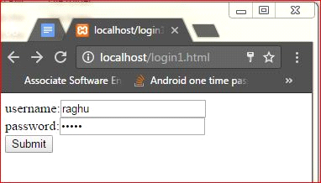
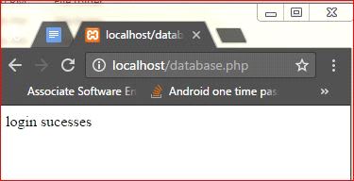
EXPERIMENT-6
OBJECTIVE:
To validate the user login using PHP and XML.
PROGRAM LOGIC:
1.Create the XML file with the tags user name and password.
2.Create an HTML File to retrieve user name and password.
3.Create PHP file to retrieve the data from the XML and HTML File.
4.Authenticate the user name and password if it is the valid user the display as successful login otherwise display failure message.
PROCEDURE:
To execute a PHP program:
1.Open XAMPP control Panel then start Apache Server and Mysql.
2.Open Notepad and Save the php program in htdocs folder of XAMPP.
3.To run the php file open the browser and type the following URL localhost:3306/directory name/filename
SOURCE CODE:
Login.html
<html>
<body>
<form action="database.php" method="post"> username:<input type="text" name="username"> <br>
password:<input type="password" name="password" maxlength="10"> <br> <input type="submit" name="submit"> </form>
</body>
</html>
Database.php
<?php
$name=$_REQUEST['username']; $pass=$_REQUEST['password']; $file=”file.xml”; $xml=simplexml_load_file($file);
If($name==$xml->username && $pass==$xml->password)
{
echo("login sucesses"); return true;
}
Else
{
echo("invalid username and paasword "); return false;
}
?>
File.xml
<?xml version=”1.0”?>
<user-detail> <username>raghu</username>
<password>siet</password>
</user-detail>
OUTPUT

EXPERIMENT-7
OBJECTIVE:
To develop simple calculator web application that takes two numbers and operator from an HTML page and returns the result page with operation performed on operands.
PROGRAM LOGIC:
1.Create an HTML file to read two variables and operator.
2.Create an PHP file to compute the arithmetic operation.
3.Dispaly the result.
PROCEDURE:
To execute a PHP program:
1.Open XAMPP control Panel then start Apache Server and Mysql.
2.Open Notepad and Save the php program in htdocs folder of XAMPP.
3.To run the php file open the browser and type the following URL localhost:90/directory name/filename
SOURCE CODE:
cal.html
<html>
<body>
<form method="POST" action="process.php">
NO1:<input type="text" name="num1" id="num1"> <br>
NO2:<input type="text" name="num2" id="num2"> <br>
<select name = "func">
<option value="+">Add [+]</option> <option value="-">Subtract[-]</option> <option value="*">Multiple[*]</option> <option value="/">Divide[/]</option>
<option value=”%”>modulus</option>
</select>
<input type="submit" name="submit" value="Submit" >
</form
</body>
</html>
Process.php
<?php
$num1 = ($_POST['num1']); $num2 = ($_POST['num2']); $func= ($_POST['func']);
if(is_numeric($num1) &&is_numeric($num2) )
{
if($func != null)
{
switch($func)
{
case "+" :
$result= $num1 + $num2; break;
case "-" :
$result= $num1 - $num2; break;
case "*" :
$result= $num1 * $num2; break;
case "/" :
$result= $num1 / $num2; break;
case "%" :
$result= $num1 % $num2; break;
}
echo("calculation result: ". $result);
}
}
?>
OUTPUT
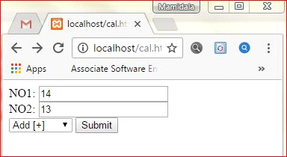
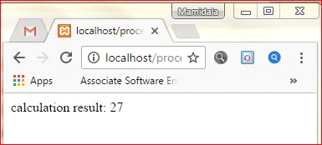
EXPERIMENT-8
OBJECTIVE:
To validate age attribute, if age is less than 18 then display a message the user is not authorized to visit this site otherwise a welcome message should be displayed using PHP.
PROGRAM LOGIC:
1.Create an HTML file to read the age and username.
2.Create a PHP file to check the user age.
3.If age>18 then display a message, welcome to the site otherwise display not authorized to this site.
PROCEDURE:
To execute a PHP program:
1.Open XAMPP control Panel then start Apache Server and Mysql.
2.Open Notepad and Save the php program in htdocs folder of XAMPP.
3.To run the php file open the browser and type the following URL localhost:3306/directory name/filename
SOURCE CODE:
Login.html
<html>
<body>
<form action="age.php" method="post"> username:<input type="text" name="username"> <br>
password:<input type="number" name="age" maxlength="10"> <br> <input type="submit" name="submit">
</form>
</body>
</html>
Age.php
<?php
$name=$_REQUEST['username']; $age=$_REQUEST['age']; if($age<=18)
{
echo("hello!".$name.".not authorized to visit this site");
}
else
{
echo("hello!".$name.".welcome to this site");
}
?>
OUTPUT
