Opening the Black Box on Intl Aid Data Section

Jack Hasler

August 3, 2018

So this is the document for preparing and presenting results. Moving things over from various other files. The goal of this is to be a working document that can eventually become an appendix to the paper. We’ll pull our main models from here and keep the others as robustness checks.

Importing the libraries that we’ll need for all of the following projects.

Gonna break this into three big sections for now. (1) Analysis by Recipient (target?) country, (2) Analysis by donor-recipient dyad, and (3) Subnational analysis. If there are not some descriptive statistics in every section, there should be!

## Analysis by Recipient-Year

## Analysis by Dyad-Year

# Lagged VDEM

# Main Results

Dependent variable:   
 -------------------------------------------  
 Electoral Liberal Participatory PolityIV

|  |
| --- |
| Donor Gov 0.005 0.008 0.007 0.003 (0.009) (0.008) (0.007) (0.009) |
| Target Gov 0.006 0.013 0.005 0.017* (0.010) (0.009) (0.008) (0.010) |
| NGO 0.035*** 0.025*** 0.038*** 0.048*** (0.009) (0.008) (0.007) (0.009) |
| IGO 0.017** 0.011 0.011 0.045*** (0.009) (0.008) (0.007) (0.009) |
| Corporation 0.035 0.041* 0.036* 0.054** (0.024) (0.021) (0.020) (0.024) |
| Other 0.038*** 0.033*** 0.029*** 0.031*** (0.008) (0.008) (0.007) (0.009) |
| log(GDP) 0.154*** 0.088*** 0.092*** 0.066*** (0.013) (0.012) (0.011) (0.013) |
| Urban -0.018*** -0.015*** -0.018*** -0.009*** (0.002) (0.002) (0.002) (0.002) |
| log(Population) 0.125** 0.238*** 0.244*** 0.445*** (0.055) (0.050) (0.046) (0.055) |

Observations 15,798 15,798 15,798 15,798  
R2 0.017 0.011 0.016 0.020  
Adjusted R2 -0.150 -0.157 -0.151 -0.147  
F Statistic (df = 9; 13504) 25.668*** 17.099*** 23.887*** 30.172 ***======================================================================= Note:* p<0.1;** p<0.05; ***p<0.01

% Table created by stargazer v.5.2.2 by Marek Hlavac, Harvard University. E-mail: hlavac at fas.harvard.edu % Date and time: Tue, Jan 22, 2019 - 5:25:38 PM

% Table created by stargazer v.5.2.2 by Marek Hlavac, Harvard University. E-mail: hlavac at fas.harvard.edu % Date and time: Tue, Jan 22, 2019 - 5:25:38 PM

% Table created by stargazer v.5.2.2 by Marek Hlavac, Harvard University. E-mail: hlavac at fas.harvard.edu % Date and time: Tue, Jan 22, 2019 - 5:25:38 PM

% Table created by stargazer v.5.2.2 by Marek Hlavac, Harvard University. E-mail: hlavac at fas.harvard.edu % Date and time: Tue, Jan 22, 2019 - 5:25:38 PM

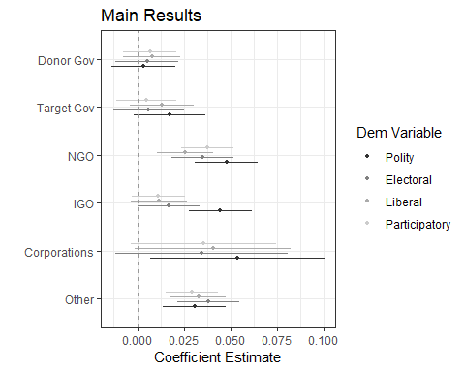

## [1] 0.9575306

## [1] 0.9606852

## [1] 0.9356202

## [1] 0.9159951

save(working, file = './working_9_4.RData')

## Subnational Stuff