YUVA INTERNSHIP PROGRAM | TASK 3
Hands-On Data Lab Implementation
Python environment setup, data manipulation, visualization and basic analysis
Detail | Information
Intern name | Sonu kumar
Task | Task 3: Hands-On Data Lab Implementation
Date of submission | 24 October 2026
Tools used | Python 3, Jupyter Notebook, pandas, NumPy, Matplotlib, Seaborn, SciPy

1. Objective
The aim of this task is to build a working data analysis environment and to use it to complete practical exercises. The task has two parts:
- Set up a data science environment with Python, Jupyter and the required libraries.
- Complete practical exercises in data manipulation, visualization and basic analysis.
This report documents every step: how the environment was set up, the dataset used, the code of each exercise, the real output produced by that code, the charts, and what was learned from them.

2. Tools and Technologies
Tool | Purpose | Version used
Python | Programming language used for all the work | 3.12.3
Jupyter Notebook | Interactive environment to write code, see output and charts together | Notebook 7+
pandas | Loading, cleaning, grouping and summarising tabular data | 3.0.2
NumPy | Fast numerical arrays and random number generation | 2.4.4
Matplotlib | Base library for drawing charts | 3.10.8
Seaborn | Statistical charts (histogram, heatmap, regression plot) | 0.13.2
SciPy | Statistical tests: correlation, t-test, linear regression | 1.17.1
Note: the library versions shown are the ones used when the outputs in this report were produced. Newer or older versions will work, but a few lines of printed output (for example the df.info() header) may look slightly different.

3. Environment Setup

Step 1: Install Python
Download Python 3.10 or newer from python.org. On Windows, tick the option "Add Python to PATH" in the installer. Then check the installation in a terminal (Command Prompt, PowerShell or Terminal):
python --version
pip --version

Step 2: Create a project folder and virtual environment
A virtual environment keeps the libraries of this project separate from the rest of the system.
mkdir data_lab
cd data_lab
python -m venv venv

# activate it
# Windows : venv\Scripts\activate
# Mac/Linux: source venv/bin/activate

Step 3: Install the required libraries
Copy the file requirements.txt (submitted with this report) into the project folder and run:
python -m pip install --upgrade pip
pip install -r requirements.txt

Without the file, the same result is obtained with:
pip install pandas numpy matplotlib seaborn scipy jupyter notebook

Step 4: Start Jupyter Notebook
jupyter notebook

The browser opens the Jupyter dashboard. Open the submitted file Task3_Data_Lab.ipynb, or choose New > Python 3 (ipykernel) to start a blank notebook. Run cells with Shift + Enter, or use Kernel > Restart & Run All to run the whole notebook.

Step 5: Verify the installation
The first cell of the notebook imports every library and prints its version. If this cell runs without an error, the environment is ready.
Code
import os
import platform
import pandas as pd
import numpy as np
import matplotlib
import matplotlib.pyplot as plt
import seaborn as sns
from scipy import stats

os.makedirs("charts", exist_ok=True)
sns.set_theme(style="whitegrid")
pd.set_option("display.width", 95)
pd.set_option("display.max_columns", 20)

print("Python :", platform.python_version())
print("pandas :", pd.__version__)
print("numpy :", np.__version__)
print("matplotlib :", matplotlib.__version__)
print("seaborn :", sns.__version__)

Output
Python : 3.12.3
pandas : 3.0.2
numpy : 2.4.4
matplotlib : 3.10.8
seaborn : 0.13.2

Alternative: if installing on a local machine is not possible, the same notebook runs without any setup on Google Colab (colab.research.google.com) or inside Anaconda, which already ships with all these libraries.

Common problems and fixes
Problem | Fix
"python" or "pip" is not recognized | Python was installed without "Add to PATH". Re-run the installer and tick that option, or use "py" instead of "python" on Windows.
ModuleNotFoundError: No module named ... | The library is not installed in the active environment. Activate the virtual environment and run pip install <library>.
"jupyter" is not recognized | Run python -m notebook, or install it with pip install notebook.
Notebook kernel does not start | Run python -m pip install ipykernel, then restart Jupyter.
Charts do not show in the notebook | Add %matplotlib inline at the top of the first cell.

4. Dataset Used
A practice dataset of an online store (sales_data.csv) was created with Python and NumPy using a fixed random seed (42), so the same data and the same results are obtained every time the notebook is run. It contains 1,000 orders placed during 2025. To make the cleaning exercise realistic, 20 duplicate rows and some missing values were added on purpose, so the raw file has 1,020 rows and 11 columns.
Column | Type | Description
order_id | int | Unique order number
order_date | datetime | Date of the order (2025)
region | text | North, South, East or West (2% missing)
category | text | Electronics, Clothing, Home & Kitchen or Books
product | text | Product sold (16 different products)
quantity | int | Units ordered (1 to 5)
unit_price | int | Price per unit in rupees
discount | float | Discount given: 0, 5, 10, 15 or 20 percent (as a fraction)
customer_age | float | Age of customer, 18 to 65 (4% missing)
payment_mode | text | UPI, Credit Card, Debit Card, Cash on Delivery or Net Banking
rating | float | Customer rating from 1 to 5 (5% missing)
Columns created later during the exercises: revenue, month and age_group.
Note: the data is generated for practice, so the findings below demonstrate the techniques and should not be read as real business facts. The same code works on any real CSV file (for example a Kaggle dataset) by changing the file name and column names.

Creating the dataset
Code
rng = np.random.default_rng(42)
n = 1000

catalog = {
"Electronics": {"Headphones": 1500, "Smartwatch": 4500, "Power Bank": 1200, "Bluetooth Speaker": 2500},
"Clothing": {"T-Shirt": 600, "Jeans": 1800, "Jacket": 3200, "Kurta": 1400},
"Home & Kitchen": {"Mixer Grinder": 3500, "Cookware Set": 2800, "Water Bottle": 450, "Bedsheet": 1100},
"Books": {"Novel": 350, "Self-Help": 450, "Textbook": 900, "Comics": 250},
}
categories = rng.choice(list(catalog), size=n, p=[0.30, 0.28, 0.24, 0.18])
products = [rng.choice(list(catalog[c])) for c in categories]
unit_price = [catalog[c][p] for c, p in zip(categories, products)]

# more orders in the festive months (Oct-Nov)
month_probs = np.array([6, 6, 7, 7, 7, 7, 7, 8, 8, 13, 12, 12], dtype=float)
month_probs /= month_probs.sum()
months = rng.choice(np.arange(1, 13), size=n, p=month_probs)
days = rng.integers(1, 29, size=n)
order_date = pd.to_datetime(pd.DataFrame({"year": 2025, "month": months, "day": days}))

discount = rng.choice([0, 0.05, 0.10, 0.15, 0.20], size=n, p=[0.35, 0.20, 0.20, 0.15, 0.10])
rating = np.clip(np.round(3.4 + 4 * discount + rng.normal(0, 0.9, n)), 1, 5)

raw = pd.DataFrame({
"order_id": np.arange(1001, 1001 + n),
"order_date": order_date,
"region": rng.choice(["North", "South", "East", "West"], size=n, p=[0.30, 0.27, 0.18, 0.25]),
"category": categories,
"product": products,
"quantity": rng.integers(1, 6, size=n),
"unit_price": unit_price,
"discount": discount,
"customer_age": np.clip(rng.normal(32, 9, n).round(), 18, 65),
"payment_mode": rng.choice(["UPI", "Credit Card", "Debit Card", "Cash on Delivery", "Net Banking"],
size=n, p=[0.38, 0.20, 0.18, 0.15, 0.09]),
"rating": rating,
})

# add missing values and duplicate rows on purpose
for col, frac in [("customer_age", 0.04), ("rating", 0.05), ("region", 0.02)]:
raw.loc[rng.choice(n, int(n * frac), replace=False), col] = np.nan
raw = pd.concat([raw, raw.sample(20, random_state=1)], ignore_index=True)

raw.to_csv("sales_data.csv", index=False)
print("sales_data.csv saved with", raw.shape[0], "rows and", raw.shape[1], "columns")

Output
sales_data.csv saved with 1020 rows and 11 columns

5. Practical Exercises

Exercise 1: Load and inspect the data
Aim: Load the CSV file into a pandas DataFrame and understand its size, columns, data types, missing values and duplicates before doing anything else.
Code
df = pd.read_csv("sales_data.csv", parse_dates=["order_date"])

print("Shape (rows, columns):", df.shape)
print()
print(df.head())
print()
df.info()
print()
print("Missing values per column:")
print(df.isna().sum())
print()
print("Duplicate rows:", df.duplicated().sum())

Output
Shape (rows, columns): (1020, 11)

order_id order_date region category product quantity unit_price \
0 1001 2025-10-06 North Home & Kitchen Bedsheet 2 1100
1 1002 2025-12-01 North Clothing T-Shirt 1 600
2 1003 2025-06-18 West Books Self-Help 3 450
3 1004 2025-07-20 North Home & Kitchen Cookware Set 2 2800
4 1005 2025-11-22 South Electronics Bluetooth Speaker 1 2500

discount customer_age payment_mode rating
0 0.15 27.0 UPI 3.0
1 0.10 29.0 Cash on Delivery 2.0
2 0.00 47.0 Debit Card 5.0
3 0.10 23.0 UPI 5.0
4 0.00 24.0 UPI 3.0

<class 'pandas.DataFrame'>
RangeIndex: 1020 entries, 0 to 1019
Data columns (total 11 columns):
# Column Non-Null Count Dtype
--- ------ -------------- -----
0 order_id 1020 non-null int64
1 order_date 1020 non-null datetime64[us]
2 region 1000 non-null str
3 category 1020 non-null str
4 product 1020 non-null str
5 quantity 1020 non-null int64
6 unit_price 1020 non-null int64
7 discount 1020 non-null float64
8 customer_age 980 non-null float64
9 payment_mode 1020 non-null str
10 rating 968 non-null float64
dtypes: datetime64[us](1), float64(3), int64(3), str(4)
memory usage: 87.8 KB

Missing values per column:
order_id 0
order_date 0
region 20
category 0
product 0
quantity 0
unit_price 0
discount 0
customer_age 40
payment_mode 0
rating 52
dtype: int64

Duplicate rows: 20

Observation
- The raw file has 1,020 rows and 11 columns.
- Missing values were found in 3 columns: rating (52), customer_age (40) and region (20).
- 20 rows were exact duplicates of other rows.
- customer_age and rating were read as float only because of the missing values; they should be whole numbers.

Exercise 2: Data cleaning
Aim: Remove duplicates, handle missing values and correct data types so that the data is reliable for analysis.
Code
print("Rows before cleaning:", len(df))

# 1) remove duplicate rows
df = df.drop_duplicates()
print("Rows after removing duplicates:", len(df))

# 2) handle missing values
df["customer_age"] = df["customer_age"].fillna(df["customer_age"].median()) # numeric -> median
df["rating"] = df["rating"].fillna(df["rating"].median()) # numeric -> median
df["region"] = df["region"].fillna("Unknown") # text -> label

# 3) fix data types
df["customer_age"] = df["customer_age"].astype(int)
df["rating"] = df["rating"].astype(int)

print("Missing values left:", int(df.isna().sum().sum()))
print()
print(df.dtypes)

Output
Rows before cleaning: 1020
Rows after removing duplicates: 1000
Missing values left: 0

order_id int64
order_date datetime64[us]
region str
category str
product str
quantity int64
unit_price int64
discount float64
customer_age int64
payment_mode str
rating int64
dtype: object

Observation
- Removing the 20 duplicates brought the data back to the intended 1,000 orders.
- Missing customer_age and rating were filled with the median, which is not affected by extreme values. Missing region was labelled "Unknown" instead of guessing a region.
- After conversion to int, there are no missing values left (0) and every column has a suitable data type.

Exercise 3: Data manipulation
Aim: Practise the core pandas operations: creating new columns, filtering rows, group-by aggregation, pivot tables, sorting and binning.
Code
# New columns (feature engineering)
df["revenue"] = df["quantity"] * df["unit_price"] * (1 - df["discount"])
df["month"] = df["order_date"].dt.month
df["age_group"] = pd.cut(df["customer_age"], bins=[17, 25, 35, 45, 65],
labels=["18-25", "26-35", "36-45", "46-65"])
print(df[["order_id", "category", "quantity", "unit_price", "discount", "revenue"]].head())

# Filtering
high_value = df[df["revenue"] > 10000]
print("\nHigh-value orders (revenue > 10,000):", len(high_value))

# Group by + aggregation
cat_summary = (df.groupby("category")
.agg(orders=("order_id", "count"),
total_revenue=("revenue", "sum"),
avg_revenue=("revenue", "mean"),
avg_rating=("rating", "mean"))
.round(2)
.sort_values("total_revenue", ascending=False))
print("\nCategory summary:")
print(cat_summary)

# Pivot table: region x category
pivot = df.pivot_table(index="region", columns="category", values="revenue", aggfunc="sum").round(0)
print("\nRevenue by region and category:")
print(pivot)

# Top 5 products and average revenue per age group
print("\nTop 5 products by revenue:")
print(df.groupby("product")["revenue"].sum().nlargest(5).round(0))
print("\nAverage order value by age group:")
print(df.groupby("age_group", observed=True)["revenue"].mean().round(2))

Output
order_id category quantity unit_price discount revenue
0 1001 Home & Kitchen 2 1100 0.15 1870.0
1 1002 Clothing 1 600 0.10 540.0
2 1003 Books 3 450 0.00 1350.0
3 1004 Home & Kitchen 2 2800 0.10 5040.0
4 1005 Electronics 1 2500 0.00 2500.0

High-value orders (revenue > 10,000): 147

Category summary:
orders total_revenue avg_revenue avg_rating
category
Electronics 308 2173735.0 7057.58 3.64
Home & Kitchen 244 1319670.0 5408.48 3.62
Clothing 268 1253270.0 4676.38 3.63
Books 180 223670.0 1242.61 3.69

Revenue by region and category:
category Books Clothing Electronics Home & Kitchen
region
East 26042.0 162960.0 423015.0 249330.0
North 65615.0 411690.0 640690.0 436458.0
South 58058.0 358370.0 533380.0 355805.0
Unknown 3578.0 50710.0 26490.0 12600.0
West 70378.0 269540.0 550160.0 265478.0

Top 5 products by revenue:
product
Smartwatch 1111725.0
Jacket 621920.0
Mixer Grinder 553700.0
Bluetooth Speaker 538750.0
Cookware Set 537180.0
Name: revenue, dtype: float64

Average order value by age group:
age_group
18-25 5123.21
26-35 5047.95
36-45 4998.55
46-65 3942.26
Name: revenue, dtype: float64

Observation
- A new column revenue = quantity x unit_price x (1 - discount) gives the actual amount earned per order.
- 147 of the 1,000 orders (14.7%) are high-value orders above Rs 10,000.
- Electronics earns the most (Rs 21.7 lakh, about 44% of total revenue) while Books earns the least (Rs 2.2 lakh, about 4.5%), although average ratings are almost equal in all categories (3.6 to 3.7).
- North is the strongest region and Smartwatch is the best product, with Rs 11.1 lakh from a single product.
- Customers aged 46 to 65 spend less per order (about Rs 3,942) than the younger groups (about Rs 5,000).

Exercise 4: Data visualization
Aim: Turn the summarised tables into charts that make patterns easy to see. Four chart types were used: bar chart, line chart, histogram and heatmap.

Chart 1: Total revenue by category (bar chart)
Code
fig, ax = plt.subplots(figsize=(7, 4))
cat_summary["total_revenue"].plot(kind="bar", ax=ax, color=sns.color_palette("viridis", 4))
ax.set_title("Total Revenue by Category")
ax.set_ylabel("Revenue (₹)")
ax.set_xlabel("")
plt.xticks(rotation=0)
plt.tight_layout()
plt.savefig("charts/01_revenue_by_category.png", dpi=150)
plt.show()

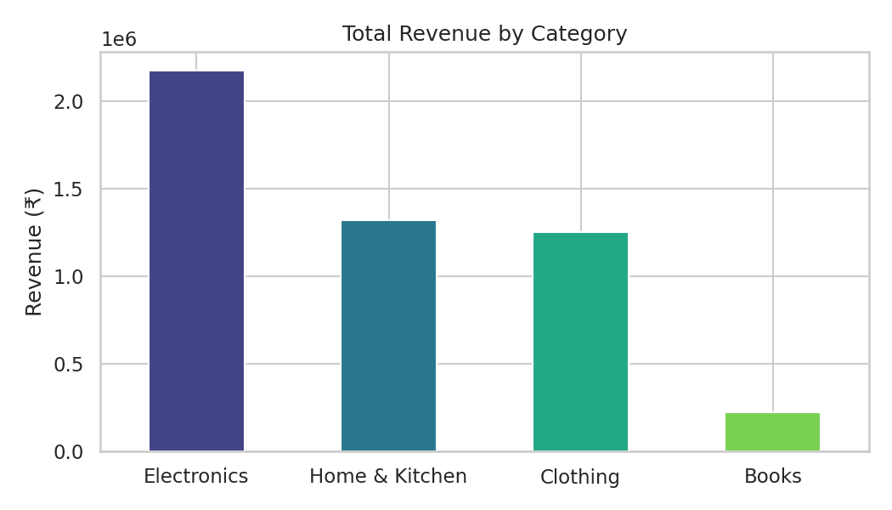
Figure 1: Total revenue by category
Observation
- Electronics is far ahead of every other category. Home & Kitchen and Clothing are close to each other, and Books is a small share.

Chart 2: Monthly revenue trend (line chart)
Code
monthly = df.groupby("month")["revenue"].sum()
labels = ["Jan", "Feb", "Mar", "Apr", "May", "Jun", "Jul", "Aug", "Sep", "Oct", "Nov", "Dec"]

fig, ax = plt.subplots(figsize=(8, 4))
ax.plot(monthly.index, monthly.values, marker="o", linewidth=2, color="#1F4E79")
ax.set_xticks(range(1, 13))
ax.set_xticklabels(labels)
ax.set_title("Monthly Revenue Trend (2025)")
ax.set_ylabel("Revenue (₹)")
plt.tight_layout()
plt.savefig("charts/02_monthly_revenue.png", dpi=150)
plt.show()

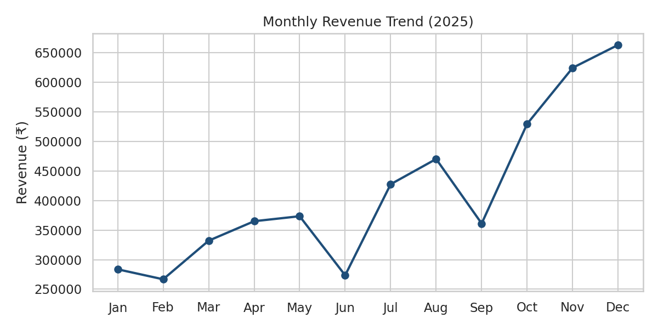
Figure 2: Monthly revenue trend, 2025
Observation
- Revenue grows through the year and rises sharply from October to December. These three months bring 36.6% of the yearly revenue, which matches the festive-season buying pattern.
- There are visible dips in June and September.

Chart 3: Customer age distribution (histogram)
Code
fig, ax = plt.subplots(figsize=(7, 4))
sns.histplot(df["customer_age"], bins=15, kde=True, color="#2E75B6", ax=ax)
ax.set_title("Customer Age Distribution")
ax.set_xlabel("Age (years)")
ax.set_ylabel("Number of orders")
plt.tight_layout()
plt.savefig("charts/03_age_distribution.png", dpi=150)
plt.show()

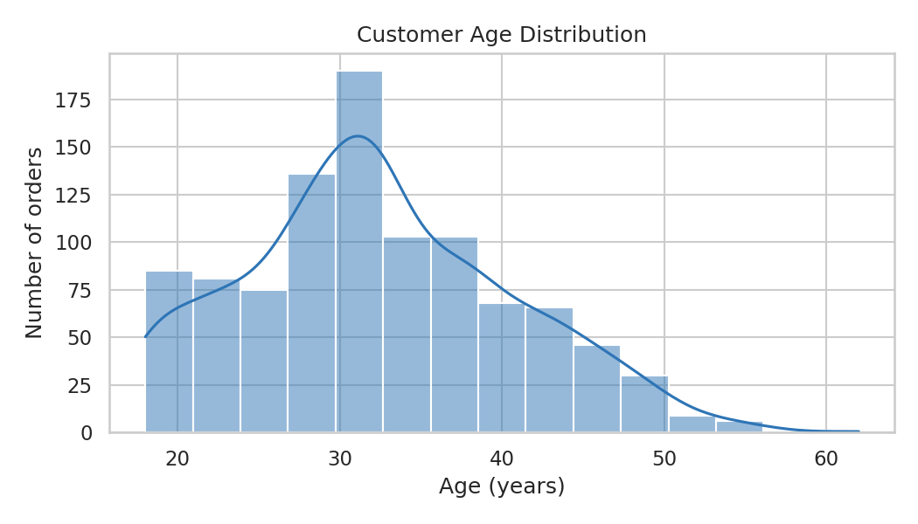
Figure 3: Customer age distribution
Observation
- Most customers are in their late twenties and thirties, with the peak near age 30 to 32. The distribution is right-skewed, meaning there are fewer older customers.

Chart 4: Region vs category revenue (heatmap)
Code
fig, ax = plt.subplots(figsize=(8, 4.5))
sns.heatmap(pivot, annot=True, fmt=".0f", cmap="YlGnBu", ax=ax)
ax.set_title("Revenue by Region and Category (₹)")
ax.set_xlabel("")
ax.set_ylabel("")
plt.tight_layout()
plt.savefig("charts/04_region_category_heatmap.png", dpi=150)
plt.show()

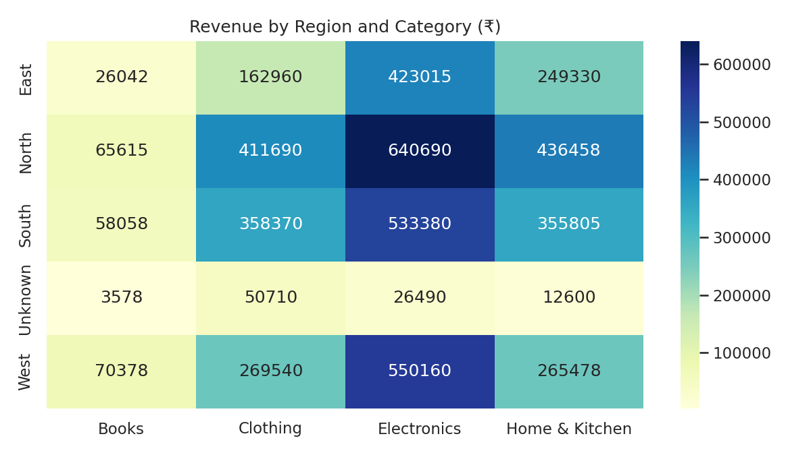
Figure 4: Revenue by region and category
Observation
- Electronics is the top category in every region, and the North-Electronics combination is the highest single cell (Rs 6.4 lakh).
- East is the weakest region in every category. The "Unknown" row is small because it only holds the orders with a missing region.

Exercise 5: Basic statistical analysis
Aim: Describe the data with summary statistics, measure relationships with correlation, test a simple hypothesis with a t-test and fit a simple linear regression line.
Code
# 1) Descriptive statistics of revenue
print("Revenue summary:")
print(df["revenue"].describe().round(2))
print("\nMedian revenue:", round(df["revenue"].median(), 2))
print("Skewness :", round(df["revenue"].skew(), 2))

# 2) Correlation matrix
num_cols = ["quantity", "unit_price", "discount", "customer_age", "rating", "revenue"]
print("\nCorrelation matrix:")
print(df[num_cols].corr().round(2))

# 3) Does a higher discount go with a better rating?
r, p = stats.pearsonr(df["discount"], df["rating"])
print(f"\nPearson correlation (discount vs rating): r = {r:.3f}, p-value = {p:.4g}")

high = df.loc[df["discount"] >= 0.10, "rating"]
low = df.loc[df["discount"] < 0.10, "rating"]
t, p2 = stats.ttest_ind(high, low, equal_var=False)
print(f"Average rating, discount >= 10%: {high.mean():.2f}")
print(f"Average rating, discount < 10%: {low.mean():.2f}")
print(f"Welch t-test: t = {t:.2f}, p-value = {p2:.4g}")

# 4) Simple linear regression
lr = stats.linregress(df["discount"], df["rating"])
print(f"\nRegression: rating = {lr.intercept:.2f} + {lr.slope:.2f} x discount (R-squared = {lr.rvalue**2:.3f})")

fig, ax = plt.subplots(figsize=(7, 4))
sns.regplot(data=df, x="discount", y="rating", x_jitter=0.01, y_jitter=0.15,
scatter_kws={"alpha": 0.25, "s": 18}, line_kws={"color": "#C00000"}, ax=ax)
ax.set_title("Discount vs Customer Rating")
ax.set_xlabel("Discount (fraction)")
ax.set_ylabel("Rating (1-5)")
plt.tight_layout()
plt.savefig("charts/05_discount_vs_rating.png", dpi=150)
plt.show()

Output
Revenue summary:
count 1000.00
mean 4970.34
std 4730.75
min 200.00
25% 1400.00
50% 3240.00
75% 6750.00
max 22500.00
Name: revenue, dtype: float64

Median revenue: 3240.0
Skewness : 1.46

Correlation matrix:
quantity unit_price discount customer_age rating revenue
quantity 1.00 0.02 0.04 -0.05 0.05 0.52
unit_price 0.02 1.00 -0.06 -0.04 -0.02 0.78
discount 0.04 -0.06 1.00 0.01 0.25 -0.12
customer_age -0.05 -0.04 0.01 1.00 -0.03 -0.03
rating 0.05 -0.02 0.25 -0.03 1.00 -0.01
revenue 0.52 0.78 -0.12 -0.03 -0.01 1.00

Pearson correlation (discount vs rating): r = 0.251, p-value = 7.232e-16
Average rating, discount >= 10%: 3.86
Average rating, discount < 10%: 3.47
Welch t-test: t = 7.10, p-value = 2.466e-12

Regression: rating = 3.41 + 3.27 x discount (R-squared = 0.063)

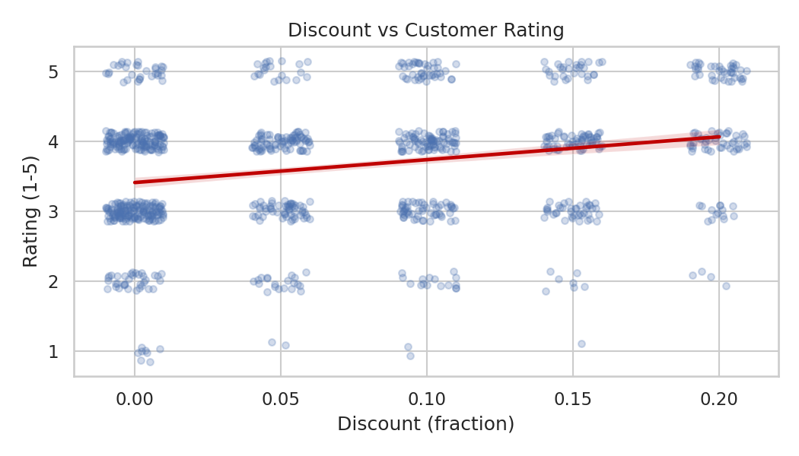
Figure 5: Discount vs customer rating with regression line
Observation
- The average order value is Rs 4,970 but the median is only Rs 3,240. With a skewness of 1.46, a few very large orders pull the mean up, so the median describes a typical order better.
- Revenue is strongly related to unit_price (r = 0.78) and moderately related to quantity (r = 0.52), which is expected because revenue is calculated from them.
- Discount and rating have a weak but real positive relationship (r = 0.25, p < 0.001). Customers who got a discount of 10% or more gave an average rating of 3.86 against 3.47 for the others, and the Welch t-test confirms this difference is statistically significant (p < 0.001).
- The regression line predicts that each extra 10% of discount raises the rating by about 0.33 points. However, R-squared is only 0.063, so discount explains about 6% of the variation in ratings and many other factors matter.
- Correlation does not prove cause: this result shows that the two move together, not that discounts alone create happier customers.

6. Key Findings
The last cell of the notebook prints a short summary calculated directly from the cleaned data:
Code
known = df[df["region"] != "Unknown"]
best_region = known.groupby("region")["revenue"].sum().idxmax()
pay_share = (df["payment_mode"].value_counts(normalize=True) * 100).round(1)

print("1. Top category :", cat_summary.index[0], "- Rs", f"{cat_summary['total_revenue'].iloc[0]:,.0f}")
print("2. Best month :", labels[monthly.idxmax() - 1], "- Rs", f"{monthly.max():,.0f}")
print("3. Top region :", best_region)
print("4. Most used payment :", pay_share.index[0], f"({pay_share.iloc[0]}% of orders)")
print("5. Average order : Rs", f"{df['revenue'].mean():,.0f}", "| Median: Rs", f"{df['revenue'].median():,.0f}")
print("6. Festive share :", f"{monthly.loc[[10, 11, 12]].sum() / monthly.sum() * 100:.1f}% of revenue came from Oct-Dec")

Output
1. Top category : Electronics - Rs 2,173,735
2. Best month : Dec - Rs 663,070
3. Top region : North
4. Most used payment : UPI (36.4% of orders)
5. Average order : Rs 4,970 | Median: Rs 3,240
6. Festive share : 36.6% of revenue came from Oct-Dec

- Electronics is the main revenue driver and Books contributes very little.
- Sales are strongly seasonal, with the highest revenue in the last quarter of the year.
- North is the top region, and UPI is the most used payment mode (36.4% of orders).
- Order values are right-skewed, so the median is a better measure of a typical order than the mean.
- Higher discounts are linked with slightly better ratings, but the effect is small.

7. Challenges and Learnings
- Dirty data is normal. Duplicates and missing values must be found and handled first, otherwise every later number is slightly wrong.
- Choice of fill value matters. The median is safer than the mean for skewed columns, and a label such as "Unknown" is more honest than a guess for text columns.
- Data types affect results. Columns that became float because of missing values had to be converted back to int after cleaning.
- Library versions differ. Newer pandas versions print slightly different output and give warnings in places such as groupby on categorical columns (solved here with observed=True).
- Charts must be chosen for the question. Bar charts for comparing categories, line charts for trends over time, histograms for distributions and heatmaps for two-way comparisons.
- Reproducibility. Using a fixed random seed and a requirements.txt file lets anyone repeat the lab and get identical results.

8. Conclusion
A complete data science environment was set up with Python, Jupyter and the required libraries, and verified by importing all of them. Using this environment, a dataset was loaded, inspected, cleaned and transformed with pandas; summarised with group-by and pivot tables; visualised with five charts; and analysed with descriptive statistics, correlation, a t-test and linear regression. The exercises gave hands-on practice with the standard workflow of a data analysis project, from raw data to insights, and the same workflow can now be applied to real datasets.

9. Files Submitted
File | Description
Task3_Data_Lab_Report.docx | This report
Task3_Data_Lab.ipynb | Jupyter notebook with all code, outputs and charts (run top to bottom)
sales_data.csv | Practice dataset used in the exercises (1,020 raw rows)
requirements.txt | List of libraries to install with pip install -r requirements.txt

