YUVA INTERNSHIP PROGRAM | TASK 3
Real-World Dataset Analysis Project
Breast Cancer Wisconsin (Diagnostic): selection, exploration, cleaning, exploratory analysis, visualization and insights
Detail | Information
Intern name | Sonu kumar
Project | Task 3: Real-World Dataset Analysis Project
Dataset | Breast Cancer Wisconsin (Diagnostic), 569 cases, 30 numeric features
Source | UCI Machine Learning Repository (doi: 10.24432/C5DW2B)
Tools used | Python 3, Jupyter Notebook, pandas, NumPy, SciPy, Matplotlib, Seaborn, scikit-learn
Date of submission | 24 October 2026

Summary of the Project
This project analyses a real clinical dataset in which each row describes the cell nuclei of one breast-mass sample, together with the final diagnosis (benign or malignant). The aim was to understand the data, prepare it properly, and find out which measurements best distinguish the two groups. The main results are:
- The dataset has 569 cases (357 benign, 212 malignant) and 30 measurements. It has no missing values and no duplicates; 171 rows (30.1%) contain statistical outliers, which were checked and kept because they are genuine large tumours.
- Malignant tumours are larger and more irregular: the average area is 978 against 463 for benign cases (2.1 times), and the concavity measures are about 3.4 to 3.5 times higher.
- The best single separators are concave_points_worst, perimeter_worst and concave_points_mean (Cohen's d from 2.5 to 2.7). 26 of the 30 features differ significantly between the groups even after a Bonferroni correction.
- Many features are almost duplicates of each other (radius, perimeter and area correlate at 0.99 or more), so the real amount of independent information is much smaller than 30 columns.
- A simple logistic regression reaches 93.2% cross-validated accuracy with only 3 features and 98.1% at best, against 62.7% for always guessing "benign". This shows the groups are very separable; it is not a clinical tool.

1. Project Objectives
The project follows the six objectives given in the task. The table shows where each one is covered in this report.
No. | Objective | Covered in
1 | Select a real-world dataset from a reliable source and understand its context, variables, objectives and expected outcomes | Section 2
2 | Explore the structure, data types, distributions, missing values, duplicates and relationships | Sections 4 and 5
3 | Clean and preprocess: missing values, duplicates, inconsistent data, data types and outliers | Section 6
4 | Exploratory data analysis with pandas, NumPy and statistical techniques | Section 7
5 | Create meaningful visualizations (bar, histogram, line, scatter, box plot and others) | Sections 6, 8 and 9
6 | Present insights, interpretations, conclusions and recommendations in a structured notebook and report | Sections 10 to 14, and the notebook

2. Dataset Selection and Context

2.1 Why this dataset was chosen
- Reliable source. It is published in the UCI Machine Learning Repository, one of the most widely used and cited public data archives, and was created by researchers at the University of Wisconsin.
- Real-world data. The measurements come from real fine needle aspirate (FNA) samples of breast masses, not from simulated numbers.
- Suitable for every required technique. It has numeric features with different scales and skewness, outliers, strongly correlated variables, and a clear two-group outcome, so distributions, box plots, correlations, group comparison and statistical tests are all meaningful.
- Manageable size. 569 rows and 30 features run in seconds on any laptop, so the whole analysis can be reproduced easily.

2.2 Source and background
To obtain the data, a small amount of fluid is taken from a breast lump with a thin needle (fine needle aspirate). The sample is photographed under a microscope, and image-analysis software outlines each cell nucleus and measures its shape. A doctor then gives the final diagnosis: benign (not cancer) or malignant (cancer). The dataset was donated to UCI in 1995 by Nick Street and was created by Dr. William H. Wolberg, W. Nick Street and Olvi L. Mangasarian. A copy of the same data is bundled with scikit-learn, which is how it is loaded in the notebook, so no internet download is needed.

2.3 Analytical context and questions
Early and correct diagnosis matters because it decides the treatment path, and a measurement-based method can support doctors by pointing to the features that matter most. The analysis tries to answer these questions:
- How are the two diagnosis groups distributed, and is the data balanced?
- Which nucleus measurements differ most between benign and malignant cases?
- Which measurements carry the same information (are redundant)?
- Do the outliers represent errors or real cases?
- How much of the diagnosis can be explained by a few simple measurements?

2.4 Variables
Ten basic measurements are computed for every nucleus in an image. For each of them the dataset stores three values, which gives 30 numeric features: the mean (suffix _mean), the standard error (_se) and the "worst" value, i.e. the mean of the three largest values (_worst). The last column is the diagnosis.
Measurement | Meaning
radius | Average distance from the centre of the nucleus to points on its boundary
texture | Standard deviation of gray-scale values (how uneven the nucleus looks)
perimeter | Length of the nucleus boundary
area | Area of the nucleus
smoothness | Local variation in radius lengths
compactness | Perimeter squared divided by area, minus 1
concavity | Severity of the concave (inward) parts of the boundary
concave_points | Number of concave parts of the boundary
symmetry | How symmetric the nucleus is
fractal_dimension | Complexity of the boundary ("coastline approximation" minus 1)
diagnosis | Target: Malignant or Benign

2.5 Expected outcomes
- Larger and more irregular nuclei (higher radius, area, concavity) are expected in malignant cases.
- Size-related features (radius, perimeter, area) are expected to be almost perfectly correlated with each other.
- A small group of features is expected to explain most of the difference between the two groups.

3. Methodology and Environment
Phase | What was done | Main tools
Load | Loaded the dataset, renamed columns, labelled the target | pandas, scikit-learn
Explore | Shape, data types, summary statistics, missing values, duplicates, class balance | pandas
Clean | Validity checks, data-type fixes, IQR outlier analysis with sensitivity test | pandas, NumPy, SciPy
Analyse | Group comparison, effect sizes, Mann-Whitney tests with Bonferroni correction, correlation, skewness | pandas, SciPy
Visualize | Bar chart, histograms, box plots, heatmap, scatter plot, line chart | Matplotlib, Seaborn
Interpret | Cross-validated logistic regression as a signal check, insights and recommendations | scikit-learn

Running the project
- Install Python 3.10 or newer (python.org) and open a terminal in a new folder.
- Create and activate a virtual environment: python -m venv venv, then venv\Scripts\activate (Windows) or source venv/bin/activate (Mac/Linux).
- Install the libraries: pip install -r requirements.txt
- Start Jupyter with jupyter notebook, open Real_World_Dataset_Analysis.ipynb and choose Kernel > Restart & Run All.
The first cell loads all libraries and prints their versions:
Code
import os
import platform
import numpy as np
import pandas as pd
import matplotlib
import matplotlib.pyplot as plt
import seaborn as sns
from scipy import stats

os.makedirs("charts", exist_ok=True)
sns.set_theme(style="whitegrid")
pd.set_option("display.width", 95)
pd.set_option("display.max_columns", 20)
PAL = {"Benign": "#2E75B6", "Malignant": "#C00000"}

print("Python :", platform.python_version())
print("pandas :", pd.__version__)
print("numpy :", np.__version__)
print("matplotlib :", matplotlib.__version__)
print("seaborn :", sns.__version__)

Output
Python : 3.12.3
pandas : 3.0.2
numpy : 2.4.4
matplotlib : 3.10.8
seaborn : 0.13.2

4. Data Loading
The data is loaded from scikit-learn, the columns are renamed in the UCI style (for example "mean radius" becomes radius_mean), and the numeric target is converted into the labels Benign and Malignant. In the source copy 0 means malignant and 1 means benign, which is easy to get backwards, so the mapping is checked against the printed target names instead of being assumed. The cleaned table is also saved as breast_cancer_wisconsin.csv.
Code
from sklearn.datasets import load_breast_cancer

raw = load_breast_cancer(as_frame=True)
df = raw.frame.copy()

def rename(col):
col = col.replace(" ", "_")
if col.startswith("mean_"):
return col[5:] + "_mean"
if col.startswith("worst_"):
return col[6:] + "_worst"
if col.endswith("_error"):
return col[:-6] + "_se"
return col

df = df.rename(columns=rename)

# in the original data target 0 = malignant and 1 = benign (check it, do not assume)
print("Target names in the source:", [str(n) for n in raw.target_names])
df["diagnosis"] = df["target"].map({0: "Malignant", 1: "Benign"})
df = df.drop(columns="target")

base = ["radius", "texture", "perimeter", "area", "smoothness",
"compactness", "concavity", "concave_points", "symmetry", "fractal_dimension"]
mean_cols = [b + "_mean" for b in base]
feature_cols = [c for c in df.columns if c != "diagnosis"]

df.to_csv("breast_cancer_wisconsin.csv", index=False)
print("Saved breast_cancer_wisconsin.csv:", df.shape[0], "rows x", df.shape[1], "columns")
print("Number of numeric features:", len(feature_cols))

Output
Target names in the source: ['malignant', 'benign']
Saved breast_cancer_wisconsin.csv: 569 rows x 31 columns
Number of numeric features: 30

Observation
- 569 rows and 31 columns were loaded: 30 numeric features and the diagnosis.
- The target names in the source are printed as [malignant, benign], which confirms that 0 = malignant and 1 = benign, and that the mapping is correct.

5. Data Exploration

5.1 Structure and data types
Code
print("Shape (rows, columns):", df.shape)
print()
print(df[["radius_mean", "texture_mean", "perimeter_mean", "area_mean", "smoothness_mean", "diagnosis"]].head())
print()
df.info()

Output
Shape (rows, columns): (569, 31)

radius_mean texture_mean perimeter_mean area_mean smoothness_mean diagnosis
0 17.99 10.38 122.80 1001.0 0.11840 Malignant
1 20.57 17.77 132.90 1326.0 0.08474 Malignant
2 19.69 21.25 130.00 1203.0 0.10960 Malignant
3 11.42 20.38 77.58 386.1 0.14250 Malignant
4 20.29 14.34 135.10 1297.0 0.10030 Malignant

<class 'pandas.DataFrame'>
RangeIndex: 569 entries, 0 to 568
Data columns (total 31 columns):
# Column Non-Null Count Dtype
--- ------ -------------- -----
0 radius_mean 569 non-null float64
1 texture_mean 569 non-null float64
2 perimeter_mean 569 non-null float64
3 area_mean 569 non-null float64
4 smoothness_mean 569 non-null float64
5 compactness_mean 569 non-null float64
6 concavity_mean 569 non-null float64
7 concave_points_mean 569 non-null float64
8 symmetry_mean 569 non-null float64
9 fractal_dimension_mean 569 non-null float64
10 radius_se 569 non-null float64
11 texture_se 569 non-null float64
12 perimeter_se 569 non-null float64
13 area_se 569 non-null float64
14 smoothness_se 569 non-null float64
15 compactness_se 569 non-null float64
16 concavity_se 569 non-null float64
17 concave_points_se 569 non-null float64
18 symmetry_se 569 non-null float64
19 fractal_dimension_se 569 non-null float64
20 radius_worst 569 non-null float64
21 texture_worst 569 non-null float64
22 perimeter_worst 569 non-null float64
23 area_worst 569 non-null float64
24 smoothness_worst 569 non-null float64
25 compactness_worst 569 non-null float64
26 concavity_worst 569 non-null float64
27 concave_points_worst 569 non-null float64
28 symmetry_worst 569 non-null float64
29 fractal_dimension_worst 569 non-null float64
30 diagnosis 569 non-null str
dtypes: float64(30), str(1)
memory usage: 137.9 KB

Observation
- All 30 features are stored as float64 and none has a missing value (569 non-null in every column). The diagnosis is text.
- The first rows already show the pattern that is analysed later: the malignant cases have larger radius, perimeter and area values.

5.2 Distributions, missing values, duplicates and class balance
Code
print("Summary statistics of the 10 'mean' features:")
print(df[mean_cols].describe().T.round(3))

print("\nMissing values in the whole dataset:", int(df.isna().sum().sum()))
print("Fully duplicated rows :", int(df.duplicated().sum()))
print("Duplicates considering features only:", int(df[feature_cols].duplicated().sum()))

print("\nClass balance:")
balance = df["diagnosis"].value_counts()
print(pd.DataFrame({"count": balance, "percent": (balance / len(df) * 100).round(1)}))

Output
Summary statistics of the 10 'mean' features:
count mean std min 25% 50% 75% max
radius_mean 569.0 14.127 3.524 6.981 11.700 13.370 15.780 28.110
texture_mean 569.0 19.290 4.301 9.710 16.170 18.840 21.800 39.280
perimeter_mean 569.0 91.969 24.299 43.790 75.170 86.240 104.100 188.500
area_mean 569.0 654.889 351.914 143.500 420.300 551.100 782.700 2501.000
smoothness_mean 569.0 0.096 0.014 0.053 0.086 0.096 0.105 0.163
compactness_mean 569.0 0.104 0.053 0.019 0.065 0.093 0.130 0.345
concavity_mean 569.0 0.089 0.080 0.000 0.030 0.062 0.131 0.427
concave_points_mean 569.0 0.049 0.039 0.000 0.020 0.034 0.074 0.201
symmetry_mean 569.0 0.181 0.027 0.106 0.162 0.179 0.196 0.304
fractal_dimension_mean 569.0 0.063 0.007 0.050 0.058 0.062 0.066 0.097

Missing values in the whole dataset: 0
Fully duplicated rows : 0
Duplicates considering features only: 0

Class balance:
count percent
diagnosis
Benign 357 62.7
Malignant 212 37.3

Observation
- The features are on very different scales: area_mean ranges from 144 to 2,501, while smoothness_mean stays between 0.05 and 0.16. Any distance-based method would therefore need scaling.
- For most size features the mean is clearly larger than the median (area_mean: 655 against 551), which indicates right-skewed distributions.
- There are 0 missing values, 0 fully duplicated rows and 0 duplicates when only the features are compared.
- The classes are moderately imbalanced: 357 benign (62.7%) against 212 malignant (37.3%). This is not severe, but accuracy alone can flatter a model, so the 62.7% majority-class baseline is used later for comparison.

6. Data Cleaning and Preprocessing
Each type of problem named in the task was checked explicitly. The table summarises the result and the treatment that was applied (or that would be applied if the problem had been found).
Issue | Check | Finding | Treatment
Missing values | isna().sum() | None (0 of 17,639 cells) | None needed. If present: median for skewed numbers, mode or "Unknown" for text
Duplicate records | duplicated() on all columns and on features only | None | None needed. If present: drop_duplicates()
Inconsistent data | Negative values, value ranges, area vs pi x r squared, label spelling | No negatives, ranges valid, geometry consistent, 2 clean labels | None needed. Zeros in concavity columns are valid (see 6.1)
Incorrect data types | dtypes | Diagnosis stored as a numeric code (0 = malignant, 1 = benign), which is easy to misread | Converted to a labelled category and added diagnosis_code (1 = malignant)
Outliers | IQR rule (1.5 x IQR) | 171 rows (30.1%) flagged | Kept, after a sensitivity test with capped values (see 6.3)

6.1 Validity and consistency checks
Code
# 1) Impossible values: negative numbers are not allowed for any measurement
print("Negative values in any feature:", int((df[feature_cols] < 0).sum().sum()))

# 2) Zero values: are they errors or real measurements?
zeros = (df[feature_cols] == 0).sum()
print("\nColumns that contain zeros:")
print(zeros[zeros > 0])

# 3) Range check for smoothness-type features (must lie between 0 and 1)
print("\nMax smoothness_mean:", df["smoothness_mean"].max().round(3), "| max symmetry_mean:", df["symmetry_mean"].max().round(3))

# 4) Internal consistency: area should be close to pi * radius^2, perimeter close to 2 * pi * radius
ratio = df["area_mean"] / (np.pi * df["radius_mean"] ** 2)
print("\nArea / (pi x radius^2):")
print(ratio.describe().round(3))
print("Correlation perimeter vs 2 x pi x radius:",
round(np.corrcoef(df["perimeter_mean"], 2 * np.pi * df["radius_mean"])[0, 1], 4))

# 5) Label consistency
print("\nUnique diagnosis labels:", sorted(df["diagnosis"].unique()))

Output
Negative values in any feature: 0

Columns that contain zeros:
concavity_mean 13
concave_points_mean 13
concavity_se 13
concave_points_se 13
concavity_worst 13
concave_points_worst 13
dtype: int64

Max smoothness_mean: 0.163 | max symmetry_mean: 0.304

Area / (pi x radius^2):
count 569.000
mean 0.981
std 0.015
min 0.917
25% 0.972
50% 0.981
75% 0.988
max 1.064
dtype: float64
Correlation perimeter vs 2 x pi x radius: 0.9979

Unique diagnosis labels: ['Benign', 'Malignant']

Observation
- No feature contains a negative value, and smoothness and symmetry stay within sensible limits (maximum 0.16 and 0.30).
- Six columns contain exactly 13 zeros each: concavity and concave_points in their mean, se and worst versions. Zero concavity simply means that the nucleus outline has no inward dents, so these are valid measurements and not missing data. They were not replaced.
- The geometry is consistent: area divided by pi x radius squared averages 0.98 (range 0.92 to 1.06), and perimeter matches 2 x pi x radius with a correlation of 0.998. This confirms that the three size features were measured correctly and are strongly linked.
- Only the two labels Benign and Malignant exist, so there are no spelling or case variants to fix.

6.2 Data types
Code
df["diagnosis"] = pd.Categorical(df["diagnosis"], categories=["Benign", "Malignant"])
df["diagnosis_code"] = (df["diagnosis"] == "Malignant").astype(int) # 1 = malignant, 0 = benign

print(df.dtypes.value_counts())
print("\nDiagnosis column:", df["diagnosis"].dtype, "| categories:", list(df["diagnosis"].cat.categories))
print("Malignant cases coded as 1:", int(df["diagnosis_code"].sum()))

Output
float64 30
category 1
int64 1
Name: count, dtype: int64

Diagnosis column: category | categories: ['Benign', 'Malignant']
Malignant cases coded as 1: 212

Observation
- The diagnosis became a categorical column with a fixed order, and diagnosis_code (1 = malignant) was added for correlation and modelling. 212 cases are coded as 1, which matches the number of malignant cases counted before.

6.3 Outliers
Code
def cohens_d(X, y):
"""Standardised difference of means: malignant minus benign, in pooled standard deviations."""
a, b = X[y == 1], X[y == 0]
pooled = np.sqrt(((len(a) - 1) * a.var() + (len(b) - 1) * b.var()) / (len(a) + len(b) - 2))
return (a.mean() - b.mean()) / pooled

X = df[feature_cols]
y = df["diagnosis_code"]

Q1, Q3 = X.quantile(0.25), X.quantile(0.75)
IQR = Q3 - Q1
lower, upper = Q1 - 1.5 * IQR, Q3 + 1.5 * IQR
is_out = (X < lower) | (X > upper)

out_counts = is_out.sum().sort_values(ascending=False)
print("Features with the most outliers (out of", len(df), "rows):")
print(out_counts.head(10))

rows_flagged = is_out.any(axis=1)
print("\nRows with at least one outlier:", int(rows_flagged.sum()), f"({rows_flagged.mean() * 100:.1f}%)")
print("Share of rows with an outlier, by diagnosis:")
print((rows_flagged.groupby(df["diagnosis"], observed=True).mean() * 100).round(1))

# Sensitivity test: cap the outliers at the IQR fences and compare the conclusions
X_cap = X.clip(lower=lower, upper=upper, axis=1)
d_raw, d_cap = cohens_d(X, y), cohens_d(X_cap, y)
rho = stats.spearmanr(d_raw.abs(), d_cap.abs())[0]
top5_raw = set(d_raw.abs().nlargest(5).index)
top5_cap = set(d_cap.abs().nlargest(5).index)
print("\nSpearman correlation of effect-size ranking, original vs capped:", round(rho, 3))
print("Features shared by the two top-5 lists:", len(top5_raw & top5_cap), "of 5")

fig, ax = plt.subplots(figsize=(7, 4.2))
out_counts.head(10).sort_values().plot(kind="barh", color="#2E75B6", ax=ax)
ax.set_title("Number of IQR Outliers per Feature (top 10)")
ax.set_xlabel("Outlier count")
plt.tight_layout()
plt.savefig("charts/01_outliers_per_feature.png", dpi=150)
plt.show()

Output
Features with the most outliers (out of 569 rows):
area_se 65
radius_se 38
perimeter_se 38
area_worst 35
smoothness_se 30
fractal_dimension_se 28
compactness_se 28
symmetry_se 27
area_mean 25
fractal_dimension_worst 24
dtype: int64

Rows with at least one outlier: 171 (30.1%)
Share of rows with an outlier, by diagnosis:
diagnosis
Benign 16.0
Malignant 53.8
dtype: float64

Spearman correlation of effect-size ranking, original vs capped: 0.969
Features shared by the two top-5 lists: 4 of 5

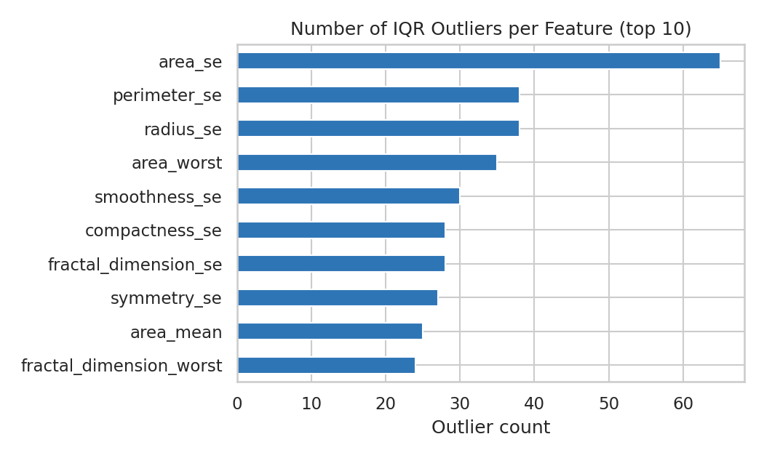
Figure 1: Number of IQR outliers per feature (top 10)
Observation
- 171 rows (30.1%) have at least one outlier. The "standard error" features have the most: area_se alone has 65.
- Outliers are much more common among malignant cases (53.8% of rows) than among benign ones (16.0%). They are therefore mostly very large tumours, which are real and important observations. Removing them would delete over half of the malignant cases, so they were kept.
- As a sensitivity test, all values were capped at the IQR limits and the effect sizes were recalculated. The ranking of features stays almost the same (Spearman correlation 0.969) and 4 of the top 5 features are the same. Only one feature changes place in the top 5, so the conclusions do not depend on the outliers.
- Because the data has outliers and skewness, median-based summaries, rank-based tests (Mann-Whitney) and standardisation before modelling are used in the later steps.

7. Exploratory Data Analysis

7.1 Comparing malignant and benign tumours
For every feature the groups are compared with the average value, an effect size (Cohen's d, the difference of means measured in pooled standard deviations) and a Mann-Whitney U test. Because 30 tests are run, a Bonferroni correction is applied (significance level 0.05 / 30 = 0.00167). As a rule of thumb, d above 0.8 is a large effect.
Code
# Mean of each 'mean' feature in the two groups
group_means = df.groupby("diagnosis", observed=True)[mean_cols].mean().T.round(3)
group_means["ratio (M/B)"] = (group_means["Malignant"] / group_means["Benign"]).round(2)
print("Average value by diagnosis:")
print(group_means)

# Effect size and a non-parametric significance test for all 30 features
rows = []
for col in feature_cols:
m = df.loc[df["diagnosis_code"] == 1, col]
b = df.loc[df["diagnosis_code"] == 0, col]
p = stats.mannwhitneyu(m, b, alternative="two-sided").pvalue
rows.append((col, cohens_d(df[col], df["diagnosis_code"]), p))
tests = pd.DataFrame(rows, columns=["feature", "cohens_d", "p_value"]).set_index("feature")
tests["abs_d"] = tests["cohens_d"].abs()
tests = tests.sort_values("abs_d", ascending=False)

alpha = 0.05 / len(tests) # Bonferroni correction for 30 tests
print(f"\nBonferroni threshold: {alpha:.5f}")
print("Features significant after correction:", int((tests["p_value"] < alpha).sum()), "of", len(tests))
print("\nTop 10 features by effect size (Cohen's d, malignant minus benign):")
fmt = {"cohens_d": "{:.3f}".format, "p_value": "{:.2e}".format}
print(tests[["cohens_d", "p_value"]].head(10).to_string(formatters=fmt))
print("\nWeakest 3 features:")
print(tests[["cohens_d", "p_value"]].tail(3).to_string(formatters=fmt))

Output
Average value by diagnosis:
diagnosis Benign Malignant ratio (M/B)
radius_mean 12.147 17.463 1.44
texture_mean 17.915 21.605 1.21
perimeter_mean 78.075 115.365 1.48
area_mean 462.790 978.376 2.11
smoothness_mean 0.092 0.103 1.12
compactness_mean 0.080 0.145 1.81
concavity_mean 0.046 0.161 3.50
concave_points_mean 0.026 0.088 3.38
symmetry_mean 0.174 0.193 1.11
fractal_dimension_mean 0.063 0.063 1.00

Bonferroni threshold: 0.00167
Features significant after correction: 26 of 30

Top 10 features by effect size (Cohen's d, malignant minus benign):
cohens_d p_value
feature
concave_points_worst 2.693 1.86e-77
perimeter_worst 2.598 2.58e-80
concave_points_mean 2.545 1.01e-76
radius_worst 2.544 1.14e-78
perimeter_mean 2.290 3.55e-71
area_worst 2.230 1.80e-78
radius_mean 2.205 2.69e-68
area_mean 2.076 1.54e-68
concavity_mean 2.003 2.16e-68
concavity_worst 1.812 1.76e-63

Weakest 3 features:
cohens_d p_value
feature
fractal_dimension_mean -0.027 5.37e-01
texture_se -0.017 6.44e-01
symmetry_se -0.013 2.78e-02

Observation
- Malignant tumours are bigger: radius is 1.44 times, perimeter 1.48 times and area 2.11 times higher than in benign tumours.
- They are also much more irregular: concavity is 3.50 times and the number of concave points 3.38 times higher, and compactness is 1.81 times higher.
- The best separators are concave_points_worst (d = 2.69), perimeter_worst (2.60), concave_points_mean (2.55) and radius_worst (2.54). All ten top features have very large effect sizes (d above 1.8) and p-values far below 0.001.
- 26 of 30 features remain significant after the Bonferroni correction.
- Some features carry almost no information: fractal_dimension_mean (ratio 1.00, d = -0.03, p = 0.54) and texture_se (d = -0.02, p = 0.64) do not differ between the groups, and symmetry_se (p = 0.028) does not pass the corrected threshold.

7.2 Correlations and skewness
Code
corr = df[mean_cols].corr()

# strongly related pairs among the 'mean' features
pairs = (corr.where(np.triu(np.ones(corr.shape, dtype=bool), k=1))
.stack().rename("r").reset_index())
pairs.columns = ["feature_1", "feature_2", "r"]
strong = pairs[pairs["r"].abs() >= 0.85].sort_values("r", ascending=False)
print("Pairs of 'mean' features with |r| >= 0.85:")
print(strong.round(3).to_string(index=False))

# correlation of every feature with being malignant
target_corr = df[feature_cols].corrwith(df["diagnosis_code"]).sort_values(ascending=False)
print("\nStrongest correlations with malignant diagnosis:")
print(target_corr.head(6).round(3))
print("\nWeakest correlations (closest to zero):")
print(target_corr.abs().sort_values().head(3).round(3))

skew = df[feature_cols].skew().sort_values(ascending=False)
print("\nMost right-skewed features:")
print(skew.head(5).round(2))
print("Features with |skew| > 1:", int((skew.abs() > 1).sum()), "of", len(skew))

Output
Pairs of 'mean' features with |r| >= 0.85:
feature_1 feature_2 r
radius_mean perimeter_mean 0.998
radius_mean area_mean 0.987
perimeter_mean area_mean 0.987
concavity_mean concave_points_mean 0.921
compactness_mean concavity_mean 0.883
perimeter_mean concave_points_mean 0.851

Strongest correlations with malignant diagnosis:
concave_points_worst 0.794
perimeter_worst 0.783
concave_points_mean 0.777
radius_worst 0.776
perimeter_mean 0.743
area_worst 0.734
dtype: float64

Weakest correlations (closest to zero):
symmetry_se 0.007
texture_se 0.008
fractal_dimension_mean 0.013
dtype: float64

Most right-skewed features:
area_se 5.45
concavity_se 5.11
fractal_dimension_se 3.92
perimeter_se 3.44
radius_se 3.09
dtype: float64
Features with |skew| > 1: 22 of 30

Observation
- Radius, perimeter and area are practically the same information: radius vs perimeter r = 0.998, radius vs area 0.987, perimeter vs area 0.987. Concavity and concave points also move together (r = 0.92).
- In total, 6 pairs of the 10 "mean" features have |r| of 0.85 or more. This is multicollinearity: it is harmless for exploration, but it would make the coefficients of a regression model unstable.
- The features most correlated with a malignant diagnosis are concave_points_worst (0.79), perimeter_worst (0.78), concave_points_mean (0.78) and radius_worst (0.78); the correlation is positive, meaning larger values go with malignancy.
- The distributions are strongly right-skewed: 22 of the 30 features have |skewness| above 1, with the extreme cases being area_se (5.45) and concavity_se (5.11). A log transformation would be a sensible step before using these features in a model.

8. Data Visualizations
Figure 1 (outlier counts) was shown in Section 6. The following charts present the main findings; the type of chart was chosen to match the question: bar chart for counts, histograms for distributions, box plots for spread and outliers, heatmap for correlations and a scatter plot for the relation of two variables.

8.1 Class distribution (bar chart)
Code
fig, ax = plt.subplots(figsize=(6, 4))
counts = df["diagnosis"].value_counts().reindex(["Benign", "Malignant"])
bars = ax.bar(counts.index, counts.values, color=[PAL["Benign"], PAL["Malignant"]], width=0.55)
for bar, v in zip(bars, counts.values):
ax.text(bar.get_x() + bar.get_width() / 2, v + 6, f"{v} ({v / len(df) * 100:.1f}%)", ha="center", fontweight="bold")
ax.set_title("Number of Cases by Diagnosis")
ax.set_ylabel("Number of cases")
ax.set_ylim(0, counts.max() * 1.15)
plt.tight_layout()
plt.savefig("charts/02_class_distribution.png", dpi=150)
plt.show()

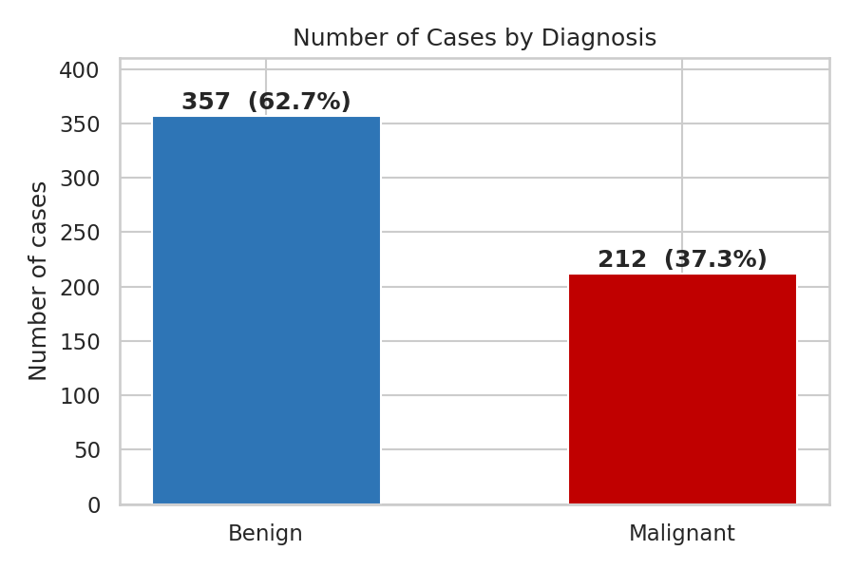
Figure 2: Number of cases by diagnosis
Observation
- There are about 1.7 benign cases for every malignant case. The imbalance is moderate and does not prevent a meaningful comparison.

8.2 Feature distributions (histograms)
Code
cols = ["radius_mean", "texture_mean", "concave_points_mean", "smoothness_mean"]
fig, axes = plt.subplots(2, 2, figsize=(9, 6))
for ax, col in zip(axes.ravel(), cols):
sns.histplot(data=df, x=col, hue="diagnosis", palette=PAL, kde=True, stat="density",
common_norm=False, alpha=0.4, ax=ax, legend=(col == cols[0]))
ax.set_title(col)
ax.set_ylabel("Density")
fig.suptitle("Distribution of Key Features: Benign vs Malignant", y=1.0, fontsize=13)
plt.tight_layout()
plt.savefig("charts/03_histograms_by_diagnosis.png", dpi=150)
plt.show()

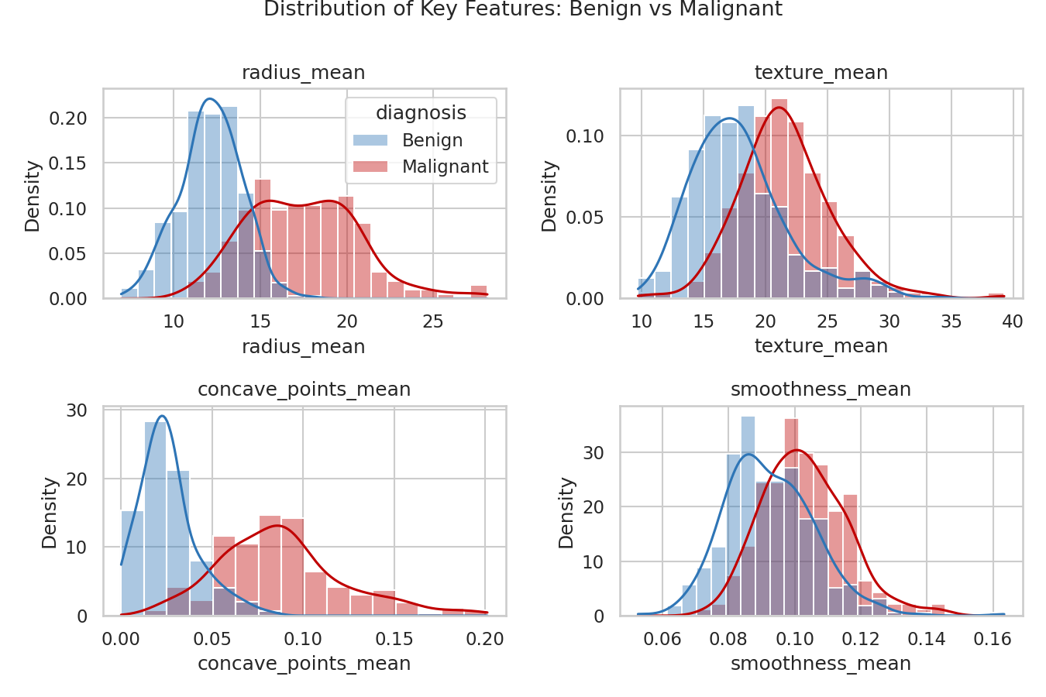
Figure 3: Distribution of key features, benign vs malignant
Observation
- radius_mean and concave_points_mean show two clearly different humps: benign cases cluster around a radius of 12 and malignant cases are spread around 17 to 19, and the overlap is small.
- texture_mean and smoothness_mean overlap much more, so they separate the groups only partly. The malignant curves are shifted to the right and are wider, which means malignant tumours also vary more.

8.3 Spread and outliers (box plots)
Code
cols = ["radius_mean", "texture_mean", "area_mean", "smoothness_mean", "concave_points_mean", "fractal_dimension_mean"]
fig, axes = plt.subplots(2, 3, figsize=(10, 6))
for ax, col in zip(axes.ravel(), cols):
sns.boxplot(data=df, x="diagnosis", y=col, hue="diagnosis", order=["Benign", "Malignant"],
palette=PAL, legend=False, ax=ax, width=0.55, fliersize=3)
ax.set_title(col)
ax.set_xlabel("")
ax.set_ylabel("")
fig.suptitle("Box Plots of Selected Features by Diagnosis", y=1.0, fontsize=13)
plt.tight_layout()
plt.savefig("charts/04_boxplots_by_diagnosis.png", dpi=150)
plt.show()

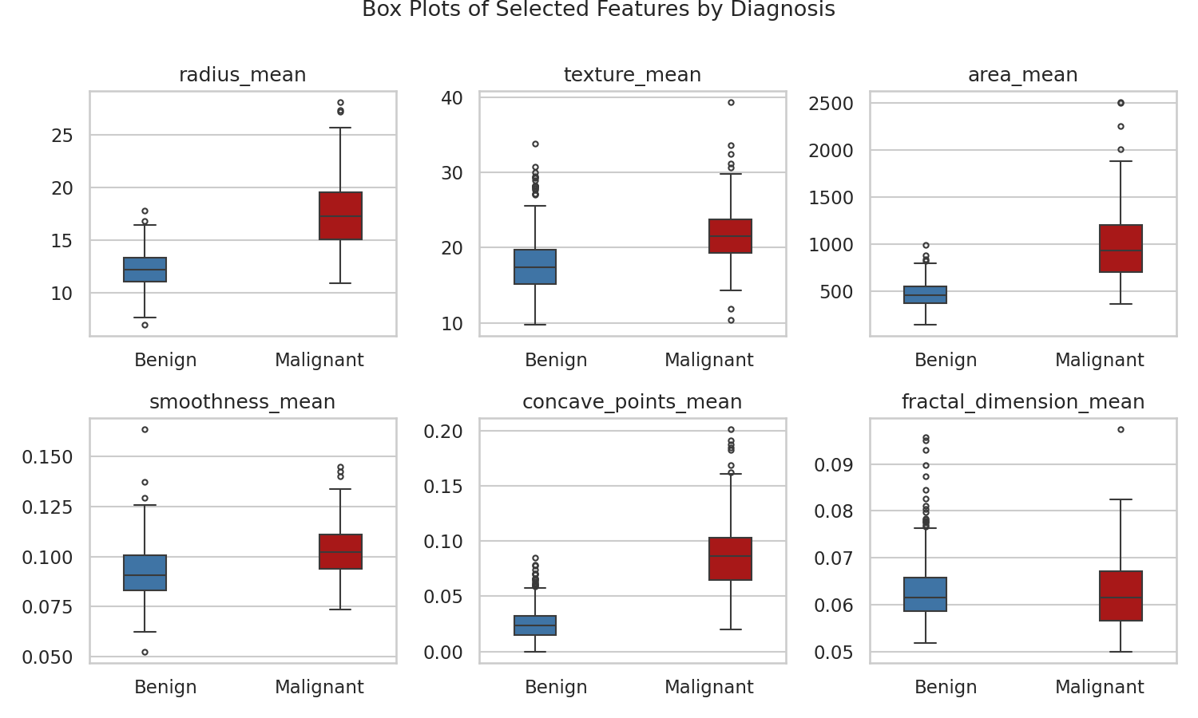
Figure 4: Box plots of selected features by diagnosis
Observation
- For radius_mean, area_mean and concave_points_mean the box of the malignant group lies almost completely above the box of the benign group.
- The malignant group has the long upper whiskers and the extreme points in area_mean, which is where the outliers found in Section 6 come from.
- fractal_dimension_mean is the contrast case: the two boxes are at the same height, so this feature cannot tell the groups apart, which matches its effect size of nearly zero.

8.4 Correlation heatmap
Code
fig, ax = plt.subplots(figsize=(9, 7))
labels = [c.replace("_mean", "") for c in mean_cols]
sns.heatmap(corr.set_axis(labels, axis=0).set_axis(labels, axis=1), annot=True, fmt=".2f",
cmap="RdBu_r", vmin=-1, vmax=1, annot_kws={"size": 8}, ax=ax)
ax.set_title("Correlation Between the 10 'Mean' Features")
plt.tight_layout()
plt.savefig("charts/05_correlation_heatmap.png", dpi=150)
plt.show()

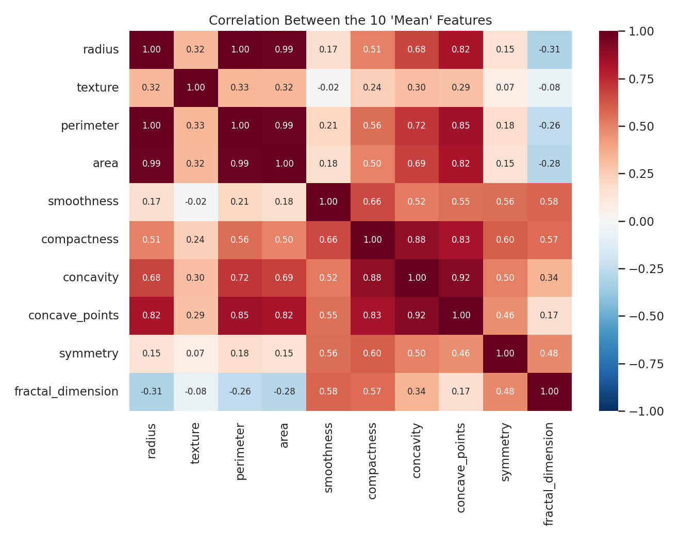
Figure 5: Correlation between the 10 mean features
Observation
- A dark red block in the top-left shows that radius, perimeter and area are practically identical (1.00, 0.99). Concavity and concave points form a second tightly linked pair (0.92).
- Texture is only weakly related to the other features (between -0.08 and 0.33), so it adds information that is different from the size features.
- Fractal dimension is negatively related to the size features (about -0.3), meaning that larger nuclei tend to have a slightly less complex boundary.

8.5 Two key features together (scatter plot)
Code
fig, ax = plt.subplots(figsize=(7, 5))
sns.scatterplot(data=df, x="radius_mean", y="concave_points_mean", hue="diagnosis",
hue_order=["Benign", "Malignant"], palette=PAL, alpha=0.65, s=35, ax=ax)
ax.set_title("Tumour Radius vs Concave Points")
ax.set_xlabel("radius_mean")
ax.set_ylabel("concave_points_mean")
plt.tight_layout()
plt.savefig("charts/06_scatter_radius_concave.png", dpi=150)
plt.show()

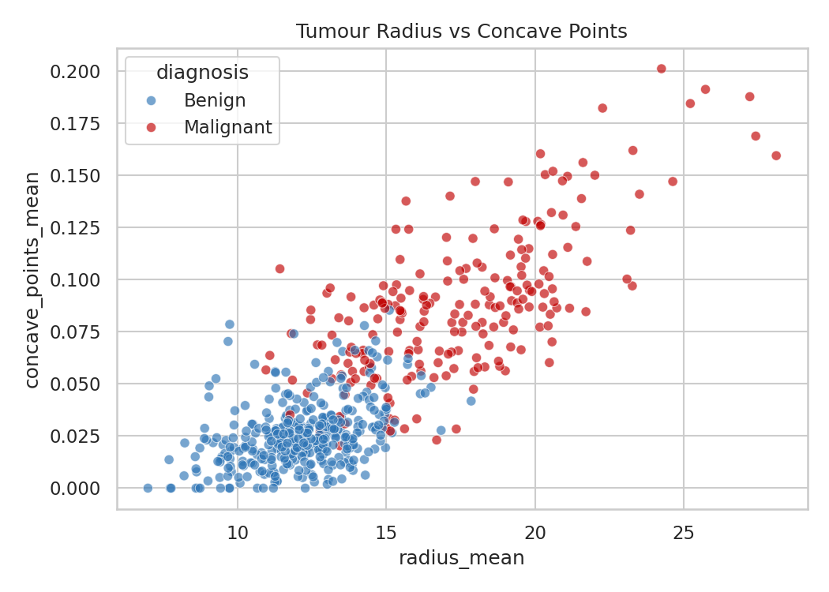
Figure 6: Tumour radius vs concave points by diagnosis
Observation
- The two variables rise together, and the groups form two largely separate clouds: benign cases in the lower left, malignant cases in the upper right.
- Two features alone already separate most cases. The remaining overlap, in the middle of the plot, is where the other features matter.

8.6 Strongest separating features (bar chart)
Code
top = tests.head(10).sort_values("abs_d")
fig, ax = plt.subplots(figsize=(7.5, 4.6))
ax.barh(top.index, top["abs_d"], color="#C00000")
ax.set_title("Top 10 Features by Effect Size (|Cohen's d|)")
ax.set_xlabel("|Cohen's d| (larger = better separation)")
plt.tight_layout()
plt.savefig("charts/07_top_effect_sizes.png", dpi=150)
plt.show()

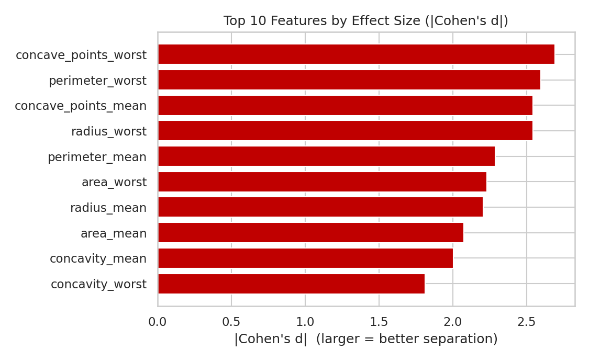
Figure 7: Top 10 features by effect size
Observation
- Concave points, perimeter and radius (in their "worst" and "mean" versions) take the top positions, followed by area and concavity.
- The "worst" versions are mostly stronger than the "mean" versions (for example concave points 2.69 against 2.55), which suggests that the most extreme nuclei in a sample are especially informative.

9. Supporting Analysis: How Much Signal Do the Features Carry?
To measure how well the groups can be told apart, a standardised logistic regression was tested with 5-fold stratified cross-validation, using the top 1, 2, 3 ... 30 features. The features are ranked by effect size inside each training fold, so the test data never influences the ranking and the result is not inflated. The line chart shows how accuracy changes when more features are added.
Code
from sklearn.linear_model import LogisticRegression
from sklearn.model_selection import StratifiedKFold
from sklearn.pipeline import make_pipeline
from sklearn.preprocessing import StandardScaler

skf = StratifiedKFold(n_splits=5, shuffle=True, random_state=42)
ks = list(range(1, 31))
acc = {k: [] for k in ks}

for train_idx, test_idx in skf.split(X, y):
X_tr, y_tr = X.iloc[train_idx], y.iloc[train_idx]
X_te, y_te = X.iloc[test_idx], y.iloc[test_idx]
order = cohens_d(X_tr, y_tr).abs().sort_values(ascending=False).index
for k in ks:
cols_k = list(order[:k])
model = make_pipeline(StandardScaler(), LogisticRegression(max_iter=1000))
model.fit(X_tr[cols_k], y_tr)
acc[k].append(model.score(X_te[cols_k], y_te))

mean_acc = np.array([np.mean(acc[k]) for k in ks])
std_acc = np.array([np.std(acc[k]) for k in ks])
print("Cross-validated accuracy by number of features used:")
for k in [1, 2, 3, 5, 10, 20, 30]:
print(f" top {k:>2} feature(s): {mean_acc[k - 1] * 100:.1f}% (+/- {std_acc[k - 1] * 100:.1f})")
best_k = int(np.argmax(mean_acc)) + 1
print(f"\nHighest accuracy: {mean_acc.max() * 100:.1f}% with {best_k} features")
print(f"Majority-class baseline (always predict benign): {(1 - y.mean()) * 100:.1f}%")

fig, ax = plt.subplots(figsize=(7.5, 4.2))
ax.plot(ks, mean_acc * 100, marker="o", markersize=4, color="#1F4E79")
ax.fill_between(ks, (mean_acc - std_acc) * 100, (mean_acc + std_acc) * 100, alpha=0.2, color="#1F4E79")
ax.axhline((1 - y.mean()) * 100, color="grey", linestyle="--", label="Always predict benign")
ax.set_title("Cross-Validated Accuracy vs Number of Features")
ax.set_xlabel("Number of top-ranked features used")
ax.set_ylabel("Accuracy (%)")
ax.legend(loc="lower right")
plt.tight_layout()
plt.savefig("charts/08_accuracy_vs_features.png", dpi=150)
plt.show()

Output
Cross-validated accuracy by number of features used:
top 1 feature(s): 90.7% (+/- 1.2)
top 2 feature(s): 93.2% (+/- 2.4)
top 3 feature(s): 93.2% (+/- 2.0)
top 5 feature(s): 94.2% (+/- 1.6)
top 10 feature(s): 95.1% (+/- 1.6)
top 20 feature(s): 97.5% (+/- 1.3)
top 30 feature(s): 97.4% (+/- 1.7)

Highest accuracy: 98.1% with 26 features
Majority-class baseline (always predict benign): 62.7%

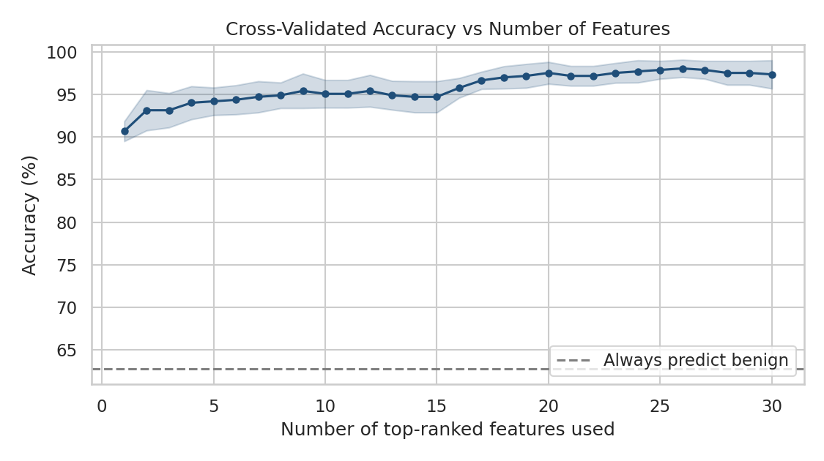
Figure 8: Cross-validated accuracy vs number of features
Observation
- Always predicting "benign" would be correct 62.7% of the time. A model with a single feature already reaches 90.7%, and with 3 features 93.2%.
- Accuracy rises slowly to 95.1% with 10 features and 97.5% with 20, and peaks at 98.1% with 26 features. Adding all 30 gives 97.4%, so the last features add nothing (or slightly hurt), which fits the redundancy found in Section 7.
- The shaded band (one standard deviation across folds) is narrow, so the result is stable.
- This is only a signal check. Accuracy is not enough for a medical test: missing a malignant case is far more harmful than a false alarm, so sensitivity and specificity would have to be reported in any real study.

10. Key Insights and Interpretations
Code
mal = df[df["diagnosis"] == "Malignant"]
ben = df[df["diagnosis"] == "Benign"]
print(f"1. Dataset : {len(df)} cases, {len(feature_cols)} features, no missing values, no duplicates")
print(f"2. Class balance : {len(ben)} benign ({len(ben) / len(df) * 100:.1f}%) vs {len(mal)} malignant ({len(mal) / len(df) * 100:.1f}%)")
print(f"3. Mean radius : malignant {mal['radius_mean'].mean():.2f} vs benign {ben['radius_mean'].mean():.2f}")
print(f"4. Mean area : malignant {mal['area_mean'].mean():.0f} vs benign {ben['area_mean'].mean():.0f}")
print(f"5. Best separators : {', '.join(tests.index[:3])}")
print(f"6. Weakest separator : {tests.index[-1]} (d = {tests['cohens_d'].iloc[-1]:.2f})")
print(f"7. Redundant features : {len(strong)} pairs of mean features with |r| >= 0.85")
print(f"8. Predictive signal : {mean_acc[2] * 100:.1f}% accuracy with only 3 features, {mean_acc.max() * 100:.1f}% at best")

Output
1. Dataset : 569 cases, 30 features, no missing values, no duplicates
2. Class balance : 357 benign (62.7%) vs 212 malignant (37.3%)
3. Mean radius : malignant 17.46 vs benign 12.15
4. Mean area : malignant 978 vs benign 463
5. Best separators : concave_points_worst, perimeter_worst, concave_points_mean
6. Weakest separator : symmetry_se (d = -0.01)
7. Redundant features : 6 pairs of mean features with |r| >= 0.85
8. Predictive signal : 93.2% accuracy with only 3 features, 98.1% at best

- Size and irregularity separate the groups. Malignant nuclei are larger (area 2.1 times) and have a more irregular outline (concavity about 3.5 times). Both agree with the idea that cancer cells grow abnormally and lose their regular shape.
- A few features explain most of the difference. Concave points, perimeter and radius have very large effect sizes (d from 2.5 to 2.7), and 3 features alone reach 93.2% accuracy.
- The 30 columns hold much less than 30 pieces of information. Radius, perimeter and area are almost the same variable (r of 0.99 or more), and concavity and concave points are close to it as well.
- Outliers are real, not errors. They are concentrated in malignant cases, and the conclusions barely change when they are capped.
- Some features are useless for this question. fractal_dimension_mean, texture_se and symmetry_se show no meaningful difference between the groups.
- Correlation is not diagnosis. The analysis shows which measurements go together with malignancy; it does not show that changing a measurement causes the disease.

11. Recommendations
- Focus on shape and size features. Any screening-support model or dashboard should start from concave points, perimeter, radius and area (especially the "worst" values) and concavity.
- Remove redundancy before modelling. Keep one of radius, perimeter and area, or use regularisation or PCA, so that the model is simpler and its coefficients are stable.
- Keep the outliers, use robust methods. Standardise the features, consider a log transformation for the strongly skewed "se" features, and prefer rank-based or median-based statistics.
- Judge a model by the right measures. Report sensitivity (share of malignant cases detected), specificity and a confusion matrix, not only accuracy, and decide what error rate is acceptable for a missed malignant case.
- Validate before using. Test on data from other hospitals and years, and review the findings with medical experts, before drawing any practical conclusion.

12. Limitations
- The dataset is small (569 cases) and comes from one source and from the 1990s, so the results may not hold for other populations or modern imaging.
- The features are computed by image-analysis software from selected nuclei; the quality of this process affects every number.
- The accuracy figures come from a simple model and cross-validation on this one dataset. They are not a claim about real clinical performance.
- Many of the 30 tests are on correlated features, so the significance results are not independent; the effect sizes are the more reliable guide.
- This project is a data analysis exercise. It is not medical advice and must not be used to diagnose anyone.

13. Conclusion
A real clinical dataset from the UCI repository was selected, explored, checked for every type of data-quality problem, analysed with statistical techniques and presented through eight visualizations. The data turned out to be clean in terms of missing values and duplicates, while outliers and skewness needed careful treatment. The analysis shows that malignant tumours are larger and more irregular, that concave points, perimeter and radius are the strongest separating features, that many features are redundant, and that very few features are enough to separate the groups well. The structured notebook submitted with this report reproduces every number, table and chart, and the same workflow can be applied to any other dataset.

14. References
- Wolberg, W., Mangasarian, O., Street, N., & Street, W. Breast Cancer Wisconsin (Diagnostic) [Dataset]. UCI Machine Learning Repository. https://doi.org/10.24432/C5DW2B
- Street, W.N., Wolberg, W.H., & Mangasarian, O.L. (1993). Nuclear feature extraction for breast tumor diagnosis. IS&T/SPIE International Symposium on Electronic Imaging.
- Pedregosa et al. Scikit-learn: Machine Learning in Python. Journal of Machine Learning Research (the library that bundles a copy of the dataset).
- Documentation of pandas, NumPy, SciPy, Matplotlib and Seaborn.

15. Files Submitted
File | Description
Task3_Real_World_Dataset_Analysis.docx | This report
Real_World_Dataset_Analysis.ipynb | Jupyter notebook with all code, outputs and charts (run top to bottom)
breast_cancer_wisconsin.csv | The dataset used (569 rows, 30 features and diagnosis)
requirements.txt | Libraries to install with pip install -r requirements.txt

