Citrus Leaf Disease Classification
Deep Learning Model Comparison and Evaluation Report
Prepared from the recorded experiments on the supplied citrus leaf dataset.
Report generated: 09 October 2026

1. Executive Summary
This project evaluates seven pretrained image-classification architectures for five citrus leaf classes: Black spot, Canker, Greening, Healthy, and Melanose. The reported experiments used the project's own dataset. Among the reported test results, ViT-B/16 achieved the highest test accuracy at 88.76%, with macro F1 of 0.8554 and weighted F1 of 0.8905.

2. Dataset Description
The recorded dataset contains 1,716 images across five classes. The class distribution is shown below.
Class | Image Count | Percentage
Black spot | 238 | 13.87%
Canker | 237 | 13.81%
Greening | 220 | 12.82%
Healthy | 705 | 41.08%
Melanose | 316 | 18.41%
The dataset is imbalanced: Healthy has the largest number of images. Class-wise precision, recall, and F1 should therefore be considered alongside overall accuracy.

3. Methodology
The models are based on pretrained architectures. In the recorded repository-based experiments, the feature backbone was frozen and the classification head was replaced for the five target classes. Training used eight epochs in the experiments summarized here. The recorded pipeline used image resizing/cropping, online training augmentation, ImageNet normalization, weighted cross-entropy loss with label smoothing, and an adaptive learning-rate scheduler.
Five models—ViT-B/16, MobileNetV3-Large, ConvNeXt-Tiny, Swin-Tiny, and MobileViT-Small—used the same saved stratified split with seed 42. ResNet34 and EfficientNet-B0 were earlier experiments with different splits.

4. Model Comparison
Validation accuracy reflects model selection on the validation data. Test accuracy reflects the recorded held-out test evaluation. F1 values for ResNet34 and EfficientNet-B0 are rounded historical values; the remaining values are taken from their recorded reports.
Model | Best Val. | Test Acc. | Macro F1 | Weighted F1 | Time (min)
ResNet34 | 70.43% | 76.74% | 0.7500 | 0.7800 | N/A
EfficientNet-B0 | 86.38% | 88.37% | 0.8500 | 0.8800 | N/A
ViT-B/16 | 88.33% | 88.76% | 0.8554 | 0.8905 | 7.13
MobileNetV3-Large | 73.15% | 77.52% | 0.7459 | 0.7849 | 1.16
ConvNeXt-Tiny | 81.71% | 85.27% | 0.8269 | 0.8586 | 1.39
Swin-Tiny | 85.21% | 85.27% | 0.8222 | 0.8566 | 1.33
MobileViT-Small | 78.60% | 81.40% | 0.7731 | 0.8137 | 1.24

5. Interpretation of Results
ViT-B/16 has the highest recorded test accuracy among these runs. EfficientNet-B0 also recorded strong accuracy, but it used a different data split, so its score should not be directly ranked against the five shared-split models as if the comparison were controlled.
MobileViT-Small achieved 81.40% test accuracy. Its recorded Black spot recall was 0.4444, indicating that many Black spot samples were predicted as other classes. This illustrates why class-wise evaluation is important in a plant-disease classification task.
The class-wise reports and confusion matrices are included in each model's results folder when available.

6. Confusion Matrices

ResNet34
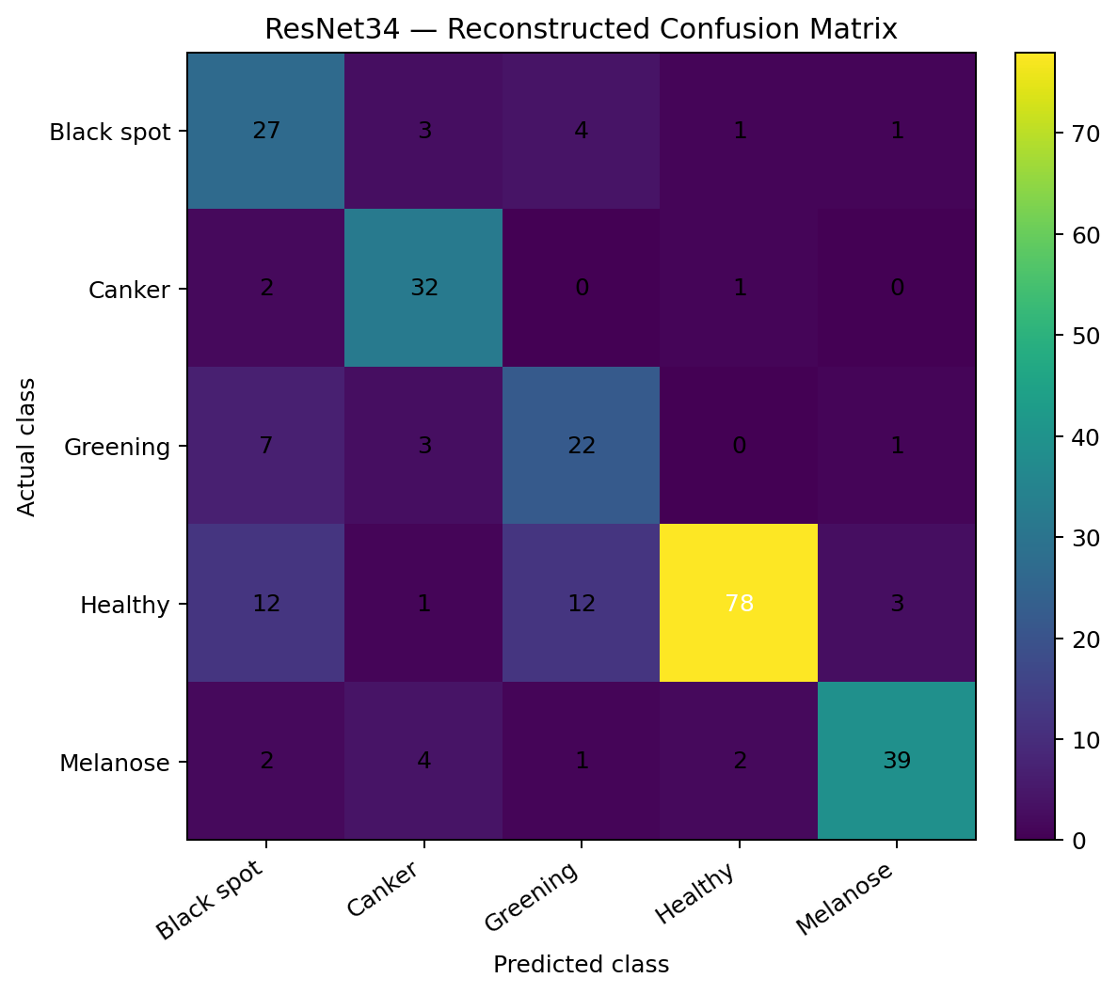
Classification report:
precision recall f1-score support
Black spot 0.54 0.75 0.63 36
Canker 0.74 0.91 0.82 35
Greening 0.56 0.67 0.61 33
Healthy 0.95 0.74 0.83 106
Melanose 0.89 0.81 0.85 48
accuracy 0.77 258
macro avg 0.74 0.78 0.75 258
weighted avg 0.80 0.77 0.78 258

EfficientNet-B0
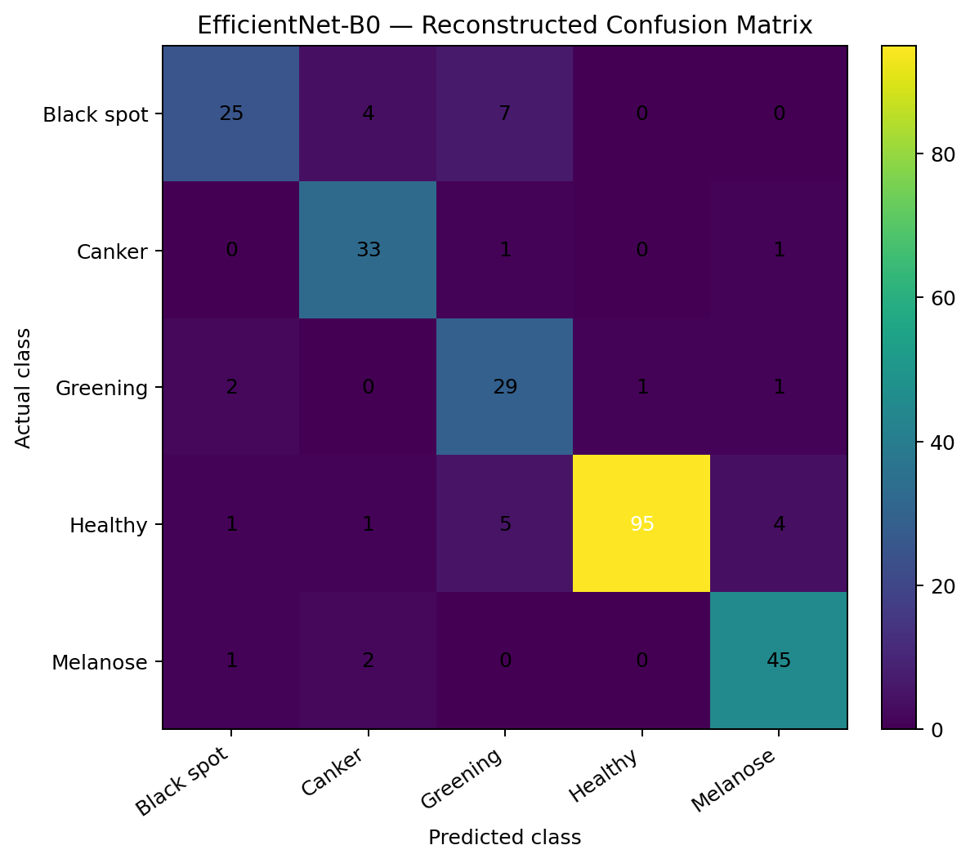
Classification report:
precision recall f1-score support
Black spot 0.86 0.69 0.77 36
Canker 0.82 0.94 0.88 35
Greening 0.69 0.88 0.77 33
Healthy 0.99 0.90 0.94 106
Melanose 0.88 0.94 0.91 48
accuracy 0.88 258
macro avg 0.85 0.87 0.85 258
weighted avg 0.89 0.88 0.88 258

ViT-B/16
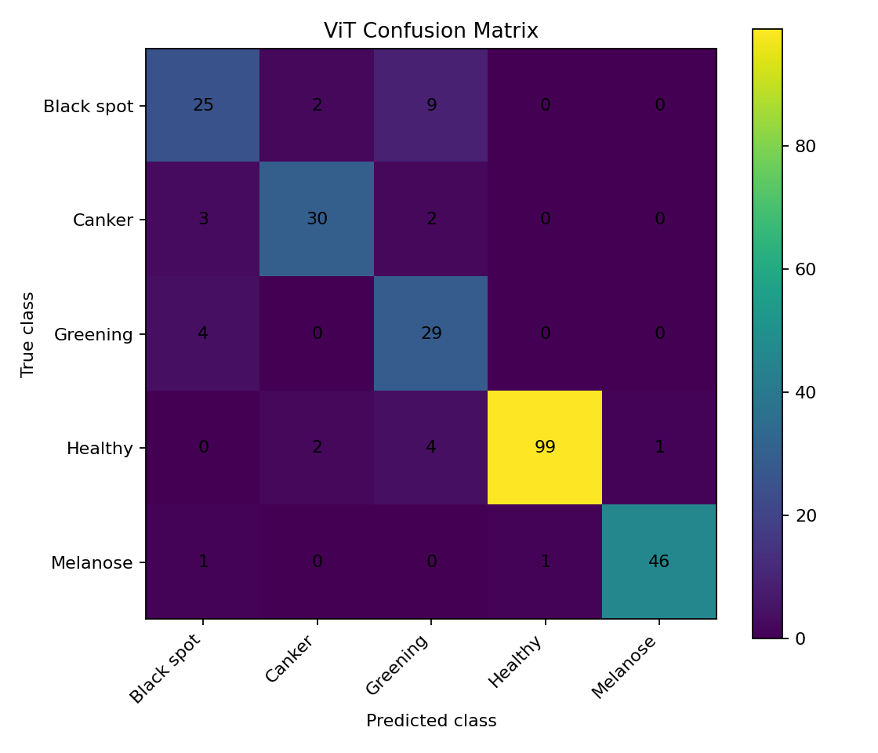
Classification report:
Best validation accuracy: 0.883268
Test accuracy: 0.887597
Training duration seconds: 427.85
precision recall f1-score support
Black spot 0.7576 0.6944 0.7246 36
Canker 0.8824 0.8571 0.8696 35
Greening 0.6591 0.8788 0.7532 33
Healthy 0.9900 0.9340 0.9612 106
Melanose 0.9787 0.9583 0.9684 48
accuracy 0.8876 258
macro avg 0.8535 0.8645 0.8554 258
weighted avg 0.8985 0.8876 0.8905 258
Confusion matrix:
[[25 2 9 0 0]
[ 3 30 2 0 0]
[ 4 0 29 0 0]
[ 0 2 4 99 1]
[ 1 0 0 1 46]]

MobileNetV3-Large
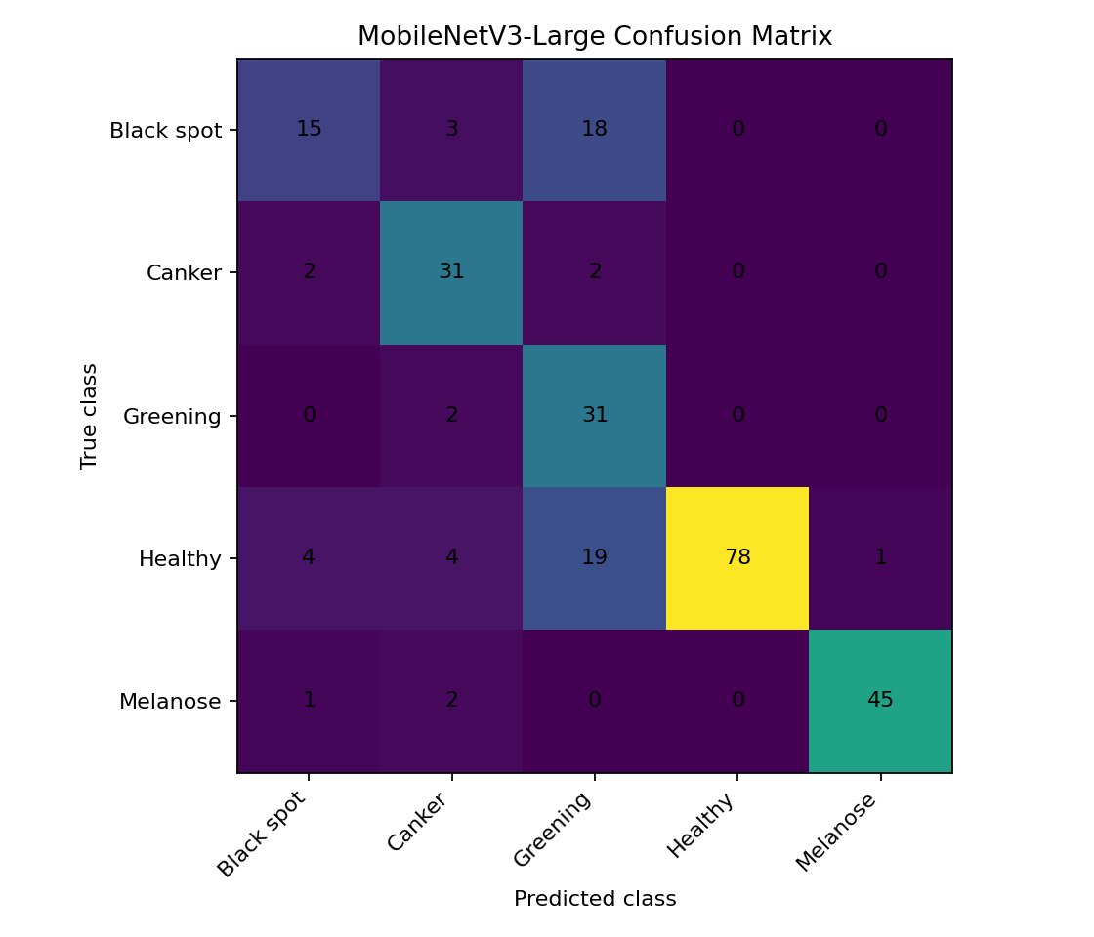
Classification report:
Best validation accuracy: 0.731518
Test accuracy: 0.775194
Training duration seconds: 69.49
precision recall f1-score support
Black spot 0.6818 0.4167 0.5172 36
Canker 0.7381 0.8857 0.8052 35
Greening 0.4429 0.9394 0.6019 33
Healthy 1.0000 0.7358 0.8478 106
Melanose 0.9783 0.9375 0.9574 48
accuracy 0.7752 258
macro avg 0.7682 0.7830 0.7459 258
weighted avg 0.8448 0.7752 0.7849 258
Confusion matrix:
[[15 3 18 0 0]
[ 2 31 2 0 0]
[ 0 2 31 0 0]
[ 4 4 19 78 1]
[ 1 2 0 0 45]]

ConvNeXt-Tiny
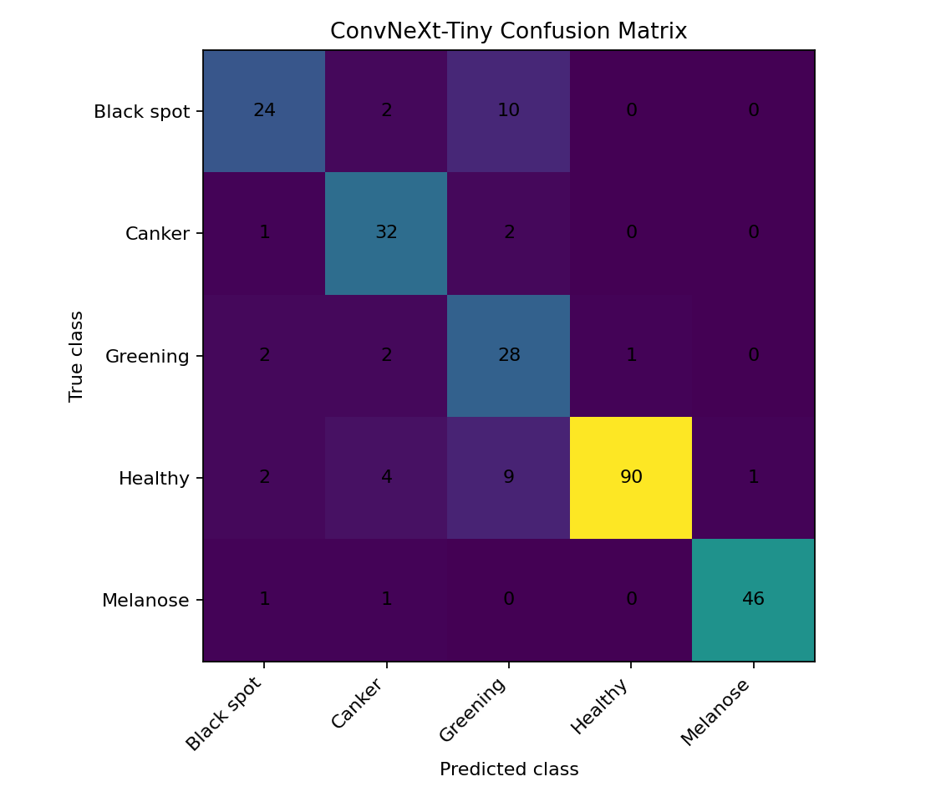
Classification report:
Best validation accuracy: 0.817121
Test accuracy: 0.852713
Training duration seconds: 83.53
precision recall f1-score support
Black spot 0.8000 0.6667 0.7273 36
Canker 0.7805 0.9143 0.8421 35
Greening 0.5714 0.8485 0.6829 33
Healthy 0.9890 0.8491 0.9137 106
Melanose 0.9787 0.9583 0.9684 48
accuracy 0.8527 258
macro avg 0.8239 0.8474 0.8269 258
weighted avg 0.8790 0.8527 0.8586 258
Confusion matrix:
[[24 2 10 0 0]
[ 1 32 2 0 0]
[ 2 2 28 1 0]
[ 2 4 9 90 1]
[ 1 1 0 0 46]]

Swin-Tiny
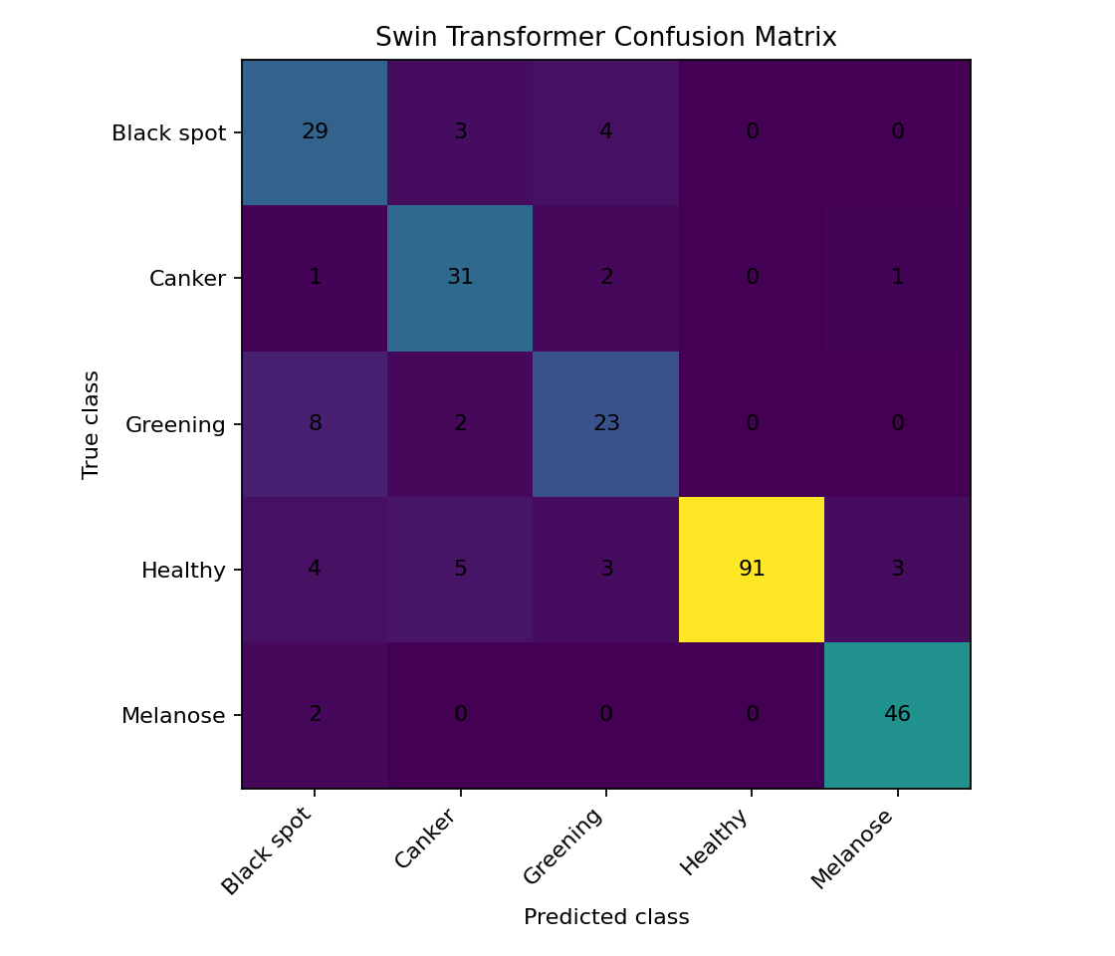
Classification report:
Best validation accuracy: 0.852140
Test accuracy: 0.852713
Training duration seconds: 79.93
precision recall f1-score support
Black spot 0.6591 0.8056 0.7250 36
Canker 0.7561 0.8857 0.8158 35
Greening 0.7188 0.6970 0.7077 33
Healthy 1.0000 0.8585 0.9239 106
Melanose 0.9200 0.9583 0.9388 48
accuracy 0.8527 258
macro avg 0.8108 0.8410 0.8222 258
weighted avg 0.8685 0.8527 0.8566 258
Confusion matrix:
[[29 3 4 0 0]
[ 1 31 2 0 1]
[ 8 2 23 0 0]
[ 4 5 3 91 3]
[ 2 0 0 0 46]]

MobileViT-Small
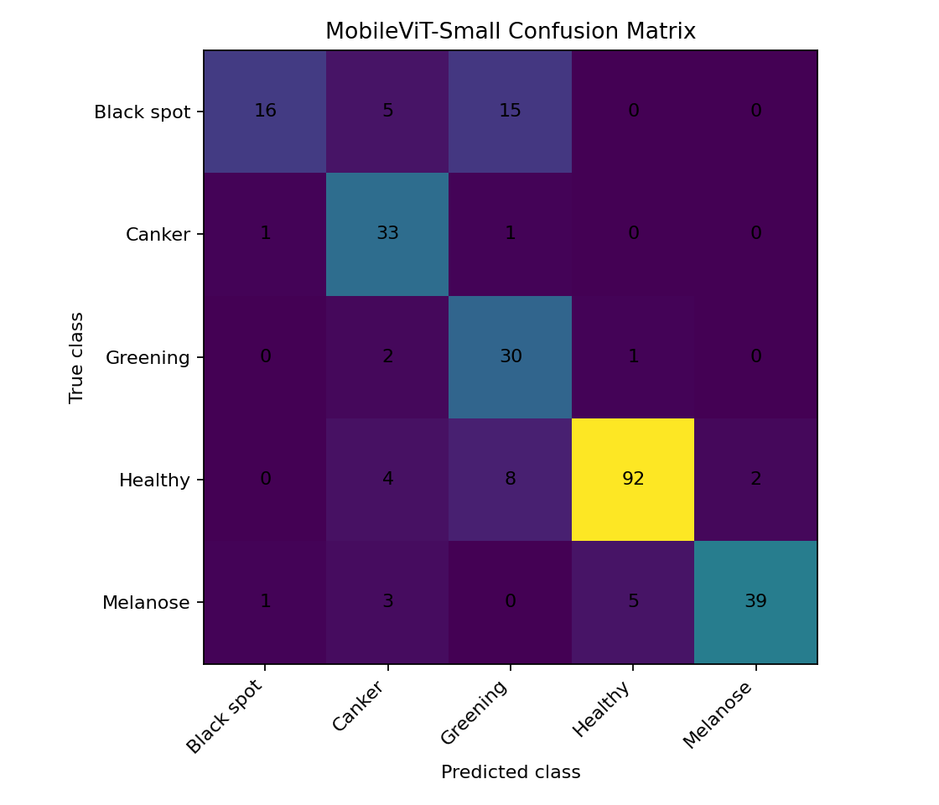
Classification report:
Best validation accuracy: 0.785992
Test accuracy: 0.813953
Training duration seconds: 74.59
precision recall f1-score support
Black spot 0.8889 0.4444 0.5926 36
Canker 0.7021 0.9429 0.8049 35
Greening 0.5556 0.9091 0.6897 33
Healthy 0.9388 0.8679 0.9020 106
Melanose 0.9512 0.8125 0.8764 48
accuracy 0.8140 258
macro avg 0.8073 0.7954 0.7731 258
weighted avg 0.8530 0.8140 0.8137 258
Confusion matrix:
[[16 5 15 0 0]
[ 1 33 1 0 0]
[ 0 2 30 1 0]
[ 0 4 8 92 2]
[ 1 3 0 5 39]]

7. Limitations
- Two early models used different splits, preventing a strict comparison against the five models trained on the shared split.
- The number of epochs was limited to eight for the recorded experiments; these results do not establish the maximum attainable performance.
- The dataset is imbalanced, and aggregate accuracy can conceal weaker performance for particular disease classes.
- Performance on external field images has not been established by these results.
- The historical ResNet34 and EfficientNet-B0 result folders did not contain saved training histories or original confusion-matrix images. Their confusion matrices were reconstructed from recorded counts.

8. Recommendations
- For a fair ranking, retrain all seven architectures using the exact same saved split and evaluation procedure.
- Compare macro F1, per-class recall, confusion matrices, and model size in addition to test accuracy.
- Investigate Black spot and Greening errors and review potentially ambiguous images.
- Evaluate the selected model on independent field images before making real-world diagnostic claims.

9. Conclusion
The recorded experiments show that pretrained vision architectures can classify the five citrus leaf categories with promising performance on this dataset. ViT-B/16 produced the highest recorded test accuracy in the summarized runs. However, a controlled comparison using the same data split for all models and validation on independent field images is recommended before selecting a final deployment model.

10. Supporting Files
The accompanying package contains model checkpoints, available classification reports, confusion matrices, test predictions, training histories, class mappings, a consolidated comparison table, and dataset class distribution.

