**Analyzing Amazon Sales Data**

**Problem statement**

Sales management has gained importance to meet increasing competition and the need for improved methods of distribution to reduce cost and to increase profits. Sales management today is the most important function in a commercial and business enterprise.

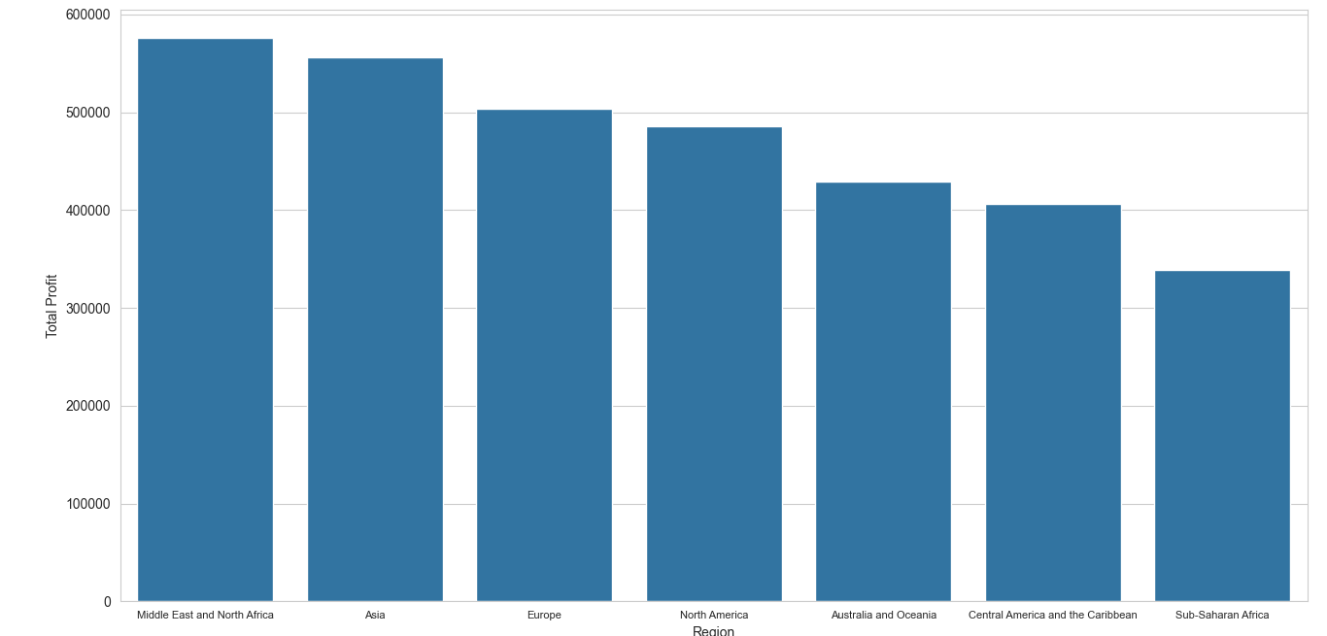**Research Question**

As it can be observed, there is an apparent trend e.g. Middle East and North America Having maximum profit while Sub-Saharan Africa manage to get lowest profit margin.

What are the key factors influencing profitability in a region? And what are possible methods to maximize it?

**Assumptions**

For the scope of this project, there are handful of assumptions has been made for analyzing purposes

* The data has been assumed to not have many outliers which will affect the analysis drastically
* The data is valid in the current status quo .

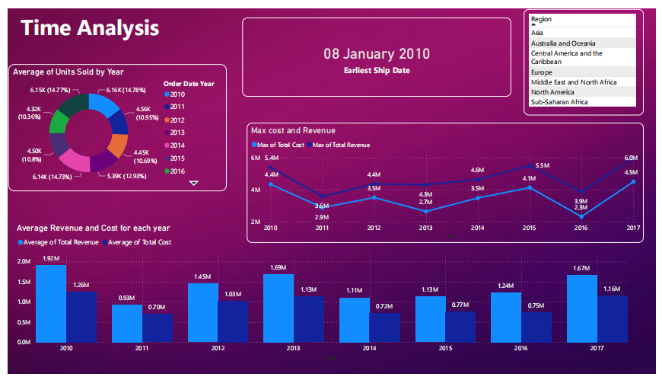**Time Analysis**

The data indicates that, on average, there has been a **4.73% increase in revenue** and a **5.02% increase in costs**. Taken together, these figures suggest that the **average profit has decreased by 0.29%**.

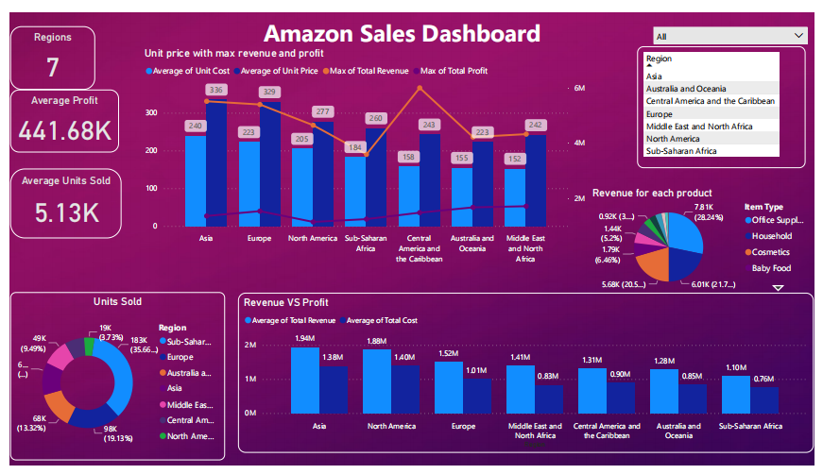**Key insights**

From the dashboard, let’s define cost-to-Revenue Ratio(CRR) for each region:

|  |  |  |
| --- | --- | --- |
| Region | CRR | Profit |
| Asia | 0.71 | 0.29 |
| North America | 0.74 | 0.26 |
| Europe | 0.66 | 0.34 |
| Middle East and North Africa | 0.59 | 0.41 |
| Central America and the Caribbean | 0.69 | 0.31 |
| Australia and Oceania | 0.66 | 0.34 |
| Sub-Saharan Africa | 0.69 | 0.31 |

**Which tells us that the cost is highest for North America and Asia.**

Consequently, in the comparison of profits, Asia occupies the 2nd position while North America stands in 4th place. This represents a notable decline compared to their revenue standings, where Asia holds the 1st position and North America holds the 2nd position.

------------------------------------------------------------------------------------------------

If we analyze the demand of each item types in each region, we can conclude the most and least demanded item type from each region.

|  |  |  |  |  |  |  |  |  |  |  |  |  |
| --- | --- | --- | --- | --- | --- | --- | --- | --- | --- | --- | --- | --- |
| Region | Baby Food | Beverages | Cereal | Clothes | Cosmetics | Fruits | Household | Meat | Office Supplies | Personal Care | Snacks | Vegetables |
| Asia | 0 | 0 | 0 | 14193 | 6952 | 6267 | 12080 | 0 | 11718 | 4901 | 0 | 3856 |
| Australia and Oceania | 12899 | 18768 | 682 | 9905 | 9654 | 7585 | 0 | 5908 | 2924 | 0 | 0 | 0 |
| Central America and the Caribbean | 0 | 8156 | 2804 | 5498 | 1705 | 0 | 8974 | 0 | 0 | 6409 | 2225 | 0 |
| Europe | 22087 | 9784 | 0 | 11784 | 30100 | 0 | 4795 | 0 | 14053 | 5343 | 0 | 171 |
| Middle East and North Africa | 0 | 0 | 4063 | 14000 | 23615 | 4979 | 0 | 0 | 2021 | 0 | 0 | 0 |
| North America | 0 | 0 | 0 | 0 | 0 | 0 | 6954 | 0 | 0 | 12189 | 0 | 0 |
| Sub-Saharan Africa | 5559 | 20000 | 18328 | 15880 | 11692 | 31167 | 11924 | 4767 | 16251 | 19866 | 11412 | 16024 |
| Total | 34986 | 36708 | 25877 | 71260 | 83718 | 49998 | 44727 | 10675 | 46967 | 48708 | 13637 | 20051 |

Similarly, it’s important to analyze the total revenue distribution for each region corresponding to each item type,

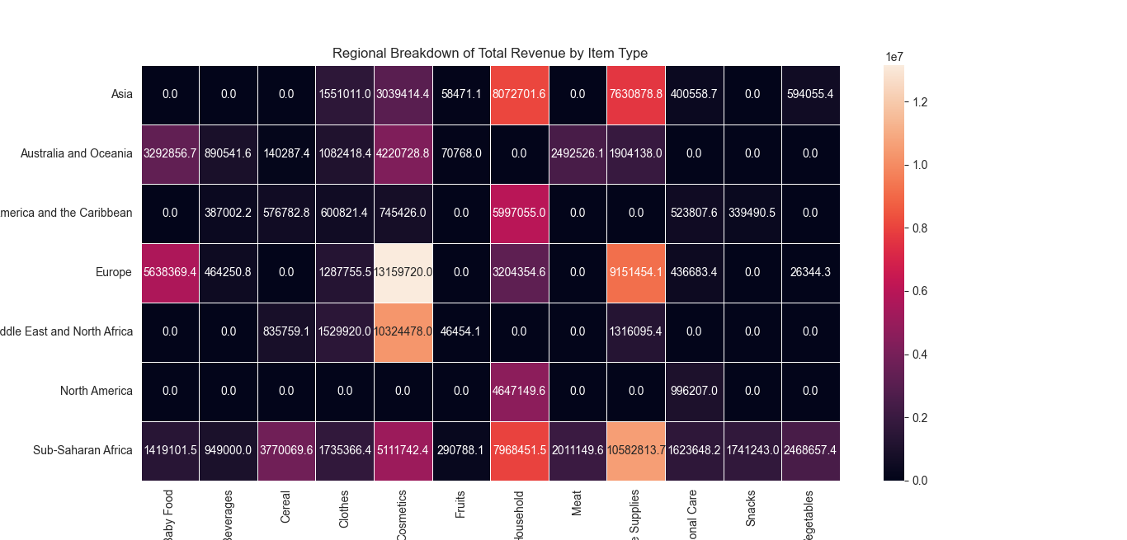

Analyzing the total cost for each region corresponding to each item type is necessary,

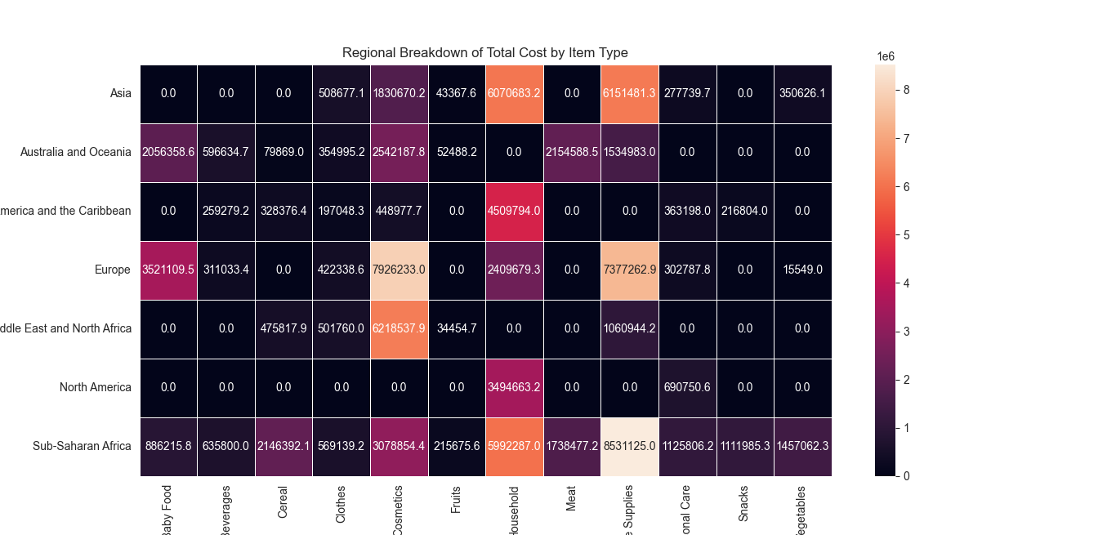

**Summary**

**Demand:**

|  |  |  |
| --- | --- | --- |
| **Region** | **Most Demanded Item** | **Least Demanded Item** |
| **Asia** | **Clothes** | **Vegetables** |
| **Australia and Oceania** | **Beverages** | **Cereal** |
| **Central America and the Caribbean** | **Household** | **Cosmetics** |
| **Europe** | **Cosmetics** | **Vegetables** |
| **Middle East and**  **North Africa** | **Cosmetics** | **Office Supplies** |
| **North America** | **Personal Care** | **Household** |
| **Sub-Saharan Africa** | **Beverages** | **Meat** |

**Revenue:**

|  |  |  |
| --- | --- | --- |
| **Region** | **Top-Seller** | **Low Yield** |
| **Asia** | **Household** | **Personal care** |
| **Australia and Oceania** | **Cosmetics** | **Cereal** |
| **Central America and the Caribbean** | **Household** | **Snacks** |
| **Europe** | **Cosmetics** | **Vegetables** |
| **Middle East and**  **North Africa** | **Cosmetics** | **Fruits** |
| **North America** | **Household** | **Personal Care** |
| **Sub-Saharan Africa** | **Office Supplies** | **Fruits** |

**Cost-to-company:**

|  |  |  |
| --- | --- | --- |
| **Region** | **Major Outlay Item** | **Minor Outlay Item** |
| **Asia** | **Office Supplies** | **Fruits** |
| **Australia and Oceania** | **Cosmetics** | **Fruits** |
| **Central America and the Caribbean** | **Household** | **Clothes** |
| **Europe** | **Cosmetics** | **Vegetables** |
| **Middle East and**  **North Africa** | **Cosmetics** | **Fruits** |
| **North America** | **Household** | **Personal Care** |
| **Sub-Saharan Africa** | **Office Supplies** | **Fruits** |

**Suggestions**

1. **Asia**: With the second-largest cost-to-revenue ratio, Asia's overall profit is adversely affected. To improve profitability, Amazon should focus on cost reduction strategies for vegetable items in this region.
2. **Australia and Oceania:** Amazon can enhance its profit rate in this region by reducing costs associated with office supplies.
3. **Central America and Caribbean**: Ranking second from the bottom in terms of profit, Central America presents an opportunity for revenue growth. Amazon should consider adjusting unit prices for household items to increase profitability.
4. **Europe:** Despite boasting the best average profile, Europe still has room for revenue improvement. Amazon could explore increasing unit prices for cosmetics to further boost revenue generation.
5. **Middle East and North Africa:** With the best performance in terms of profit growth relative to revenue, Amazon can optimize profitability by implementing cost-saving measures for office supplies in this region.
6. **North America:** Experiencing a significant decline in profit profile, urgent measures are required. Amazon should consider increasing unit prices for personal care items to reverse this trend.
7. **Sub-Saharan Africa**: Facing challenges in both revenue and profit profiles, Amazon can implement targeted strategies. Cost reduction for meat items can boost profitability, while slight price adjustments for beverages can improve overall performance.