Team VIS Software

Modern Software Requirements Specification

For Tracking Vehicle Information

Version <2.0>

Table of Contents

1. Introduction............................................................................................................ 4
1.1 Purpose....................................................................................................... 4
1.2 Scope.......................................................................................................... 4
1.3 Definitions Acronyms and Abbreviations.................................................. 4
1.4 Overview.................................................................................................... 4

2. Overall Description................................................................................................ 4
2.1 Business Case............................................................................................. 5ma

2.2 Assumptions and Dependencies................................................................. 7

3. Requirements.......................................................................................................... 8
3.1 Functional Requirements............................................................................ 8
3.2 Non-functional Requirements..................................................................... 9
3.3 Supportability.............................................................................................. 9
3.4 Design Constraints...................................................................................... 9
3.5 Purchased Components............................................................................... 10
3.6 Interfaces..................................................................................................... 10
3.6.1 User Interface.................................................................................. 10
3.6.2 Hardware Interface.......................................................................... 10
3.6.3 Software Interface........................................................................... 10
3.7 Licensing Requirements............................................................................. 10
3.8 Legal, Copyright, and Other Notices.......................................................... 10
3.9 Applicable Standards.................................................................................. 10

4. Use-Case Model Summary..................................................................................... 10
4.1 Introduction................................................................................................. 10
4.2 Survey Description...................................................................................... 10
4.3 Use Case Model Hierarchy.......................................................................... 11
4.3.1 Timed Service Events...................................................................... 11
4.3.2 Local Service Events....................................................................... 11
4.3.3 Local Message Client...................................................................... 11
4.4 Diagrams of Use Case Model...................................................................... 11
4.5 Use Case Specification................................................................................ 15

5. System Architecture................................................................................................ 15
5.1 Functional Architecture............................................................................... 15
5.2 Logical Architecture.................................................................................... 16

Revision History
Date | Version | Description | Author
14/4/2011 | 1.0 | Initial Document Creation | Joshua “Tank” Dutton
27/4/2011 | 1.5 | Document Cleanup & Additional information pertaining to predicted maintenance costs | Joshua “Tank” Dutton
27/4/2011 | 2 | Added Table of contents and more clarification on various elements | Jeffrey Conradt

1. Introduction
This Modern System Requirements Specification (SRS) encompasses the project information for the Red Cloud vehicle information tracking system. This system is being created at and for the Oregon Institute of Technology (OIT).

1.1 Purpose
This Modern SRS has been developed to help describe the use and behavior of the Red Cloud tracking system, the requirements, and the details of its architectures. Explanations behind the construction of the Red Cloud system are also included. Readers of this SRS will gain a better understanding about the system and its functionalities.

1.2 Scope
This project is designed to be used in electric vehicles for tracking information gathered from its sensors. Users will be able to track GPS location information, Battery Management System (BMS) information, as well as information from the electric controller.

1.3 Definitions, Acronyms, and Abbreviations
SRS……………………………………………….Software Requirements Specifications
OIT……………………………………………………….Oregon Institute of Technology
USB………………………………………………………………….Universal Serial Bus
BO………………………………………………………………………...Business Object
BOL………………………………………………………………..Business Object Logic
BMS…………………………………………………….......Battery Management System
CSET………………………………………..Computer Systems Engineering Technology

1.4 Overview
The information contained in this SRS document pertains to all useful information regarding Team VIS’s Junior Project. The following sections include the business case that explains the reasons behind developing this project, who the system is designed for, and the benefits of the system. The requirements of the system are also covered in this SRS. The requirements include the functionality, usability, supportability, design constraints, purchased components, interfaces, licensing requirements, legal information, and applicable standards. The final sections of the SRS include diagrams and information about the system architecture. This includes the functional, logical, component and physical architectures of the system.

2. Overall Description
The Red Cloud system is a fleet management system designed to keep track of electric vehicles. The system is designed so that all stored information is geologically and chronologically tagged, allowing for fleet managers to keep track of their employees as well as statistical information, such as speed, routing, battery charge, etc. regarding the fleet as a whole, as well as individual vehicles. The system is based entirely around client-server relationships, and is therefore scalable to any size fleet.

2.1 Business Case
Our business case presents information about the system, why it is necessary to Ambiente Motors, and the best way to implement the system.

System Being Developed:
The “RED-Cloud” (Remote Electronic Vehicle Diagnostics) system, as proposed by Professor James Long of the Oregon Institute of Technology CSET department and developed alongside Ambiente Motors and Cafe Electric, is designed for use as a telemetry system managing fleets of electric vehicles. This includes centralized monitoring of individual vehicle's locations, system diagnostics; as well as a centralized interface to provide drivers with route updates in real-time. The “Cloud” aspect of RED-Cloud involves sending data in real-time, to a remote location, and making data accessible at any point via a web-interface. There currently exist no alternative fleet management systems designed for electronic vehicles, making RED-Cloud unique.

Hardware:
Through the Zilla controller the RED-Cloud system is capable of retrieving any data relevant to an electrical system. RPM information, electrical and temperature status of the motor, and diagnostic information. (Zilla Manual) Relevant data are stored both locally and remotely. Automated alerts for new errors or diagnostic issues are immediately sent to both the driver and the main web-interface so that a fleet manager or technician may identify and fix a problem remotely, or recall a vehicle so that immediate maintenance can be performed.

By utilizing a Garmin GPS 18 LVC, RED-Cloud tags all data coming into the system, allowing for information to be correlated based on route as well as specific locations. The data collected from the GPS will be used to tag all stored data, as well as broadcast the vehicle's position to a centralized location in real time. The advantages of this are numerous, giving fleet-managers a real-time display of vehicle location at any given time allows for an improved distribution of resources at all times.

Each of these components is wrapped into a single “black box” which is installed on the vehicle along with Ambiente Motor's IC³, and Caffe Electric's Zilla controller, to provide an affordable and universal experience as a fleet-management system. This black box communicates directly with a centralized server automatically, requiring no input from a driver or technician to initialize. The system is self contained and does not provide any form of distraction to a driver.

Software:
RED-Cloud is a cost effective system, both in development, and in licensing. Because we use a modified Linux kernel as an OS, and LGPL (Lesser General Public License) Qt framework for GUI elements, the actual cost of beginning development is nothing. Approximately 90% of the code written for the GUI front end is portable to different environments without modification, due to the cross-platform development of Qt. (http://qt.nokia.com/) By using C/C++ as the primary development language behind the “black box” itself, modifying existing, and adding new hardware is a relatively simple task that can be accomplished with minimal effort for developers.

Target Market:
RED-Cloud offers a unique service to fleet managers, in that it alerts the user when there is a problem, logs any issue, and sends alerts to both the driver and the manager for each individual vehicle. By doing this, RED-Cloud allows for cost effective fleet-management by cutting costs and allowing fleet managers to keep track of data relevant to both drivers and vehicles.

A shipping company may use RED-Cloud to provide accurate time and location estimates to customers at any time. A fleet manager may also use the system to keep track of where vehicles are at any point, how long they have been there, and manage work flow effectively.

Public bus systems, as well as other transportation entities, would also find benefit from the RED-Cloud system. Tracking individual vehicles gives the advantage of being able to provide route planning and arrival times to the public as accurately as possible.

Ambiente Motors intends on marketing the fully integrated system with RED-Cloud, Cafe Electric's Zilla Controller, and their own IC³ system as a whole to developing nations, such as Brazil, who wish to focus on a “green” industry. In addition, RED-Cloud may be adopted at any time by companies who intend on transitioning to, or building an electronic fleet for use in delivery, transportation, etc.

Competing Systems:
Currently RED-Cloud is the only system of its kind which supports fleet-management and telemetry for electronic vehicles. Other companies, such as Zonar, Orchid, NAFA, and others all provide similar solutions, while none currently cater to an EV fleet.

The costs of these systems vary from one company to another, each offering similar systems, but omitting or focusing on different aspects, explained in detail below.

Fleetmatics
Fleetmatics has the following features:
Fleet Tracking Dashboard – Tracking of individual and group behaviors including speeding, idle time and run time.
Route Replay – Allows for the tracking of vehicles and their routes.
Fleet Reports – Allow for the tracking of all imformation and to have it be sent via email as a report.
GPS fleet tracking alerts – Allows for instant feedback on unwanted behaviors.
GeoFencing and Landmarks – Allow for the marking off of unwanted zones and for a report of how long the vehicle was there.
Fuel card integration – Allows for fuel card usage to be linked to GPS location and vehicle.
Garmin Integration – Allows for the integration of garmin directions for the drivers.
Fleet Management Report – Allows for reporting of information related to vehicles such as scheduled maintainence.
All data gathered from http://www.fleetmatics.com

Wireless Matrix:
Wireless Matrix offers the following features:
Dashboard – Allows for the tracking of the overall information of the fleet, allows for flags of vehicles that are not following regulations.
Mapping – Allows for the overlay of maps onto street views, allowing for a look at the surroundings.
Landmarks – Allows for the location of drivers in relation to well-known landmarks
Breadcrumbs – Allow for the tracking of vehicles as they travel, allows users to see where the vehicles have been.
Alerts – Allow for the reporting of any non-normal activities
Reports – Allow for the tracking of individual drivers statistics
Vehicle Maintainence – Allow for the tracking of vehicles maintainence
In-Cab Navigation(Gold & Platinum) – Allow for the drivers to receive directions
Workforce management (Platinum)– Allows for the tracking of drivers and inventories
Integration (Platinum) – Allows for web services to track drivers and their cargoes.
All data gathered from http://www.wirelessmatrix.com/

Fleet Management Solutions
Fleet Management Solutions offers the following solutions:
Active Satellite GPS tracking – Track vehicles and their locations as well as engine activity, idle and stop information.
Fleet Director Global Reporting – Provides interface to view vehicle information.
Vehicle diagnostics – Allows end users to see vehicle status as well as bad start/stops
Alerts and emergencies – Inform controllers when vehicles are in trouble or preform activities outside a range, like stopping too long or speeding.
Message Display Terminal – Interfaces controllers and drivers so they can communicate instantly.
Data Security – Data is transferred on secure lines as well as being stored in a secure server.
All data gathered from http://fmsgps.com/frontend/

Predicted Maintenance Costs:
Once completed, the entire system is small enough that it could be maintained by a single developer. In addition, one person would also be sufficient to accommodate for changes in hardware, as well as designing additional features for specific markets.

Proof.

2.2 Assumptions & Dependencies
The Red Cloud system is built on a Linux platform, and as such does not currently support Microsoft Windows or any other Operating System.

3 Requirements
The system requirements are located in the following section. This includes both functional and non-functional requirements. Each requirement is also labeled with a priority that shows what is needed immediately and can be added at a later time after the Alpha release.

3.1 Functionality
- The System Shall acquire data from registered devices at regularly scheduled intervals (high)
  - The System shall acquire motor information from a device (high)
    - The System shall support acquisition of motor data from a motor controller
      - The system shall support acquiring motor data from the Zilla Controller's RS232 interface. (high)
    - The system shall acquire motor RPMs (high)
    - The system shall acquire car Speed (high)
    - The system shall acquire current drawn by the motor (high)
    - The system shall acquire motor voltage (high)
    - The system shall acquire the motor's Average Duty Cycles (medium)
  - The system shall support acquiring data from a Electric Controller (high)
    - The System shall support acquiring data from Zilla Controller made by Cafe Electric LLC through an RS232 serial interface (high)
    - The System Shall acquire information related to controller such as:
      - Average current (high)
      - Available current (high)
      - Drive Pot Value(what is this) (medium)
      - Temperature (high)
      - Operation Status (medium)
        - (Define specifics here)
      - Error Codes (medium)
        - (Define specifics here)
  - The system shall support acquiring data from a Battery Management System(BMS). (high)
    - The system shall support acquiring data from the Lithiumate BMS made by Elithion through a UDP interface (high)
    - The system shall be able to gather information about each cell (high)
      - Voltage (high)
      - Resistance (high)
      - Temperature (high)
      - Current (high)
    - The system shall gather information about the Battery Management State (high)
      - Fault Codes provided by the BMS (medium)
        - (Define specifics here)
      - Number of On/Off cycles (medium)
      - Time since power came on (medium)
      - State of Charge (high)
      - Average Battery Voltage (high)
      - Average Battery Resistance (high)
      - Average Battery Current (high)
  - The system shall acquire the car's vector information from a GPS (high)
    - The system shall support the following GPSs (high)
      - The system shall support acquiring vector information from a Garmin GPS-18 (high)
    - The system shall acquire the longitude from the GPS (high)
    - The system shall acquire the latitude from the GPS (high)
    - The system shall acquire or calculate speed from the GPS (low)
    - The system shall acquire or calculate bearing from the GPS (high)
- The system shall report data at regular intervals after the data has been updated. (high)
  - The system shall report all data with a time and location stamp (high)
  - The system needs to support reporting the following data (high)
    - The system shall report motor data as outlined in req. 1.1.2-6 (high)
    - The system shall report controller data as outlined in requirement 1.2.2 (high)
    - The system shall report battery management state as outlined in requirement 1.3.3 (high)
    - The system shall report individual battery data as outlined in requirement 1.3.2 (high)
  - The system shall report it's updated findings locally on the system (high)
  - The system shall report it's findings through an XML stream as outlined in the Velo project (high)
    - The system shall support the limitations of using a mobile broad band card (medium)
      - The system shall deal with a lost connection without stopping the collection of data (medium)
      - The system shall support reducing what data is being sent over the internet. (low)
  - The system shall provide a local method of reporting data to other systems on the machine (medium)
- The system shall have a web site that allows users to view data remotely (high)
  - The system shall display data in the form of strip chart (high)
  - The system shall allow the user to select the variables to view (medium)
  - The system shall allow for two vectors for comparison purposes on one graph (low)
  - The system shall support the viewing of multiple graphs on one page (low)

3.3 Supportability
The coding standards of this system are based on the OIT CSET style guide. The OIT CSET style is followed in both the documentation and layout of code. All naming conventions also follow the OIT CSET style guide.

3.4 Design Constraints
The application is displayed on a touch screen, based in C++ code. There are also parts of the system that use MYSQL Database.

3.5 Purchased Components
Our system did not require us to purchase components.

3.6 Interfaces
Below will describe the different user interfaces that a user will see and will be able to interact with.

3.6.1 User Interfaces
The main user interface for our system is the touch screen. The user can interact only with the touch screen. This interface will consist of 3 tabs. 1 tab displays GPS information. 1 Tab displays the battery management system information, and the other tab displays the electric controller information.

3.6.2 Hardware Interfaces
The system will interface with different hardware. There is the GPS that the system will interface to get the live feed. It will also interface with a BMS and electric vehicle controller through serial as well as connecting to the touch screen for displaying the information..

3.6.3 Software Interfaces
The system provides its own libraries and interfaces for accessing information, and uses a Graphical environment as its only public interface.

3.7 Licensing Requirements
Red Cloud is a free open source application. The system must adhere to the open source licensing requirements.

3.8 Legal, Copyright and Other Notices
VIS is a student group that has created this system for the Oregon Institute of Technology.

3.9 Applicable Standards
There is only the OIT CSET coding standards that our system follows.

4. Use-Case Model Survey
The systems use-case model shows the changes that the system goes through. These changes are correspondent to the actors actions. This survey details the requirements trace, interactions between packages and the definitions of our actors for each use case.

4.1 Introduction
Our system is divided into 2 use-case packages. These packages are: Timed Service Events and Local Service Events.

4.2 Survey Description
The use-case model survey itemizes the state changes. The users actions will directly change the state of the system

4.3 Use-Case Model Hierarchy

4.3.1 Timed Service Events

This package contains the use cases for updating information relating to input devices.. All of these cases are linked to high priority requirements.
The list below is what use cases are contained in the package (there are no dependencies).
- Report Data
- Update BMS Data
- Update Electric Controller Data
- Update GPS Data

4.3.2 Local Service Events

This package contains all use cases for events the system will preform for itself
The list below are the use cases contained in the package (there are no dependencies).
- Start Acquisition Service
- Stop Acquisition Service.

4.3.3 Local Message Client

This package contains all use cases for events the system will preform for data tranfer
The list below are the use cases contained in the package (there are no dependencies).
- Update Local Application
4.4 Diagrams of the Use-Case Model
The diagram displayed below models our use-cases and actors involved. Each picture following represents what is inside of each use-case package.

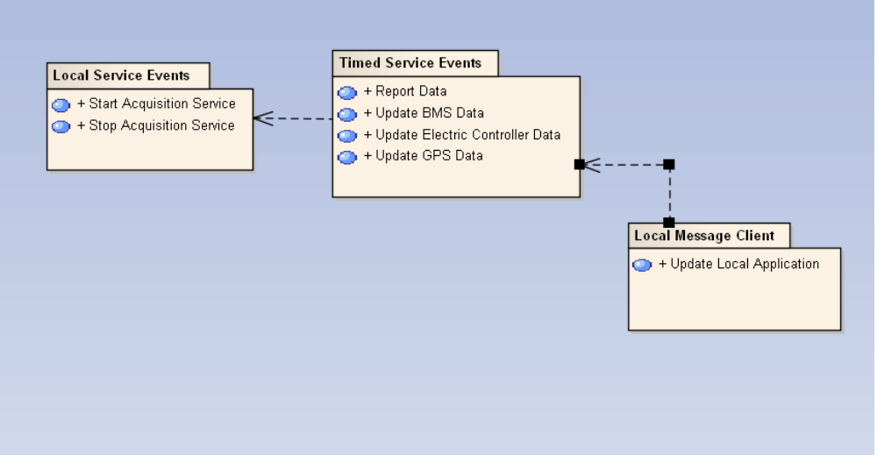
Figure 4.4.1 – Use-Case Relationship Diagram
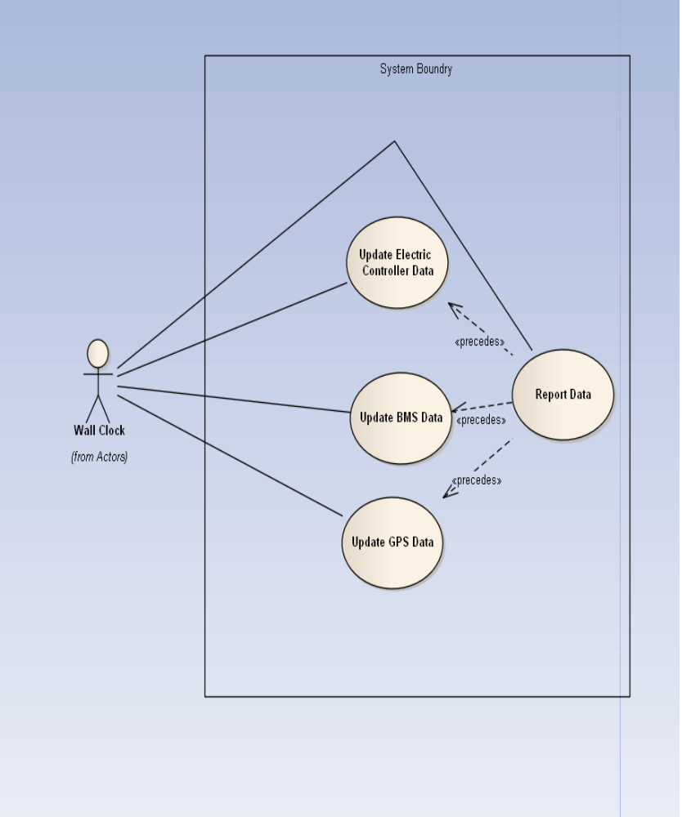
Figure 4.4.2 – Timed Service Events Use-Case Diagram
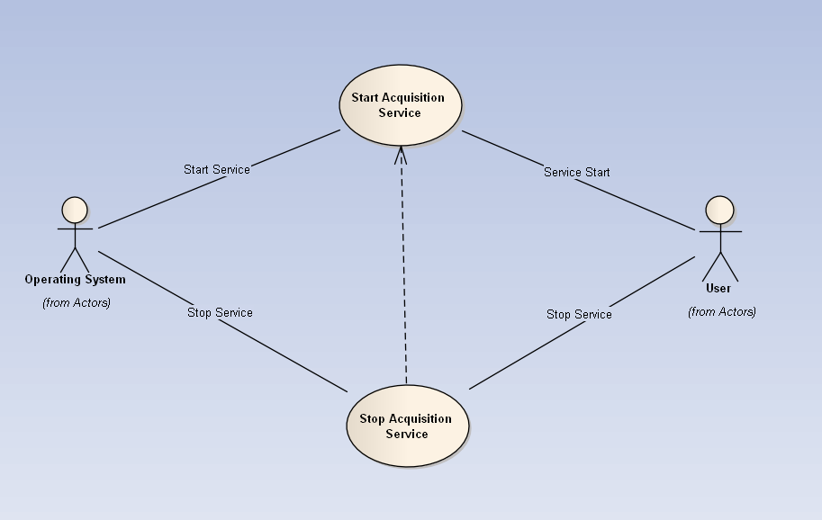
Figure 4.4.3 – Local Service Events Use-Case Diagram
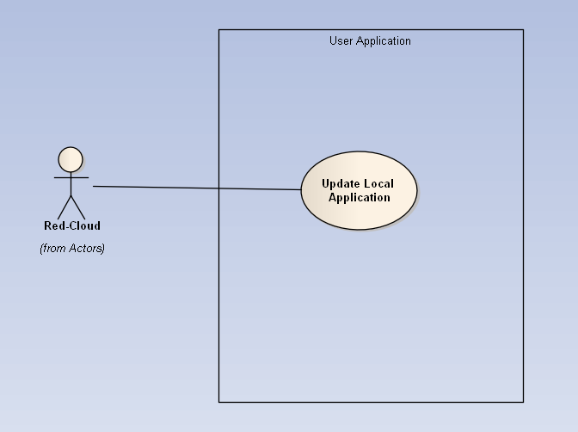
Figure 4.4.4 – Local Message Client Use-Case Diagram

4.5 Use-Case Specification

UC – Start Acquisition Service
Begin acquiring data from system, user will be able to see data stream from components.

UC – Stop Acquisition Service
Stop acquiring data from sensors, Will allow user to properly shut down system.

UC – Report Data
Allows user to view data as its being sent from the system.

UC – Update Electric Controller Data
Updates system of current information being sent by the electric controller.

UC - Update GPS Data
Updates system of current information being sent by the GPS.

UC – Update BMS Data
Updates the system of current information being sent by the BMS

5. System Architecture

The architecture of our system is broken down into functional, logical, component and physical. Each architecture will contain figures that depict how our system is set up. Our system will follow all architecture rules shown below.

5.1 Functional Architecture
Our functional architecture is broken into 3 packages, Acquisition, Reporting, and Viewing. The Acquisition package focuses on gathering data from the sensors. The Reporting package focuses on taking data provided by Acquisition, tagging it with the current geological and chronological information, and passing that data to the remote server and local databases respectively. Viewing focuses on the requirements related to viewing of data stored on the remote server.
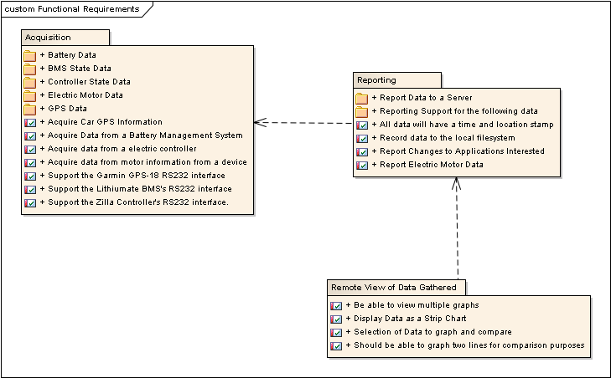
Figure 5.1 - Functional Architecture

5.2 Logical Architecture
The logical Architecture is broken into 3 sections. First, we have our User Interface layer: This layer handles our GUI, and any user driven commands relating to acquisition and testing. The second layer is Acquisition and Processing: This layer focuses on collecting data from the sensors, geo-tagging, time-stamping, data integrity verification, and the sending of notifications to the UI and Persistence layers that new data has become available. The final section of our Logical Architecture covers the Persistence layer: The Persistence layer contains both the local and remote databases.
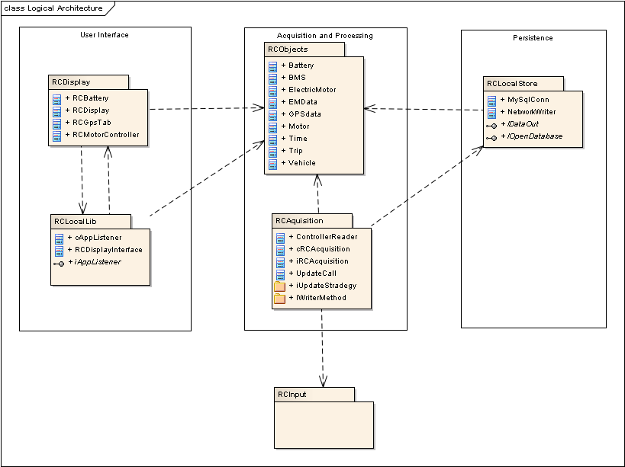
Figure 5.2 – Logical Architecture
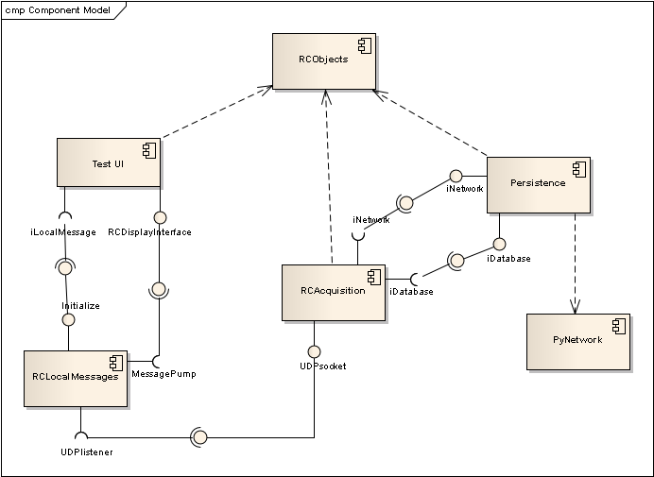
Figure 5.3 – Component Model

