IP POSITION BRIEF
Warpage Control in Large-Area Packages
Lid Monolithization, the Bonding Sequence It Implies, and Claim Analysis

This document addresses warpage control at the interposer-to-substrate bonding stage (L2) of large-area heterogeneous packages. From a publicly observable design change - the transition of the lid from a segmented to a monolithic structure - it infers the bonding process sequence and analyses how that sequence relates to the claim scope held by Cools Inc. The assessments set out below are engineering inferences by Cools Inc. and are not confirmations of any particular manufacturer's process sequence.
Cools Inc. | Changwon, Republic of Korea
July 2026

1. Summary
Warpage control in large-area packages admits three physical routes: increasing bending stiffness by means of a stiffening member, localizing thermal input at the bonding instant, and substituting the substrate material or structure at its root. Cools Inc. holds claim scope across all three.
The central proposition of this document is as follows. Converting the lid from a segmented to a monolithic structure yields no engineering benefit if the conventional bonding sequence is retained. A monolithic lid possesses no degrees of freedom by which the curvature component can be absorbed, and attachment to a substrate on which warpage has already been locked in by joint solidification is therefore difficult to reconcile with the physics. Cools accordingly assesses that, in a process adopting a monolithic lid, lid attachment is likely to occur at the bonding instant.
Once lid attachment moves inside the bonding process, the upper thermal path is obstructed and the means of heating the joint is confined to wavelength-selective irradiation transmitted through the underside of the substrate. At that point, pre-solidification joining of the stiffening member and joint-selective heating arise together; both elements, and their combination, are independently claimed by Cools Inc.
Adoption of monolithic lid structures in large-area packaging has been reported publicly. Should such a process be operated with lid attachment at the bonding instant, Cools assesses that the process may be using technology held by Cools Inc.
This assessment is an engineering inference drawn from publicly observable structure. Cools will review and revise it upon receipt of information concerning actual process sequence.

2. The Physical Routes to Warpage Control
Warpage in large-area packages arises from thermal input during the bonding interval and from the mismatch in coefficient of thermal expansion among constituent materials. The available countermeasures are classified below by the instant at which and the location where they act.
Route | Means | Operating principle and limitation
(1) Passive stiffening | Stiffener ring, lid, low-CTE core materials | Restrains deformation by raising bending stiffness E·I. A trade-off exists in that greater constraint returns greater thermal stress to the substrate, and a ring geometry restrains the perimeter but not the central bow of a body on the order of 100 mm.
(2) Thermal localization | Joint-selective heating by wavelength-selective transmitted irradiation | Delivers energy only to the bonding interface, excluding bulk heating. Because it suppresses the generation of deformation, it bypasses the trade-off inherent to route (1).
(3) Substrate substitution | Ceramic or glass boards, via-less structures | Removes the CTE burden and via reliability weak point of the organic substrate. Entails architectural change and therefore a longer adoption cycle.
Route (1) constrains deformation after it has occurred, route (2) suppresses its generation, and route (3) removes its cause. No fourth route has been identified.

3. Deriving the Bonding Sequence from Lid Monolithization

3.1 Structure of the conventional sequence
In the conventional assembly sequence, the interposer module is bonded to the substrate, cooling and solidification are completed, and the lid is then attached in a separate process. Because the lid is joined to a joint that has already set, it cannot act on the deformation generated during the L2 bonding interval and restrains only additional deformation arising in subsequent thermal cycling. The constraint is applied after the fact.
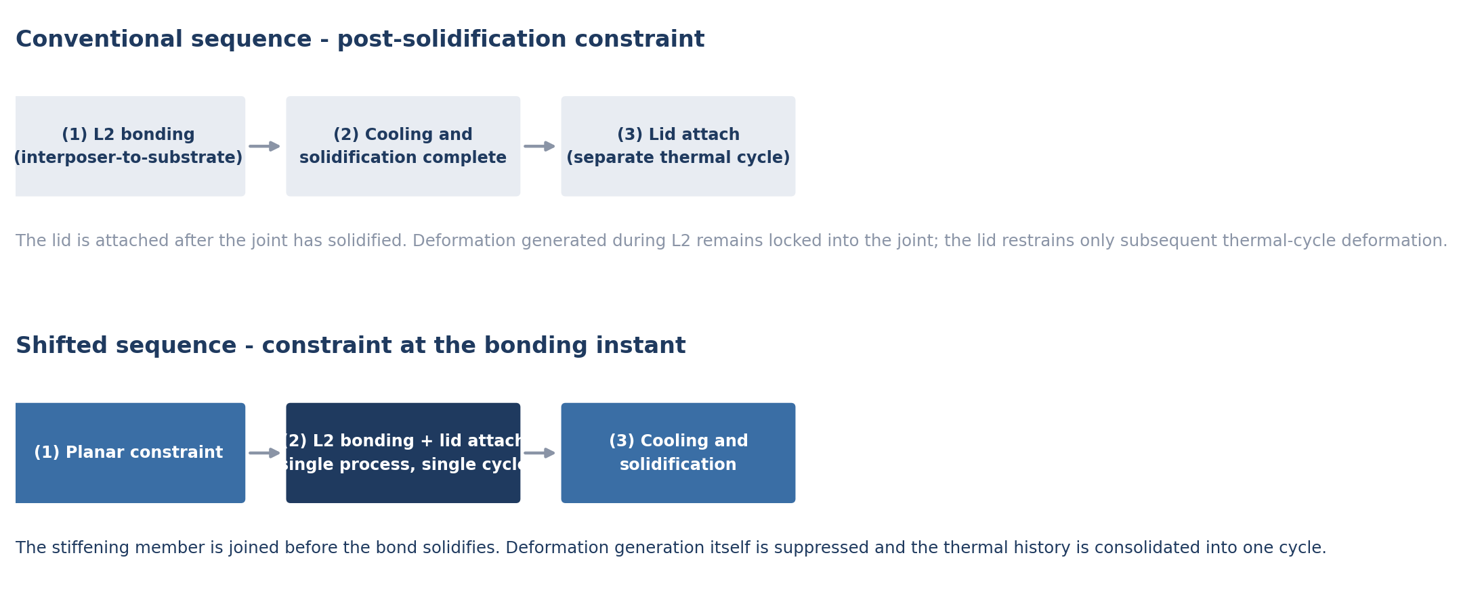
Figure 1. Process configuration of the conventional and shifted sequences

3.2 Degrees of freedom - a monolithic lid cannot absorb form
For a segmented lid of N segments, each segment independently possesses three translational and three rotational rigid-body degrees of freedom. The resulting 6N degrees of freedom absorb the curved substrate surface by piecewise planar approximation. Segmentation has been adopted not only for stress relief but for this form-absorbing capability.
A monolithic lid has N = 1 and therefore six degrees of freedom. Applied to a curved surface, six freedoms permit no more than a least-squares plane fit; the curvature component is not absorbable in principle. The residual adhesive gap scales with bow amplitude. Where, for a body on the order of 100 mm, residual bow after L2 bonding exceeds the bondline thickness tolerance, attaching a monolithic lid after solidification does not hold.
If attachment after solidification is nonetheless forced, one of two outcomes follows. Either the bondline thickness varies so widely across position that the structural and thermal functions of the lid are lost, or the rigid member flattens the warped substrate by force and imposes shear on a joint that has already solidified, degrading joint reliability.
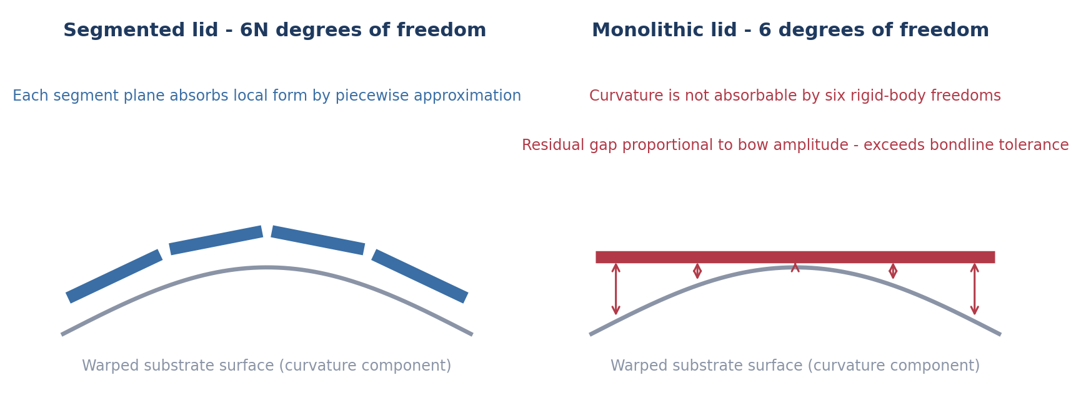
Figure 2. Form-absorbing degrees of freedom: segmented versus monolithic lid

3.3 Loss of benefit - monolithization is a net cost under the conventional sequence
The dominant component of large-area warpage is generated during the L2 bonding interval. Under the conventional sequence the lid is attached after that component has set, so raising stiffness does not act on it; the lid acts only on additional deformation in subsequent thermal cycling.
Monolithization, meanwhile, carries added member cost, an altered thermal resistance path, a heavier TIM gap control burden, and more demanding cure conditions owing to the enlarged adhesive area. Adopting a monolithic lid while retaining the conventional sequence therefore increases cost and process burden without acting on the dominant component. The likelihood that such a configuration would be selected for volume production is low.

3.4 Thermal history
The conventional sequence imposes two thermal histories: the L2 bonding ramp and the lid adhesive cure. The second is applied to a joint that has already solidified and therefore induces re-deformation. A monolithic lid enlarges the adhesive area and strengthens the cure requirement, increasing that re-deformation component. The only way to adopt monolithization while avoiding it is to consolidate the two histories into one, which is equivalent to performing lid attachment within the same process as L2 bonding.

3.5 TIM gap tolerance
In a monolithic lid the standoff to the die top surface is fixed by the stiffness of the member. Under the conventional sequence, residual warpage after bonding varies that standoff across position and the rigid lid does not accommodate the variation. TIM gap tolerance holds only if die top coordinates are established under planar constraint, which requires that lid attachment occur at the bonding instant.

3.6 Assessment
The four arguments set out in 3.2 through 3.5 rest on independent physical grounds and converge on the same conclusion. To rebut them individually, it would be necessary to show, under a retained conventional sequence, how a monolithic lid absorbs the curvature component, how it acts on the dominant warpage component, how it avoids re-deformation from the additional thermal history, and how it secures TIM gap tolerance.
Observed structure | Compatibility with the conventional sequence | Discriminating power as to sequence
Segmented lid | Holds. Per-segment freedoms absorb residual form. | None. Both post-solidification and in-process attachment remain possible.
Monolithic lid | Does not hold. No means exists to absorb the curvature component. | Concentrated. Post-solidification attachment is difficult to sustain, leaving in-process attachment.
Relinquishing the form-absorbing capability that segmentation provided, in favour of a monolithic structure, holds where no form error remains to be absorbed at the instant of attachment. That condition obtains while the substrate is held under planar constraint, and within the range examined that state exists inside the L2 bonding process.

4. Thermal Path Constraint Imposed by the Shifted Sequence
With the lid covering the upper surface at the bonding instant, the upper thermal path of a conventional thermocompression bond head is obstructed. The paths by which heat can reach the joint are enumerated below.
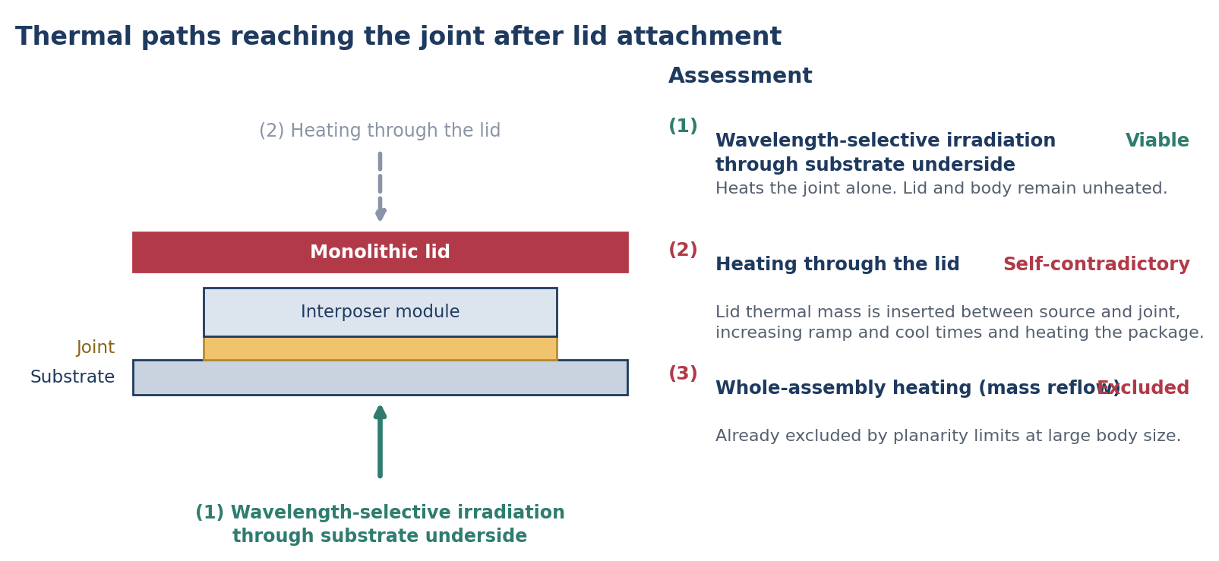
Figure 3. Enumeration and assessment of thermal paths reaching the joint after lid attachment
– (1) Wavelength-selective irradiation through the substrate underside - a wavelength that transmits through the substrate and interposer body and is absorbed at the bonding interface heats the joint alone. Lid and body are not heated.
– (2) Heating through the lid - the thermal mass of the lid is interposed between source and joint, increasing ramp and cool times and heating the whole package. This nullifies the very purpose of the sequence shift, namely deformation suppression at the bonding instant, and is therefore self-contradictory.
– (3) Whole-assembly heating - already excluded by planarity limits at large body size, independently of whether the sequence has shifted.
Paths (2) and (3) are eliminated as self-contradictory and pre-excluded respectively, leaving path (1). This follows from exhaustion of the available heat transfer paths rather than from a design preference.

5. Element Analysis
Combining the assessment in section 3 with the thermal path constraint in section 4, a process that has adopted the sequence shift is analysed as exhibiting the following elements simultaneously.
Element present | Physical basis | Related family
Stiffening member joined to the substrate before joint solidification | A monolithic lid requires the absence of form error at the instant of attachment, a state that exists only under planar constraint. | Stiffener family  54 claims
Joint-selective heating by wavelength-selective irradiation through the substrate underside | The sole path remaining once the upper thermal path is obstructed. | Optical bonding family  41 claims
Structure combining pre-attachment of the stiffening member with selective heating in a single process | Both elements follow from the same decision to shift the sequence. | Integrated family  55 claims
Total | The three elements do not arise from separate adoption decisions; they arise together with the sequence shift. | 150 claims
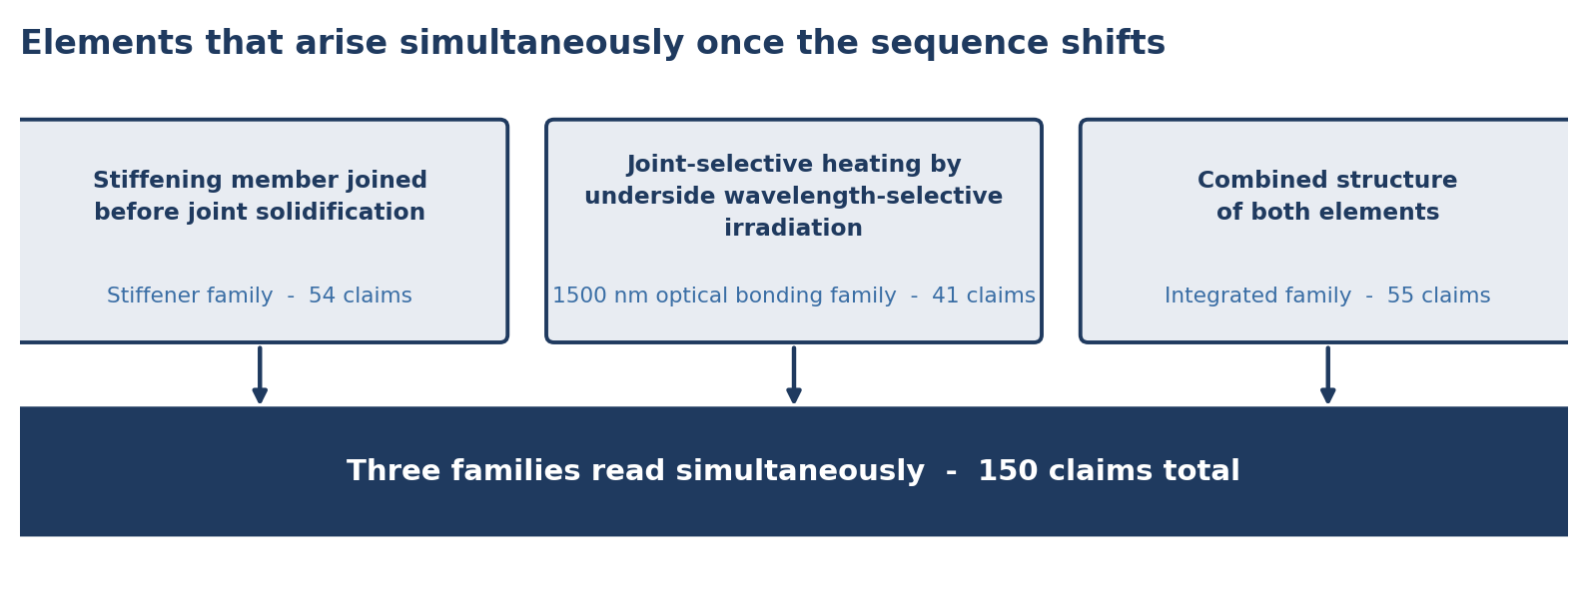
Figure 4. Elements arising simultaneously upon adoption of the sequence shift, and the related families

6. Design-Around Lattice
The design changes available to a process that has adopted the sequence shift, and the point each change arrives at, are set out below.
Design change | Consequence | Assessment
Revert the lid to a segmented structure | Form-absorbing capability is restored but bending stiffness falls, nullifying the purpose of monolithization and returning to the trade-off of route (1) in section 2. | Purpose nullified
Return lid attachment to after solidification | The absorption failure of 3.2 recurs and attachment of a monolithic lid does not hold. | Not viable
Adopt heating through the lid | Interposed lid thermal mass increases ramp and cool times and heats the body. Corresponds to path (2) of section 4. | Self-contradictory
Return to whole-assembly heating | Already excluded by planarity limits at large body size. Corresponds to path (3) of section 4. | Pre-excluded
Substitute a ceramic or glass substrate | Moves to route (3) of section 2, for which separate claim scope also exists. | Route transfer
The five changes resolve respectively to purpose nullification, non-viability, self-contradiction, pre-exclusion and route transfer. Within the range examined, no design path emerges by which the elements are avoided while the sequence shift is retained.

7. Portfolio Structure
Cools Inc. holds a portfolio of more than 1,500 patent filings. The subject of this brief is the three families totalling 150 claims that fall on the large-area package warpage and bonding axis. All rights are owned solely by Cools Inc.; no individual holding or exclusive licence structure exists.
Family | Claims | Role within the portfolio
Stiffener | 54 | Defends the stiffening-member route taken alone. Covers the geometry variants: region partitioning, stress-relief slots, thickness gradients, cellular lattices, annular frames with inter-die bridge ribs, neutral-axis offset, and high-conductivity low-CTE inserts.
Wavelength-selective optical bonding | 41 | Defends the joint-selective heating route by underside transmitted irradiation, with independent claims on the method, the apparatus and the bond head.
Integrated (stiffener × optical bonding) | 55 | Claims the combination of the two elements as a distinct invention, so that a combined configuration adopted to avoid either single family falls within the integrated scope.
Total | 150 | Two single-route families close the individual design-arounds and one integrated family claims the combination.
Adjacent to this axis, a thermal-path-switching pressurized cooling platform of four filings and 137 claims, together with the via-less ceramic and glass board architecture line, forms the neighbouring portfolio.

8. Forms of Engagement and Enquiries
The subject technology can be made available in three forms: licensing, equipment and module supply, and joint process development. The forms differ in exclusivity scope and supply structure.
Form | Content | Scope
Licence | Licence under the three families | Exclusivity delimited by product line, term and territory.
Equipment and module supply | Supply of the wavelength-selective irradiation head and the stiffening module | Supply reserved to Cools Inc. irrespective of any licence granted.
Joint process development | Line suitability evaluation and derivation of process conditions | Conducted in four-week increments following execution of a non-disclosure agreement.
The sequence of engagement is execution of a non-disclosure agreement, technical review of claim scope and physical basis, line suitability evaluation, and negotiation of terms.
The assessment of process sequence set out in this document is an inference drawn from publicly observable structure. Where a party holding information as to actual process sequence provides it, Cools Inc. will review that information and revise the relevant passages of this document accordingly.

