1. In the Ricardian model when a country requires fewer resources to produce a given level of output of a product compared to other countries, it is said to have a(n):
   1. Lower opportunity cost of producing the product
   2. Higher opportunity cost of producing the product
   3. **An absolute advantage in the production of the product**
   4. A comparative advantage in product’s production
2. What is the marginal product of labor?
   1. the total output obtained by using one more unit of labor
   2. the total output divided by total amount of labor input
   3. **the extra output obtained by using one more unit of labor**
   4. the product price multiplied by the average product of labor
3. In the Ricardian model the slope of the PPF can be expressed as:
   1. **the ratio of the marginal products of labor in producing each good**
   2. the ratio of the quantities of good 1 and good 2.
   3. the ratio of total capital to labor.
   4. Price times the average marginal product of labor between the two sectors
4. Compared to no-trade, international trade allows countries to:
   1. Produce outside their PPF
   2. **Consume outside their PPF**
   3. Both of the above
   4. Produce inside their PPF
5. Suppose the marginal product of a worker is MPLB = 14 bunches of bananas per worker per day and the country is specialized in the production of Bananas. The country exchanges Bananas for Gadgets at world relative price or $\frac{P_{B}}{P_{G}}=2$ gadgets per banana. What is $\frac{w}{P_{G}}$, the real wage of a worker (measured in gadgets purchasing power)?
   1. 7 gadgets per day
   2. 14 gadgets per day
   3. **28 gadgets per day**
   4. 2 gadgets per day
6. Suppose that there are two factors, capital and land, and that the United States is relatively land endowed while the European Union is relatively capital-endowed. According to the Heckscher-Ohlin-Samuelson (HOS) model
   1. all capitalists in both countries should support free trade.
   2. the U.S. should compensate European countries once trade commences.
   3. Europe landowners should support free trade.
   4. all landowners should support free trade.
   5. European capitalists should support free trade.
7. In the two-country model of international labor mobility (think SFM but for migration between the ‘North’ and the ‘South’)
   1. migration has no effect on global output, though some groups are made worse off.
   2. **migration increases global output, makes some groups worse off.**
   3. migration may reduce global output, some groups are made better off.
   4. migration results in increased global output, and all groups are made better off.
8. The PPF of a country will be skewed toward that good that:
   1. uses its intensive factor abundantly.
   2. uses its scarce factor intensively.
   3. **Uses its abundant factor intensively**
   4. Does not use its intensive factor abundantly.
9. According to the graph (which shows Home and Foreign in autarky), which nation has a higher no-trade relative price for computers (in terms of shoes)?

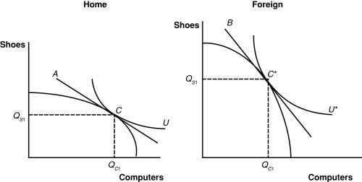

* 1. Home
  2. **Foreign**
  3. Both countries have the same relative price
  4. Cannot tell without knowing more about consumer preferences.

1. Assume a Ricardian model with fixed labor requirements in which the United States had an absolute advantage in both industries compared to Mexico. Mexico is specialized in producing Avocados and the US is specialized in producing SUV trucks. Suppose now that Mexican workers in both Avocados and the Mexican SUV truck sector improve their productivity (US productivity unchanged). The pattern of comparative advantage does not change. The expected effect includes:
   1. US workers real wages fall as they face increased competition from now more productive Mexican labor
   2. **Relative product prices change and US workers real wages increase**
   3. Mexican workers become unemployed and Mexican wages fall as higher productivity renders many workers redundant.
   4. The rental rate of capital in Mexico rises.
2. The evidence from the ‘China Shock’ papers by Autor and his co-researchers found geographically persistent impacts of a surge of Chinese imports. This is most consistent with the evidence from which of the following models:
   1. Ricardian
   2. **Specific Factors**
   3. Heckscher-Ohlin-Samuelson
   4. IRS with monopolistic competition
3. The effects of a 10% import tariff on a good is similar to:
   1. A 10 % consumption tax on both the imported and domestically produced good
   2. A 10 % production subsidy on the domestically produced good
   3. **The combination of a. and b.**
   4. A 10% wage subsidy to workers in the domestic production of that good.
4. According to economic historians Engerman and Sokoloff which place in the Americas (described today with their modern day names) had the highest average per-capita output in 1790 (hint: which region had the highest marginal value productivity per worker)?
   1. Britain b. USA. c. Mexico d. **Haiti**

Trade Midterm. NAME: Answer page 2.

**Section II: Short Answers**

II.1 (20 points) Suppose you are in an HOS setting. The Home country produces Food (F) and Steel (S) using capital and labor and both factors are mobile across sectors. Food is the more labor intensive production technology. The economy is initially closed to trade and the country has a comparative advantage in Steel production, so when it opens up to trade the relative price of Steel will increase.

Fill in the boxes below with an U, D or N (to indicate UP, DOWN or NO CHANGE) to indicate how each of the following variables will move in response to this product price change.

$Q_{S}$, $\frac{w}{r}$, $\frac{K_{F}}{L_{F}}$, $\frac{K_{S}}{L_{S}}$, $\frac{w}{P_{F}}$, $\frac{w}{P_{S}}$

The diagram below depicts the initial no-trade equilibrium and autarky relative prices with production and consumption at point B0. [Plan out your diagram to avoid messy or ambiguous diagrams and be sure to indicate tangencies between lines clearly]: Indicate the impacts of the rise in the relative price of steel by clearly drawing: (A) the new production point on the PPF (mark the point and label it B1 . (B) draw a new price line to reflect the higher relative price of steel passing through this point. (C) indicate a likely new consumption point and label it C1 (you do not need to draw an indifference curve through this point). (D) using vertical dashed indicator lines running from points B0 and B1 down to the horizontal axis label the value of domestic steel output QS and consumption CS on the horizontal axis. Finally indicate the quantity of imports or exports of steel by drawing an arrow range like this and label it either “imports” or “exports” of steel.

In this HOS model are steel workers real wages affected differently or the same as food workers real wages? Answer and briefly explain why:

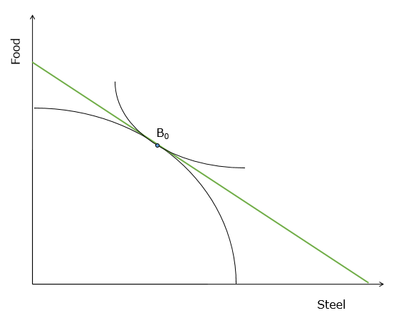

II.2 (20 points) The partial equilibrium diagram below indicates import quantities   
(D1 – S1) of steel both at the world market price Pw and after the imposition of a specific tariff *t*. Fill in the boxes with the correct area a, b,c, or d, or by a sum of areas (e.g. d+a). If the answer is zero enter 0.

NAME:

Tariff Revenue Gains in producer surplus

Total DWL

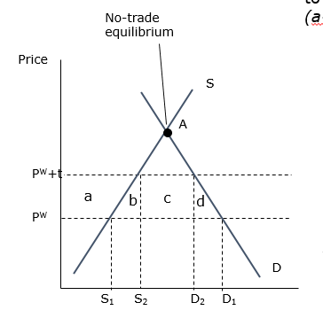

Now reuse the diagram to describe the effects of **only a production subsidy** compared to a no intervention-situation (free trade).

Government subsidy payments: Gain in producer surplus from subsidy:

Loss in consumer surplus: Total DWL:

**In the initial tariff analysis, what is area b in the diagram, and how do we interpret it? Be brief.**

NAME:

**III. (30 points) last question**

Consider an economy -- initially closed to trade -- that produces Agriculture and Manufacturing. Agriculture uses specific (inmobile) land and labor; Manufacturing uses specific capital and labor. Labor is mobile across sectors. The diagram below depicts an initial equilibrium where there are La =200 workers in agriculture and Lm=200 workers in Manufacturing and an equilibrium nominal wage of *w*.

1. Suppose the country now opens to trade and that this leads to a *RISE* in the relative price of Agricultural goods. Think of this as *Pa* rising and *Pm* remaining unchanged. Draw on top of the diagram below to show how a new equilibrium nominal wage and labor allocation across sectors is determined (shift one or more of the curves as required by a reasonable amount to make the impacts clear and indicate the new labor allocation and nominal wage.

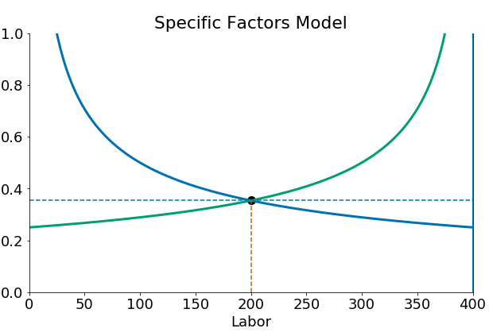

*w*

𝑝*m*⋅𝑀𝑃𝐿*m*(𝐿m)

𝑝*a*⋅𝑀𝑃LA(𝐿𝐴)

Fill in the boxes below with an U, D or 0 (to indicate UP, DOWN or no change) to indicate which way each of the following variables moved in response to the rise in *Pm/Pa*. Note that *r* is the rental rate of capital in manufacturing and *v* is the rental rate of land in manufactures.

$\frac{w}{P_{m}}$, $\frac{w}{P_{a}}$, $\frac{r}{P_{m}}$, $\frac{r}{P_{a}}$, $\frac{v}{P_{m}}$, $\frac{v}{P_{a}}$

(answers page 5)

1. Consider the same SFM economy again as depicted below. Assume this time this is a small country already open to trade so prices Pm and Pa are set on world markets and will not change in the analysis. Use the diagram below to depict the effect of the arrival of 200 new workers into the economy (raising the total labor supply from 400 to 600).



𝑝*m*⋅𝑀𝑃𝐿*m*(𝐿m)

𝑝*a*⋅𝑀𝑃LA(𝐿𝐴)

1. Fill in the boxes below that are not yet filled with an U, D or 0 (to indicate UP, DOWN or no change) to indicate which way each of the following variables moved in response to this influx of labor,. Note that *r* is the rental rate of specific capital in manufacturing and *v* is the rental rate of specific land in manufactures.

*w La Lm Ta*

, , , , U $\frac{v}{P_{m}}$, U $\frac{v}{P_{a}}$

1. Explain briefly in words why the real rental rate of land must increase (you may use bullet points and symbols like $→, ↑$ to save space).

You may use this as a scratch area. (answers page 6)