Bi-monthly commentary:
My results have been weak, returning a disappointing -1.9% TSR, 100 bps behind the S&P500 and almost 800 bps behind the Russell 1000 value. Across the four securities in which I am invested, there is no overarching theme of mistake, though I welcome suggestions from anyone else who may identify one. Notably, my holdings are sensitive to the health of the consumer (FDX, FUN), Bitcoin (STRC), and artificial intelligence sentiment (WDAY).

I am not making any allocation changes.

Thesis one-liners:
WDAY: Workday is a top-tier software company, and I believe the investment does fine in a world where AI renders them quickly obsolete (long contracts + 97% historical gross retention), providing a value floor even if the company’s AI monetization efforts are unsuccessful. The WDAY founder/CEO Aneel Bhusri has demonstrated the humility to tap out and significantly change the company’s course when he’s not the man for the job.
FDX: I believe FDX is a strong and improving business today (going through major consolidation and cost-cutting), and I think their opportunity to improve automation inexpensively is under appreciated. I expect FDX to build AMZN-class automation for a fraction of the cost as automation, integration, and robotics costs fall dramatically.
STRC: I believe Microstrategy (the issuer) has and recognizes a very strong incentive to bring this instrument from $92 to par. Aligned interests with equity and a 70% BTC drawdown (which would equal 90% peak-to-trough) in order to impair the STRC capital are positive setups for the security.
FUN: A turnaround, I think (highly levered) Six Flags has valuation support from the value of its land and upside from proper execution. I think there’s a chance FUN could be acquired by NFLX or WBD.
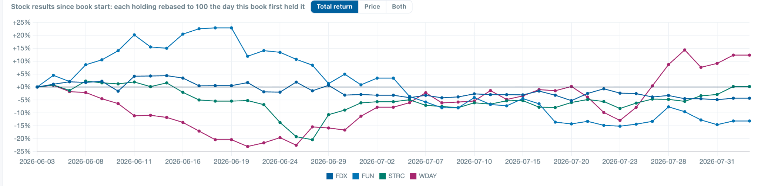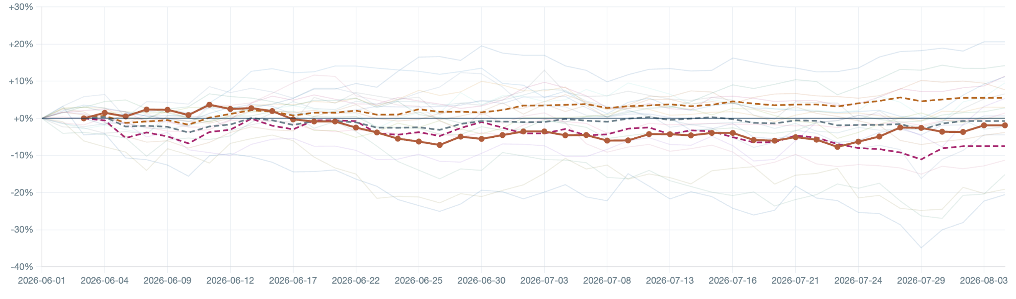

FDX — Fedex $74bn Mcap, ~14x ’27 P/E (15x on street ’27), 1.9% div yield; BUY for ~18% ann. TSR

Updates
FDX is down 3% since initiation versus UPS flat. There has not been significant news flow for FDX, though UPS is facing increasing pressure from AMZN in-sourcing its shipping. The FDXF spinout (their less-than-truckload business) has done fine, but retained shares represent only ~5% of total equity value. I initiated after the June 1 spinout so do not hold any FDXF directly.

FDX announced earnings on June 23. They were ‘business as usual’ beat and raise that the market seemed to mainly have priced in; the stock traded down ~2% in pre-market trading that day. I have updated my model structure but have not materially changed my outlook. I’ve increased my CY26-27 estimates of both revenue and profit by a few percent.

Fuel price sensitivity wasn’t something I had significantly engaged with and likely moved the stock somewhat. I estimate a 5% stock move for every 10% change in long-term prices of oil, based on historic stock price/ oil price regressions and my estimates for fuel consumption between planes, trucks, and pass-through from local delivery partners.

Thesis reminder
1. Automation commoditizes AMZN’s cost advantage. Flexible and learning robots will fit into existing workflows and facilities without major redesign or customization. Figure AI had a recent demo I enjoyed (sorting and separating packages), and PI (pi.website) and other world models are advancing quickly. I believe FDX is a good way to express an AI automation thesis without an opinion on winning silicon type, watts/intelligence, frontier lab winner, etc.
2. Union-locked UPS will face adoption difficulty, facing pressure from Teamsters and other unions, where FDX will act with more agility. This allows FDX to maintain pricing power.
3. Basic route economics contain the neo-shippers. This is more ‘risk containment’ but the most profitable deliveries are the most difficult to compete with because they require national and global scale.
4. Efficiency campaign will strengthen near-run profitability over N2Y ~28% (Agree with the street here); this campaign was disruptive for much of 2025, adding to supply chain reorganization and tariff compliance from 2022.

Efficiency gains
To clarify my model, I don’t expect a monumental CAPEX build for modernization given I think prices will fall significantly for these robots, and their unique operating structure (partners handle deliveries) means the partners are likely to spend on the fleet upgrades. In this modernization push, FDX is:
- Consolidating their two truck networks (ground, operated by contractors and Express, operated by FDX) into one, mainly run and paid for by contractors. -$500m/yr in capex, reflected in opex.
- Reducing aircraft expenditures from $2-3bn/yr to ~$1bn. Historic $2-3b was modernization push. I am looking into aircraft data to see if I can estimate fair maintenance CAPEX numbers here and validate their estimates, which I currently take at face value. -$1.5bn/yr capex.
- I expect significant cost savings and utilization factor increases from robotics. I have wide error bars, but ~$80k with $15k/yr upkeep would represent ~50% ROIC. $1.5bn spent ‘28-31.
Route economics and Neo Shippers:
Neo-Shippers like Lasership have taken share in the past few years, but they’re mainly focused on eCommerce; B2C plus C2C is only 20% of FDX revenue vs. 40% for UPS. These high-density cities ground shipments are not very profitable for FDX (I estimate $3 marginal profit/pkg and -$2.3 inclusive of overhead vs. $7 marginal profit in suburbs). Similar to other delivery route businesses, it will be difficult to establish profitable rural routes for neo-shippers given low starting route density and low total route capacity (number of trucks by each house). Neoshippers won’t compete in rural and suburban, and I believe UPS will struggle to adapt.

Multiple:
I assign a 16x P/E 2031 exit multiple for FDX versus ~17.5x today and 15x for UPS today. I expect EPS to be growing ~20% CAGR 2028-31, but I worry that compounding won’t be visible into 2033 as UPS catches up (5 years late).

AMZN risk: AMZN is an intuitive threat, but I think their ‘forward deployed’ model works well for B2C low-cost high-velocity goods (20% FDX volume when including C2C) but would require significant reworks to serve B2B customers well with high ASP, high velocity, low volume needs.
- In the short-to-medium term, I believe AMZN’s competitive offering will look more like “Supply chain by Amazon” than “Ship by Amazon.” Their proficiency is in locally stocking goods and delivering those very quickly and inexpensively. Pickup-transport-dropoff is a different proficiency, and I don’t think they’re close or experimenting. Their business is best for low ASP items that sell quickly, not Corning glass samples sent overnight from Kentucky.
- I believe a well executed supply chain business from AMZN could take 10% (half of consumer) from FDX. This shock would reduce profitability by ~40%, but I think some could be offset through fixed cost reductions, leading to a 30% drawdown. For example, Fdx received less volume from Corning Glass and is now closing their facility at the Corning local airport.
- I don’t think AMZN should do peer-to-peer shipping.Though the extension intuitively sounds reasonable, I believe the intake and ‘reverse logistics’ networks will be hard to build. Their current B2C offering is ground shipping only. I’ll monitor Amazon/com returns to see if they begin pilots to in-house those (currently 4-12 day return delivery, masked by refunds before they receive the goods) as a leading indicator. I don’t have a sense of margins, but Ship with Amazon prices are higher than FDX in many cases!
UPS union-mandated salary increases may be onerous, and UPS’s unionized employees (70% of total employees) will be hard to remove from the workforce.
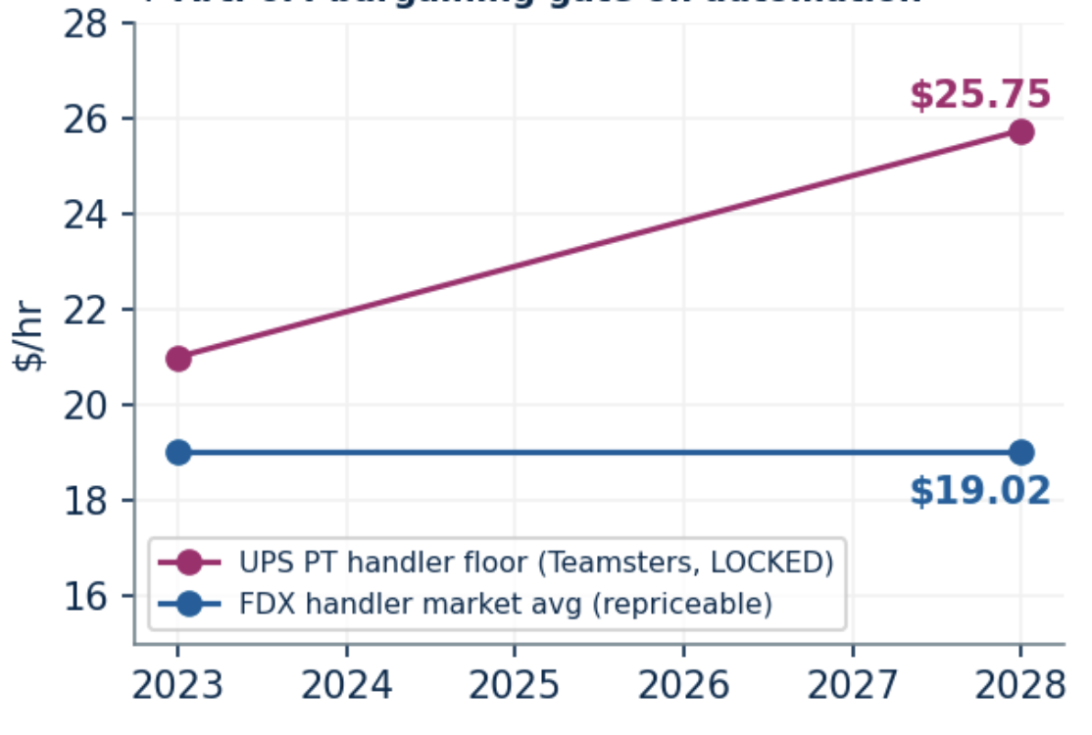
FDX is 60% more profitable per package than UPS (lower two bars), despite similar revenue per package (top set of bars). Note the FDX yield net of fuel, labor, and last-mile delivery includes truck costs (passed on through last-mile provider) while the UPS number does not.
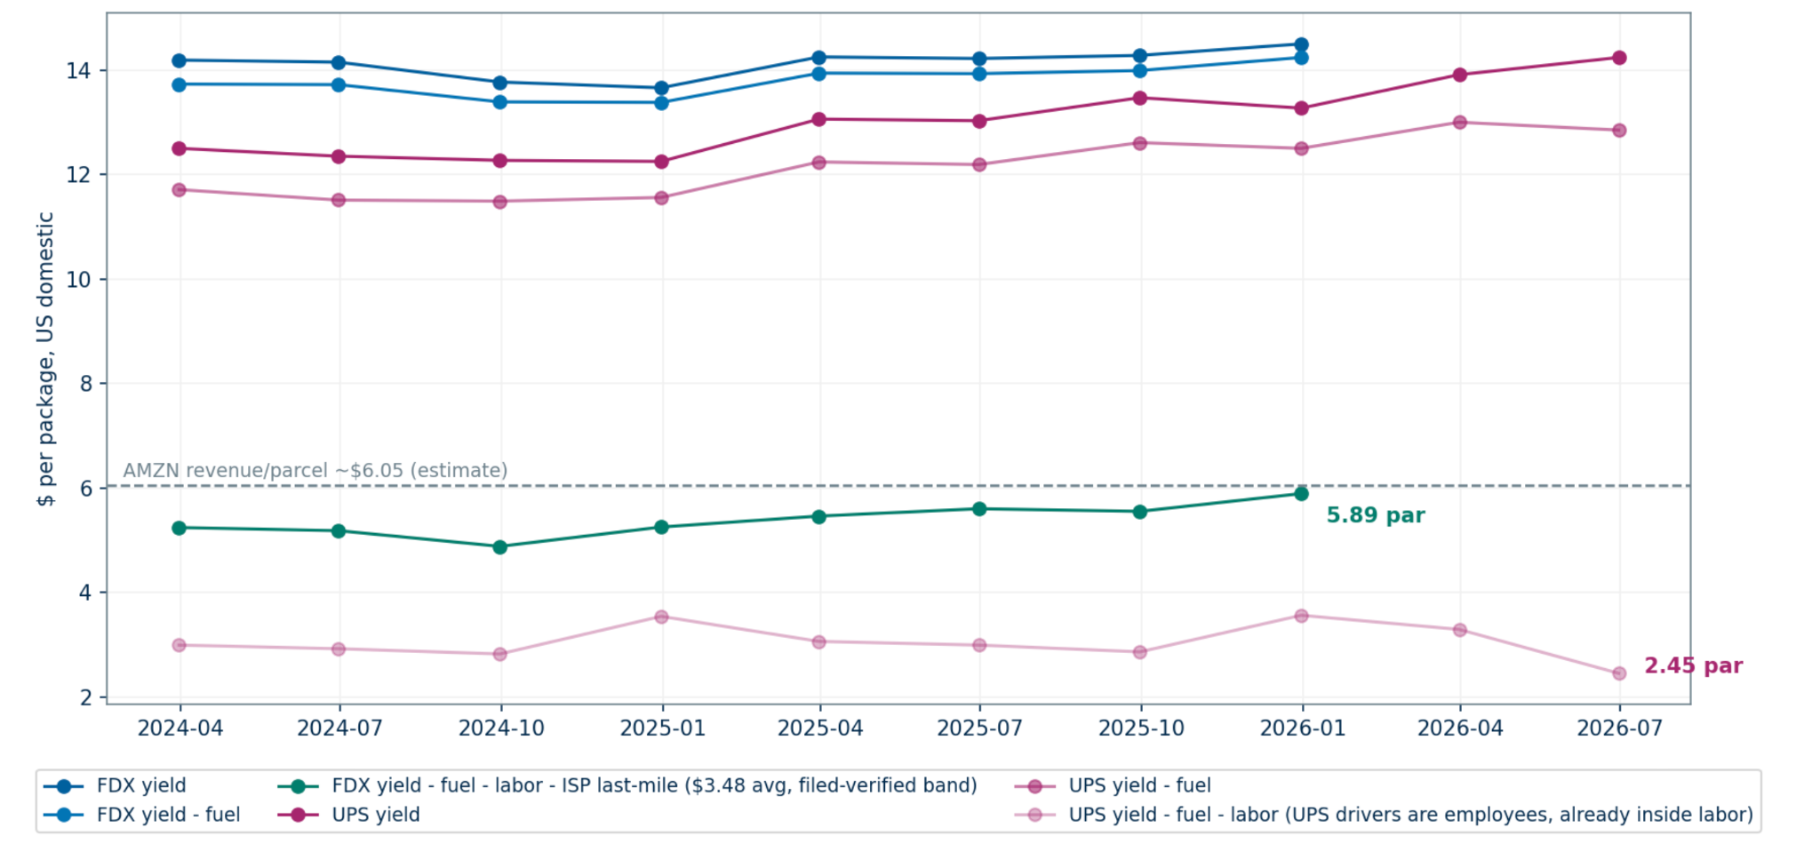
Fedex has lost almost no volume (5% of total) to neo shippers; UPS has lost 4x more share.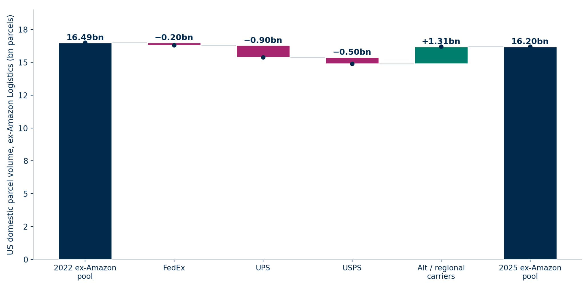

FDX base-case Model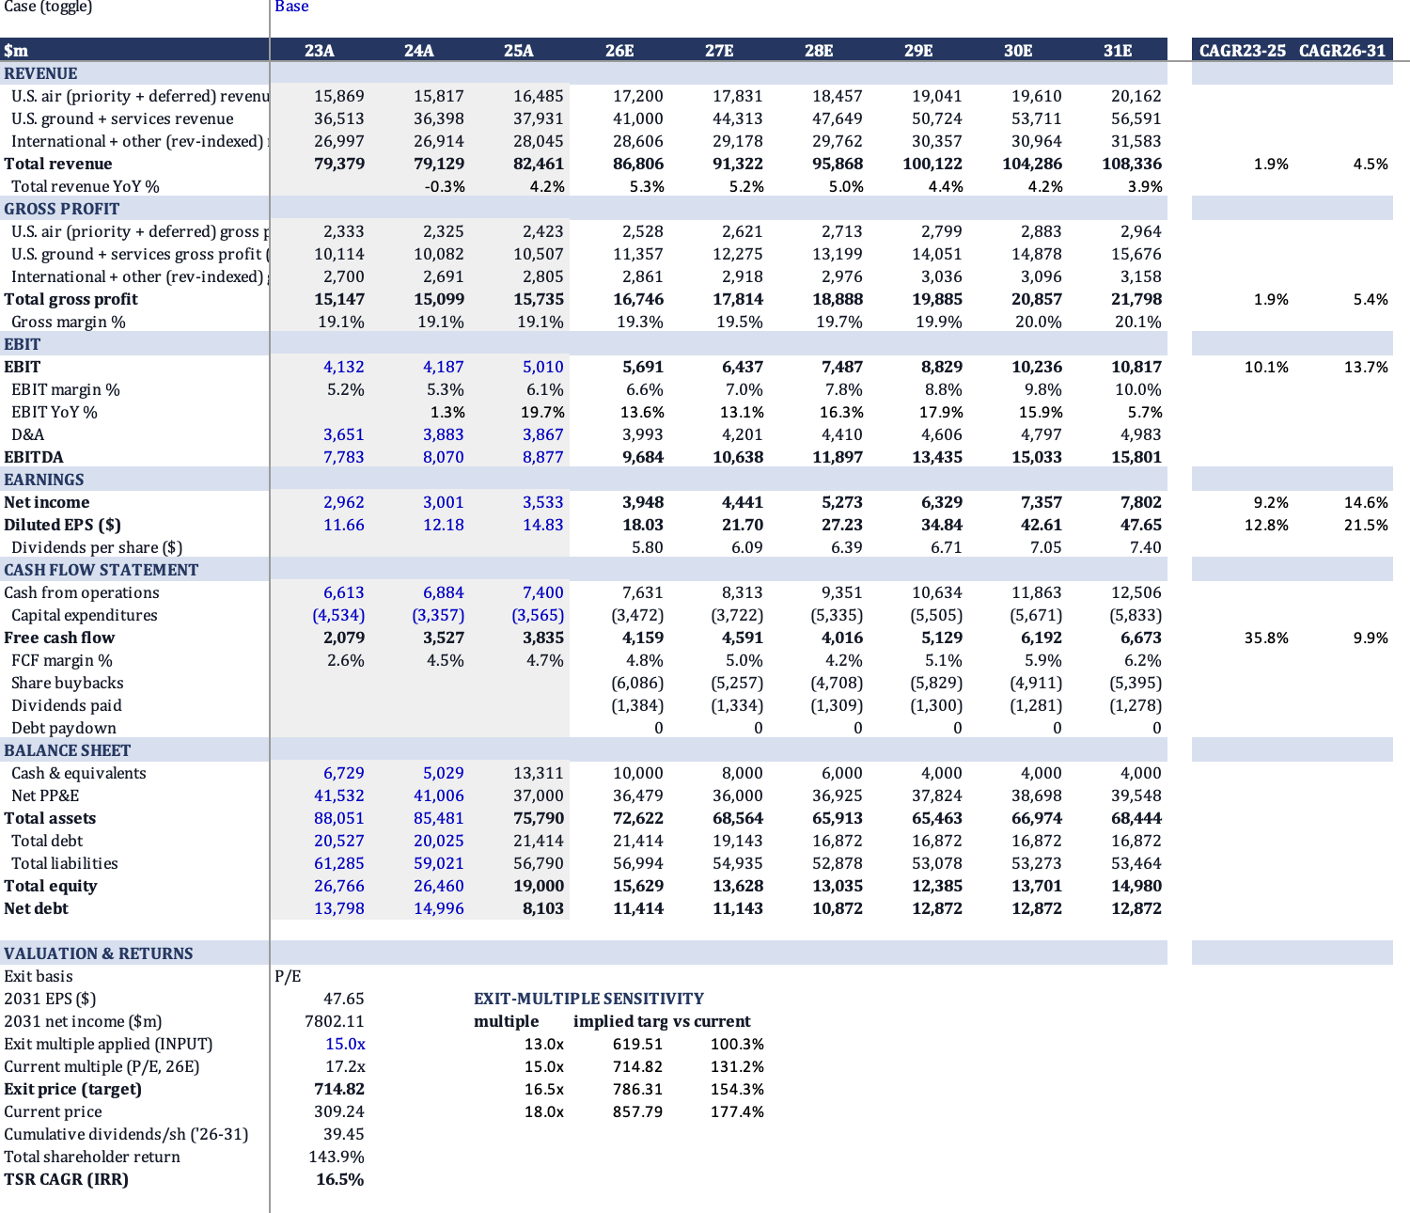

STRC – $92: a much longer round-trip than I expected.

Thesis reminder:
I like the BTC exposure within my portfolio but believe the volatility will be difficult to absorb with the relatively short time horizon of this challenge. STRC, issued by Microstrategy, is a debt product which MSTR can arbitrarily toggle between cash and payment in kind (PIK) interest. MSTR can issue STRC at par ($100) in order to raise additional debt. I like 1. the significant asset coverage of the security, 2. The 12% dividend, and 3. That management appreciates STRC must trade at par in order to justify the larger company trading at or above 1.0 P/B.
My differentiated view is the extent to which MSTR management believes in the importance of STRC for their MSTR ambitions.
Update:
I thought I was getting a great deal buying STRC at a 6% discount from where STRC had been trading for months and thought the sale of 1% of 1% of MSTR’s BTC, which precipitated the worry and de-pegging, was actually bullish for their demonstrated defense of STRC. MSTR’s USD reserve as measured in months of dividends had drifted alongside the $10bn of STRC issuance over the past year.

STRC then traded from $94 down to $74 before now returning to $92; Including paid dividends, my cost basis is ~$94.5. I grossly misestimated the amount of worry and the risk of spiraling beliefs within the system. MSTR has increased their USD reserve and bought back STRC, announcing returning STRC to par is their “primary objective” (a statement to be discounted).

I still think the coverage is favorable and believe STRC should trade to par:

At BTC = $64,346, Strategy's ~842,138 BTC is worth about $54.2B; adding the ~$4.00B USD reserve gives roughly $58.2B in assets. Senior to STRC sits ~$8.9B (the $6.75B convertible notes plus ~$1.28B STRF and ~$0.89B STRE), and STRC itself is ~$10.4B notional. On that basis:
• Total Assets (TAV): ~$58.2B (842,138 BTC × $64.3K + $4.0B cash)
• Senior to STRC: ~$8.9B ($6.75B notes + ~$1.28B STRF + ~$0.89B STRE)
• TAV − senior: ~$49.3B → about 4.8× STRC's ~$10.4B claim
• TAV ÷ (senior + STRC): $58.2B ÷ ~$19.3B → about 3.0×

Reflections:
- I am surprised I didn’t act when STRC traded to $74; I should have forced myself to be more decisive in that moment. In retrospect, I should have added, but I will more consciously log my decisions and deliberations during major drawdowns going forward.
- I didn’t appreciate what an attractive instrument STRC is to short (it shouldn’t ever trade above $100); WKP wrote a good CC note on the leverage and raised good questions about whether leverage and BTC will always go together.
- “Effective interest rate” is still higher today than 12/.92=13% because the market is pricing the probability of a quick return to par; there may be sellers exiting as (if) STRC appreciates.
- 12% interest is high; I wonder how they intend to hold the peg if they’d like to reduce the rate. Don’t think that’s possible, though maybe you assume STRC goes to the same implied interest rate and then MSTR has to work to appease bondholders and return the instrument to par.
Please note the axes on this graph are zoomed in.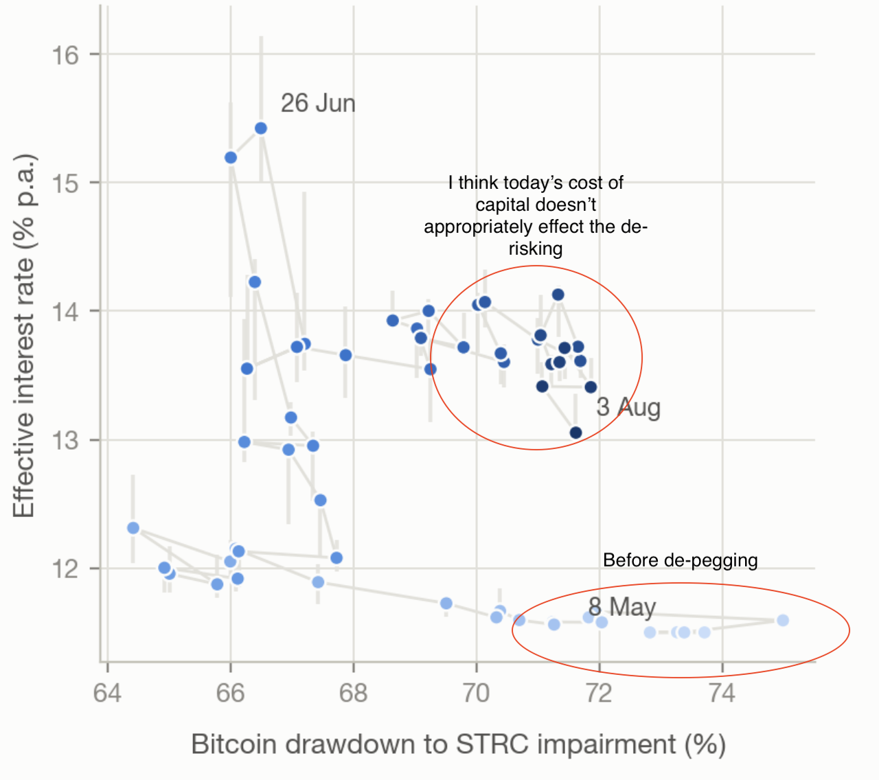
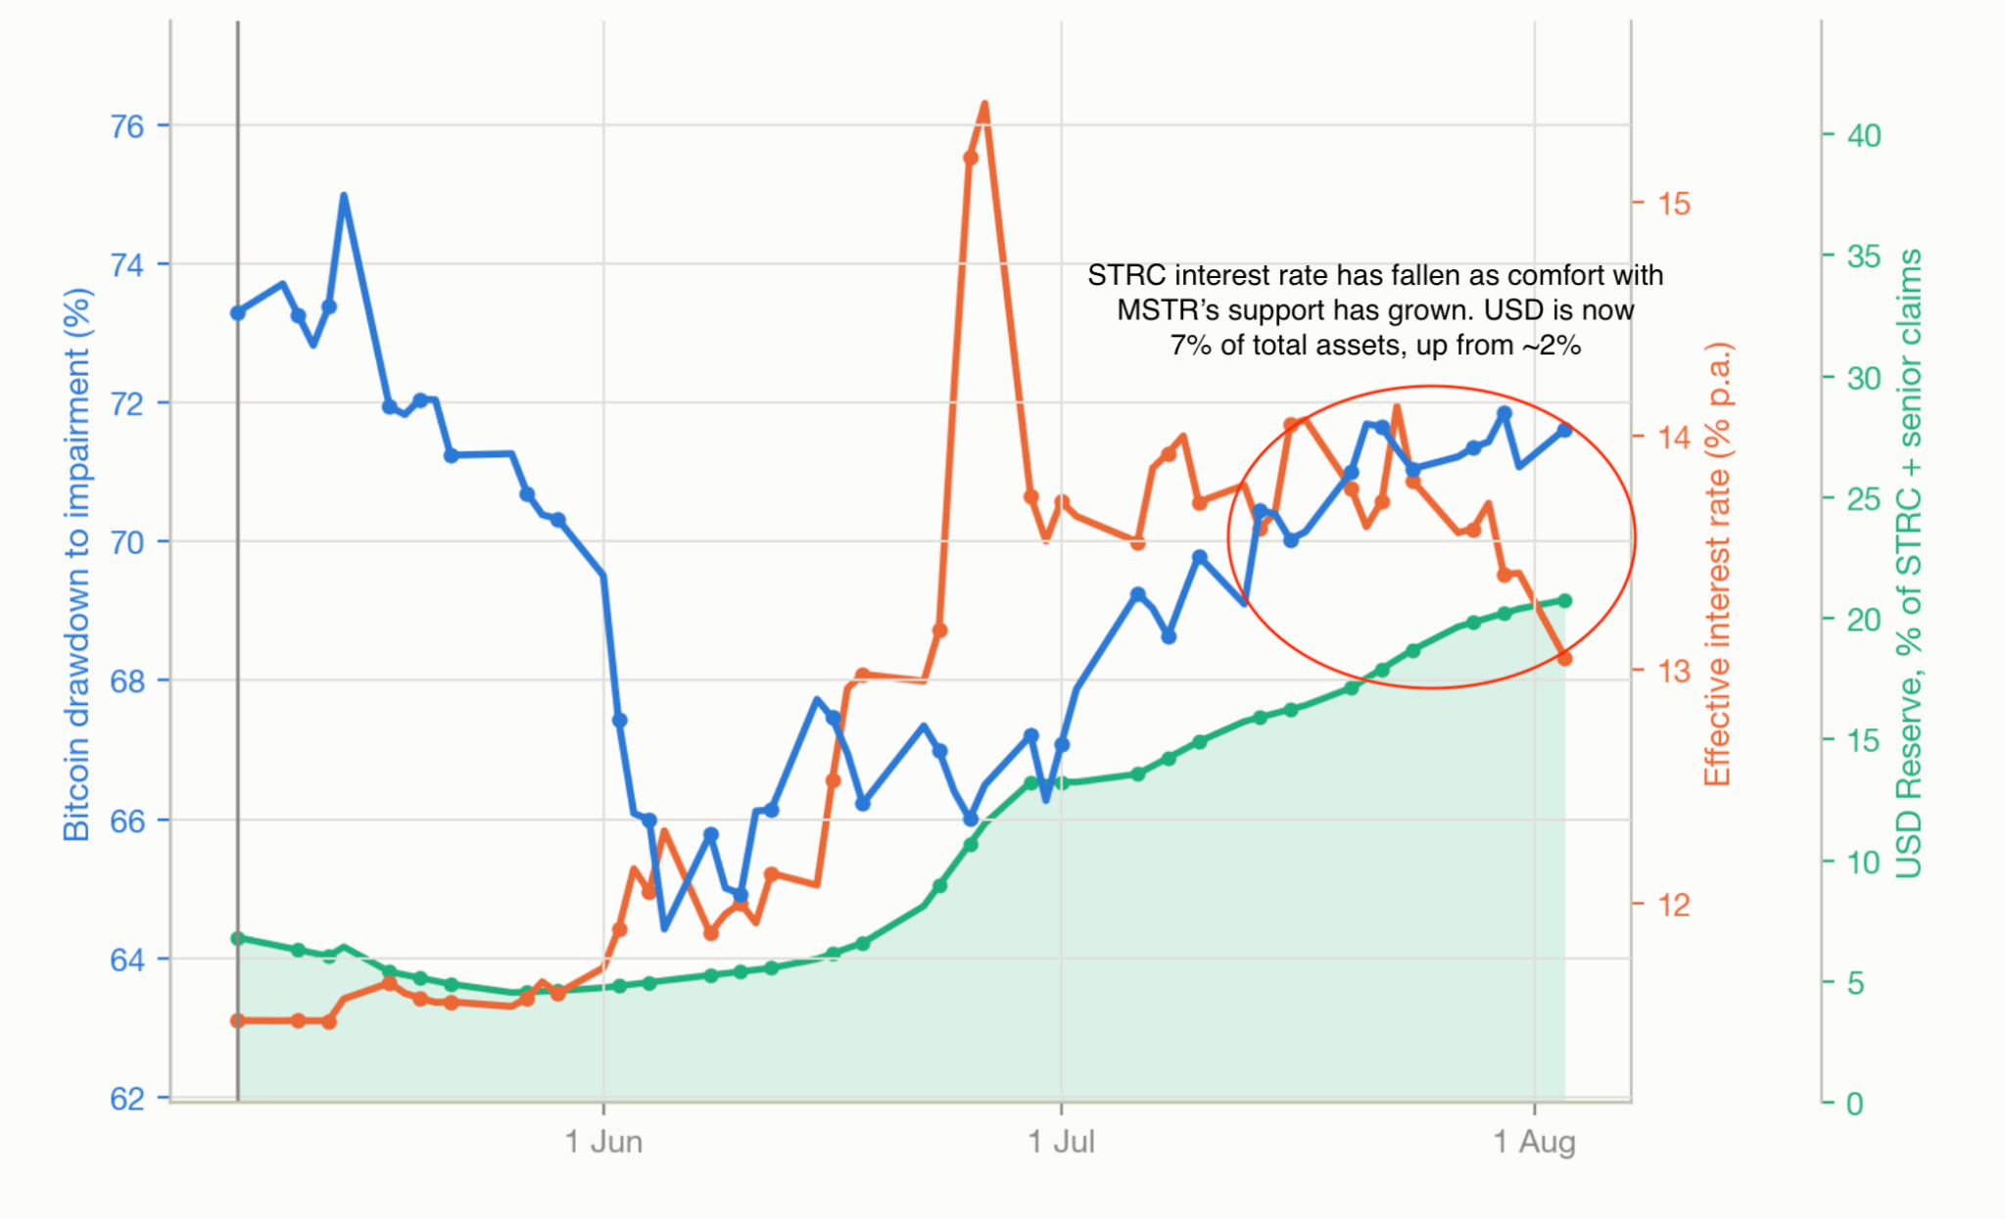
WDAY xARR

Thesis reminder: I believe the WDAY downside is bounded by contracted revenues and FCF generation capacity with a valuation support of ~$100/share. This return of capital, mainly through dividends, assumes the current pipeline and continued 13% growth for 6m before 50% loss rates on re-subscriptions (vs 97% gross retention today) and loss of pricing power. Additionally, my base case includes 14% TSR, and I think Workday’s platform offers asymmetric upside opportunities to become an AI beneficiary, though visibility is difficult today. Importantly, the founder/CEO Aneel is pushing hard for innovation and has demonstrated humility to step back and let the business focus on margins when he’s been proven wrong.
I believe the AI bear case is better than the market believes and that the middle-of-road and AI-winner cases are both very attractive and possible.

Updates: There have not been significant newsflow items since the start of the challenge. WDAY stock is up about 13% June 3 through Aug. 3, but this is mainly due to the high-level narrative shift and ‘AI rotation’ than company-specific newsflow. I believe the market now prices slower disruption.
Earnings are Aug. 20; I will be curious to understand backlog growth dynamics and will be closely listening to hear more about headcount projections and efficiency measures. Aneel reduced the “AI Agent” initiatives from 41 to 16 earlier this year; I’ll monitor the growth trajectory. I have updated my model, but my underlying convictions are similar.

What does it mean to ‘Run WDAY for Cash’?
I believe WDAY has the capacity to quickly reduce headcount and bring their ~83% GM software to 90%+ with high GM to FCF conversion. I model share decreasing slowly and pricing power decreasing rapidly outside of the existing signed backlog.
Bull case update
My conviction that WDAY will be able to provide unique offerings to maintain pricing power is growing.

Fine-tuned model opportunities.
Following research by PLTR and Thinking Machines // Bridgewater, I have spent time thinking about business opportunities for fine-tuned models. Tuning open-source models (through RLHF post-training) has allowed companies to achieve performance equal or better than frontier models with a fraction of the inference cost. Basically: liberal arts superstar underperforms trained engineering student at engineering in output and massively underperforms on intelligence per watt and per dollar basis.
Fine Tuning could look a lot like traditional SaaS: high up-front training cost, near zero marginal cost (of model distribution, inference cost is non-trivial), customers save money by using shared model vs. in-house development, specialized per-industry. There are also differences like cost to update a model is higher (presumably would fine-tune new open-source models as they come out).
WDAY could be in a good position to sell fine tuned models as a service, especially within HR and CFO/Finance roles. 1. Existing strong relationships with enterprises 2. Full access to data and data structures within clients 3. 3 trillion existing datapoints (value TBD here).
I am not including fine-tuned models within my model, but it’s an example of new business possibilities where WDAY’s setup provides an advantage but wasn’t considered 3 months ago. I haven’t heard anyone else talk about this yet, so I don’t know whether others think about it as an opportunity set.

Headcount efficiency
I found some open-source WDAY codebases, and commits/yr have 3x while the number of contributors is 1/2. This adds confidence that WDAY can quickly reduce staff needed to maintain, though they’re currently investing in growth.

I don’t think WDAY has outperformed for particularly idiosyncratic reasons; instead it’s traded like a high-beta tech stock. I expect continued volatility.
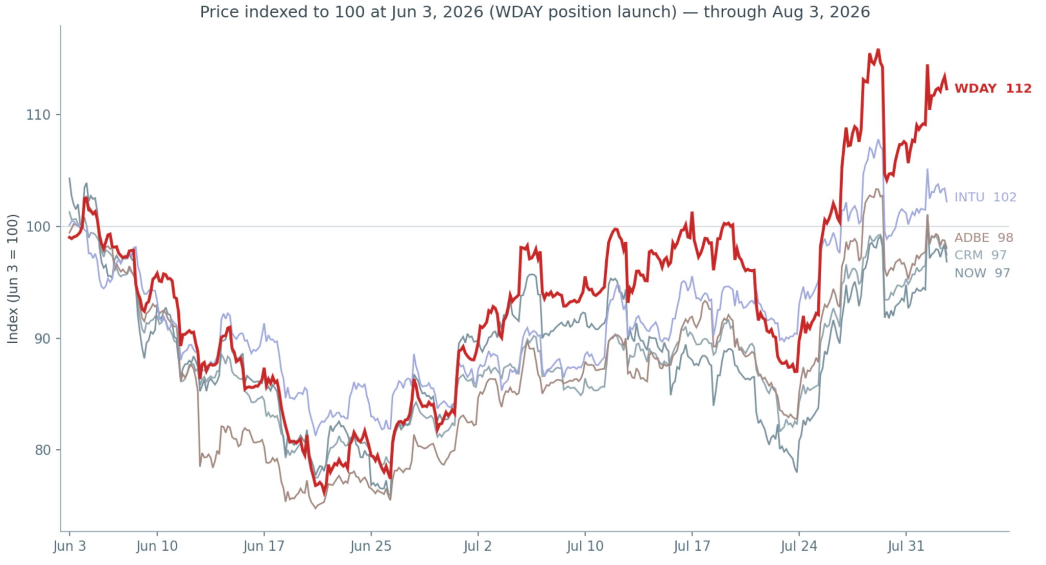
In bear case, I expect the backlog to fall, with some re-signs with negative pricing power.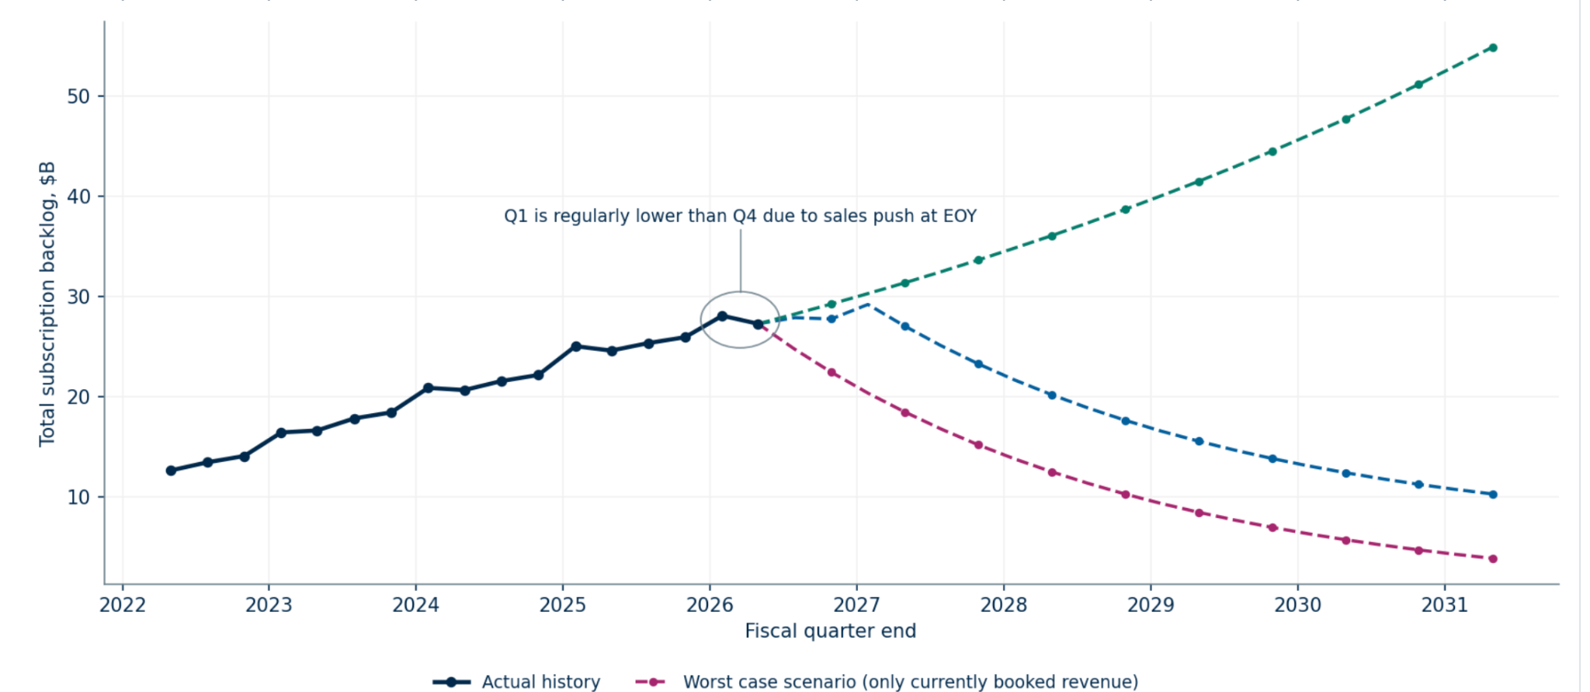
M&A under previous CEO overstates growth; I’m wary of additional M&A, given technology acquired is lackluster, especially with the largest, $1bn Sana acquisition (agents + employee training)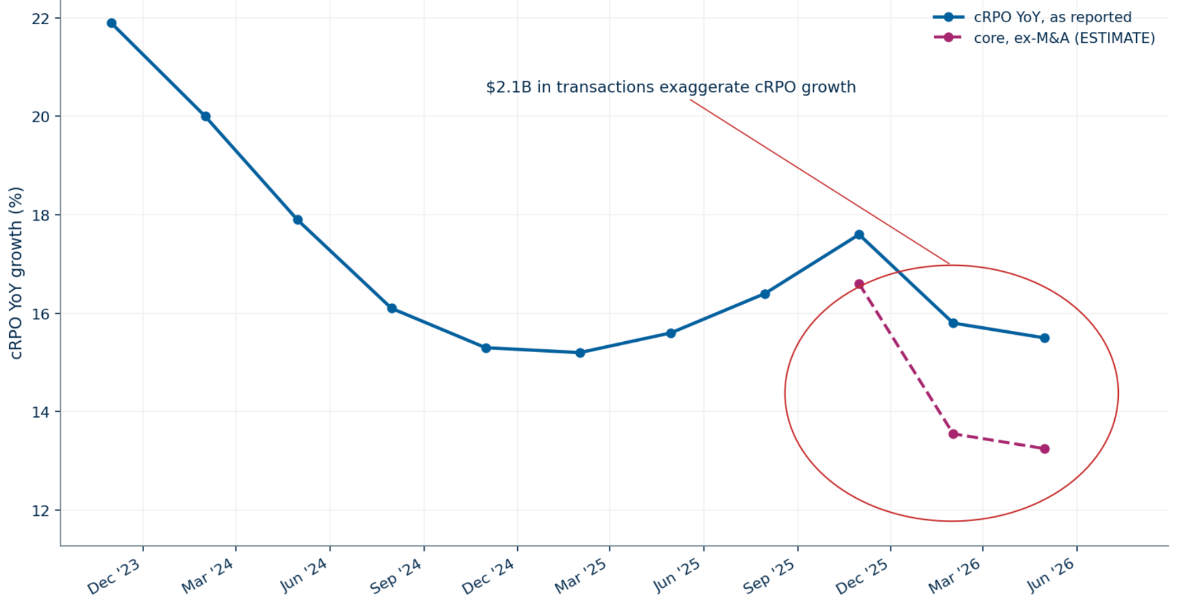

WDAY Model Slow Decline case (vs. fast decline or upside cases) cuts reinvestment into the business and assumes about ½ of re-subscribing customers churn. I think this case is relatively unlikely (inflection to upside case or more severe downside case are more likely), but a useful frame of reference. These margins seem extreme but I believe are defensible with a decisive CEO in Aneel.
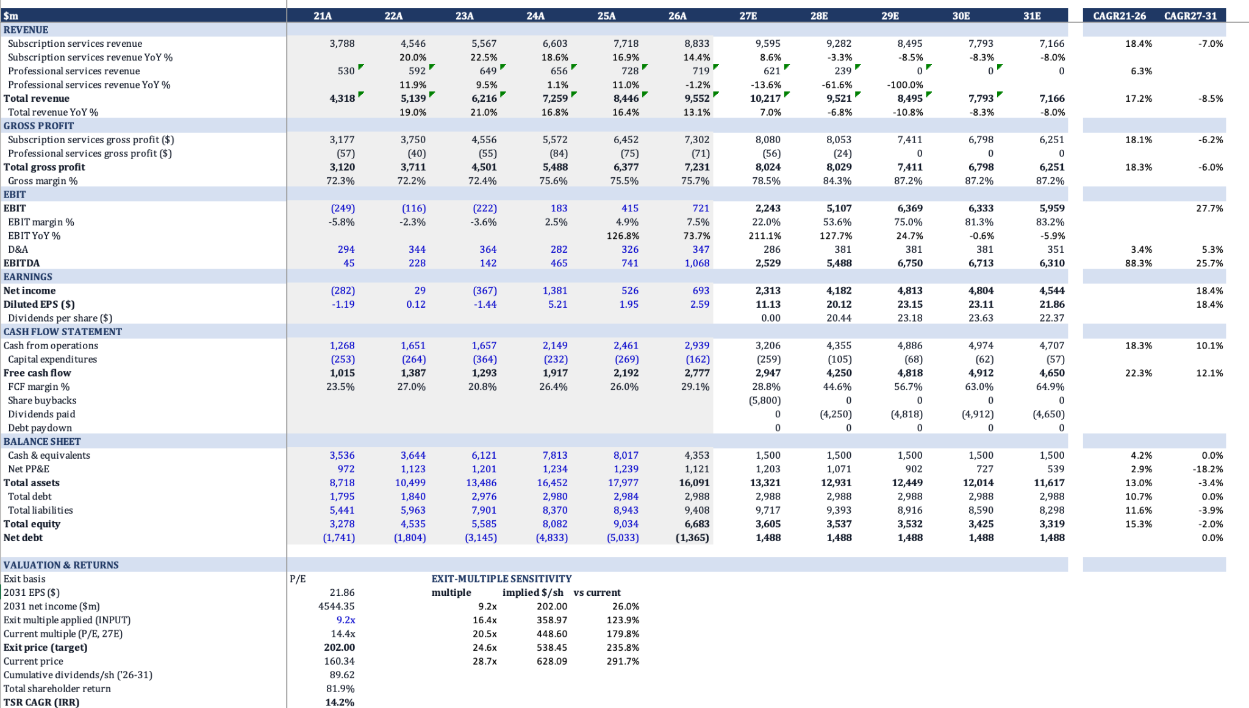
FUN

Thesis reminder:
- Operations execution – focus less on squeezing margin and more on customer experience and repeat visitors. Example: new head chef to improve quality. Encouraging reports in July of better rules around all-you-can eat passes to prevent sharing. I believe the new CEO’s longer term focus on customer will strengthen attendance.
- Capex cycle closing – major upgrades, especially to bring Legacy Six Flags parks to par with Cedar Fair.
- Land value – SOTP for the underlying land (plus the top few parks) is attractive.
- IP opportunity – 80% of DIS profits come from hospitality and parks, and NFLX or WBD could not replicate the parks given permitting difficulty etc. and these could be very profitable ways to massively increase ARM.

Updates:

Six Flags is down ~13% since initiation. This mainly seems to be based on worse credit card numbers. Some talk about weather and about smoke from Canadian forest fires. Before, the stock was up significantly. This remains a highly volatile stock and highly levered company. I have not seen

The company will announce earnings on Thursday, after PRKS (owner of Busch Gardens parks and Seaworld) announces Wednesday afternoon.

Given WBD delays, I have decreased confidence that FUN parks would be useful targets for M&A, though I’m continuing to evaluate. I still believe redone parks (paid for or acquired by IP owner) could drive significant valuation. Interestingly, EPR holdings, the REIT which bought several FUN parks for $300m last year and is currently diversifying from its movie theatre ownership, recently bought the real estate under Netflix House from NFLX. NFLX is hesitant around hard assets.

At earnings, I will be most focused on the F&B numbers and commentary, as a core part of my thesis around management improving customer experience.

As JEQR pointed out in her FUN company project, the core parks generate most (~60%) of the profitability, and represent better, faster-growing parks than PRKS’s portfolio.
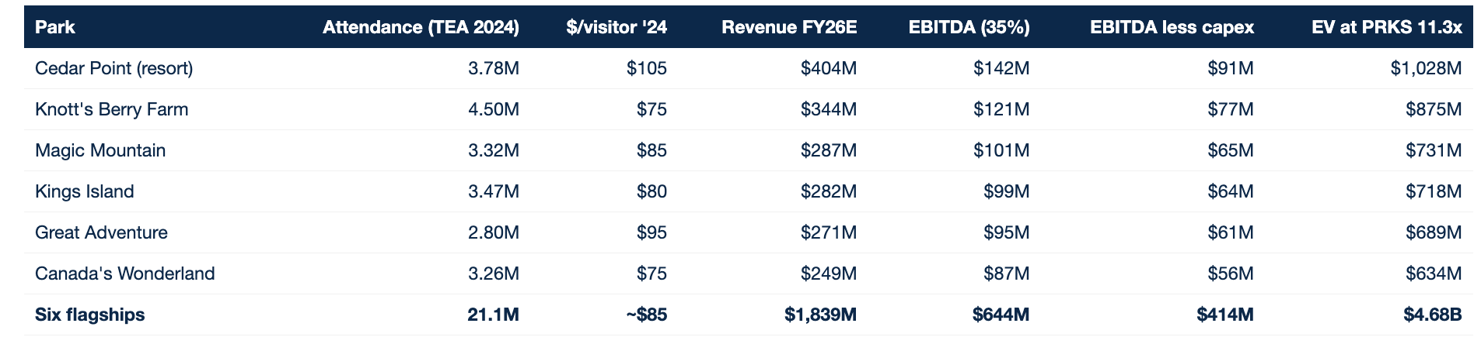
I developed valuation for remaining parks by looking at similar 10ac+sales in the area. I believe the properties are significantly more valuable than comps given rarity of continuous parcels and comps were of qualitatively lower quality and worse locations. 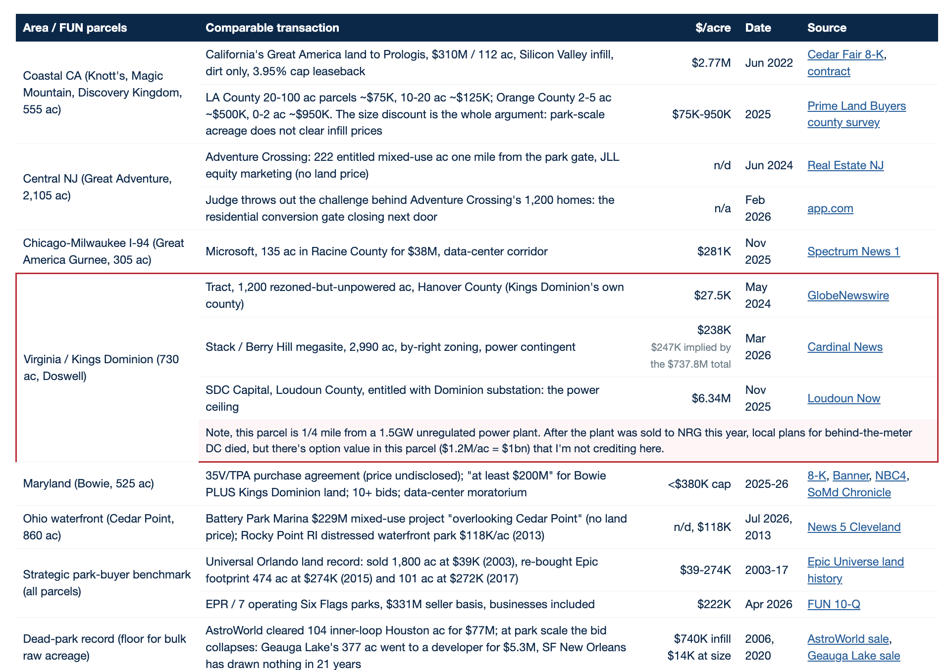
SOTP helps provide a valuation floor without credit to the operating business in 28/34 parks. 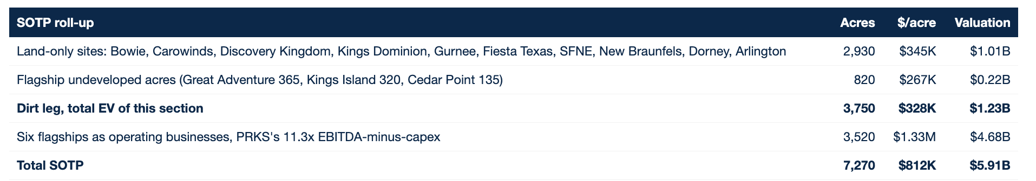
FUN Base-case model