HEALY FAMILY TREE
Relatives of and ancestors of Joseph Anthony HEALY, father of James Joseph HEALY, father of Joseph Edward HEALY
Including but not limited to surnames --- HEALY, SCHMIDT, DELANEY, O’BRIEN, KELLY, O’DONOGHUE
Version 1.0

Author – Joe Healy
Junior amateur genealogist
Josephehealy@hotmail.com

Table of Contents
DELANEY 1
PEOPLE 1
DELANEY, ANDREW (1864-1904) 1
DELANEY, ELIZA (1867-?) 1
DELANEY, FRANCIS 1
O’BRIEN, MICHAEL (-) 1
THE FRENCH CONNECTION 1
tuberculosis 1
THE WORKHOUSE 1
LILLIAN AND THE EVIL AUNTIE 1
IRISH DANCING 1
HEALY PEOPLE 1
HEALY, DENIS JOSEPH 1
HEALY, EDWARD JAMES (1967-) 1
HEALY, JOSEPH ANTHONY (1916-2002) 1
HEALY, JOSEPH EDWARD (1965-) 1
HEALY DNA CHASING 1
DNA tests 1
DNA RESULTS 1
HEALY, Joseph Edward (1965-) 1
SCHMIDT 1
PEOPLE 1
SCHMIDT, MARY (1923-2002) 1
ALBERT MEETING THERESA AT WEST POINT 1
LEAVING OHIO 1
ADDRESSES 1
NEW YORK (MANHATTAN, QUEENS, BRONX, LONG ISLAND) 1
• 1884 Arthur Avenue 1
• 373 EAST 175TH ST 1
• 227 ST ANNE’S AVENUE 1
• 2 Totten Street 1
IRELAND, DUBLIN 1
• 10 BRABAZON PLACE, MERCHANTS QUAY – Address for Andrew Delaney (1864) birth. Parents Francis Delany and Teresa Giles resident there in 1864. Referred to as part of “The Liberties” - 1
• 38 CHAMBER STREET – 1
• 30 THE COOMBE, MERCHANTS QUAY 1
• 33 Cork Street 1
• 5 DENZILLE ST 1
• 19 LAUDERDALE TERRACE – Deathplace of Francis Delaney in 1911 – Residence of Teresa Delaney in 1911 (53.33794, -6.27411) – Hard to find in gmaps, bing finds it fine 1
• MEATH ST 1
• 1 PIMLICO SQUARe, the coombe, MERCHANTS QUAY 1

DELANEY

PEOPLE

DELANEY, ANDREW (1864-1904)
Father of Theresa Schmidt, nee Delaney. GG-Grandfather of document author J. Healy.
Baptized April 4, 1864 at St Nicholas' (Without), Dublin City, Dublin. Parents Francis Delany and Teresa Giles of 10 Brabazon Lane, Witnesses Henry Ledridge and Julia Lynch witnesses.
1864 Baptism Record for Andrew Delany

Married April 19 1896 to Catherin O’Brien. Marriage #165 registered 25 Aril 1896 . Andrew Delaney (widower) of 30 Coombe and Catherine Obrien (spinster) of 1 Pimlico Square, parents Frances Delaney (laborer) and Michael Obrien (laborer). Meath Street Catholic church by John Kelly. Witness: Samuel Mooney and Margeret Hughes.
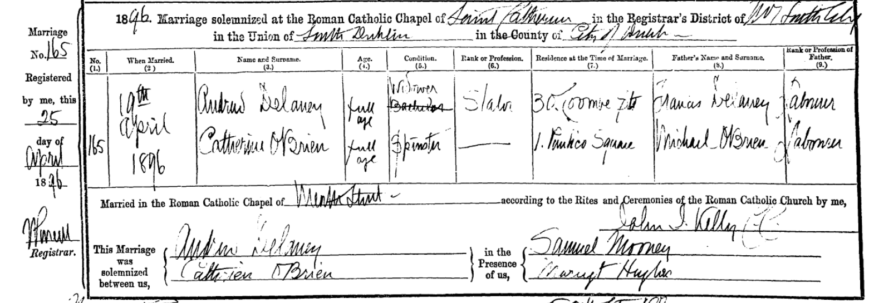
1896 Meath St Church Record for A.Delaney and C.Obrien marriage

DELANEY, ANDREW (1899-1902)
Born August 09, 1899 in Dublin South to Andrew Delany and Catherine O’Brien. Parents living in 6 Fitzgerald’s Cottages, Brown Street, Arran Quay in St Catherine’s Parish at the time. Per family verbal history was a bit mentally off [via Katie Rappold]. Tracey Walsh relayed a story from Ellen Delaney ( 1897-1983 ) that Andrew Delaney (1864-1904), his father, used to come home with a few pints in him and play baby toss. Apparently, he dropped baby Andrw - hard. The drop was viewed as the cause of baby Andrew’s slow development. Author finds sadness in this as he too has been guilty of Guinness inspired baby toss. <sadface/>. Andrew is present in the 1901 Irish census at 38 Chamber Street, about 250 yards from his birth location. He died at the age of 3, living at 38 Chamber Street. The record lists the cause of death as heart failure. He is buried in Glasnevin Cemetery in grave B-J-21 ½ (a shared grave), the same cemetery as his father.

DELANEY, ELIZA (1867-?)
Born April 29 1867 at 10 Brabazon Place, Merchants Quay, Dublin to Francis Delaney and Teresa Giles. Parish of St Nicholas (Without). Sister to Andrew Delany (1864).

DELANEY, FRANCIS
Father of Teresa Delaney 1871. 1911 July 16 death, Widowed, slater,Teresa Delany 1871, his daughter, present. Both residents at 19 Lauderdale Terrace. GGG-Grandfather of document author J.Healy.

O’BRIEN, CATHERINE (-)
Mother of Theresa Schmidt, nee Delaney. GG-Grandfather of document author J. Healy.
Married April 19 1896 to Catherin O’Brien. Marriage #165 registered 25 Aril 1896 . Andrew Delaney (widower) of 30 Coombe and Catherine Obrien (spinster) of 1 Pimlico Square, parents Frances Delaney (laborer) and Michael Obrien (laborer). Meath Street Catholic church by John Kelly. Witness: Samuel Mooney and Margeret Hughes.

O’BRIEN, MICHAEL (-)
Father of Catherine O’Brien. Mentioned in 1896 church record of Catherine’s marriage. GGG-Grandfather of document author J.Healy.

THE FRENCH CONNECTION
Anecdotal story. My father JJ Healy (1941) relayed an interesting tale his grandmother had told me. Apparently she had heard there was French in her family tree. Given the initial population of the weaver area of Dublin ( Merchants Quay ) by immigrant Huguenots perhaps that is the French connection. Ref – “The Liberties” - https://en.wikipedia.org/wiki/The_Liberties,_Dublin .
Ancestry-ToDo: I recall French Delanys from some online research. Dig this back out
Ancestry-ToDo: Figure out a MTDNA line to the Delaney’s and get them tested. It would go to O’Brien instead of Delany however. Worth the effort.

TUBERCULOSIS
Also known at the time and noted on death certificates as “psthsis” or “consumption” ( https://en.wikipedia.org/wiki/Phthisis ) took a terrible toll on the Delany clan. TB caused the death of Andrew Delany in 1904, leading to his family disintegrating and going to the Irish workhouses, as well as a significant number of other Delany relatives.
“The other major killer in Dublin (JEH: the first was infant mortality) was tuberculosis. A report published in 1912 claimed that the death-rate from tuberculosis was 50 per cent higher in Ireland than in Scotland and England. The report added that in Dublin "the vast majority of deaths (from tuberculosis) occurred among the poorer classes, especially in the families occupying single-room dwellings." http://spartacus-educational.com/ITdublin.htm
I can imagine the nightmare that crept through my ancestors as TB stalked them over the years. A quote from http://skehana.galwaycommunityheritage.org/content/topics/health-issues/tb-ireland-tuberculosis best sums it up.
“Survivors can still recall the silent terror. A child develops the disease, then a brother contracts it, and his friend a few doors down is next. In Dublin alone, it killed more than 10,000 people a year, more than half of them children. The highly infectious tuberculous bacillus thrived in the crowded tenements of inner city Dublin and in the poorly ventilated, thatched cottages in the country.”
The following persons in the Delany clan died of TB:
- Francis Delany (1888-1901) – died at 38 Chamber, age 12
- Andrew Delaney (1864-1904) – died at 38 Chamber, age 44

THE WORKHOUSE
Story here

LILLIAN AND THE EVIL AUNTIE
Story here

IRISH DANCING
Went to Ireland to compete in Irish dancing. Got 3rd or 2nd in some national contest. Put story here. Per JJ.
Ancestry-ToDo: Ping aunt terry and steve on this.

HEALY
The Healy tree is concerned with the Healy ancestors of James Joseph Healy, beginning with his father Joseph Anthony Healy. Joseph’s father, Dennis Healy, was an Irishman who emigrated from Kilgarvan, County Kerry, Ireland in the early 1900s. The Healy family still is resident in Kilgarvan, and are directly related ( and DNA proofed ) to the famous Healy-Rae policitician family. There is a Healy-Rae pub in Ireland owned by the 4th/5th cousins of the author of this document. The Healy-Raes are said to have come to Kilgarvan from Donoughmore in County Cork. By legend a Healy killed a tax collector and then fled across the mountains. Given the origins in Donoughmore, the Healy crest is not the common three boars, but actually three stags. Contact with Healy extended cousins are common. Many connections have been made via DNA – see the Healy DNA section in this document.

HEALY, DENIS JOSEPH (1884-abt 1962)
Key figure in the author’s family history as this is his great-grandfather. Denis is the Healy who emigrated and was the core of the Bronx/Bethpage Healy line. Accordingly, expanded details and stories as know are below.
1884 July 4 Born July 4, 1884 in Kilgarvan, County Kerry, Ireland to Daniel “DanDan” Healy and Mary Sullivan McCann. Birth record excerpt from IrishGenealogy.ie below. Date of birth given on civil registration as 14 July 1884.
Area - KERRY (RC), Parish/Church/Congregation - KILGARVAN
Baptism of DENIS HEALY of REIGHCUSLAGH on 12 July 1884
Name DENIS HEALY
Date of Birth 12 July 1884 (BASED ON OTHER DATE INFORMATION)
Address REIGHCUSLAGH
Father DANIEL HEALY
Mother MARY SULLIVAN
Child Denomination RC
Sponsor 1 DANIEL SULLIVAN
Sponsor 2 JOHANNA LYNE
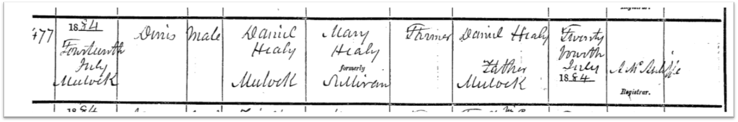
Commentary
- Dad (JJ) said he sounded like big bearded cop in the TV show “copper”.
- When asked what they farmed in Ireland, he said, “Rocks and swamp”.
- Had cousins in Delaware, per Jeannie Pollock
- Passed away watching TV with Jeannie as a young girl sleeping in his lap. He was babysitting. Jeannie’s parents came home and he was gone with her asleep. Good way to go.
TODOS:
- Death cert – date of death
- Write area churches for marriage records
- Police record
- Marriage record
- Notes from immigration

HEALY, EDWARD JAMES (1967-)
Born in 1965 to James Joseph Healy (1941-2014) and Christine Cecile Laukaitis (1943-) in West Hempsted New York. Lived in Atlanta, Social Circle GA, and Charleston, SC. Graduate of Presbyterian College. Played linebacker for Presbyterian. Married to Jessica McMillon (1967-). One son, Connor. Employers include US Surgical and WL Gore.

HEALY, JOSEPH ANTHONY (1916-2002)
Born August 8 1916 to Dennis Joseph Healy and Nellie Casey in the Bronx, New York. Sister Eileen (1919) and Sheila Teresa (1920). Graduated Loyola College, Majored in ?Greek Language and ?Philosphy approximately 1935-1940. In 1940 employed as a clerk in the US Post Office. Shortly thereafter employed as NY Police (1940-?), Baliff -New York Courts until retirement. Marriage to Mary
Schmidt in 1941. Four children, James Joseph (1941-2014), Theresa, Elynn, and Martin James.
Rumored that he made detective and worked vice. Mary Healy nee Schmidt made him quit vice after finding pack of cigarettes in his jacket, and him explaining how he used them to give to hookers to get information. Worked China Town / Hells Kitchen before any Asian officers on force. Asian gangs would fight each other with Tomahawks and they would attempt to get information, to no avail. Love OTB, golf, and trips to Hawaii on his son JJs buddy passes.
Residences
- 1884 Arthur Avenue, Bronx, NY – 1916? to 1940 or later with parents.
- 2 Totten Street, Bethpage, NY – 1941? to death
Records to be obtained - Birth record NYC - Church record for birth – marriage record – death record
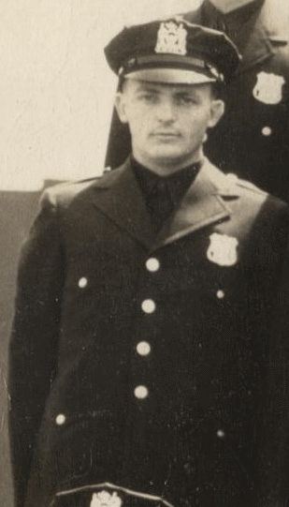 | 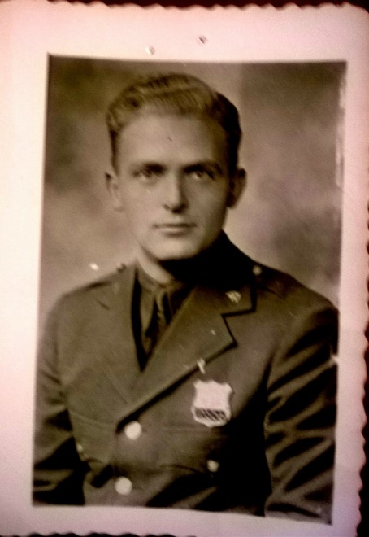
Headshot from 1940 class photo | 1940s Police Photo
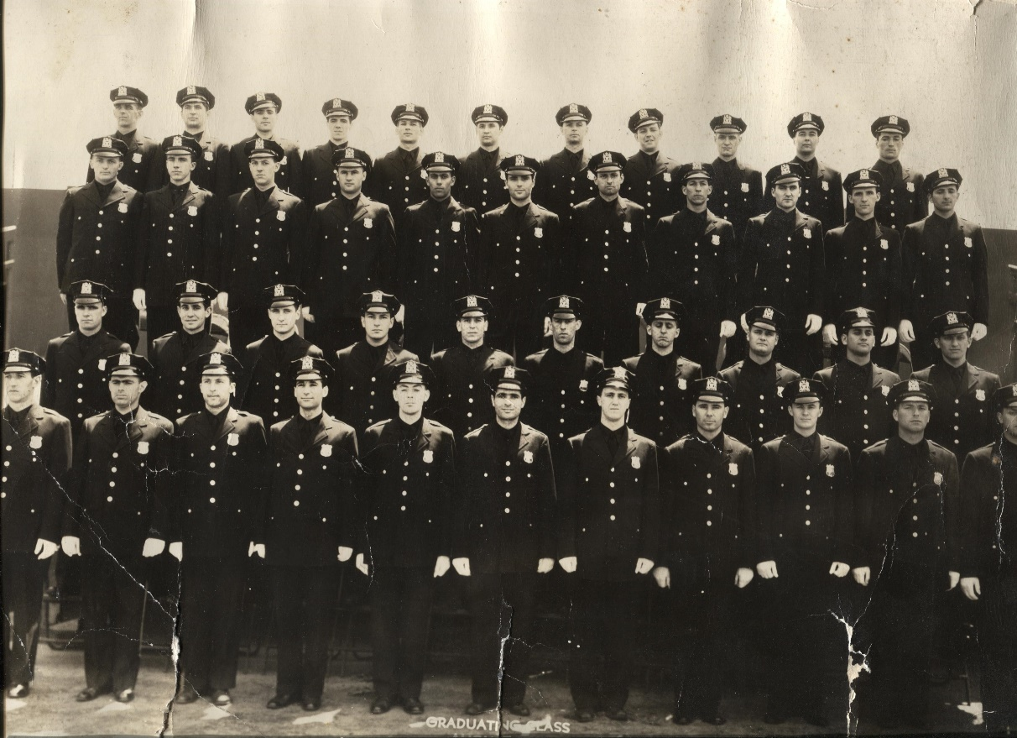
1940 Police Academy Graduation. Joe Healy is 2nd row from top, first on left facing…

HEALY, JOSEPH EDWARD (1965-)
Born in 1965 to James Joseph Healy (1941-2014) and Christine Cecile Laukaitis (1943-) in West Hempsted New York. Lived in Atlanta, Social Circle GA, and Tampa Bay area Florida. Married to Anne Catherine Sullivan (1967-). Two girls, Ryan and Morgan. Employers include Microsoft, Netwise Technology, eAngler, Cap Gemini, Arthur Andersen, IBM, EDS, University of Georgia Computer Lab, Target Stores, Shed Painting Company, Mason’s Peach Packing House, and the Newton County Recreation Department.

SCHMIDT

PEOPLE

SCHMIDT, MARY (1923-2002)
Born in 1923 in Middleton, Coumbiana, Ohio to Albert Herman Schmidt and Theresa Mary Delaney, both immigrants for all practical purposes. Moved to the Bronx cira 1930 after the Masonic Catholic incident ( see Theresa Delaney ) for details. Married Joseph Anthony Healy (1916) in 1941. Four children, James, Martin, Theresa, and Ellyn. Died in 2002, The Villages, Leesburg, FL.
Had a red hair, cat named mushkie, liked ketchup on her eggs, smoked like a fiend, and always bought me yoohoo, pretzels, cookies from francesco’s Italian bakery, and Bethpage pizza.
Residences
- 227 St Anne’s Avenue, Bronx, NY – 1930 with parents
- 373 East 175th Street, Bronx, NY – abt 1935 to 1940 with parents
- 2 Totten Street, Bethpage, NY – 1941? to death
Records needed: Birth, death, marriage

ALBERT MEETING THERESA AT WEST POINT
Story here

LEAVING OHIO
Story one – crosses on the lawn. Lots of searching Ohio papers. Cross burnings not mentioned
Story two – that naughty masonic order

DNA CHASING

DNA tests
- Ancestry under user ‘josephehealy’
- GEDMatch.com - A869398 on gedmatch
- FTDNA.com - 327263 - Joe Healy

DELANEY DNA MATCHES
Ironside and autismesq

SCHMIDT DNA MATCHES
Michael Schmidt

HEALY DNA MATCHES

HEALY, Joseph Edward (1965-)
Ancestry.com – 33% Ireland, FTDNA.com – 52% British Isles, Haplogroup – I-P37 matching I-M26 and even more specifically I-PF6947
Dialogs with some experts on DNA led to the placing of us into the I-M26 and I-PF6947 Haplogroups. By their records, all the known members of I-PF6947 have paternal ancestry from Ireland, and they belong to three clusters which can almost each be considered a single, old, family, but with more than one surname.

1) Cullen, Know, Carberry and McCarbery
2) Healy, Haley, O'Donoughue and Spain
3) Crowley, Kenneff, and a different Carberry. And probably an Icelandic man named Skagfield is part of this cluster also.

My Healy chain is definitely in the second group. To see other I2A1 ( i-pf6947 ) relations go to https://www.familytreedna.com/public/I2aHapGroup/default.aspx?vgroup=I2aHapGroup&vgroup=I2aHapGroup&section=ycolorized .
Autosomal matches – “cousins” – directly lineage is ascertained by perusing family trees and hoping for a match
- Bandito2007 on Ancestry – closed tree so you can’t view – pinged me re Maytor Healy. When I asked to see his tree he went dark. No contact since….
- on Ancestry – Resarching Maytor Healy chain ( http://trees.ancestry.com/tree/52555548/person/13389750765 ) . Match presumedly on Maytor Healy chain - Marjorie Healy of Utah (1903-1969) married John Samuel Sabin. Ogden, Utah Marilyn_sabin Healys.
- Patrick Healy IV – patrickhealy1@..... I-P37 Ha;logroup – Paternal links to Mayter Healy, b 1817 Kenmare, County Kerry
- John Maurice Sullivan aka John McCann Sullivan of Tallahassee, FL – In the “McCann Sullivan” forefather line for the “Healy-Rae” clan, but can’t quite pin down where we intersect. Family originated from Kilgarvan, Kerry County and Mangerton Mountain, Kerry
Y-DNA – passed along the male lines, father to son. If your last name matches a Y-DNA hit, it should be good. Also watch out for “neighbor syndrome”…..
- Denis Healy – most distant ancestor is Jeremiah Healy b 1851 – no tree available but does not look like his relatives ever emigrated to the USA. Reached out to him and waiting.
- Patrick Healy IV – Maytor Healy line, b 1817 County Kerry. Same Patrick Healy from “autosomal” matches. I-P37 with terminal SNP of P37.
- Thomas Harold Healy – most distance ancestor is Jeremiah Healy, b 1807 in Kilgarvan, County Kerry, Ireland. Lived in Cork as well and had children there. d. 1897 in Castletown, Ireland. http://trees.ancestry.com/tree/43887651/person/26082601584?ssrc=&ml_rpos=1 . Healy41 on ancestry.

ADDRESSES

NEW YORK (MANHATTAN, QUEENS, BRONX, LONG ISLAND)
- 1884 Arthur Avenue, Bronx, NY – Home of Dennis Healy and Helen Casey circa 1920 to circa 1940. Birthplace of Joseph, Eileen, and Sheila Healy
- 373 EAST 175TH ST, BRONX NY – Albert Schmidt family 1935 to at least 1940.
- 227 ST ANNE’S AVENUE, Bronx, NY – Home of the Schmidt’s in the 1930s.
- 2 Totten Street, Bethpage, NY – Home of Joseph Healy and Mary Schmidt from approximately 1948 to 2002. Residence for James, Martin, Ellyn, and Theresa for many years.

IRELAND, DUBLIN
- 10 BRABAZON PLACE, MERCHANTS QUAY – Address for Andrew Delaney (1864) birth. Parents Francis Delany and Teresa Giles resident there in 1864. Referred to as part of “The Liberties” - https://en.wikipedia.org/wiki/The_Liberties,_Dublin
- brown street, arran quay, st catherine parish, dublin south – 6 Fitzgerald’s Cottages. Family location when Andrew Delany was born in 1899. SW of Chamber Street off Weaver’s Square. Same location as #6 Geraldine Square.
- 38 CHAMBER STREET – Merchants Quay area – listed as tenements and ruins in 1897, 1908 and 1916 directory of Dublin. Listed as death address for Andrew Delaney. House no longer stands.
  - 1875 Fire gutted chamber st – quote newspaper
  - other chamber st addresses and relevance
- 30 THE COOMBE, MERCHANTS QUAY - Residence of Andrew Delaney when he married Catherin Obrien in 1896. https://en.wikipedia.org/wiki/The_Coombe,_Dublin .
- 33 CORK STREET – Residence of Michael OBRIEN and Ellen KELLY at least from 1865 to 1884. Likely birthplace of Catherine DELANEY nee Obrien. Primarily tenements in 1861, 1897 and 1889 directories of Dublin. Now site of Sisters of Mercy Convent.
- 5 DENZILLE ST – Residence of Elizabeth OBRIEN and George SULLIVAN from abt 1886 to 1894. 1887 directory lists tenements there. St James Gate Guinness brewery built over this location.
- Geraldine square, merchants quay, dublin – Birthplace of Theresa Delaney and Andrew Delaney. Same place as #6 Fitzgerald Cottages, Merchants Quay, Dublin. South side of Brown Street South. Fitzgerald house noted. Notable as location for James Spain anti-treaty IRA killed by Irish Free State in 1922 - https://comeheretome.com/2013/02/04/james-spain-of-geraldine-square/ . You can see Geraldine square on the c1900 Ordnance Survey Map at the following link : http://maps.osi.ie/publicviewer/#V1,714320,733146,7,9 .
- glasnevin cemetary, finglas road, glasnevin, DUBLIN – Delaney cemetary, both Andrews reside here in the same grave. Also final resting place of James Joyce.
- 19 LAUDERDALE TERRACE – Deathplace of Francis Delaney in 1911 – Residence of Teresa Delaney, his daughter, in 1911 (53.33794, -6.27411) – Hard to find in gmaps, bing finds it fine
- MEATH ST – Location of church where A.Delaney and C.Brien were married.
- 1 PIMLICO SQUARe, the coombe, MERCHANTS QUAY - Residence of Catherine O’Brien when she married Andrew Delaney in 1896. Close to St James Gate Guiness Brewery. Adjacent to Cork Street, caddy to The Coombe, situated approx.0.5km south of the Guinness Store House. Two blocks from Meath St https://en.wikipedia.org/wiki/Pimlico,_Dublin .

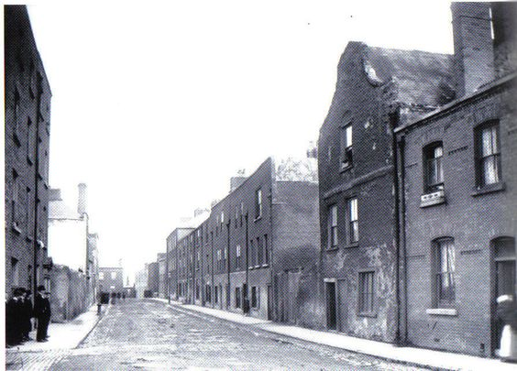
Brown Street, Dublin, 1900s
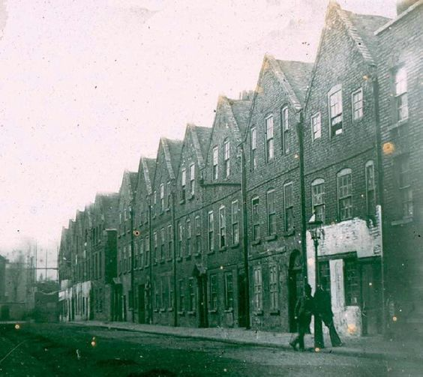 | 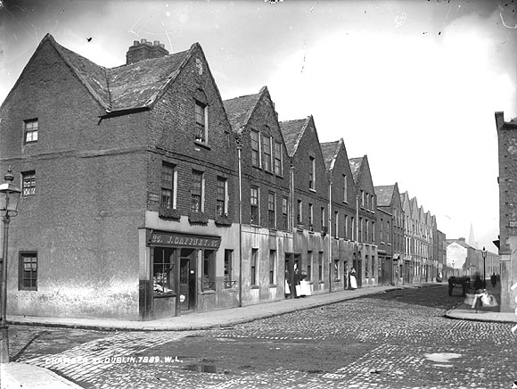
Chamber Street, Dublin, 1910s | Chamber Street, Dublin, 1910s
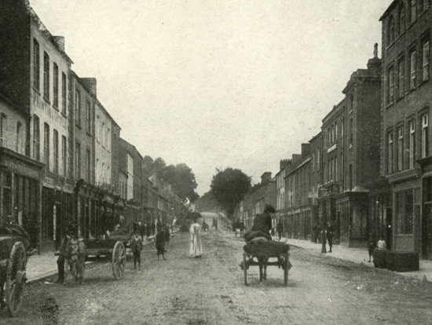 | 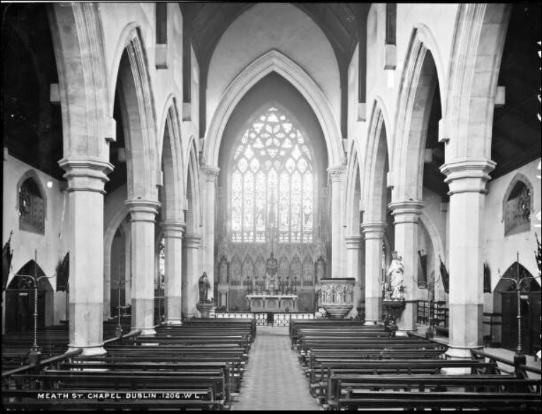
Old Cork Street, Dublin Ireland | Meath St Church, Dublin

