Jeremy Heath

SWENG 861

Course Project

05/03/2020

Music Magician

# Prerequisites

The software was originally developed on Windows 10, however, other operation systems, such as Linux or OSX are capable of building and developing the software.

## JAR Files

The following JAR files are required, but are handled by Maven:

* okhttp-2.7.5.jar
* okio-1.6.0.jar
* json-20190722.jar
* jsoup.1.8.3.jar

## Additional Dependencies

* The file SpringUtilities.java is included in this project and is provided by Oracle

## Building from the command line

To build from the command line, the following software must be installed:

* Java SDK 11 or later (earlier versions may be compatible as well)
* Maven

## Building from Eclipse

To build from eclipse, the following software must be installed:

* Eclipse 2019-06 (note that other versions may be compatible)

# Building the software

The following instructions provide the steps to building the software:

## Building and running from the command line

* “mvn package” will generate a jar file
* After “mvn package” has been ran, “mvn exec:java” will execute the main class as configured in the pom.xml file
* Alternatively, an executable jar can be build using the command “mvn clean compile assembly:single”. After this jar is built, the jar can be executed directly. The jar will be in the workspace-SWENG861\SWENG861Project\target and is named MusicMagician-0.0.1-SNAPSHOT-jar-with-dependencies.jar/.

## Building and running from Eclipse

* Import the project into eclipse (if needed, convert to a maven project. The pom file is included)
* Select the main class, MusicMagicianController, and select Run, Run Configurations, and enter the main class to be edu.psgv.sweng861.controller.MusicMagicianController

# Expected Input

The user will be able to search for information using the following as filters:

* Artist name
* Song name
* Album name
* Artist and Song name
* All (this leaves it up to the API’s discretion to determine the relevant results)

The user will select one the above filters and enter search parameters related to the list filters.

# Expected Output

The user will be able to view information on the following topics, when available:

* Artist
  + Name
  + Artist Image
  + Artist Biography
* Song
  + Title
  + Release Date
  + Lyrics
  + Artist
  + Duration
  + Album name
* Album
  + Title
  + Track list
  + Number of tracks
  + Album cover image
  + Duration
  + Release Date
  + Artist Name

# Running the Application

When the application is executed, the main display is shown, allowing for the user to enter search parameters and select search criteria. The search criteria include Artist, Song, Album, Artist and Song, and All.

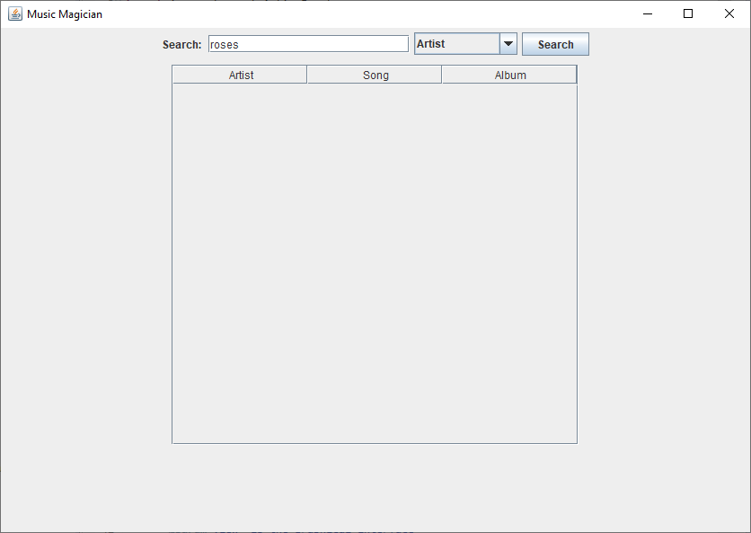

When the user searches, the following results appear. The list is populated in segments, so not all results are instantly available. It may take a few seconds for the entire list to finish populating.

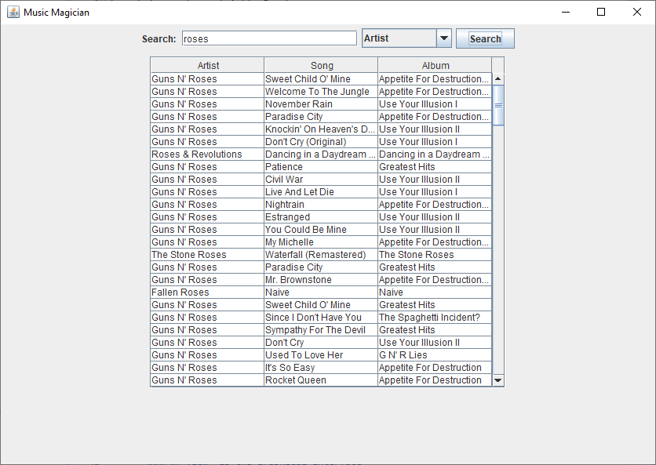

When the user selects to view more information on the artist by clicking on the appropriate artist row and column, the following information is displayed:

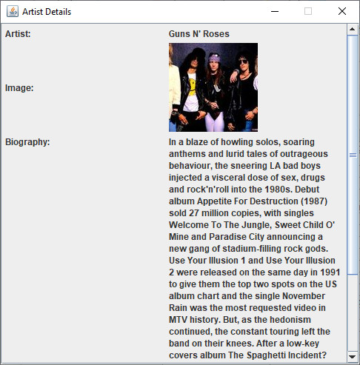

If a biography is not available, the text “No biography found” is displayed

When the user selects to view more information on the song by clicking on the appropriate song row and column, the following information is displayed:

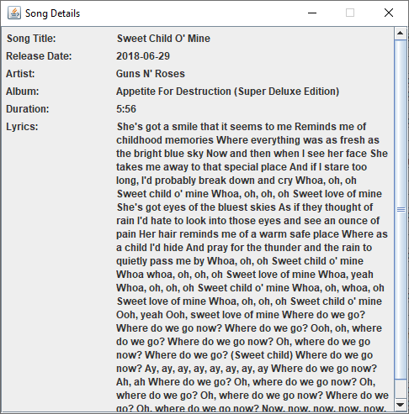

When the user selects to view more information on an album by clicking on the appropriate album row and column, the following information is displayed:

