**Worksheet: AVL Trees Name:**

An Active Learning Approach to Data Structures using C

Worksheet: AVL Tree Practice

In Preparation: Read Chapters 8 and 10 on Bags and Trees, respectively. In you have not done so ready, do Worksheets 29 and 30 on Binary Search Trees.

Insert the following values, in the order that they are given into an AVL Tree.

1) 30, 20, 50, 40, 60, 70

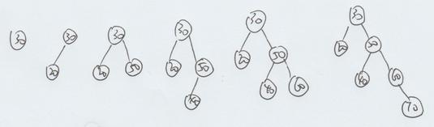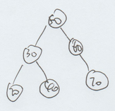

2) 50, 22, 80, 70, 75, 73

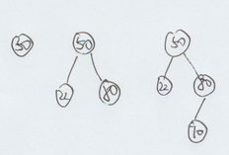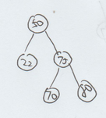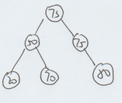

3) 75, 70, 100, 60, 80, 105, 77, 120

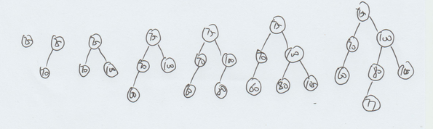

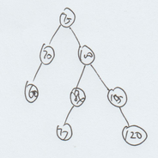

4) Take the tree from #3 and remove 60

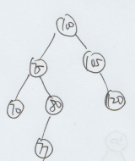

5) Take the tree from #3. Remove 120. Remove 60.

