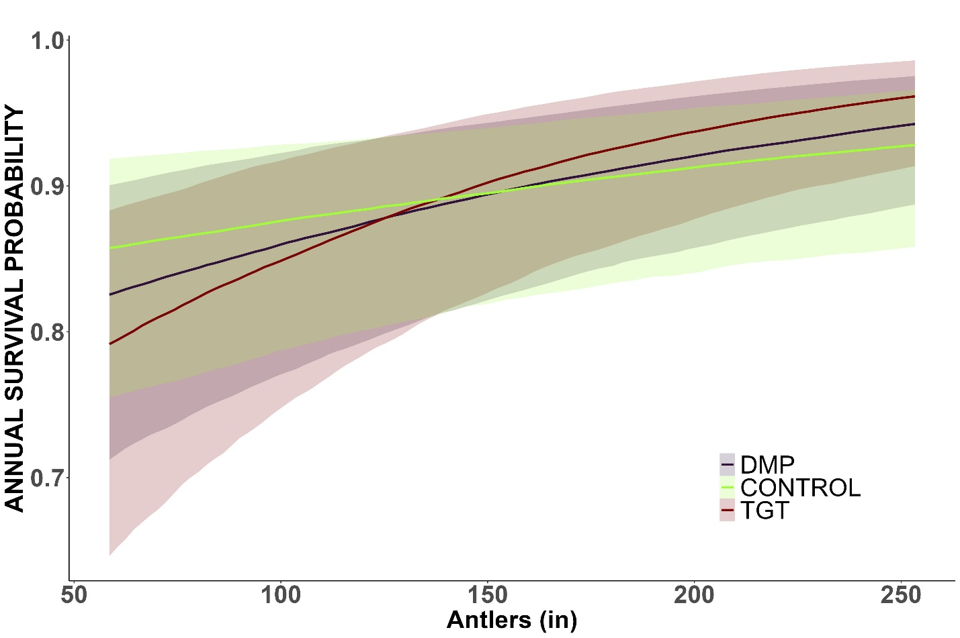

Figure 1: phi ~ b1 + b2 + b3 + b4 + eps1, survival is a function of age (b1), antler score (b2), birth year total rainfall (b3), the interaction between antler score and birth site (b4), and a random effect of birth site (eps1) and capture year (eps2). The effect of antler size on annual survival is mediated through site. For every x of antlers, survival increases y for control,

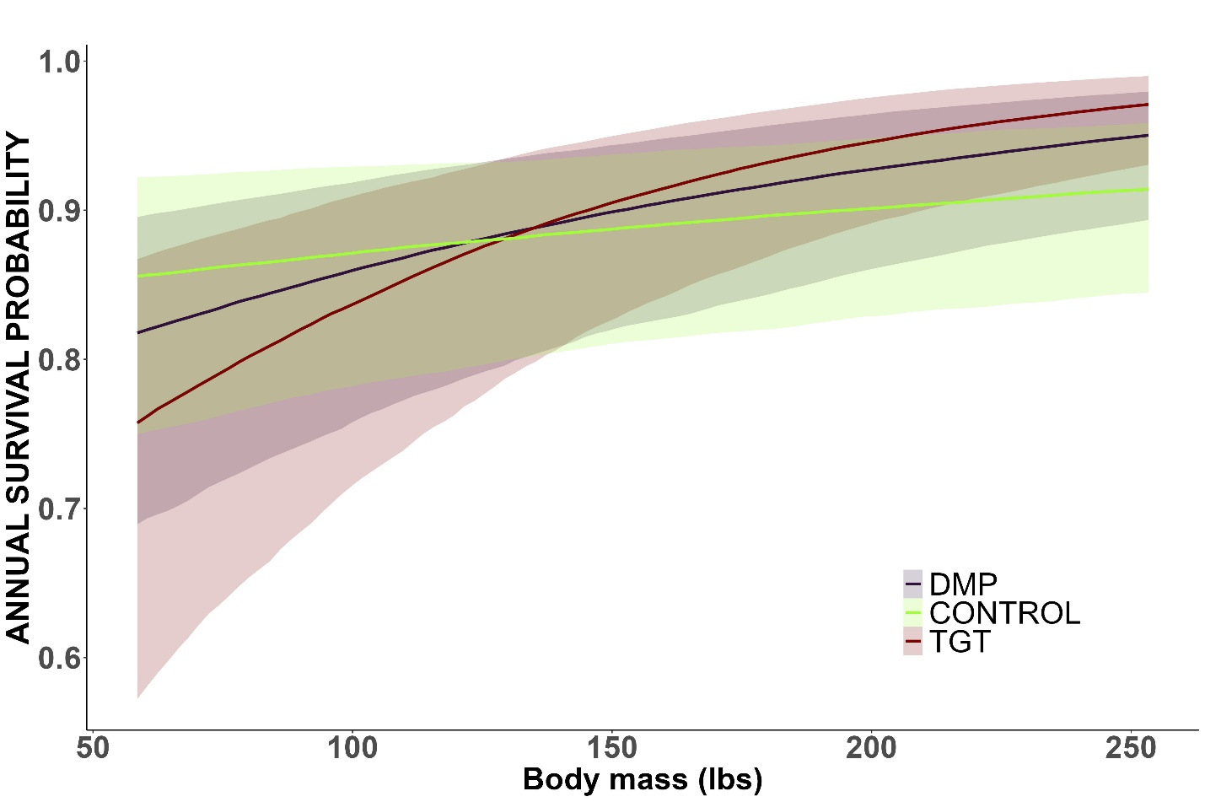

Figure 1: phi ~ b1 + b2 + b3 + b4 + eps1 + eps2, survival is a function of age (b1), body mass (b2), birth year total rainfall (b3), the interaction between body mass and birth site (b4), and a random effect of birth site (eps1) and capture year (eps2). The effect of body mass on annual survival is mediated through site. For every x of body mass, survival increases y for control.

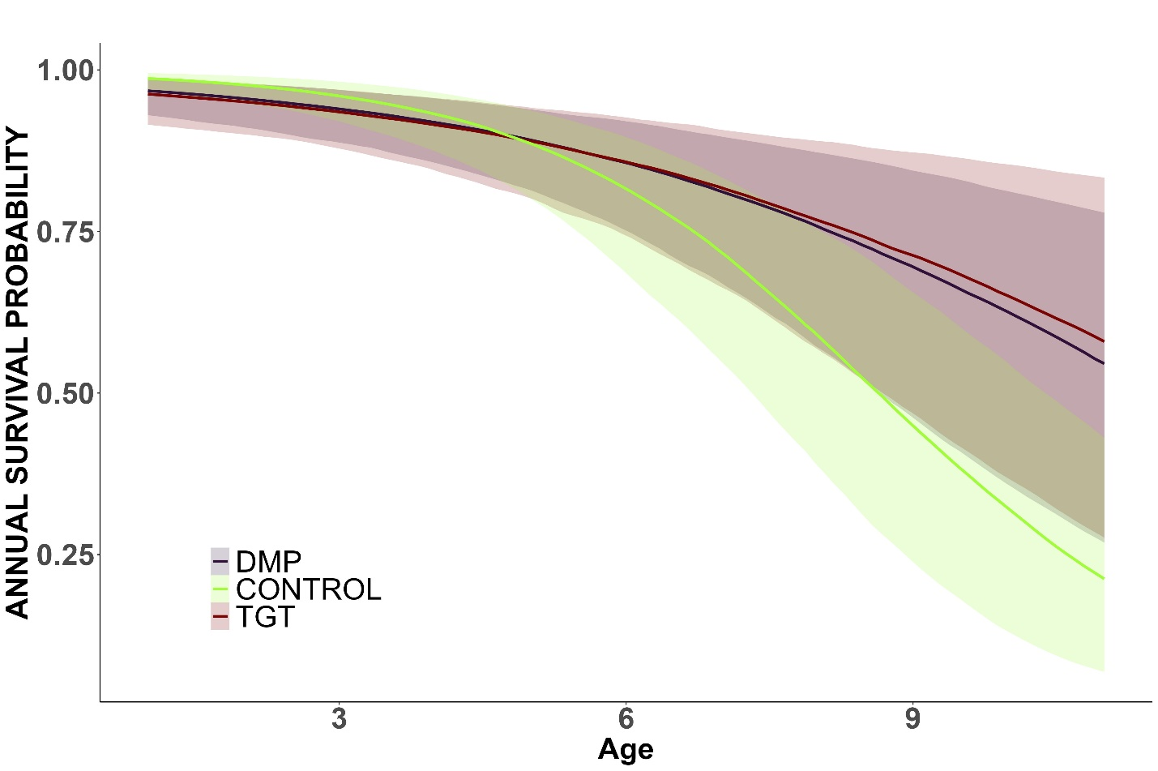

Figure 3: phi ~ b1 + b2 + b3 + b4 + eps1 + eps2, survival is a function of age (b1), body mass (b2), birth year total rainfall (b3), the interaction between age and birth site (b4), a random slope and intercept of birth site (eps1) and capture year (eps2). This figure is showing the effect of age mediated by birth site on annual survival probability while accounting for body mass and birth year total rainfall.