APCS A Lab: Donation



**Directions**

A set of classes is used to manage the different donations made to a charitable organization. The donors are organized into clubs depending upon the amount of their donation. The class hierarchy is shown in the following diagram.

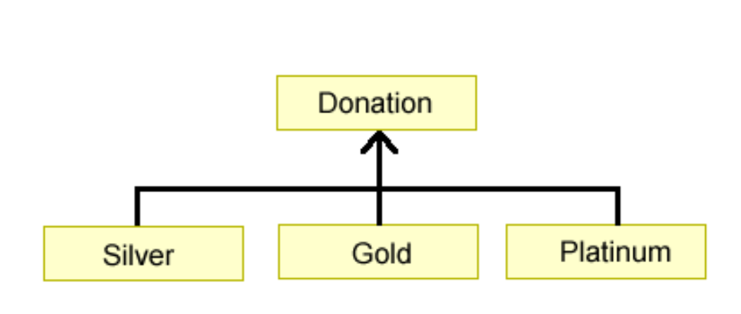

­The class **Donation** is specified as an abstract class as shown in the following declaration.

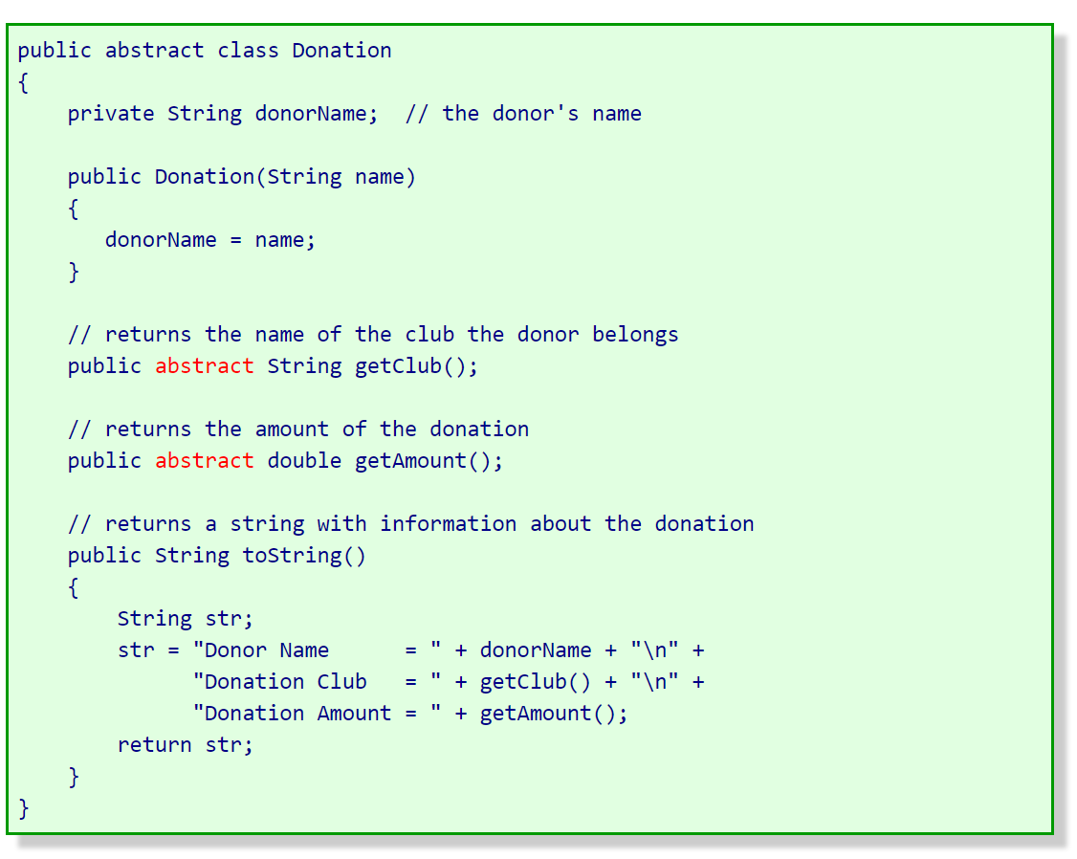

All donations have a donor name. For all donation classes, the toString method returns a string containing the information for that donation. Three additional classes are used to represent the different types of donations and are described in the table below.

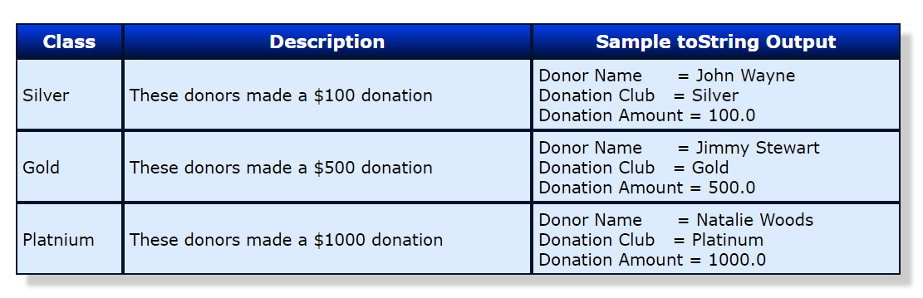

Using the class hierarchy and specifications given above, you will write complete class declarations for the Silver, Gold, and Platinum classes.

**Modifications**

1. **Silver Class**

Write the complete class declaration for the class Silver. Include all necessary instance variables and implementations of its constructor and method(s). The constructor should take a parameter that indicates the name of the donor. A donor becomes a member of the Silver club if they make a donation of $100.

1. **Gold Class**

Write the complete class declaration for the class Gold. Include all necessary instance variables and implementations of its constructor and method(s). The constructor should take a parameter that indicates the name of the donor. A donor becomes a member of the Gold club if they make a donation of $500.

1. **Platinum Class**

Write the complete class declaration for the class Platinum. Include all necessary instance variables and implementations of its constructor and method(s). The constructor should take a parameter that indicates the name of the donor. A donor becomes a member of the Platinum club if they make a donation of $1000.

**Sample Run**

Enter donor name -->John Wayne

Enter donation amount ($100, $500, $1000) --> $100

Enter Another [Y/N]? Y

Enter donor name -->Jimmy Stewart

Enter donation amount ($100, $500, $1000) --> $500

Enter Another [Y/N]? Y

Enter donor name -->Natalie Wood

Enter donation amount ($100, $500, $1000) --> $1000

Enter Another [Y/N]? n

Summary of Donations

====================

Donor Name = John Wayne

Donation Club = Silver

Donation Amount = 100.00

Donor Name = Jimmy Stewart

Donation Club = Gold

Donation Amount = 500.00

Donor Name = Natalie Wood

Donation Club = Platinium

Donation Amount = 1000.00