c) For the first normal form each cell should only contain a single value so classes must be separated.

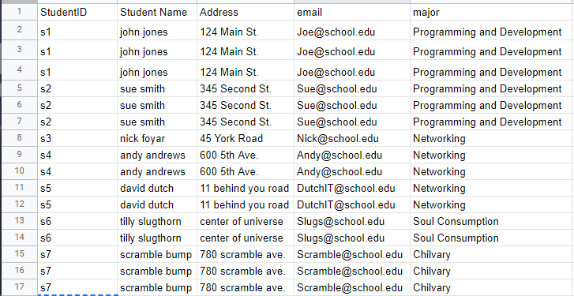

For second normal form classes needed to be pulled out so that the primary key had no duplicates:

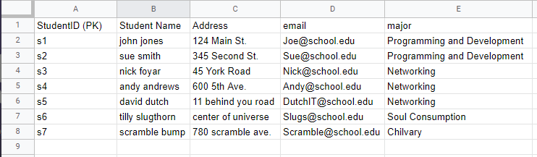

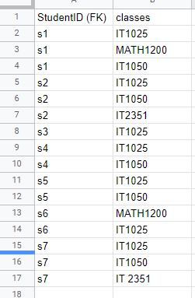

If something is required for the third normal form it is beyond me. Normally I should pull out any data that has transitive dependency but this has already been achieved in this example. Name, address, email, and major all are solely dependent on student ID. They could be pulled out and put into separate tables but that would only be required if they experienced duplicates in the future.