York & North Yorkshire Combined Authority
Data story — build spec for the YNYCA page (index.html)
How to read this document
This is a scrollable data story. Each section has up to three block types that map directly onto the page:
MAIN TEXT — the short narrative that scrolls on the page. Headline finding + only the one or two numbers a general reader needs.
CHART [C#] — the visual aligned to its main text. The spec caption (type / shows / source) is the instruction; the embedded image is the reference to rebuild or reuse.
TECHNICAL BOX [T#] — a collapsed dropdown (“Method & detail”), hidden until expanded. Method, weighting, statistics, caveats, robustness — kept OUT of the scrolling text.
Scope: covers only the topics already in the draft, resequenced to follow the presentation. IDs (C#, T#) are stable references for the build.
The spine
YNYCA is a single authority stitched from two very different economies: the compact, prosperous, graduate-attracting city of York, and a vast, sparse, older rural county. Almost every finding below is a version of that split. Lead with it, and let each section return to it.

1. Rural and vast
Main text
YNYCA is the 3rd most rural of the 20 MSAs. 42% of residents live in rural areas, and two national parks — the Yorkshire Dales and North York Moors — cover much of its 8,300 km² (the largest MSA by area). Rurality is not a backdrop; it drives the deprivation, connectivity and growth stories that follow.
Chart [C1]
Type: Ranked dot / lollipop plot, 20 MSAs
Shows: Rurality index by MSA, YNYCA highlighted as 3rd most rural. The most urban MSAs tend to be Established authorities.
Source: ONS 2021 Rural–Urban Classification (Output Area); ONS mid-2024 population estimates.
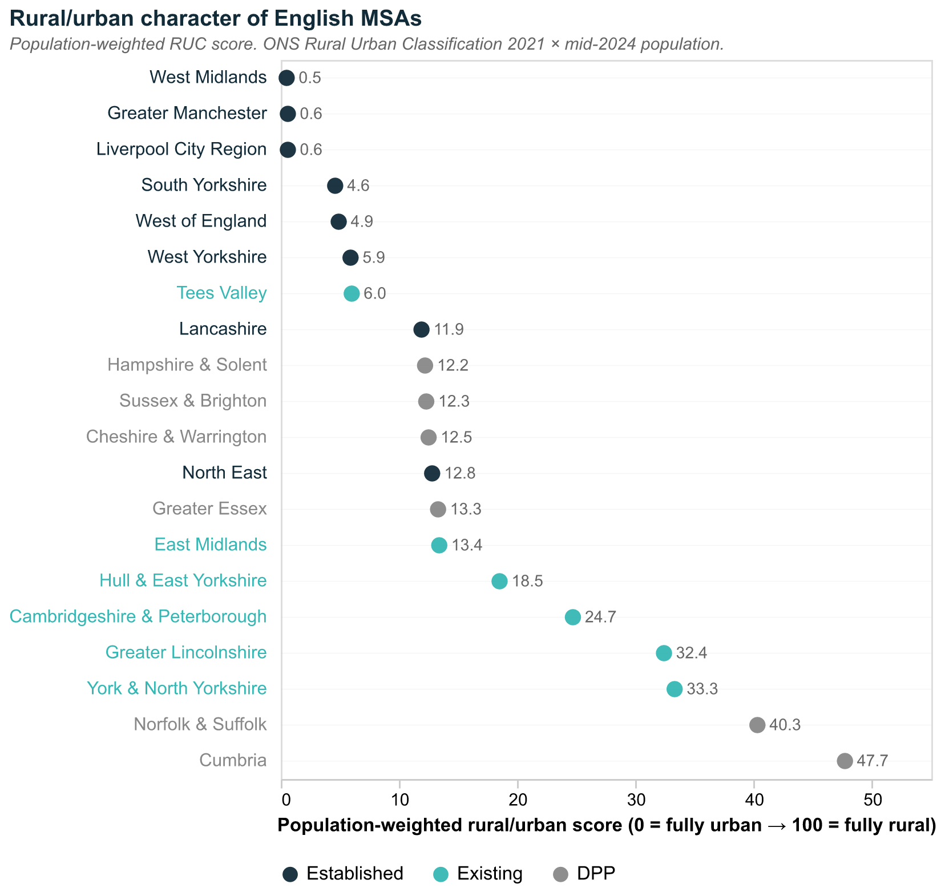

2. A tale of two regions
Main text
YNYCA is a marriage of two Local Authority Districts. The City of York is denser, younger, better connected and more productive. North Yorkshire is sparse, older, more tourism-dependent, less digitally connected, and carries higher deprivation. This duality runs through every indicator that follows.
Chart [C2]
Type: Paired comparison (two panels): demographic and economic indicators, City of York vs North Yorkshire
Shows: C2a demographic — density, age, short-term lets, child poverty. C2b economic — productivity, tourism dependence, digital connectivity, deprivation.
Source: ONS Explore Local Statistics (ELS). Note: log scale.
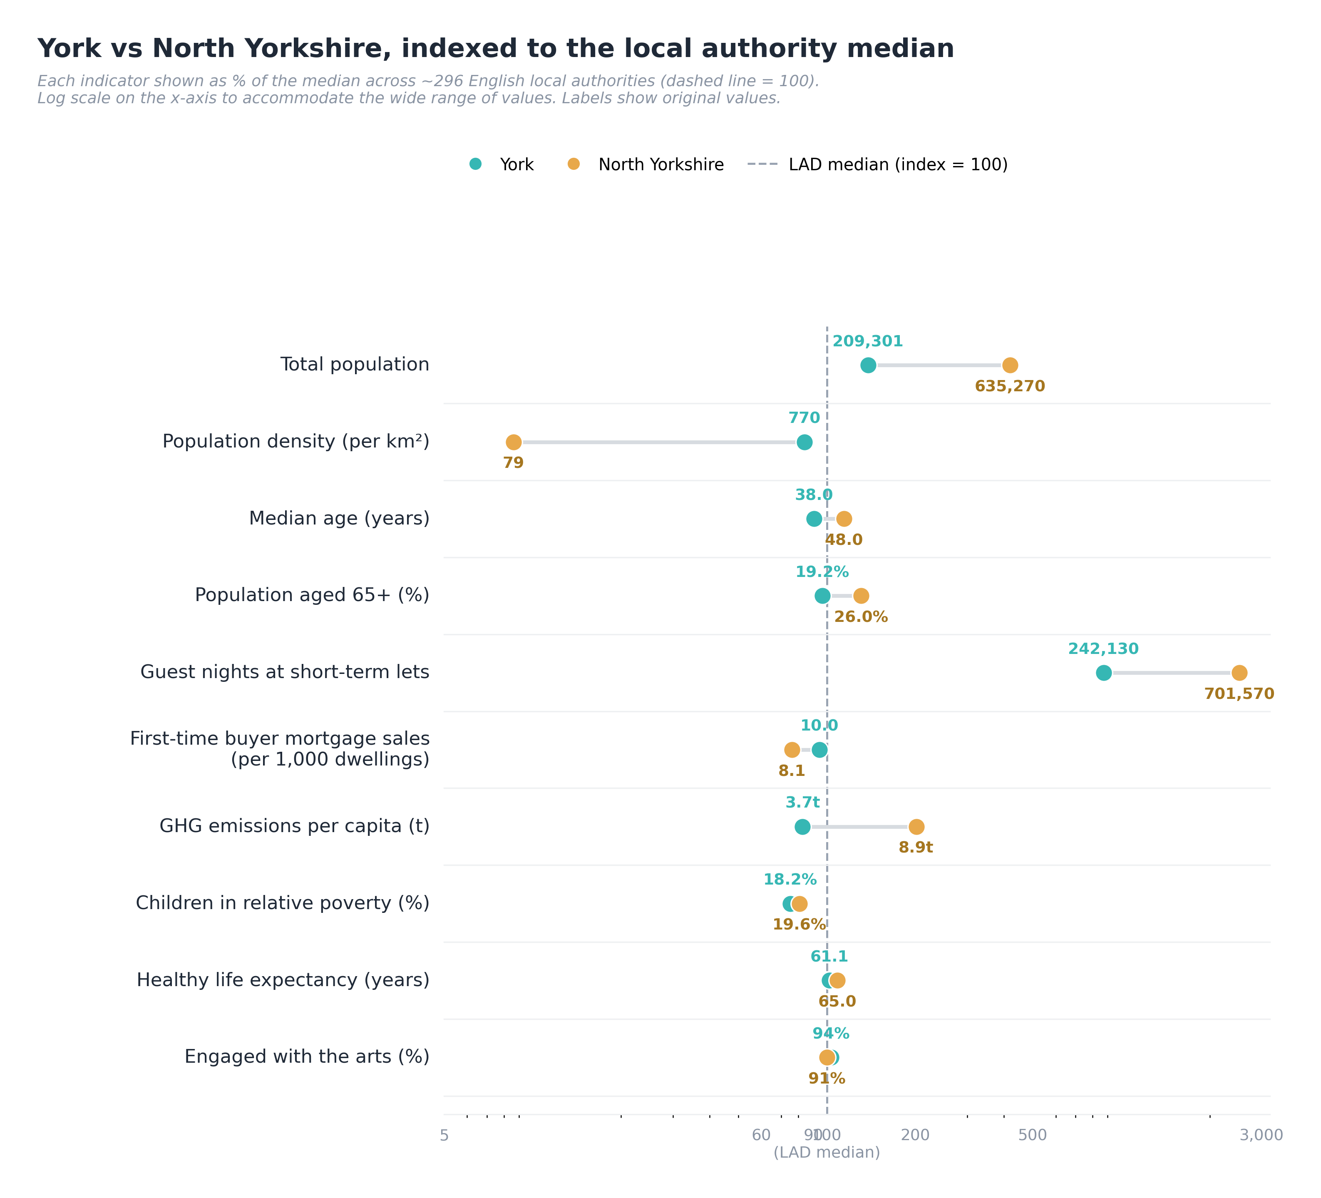
C2a — demographic indicators
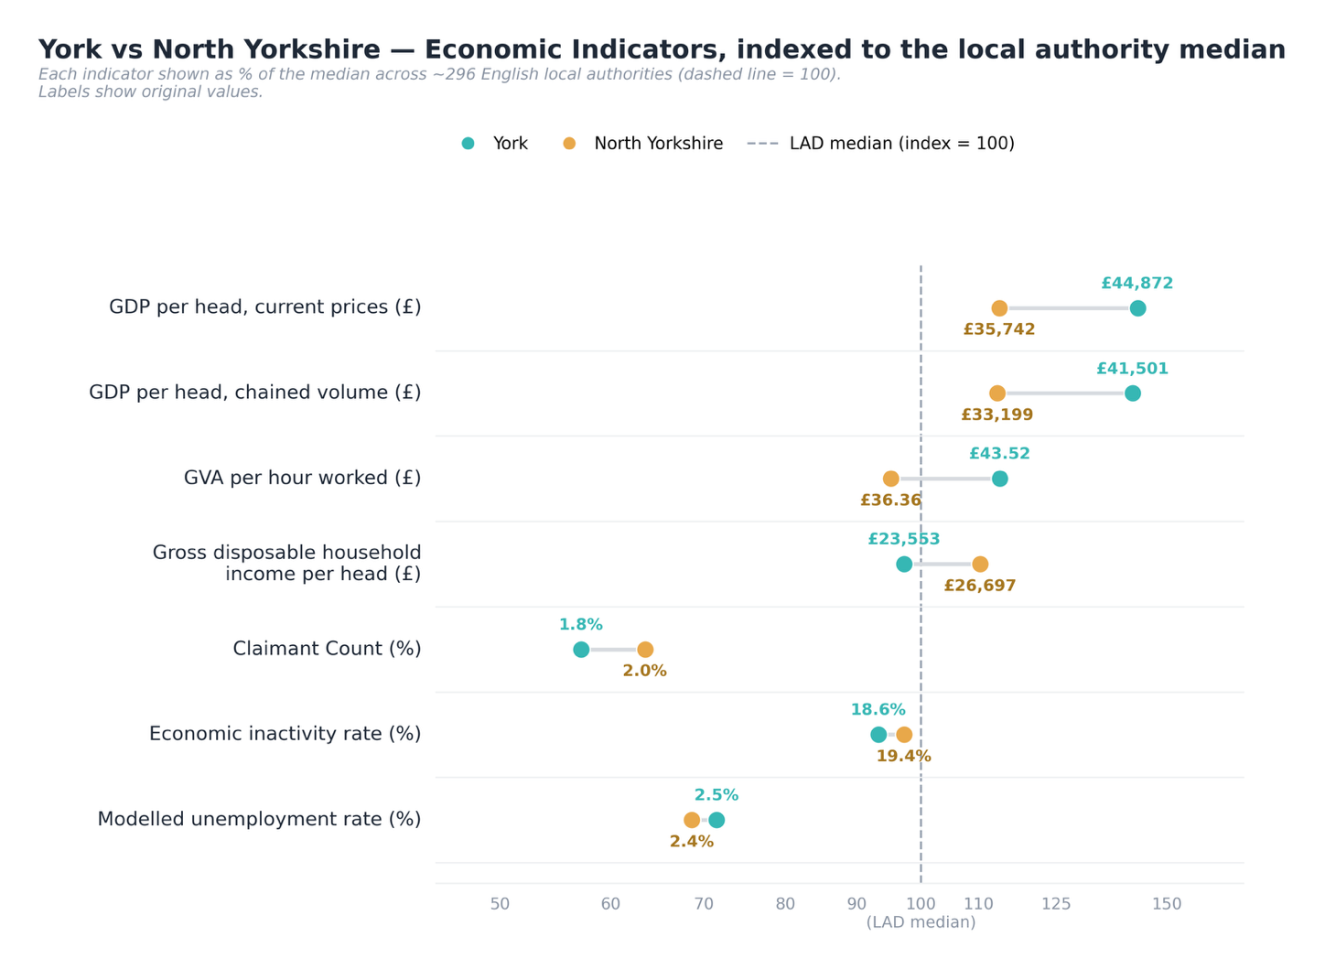
C2b — economic indicators
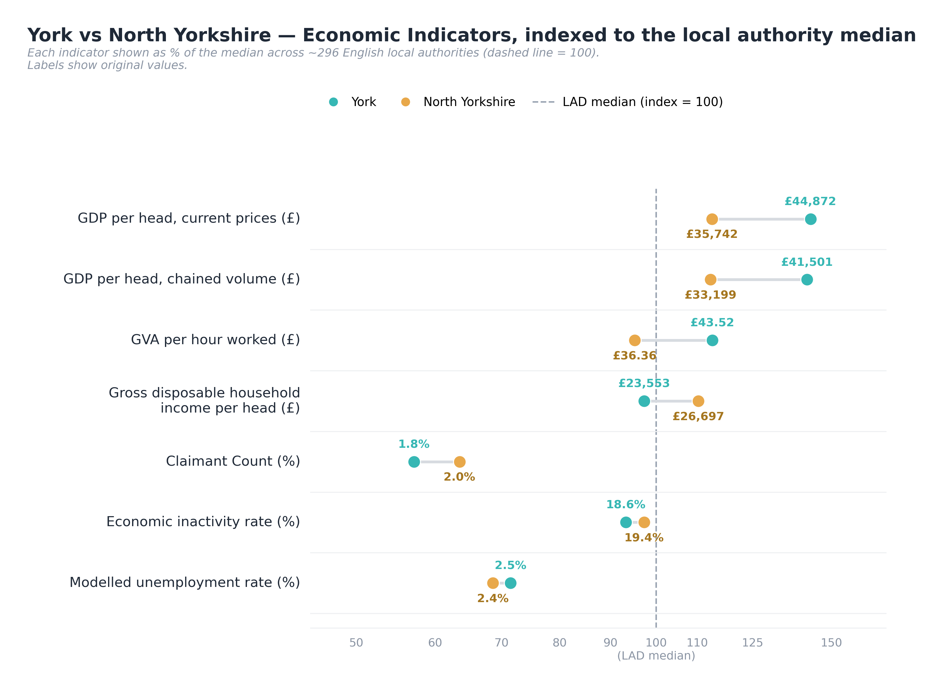
Shared legend (City of York / North Yorkshire)

3. Deprivation
Main text
On the standard composite measure, YNYCA is the least-deprived MSA on average, with relatively little variation across areas. But the average hides three distinct pockets of disadvantage — coastal, inner-city and rural — and it systematically understates the rural kind.
Chart [C3]
Type: Choropleth map(s) — full MSA plus a City of York inset
Shows: National IMD decile by LSOA across YNYCA, with a York zoom.
Source: ONS English Indices of Deprivation, 2025.
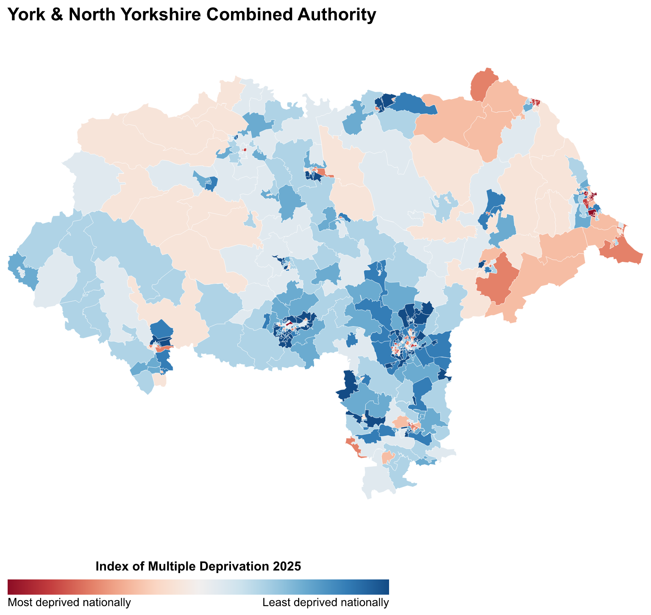
C3 — YNYCA composite IMD by LSOA
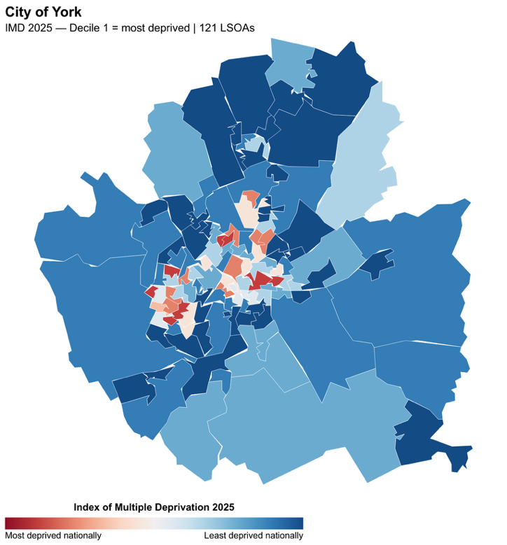
C3 inset — City of York
TECHNICAL BOX [T1] dropdown: “Least deprived: the numbers”
- YNYCA has 10 LSOAs in the nationally most-deprived decile — 2.0%, versus the 10.0% expected under an even national spread.
- Ranks 1st (least deprived) on the average national IMD rank of its LSOAs, and 1st on the lowest share in the most-deprived decile (2.0%).
- The "least deprived on average" finding is robust to population-weighting.
- Within rural areas, remoteness predicts deprivation: rurality explains over a quarter of the variation in deprivation rank across rural LSOAs (r = −0.51, p < 0.001) — far stronger than across YNYCA as a whole (r = −0.11). It is driven by isolated rural communities, not coastal proximity, which is not significant once urban areas are excluded.

3a. Coastal — the sharpest exception
Main text
The coast breaks the pattern. Scarborough and Whitby are among England’s most deprived coastal communities. In Scarborough, 28% of LSOAs fall in the most-deprived national quintile — a clear outlier among YNYCA’s urban districts.
Chart [C4]
Type: Choropleth map + horizontal bar of quintile shares by urban district
Shows: Deprivation profiles of urban districts; Scarborough’s concentration in the worst national quintile.
Source: ONS English Indices of Deprivation, 2025. (1 LSOA ≈ 1,500 people / 650 households.)
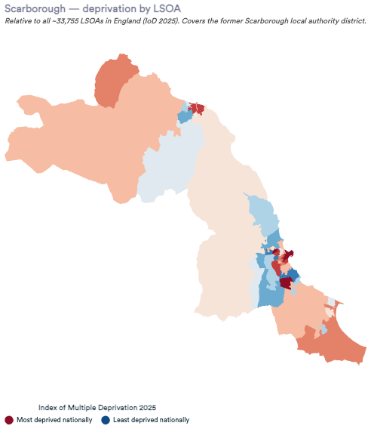
C4 — Scarborough district
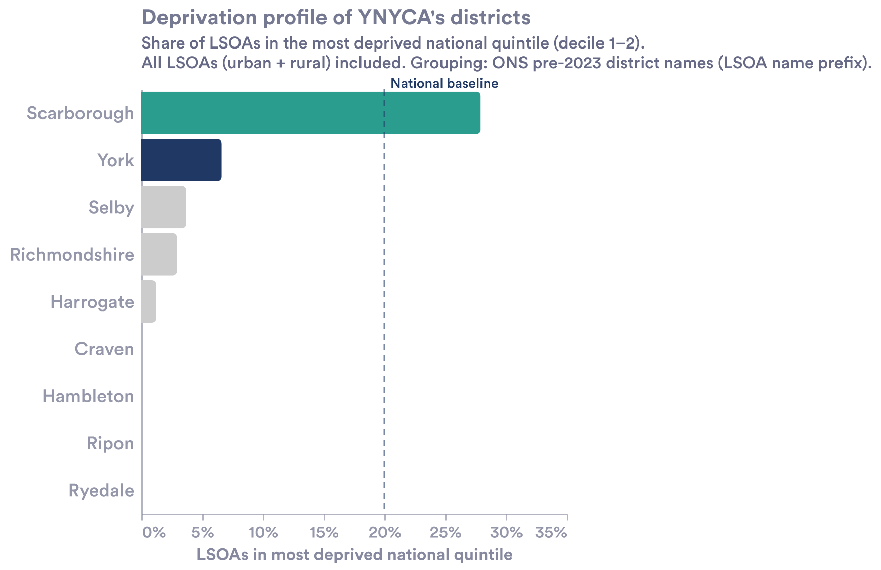
C4 — deprivation profiles of urban districts

3b. Inner-city — the donut effect
Main text
The cities show the opposite pattern. In York and Ripon, deprivation forms a "donut" — an outer ring of disadvantage around a relatively affluent centre.
Chart [C5]
Type: Scatter / distance-gradient (urban LSOAs only)
Shows: Distance from urban centre vs national IMD rank, for York and Ripon — the donut gradient.
Source: ONS English Indices of Deprivation, 2025.
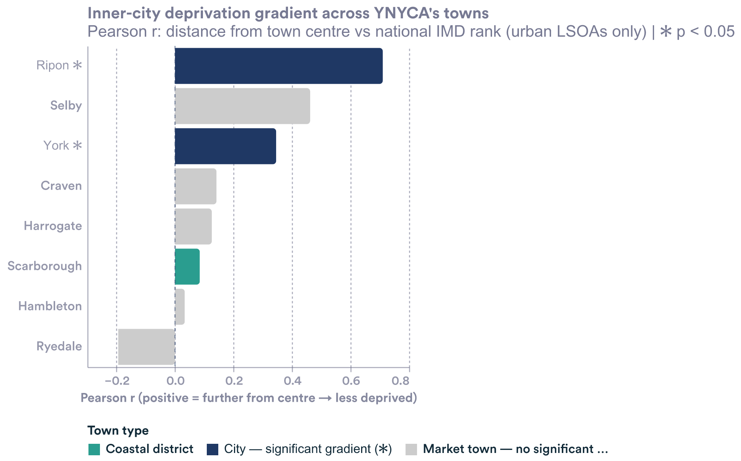
C5 — urban deprivation gradient (York / Ripon)

3c. Rural — hidden by the composite
Main text
The composite measure is weakest exactly where YNYCA is most exposed. It understates rural deprivation (McLennan et al., 2025): YNYCA scores poorly on the living-environment domain — indoor housing conditions and geographic barriers to services such as travel time and distance.
Chart [C6]
Type: Horizontal bar / ranked domain scores
Shows: YNYCA’s rank and worst-quintile share on the rural-relevant IMD domains.
Source: IoD 2025, File 7.
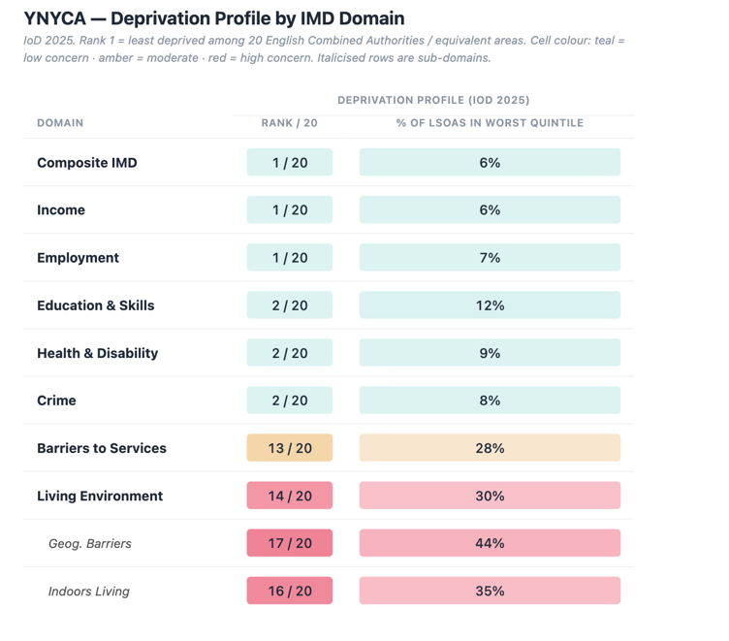
C6 — rural IMD domain scores
TECHNICAL BOX [T2] dropdown: “Why the composite understates rural deprivation”
YNYCA ranks 1st (least deprived) overall — but the composite is dominated by income and employment indicators (45% of total weight combined), the areas where YNYCA’s rural economy performs relatively well.
On the domains that define rural quality of life, YNYCA is near the bottom:
- Geographic barriers: rank 17/20; 44% of communities in the worst national quintile — residents travel unusually far for services.
- Indoors living: rank 16/20; 35% in the worst quintile — a separate story, about the condition and heatability of rural housing stock.
- Living environment overall: 30% in the worst quintile — including air quality and road traffic.
Concentration bias: low population density spreads deprivation thinly across geography, suppressing average scores even where individual communities face serious disadvantage. The IoD 2025 strengthened the geographic-barriers and indoors-living sub-domains precisely to capture what the composite misses in rural England.
(Indoors living = quality and physical condition of housing within a neighbourhood.)

4. Digital connectivity
Main text
York is a well-connected small city; North Yorkshire lags on every measure. Weak rural connectivity limits home-working and compounds the region’s geographic inequality.
Chart [C7]
Type: Grouped bars / small multiples, City of York vs North Yorkshire
Shows: Digital connectivity measures, York vs North Yorkshire.
Source: Ofcom Connected Nations 2024.
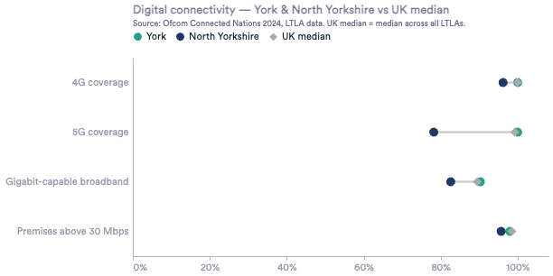
C7 — digital connectivity, York vs North Yorkshire
TECHNICAL BOX [T3] dropdown: “Data note”
Treat working-from-home figures drawn from the 2021 Census with caution — the Covid period distorts them.

5. Output and growth
Main text
Across the 20 MSAs, YNYCA sits mid-table on the level of economic output — but it is growing fast.
Chart [C8]
Type: Scatter, 20 MSAs
Shows: GVA per head vs (approximate) total GVA, YNYCA highlighted.
Source: ONS Regional GVA (Balanced) per head, Table 2.
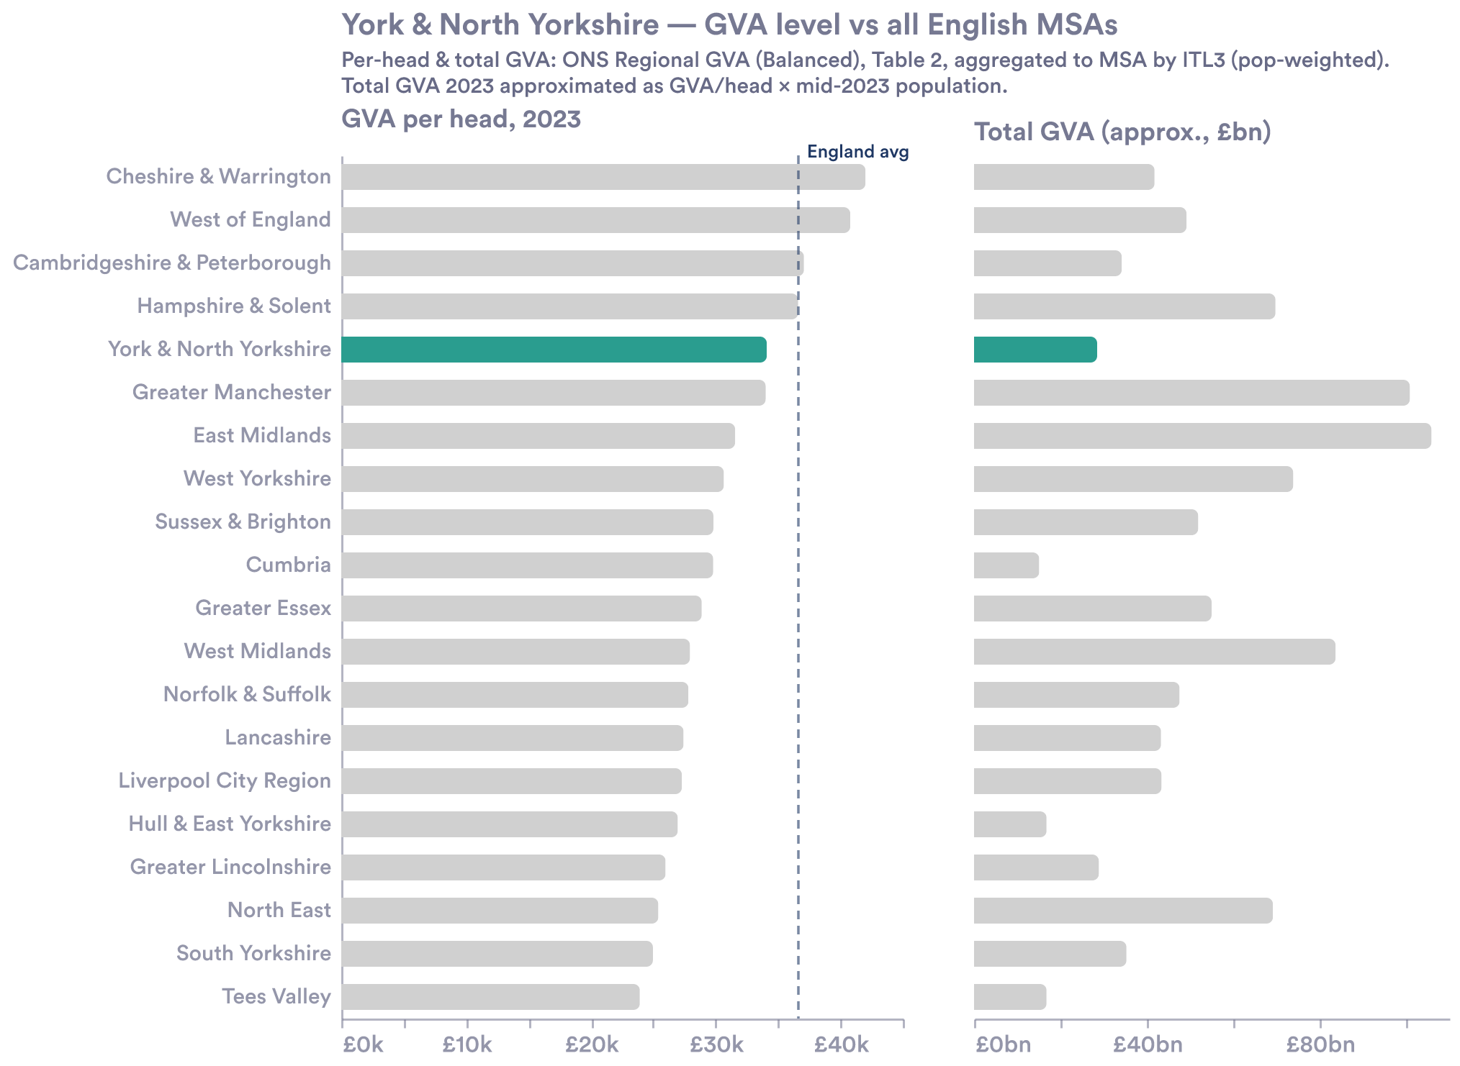
C8 — relative performance of 20 MSAs
TECHNICAL BOX [T4] dropdown: “How MSA GVA is built”
ONS publishes no GVA figure for Combined Authorities. It publishes at ITL3 level — sub-regional units at roughly county / large-district scale (e.g. one ITL3 covers West Yorkshire, but Greater Manchester splits into five).
GVA per head, per MSA:
- Identify the ITL3s that fall within each MSA boundary.
- Take each ITL3’s GVA per head from ONS Table 2 (Regional GVA Balanced).
- Average across ITL3s weighted by population, so larger ITL3s count proportionally more.
Total GVA: no official MSA figure exists, so it is approximated as GVA per head × mid-2023 population — order-of-magnitude only, and flagged as indicative on the chart. The indexed growth series (2013 = 100) is the cleaner comparison.
Some ITL3s straddle two MSAs; each is assigned to the MSA it most overlaps.

5a. Growth — overtaking England
Main text
YNYCA is the 3rd fastest-growing English MSA — behind only Greater Manchester and the West of England — and the strongest-growing of any Yorkshire MSA, pulling above the England average.
Chart [C9]
Type: Indexed line chart (2013 = 100)
Shows: GVA per head growth, YNYCA vs England and comparator MSAs.
Source: ONS Regional GVA (Balanced) per head, Table 2. Current prices.
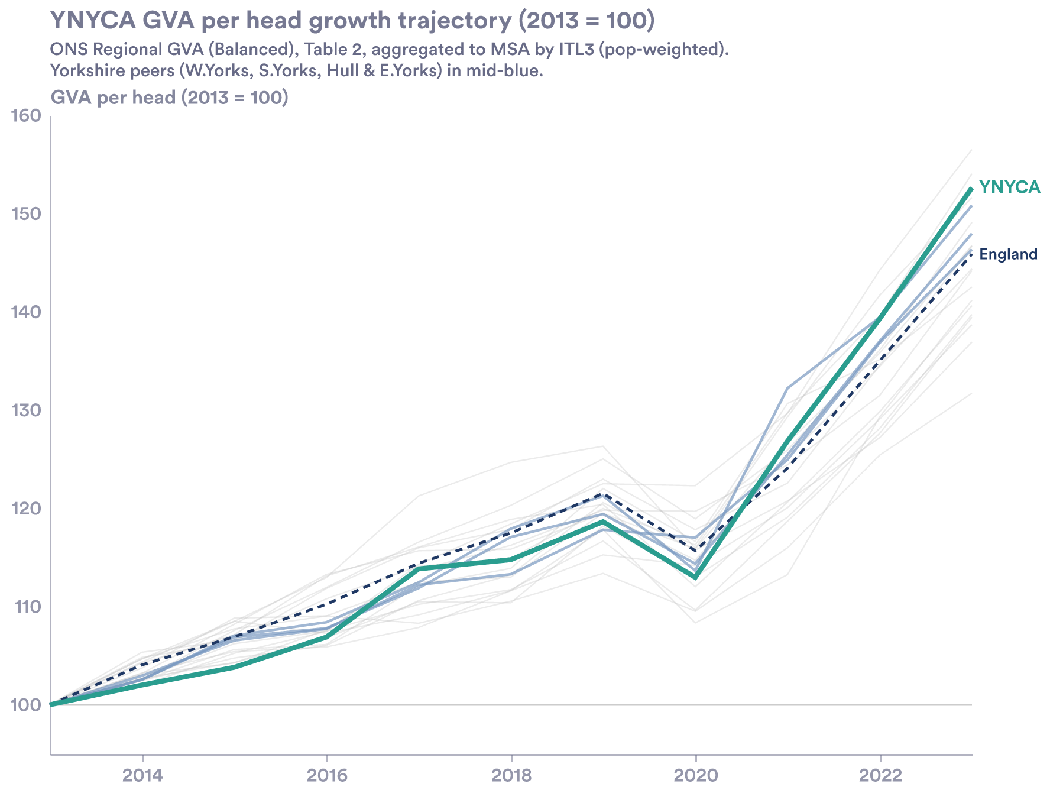
C9 — indexed GVA growth

5b. York vs North Yorkshire — a persistent gap
Main text
The headline growth hides a persistent internal gap: York consistently outperforms North Yorkshire on GVA per capita, and the gap has not closed.
Chart [C10]
Type: Two-line time series
Shows: GVA per head, City of York vs North Yorkshire, over time.
Source: ONS Regional GVA (Balanced) by ITL3, current prices.
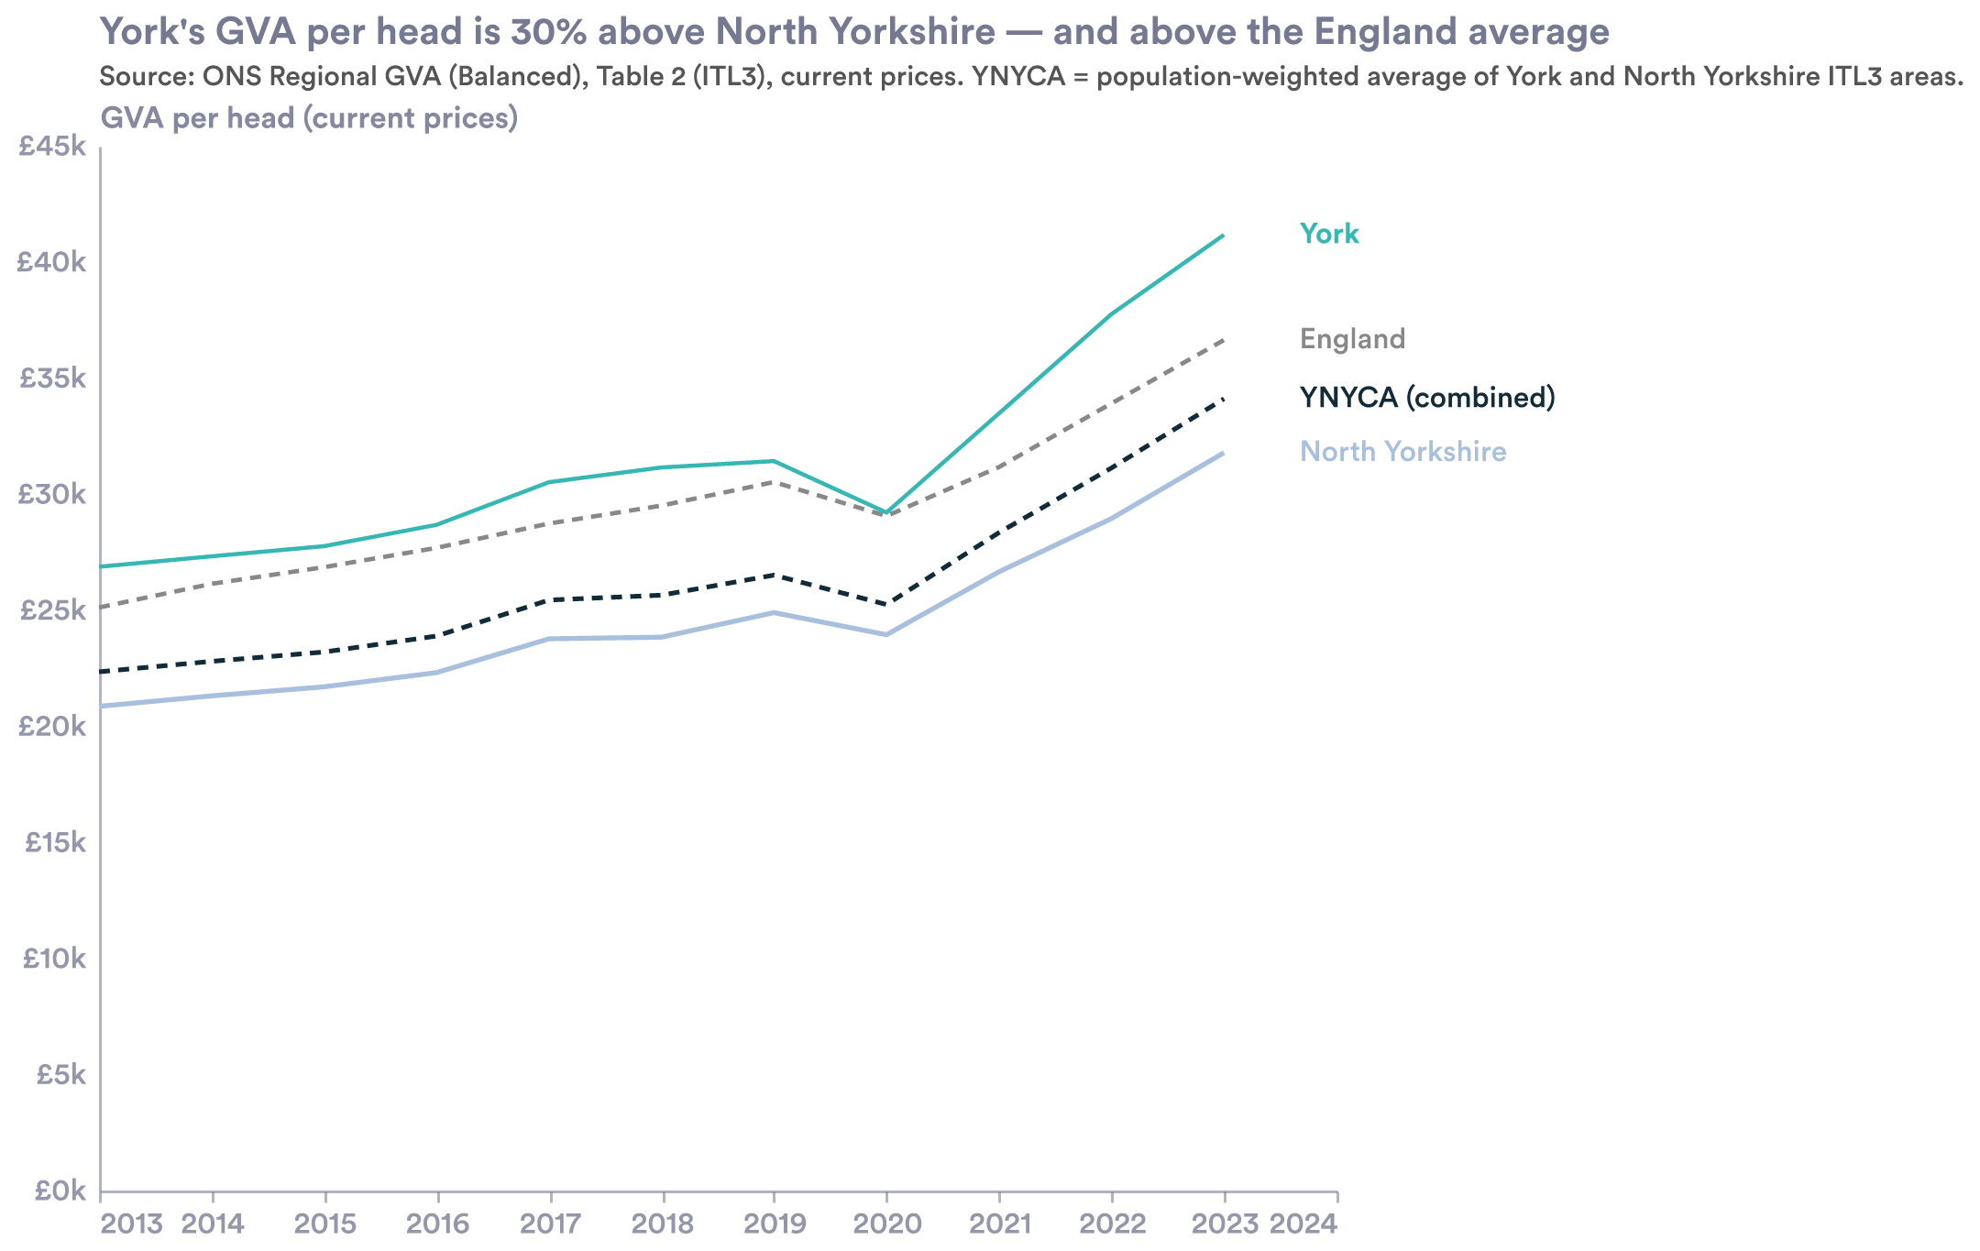
C10 — York vs North Yorkshire GVA per capita

6. Graduates: brain gain, an anchor city, and rural drain
Main text
YNYCA ranks 5th of 20 MSAs for net graduate gain, at +9%. But that headline is almost entirely York.
Chart [C11]
Type: Ranked bar, 20 MSAs
Shows: Net brain-gain rate by MSA, YNYCA 5th (+9%).
Source: ONS Graduate Retention Study.
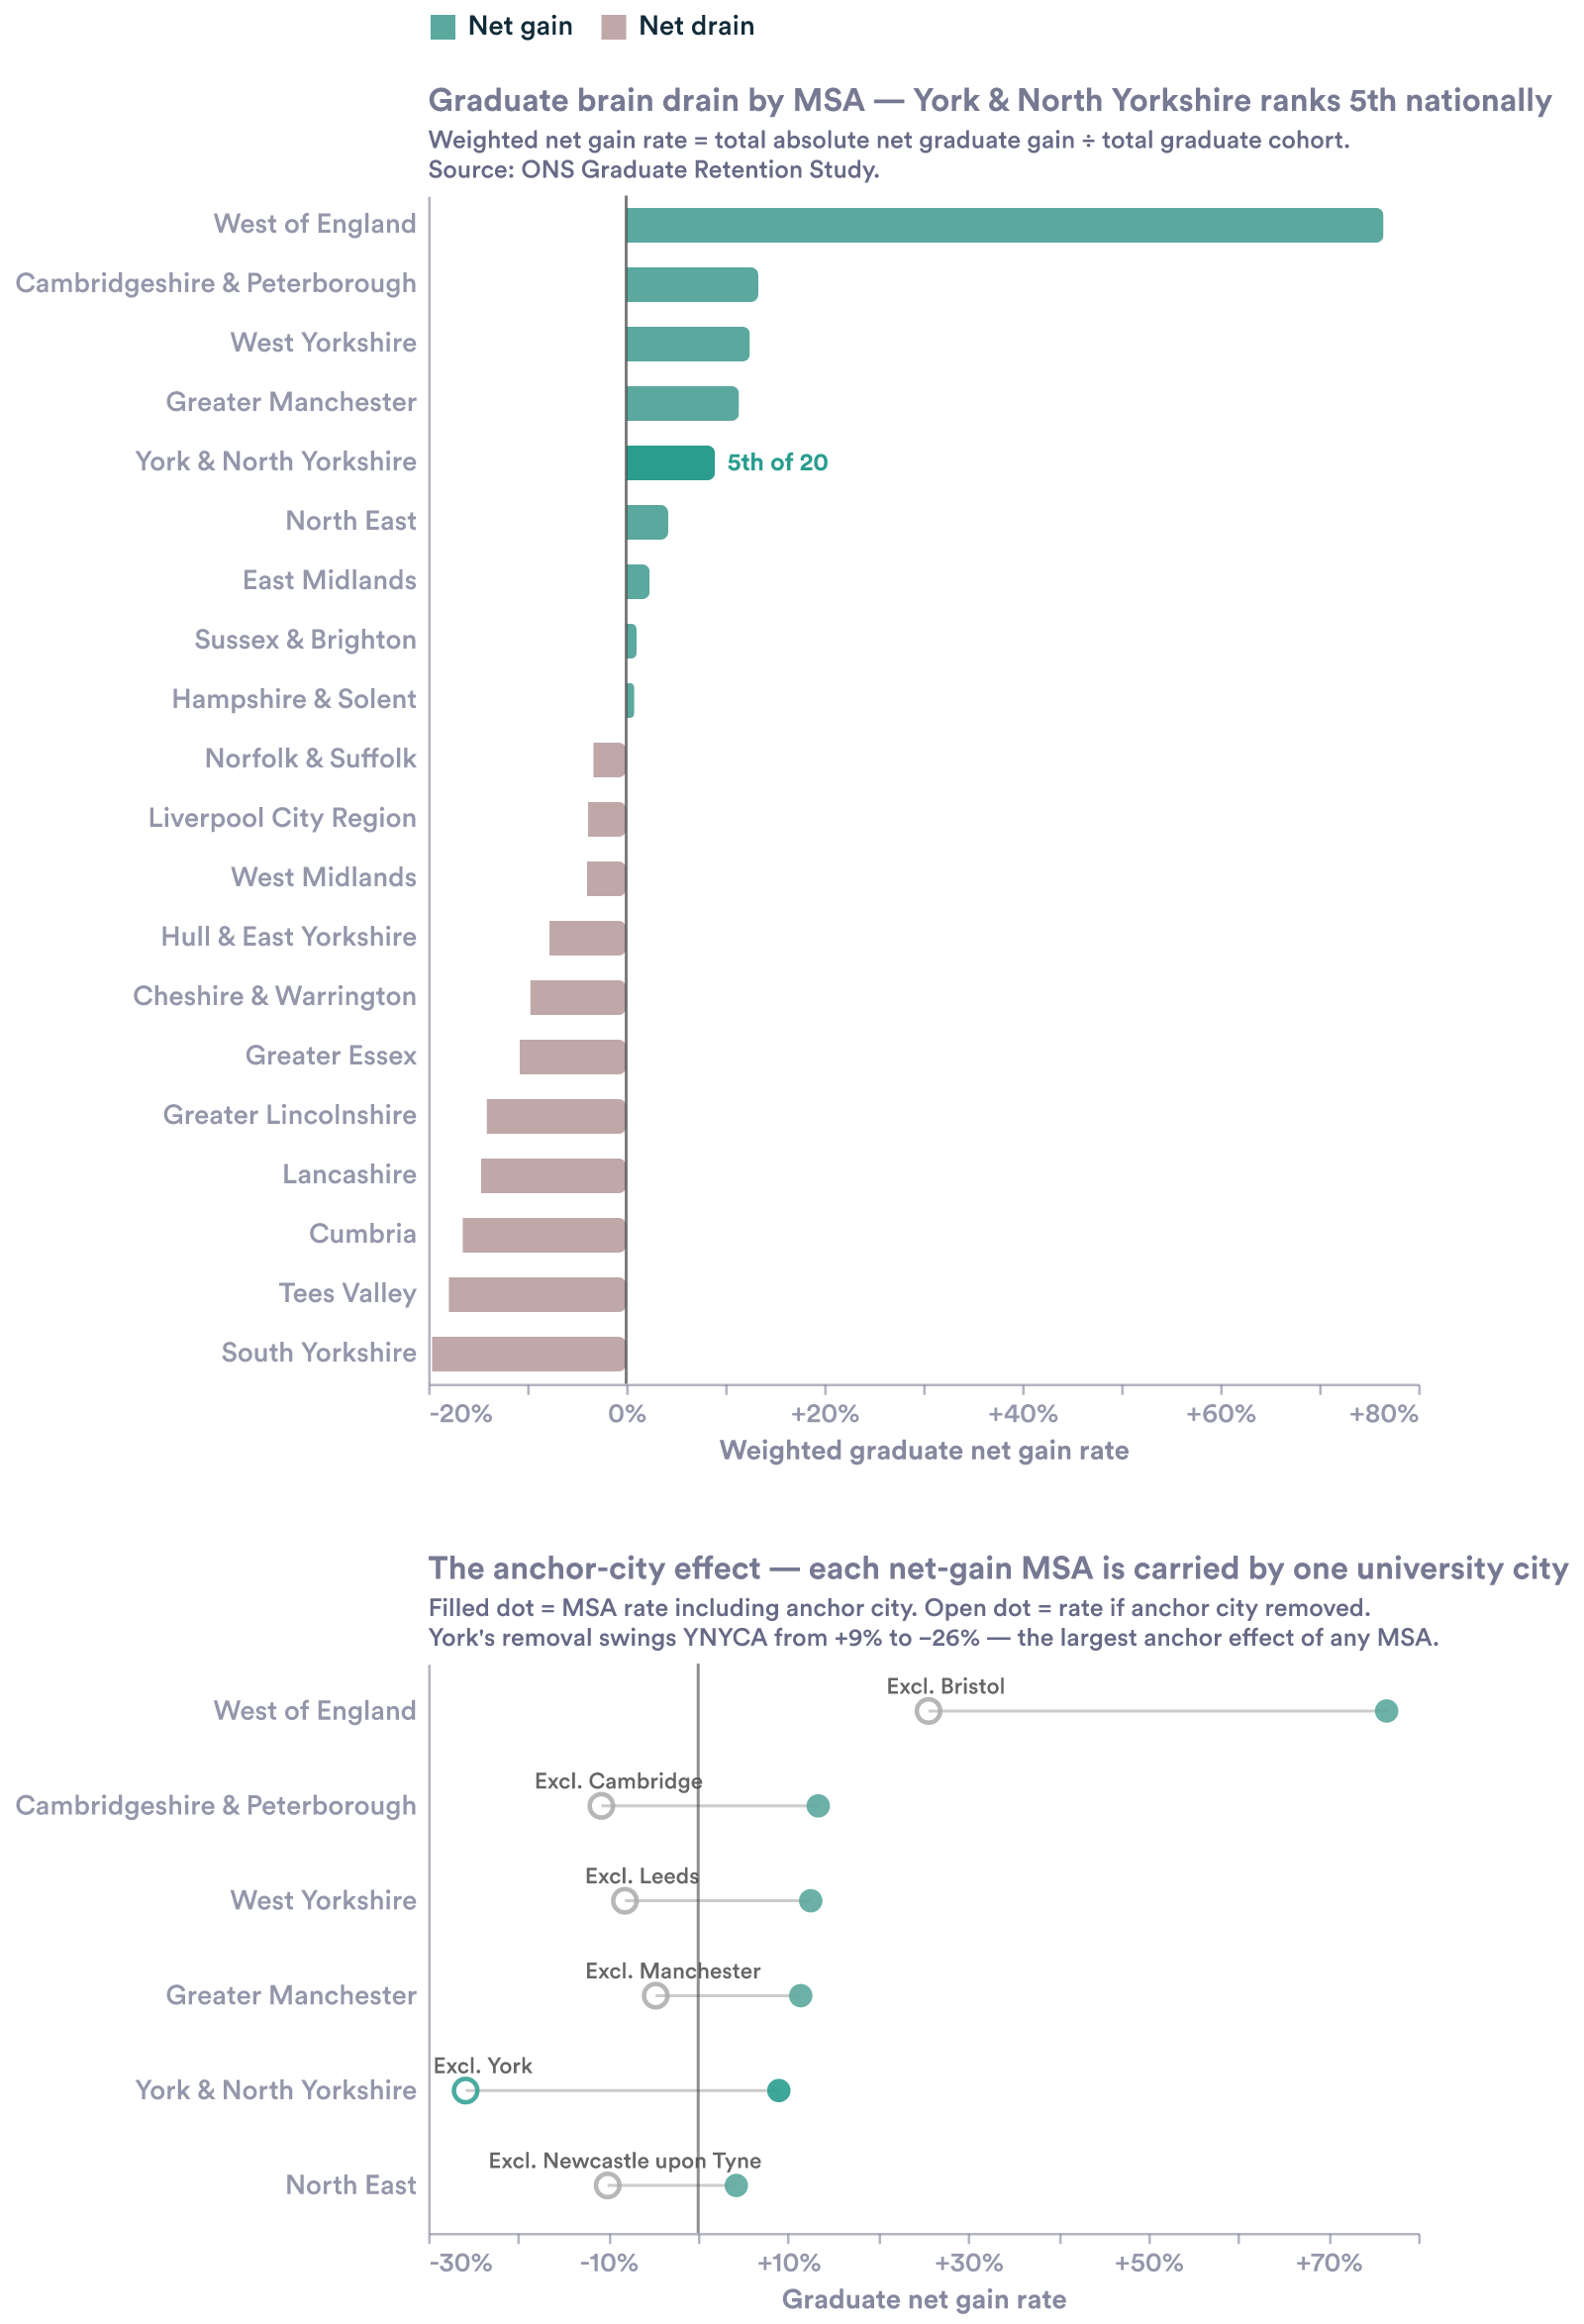
C11 — net graduate gain by MSA
TECHNICAL BOX [T5] dropdown: “How the brain-gain rate is built”
Per town: graduates arriving minus graduates leaving, scaled to a headcount gained/lost; summed across an MSA’s towns and divided by the MSA’s total graduate cohort — so larger graduate towns weigh more than small market towns. (Formula: Σ net graduates gained/lost ÷ Σ total graduates.)
Source: ONS Graduate Retention Study — a GCSE cohort tracked from 2008–11 to where they lived in 2018–19, across England’s 1,104 built-up areas.
University cities can exceed +100% because they attract far more graduates than their own local cohort ever produced.
Caveats:
- Pre-Covid, pre-remote-work cohort.
- Suppressed (very small) towns are excluded; they tend to be slightly higher-drain, biasing MSA rates a touch upward.
- The West of England’s +77% is genuine but reflects three co-located university cities in a compact geography.

6a. York is an anchor city
Main text
York does the work of a national university city. It ranks 7th of 933 English towns for inward graduate migration — top 1%, alongside Cambridge, Bath and Oxford — and retains 61% of its own graduates. Strip York out, and YNYCA flips to a −26% brain drain.
Chart [C12]
Type: Dumbbell / dot plot, the 6 net-gain MSAs
Shows: Net graduate gain with (filled dot) and without (open dot) the dominant university city. YNYCA’s open dot is pure market-town performance, because York is its only university town.
Source: ONS Graduate Retention Study. Primary university towns excluded for the open dots.
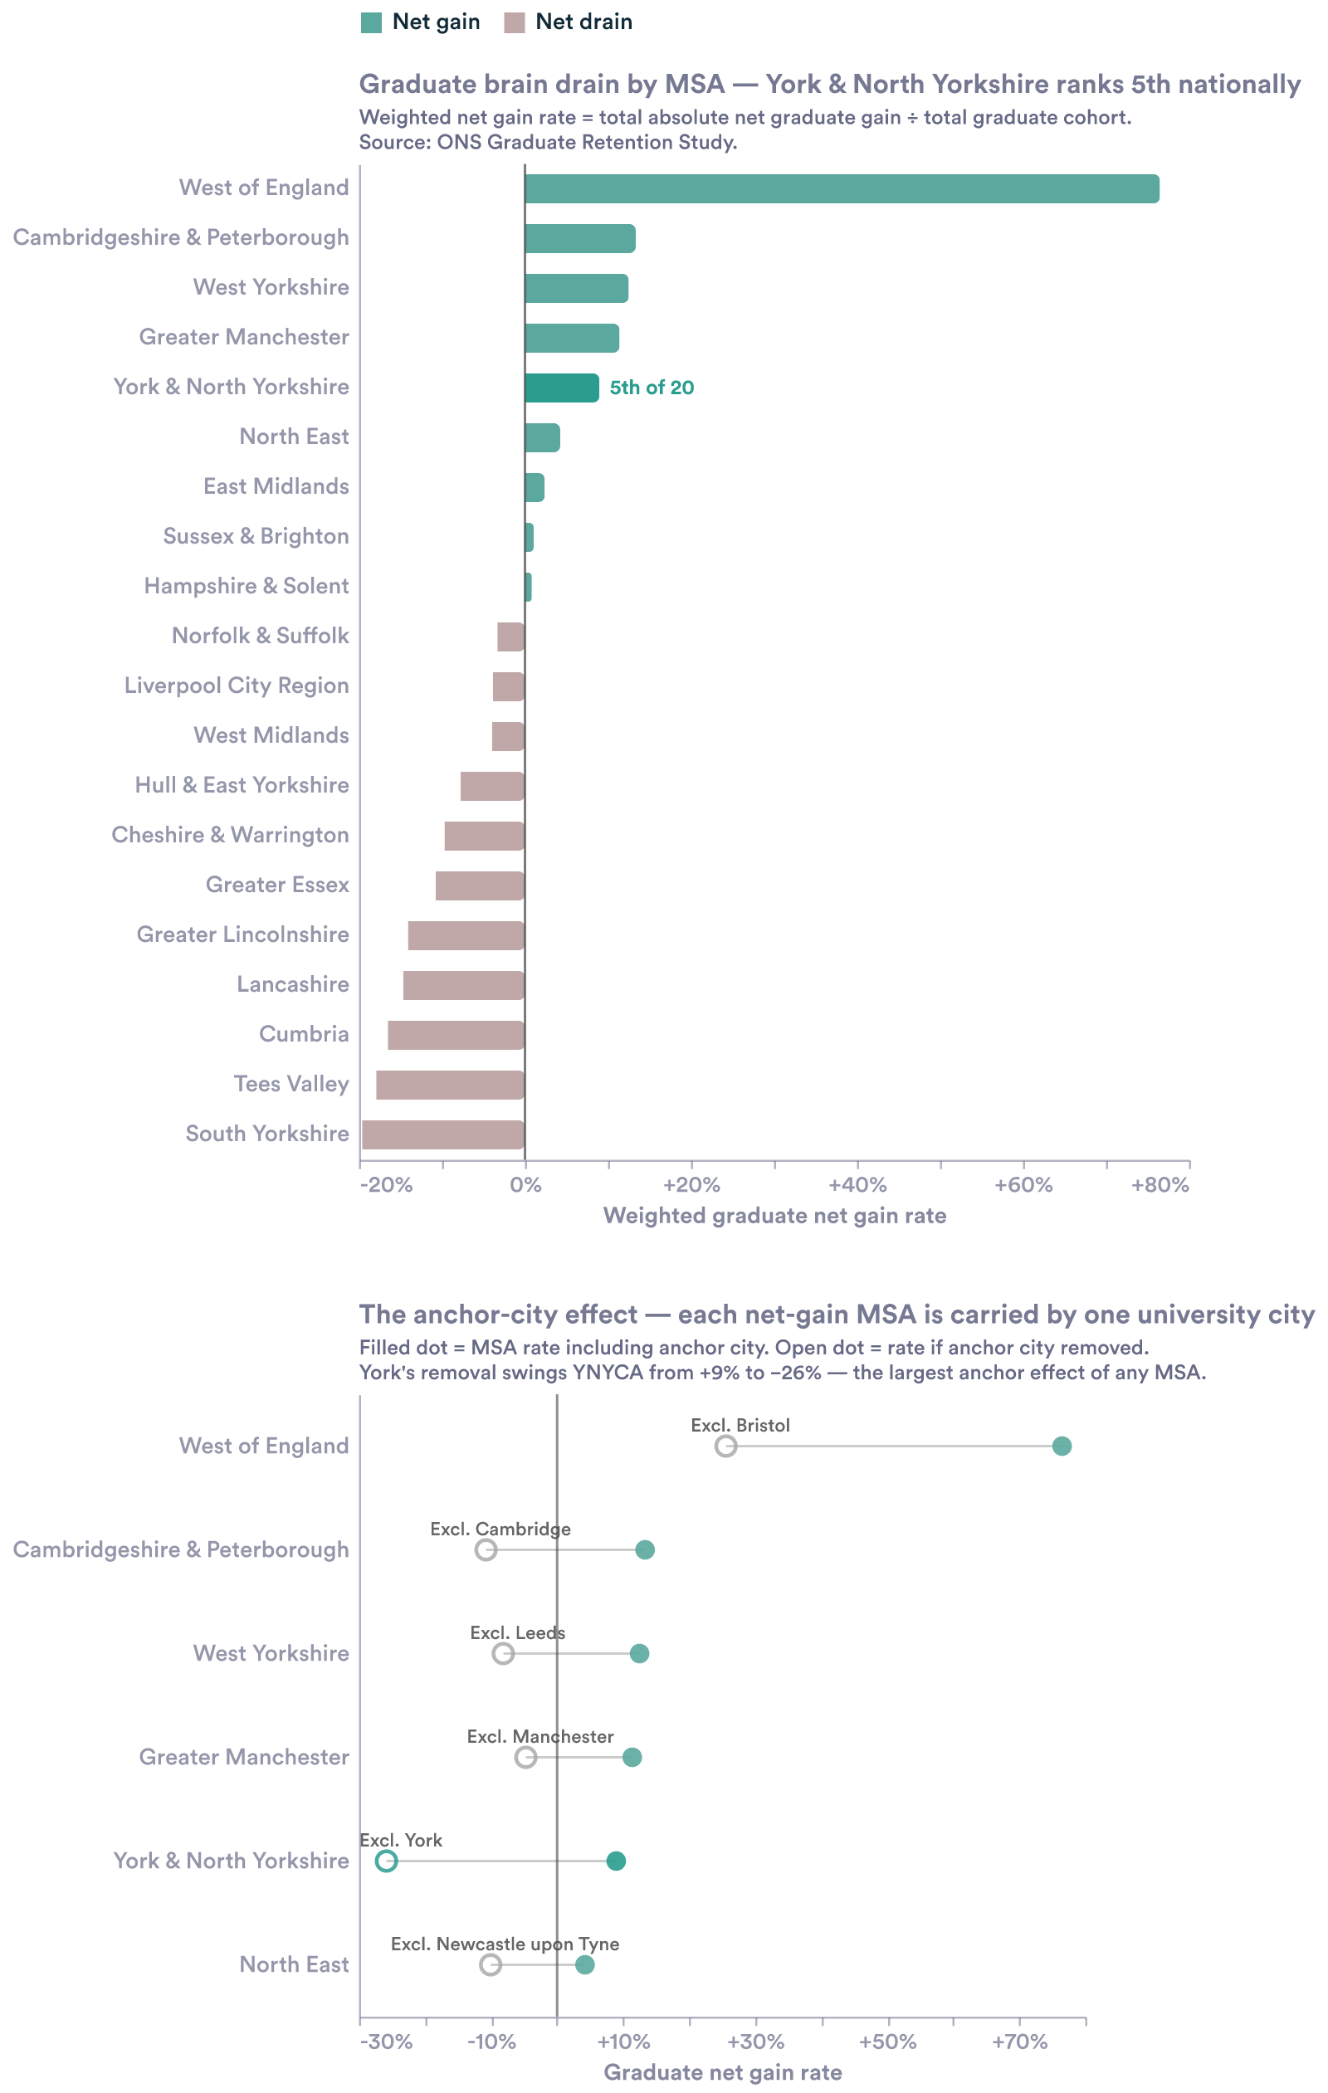
C12 — net gain with vs without the anchor city
TECHNICAL BOX [T6] dropdown: “York’s pull, and the robustness check”
York in detail:
- Inward rate 44.7% — attracts graduates equal to 44.7% of its own local cohort.
- Retention 61.0% — share of York-origin graduates who end up living in York.
- Net gain +1.034 — the only YNYCA town with a positive net graduate gain.
- Non-mover retention 76.6% — of those who didn’t leave for university, 76.6% stayed.
The dot plot removes each MSA’s single dominant university city. Some MSAs keep other university towns (e.g. Greater Manchester keeps Salford, West Yorkshire keeps Huddersfield), so open dots are not pure non-university rates — except YNYCA, where York is the sole university town.
Robustness: excluding every university-flagged town, Greater Manchester, West Yorkshire, Cambridgeshire & Peterborough and the North East cluster tightly at −10% to −11%; YNYCA’s hinterland sits at −26%, more than twice as negative. York’s dominance holds either way. (West of England is not comparable here — only 22% of its graduates are in non-university towns.)

6b. Brain drain — a distinctly rural problem
Main text
Beyond York, the picture is rural drain. 15 of 17 towns with data are net exporters of graduates, concentrated in the most rural and isolated places — and 3 in 5 leaving graduates leave Yorkshire altogether.
Chart [C13]
Type: Town-level ranked chart / map (17 towns)
Shows: Net graduate flow by town; rural and isolated towns as net exporters.
Source: ONS Graduate Retention Study (17 towns with available data).
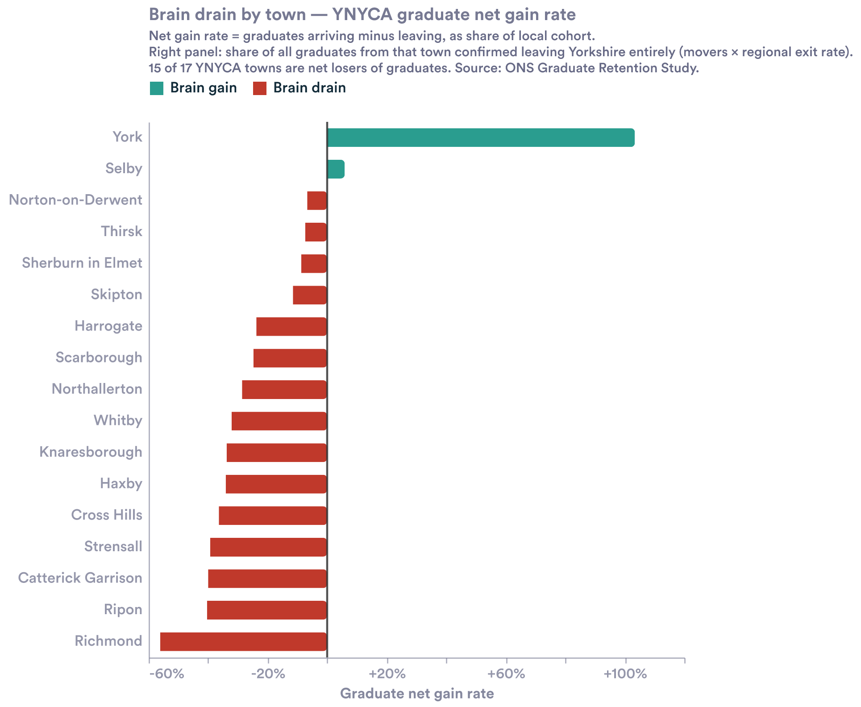
C13 — town-level net graduate flow
TECHNICAL BOX [T7] dropdown: “Reading the town-level picture”
- True MSA-level retention is probably higher than the town view suggests: York’s large inward rate partly catches YNYCA graduates relocating internally to the economic centre, not only arrivals from outside the MSA.
- Catterick Garrison (53%) and Richmond (44%) are military / isolated towns that pull the mean up.
End of spec. Chart IDs C1–C13 and technical-box IDs T1–T7 are stable references for the build. Embedded images are the draft reference charts — rebuild as interactive site charts or reuse as-is.

