Jack Hepburn

Game Design II

The maximum amount of rounds played per game is 30, first to 16 won rounds wins. No overtime

Round Timer

1 minute and 55 seconds

Bomb Plant Timer: 40 seconds

Voice chat can be used to communicate with team.

Goal as terrorist is to plant bomb or kill all counter-terrorists. Goal as Counter-terrorist is to hold off Terrorist from planting until timer runs out, defuse bomb, or kill all terrorists.

Upper B and Lower B introduce indoor combat with less space to utilize.

Smoke grenades and flash grenades can be used to obstruct enemy vision to safely cross dangerous territories. Ex. If enemies are in CT Spawn watching the “Long A” cross, and your team is trying to get onto A site, you can throw smoke and flash grenades to safely cross.

Every move in this game is situational and there is never a single “correct way to play.” These are some examples of where a terrorist player would play after the bomb plant.

A site as opposed to B site is much more open which allows for spread out team setups. Here are some of the most common spots to hold, post plant.

Attacker and Defender Roles (Terrorists, Counter-Terrorists)

Plant and Defuse game mode

5V5

Site A is elevated and connects to “catwalk” which leaves many safe areas to hold.

Site B is more congested and has areas of elevation that introduce another dimension of danger.

CT Spawn

Money is awarded for killing other players, planting, defusing, winning rounds, and losing rounds.

Scoreboard feature keeps track of player kills, points, MVP, rounds, and money.

De_dust2 consists of A and B bombsite and two start spawn areas.

Multiple routes can be taken to each respective site (Ex. Mid to B, Tunnels to B, Mid to A, Long to A, etc.) but there is no set routes. Decisions based on what is dynamically happening in the surrounding areas determine the outcome.

Separate Spawns across map for each opposing side.

Counter-Strike: Global Offensive

De_dust2

Plant and Defuse game mode

5V5

To go B, there is an inner tunnel called “B Main” similar to “B tunnels” in dust2. This leads onto B site where there is an elevation drop to the plant site. There is a catwalk that is elevated along the side above site which creates challenging fights when the enemy has the high ground.

Ascent has an A and B plant site in a similar orientation to de_dust2.

Valorant

Ascent

Attacker and Defender Roles (Attackers and Defenders)

This game is based around an array of different character types in addition to the counter-strike esque gameplay.

Character types include: Duelists, Initiators, Sentinels, and controllers.

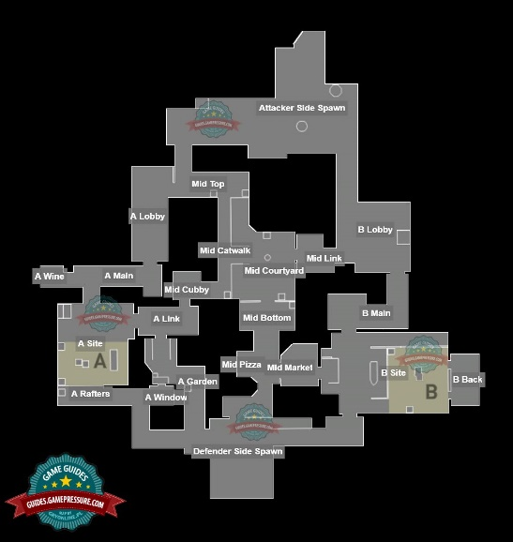

Players can use interactive buttons to close doors in order to block off enemies.

Map flipped upside down to match attacker spawn point of view of de_dust2.

Certain characters may struggle on one map and may be very strong on another map in this game as a result of the more complex maps.

In Valorant there are millions of different scenarios because of the array of different characters and abilities and complexity of maps.

The attackers goal is to either kill all defenders or plant the spike. Defenders goal is to kill attackers, defuse spike, or let time run out.

Rafters

A site has rafters which can be a strong area to have control of because of the high ground advantage.

B Main

Round Timer

1 minute and 40 seconds

Bomb Plant Timer: 40 seconds

Voice chat can be used to communicate with team.

There are multiple areas that have similar flow and mechanics to de_dust2.

The middle section of the map is also setup in a similar way to dust2. It consists of a catwalk and a mid door/entrance.

Separate Spawns across map for each opposing side.

Scoreboard feature keeps track of player kills, ultimate ability, and credits.

Site A on ascent is still a more congested plant site, but it is more spacious and has more varieties of angles to hold.

Credits are awarded for kills, defuses, plants, and round wins. You can cancel purchases in buy phase as well.

The maximum amount of rounds played per game is 25 then it goes into overtime. Otherwise, first to 13 won rounds wins.

I prefer any of the Counter-Strike games over Valorant. Dust2 has existed longer than I’ve been alive, and they have had so much time to update and polish the map. 20+ years later, dust2 flows very well for this type of competitive shooter. The simplicity of the map and balance between each side which encourages skillful playing and more strategic play, rather than relying on luck. The layout of Ascent in Valorant is eerily similar to that of dust2. Ascent is a bit more complex which makes sense considering the game mechanics of Valorant are also more complex than Counter-strike.

In conclusion, Counter-Strike’s de_dust2 is a simple but effective map. It is balanced and relies more on player skill over player luck. The environment is static, which allows for even fairness between each team. Valorant’s Ascent is like a more complex dust2. I feel like this map relies less on player skill because it has an interactive environment where two doors can be shut to block off enemies. I do like the layout of Ascent but there is too much bias toward the defenders in my opinion. Out of the two maps, dust2 is the winner for me.