Customer Churn Analysis
MySQL • Data Cleaning • Exploratory Analysis • Customer Risk Segmentation

The purpose of this SQL project is to analyze customer churn data and identify patterns that may explain why customers leave a business. The analysis combines data-quality checks, customer and revenue metrics, churn-rate analysis, demographic segmentation, tenure analysis, subscription and contract analysis, revenue loss measurement, and customer risk scoring.

1. Data Cleaning and Quality Checks

1.1 Inspect the Dataset
SELECT * FROM customer_churn_data;
Purpose: Purpose: To view all records and understand the structure and contents of the customer churn dataset before performing analysis.

1.2 Count Distinct Customers
SELECT
COUNT(DISTINCT CustomerID) AS total_customers
FROM customer_churn_data;
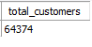
Purpose: Determine the number of unique customers in the dataset.

1.3 Count Distinct Customers

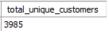
Purpose: Purpose: To detect duplicate customer records that contain identical values across the selected customer attributes.

2. Business Analysis Queries

2.1 Overall Customer and Revenue KPIs
SELECT
COUNT(CustomerID) AS total_customers,
SUM(Total_Spend) AS total_revenue,
SUM(Churn) AS total_churned_customers,
ROUND((SUM(Churn) / COUNT(CustomerID)) * 100, 2) AS churned_rate_pct,
AVG(Total_Spend) AS avg_spend
FROM customer_churn_data;
Purpose: Purpose: To establish the main business-level KPIs for the dataset: total customers, total revenue/spend, number of churned customers, overall churn rate, and average customer spend.3. Key Performance Indicators (KPIs)

2.2 Overall Customer Engagement and Operational Averages
SELECT
ROUND(AVG(Tenure), 2) AS avg_tenure,
ROUND(AVG(Usage_Frequency), 2) AS avg_usage_frequency,
ROUND(AVG(Payment_Delay), 2) AS avg_payment_delay,
ROUND(AVG(Support_Calls), 2) AS avg_support_calls
FROM customer_churn_data;
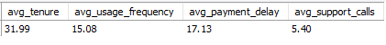
Purpose: To understand the average customer behavior and operational activity across the entire customer base.

2.3 Churn Rate by Contract Length
SELECT
Contract_Length,
COUNT(CustomerID) AS total_customer,
SUM(CASE WHEN Churn = 1 THEN 1 ELSE 0 END) AS churned_customers,
ROUND(SUM(CASE WHEN Churn = 1 THEN 1 ELSE 0 END) * 100 / COUNT(CustomerID), 2) AS churned_rate_pct
FROM customer_churn_data
GROUP BY Contract_Length;
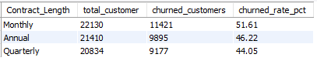
Purpose: To determine whether churn differs depending on the length of a customer's contract.

2.4 Churn Rate by Support Call Volume
SELECT
Support_Calls,
COUNT(CustomerID) AS total_customer,
SUM(Churn) AS total_churned_customer,
ROUND((SUM(Churn) / COUNT(CustomerID)) * 100, 2) AS churned_rate_pct
FROM customer_churn_data
GROUP BY Support_Calls
ORDER BY Support_Calls ASC;
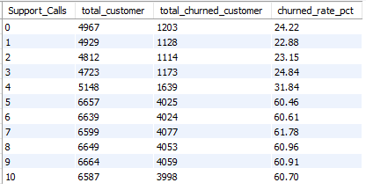
Purpose: To investigate whether the number of support calls is associated with customer churn.

2.5 Impact of Payment Delay on Churn
SELECT
CASE
WHEN Payment_Delay = 0 THEN "0 Days (On-Time)"
WHEN Payment_Delay BETWEEN 1 AND 7 THEN "1-7 Days"
WHEN Payment_Delay BETWEEN 8 AND 15 THEN "8-15 Days"
WHEN Payment_Delay BETWEEN 16 AND 30 THEN "16-30 Days"
ELSE "30+"
END AS payment_delay_bracket,
COUNT(CustomerID) AS total_customers,
SUM(Churn) AS total_churned_customers,
ROUND((SUM(Churn) / COUNT(CustomerID)) * 100, 2) AS churned_rate_pct
FROM customer_churn_data
GROUP BY payment_delay_bracket
ORDER BY churned_rate_pct desc;
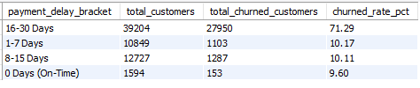
Purpose: To determine whether customers with longer payment delays have different churn rates.

2.6 Demographics Matrix: Age Group and Gender
SELECT
CASE
WHEN Age < 25 THEN "Under 25"
WHEN Age BETWEEN 25 AND 34 THEN "25-34"
WHEN Age BETWEEN 35 AND 49 THEN "35-49"
WHEN Age BETWEEN 50 AND 64 THEN "50-64"
ELSE "65+"
END AS age_bracket,
Gender,
COUNT(CustomerID) AS total_customers,
SUM(Churn) AS total_churned_customers,
SUM(Total_Spend) AS total_spend,
ROUND(AVG(Total_Spend), 2) as avg_spend,
ROUND((SUM(Churn) / COUNT(CustomerID)) * 100, 2) AS churned_rate_pct
FROM customer_churn_data
GROUP BY age_bracket, Gender
ORDER BY age_bracket, Gender;
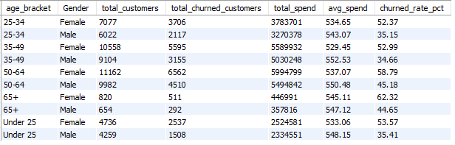
Purpose: To compare customer count, churn, and spending across age groups and gender categories.

2.7 Customer Tenure Cohort vs Churn
SELECT
CASE
WHEN Tenure <= 6 THEN "6 Months"
WHEN Tenure BETWEEN 7 AND 12 THEN "7-12 Months"
WHEN Tenure BETWEEN 13 AND 24 THEN "1-2 Years"
WHEN Tenure BETWEEN 25 AND 36 THEN "2-3 Years"
ELSE "3+ Years"
END AS tenure_bracket,
COUNT(CustomerID) AS total_customers,
SUM(Churn) AS total_churned_customers,
ROUND((SUM(Churn) / COUNT(CustomerID)) * 100, 2) AS churned_rate_pct
FROM customer_churn_data
GROUP BY tenure_bracket
ORDER BY churned_rate_pct DESC;
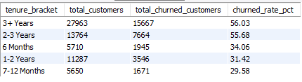
Purpose: To examine whether customer longevity is associated with churn.

2.8 Revenue Breakdown by Subscription Type and Contract Length
SELECT
Subscription_Type,
Contract_Length,
COUNT(CustomerID) AS total_customers,
SUM(Total_Spend) AS total_revenue,
ROUND(AVG(Total_Spend), 2) AS avg_spend,
SUM(Churn) AS total_churned_customers,
ROUND((SUM(Churn) / COUNT(CustomerID)) * 100, 2) AS churned_rate_pct
FROM customer_churn_data
GROUP BY Subscription_Type, Contract_Length
ORDER BY total_revenue DESC;
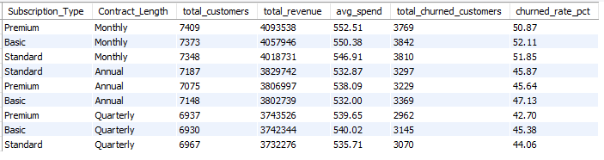

Purpose: To identify which subscription and contract combinations generate the most revenue and how churn varies across those combinations.

2.9 Revenue Retained vs Revenue Lost to Churn
SELECT
SUM(CASE WHEN Churn = 0 THEN Total_Spend ELSE 0 END) AS retained_revenue,
SUM(CASE WHEN Churn = 1 THEN Total_Spend ELSE 0 END) AS revenue_lost_to_churn,
SUM(Total_Spend) AS gross_potential_revenue,
ROUND(SUM(CASE WHEN Churn = 1 THEN Total_Spend ELSE 0 END) / SUM(Total_Spend),2) AS revenue_loss_percent
FROM customer_churn_data;
Purpose: To quantify how much recorded customer spend is associated with retained customers versus churned customers.

2.10 Customer Risk Scoring Matrix
SELECT
CustomerID,
Subscription_Type,
Contract_Length,
Total_Spend,
Churn,
CASE
WHEN (Payment_Delay > 15 AND Support_Calls > 5) THEN "High Risk"
WHEN (Payment_Delay BETWEEN 7 AND 15 OR Support_Calls BETWEEN 3 AND 5) THEN "Medium Risk"
ELSE "Low Risk"
END AS risk_segment
FROM customer_churn_data;

Purpose: To classify customers into Low, Medium, or High Risk segments using payment delay and support-call behavior.

3. Conclusion
This SQL documentation presents a complete customer churn analysis workflow. The queries are designed to answer practical business questions about customer retention, customer behavior, revenue, and risk. The analysis can serve as the SQL component of a broader data analytics portfolio project and can be extended with Power BI dashboards, additional statistical analysis, or predictive churn modeling.
The resulting outputs also serves as the foundation for a dashboard in Power BI.

