Retail Sales Analysis Using MySQL
SQL Data Cleaning, Validation, KPI Analysis, and Sales Insights

This document provides a detailed explanation of the SQL queries used to analyze a retail sales dataset. The analysis covers data preparation, data validation, key performance indicators (KPIs), time-based sales trends, product performance, category performance, and regional performance.

1. Data Preparation

1.1 Convert Order Date from Text to Date
UPDATE sales_data
SET order_date = STR_TO_DATE(order_date, "%m/%d/%Y");
ALTER TABLE sales_data
MODIFY COLUMN order_date DATE;
Purpose: Convert the order date from a text/string value into a proper MySQL DATE value.

1.2 Count Unique Orders
SELECT
COUNT(DISTINCT order_id) AS total_unique_orders
FROM sales_data;
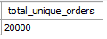
Purpose: Determine the number of unique orders in the dataset.

1.3 Count Unique Customers
SELECT
COUNT(DISTINCT customer_id) AS total_unique_customers
FROM sales_data;
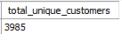
Purpose: Determine how many unique customers are represented in the dataset.

1.4 Identify the Date Range
SELECT
MIN(order_date), -- earliest recorded order date
MAX(order_date) -- latest recorded order date
FROM sales_data;
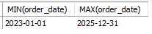
Purpose: Find the earliest and latest order dates in the dataset.

2. Data Validation – Duplicate Records

2.1 Check for Duplicate Rows
WITH cte_duplicates AS
(
SELECT
*,
ROW_NUMBER() OVER(
PARTITION BY order_id, order_date, customer_id,
gender, age, region, city, category, product,
unit_price, quantity, discount, sales, profit,
channel, payment_method, rating
) AS row_num
FROM sales_data
)
SELECT *
FROM cte_duplicates
WHERE row_num > 1;
Purpose: Identify exact duplicate records across the important fields in the sales dataset.

3. Key Performance Indicators (KPIs)

3.1 Total Sales
SELECT
SUM(sales) AS total_sales
FROM sales_data;
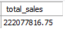
Purpose: Calculate the total revenue generated across all sales records.

3.2 Total Orders
SELECT
COUNT(DISTINCT order_id) AS total_orders
FROM sales_data;
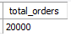
Purpose: Calculate the total number of unique orders.

3.3 Total Units Sold
SELECT
SUM(quantity) AS total_units_sold
FROM sales_data;
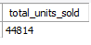
Purpose: Calculate the total quantity of products sold.

3.4 Average Order Value (AOV)
WITH cte AS
(
SELECT
SUM(sales) AS total_sales,
COUNT(DISTINCT order_id) AS total_orders
FROM sales_data
)
SELECT
total_sales / total_orders AS avg_order_value
FROM cte;
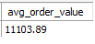
Purpose: Calculate the average amount of revenue generated per order.

3.5 Average Selling Price
WITH cte AS
(
SELECT
SUM(sales) AS total_sales,
SUM(quantity) AS total_units_sold
FROM sales_data
)
SELECT
total_sales / total_units_sold AS avg_selling_price
FROM cte;
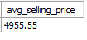
Purpose: Calculate the average revenue generated per unit sold.

4. Time-Based Sales Analysis

4.1 Identify the Best-Performing Month in Each Year
SELECT
YEAR(order_date) AS year,
MONTHNAME(order_date) AS monthname,
SUM(sales) AS total_sales
FROM sales_data
GROUP BY year, monthname
ORDER BY year ASC, total_sales DESC;
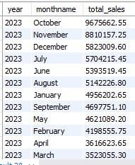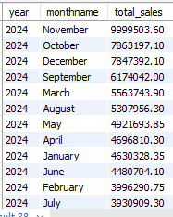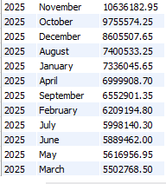
Purpose: Compare monthly revenue within each year to identify the strongest months.

4.2 Identify the Worst-Performing Month in Each Year
SELECT
YEAR(order_date) AS year,
MONTHNAME(order_date) AS monthname,
SUM(sales) AS total_sales
FROM sales_data
GROUP BY year, monthname
ORDER BY year ASC, total_sales ASC;
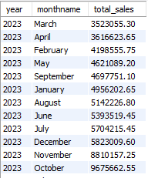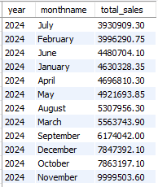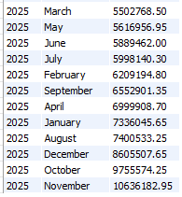
Purpose: Identify the months with the lowest sales revenue within each year.

4.3 Analyze Month-over-Month Sales Growth
WITH year_month_sales AS
(
SELECT
YEAR(order_date) AS year,
MONTH(order_date) AS month_num,
MONTHNAME(order_date) AS monthname,
SUM(sales) AS monthly_sales
FROM sales_data
GROUP BY year, month_num, monthname
)
SELECT
year,
month_num,
monthname,
monthly_sales,
LAG(monthly_sales, 1) OVER(ORDER BY year ASC, month_num ASC) AS prev_monthly_sales,
ROUND(monthly_sales - LAG(monthly_sales, 1) OVER(ORDER BY year ASC, month_num ASC)) AS month_over_month_growth,
ROUND((monthly_sales -LAG(monthly_sales, 1) OVER(ORDER BY year ASC, month_num ASC))
/ LAG(monthly_sales, 1) OVER(ORDER BY year ASC, month_num ASC) * 100,2) AS month_over_month_growth_pct
FROM year_month_sales
ORDER BY year ASC, month_num ASC, monthname;
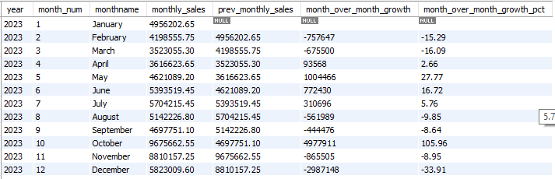
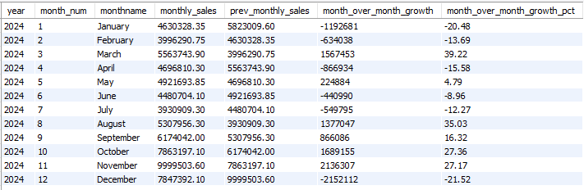
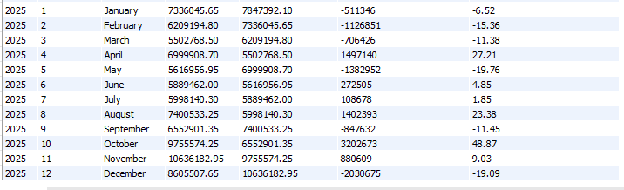
Purpose: Measure monthly sales changes over time using both absolute and percentage growth.

5. Product Analysis

5.1 Products Generating the Most Revenue
SELECT
product,
SUM(sales) AS total_sales
FROM sales_data
GROUP BY product
ORDER BY total_sales DESC;
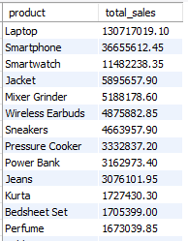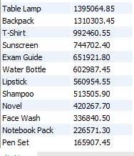
Purpose: Rank products according to the total revenue they generate.

5.2 Products Selling the Most Units
SELECT
product,
SUM(quantity) AS total_sold_units
FROM sales_data
GROUP BY product
ORDER BY total_sold_units DESC;
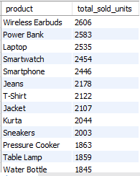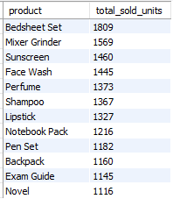
Purpose: Rank products based on the number of units sold.

5.3 Compare Unit Sales Rank with Revenue Rank
WITH cte AS
(
SELECT
product,
SUM(quantity) AS total_units_sold,
SUM(sales) AS total_sales
FROM sales_data
GROUP BY product
)
SELECT
product,
total_units_sold,
total_sales,
DENSE_RANK() OVER(ORDER BY total_units_sold DESC) AS unit_rank,
DENSE_RANK() OVER(ORDER BY total_sales DESC) AS revenue_rank
FROM cte
ORDER BY unit_rank ASC;
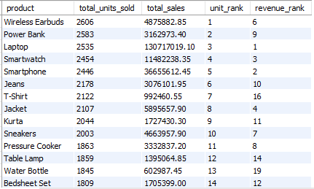
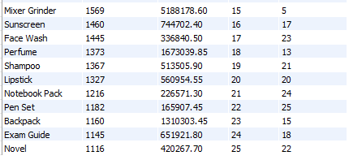
Purpose: Determine whether the products selling the most units are also the products generating the most revenue.

6. Category Analysis

6.1 Category Generating the Most Revenue
SELECT
category,
SUM(sales) AS total_sales
FROM sales_data
GROUP BY category
ORDER BY total_sales DESC;
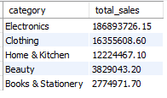
Purpose: Rank product categories according to revenue.

6.2 Category with the Lowest Performance
SELECT
category,
SUM(sales) AS total_sales
FROM sales_data
GROUP BY category
ORDER BY total_sales ASC;
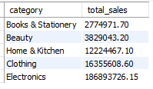
Purpose: Identify categories with the lowest total revenue.

7. Regional Analysis

7.1 Best-Performing Region
SELECT
region,
SUM(sales) AS total_sales
FROM sales_data
GROUP BY region
ORDER BY total_sales DESC;
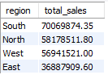
Purpose: Rank regions according to total sales revenue.

7.2 Worst-Performing Region
SELECT
region,
SUM(sales) AS total_sales
FROM sales_data
GROUP BY region
ORDER BY total_sales ASC;
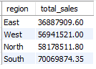
Purpose: Identify the regions with the lowest total sales.

8. Summary of Analytical Questions
- Data quality: Are the dates correctly formatted, and are there duplicate records?
- Customer base: How many unique customers are represented in the dataset?
- Transaction volume: How many unique orders were placed and how many units were sold?
- Revenue: How much total sales revenue was generated?
- Customer spending: What is the average order value?
- Pricing: What is the average selling price per unit?
- Seasonality: Which months perform best and worst in each year?
- Growth: Are sales increasing or decreasing from month to month?
- Products: Which products generate the most revenue and sell the most units?
- Product efficiency: Do the highest-volume products also rank highly in revenue?
- Categories: Which categories contribute the most and least revenue?
- Regions: Which regions perform best and worst based on sales?

9. Conclusion
The SQL analysis provides a structured overview of retail sales performance. The workflow begins with data preparation and validation, then calculates high-level KPIs before moving into more detailed time, product, category, and regional analyses.
The resulting outputs also serves as the foundation for a dashboard in Power BI. The total sales, total orders, total units sold, average order value, monthly sales trends, top products, category performance, and regional performance

