“Integration Dic” requirements
These tags tell the importance of the requirement
Must, Should, Nice to have

Add Integration

Name at create

I expect the name to be overridden at save

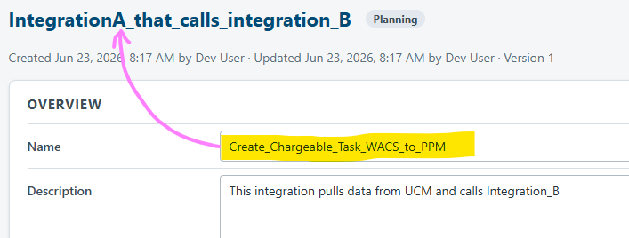

Version is needed as part of the unique key
Must have: Add Version as part of t1he uniqueness: 1 integration can have major version 1 and version 2 active at the same time in OIC. This happens on utilities versions on when the end point significantly changes

Complexity and Business logic - Help needed
What is the purpose of these fields? What will be the criteria for setting each level?
Maybe we should not ask PMs or Consultants to fill these fields…
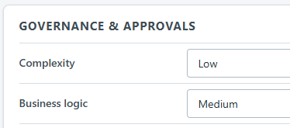

Security & Access
I the intent of this section for How to access the Integration, it fills the purpose as it is.
There is another information that we need: Connections credentials – The connections the integration will connect to pull or push data.
Most integration uses at least 2 connections – Connection A to source, connection B to target. Connections are shared across integrations - Connection A can be used by integration H, I, and J. I have seen same happening with point to point integrations – ServiceNow has 1 connection to Fusion Apps, and that connection is used by multiple Service Now integrations.
- 1 to N relation sheep is needed
- Connections are per environment
  - The Account for Connection A in TEST is WACS_Service_Test and for PROD is WACS_Service
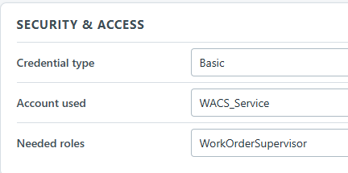

Copy integration
It will make the app easier to use by adding Copy Integration functionality – Only some fields are added
Field | Not copied | Copied | Default to
Name | X
Description |  | X
Status |  |  | Planning
Type |  | X
Tags |  | X
Associated Projects |  | X
Documentation URL |  | x

- Status defaults to Planning

Add type-completion / or dropdown
Add the functionality similar to Source Systems on the following fields:
- Associated projects

Integration details

Overview
Should have: Documentation URLs as a Diccionary Collection:
- Configuration Doc: http://somewhere.tsgt
- Migration Doc:
- Tech Design Doc: http://deam-on.tsgt
- Functional Design Doc: http://yeah-right-on.tsgt

Relationships
Should have: Upstream and Downstream names cause confusion. I recommend: Calls To, Called By.
Should have: Remove “Integrated with” because Calls To or Called By covers it. Or does “Integrates with” has a different meaning?
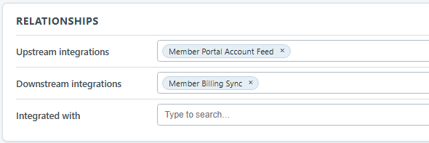

Governance & Approvals
Must have: The following Doc Approvals are missing:
- Migration Documentation
- Integration Configuration ( template )
- Connections Configuration (template) : In this document we ask for the security roles needed to connect, so if the new WEB App will hold this security info, we can remove it from the Template
Approval:
- Must have: Approvals are by Project/Bug-fix level (or git branch) but not at the integration level. Example: Project A and B are touching the same framework artifact different business object. The Project B can be approved, but the project A is not approved yet.
- Should have: Multiple Approvals along its life: An integration can get many approvals along it’s life. Real Example: Vendor Integration from HCM into WACs initial design was using Oracle OICC, that got approved at that time. Months later we found out it was a bad design, now it needs refactoring to use BIPublisher instead. A second approval is needed.
- Nice to have: Idea for near future: Having GIT deal with approvals (code and designs are uploaded into git) helps keep track of requests, rejection comments, and approvals. The app can pull the GIT Change Requests from the branch.
  - Also keeping track of where the integration is in the pipeline: Test or Prod

Security & Access
Must Have: Integrations deal with at least 3 apps/services: Source(s), Target(s), Utilities/Services. Therefore their access info is needed. Another access definition is the access to the integration itself.
- Source: Credentials and Access Roles the integration uses to call the Source
  - Can have multiple sources
- Target: Credentials and Access Roles the integration uses to call the Target
  - Can have multiple targets
- Utilities/Services: Object Store, Vaults, SFTP Severs, ATP databases. Etc
- Itself: Credentials and Access role needed to call this integration – Example The BIPublisher, when it finishes it calls the integration to let it know the csv file is ready. BIPublisher needs the credentials to call the integration… hmmm…. For BIPublisher, it has the integration as target…. Will “Itself” be needed? Well, somewhere we need access documentation for the integration.
The relationship between integration a Security & Access is 1 integration N: accesses (aka connections)

Integration Dic Roles and Permissions
- Must have: Users shall be able to change/delete an integration as long as it has not put into Prod environments. Once an integration makes it into PROD, that cannot be changed nor Deleted by users.

