ASIMOV v1
ARCHITECTURE DESCRIPTION DOCUMENT
Concept-phase · System boundary · Functional decomposition · Safety architecture · CAN topology · Mode FSM

Document control
Field | Value
Document ID | ASV1-ARCH-CP-001
Revision | 0.1 (draft)
Issue date | 2026-05-03
Author | J. Herrod-Thomas
Item | Asimov v1 humanoid robot — github.com/jherrodthomas/asimov-v1
Companion artefacts | ASV1-SC-CP-001 Safety Case · ASV1-DFMEA-CP-001 DFMEA · ASV1-REQ-CP-001 Requirements
Standards basis | ISO/IEC/IEEE 42010:2022 · ISO 12100 §5 · ISO 13482 §5 · ISO 13849-1 §6
Confidentiality | Public — distributed under CERN-OHL-S-2.0 reciprocity

Important — concept-phase architecture
This document describes the architecture as inferred from the upstream repository (CAD subassemblies, KiCad sources, WireViz harness, MuJoCo model, manual). Where the upstream documentation is silent — for example, the wireless E-Stop internal architecture — assumptions are flagged and traced to the Gap Register in the Safety Case workbook.

1. Introduction
This document describes the concept-phase architecture of the Asimov v1 open-source humanoid robot. It supplements the Preliminary Safety Case (ASV1-SC-CP-001), the DFMEA (ASV1-DFMEA-CP-001), and the Requirements Specification (ASV1-REQ-CP-001). The architecture is presented through five complementary views:
View | Diagram | Purpose
Context | Diagram 1 — System boundary | Item, actors, external interfaces, hazard zones (ISO 12100 §5)
Functional | Diagram 2 — Functional block | Subsystem decomposition with power, CAN, signal flows
Safety | Diagram 3 — SF allocation map | 25 safety functions allocated to HW / SW / procedure with PL targets
Communication | Diagram 4 — CAN bus topology | Six CAN buses with node lists and termination strategy
Behavioural | Diagram 5 — Mode FSM | DAMP / STAND / MOVE state machine with watchdog and E-Stop gating

1.1 Architecture style and decomposition principles
Asimov v1 is decomposed by physical subassembly (mechanical) and by logical board (electrical), with the Motion Control Board (MCB) acting as the central kHz-rate controller and the Raspberry Pi 5 (RPi5) acting as a media and tele-op gateway. The split mirrors the safety architecture: hard real-time and safety-critical functions live on the MCB; rich-OS, network and media functions live on the RPi5. Communication between MCB and the limbs uses six CAN buses partitioned by limb to limit the blast-radius of a single bus failure (one bus-off → one limb lost, not the whole robot).
1.2 Architectural assumptions
ID | Assumption | Trace
AA-01 | Each limb is on its own CAN bus; bus-off on one bus does not affect the other limbs | SYRS-022 · SF-08
AA-02 | MCB and RPi5 are on separate power rails with separate brown-out detection | HWRS-016
AA-03 | Wireless E-Stop receiver is independent of MCB — it cannot be vetoed by FW | HWRS-019 · GAP-13482-04
AA-04 | Battery (when fitted) authenticates to the MCB before motor rails enable | SYRS-014 · SRS-018
AA-05 | Locomotion policy is software-only and runs as a clamped output through SF-03 | SRS-006 · GAP-LP-01
AA-06 | The kit ships pre-crimped harness — DIY users do not crimp safety-critical connections | FM-18 · HWRS-012
AA-07 | Operator tele-op session is authenticated end-to-end via TLS 1.3 | SYRS-010 · SRS-007

2. System boundary and context
The system boundary follows ISO 12100 §5 (determination of the limits of the machinery) and ISO 13482 §5 (personal-care robot scoping). External actors include the trained operator, bystanders (only relevant outside OE-1), the operating environment, the maintainer, the power source (battery or bench supply), the cloud / network providing WebRTC tele-op, the operator app, the charger, supply-chain partners, and the regulatory authority for any deployment outside an internal lab.
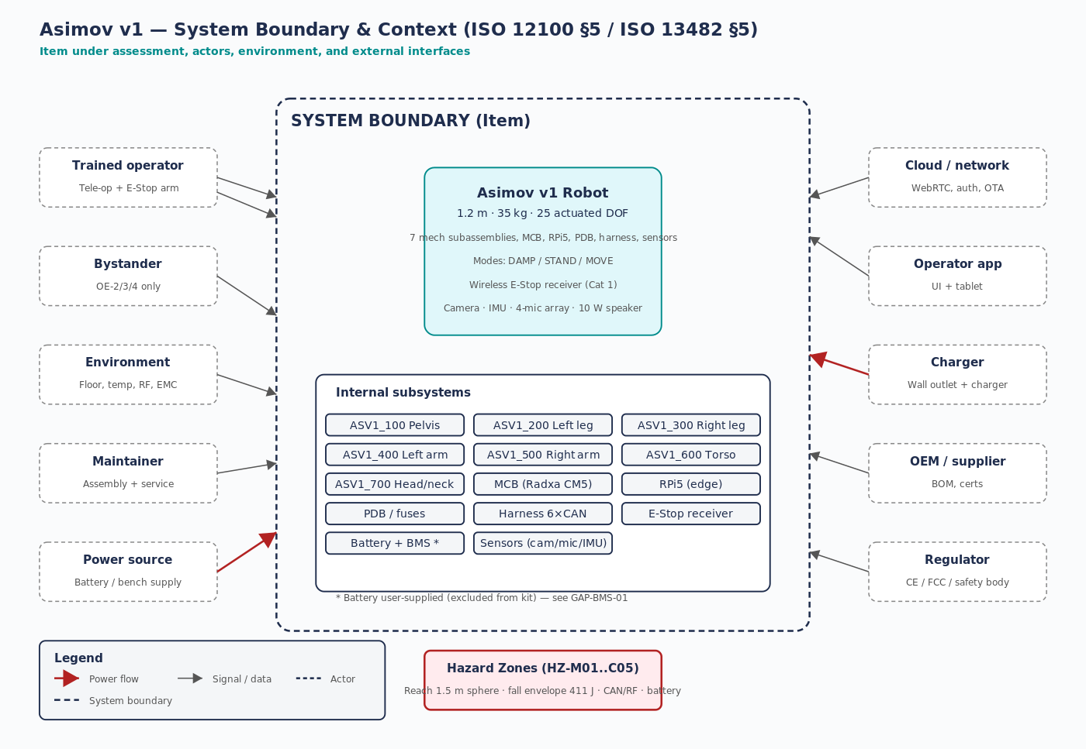
Figure 1 — System boundary and context per ISO 12100 §5 / ISO 13482 §5.

2.1 External interfaces
Interface | Direction | Medium | Safety relevance
Operator → tele-op | in | Wi-Fi / 4-5G WebRTC | SAFE — auth + idle lock (SYRS-010, SRS-007)
Operator → E-Stop | in | Wireless RF | SAFE Cat 1 — link surveillance (SYRS-003, HWRS-019)
Robot → operator app | out | WebRTC media + data | Telemetry + camera + audio
Bystander exposure | — | Physical (reach) | Hazard zones (HZ-M01..M07, HZ-P02..P06)
Environment | in | Air, surface | +10..+35 °C, ≤5° slope, dry indoor
Maintainer assembly | — | Procedural | Lift / PPE / ESD (SF-12, SF-17, SF-18)
Power source | in | DC via XT30 | SF-10 isolation, SF-15 BMS handshake
Charger | in | Mains AC | External — assumed compliant per AA-04
OEM / supplier | — | Procurement | Material certs (SYRS-028)
Regulator | — | Compliance | CE / FCC / national robotics frameworks (out of scope this rev)

2.2 Operating envelope
The architecture supports four declared operating envelopes; only OE-1 (lab supervised, tethered) is provisionally permitted at this revision:
OE | Description | Risk | Acceptance
OE-1 | Lab, supervised, tethered, no bystanders | LOW | PROVISIONAL YES
OE-2 | Industrial cobot, defined cell | MEDIUM | Not yet — 12 gaps
OE-3 | Home / consumer, untrained users, children/pets | HIGH | Not yet — 19 gaps
OE-4 | Public space, free roaming | VERY HIGH | Not yet — 21 gaps + regulatory engagement

3. Functional architecture
The functional view shows the seven mechanical subassemblies (ASV1_100 through ASV1_700) plus the four core electronics modules (RPi5 edge, MCB, PDB, Wireless E-Stop receiver) plus user-supplied battery and BMS, and the sensors block (camera, IMU, mics, encoders, thermistors). Connections are categorised as power (red), CAN (teal), or signal (grey).
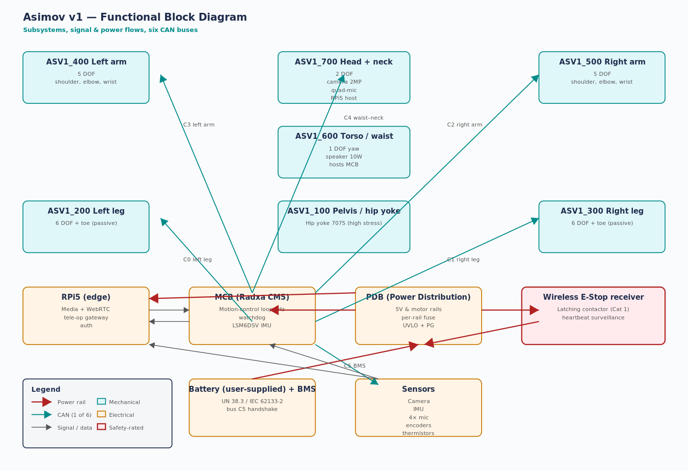
Figure 2 — Functional block diagram showing mechanical subassemblies, electronics, and the six CAN buses.

3.1 Subsystem responsibilities
Subassembly / module | Function | Allocated reqs
ASV1_100 Pelvis / hip yoke | Carry full body weight + walking moments; house BMS bus stub | HWRS-002, FM-01
ASV1_200 Left leg | 6 DOF + toe; left-side bipedal locomotion | F-200, SF-01
ASV1_300 Right leg | 6 DOF + toe; right-side bipedal locomotion (mirror of 200) | F-300
ASV1_400 Left arm | 5 DOF; payload to 18 kg lateral | F-400, SYRS-020
ASV1_500 Right arm | 5 DOF; mirror of 400; uses SLM 316L parts | F-500, FM-30
ASV1_600 Torso / waist | 1 DOF waist yaw; hosts MCB + 10 W speaker | F-600, SYRS-015
ASV1_700 Head / neck | 2 DOF neck; hosts camera, mic-array, RPi5 | F-700, FM-29
MCB (Radxa CM5) | Run motion-control kHz loop, 6 CAN, watchdog, host IMU | F-MCB, SF-08, SF-23, SF-24
RPi5 | Media, network, WebRTC tele-op gateway, authentication | F-RPI, SF-21, SF-22
PDB | 5 V + motor rail distribution, per-rail fuse, UVLO + PG | F-PDB, SF-10, SF-11
Wireless E-Stop receiver | Latching motor-power contactor; link surveillance | SF-13, HWRS-019
Battery + BMS (user) | Energy storage with cell-voltage / temp / current cutoff | SF-15, GAP-BMS-01
Sensors | Image, audio, IMU, joint encoders, thermistors | F-SEN

4. Safety architecture
Twenty-five safety functions are declared in the Functional Safety Concept (Safety Case tab 09_FSC). They are allocated to hardware (9), software / firmware (13), or procedure (3). The diagram below makes the allocation explicit and tags each function with its required Performance Level per ISO 13849-1.
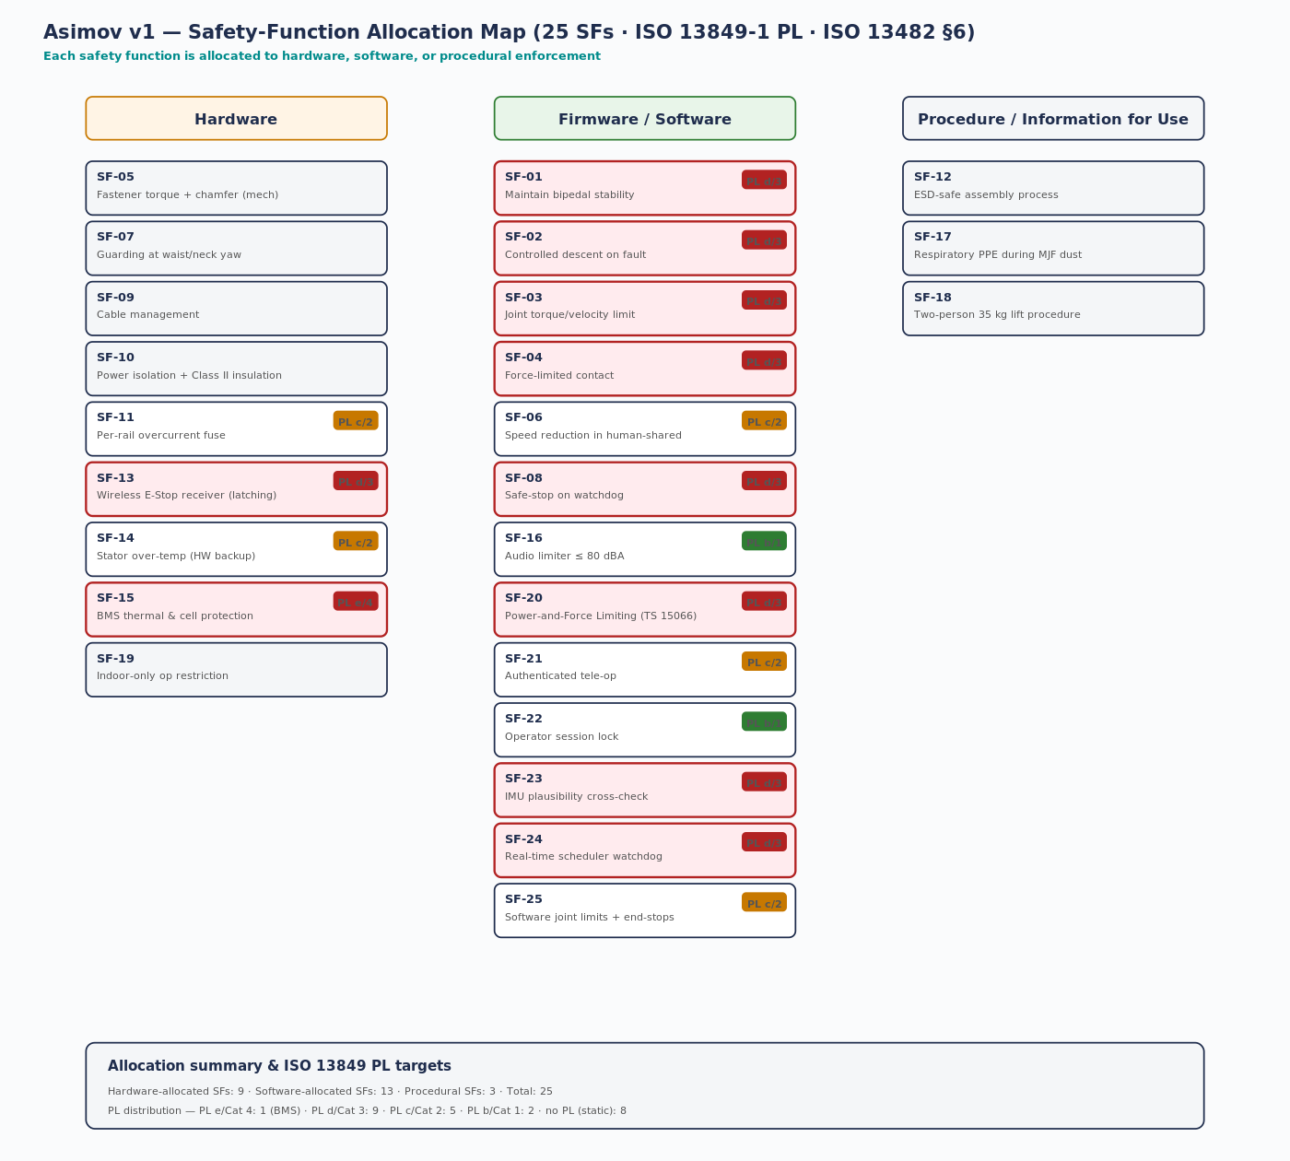
Figure 3 — Safety function allocation map: HW (left) / SW (centre) / Procedural (right) with PL targets.

4.1 PL distribution
The aggregate Performance Level distribution across the 25 SFs is:
PL / Cat | Count | Implication
PL e / Cat 4 | 1 | BMS — single-fault tolerance with self-test
PL d / Cat 3 | 9 | Stability, controlled descent, torque/velocity limit, PFL, watchdog stop, E-Stop link, IMU plausibility, scheduler watchdog, BMS interlock
PL c / Cat 2 | 5 | Speed reduction, overcurrent, stator over-temp, joint software limits, auth
PL b / Cat 1 | 2 | Audio limiter, idle lock
Static / no PL | 8 | Inherent design or procedure (chamfering, guarding, PPE, lift)

4.2 Cat 3 architecture rationale
Per ISO 13849-1 §6.2.6, a Cat 3 architecture requires that a single fault does not lead to loss of the safety function, and that single faults are detected whenever reasonably practicable. For Asimov v1 this implies:
SF | Required Cat 3 implementation | Status / gap
SF-01 Stability | Locomotion policy + IMU plausibility + actuator torque-monitor cross-channel | GAP-13849-01 — single-channel today
SF-02 Controlled descent | Torque-monitor + IMU plausibility + redundant stop path | GAP-13849-01
SF-03 Torque / velocity limit | Drive-side limit + FW limit + cross-monitor | Partial — drive limit present, cross-monitor missing
SF-08 Watchdog safe-stop | HW watchdog + FW watchdog + independent contactor open path | Partial — HW watchdog present, contactor TBD
SF-13 Wireless E-Stop | Two independent receivers OR dual decoding path → latching contactor | GAP-13482-04 + GAP-10218-03 — architecture undocumented
SF-15 BMS | BMS with two independent protection MOSFETs + temperature / voltage cross-check | Deferred to user-supplied pack — GAP-BMS-01
SF-23 IMU plausibility | Two independent IMUs OR IMU + commutation cross-check | GAP-13849-01 — single IMU on MCB today
SF-24 Scheduler watchdog | FW deadline monitor + HW WDT + independent stop path | Partial — both watchdogs present, stop path TBD

5. Communication architecture — six CAN buses
Asimov v1 partitions actuator and BMS communication across six CAN buses. The choice limits blast-radius (a single bus-off cannot disable both legs) and matches the Asimov manual electrical specification. The MCB hosts three native CAN controllers and three SPI-CAN bridges.
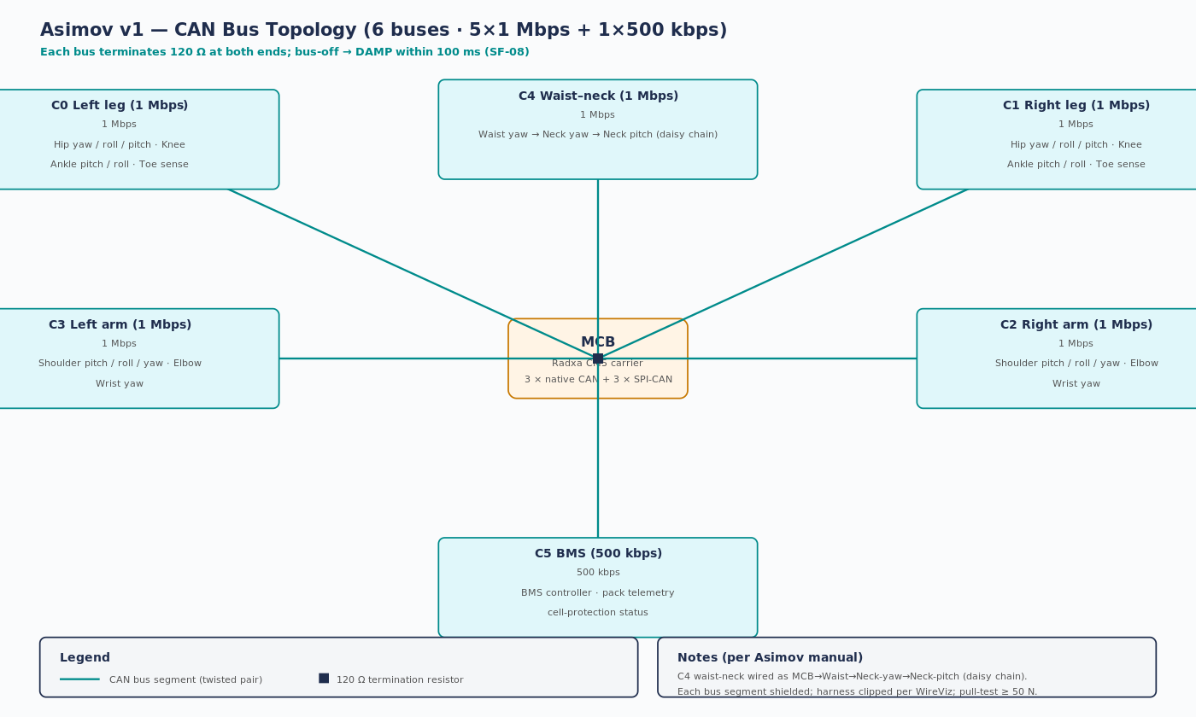
Figure 4 — CAN bus topology, six buses with 120 Ω termination at both ends.

5.1 Bus mapping and rates
Bus | Rate | Nodes (typical) | Owning subassembly
C0 — Left leg | 1 Mbps | Hip yaw / roll / pitch · Knee · Ankle pitch / roll · Toe sense | ASV1_200
C1 — Right leg | 1 Mbps | Hip yaw / roll / pitch · Knee · Ankle pitch / roll · Toe sense | ASV1_300
C2 — Right arm | 1 Mbps | Shoulder pitch / roll / yaw · Elbow · Wrist yaw | ASV1_500
C3 — Left arm | 1 Mbps | Shoulder pitch / roll / yaw · Elbow · Wrist yaw | ASV1_400
C4 — Waist-neck | 1 Mbps | Waist → Neck-yaw → Neck-pitch (daisy chain) | ASV1_600 / 700
C5 — BMS | 500 kbps | BMS controller with cell-protection telemetry | SS-BMS

5.2 Failure-mode strategy
On bus-off, the FW shall (a) attempt single recovery and (b) on second occurrence within 1 s transition to DAMP (SRS-011). Loss of the BMS bus C5 disables motor rails (SYRS-014). Bus-off → DAMP latency must be ≤ 100 ms (SF-08).

6. Behavioural architecture — Mode FSM
The robot operates in three modes — DAMP, STAND, MOVE — with deterministic transitions gated by the watchdog and wireless E-Stop. The FSM enforces that motion only occurs in MOVE, that MOVE entry requires authentication and a valid heartbeat, and that any safety-critical fault transitions immediately to DAMP.
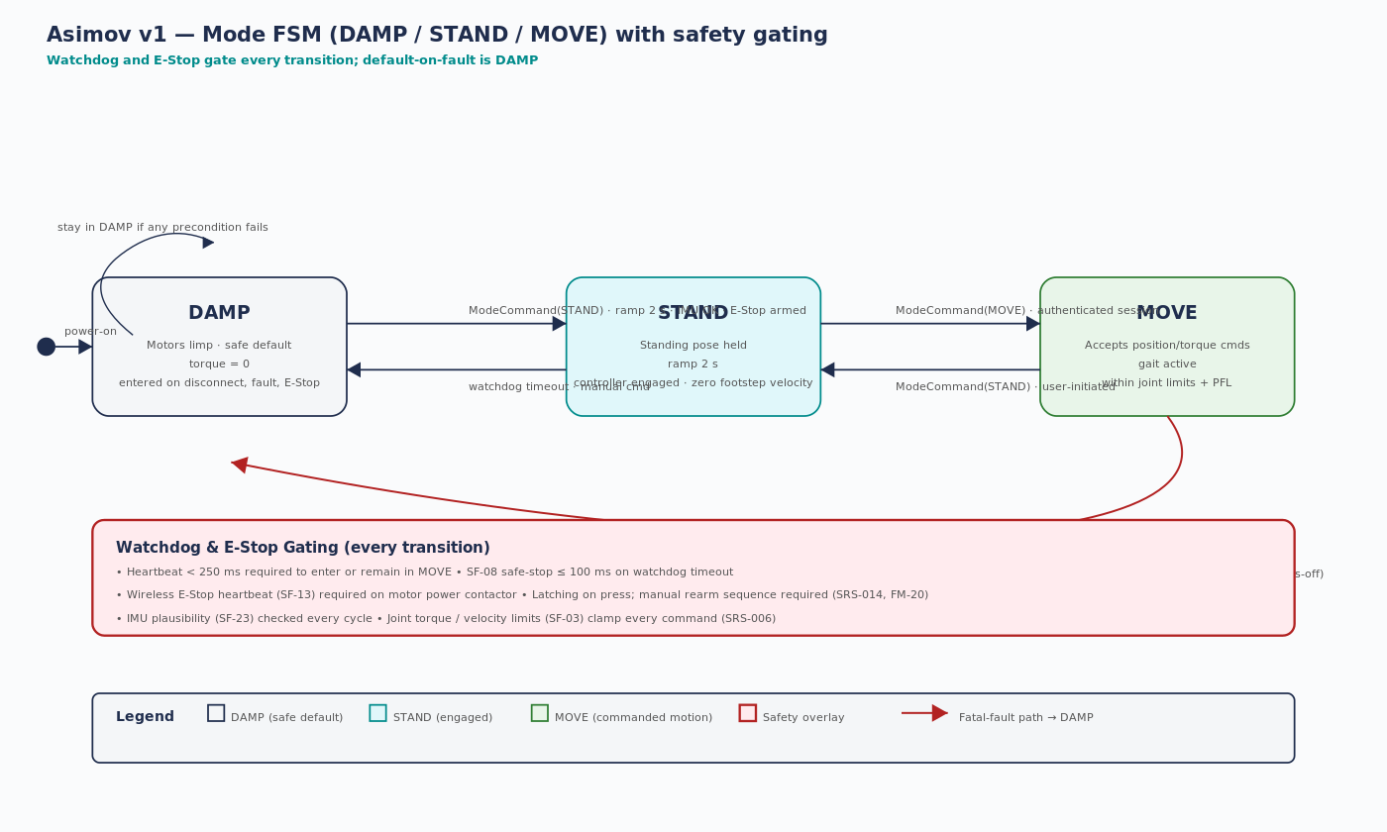
Figure 5 — Mode FSM with transitions, watchdog gates, and fatal-fault paths.

6.1 Transition guard table
From | To | Trigger | Guard conditions
(power-on) | DAMP | Boot complete | No torque applied; self-tests run (SRS-023)
DAMP | STAND | ModeCommand(STAND) | IMU plausibility OK · E-Stop armed · auth session active · 2 s ramp
STAND | MOVE | ModeCommand(MOVE) | Heartbeat < 250 ms · joint limits · torque limit · auth session
MOVE | STAND | ModeCommand(STAND) | Operator-initiated; controller transitions to standing pose
STAND | DAMP | Watchdog timeout / cmd | Any of: heartbeat lost, fault, manual command
MOVE | DAMP | FATAL FAULT | Any of: E-Stop pressed · torque-limit breach · IMU implausible · loop-deadline miss · CAN bus-off · BMS protection

6.2 Reaction-time budgets
Scenario | Detection | Reaction | Total budget
Heartbeat lost | ≤ 250 ms | ≤ 100 ms (SF-08) | ≤ 350 ms
Wireless E-Stop press | ≤ 50 ms | ≤ 500 ms (SF-13) | ≤ 550 ms
Wireless E-Stop link loss | ≤ 1000 ms | ≤ 1000 ms | ≤ 2 s — to fail-safe
Loop deadline miss | ≤ 50 ms | ≤ 50 ms (SF-24) | ≤ 100 ms
CAN bus-off | Immediate (interrupt) | ≤ 100 ms (SRS-011) | ≤ 100 ms
IMU implausibility | ≤ 50 ms (SF-23) | ≤ 50 ms | ≤ 100 ms
Stator over-temp | Continuous | ≤ 200 ms (SF-14) | ≤ 200 ms

7. Architecture-to-safety-case trace
Each architectural element is traced back to the safety case for verifiability:
Architectural element | Safety-case reference | DFMEA failure modes | Open gaps
MCB watchdog + scheduler | SF-08, SF-24 | FM-10, FM-13 | GAP-13849-01, GAP-13849-03
Wireless E-Stop receiver | SF-13 | FM-19, FM-20 | GAP-13482-04, GAP-10218-03
Battery + BMS | SF-15 | FM-21, FM-22 | GAP-BMS-01
Locomotion policy + IMU | SF-01, SF-02, SF-23 | FM-04, FM-12, FM-28 | GAP-LP-01, GAP-13849-01
Joint torque/velocity | SF-03, SF-04, SF-20 | FM-05, FM-06, FM-08 | GAP-13482-02, GAP-15066-01
Six CAN buses + harness | SF-08 | FM-11, FM-18 | GAP-13849-01
Power distribution | SF-10, SF-11 | FM-16, FM-17, FM-31 | GAP-60204-01
Tele-op auth + cyber | SF-21, SF-22 | FM-15, FM-32 | GAP-CYB-01
Mechanical structure | SF-05, SF-07 | FM-01, FM-02, FM-03, FM-30 | GAP-9001-03, GAP-13482-03

7.1 Conclusion
The architecture is internally consistent and the five views together provide a complete description of the item for concept-phase review. Significant safety-architecture gaps remain — most importantly the Cat 3 redundancy of SF-01/02/08/13/15/23/24 and the published architecture of the wireless E-Stop. These are tracked in the Safety Case Gap Register (tab 12_Gaps).
7.2 References
Standards: ISO/IEC/IEEE 42010:2022 · ISO 12100 §5 · ISO 13482 §5/§6 · ISO 13849-1 §6 · ISO 10218-1 §5. Project: github.com/jherrodthomas/asimov-v1; manual.asimov.inc/v1. Companion artefacts: Asimov_v1_Safety_Case.xlsx, Asimov_v1_DFMEA.xlsx, Asimov_v1_Requirements.xlsx.

