reBot-DevArm B601-DM
ARCHITECTURE DESCRIPTION DOCUMENT
System boundary · Functional decomposition · Safety architecture · Bus topology · Mode FSM

Document control
Field | Value
Document ID | REBOT-ARCH-CP-001
Revision | 0.1 (draft)
Issue date | 2026-05-04
Author | J. Herrod-Thomas
Item | reBot-DevArm B601-DM (Damiao motor variant) — github.com/jherrodthomas/reBot-DevArm
Companion artefacts | REBOT-SC-CP-001 Safety Case · REBOT-DFMEA-CP-001 DFMEA · REBOT-REQ-CP-001 Requirements
Standards basis | ISO/IEC/IEEE 42010:2022 · ISO 12100 §5 · ISO 10218-1 §5 · ISO/TS 15066
Confidentiality | Public — distributed under CC BY-NC-SA 4.0 (ShareAlike)

Important — concept-phase architecture
This document describes the architecture as inferred from the upstream Seeed-Projects/reBot-DevArm repository (CAD STEP files, BOM, performance test data, Python motorbridge SDK, ROS2 driver in progress). Where upstream documentation is silent — e.g. the physical E-Stop topology — assumptions are flagged and traced to the Gap Register in the Safety Case workbook.

1. Introduction
This document describes the concept-phase architecture of the reBot-DevArm B601-DM 6-DOF cobot arm. It supplements the Preliminary Safety Case (REBOT-SC-CP-001), the DFMEA (REBOT-DFMEA-CP-001), and the Requirements Specification (REBOT-REQ-CP-001). The architecture is presented through five views:
View | Diagram | Purpose
Context | Diagram 1 — System boundary | Item, actors, external interfaces, hazard zones (ISO 12100 §5)
Functional | Diagram 2 — Functional block | Joint motors, gripper, host, PSU, camera; power and bus flows
Safety | Diagram 3 — SF allocation map | 31 safety functions allocated to HW / SW / procedure with PL targets
Communication | Diagram 4 — Bus topology | CAN / RS485 daisy chain with termination strategy
Behavioural | Diagram 5 — Mode FSM | OFF / IDLE / TEACH / RUN / ESTOP with watchdog and E-Stop gating

1.1 Architecture style and decomposition principles
reBot-DevArm is decomposed into a mechanical chain of 6 actuated joints plus a gripper, all sharing a single motor bus (CAN or RS485 depending on motor variant). A separate host (Jetson, Raspberry Pi or desktop PC) runs the high-level control loop using the Python motorbridge SDK or a ROS2 driver. The split mirrors the safety architecture: deterministic, low-latency control of joint torque happens inside the motor firmware, while the host runs perception, planning, and tele-op logic at higher latency. A wired E-Stop interlock (proposed: XIAO ESP32 + latching contactor) sits independent of the host and can remove motor enable without firmware veto.
1.2 Architectural assumptions
ID | Assumption | Trace
AA-01 | All 7 motor nodes (6 joints + gripper) sit on a single bus terminated 120 Ω at both ends. | SYRS-020 · HWRS-010
AA-02 | Host PC and motor firmware are on separate fault domains; host fault → safe-stop, motor fault → safe-stop. | SF-08, SF-25
AA-03 | E-Stop is independent of host and FW — opens motor enable directly via latching contactor. | HWRS-014 · GAP-10218-02
AA-04 | PSU is external bench supply (not part of the kit BOM in some variants). | HWRS-017
AA-05 | LeRobot policy outputs are clamped at the joint controller, not trusted blind from Python. | SRS-030 · GAP-LP-01
AA-06 | Wrist camera, when fitted, is default-off; recording requires explicit operator action. | SF-31 · GAP-PRIV-01
AA-07 | B601-DM (Damiao) and B601-RS (Robstride) variants share the mechanical envelope; control-interface differences are auto-detected at boot. | SRS-037 · GAP-VAR-01

2. System boundary and context
The system boundary follows ISO 12100 §5. External actors include the trained operator, bystanders or students (relevant outside OE-1 lab), the operating environment (indoor +10..+35 °C, dry workbench), the maintainer, the 24 V DC bench PSU, the network providing tele-op, and an optional operator app. The arm is explicitly NOT a personal-care robot (ISO 13482 doesn't apply) — it is an industrial robot used in collaborative scenarios per ISO 10218 + ISO/TS 15066.
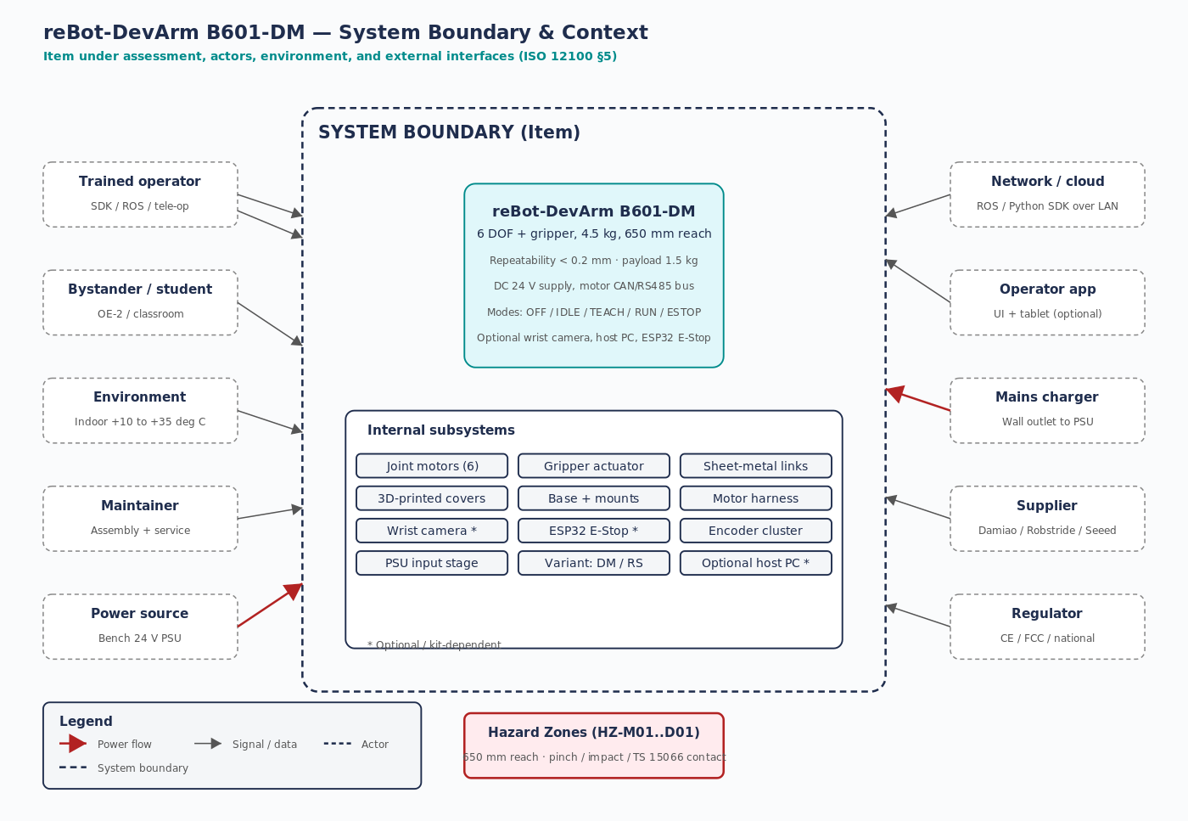
Figure 1 — System boundary and context per ISO 12100 §5.

2.1 External interfaces
Interface | Direction | Medium | Safety relevance
Operator → SDK / ROS | in | USB / Ethernet / Wi-Fi | SAFE — auth + idle lock (SF-26, SF-27)
Operator → E-Stop button | in | Wired | SAFE Cat 1 — direct contactor open (SF-08, SF-13)
Robot → operator UI / topics | out | Ethernet / ROS | Telemetry + camera + audio
Bystander exposure | — | Physical (650 mm reach) | Hazard zones (HZ-M01..M05, HZ-P01..P03)
Environment | in | Air, surface | +10..+35 °C, level workbench, dry
Maintainer assembly | — | Procedural | Lift / PPE / ESD (SF-12, SF-16, SF-19, SF-20)
Power source | in | DC 24 V (XT60/Anderson) | SF-10, SF-11, SF-13
Optional wrist camera | in | USB / MIPI | Privacy default-off (SF-31)
Supplier | — | Procurement | Damiao / Robstride / Seeed
Regulator | — | Compliance | CE / FCC / national (out of scope this rev)

2.2 Operating envelopes
OE | Description | Risk | Acceptance
OE-1 | Lab / desk research, supervised, fixtured | LOW | PROVISIONAL YES
OE-2 | Education / classroom | MEDIUM | Not yet — 9 gaps
OE-3 | Industrial cobot, defined cell | MEDIUM | Not yet — 14 gaps
OE-4 | Public-facing demo (untrained bystanders) | HIGH | Not yet — 17 gaps + regulatory

3. Functional architecture
The functional view shows six joint motor nodes (J1..J6) plus a gripper sharing a single motor bus, the host PC running the SDK / ROS2 / LeRobot stack, the optional wrist camera, the 24 V DC PSU, and the proposed XIAO ESP32 E-Stop interlock.
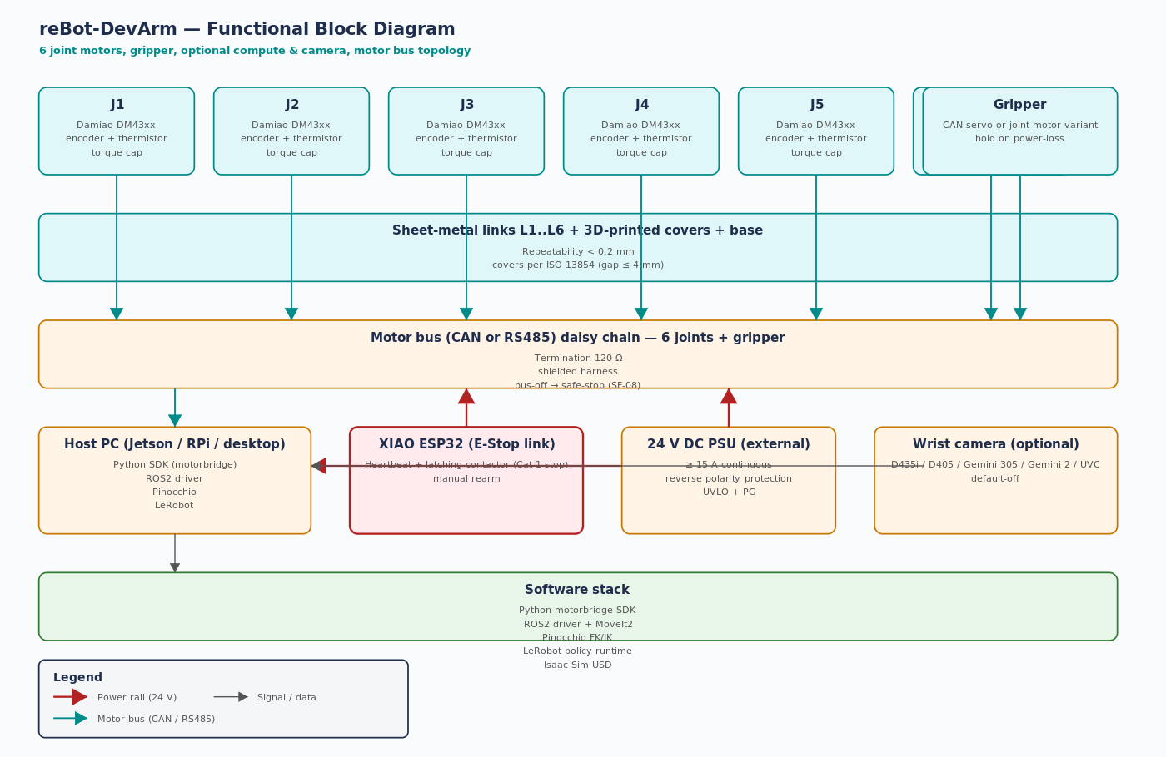
Figure 2 — Functional block diagram with joint chain, motor bus, host, PSU, and E-Stop.

3.1 Subsystem responsibilities
Subsystem | Function | Allocated reqs
Joint motors J1..J6 | Apply commanded torque; report position/velocity/temperature | F-MOTOR · SF-03 · SF-14
Gripper actuator | Open/close; hold on power loss | F-GRIP · SF-13
Sheet-metal links / 3D-printed covers | Provide structural rigidity; sharp-edge mitigation | F-MECH · SF-05 · SF-07
Base + mount | Resist tip-over moment; mounting interface | HWRS-025 · SF-12
Motor bus + harness | CAN/RS485 daisy chain; 120 Ω termination; shielded harness | F-EE · HWRS-010
Host PC (Jetson/RPi/desktop) | Run SDK / ROS2 / LeRobot / Pinocchio; auth-protected commands | F-SW · SF-25 · SF-26
XIAO ESP32 E-Stop | Open motor enable on press; latching contactor; manual rearm | SF-08 · SF-24 · HWRS-014
24 V DC PSU | Deliver 24 V at full bus current; UVLO + reverse polarity | SF-10 · SF-11 · HWRS-017
Wrist camera (opt) | Image stream for tele-op / VLA | F-CAM · SF-31

4. Safety architecture
Thirty-one safety functions are declared in the Functional Safety Concept (Safety Case tab 09_FSC). They are allocated to hardware (9), software / firmware (15), and procedure (7).
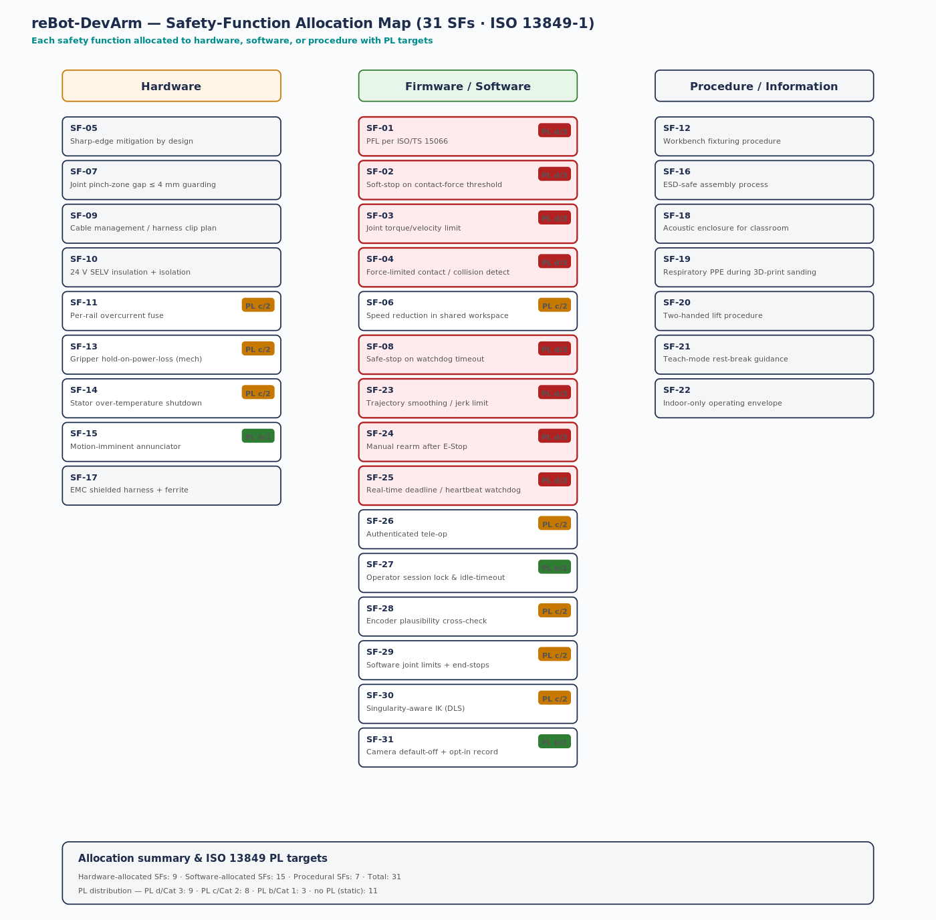
Figure 3 — Safety function allocation map: HW / SW / Procedural with PL targets.

4.1 PL distribution
PL / Cat | Count | Implication
PL d / Cat 3 | 9 | PFL, contact detection, torque/velocity limit, watchdog stop, E-Stop, jerk limit, manual rearm, RT scheduler, IK damped
PL c / Cat 2 | 8 | Speed reduction, overcurrent, gripper hold, stator over-temp, auth, encoder plausibility, joint limits, singularity
PL b / Cat 1 | 3 | Annunciator, idle lock, camera default-off
Static / no PL | 11 | Inherent design or procedure

4.2 Cat 3 architecture rationale
Per ISO 13849-1 §6.2.6, a Cat 3 architecture requires that a single fault does not lead to loss of the safety function. For the reBot-DevArm this implies redundant torque-monitor channels in the motor controller, a watchdog backed by an independent E-Stop contactor, and an encoder-plausibility cross-check that doesn't share a single point of failure with the primary feedback path. None of these are demonstrated in upstream evidence (see Safety Case Gap Register: GAP-13849-01..03).

5. Communication architecture — motor bus topology
All seven motor nodes (J1..J6 + gripper) share a single bus, terminated 120 Ω at both ends. The host is the bus master via a CAN or RS485 adapter. The choice keeps the harness simple (one daisy chain) at the cost of blast-radius: a single bus-off event halts the entire arm. SF-08 must therefore deliver safe-stop within 100 ms of bus-off detection.
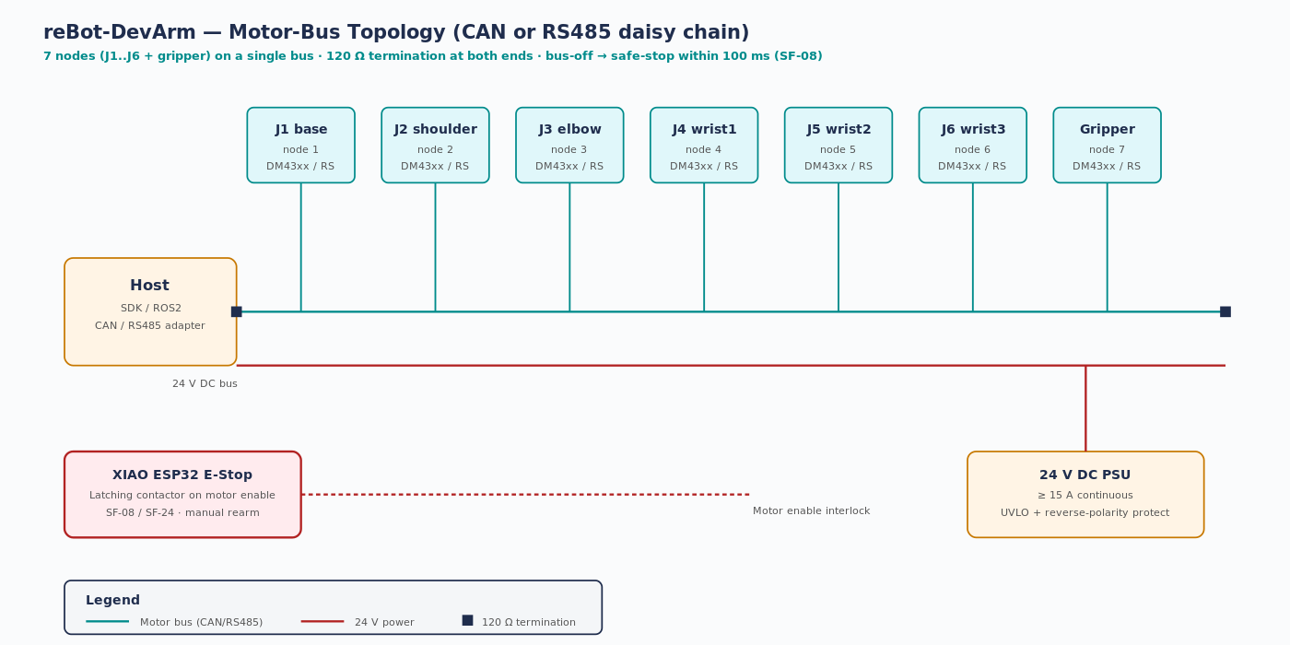
Figure 4 — Motor bus topology with 120 Ω termination, E-Stop interlock, and 24 V PSU.

5.1 Failure-mode strategy
On bus-off, FW shall (a) attempt single recovery and (b) on second occurrence within 1 s transition to safe-stop (SRS-009). E-Stop opens motor enable directly without firmware involvement. PSU UVLO triggers graceful shutdown with brake hold (SF-13 + HWRS-016).

6. Behavioural architecture — Mode FSM
Five modes — OFF, IDLE, TEACH, RUN, ESTOP — with deterministic transitions gated by the watchdog and E-Stop. The FSM enforces that motion only occurs in RUN, that RUN entry requires authentication and a valid heartbeat, and that any safety-critical fault transitions immediately to ESTOP.
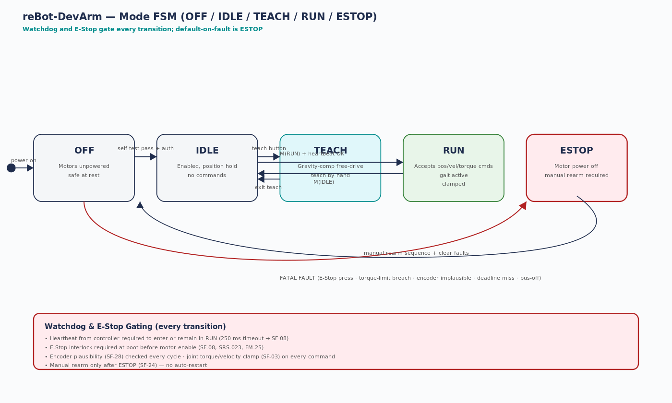
Figure 5 — Mode FSM with transitions, watchdog gates, and fatal-fault paths.

6.1 Transition guard table
From | To | Trigger | Guard conditions
(power-on) | OFF | Boot complete | All motors OFF; self-tests not yet run
OFF | IDLE | Self-test pass | E-Stop interlock OK · auth session active · all motors handshake OK
IDLE | TEACH | Teach button | Reduced-speed gravity-comp loaded · operator confirmation
TEACH | IDLE | Exit teach | —
IDLE | RUN | M(RUN) command | Heartbeat < 250 ms · joint limits configured · auth session
RUN | IDLE | M(IDLE) command | Operator-initiated
Any | ESTOP | FATAL FAULT | E-Stop · torque-limit breach · encoder implausible · deadline miss · bus-off
ESTOP | IDLE | Manual rearm | Faults cleared · E-Stop released · operator confirms rearm

6.2 Reaction-time budgets
Scenario | Detection | Reaction | Total budget
Heartbeat lost | ≤ 250 ms | ≤ 100 ms (SF-08) | ≤ 350 ms
E-Stop press | Immediate | ≤ 500 ms (SF-13) | ≤ 500 ms
Motor bus-off | Immediate (interrupt) | ≤ 100 ms (SRS-009) | ≤ 100 ms
Encoder implausible | ≤ 50 ms (SF-28) | ≤ 50 ms | ≤ 100 ms
Stator over-temp | Continuous | ≤ 200 ms (SF-14) | ≤ 200 ms
Contact-force breach | ≤ 50 ms (SF-02) | ≤ 50 ms | ≤ 100 ms

7. Architecture-to-safety-case trace
Architectural element | Safety-case reference | DFMEA failure modes | Open gaps
Joint motor + encoder | SF-03, SF-14, SF-28 | FM-01, FM-02, FM-03, FM-04 | GAP-13849-01, GAP-13849-02
Motor bus + harness | SF-08 | FM-11, FM-12, FM-13 | GAP-13849-01
Gripper | SF-13 | FM-05, FM-06 | —
XIAO ESP32 E-Stop | SF-08, SF-24 | FM-16, FM-17, FM-25 | GAP-10218-02, GAP-13849-01
24 V PSU | SF-10, SF-11 | FM-14, FM-15 | GAP-60204-01
Host SDK / ROS2 | SF-25, SF-26, SF-27 | FM-18, FM-19, FM-20 | GAP-CYB-01
LeRobot policy | SF-01, SF-03 | FM-21 | GAP-LP-01
Wrist camera | SF-31 | FM-23 | GAP-PRIV-01
Mechanical structure | SF-05, SF-07, SF-12 | FM-07, FM-08, FM-09, FM-10, FM-27 | GAP-13854-01, GAP-9001-03
PFL framework | SF-01, SF-02, SF-23 | FM-24 | GAP-15066-01, GAP-15066-02

7.1 Conclusion
The architecture is internally consistent and the five views together provide a complete description for concept-phase review. The most significant safety-architecture gap is the absence of an ISO/TS 15066 power-and-force-limiting (PFL) measurement campaign — without that, collaborative deployment to OE-2/3/4 cannot be justified. The second gap is the E-Stop topology, which is mentioned in upstream docs (XIAO ESP32) but not fully specified.
7.2 References
Standards: ISO/IEC/IEEE 42010:2022 · ISO 12100 §5 · ISO 10218-1 §5 · ISO/TS 15066 · ISO 13849-1 §6. Project: github.com/jherrodthomas/reBot-DevArm. Companion artefacts: reBot_DevArm_Safety_Case.xlsx, reBot_DevArm_DFMEA.xlsx, reBot_DevArm_Requirements.xlsx.

