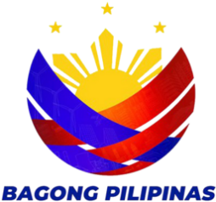
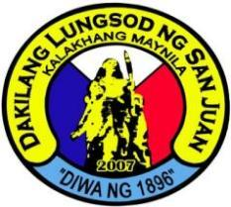
REPUBLIC OF THE PHILIPPINES
CITY OF SAN JUAN
BARANGAY BALONG BATO
Tel. No. 8723-9561
balongbato.sanjuan@gmail.com
--ooOoo--

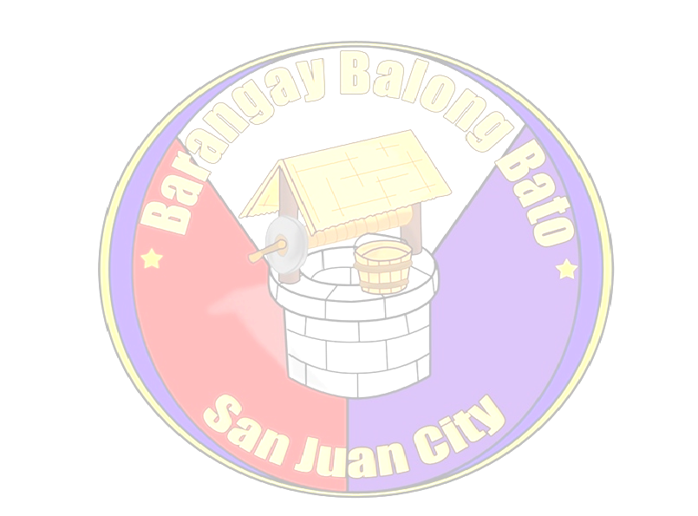

ALVIN G. ALONZO
BARANGAY CLEARANCE

This is to certify that {fullName}, Filipino, is a resident at {address}.

This certification is issued upon request of subject resident for {purpose}.

Issued this {issuedDate} at Barangay Balong bato, City of San Juan.

Certified True and Correct:

Ma. Cristina R. Aquino
Barangay Secretary

Punong Barangay

Marilyn P. Maddawin
Kagawad
Disaster Management and
Appropriation & Ways & Means
and Ethics/PIMC & Brgy.
Performance Evaluation

Noel H. Baloso
Kagawad
Education and Cultural

Herminia D. Bisco
Kagawad
Health and Gender and
Development (GAD)

Ronald O. Quiñones
Kagawad
Public Works and Traffic
Management

Leo C. Jimenez
Kagawad
Peace & Order

Edna A. Bautista
Kagawad
Clean & Green/Solid Waste
Management/Senior Citizen

Gilda O. Garcia
Kagawad
Persons with Disability/Livelihood

Jose Gabriel R. Baloso
SK Chairman/Sports

Elizabeth G. Geronca
Treasurer

{officerOftheDay}
Officer of the day

Ma. Cristina R. Aquino
For:
HON. ALVIN G. ALONZO
Punong Barangay

Secretary

Note: This will not be valid without Barangay Balong Bato Seal.

