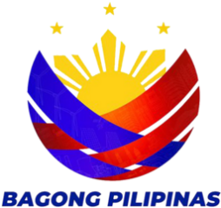
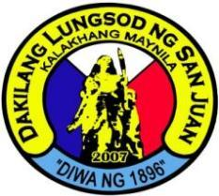
REPUBLIC OF THE PHILIPPINES
CITY OF SAN JUAN
BARANGAY BALONG BATO
Tel. No. 8723-9561
balongbato.sanjuan@gmail.com
--ooOoo--

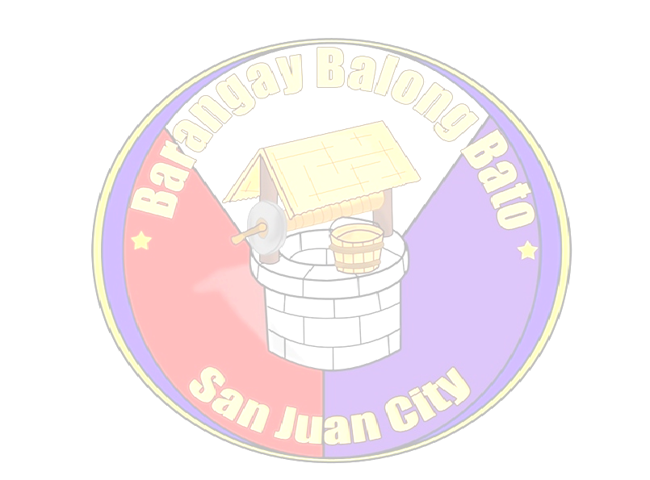

ALVIN G. ALONZO
CERTIFICATION FOR BUSINESS
CLEARANCE

This is to certify that {fullName}, is the owner of {businessName}, with business address at {businessAddress}, that the said business has complied with the requirements of the Barangay.

Provided that all existing laws, regulations and ordinances will not be violated, Any violations thereof, the Barangay may impose penalty and/or recommend the revocation of Business Permit.

Issued this {issuedDate} at Barangay Balong-Bato, City of San Juan, Metro Manila.

Punong Barangay

Marilyn P. Maddawin
Kagawad
Disaster Management and
Appropriation & Ways & Means
and Ethics/PIMC & Brgy.
Performance Evaluation

Noel H. Baloso
Kagawad
Education and Cultural

Herminia D. Bisco
Kagawad
Health and Gender and
Development (GAD)

Ronald O. Quiñones
Kagawad
Public Works and Traffic
Management

Leo C. Jimenez
Kagawad
Peace & Order

Edna A. Bautista
Kagawad
Clean & Green/Solid Waste
Management/Senior Citizen

Gilda O. Garcia
Kagawad
Persons with Disability/Livelihood

Jose Gabriel R. Baloso
SK Chairman/Sports

Elizabeth G. Geronca
Treasurer

{officerOftheDay}
Officer of the day

Ma. Cristina R. Aquino

HON. ALVIN G. ALONZO
Punong Barangay

Secretary

Note: This will not be valid without Barangay Balong Bato Seal.

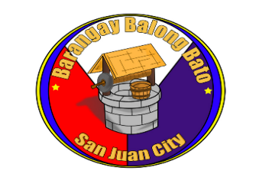
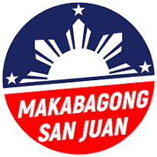

Requesting Party:

By: {fullName}
For: Renewal _ __
New __/___
OR No.: {receiptNumber}

