

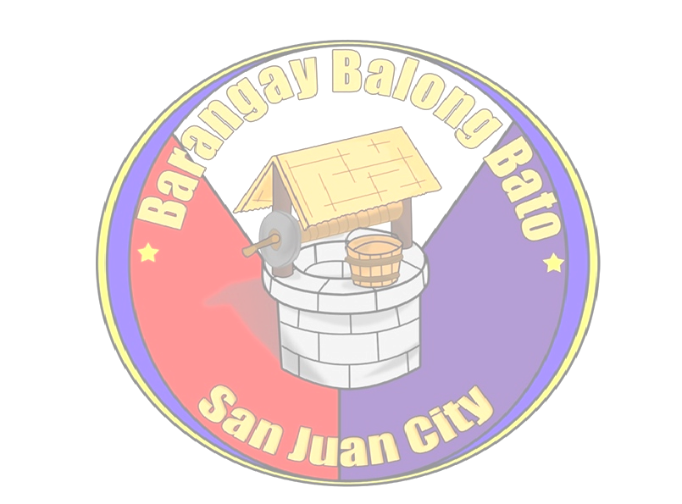

ALVIN G. ALONZO
Punong Barangay

Marilyn P. Maddawin
Kagawad
Disaster Management and Appropriation & Ways & Means and Ethics/PIMC & Brgy. Performance Evaluation

Noel H. Baloso
Kagawad
Education and Cultural

Herminia D. Bisco
Kagawad
Health and Gender and Development (GAD)

Ronald O. Quiñones
Kagawad
Public Works and Traffic Management

Leo C. Jimenez
Kagawad
Peace & Order

Edna A. Bautista
Kagawad
Clean & Green/Solid Waste Management/Senior Citizen

Gilda O. Garcia
Kagawad
Persons with Disability/Livelihood

Jose Gabriel R. Baloso
SK Chairman/Sports

Elizabeth G. Geronca
Treasurer

Ma. Cristina R. Aquino
Secretary

BARANGAY

CLEARANCE

This is to certify that {fullName}, Filipino, is a stay in worker at {address}.

This certification is issued upon request of subject resident for {purpose}.

Issued this {IssuedDate} at Barangay Balong bato, City of San Juan.

KAG. EDNA A. BAUTISTA HON. ALVIN G. ALONZO
Officer of the day Punong Barangay

Note: This will not be valid without Barangay Balong Bato Seal.

