**Sounds from Here & Yon**

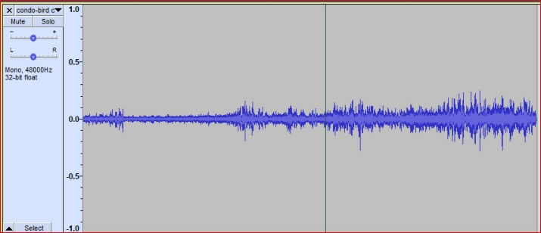This is intended as a collection of environmental sounds which we have observed in our walks and travels. The original selection is a collection of sounds we have encountered around our condo in Keene, New Hampshire. These sounds were recorded using an iPhone app called Voice recorder Pro.

Try playing one in your music app’s repeat mode as soft “background noise” in your work environment.

For the original collection, click: “[Sounds from Here](http://www.fauxes.net/Sounds.htm)”.