✦ ✦ ✦
THE GUARDIANS OF ELARIA
SESSION 4
Awakening to Shadows and Songs
An illustrated adventure. Read the gold boxes aloud; the purple boxes are for the DM.

Havenmoor in its festival best, the Great Pine shining above the harbor.
Previously, on The Guardians of Elaria...
At Ravenstone Laboratory, Professor Aelwyn studied the Essence Sphere and gave the party a road: to Gearhaven, the clockwork city, where artificers might build what a sleeping spark needs. A leafy new friend, Floraburst, chose the party as much as they chose her, and gentle Lickgloom stayed behind with the professor, happily licking everything in the laboratory in farewell.
The road south was long and wild: a shadow with three false faces in Brambleshadow Thicket, displacer beasts that spoke when they should not, mushroom wardens guarding a glowing grove. And at Stormwatch Cliffs, an old puzzle opened an old door, and a vision poured out: a Dark Figure working at the walls of the world, wanting them broken. The party carried that cold picture down the last hill and into the warm lantern light of Havenmoor, a harbor town dressed head to toe for its winter festival, where they found beds at the Sugarplum Hearth and slept to the sound of carolers. And then, morning.
▶ The heroes begin this session at level 4, grown by the long road south.
Part One: The Morning the Music Changed
The morning chill seeps through the windows of your rooms at the Sugarplum Hearth. Dawn is only a pale gray promise, and for a moment all seems calm. Then a sound threads through the silence: crying. Somewhere below, out in the snow, a woman is sobbing as if her heart has cracked in half.
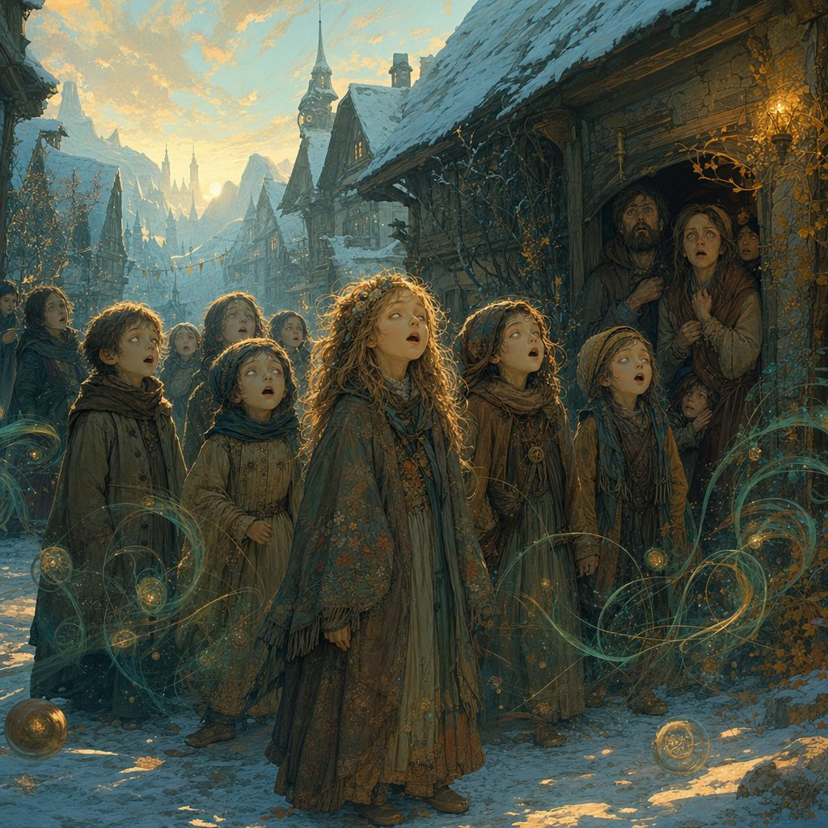
From the window, the scene outside chills you more than the frosted air. In the snow-covered street, a group of children stands huddled together, their eyes vacant and far away. Their small voices rise together in a quiet, sing-song rhyme:
♪ On the coldest night, when the stars don't shine,
The shadow creeps past the twisted pine.
A jingle, a rattle, a claw and a grin,
It takes the lost ones, then fades to the wind. ♪

The melody lingers, unsettling in its simplicity. The children are not playing. They are caught in something, like sleepwalkers singing in a dream.
Near them, a woman kneels in the snow, clutching a small, empty mitten. Her cry cuts the morning like a knife: “They took him! My boy... he is gone! The shadows took my little Finn!” Villagers gather, pale and hushed, their eyes darting to the dark line of the forest, as if even speaking of the shadows might call them back.
Greta's Warning
Greta Frostbough, the stout dwarf keeper of the Sugarplum Hearth, draws the party inside to the warmth, her kind face lined with worry. “There is something terribly wrong this winter. The stories we tell to scare the young... they are becoming real. The children feel it. That song they are singing is an old rhyme about the Krampusshade, a shadow that takes children on the longest nights.”
She reaches beneath the bar and pulls out a worn map of Havenmoor, its edges lightly singed. “There are eight bells hidden around this town, ancient holiday relics meant to keep the darkness away. Find them all and ring them together, and maybe, just maybe, we can drive back the shadows. Search these places, and talk to the people there. Hurry, before more children vanish into the night.”
Four places are marked in vivid old ink: the Sugarplum Hearth itself, the Frostwind Market Square, the Hollow Hearth Orphanage, and the Wyrmgale Lighthouse. Two bells wait at each, eight notes of one unfinished song.
Outside, the festive cheer of Havenmoor has become a brittle mask. The party looks at the empty mitten in the mother's hands, and the choice makes itself.
Part Two: The Hunt for the Winter Bells
Map in hand, the four friends went bell hunting through a frightened town, and found that every bell came wrapped in a story.
The Sugarplum Hearth: C and D
The search begins at home. The tavern is all warmth and cinnamon, garlands of holly on the rafters, a decorated tree glittering in the corner, and above the crackling hearth, gleaming quietly in plain sight, hangs an old brass bell: the C Bell. Greta lifts it down herself. “It has watched over this room longer than I have. Take it, and bring it back singing.”
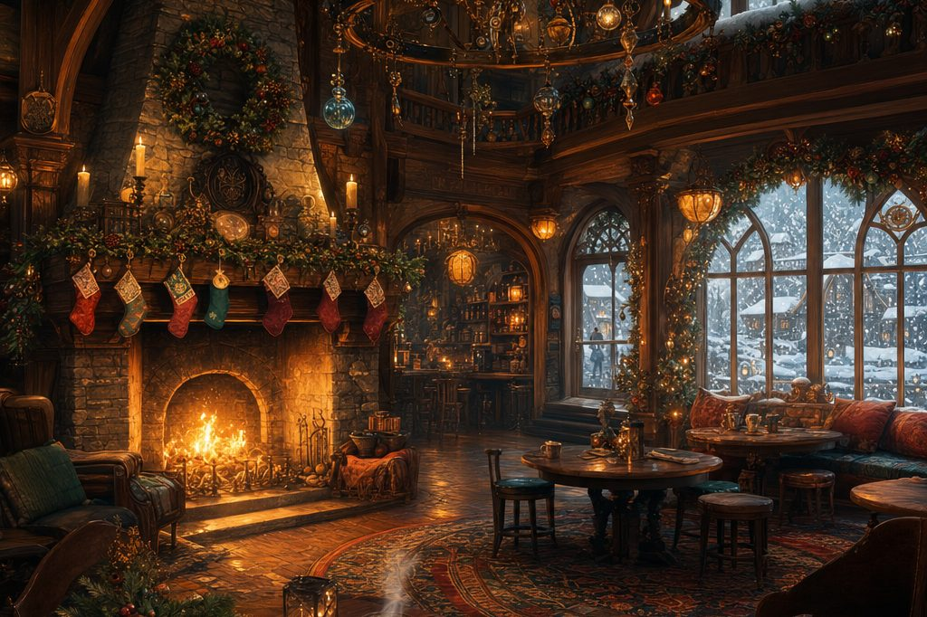
The Sugarplum Hearth, all warmth and cinnamon, the C Bell above the fire.
By the fire, Elda Merrywhistle, a cheerful half-elf bard, strums her lute and hums. “The songs we sing tonight are meant to bring joy. But some songs are darker. You have heard the one the children sing?” She plays a few notes of an old ballad, the Lay of the Longest Night, about a shadow that steals children when joy turns to fear. At the corner table, Captain Torren Windward, a weathered sailor, stares into his mug. “Strange lights dance on the cliffs at night. I have seen ships swallowed by mist and shadow. Stay off the sea after dark, if you are smart.”
It is Floraburst who finds the second bell, rustling her leaves at an ornate wreath above the bar until sharp eyes spot the glint of brass tucked deep in the pine branches: the D Bell. Greta blinks at it. “Huh. I thought we only had one.”
▶ Wisdom (Perception) DC 15 found the D Bell in the wreath. An old carved plaque above the bar, centuries old, shows a shadowy figure among pine trees and frightened children: the legend is far older than anyone living.
Frostwind Market Square: E and F
The market square should be the happiest place in Havenmoor: stalls hung with snowy garland, the smell of roasted chestnuts and cinnamon pastries, and at the center a towering pine tree dressed in glass ornaments and golden ribbon. But the laughter here is forced, and every parent keeps one hand on a small shoulder.

Bell hunting in Frostwind Market Square, under the towering festival pine.
The E Bell hangs from one of the pine's lower branches, silver, engraved with stars and snowflakes, chiming softly in the breeze as if it had been waiting to be noticed. When Ursa lifts it free, the cold air feels, for one breath, warmer.
The trail of the F Bell leads to the stall of Eldric Bramblefoot, a round little halfling merchant with a red woolen scarf and nervous eyes. “Festive cheer or not, there is something dark in those woods. I hear whispers at night. Not the wind. Something else.” Asked about bells, he digs through a box of decorations behind his stall and comes up holding a small brass bell patterned with holly. “A bell, you say? Well. If it helps bring back some peace, take it. Just... be careful out there.”
Around the square, the party gathers more than bells. Ingrid Stonegale, the blunt dwarf blacksmith, remembers the old tales: “Last time the bells were gathered, the village was spared a terrible fate. We have not seen them in years. Maybe that is why things are going wrong now.” And Lora Thistledown, the gnome baker, shows them the strangest thing: frost blooming on her gingerbread cookies overnight, in a warm stall, which no winter she knows has ever done.
▶ Charisma (Persuasion) DC 15 talked Eldric into parting with the F Bell willingly. Unnatural frost and vanishing footprints around the square hint that the shadow's reach is growing.
The Hollow Hearth Orphanage: G and A
The orphanage stands at the town's edge, weathered but tidy, a creaking sign with a faded heart swinging in the wind. Inside, a small hearth crackles against a chill that never quite leaves, and the walls are covered in children's drawings. Some of the newest drawings show a dark, horned figure standing in doorways. Sister Merida, the caretaker, follows the party's eyes and lowers her voice. “They draw what they see. I wish they didn't. Something is wrong this winter. The nights feel colder. The shadows, longer.”
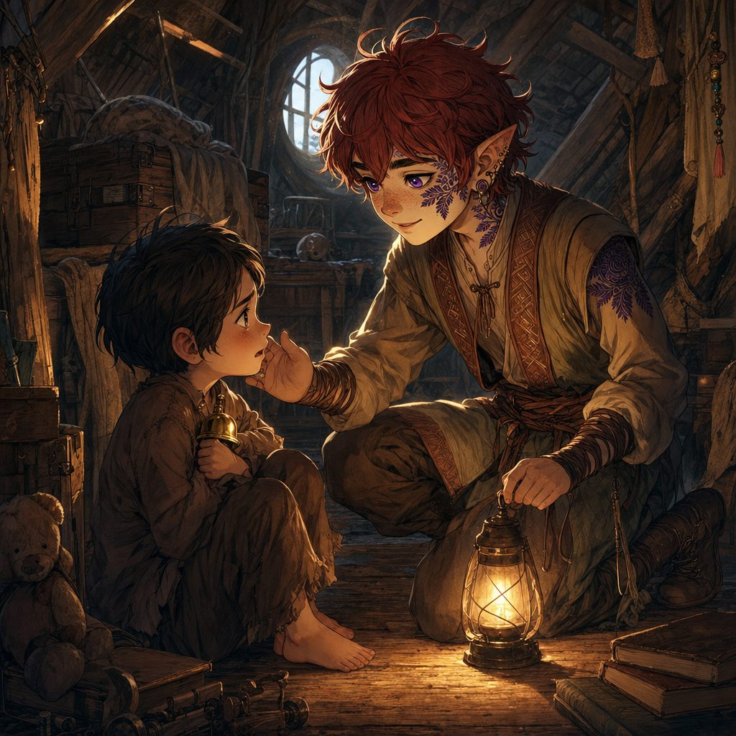
In the attic, among old trunks and forgotten toys, a dusty toy chest holds the G Bell, brass etched with tiny snowflakes, nested between stuffed animals like a secret someone hid for safekeeping. As Lilly lifts it out, a whisper seems to drift through the rafters: the bells keep us safe... don't lose them.
The last bell in the orphanage is not hidden at all. A small boy of about six, tousle-haired, sits in the corner clutching a threadbare teddy bear in one arm and a little silver bell in the other fist, humming the eerie rhyme under his breath. His name is Milo, and he will not let go. “He comes when it's dark,” Milo whispers. “With bells that jingle. I don't want to go with him.”
So the heroes sit down on the floor with him. Stabby makes his very best silly faces. Floraburst produces a bright berry from her leaves. Ursa tells him, quietly, that bells are like stars: little lights the dark cannot put out, and that this one will fight better in brave hands. Milo looks at each of them for a long moment, then opens his fist. The A Bell chimes softly as it changes hands, and for a heartbeat every shadow in the room stands a little farther away. Milo sings them one more verse, the one the grown-ups have not heard:
♪ When the bells fall silent, the cold will creep,
Shadows gather, and children weep.
Ring the light, banish the shade,
Or into the night, we'll be afraid. ♪

▶ Calming Milo took gentleness, not dice: Charisma (Persuasion) DC 14 with advantage for kindness. Intelligence (Investigation) DC 15 found the G Bell in the attic toy chest.
The Wyrmgale Lighthouse: B and High C
Last comes the lighthouse, tall and steadfast on the cliffs, battered by wind and salt spray, its beacon struggling against a mist that does not behave like mist. The keeper meets them at the door: Old Doran Bramblebeard, Havenmoor's shipwright, a tall, wiry man in an oilskin coat who tends the Wyrmgale light in winter because, as he puts it, nobody else has the stomach for it. “Storms rage out at sea, but sometimes the real danger comes from the shadows that walk these cliffs. Watch the light. Mind the dark.”
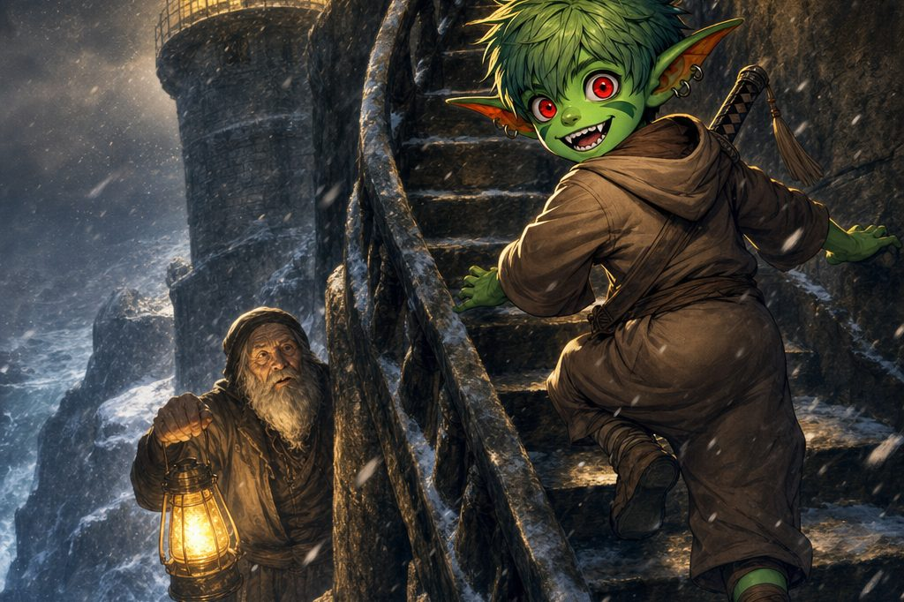
The Wyrmgale Lighthouse, tall and steadfast on the cliffs.
The B Bell hangs from a rusted iron hook near the very top of the tower, past a rickety ladder and footing slick with spray, chiming a strangely mournful note in the wind. Stabby, naturally, is up and back before anyone can say be careful, the bell cold as the sea in his hand, engraved with swirling waves.
The eighth bell hides in the storeroom at the lighthouse's base, among old nets and salt-crusted rope. A faint hum of magic leads Lilly to a large tarnished ship's bell resting on a crate, and nestled inside it, like a pearl in an oyster, the High C Bell, etched all over with tiny stars. When she lifts it free it rings one pure, clear note, and light flickers across the old ship's bell as if the stars themselves acknowledged the find.
Doran walks them out, squinting at the horizon. “Eight bells, eh? Then it is real, and it is bad. Go see Faelan, the lorekeeper. And when this is over, come find me at the shipyard. I have something on the stocks you will want to see.”
▶ Strength (Athletics) DC 15 for the climb to the B Bell; Intelligence (Arcana) DC 14 sensed the magic hiding the High C Bell in the storeroom. All eight Winter Bells: C, D, E, F, G, A, B, High C.
The Frozen Roads: A Winter Bestiary of Chances
The roads around Havenmoor that week were thick with wonders and dangers. Not all of them crossed the heroes' path, but every one of them was out there, waiting in the white silence between the pines. What follows is the DM's deck of chances, exactly as it hung over every journey out of town that winter.
▶ Travel Encounters. Whenever the party sets out through the frozen wilds around Havenmoor, roll a d20 on the table below. Notes on the most colorful entries follow; full statistics for every creature live in the bestiary compendium.
Travel Encounter Table (d20)
1. Krampusshade's Minion: a shadowy imp attacks, attempting to steal something from the party.
2. Frozen Wolves: 2d4 frost-covered wolves stalk the party, their eyes glowing with cold malice.
3. Frostbite Pixies: mischievous pixies cast Ray of Frost and try to confuse the party.
4. Icy Specter: a ghostly figure whispers a chilling warning before attacking.
5. Snowbound Bandits: desperate bandits, half-mad with cold, ambush the party.
6. Frost Golems: two small frost golems rise from the snow and attack.
7. Blizzard Trap: a sudden blizzard cuts visibility to a few feet; Wisdom (Survival) DC 14 to avoid becoming lost.
8. Enchanted Snowmen: three animated snowmen with coal-black eyes hurl snowballs laced with Ray of Frost.
9. Yule Cat: a huge predatory feline prowls near the party, looking for those who have not been good.
10. Friendly Caribou: a lost, enchanted caribou offers the party a brief rest and warmth.
11. The Sleeping Traveler: a traveler frozen beneath the snow, one hand still holding a cryptic note or map.
12. Holiday Illusions: visions of a warm celebration that hide a dangerous snow drift.
13. Frozen Will-o'-Wisps: malevolent lights lure the party toward a frozen pond.
14. Frost Hag Ambush: a frost hag disguised as a kind old woman offers poisoned treats.
15. Ice Spiders: 2d6 ice spiders drop from the trees and attack.
16. Resting Reindeer: a magical reindeer grants the party inspiration if treated kindly.
17. Frozen Treasure: a chest sealed in a block of ice; Strength DC 15 or fire magic to open.
18. Aurora Spirits: peaceful, glowing spirits offer a cryptic hint or prophecy.
19. Fey Tricksters: playful fey challenge the party to a riddle contest or a harmless prank.
20. Holiday Miracle: a warm breeze restores 1d4 hit points to each party member.
Gift Box Table (d20)
▶ Gift Boxes. When one of the Krampusshade's creatures is defeated, it leaves behind a wrapped gift box. Roll a d20 for its contents.
1. Mimic in Disguise! The gift box is a tiny mimic (CR 1), and it immediately attacks.
2-4. Lump of Coal: a mundane lump of coal. Slightly warm, but otherwise useless.
5-6. Handful of Peppermint Shards: slightly refreshing. No mechanical effect.
7-9. Gingerbread Cookie: a tasty treat that restores 1d4 hit points when eaten.
10-12. Candy Cane Dagger: a simple weapon, 1d4 piercing damage. Melts after 24 hours.
13-15. Hot Cocoa Flask: when drunk, grants resistance to cold damage for 1 hour.
16-17. Sparkling Snow Globe: shaking it causes a harmless flurry of snow, and it sheds light for 30 feet.
18-19. Frosted Cookie of Restoration: restores 2d8 hit points, grants the benefit of a short rest, and restores one spell slot.
20. Holiday Miracle Charm: a small charm granting advantage on one saving throw within 24 hours.
The Yule Cat
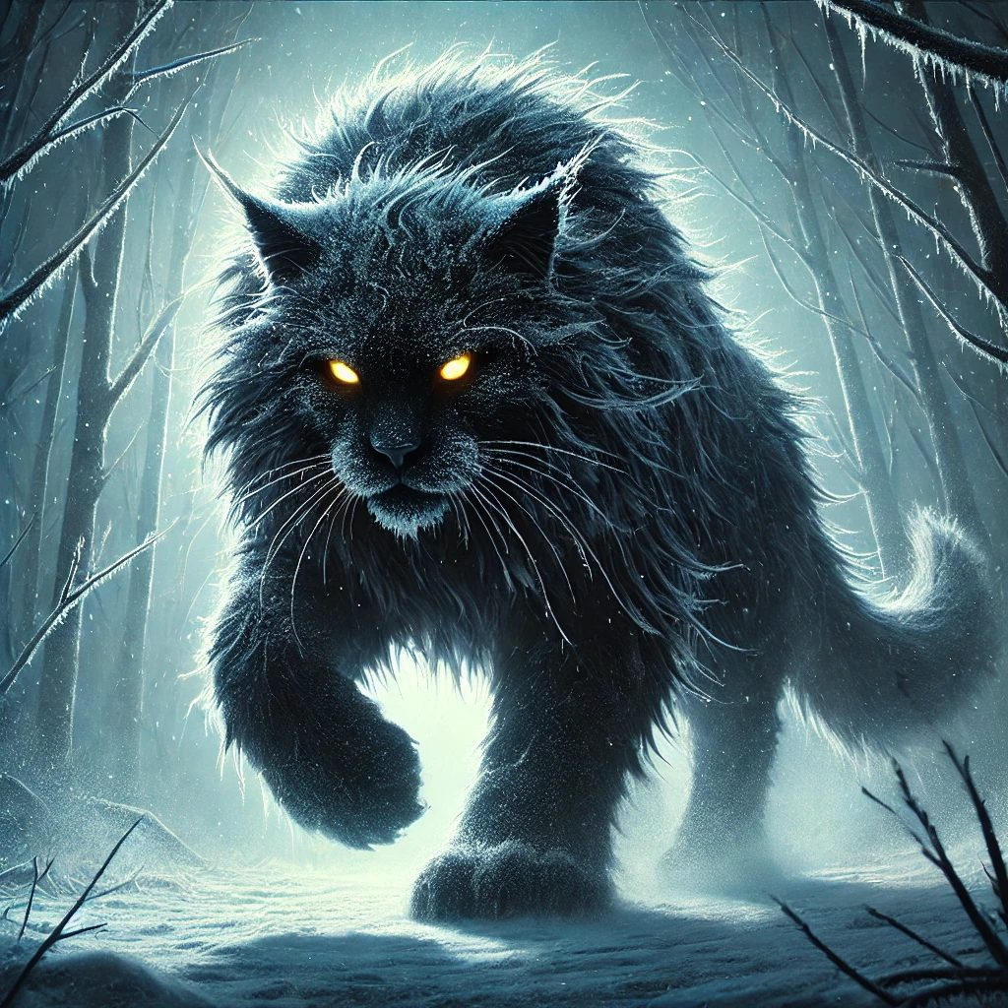
A massive black feline with frost-covered fur and glowing yellow eyes, the Yule Cat is a creature of fey legend that judges those who lack generosity or kindness. It prowls the deep snow on silent paws, and a low growl through the cold air is the only warning before it pounces. Legends around Havenmoor say it circles the houses on festival nights, counting who has shared their supper and who has not.
▶ Yule Cat (CR 3). Wisdom (Animal Handling) DC 15 calms it for a round; Wisdom (Insight) DC 14 reveals that it seeks acts of generosity, so offering food or gifts can delay its attack entirely. In a fight it relies on Frost Claw, a Frostbite Pounce that knocks heroes prone, and a Chilling Gaze (DC 14 Constitution) that paralyzes with cold. Win or appease it, and a roll on the Gift Box Table follows.
The Frost Hag
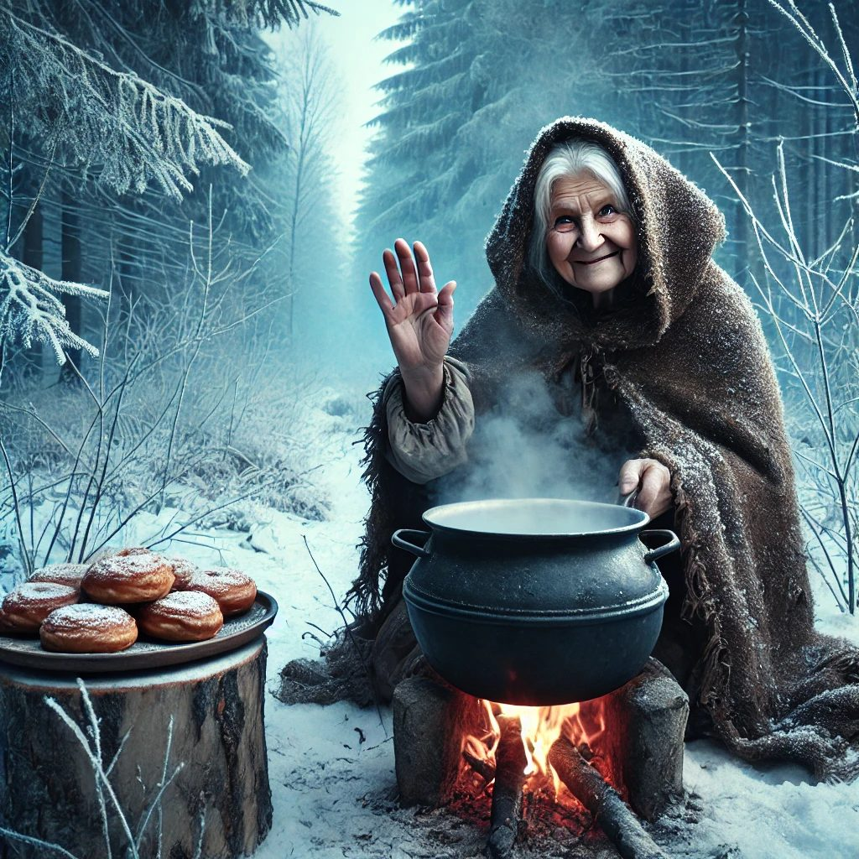
In a lonely clearing, a kindly old woman tends a bubbling cauldron and waves travelers over to warm themselves and share pastries dusted with powdered sugar. Her voice is honey and her fire is warm, but her eyes glint far too coldly for the warmth of her smile. The wisest travelers notice that no snow melts anywhere near her fire.
▶ Frost Hag (CR 4). Wisdom (Insight) DC 14 catches the malice behind the smile. Anyone who eats her treats must make a DC 13 Constitution save or be poisoned for 1 hour, taking 1d4 cold damage. Unmasked, she is ice-crusted skin and jagged teeth: Icy Claw, a 15-foot Frostbite Breath cone (DC 14 Constitution, 4d6 cold, slowed on a failure), and Misty Step as a bonus action to keep out of reach.
Snowbound Bandits

On a narrow, snow-choked path, four desperate figures rise out of the drifts with weapons trembling in frostbitten hands, and a grizzled leader with a frost-crusted beard demands the party's packs. They are cold and hungry rather than wicked, and a warm meal buys more peace than a drawn blade. A DM with a soft heart may let a fed and warmed bandit whisper a useful rumor about the roads before the band slips away into the snow.
▶ 3 Bandits and 1 Bandit Leader. Wisdom (Insight) DC 14 shows they are driven by desperation, not malice. Charisma (Persuasion) DC 15 with an offer of food or warmth avoids the fight; Intimidation DC 14 scares them into retreat, but failure means combat on slippery ice (Dexterity DC 13 to move more than 15 feet without falling prone). The leader's Frostbite Strike adds 1d6 cold damage and can slow its target. Victory yields 1d4 healing potions, 10 gold, rations for two days, and a Gift Box.
Frost Golems
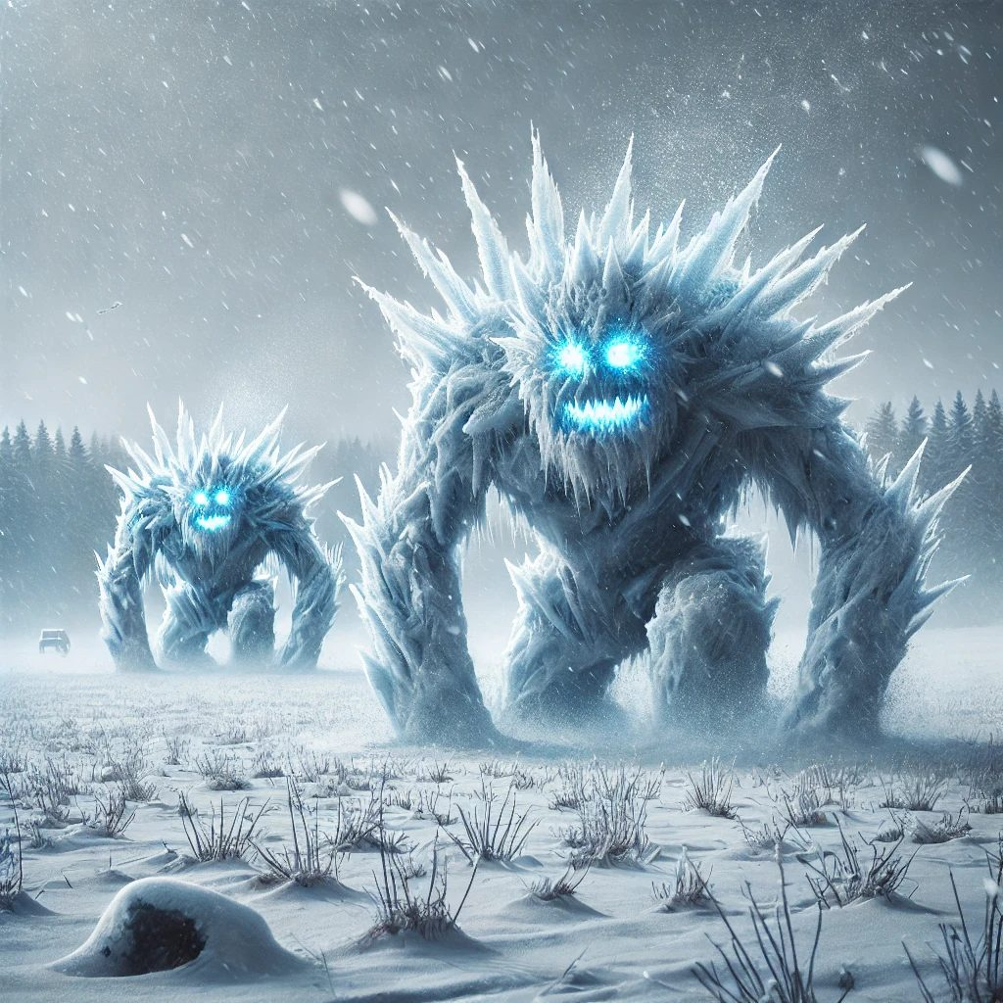
On a serene snowfield, the powder suddenly trembles and pulls itself together, packing into two jagged shapes of snow and ice shard. Their eyes glow with an eerie blue light as they lumber forward, frost radiating from their bodies, without hurry and without mercy.
▶ 2 Frost Golems (CR 2 each). Icy Slam (2d6 + 3 bludgeoning plus 1d4 cold) and a Frost Aura that deals 2 cold damage at the start of each creature's turn within 5 feet. The snowfield itself is a hazard: Dexterity (Acrobatics) DC 14 to move quickly without falling prone. The golems trudge relentlessly and try to corner heroes on the worst of the ice.

Enchanted Snowmen
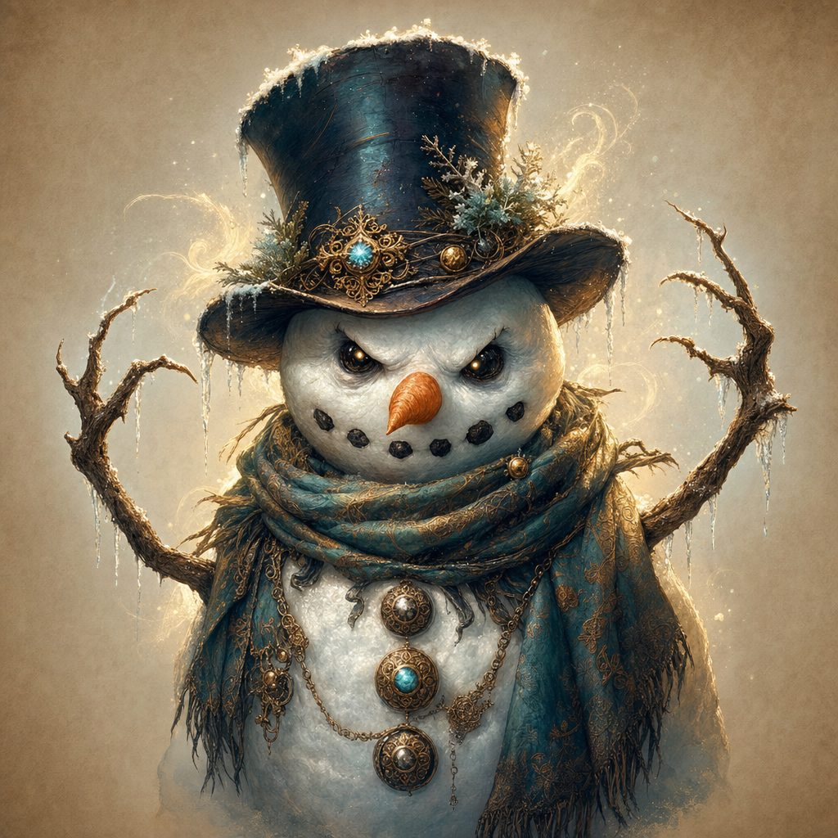
Three cheerful roadside snowmen with coal-black eyes and wicked twig grins shudder to life as travelers pass, stick arms lifting to pelt them with snowballs laced with ice magic. It would almost be funny, if the snowballs did not hit quite so hard.
▶ 3 Enchanted Snowmen (CR 1 each). Wisdom (Perception) DC 14 to act before the snowmen do. Frostball: +4 to hit, 2d4 cold damage, and a DC 12 Constitution save or the target's speed is halved until the end of its next turn. AC 13, HP 30, and they never stop grinning.
Ice Spiders
In a grove of frost-covered trees, branches creak under an unnatural weight and a faint skittering echoes overhead. Then icy webs glisten in the dappled light, and frost-coated spiders the size of wolves drop from the canopy, mandibles glittering with rime.
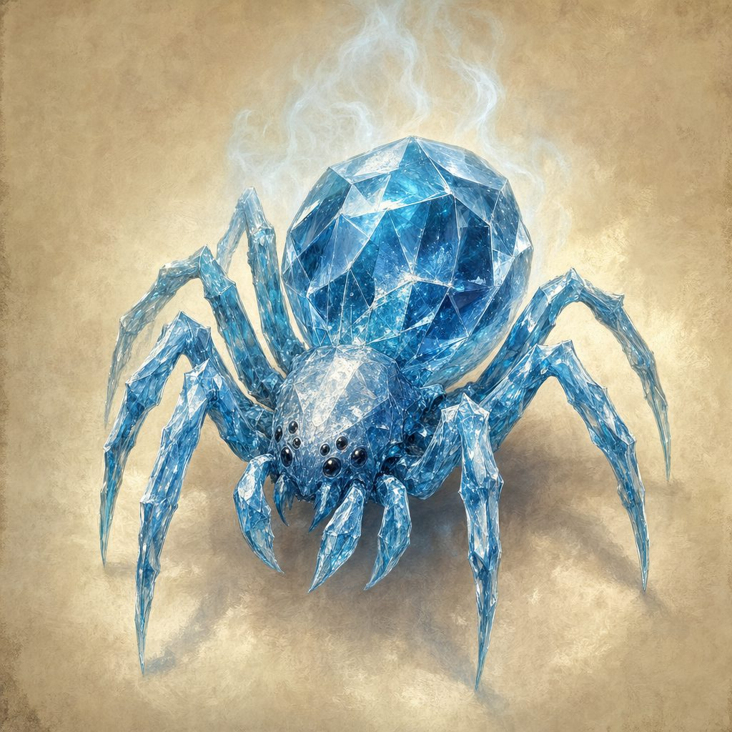
▶ 2d6 Ice Spiders (CR 1 each). Wisdom (Perception) DC 15 spots them before they drop; Wisdom (Survival) DC 14 keeps the party out of the sticky web traps (DC 13 Strength to break free). Their bite carries a venomous chill (DC 13 Constitution or poisoned 1 minute), their frozen webbing stings for 1d4 cold damage if touched, and the ground beneath the grove is slick ice, Dexterity (Acrobatics) DC 14 to keep footing.

Frozen Will-o'-Wisps
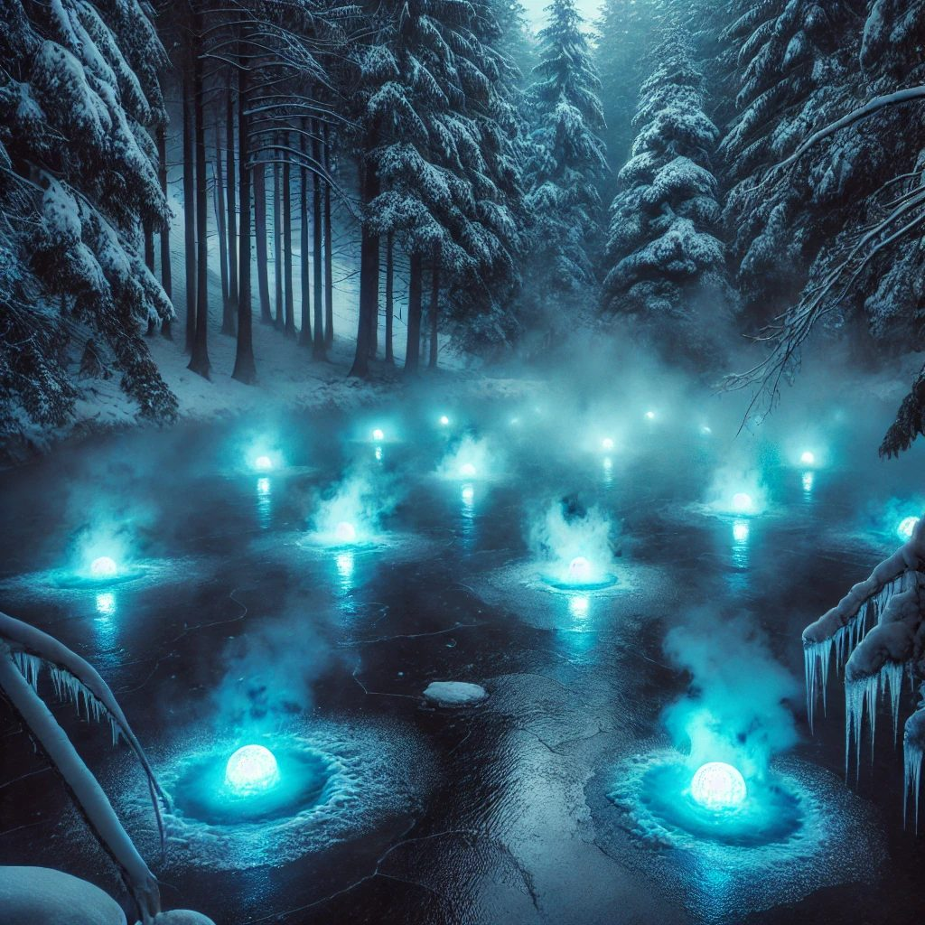
Above a frozen pond, ghostly blue lights flicker and bob, beckoning travelers out onto the ice with whispers of false promises. The scene looks tranquil, almost inviting, but the mist around the lights is far, far too cold.
▶ Frozen Will-o'-Wisps (CR 2 each). Wisdom (Perception) DC 14 notices strange ripples beneath the ice; Intelligence (Arcana) DC 15 names the lights for what they are. The careless suffer a surprise round, slippery ice (Dexterity DC 13 each round or fall prone), and 1d4 cold damage per round of exposure. Icy Shock deals lightning and cold together, and the wisps blink invisible between attacks. They guard a Gift Box, and a whispered warning of the Krampusshade's icy influence.
Tricks of the Road
▶ Blizzard Trap. The wind rises and the world goes white. Wisdom (Survival) DC 14 finds the way through to a small sheltered grove where the party can rest and warm up; failure means an hour lost in the storm and 1d6 cold damage from exposure.
▶ Holiday Illusions. A vision of a warmly lit cabin unfolds, all laughter, glowing lanterns, roasted chestnuts, and spiced cider. Intelligence (Arcana) or (Investigation) DC 15 spots the flickering seams. Those who walk in take 1d4 psychic damage as the vision shatters over a deep snow drift: DC 13 Dexterity save or become trapped and take 1d6 cold damage, then DC 14 Constitution save or gain a level of exhaustion. Seeing through the trick earns a brief warmth, a protective charm against illusions for the next hour.
▶ Mimic in Disguise. The prettiest gift box on the road is sometimes a tiny mimic, all teeth and adhesive. Its bigger cousin (CR 2, AC 12, HP 58, bite plus 1d8 acid, DC 13 Strength to escape its grip) waits in the bestiary compendium for DMs feeling festive.
Kindly Wonders
Not everything on the winter roads wished travelers ill. Some of it was watching, quietly, to see if they would be kind.
▶ Friendly Caribou. An enchanted caribou with softly glowing antlers steps from the treeline into the moonlight. Offering food or kind words earns its aura of warmth: each party member regains 1d4 hit points, and Wisdom (Animal Handling) DC 13 earns one hero Inspiration. Hostility makes it dissolve sadly into mist.
▶ Resting Reindeer. A majestic reindeer with antlers like polished silver rests beneath a frosted pine. Wisdom (Animal Handling) DC 14 to approach calmly; treated kindly, its nose glows softly and each hero gains Inspiration and temporary hit points equal to 1d6 + their level.
▶ Aurora Spirits. Beneath dancing ribbons of blue, purple, and green, serene spirits descend, humming an ethereal tune. Wisdom (Insight) DC 14 or Intelligence (Religion) DC 15 understands them as messengers of Elaria; they impart a cryptic hint about the Krampusshade and grant advantage on the next Wisdom saving throw.
▶ Fey Tricksters. Small winged pranksters flit between the trees and propose a riddle contest (Intelligence DC 15) or spring a prank to dodge (Dexterity DC 14). Winners receive a charm of luck, advantage on one roll of their choice; losers get a pie in the face and disadvantage on their next skill check.
▶ Holiday Miracle. A sudden warm breeze carries the scent of pine, cinnamon, and fresh cookies, restoring 1d4 hit points to each party member. For a moment, the world feels kinder, and the shadows retreat just a little.
Treasures in the Ice
▶ The Sleeping Traveler. A traveler frozen beneath a drift, still and peaceful as a statue, one outstretched hand holding a crumpled note. Intelligence (Investigation) DC 12 preserves the brittle parchment: a warning about the Krampusshade's minions and, tucked beneath the traveler's coat, a Map of Hidden Paths granting advantage on the next Survival check to navigate the snowy wilderness.
▶ Frozen Treasure. A sturdy chest sealed inside a block of ice carved with faintly glowing runes. Strength DC 15 breaks it open, Intelligence (Arcana) DC 14 finds the weak point, and fire magic melts it in a single round; a failed attempt stings for 2d6 cold damage. Inside wait 50 gold pieces and a Frosted Cookie of Restoration.
▶ Full statistics for every creature of the frozen roads live in the bestiary compendium. The creatures the heroes actually crossed blades with appear in the Appendix at the back of this session.
Part Three: The Lorekeeper's Tale
With eight bells wrapped warm in their packs, the heroes crossed town as the light failed, to a small cottage swallowed in ivy at the edge of Havenmoor.
The door creaks open before anyone can knock. Faelan, the village lorekeeper, is an elderly half-elf with long silver hair and piercing violet eyes, wrapped in a deep green cloak stitched with symbols of winter and renewal. “Welcome, brave ones. You have done well to gather the bells: relics of light and hope. Please, come in. We have much to discuss.”
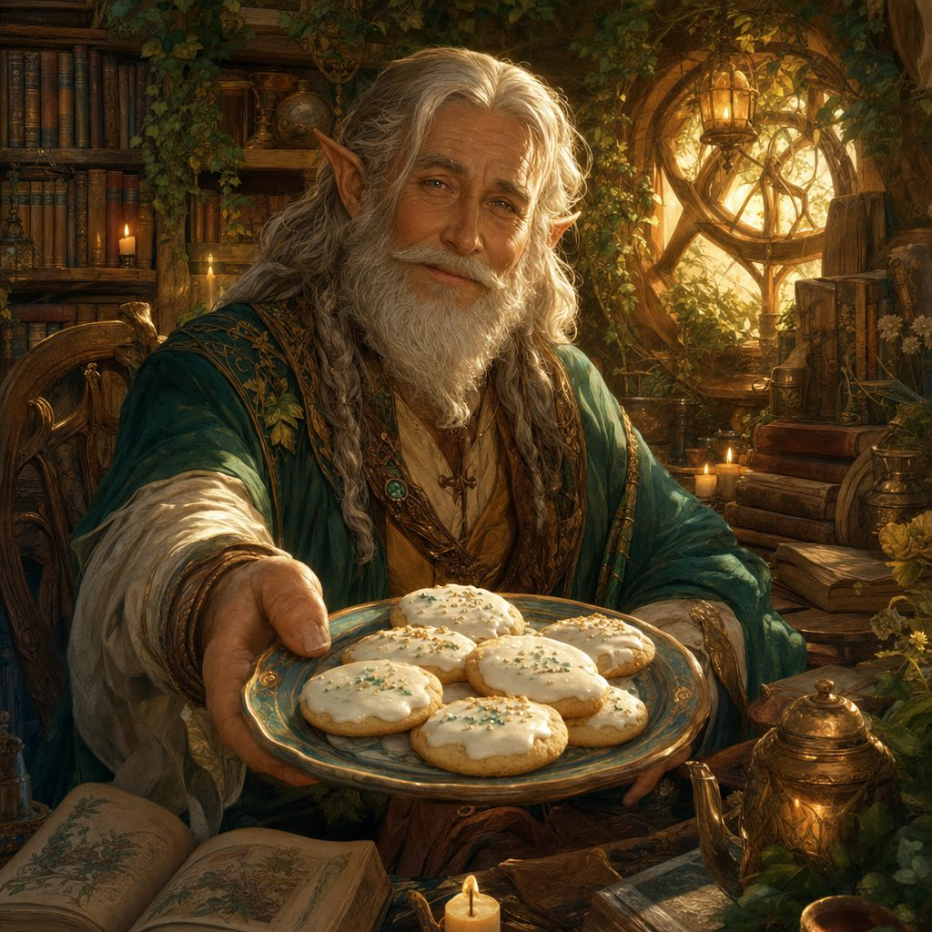
Inside, the cottage smells of herbs, pine, and old parchment. Shelves of ancient tomes and glowing crystals hum with stories. Faelan sets a wooden tray before the party: three frosted cookies, each shimmering faintly with magic. “Take these. They will warm your bodies and spirits in the trials ahead.”
▶ Faelan's Frosted Cookies. Each restores 2d8 HP, grants the benefit of a short rest, and restores one expended spell slot. Cookie-based healing: the finest kind.
Then the old lorekeeper settles into his chair, and his eyes darken. “Long ago, when winter nights seemed endless, the people of Havenmoor called on the light of the Winter Bells. The bells hold the blessing of Elaria, goddess of hope and protection. Rung in harmony, they drive back the shadows.” His fingers trace a symbol on his staff. “But there was one who thrived in the cold and dark. The Krampusshade. Once a guardian of winter, twisted by bitterness and envy, he turned against the light. He feasts on fear. He steals the joy of children and traps their laughter in a sack of shadows. The bells are the key to weakening him, for they carry the last remnants of Elaria's light here.”
He spreads a weathered map and taps three places in the wilderness around Havenmoor, one, two, three. “His power is anchored by three barriers of darkness. The Frostpine Glade, where ancient pines have twisted under frost and shadow. The Crystalbrook Stream, where dark tendrils lurk beneath the ice. The Whispering Hollow, where the very stones whisper despair. Travel to each. Ring the bells. Shatter the barriers. Only then can the Krampusshade be banished for good. His minions will not let you pass easily. But I have faith in you. You carry the light of hope, even in the deepest winter.”
Faelan raises his hands, and a soft silver light washes over each of you, warmth seeping into your bones. “Go now, brave souls. May the bells guide you, and may Elaria's light shield you from the shadows.”
Part Four: The Three Barriers of Darkness
Three marks on a map, eight bells, and one long winter day: the heroes went out into the white silence to take the Krampusshade's power apart, one song at a time.
The Frostpine Glade: Jingle Bells
The pines around the glade creak under armor of ice, and the mist between them curls as though alive. At the center stands a massive frozen pine, its trunk twisted and blackened, jagged chains of black ice wrapped around its roots. On the wind ride faint, mournful whispers: the far-off cries of taken children. The black ice pulses with a sickly blue light, humming a low, wrong-noted mockery of a holiday tune.
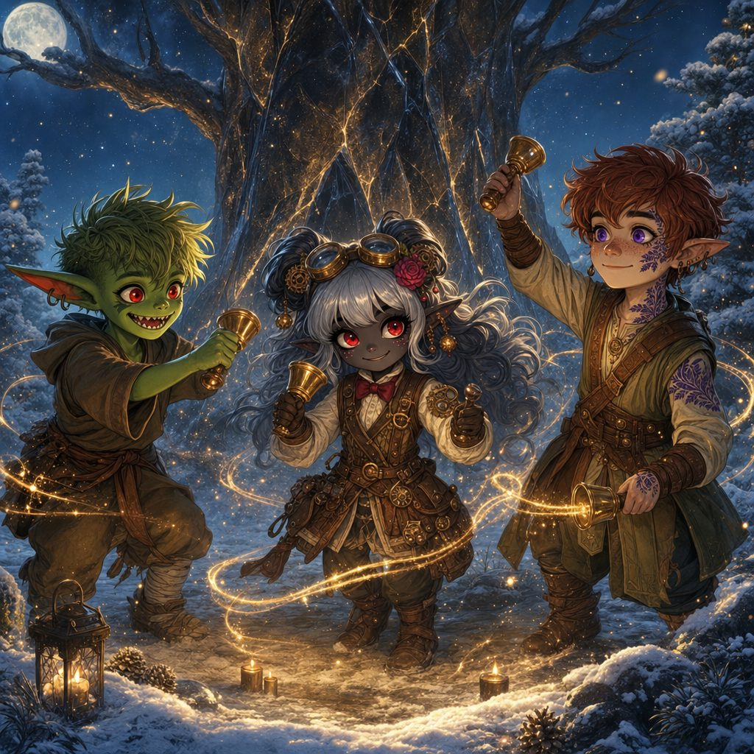
The answer is the true song. The heroes line up their bells and play it the way it was always meant to sound, bright and defiant in the dead air:
♪ Jingle Bells ♪

On the last note, golden light bursts from the bells and rolls through the black ice, and the chains shatter with a crack that shakes snow from every branch.
The mist answers back. It gathers itself into three snarling shapes: Frozen Wolves, frost-armored, eyes burning icy blue, guardians grown from the Krampusshade's own cold. The fight is knives and starlight on slick ground, wolf breath rolling white and freezing, until the last wolf comes apart into glittering mist, and the glade breathes again.
▶ The carol lock: E E E, E E E, E G C D E, F F F F, F E E E. Then 3 Frozen Wolves (pack tactics, icy ground). First barrier down.
The Crystalbrook Stream: Deck the Halls
The stream winds through a grove of silver-barked trees, its water glittering under a skin of ice. A rickety wooden bridge crosses at the narrows, and beneath it, dark tendrils snake along the underside of the planks, pulsing. Shadowy shapes flicker under the ice, faces twisted in silent song. Frost blooms across the boards as the party steps up.
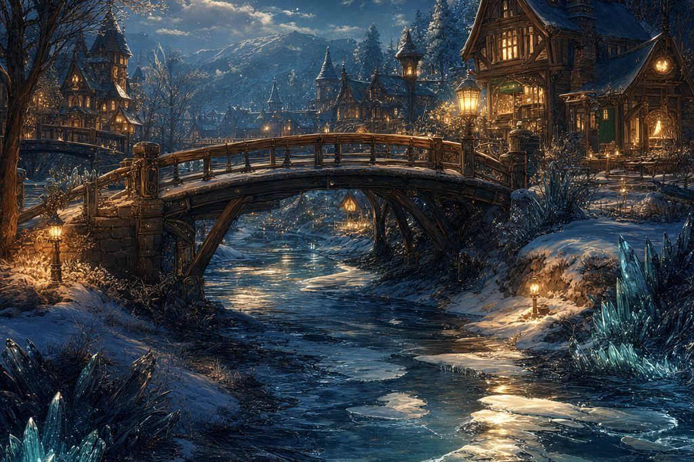
The Crystalbrook Stream and the rickety bridge at the narrows.
Eight bells ring out, lively and warm, the notes echoing down the frozen water like skaters:
♪ Deck the Halls ♪

The tendrils hiss, thrash once, and dissipate like smoke in sunlight. And then the treetops giggle. Four tiny figures dart into view on frost-covered wings, faces fixed in mischievous grins, fingers glowing with cold magic: Frostbite Pixies, flinging rays of frost and turning invisible mid-cackle. It is the silliest, slipperiest fight of the winter, and the party wins it laughing.
▶ Second carol lock, then 4 Frostbite Pixies (Ray of Frost, invisibility, slick ice underfoot). Second barrier down.
The Whispering Hollow: Silent Night
The last barrier waits between two snow-covered hills, in a hollow where the wind whistles words no one can quite make out. A ring of frost-covered standing stones rises at its heart, their old protective runes blackened and writhing. Above the stones churns a slow vortex of shadow, radiating waves of cold that sap warmth and hope together.
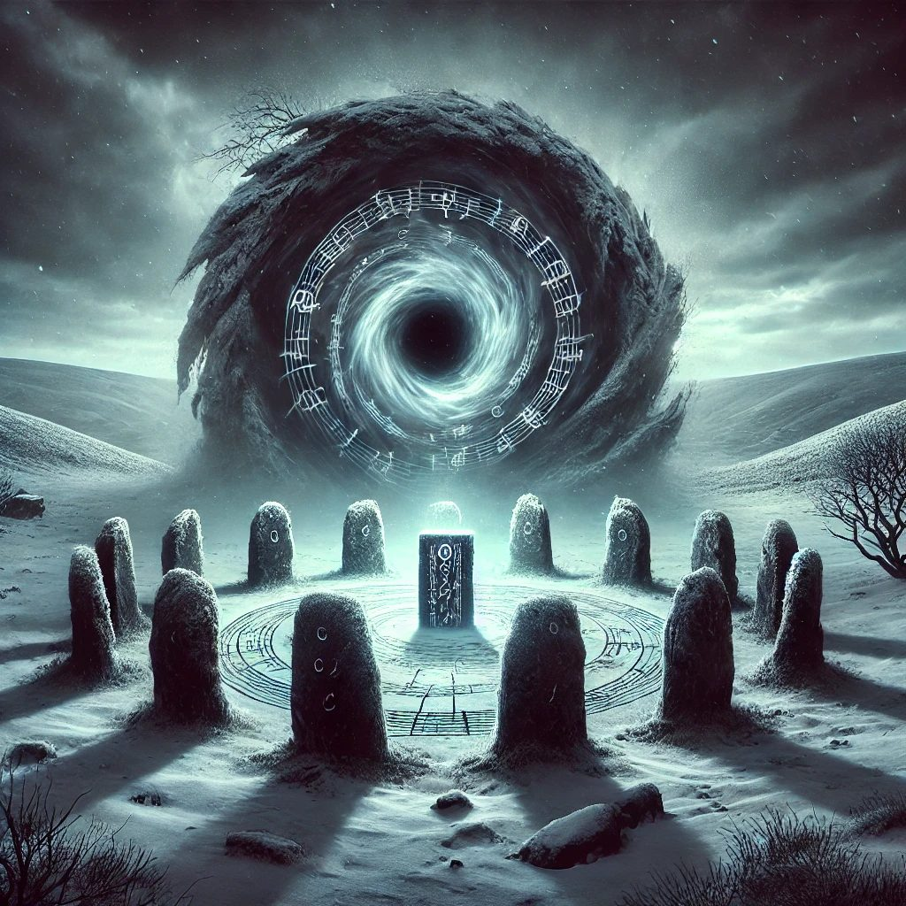
This song cannot be loud. The heroes play it slow and gentle, each note held like a candle against the dark:
♪ Silent Night ♪

The melody threads through the hollow, and gentle, radiant light washes over the standing stones. The vortex shrieks and dissolves; the blackened runes flicker, then glow their old protective silver.
From the last rags of shadow steps an Icy Specter, translucent and wreathed in frost, hollow eyes fixed on the intruders. It fights in whispers and cold hands, wailing despair at the heroes until Ursa's starlight burns through its center and it unravels on the wind. Where it stood, half-buried in the snow, lies a small blackened shard of standing stone that hums against the palm: a Shadow-Touched Rune Fragment.
▶ Third carol lock, then the Icy Specter (Wail of Despair, DC 14 Wisdom). Boon: the Shadow-Touched Rune Fragment, advantage on saves against fear for 1 hour while held. Third barrier down.
The Krampusshade Awakens
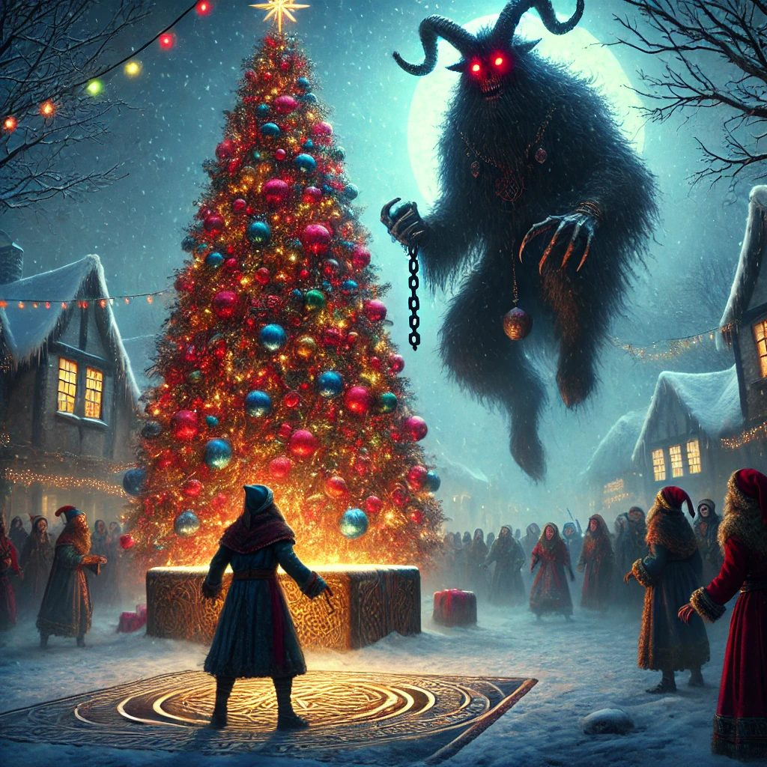
As the last barrier shatters, an unnatural silence grips the land. The wind dies. The cold bites deeper, down past skin, down to the brave part of you. Far off over Havenmoor, dark clouds swirl into a slow vortex that swallows the stars, and the festival lights of the town flicker and dim, one street at a time. From the gathering dark, two fiery red eyes flare open, and a deep voice oozes across the snow, dripping with mockery.
Krampusshade: “So. You think your bells and lights can banish me? Fools! I feast on despair, and there is plenty yet to devour.”
The heroes look at each other for exactly one heartbeat. Then they run.
Part Five: The Longest Night
Down out of the hills and along the frozen road the four friends raced the darkness home, eight bells jangling in their packs like a heart beating.
A thick, unnatural fog rolls through Havenmoor's streets, muffling sound and smearing the lantern light. The villagers are huddled at the Great Pine in the market square, clutching one another, the tree's festive lights guttering weakly against the dark. Somewhere a child's cry echoes, far away and getting farther.
Then thunder cracks the sky, and the fog peels back like a curtain. Out of the mist steps a towering figure, ten feet of shadow and frost: goat-horned, black-furred, icicles dripping from his curved horns, chains swinging from his clawed hands with a sound like cruel sleigh bells. Over his shoulder writhes a burlap sack, and from inside it come the muffled cries of children. The ground cracks with frost where he walks.
Krampusshade: “Your defiance ends here. I will feast on your fear, and the children shall be mine forever!”
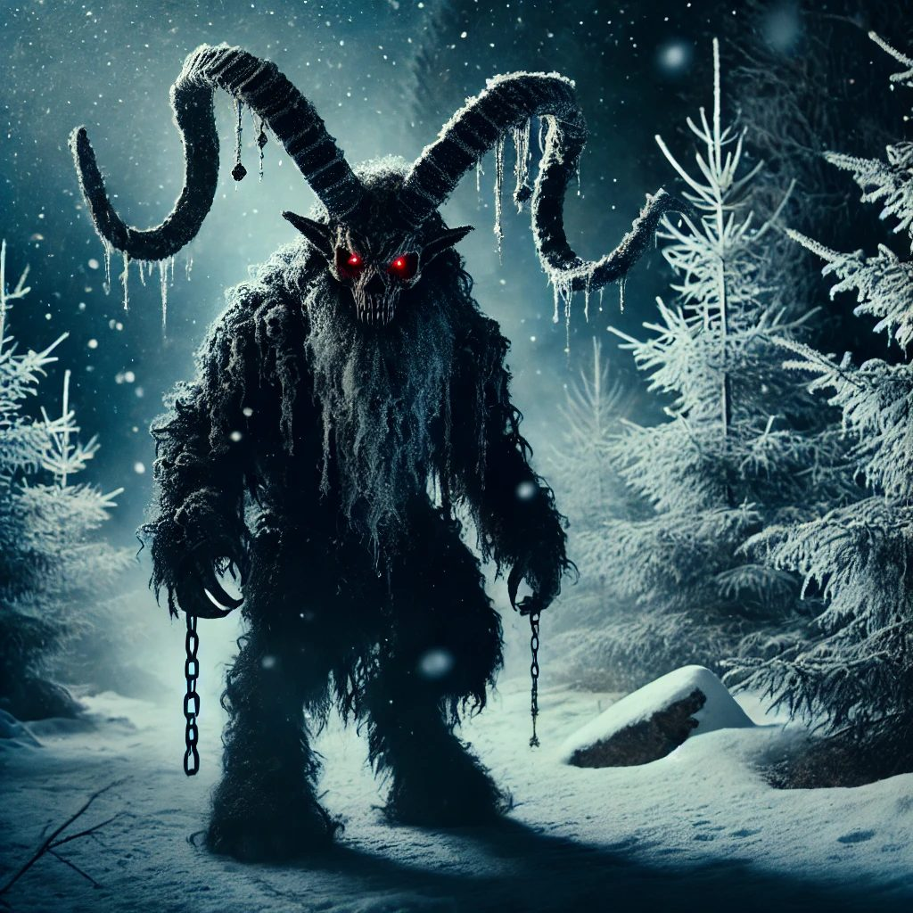
The Krampusshade comes for Havenmoor.
The Bells' Harmony
He slams his claws together and freezing power rolls across the square; his chains lash out like serpents, and shadow imps come boiling up out of the fog around him, eyes burning. But the heroes did not come to be afraid. They came to finish a song.
While blade, bolt, claw, and starlight hold the imps back, bell after bell rings out through the fog, weaving into the one carol big enough for the moment, eight notes of Elaria's light striking through the dark like lantern beams:
♪ Carol of the Bells ♪

With every toll the Krampusshade flinches. Threads of shadow peel from his shoulders like smoke from a dying fire. His chains crack. His outline gutters like a candle flame.
Stabby rings a bell in one hand and parries a chain with the other. Lilly's turret keeps time like a drummer. Floraburst shakes her petals and adds one small, clear chime of her own. And on the final note, sung by eight bells in perfect harmony, the fiend's roar breaks in the middle.
The Krampusshade's body shatters into wisps of shadow, spiraling up and up and dissolving into the night sky, banished from the world he had grown too bitter to guard. The frost gripping the village begins to melt. The fog lifts. And the burlap sack drops to the snow and bursts open.
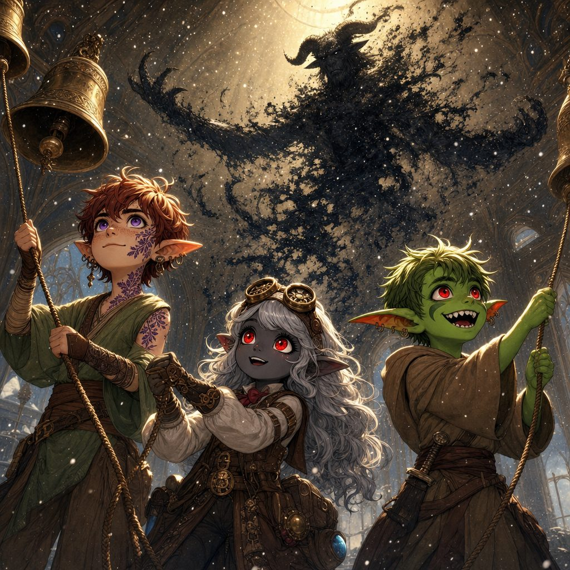
The Carol of the Bells rings out, and the Krampusshade comes apart into shadow above them.
Children tumble out, dazed, blinking, rubbing their eyes, every single one of them safe, and in the middle of them a small boy with one missing mitten. Finn hits his mother's arms at a dead run, and the sound she makes is the opposite of the one that woke the heroes that morning.
▶ The final battle: the Krampusshade (CR 5) with shadow imps rising from the fog, while the party rang the eight bells into the Carol of the Bells. Each completed phrase of the carol seared him; the eighth harmony unmade him.
The Village Rejoices
The villagers pour out of hiding, laughing and crying at once. The Great Pine blazes brighter than it has all festival, and clean, untroubled snow begins to drift down out of a clearing sky. Greta Frostbough reaches the party first, eyes shining. “You have saved us all. The darkness has lifted, and hope shines once more.” Somewhere behind her, Milo is showing the other orphans exactly how the bells went, loudly, and mostly in tune.
Gifts of Gratitude
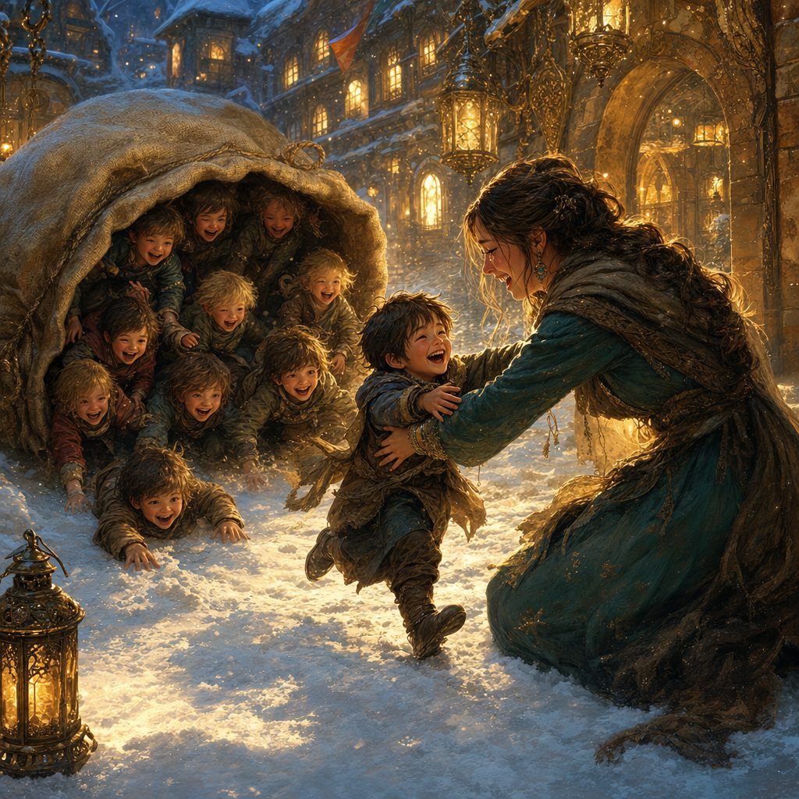
As dawn breaks over Havenmoor, Faelan comes through the celebrating crowd with three carefully wrapped packages. “Tokens of our eternal gratitude. May they aid you on the journey ahead.”
For Lilly, the Frostbite Shard Dagger: a blade of crystalline ice that never melts, glowing with faint blue arcane light, hungry to channel her spells.
For Ursa, the Amulet of Guiding Light: a polished silver starburst with a blue gem at its heart that pulses softly, like a distant star keeping watch.
And for Stabby, the Candyfang Katana: a katana of impossible candy-cane steel, red and white and wickedly sharp, trailing a faint scent of sugar. Stabby licks it immediately. It is delicious.
▶ Full statistics for all three gifts live in the treasures compendium.
Down at the harbor, the shipwright Master Doran Bramblebeard, lighthouse soot still on his sleeves, nods toward a trim vessel rocking at the dock. “The Stormwind is ready when you are. Gearhaven awaits.”
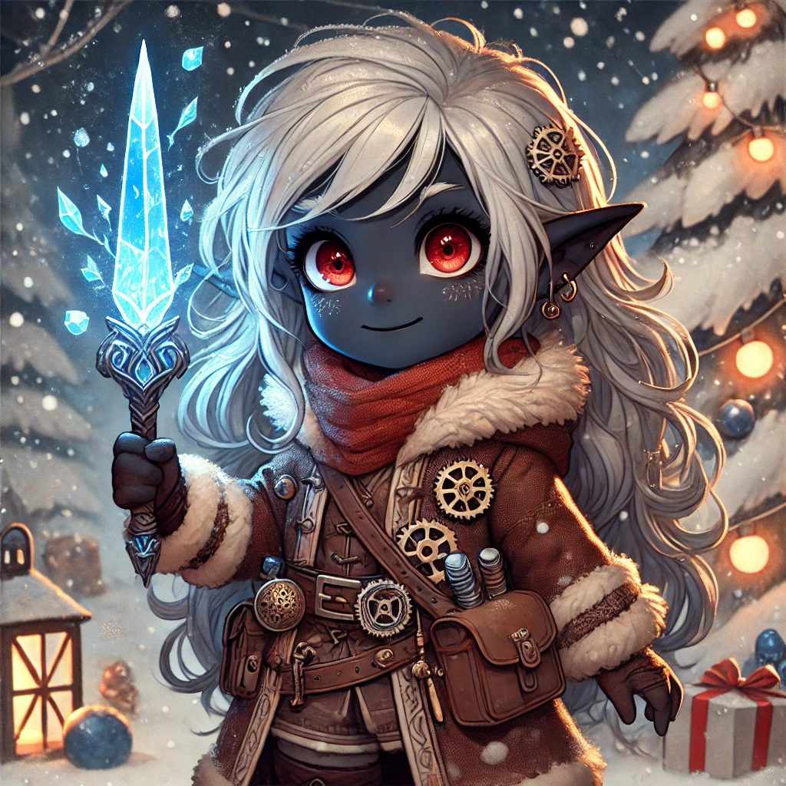 | 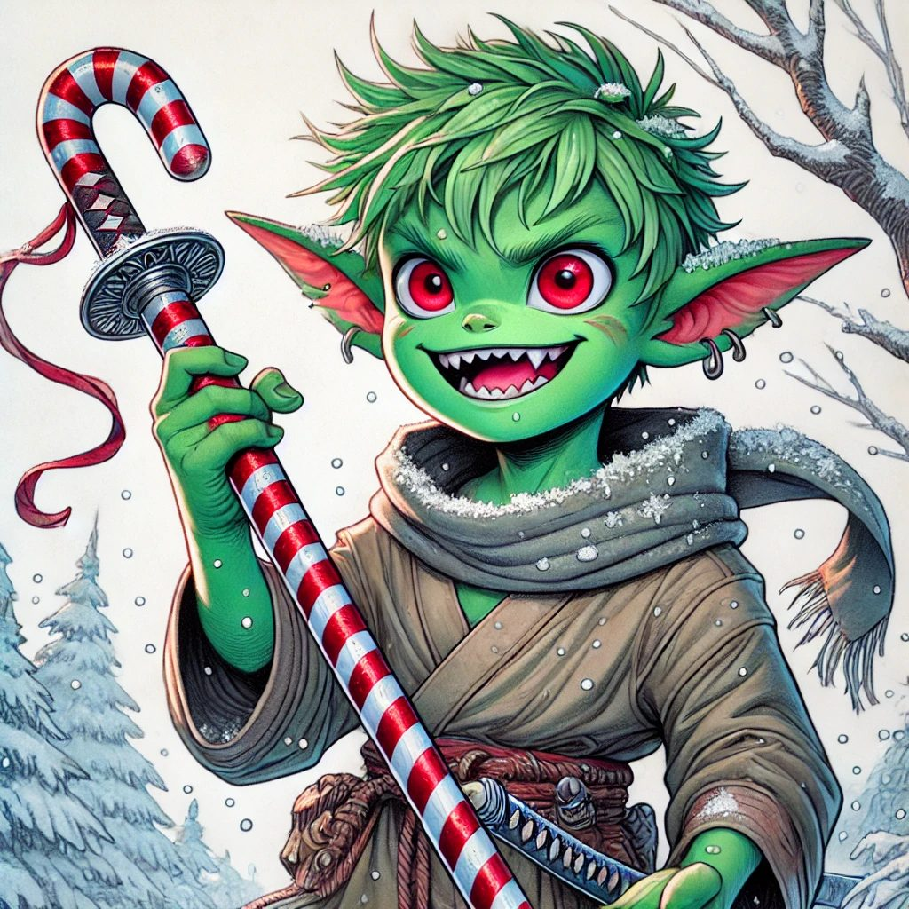
Lilly and the Frostbite Shard Dagger. | Stabby and the Candyfang Katana. Yes, he licked it.

✦ ✦ ✦
Their fourth adventure was done: a stolen child brought home, eight bells rung into one great carol, a bitter old shadow banished into the dark between the stars, and a whole town's winter given back to it. The road to Gearhaven now ran over water, and the sea, as Captain Torren could have told them, keeps its own secrets.
Next: Session 5, in which the Stormwind sails for Gearhaven, a storm has other plans, and a ghost ship rises from the deep with a captain who plays dice for souls.
Appendix: Creatures of Session Four
Compact statistics for the table. The full bestiary, with lore and pictures, lives in the compendium.
Krampusshade
Large fiend, chaotic evil. CR 5. AC 15 (natural armor), HP 102 (12d10 + 36), Speed 40 ft.
STR 18, DEX 14, CON 16, INT 12, WIS 14, CHA 17. Saves Wis +5, Cha +6.
Resistances cold, necrotic, nonmagical weapons. Immunities poison; charmed, frightened, poisoned. Darkvision 120 ft.
Multiattack. One Claw and one Chains of Despair.
Claw. +7, reach 10 ft., 2d6 + 4 slashing plus 1d10 cold.
Chains of Despair. +7, reach 15 ft., 2d6 + 4 bludgeoning; DC 14 Strength save or restrained one turn.
Gift of Despair (Recharge 5-6). A cursed gift box, 30 ft.; DC 14 Wisdom save or frightened 1 minute.
Icy Retaliation (Reaction). When hit in melee: DC 14 Constitution save or 2d6 cold, speed -10 ft.
Shadow Step (Legendary, 1/round). Teleports up to 20 ft. within dim light or darkness.
Weakened by the eight Winter Bells rung in harmony; the completed Carol of the Bells unmade him.
Krampusshade's Imp
Small fiend (shadow), chaotic evil. CR 2. AC 14 (natural armor), HP 22 (5d6 + 5), Speed 30 ft., fly 40 ft.
STR 10, DEX 16, CON 12, INT 13, WIS 11, CHA 14. Skills Stealth +6, Deception +4.
Resistances cold, fire, necrotic, nonmagical weapons. Immunity poison. Magic Resistance. Darkvision 120 ft.
Shadow Stealth. Hides as a bonus action in dim light or darkness. Invisibility (3/short rest).
Shadow Claws. +5, reach 5 ft., 2d4 + 3 slashing plus 1d6 cold.
Shadowy Grasp (Recharge 5-6). DC 13 Dexterity save or restrained one turn; 1d10 cold while held.
Frozen Wolf
Medium beast, neutral evil. AC 15 (natural armor), HP 45 (6d10 + 12), Speed 40 ft.
STR 16, DEX 15, CON 14, INT 3, WIS 12, CHA 6. Immune cold. Darkvision 60 ft.
Pack Tactics. Advantage when an ally is within 5 ft. Icy Terrain. Difficult ground within 10 ft.
Bite. +5, 2d6 + 3 piercing plus 1d8 cold; DC 13 Constitution save or speed -10 ft.
Frost Breath (Recharge 5-6). 15 ft. cone, DC 13 Dexterity save; 4d8 cold, half on success, slowed on a failure.
Frostbite Pixie
Tiny fey, chaotic neutral. CR 1/4. AC 15, HP 14 (4d4 + 4), Speed 20 ft., fly 60 ft.
STR 3, DEX 20, CON 12, INT 14, WIS 11, CHA 16. Stealth +7. Immune cold.
Ray of Frost. +5, range 60 ft., 2d8 cold; target's speed reduced 10 ft. one turn.
Invisibility. Turns invisible until it attacks or casts a spell.
Icy Specter
Medium undead, neutral evil. AC 12, HP 45 (10d8), Speed 0 ft., fly 50 ft. (hover).
STR 1, DEX 14, CON 11, INT 10, WIS 10, CHA 16.
Resistances cold, necrotic, nonmagical weapons. Immunity poison; charmed, exhaustion, grappled, paralyzed, poisoned, prone, restrained.
Chilling Touch. +5, reach 5 ft., 3d6 cold.
Wail of Despair (Recharge 5-6). 30 ft., DC 14 Wisdom save or frightened 1 minute (repeat save each turn).

