✦ ✦ ✦
THE GUARDIANS OF ELARIA
THE COMPENDIUM
Bestiary, Treasures, and Custom Content
A running reference for The Guardians of Elaria. Updated as the chronicle grows.
One volume for everything the road has taught the Guardians: every creature they have faced, freed, or befriended; every treasure and relic they carry; and the house rules, homebrew paths, and mysteries of this table. Three parts, one book, growing with the chronicle.

Part I: The Bestiary
Here is every creature the Guardians have faced, freed, or befriended, gathered with its lore and its complete statistics. When a planar creature falls, it leaves no body: a gleaming mote of its home plane rises, hangs a moment, and fades (and the Essence Sphere tugs toward it). Read on, brave heroes, and know your monsters.
Companions & Friends
Not every creature in this book is an enemy. Some walk the road beside the Guardians.
Ghostbloom is the party's dearest companion, chosen in Session 3 as Floraburst, changed aboard the sinking Dutchman and again in Wraithpine's ghost-light. Her petals are glass-pale now and chime like frost; she floats, speaks in soft telepathy, and glows brighter near planar wounds. Some say she is Elaria's own little voice.

Ghostbloom, Spectral Blossom
Tiny fey (Ghost/Grass), chaotic good

Armor Class 15 (natural armor)
Hit Points 52 (8d4 + 32)
Speed 30 ft., fly 30 ft. (hover)

STR 8 (-1) DEX 18 (+4) CON 18 (+4) INT 12 (+1) WIS 14 (+2) CHA 16 (+3)

Saving Throws Dex +7, Con +7, Wis +5
Skills Perception +5, Stealth +7
Damage Resistances necrotic, poison; bludgeoning, piercing, and slashing from nonmagical attacks
Damage Vulnerabilities fire, cold (mind the friendly fire)
Condition Immunities charmed, frightened, grappled, paralyzed, poisoned, prone, restrained
Senses darkvision 60 ft., passive Perception 15
Languages Sylvan, telepathy 30 ft. (to her keeper)
Fey Step (1/Combat). As a bonus action, teleport up to 20 ft. to an unoccupied space she can see. Her next attack this turn has advantage.
Spectral Form. She can move through creatures and objects as difficult terrain. If she ends her turn inside an object, she is shunted to the nearest space and takes 5 force damage.
Guardian's Light (Reaction, 1/Combat). When an ally within 30 ft. takes damage, she sheds bright light in a 10-ft. radius (30-ft. dim) and heals that ally for 1d8 + her Charisma modifier.

Actions
Multiattack. She makes two Vine Lash attacks.
Vine Lash. Ranged Weapon Attack: +7 to hit, range 15 ft., one target. Hit: 9 (1d8 + 5) slashing plus 3 (1d6) necrotic, and the target must succeed on a DC 13 Wisdom save or be frightened until the end of its next turn.
Ghostly Wail (1/Combat). A haunting cry in a 15-ft. cone. Each creature there makes a DC 15 Wisdom save, taking 14 (4d6) necrotic and frightened for 1 round on a fail, or half damage and no fear on a success.

Legendary Actions
Blossom of Dawn (1/Day). She releases a burst of fey energy in a 20-ft. radius. Allies there regain 2d8 + 3 hit points, and undead take 2d8 radiant (DC 14 Dexterity save for half).

Floraburst, as she was before the change: a leafy sprout-backed creature who loved sunlight and berries. This is the form the party first knew and loved in Session 3.

Floraburst
Small fey, neutral good

Armor Class 14 (natural armor)
Hit Points 45 (6d6 + 18)
Speed 30 ft.

STR 14 (+2) DEX 12 (+1) CON 16 (+3) INT 10 (+0) WIS 14 (+2) CHA 10 (+0)

Skills Nature +4, Survival +4
Damage Resistances poison
Senses darkvision 60 ft., passive Perception 12
Languages understands Sylvan and Common but cannot speak
Plant Camouflage. Advantage on Stealth checks to hide in heavy foliage.
Photosynthesis. During a short or long rest in sunlight, Floraburst recovers 10 extra hit points.

Actions
Razor Leaf. Ranged Weapon Attack: +4 to hit, range 30 ft., one target. Hit: 10 (2d8 + 2) slashing.
Vine Lash. Melee Weapon Attack: +4 to hit, reach 15 ft., one target. Hit: 8 (1d10 + 2) bludgeoning, and the target must succeed on a DC 13 Strength save or be restrained until the end of its next turn.
Floraberry (3/Day). Floraburst produces 1d4 + 1 magical berries. A creature can use an action to eat one and restore 3 hit points.

In Session 3, Professor Aelwyn offered the party three little wards; they chose Floraburst. The two who stayed behind, Aqualump and Emberpaws, are catalogued here too, for they are part of the story.

Aqualump
Small elemental, neutral good

Armor Class 16 (natural armor, Shell Defense)
Hit Points 54 (7d6 + 21)
Speed 25 ft., swim 30 ft.

STR 15 (+2) DEX 14 (+2) CON 17 (+3) INT 10 (+0) WIS 13 (+1) CHA 11 (+0)

Skills Athletics +4, Perception +3
Damage Resistances cold
Senses darkvision 60 ft., passive Perception 13
Languages understands Aquan and Common but cannot speak
Shell Defense. As a bonus action, Aqualump withdraws into its shell, gaining +4 AC until the start of its next turn; while in its shell its speed is 0.
Water Veil. Aqualump cannot be set on fire and has advantage on saves against being ignited or burned.

Actions
Water Bolt. Ranged Weapon Attack: +4 to hit, range 30 ft., one target. Hit: 10 (2d8 + 2) bludgeoning, and the target must succeed on a DC 14 Strength save or be knocked prone.
Surf (Recharge 5-6). A 15-ft. cone of water. Each creature there makes a DC 14 Dexterity save, taking 14 (4d6) cold on a fail (half on a success); those who fail are knocked prone.
Frost Shell. Ranged Weapon Attack: +4 to hit, range 20 ft., one target. Hit: 8 (1d10 + 2) cold, and the target's speed is reduced by 10 ft. until the end of its next turn.


Emberpaws
Small elemental, chaotic good

Armor Class 15 (natural armor)
Hit Points 42 (6d6 + 15)
Speed 30 ft.

STR 13 (+1) DEX 16 (+3) CON 15 (+2) INT 10 (+0) WIS 12 (+1) CHA 12 (+1)

Skills Acrobatics +5, Perception +3
Damage Immunities fire
Senses darkvision 60 ft., passive Perception 13
Languages understands Ignan and Common but cannot speak
Fiery Spirit. When reduced to 0 hit points, Emberpaws bursts into flame. Each creature within 10 ft. makes a DC 13 Dexterity save, taking 7 (2d6) fire on a fail (half on a success).
Heatwave (3/Day). As a bonus action, Emberpaws radiates heat for 1 minute; any creature that hits it with a melee attack takes 4 (1d8) fire.

Actions
Ember. Ranged Weapon Attack: +5 to hit, range 30 ft., one target. Hit: 9 (2d6 + 2) fire.
Bite. Melee Weapon Attack: +5 to hit, reach 5 ft., one target. Hit: 8 (1d8 + 3) piercing.
Tail Flame Whip. Melee Weapon Attack: +5 to hit, reach 10 ft., one target. Hit: 10 (2d6 + 3) fire, and the target must succeed on a DC 13 Dexterity save or be ignited, taking 2 (1d4) fire at the start of each of its turns until the flames are put out.

Lickgloom was the party's very first friend, met on their first night by a pond in the Forest of Whispers: round-bodied, endlessly curious, with a tongue longer than it is tall and a telepathic voice of pure feeling ('Food? Friend?'). It chose to stay among Professor Aelwyn's creatures at Ravenstone. Visits are owed.

Lickgloom
Small fey, neutral good

Armor Class 13 (natural armor)
Hit Points 27 (5d6 + 10)
Speed 30 ft.

STR 10 (+0) DEX 15 (+2) CON 14 (+2) INT 8 (-1) WIS 12 (+1) CHA 13 (+1)

Senses darkvision 60 ft., passive Perception 11
Languages telepathy 30 ft. (simple feelings and impressions)
Challenge 1 (200 XP)
Curious Palate. Lickgloom can taste the world through its tongue, granting an ally advantage on Investigation or Perception checks it helps with.

Actions
Tongue Whip. Melee Weapon Attack: reach 10 ft., one target. Hit: 1d6 + 2 bludgeoning.
Lick Attack. The tongue delivers a stunning slap. Hit: 1d8 + 2 bludgeoning, and the target must succeed on a DC 12 Constitution save or be stunned until the end of its next turn.
Sticky Lick (Recharge 5-6). Lickgloom tries to steal a small item from a creature within 10 ft.; the target must succeed on a DC 13 Dexterity save or the item is pulled to Lickgloom.

Pikachu, the Spark Fox. An old friend of the Glimmergear family, bodiless since before the chronicle began, sleeping inside the Essence Sphere. His golden projection first appeared in Gearhaven: two long ears, a lightning-bolt tail, and a warning carried through Ursa's Mark. He has no statistics yet; he is more a key than a creature, and his full return is still to come.
Session 1: The Forest of Whispers
The first creatures the Guardians ever faced, all touched by the thinning boundary between the planes. Each left behind a fading mote, the party's very first clue.

Duckleaf
Small beast (Elemental Air), neutral

Armor Class 15 (natural armor)
Hit Points 52 (8d8 + 16)
Speed 30 ft., fly 30 ft.

STR 14 (+2) DEX 16 (+3) CON 14 (+2) INT 10 (+0) WIS 12 (+1) CHA 10 (+0)

Saving Throws Dex +5, Wis +3
Skills Acrobatics +5, Perception +3
Damage Resistances slashing, bludgeoning (wind-shielded)
Senses darkvision 60 ft., passive Perception 13
Languages telepathy 30 ft. (in quacks)
Challenge 4 (1,100 XP)
Winged Leap. Duckleaf can leap 30 ft. in any direction without provoking opportunity attacks. Disrupting a stone of the rune-circle ends this ability for the rest of the battle.

Actions
Leek Strike. Melee Weapon Attack: +6 to hit, reach 5 ft., one target. Hit: 2d8 + 4 slashing.
Aerial Slash. Ranged Weapon Attack: +5 to hit, range 20/60 ft., one target. Hit: 3d6 + 3 slashing, a blade of wind.
Quack of Fury (Recharge 5-6). A thunderous telepathic quack. Each creature within 15 ft. makes a DC 14 Wisdom save or is frightened for 1 minute (repeat save at end of each turn).


Cognifin
Small beast (Elemental Water), neutral

Armor Class 14 (natural armor)
Hit Points 45 (6d8 + 18)
Speed 0 ft., fly 30 ft. (hover)

STR 10 (+0) DEX 14 (+2) CON 16 (+3) INT 10 (+0) WIS 14 (+2) CHA 12 (+1)

Saving Throws Dex +4, Wis +4
Skills Perception +4, Arcana +2
Damage Resistances cold, psychic
Senses darkvision 60 ft., passive Perception 14
Languages telepathy 60 ft. (images and feelings)
Challenge 3 (700 XP)

Actions
Headache Blast. Ranged Attack: +4 to hit, range 30 ft., one target. Hit: 2d6 + 2 psychic.
Water Pulse. Ranged Spell Attack: +4 to hit, range 30 ft., one target. Hit: 2d6 + 2 bludgeoning, and the target must make a DC 12 Strength save or be knocked prone.
Confusion Pulse (Recharge 5-6). A wave of psychic energy in a 15-ft. radius. Each creature there makes a DC 13 Wisdom save or is confused (as the confusion spell) for 1 minute (repeat save at end of each turn).

Reactions
Psychic Shield. When hit by an attack, Cognifin gains +2 AC until the start of its next turn.

Legendary Actions
Whirlpool. Cognifin makes a 5-ft.-radius whirlpool; creatures there make a DC 12 Strength save or be pulled 10 ft. to its center and restrained until the end of their next turn.
Tidal Wave. A 10-ft. line of water. Creatures in its path make a DC 12 Dexterity save or take 2d4 bludgeoning and are pushed back 5 ft.


Mist Stalker
Medium fey, unaligned

Armor Class 13
Hit Points 39
Speed 40 ft.

STR 14 (+2) DEX 16 (+3) CON 12 (+1) INT 6 (-2) WIS 12 (+1) CHA 10 (+0)

Senses darkvision 60 ft.
Challenge 2 (450 XP)
Fog Cloak. As a bonus action, the stalker wraps itself in fog, becoming heavily obscured for 1 turn.

Actions
Claw. Melee Weapon Attack: one target. Hit: slashing damage from raking claws.
Bite. Melee Weapon Attack: one target. Hit: piercing damage.
Howl of the Mist. Each creature within 30 ft. that can hear it must save or be frightened.

Session 2: The Road to Ravenstone
On the road to Oakshade and Ravenstone the party met slick water-elementals, an old goblin grudge come calling, and a serpent of living stone.

Mudskip
Small elemental (Plane of Water), neutral

Armor Class 13 (natural armor)
Hit Points 22 (4d6 + 8)
Speed 20 ft., swim 30 ft.

STR 12 (+1) DEX 14 (+2) CON 14 (+2) INT 6 (-2) WIS 12 (+1) CHA 8 (-1)

Skills Stealth +4, Perception +3
Damage Resistances fire
Damage Vulnerabilities lightning
Senses darkvision 60 ft., passive Perception 13
Languages understands Aquan but can't speak
Challenge 1/2 (100 XP)
Amphibious. The Mudskip can breathe air and water.
Mud Dweller. It ignores difficult terrain made of mud or shallow water.
Slippery. Advantage on checks and saves to escape a grapple.

Actions
Multiattack. One Mud Spit and one Tail Slap.
Mud Spit. Ranged Weapon Attack: +4 to hit, range 30 ft. Hit: 5 (1d6 + 2) bludgeoning, and on a failed DC 12 Dexterity save the target's speed drops by 10 ft. until end of its next turn.
Tail Slap. Melee Weapon Attack: +4 to hit, reach 5 ft. Hit: 6 (1d8 + 2) bludgeoning.
Mud Splash (Recharge 5-6). A 15-ft. cone of mud. DC 12 Dexterity save; 9 (2d6 + 2) bludgeoning and blinded until end of next turn on a fail, half and no blind on a success.

The Grimfang war band. A rival goblin clan carrying an old grudge against Stabby's Bloodfang: two goblin archers, a worg, a club-swinging orc, a hobgoblin sniper, and a scar-faced Goblin Boss who taunted Stabby and regretted it. Driven off, not destroyed; grudges keep. Their statistics are the standard Monster Manual entries.

Goblin Boss (the Grimfang leader)
Small humanoid (goblinoid), neutral evil

Armor Class 17 (chain shirt, shield)
Hit Points 21 (6d6)
Speed 30 ft.

STR 10 (+0) DEX 14 (+2) CON 10 (+0) INT 10 (+0) WIS 8 (-1) CHA 10 (+0)

Skills Stealth +6
Senses darkvision 60 ft., passive Perception 9
Languages Common, Goblin
Challenge 1 (200 XP)
Nimble Escape. The boss can Disengage or Hide as a bonus action on each of its turns.

Actions
Multiattack. Two attacks with its scimitar (the second only if the first hits).
Scimitar. Melee Weapon Attack: +4 to hit, reach 5 ft., one target. Hit: 5 (1d6 + 2) slashing.
Javelin. Melee or Ranged Weapon Attack: +4 to hit, reach 5 ft. or range 30/120 ft. Hit: 5 (1d6 + 2) piercing.

Reactions
Redirect Attack. When a creature the boss can see targets it with an attack, it swaps places with a goblin ally within 5 ft.; that ally becomes the target instead.

The band also fielded standard Goblins (AC 15, HP 7), a Worg (AC 13, HP 26), an Orc (AC 13, HP 15), and a Hobgoblin sniper (AC 18, HP 11).

Terranox
Large elemental (Plane of Earth), unaligned

Armor Class 16 (natural armor)
Hit Points 95 (10d10 + 40)
Speed 30 ft., burrow 30 ft.

STR 20 (+5) DEX 10 (+0) CON 18 (+4) INT 5 (-3) WIS 11 (+0) CHA 6 (-2)

Damage Resistances bludgeoning, piercing, and slashing from nonmagical, non-adamantine weapons
Damage Immunities fire, poison
Condition Immunities exhaustion, paralyzed, petrified, poisoned, prone
Senses darkvision 60 ft., tremorsense 60 ft., passive Perception 10
Challenge 4 (1,100 XP)
Earth Glide. Terranox burrows through unworked earth and stone without disturbing it.
Siege Monster. Deals double damage to objects and structures.
Elemental Resilience. Advantage on saves against spells and magical effects.
Immutable Form. Immune to any effect that would alter its form.

Actions
Multiattack. One Bite and one Tail Slam.
Bite. Melee Weapon Attack: +7 to hit, reach 10 ft., one target. Hit: 16 (2d10 + 5) piercing.
Tail Slam. Melee Weapon Attack: +7 to hit, reach 15 ft., one target. Hit: 13 (2d8 + 5) bludgeoning, and the target must succeed on a DC 15 Strength save or be knocked prone.
Stone Coil (Recharge 5-6). One creature within 10 ft. makes a DC 15 Dexterity save or is grappled and restrained (escape DC 15), taking 9 (1d8 + 5) bludgeoning at the start of each of its turns.
Earthquake Stomp (Recharge 6). A tremor in a 20-ft. radius; each creature on the ground makes a DC 15 Dexterity save, taking 14 (4d6) bludgeoning and knocked prone on a fail (half, no prone, on a success).

Session 3: The Road South
South toward the sea, the party crossed shadowed thickets and glowing fungal groves, and learned that the planar wounds are teaching old monsters new tricks.

Shadowflame
Medium undead, chaotic evil

Armor Class 14 (natural armor)
Hit Points 58 (9d8 + 18)
Speed 0 ft., fly 40 ft. (hover)

STR 8 (-1) DEX 18 (+4) CON 14 (+2) INT 12 (+1) WIS 15 (+2) CHA 18 (+4)

Skills Stealth +8, Intimidation +6
Damage Resistances acid, fire, lightning, necrotic; bludgeoning, piercing, and slashing from nonmagical weapons
Damage Immunities poison, psychic
Condition Immunities charmed, frightened, grappled, paralyzed, poisoned, prone, restrained
Senses darkvision 60 ft., passive Perception 12
Languages understands Common, Sylvan, and Abyssal (does not speak)
Challenge 4 (1,100 XP)
Illusions of Fear. At the start of combat, the Shadowflame conjures three identical illusions (AC 14). A creature attacking one must succeed on a DC 18 Arcana or Perception check to know it is false; on a failure the attack misses and the illusion remains.

Actions
Shadow Claw. Melee Weapon Attack: +6 to hit, reach 5 ft., one target. Hit: 13 (2d8 + 4) necrotic, and the target must succeed on a DC 14 Wisdom save or be frightened until end of next turn.
Terror Wave (Recharge 5-6). A 15-ft. cone of dark energy. Each creature makes a DC 14 Wisdom save, taking 16 (3d10) necrotic and frightened for 1 minute on a fail (repeat save at end of each turn).

Reactions
Shadowmeld. When hit, the Shadowflame teleports up to 20 ft. to an unoccupied space it can see, becoming lightly obscured until the start of its next turn.

Displacer Beasts (a pair). Six-legged, tentacled, and impossibly TALKING ('Fresh prey... too easy.'): the planar distortion had given old monsters new voices. Their shimmering forms impose disadvantage on attacks against them until they take damage; their barbed tentacles strike at 10 ft. Their fall revealed rune-tears in the forest floor. (Statistics as the standard Displacer Beast, CR 3, AC 13, HP 85.)
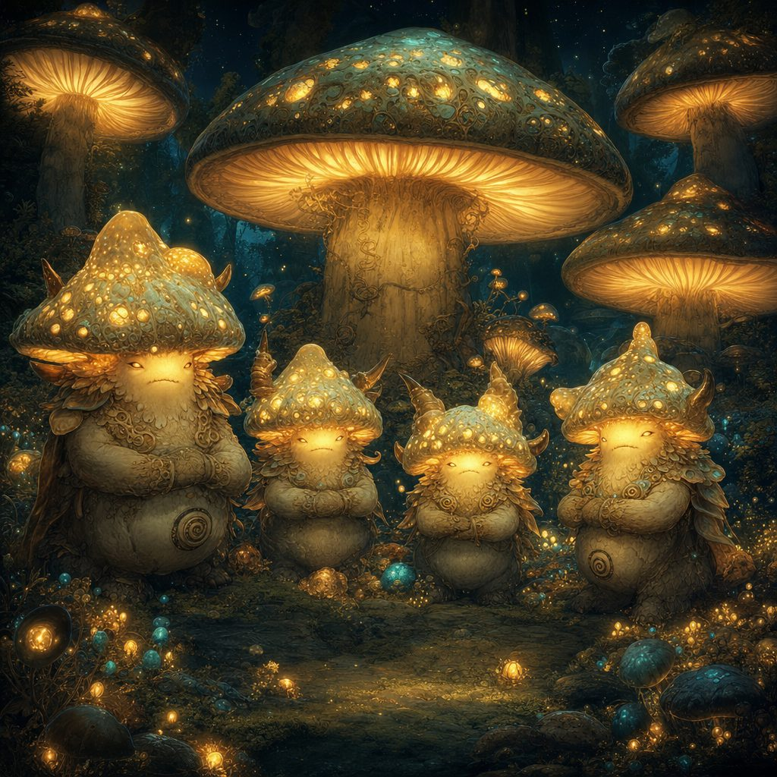
Shroomyte
Small plant, neutral

Armor Class 13 (natural armor)
Hit Points 27 (5d8 + 5)
Speed 20 ft.

STR 12 (+1) DEX 12 (+1) CON 14 (+2) INT 6 (-2) WIS 12 (+1) CHA 7 (-2)

Saving Throws Con +4, Wis +3
Skills Stealth +3, Perception +3
Damage Resistances poison
Condition Immunities poisoned
Senses darkvision 60 ft., passive Perception 13
Languages understands Sylvan but can't speak
Challenge 2 (450 XP)
Bioluminescent Glow. The Shroomyte sheds dim light in a 10-ft. radius, which it can suppress or rekindle as a bonus action.
Fungal Resilience. Advantage on saves against being charmed, frightened, or stunned.

Actions
Multiattack. One Spore Blast and one Mycelium Tendrils.
Spore Blast. Ranged Spell Attack: +4 to hit, range 30 ft. Hit: 9 (2d6 + 2) poison, and the target must succeed on a DC 13 Constitution save or be poisoned until end of its next turn.
Mycelium Tendrils. Melee Weapon Attack: +4 to hit, reach 10 ft. Hit: 7 (2d4 + 2) bludgeoning, and a DC 13 Strength save or restrained until end of its next turn.

Reactions
Fungal Retribution. When a creature within 5 ft. hits it in melee, the Shroomyte bursts spores; the attacker makes a DC 13 Constitution save or takes 5 (2d4) poison.

Session 4: The Longest Night of Havenmoor
A whole winter court had risen with the Krampusshade. These are the dangers that stalked the frozen roads of Havenmoor, and the fiend that ruled them.

The Krampusshade
Large fiend, chaotic evil

Armor Class 15 (natural armor)
Hit Points 102 (12d10 + 36)
Speed 40 ft.

STR 18 (+4) DEX 14 (+2) CON 16 (+3) INT 12 (+1) WIS 14 (+2) CHA 17 (+3)

Saving Throws Wis +5, Cha +6
Damage Resistances cold, necrotic; bludgeoning, piercing, and slashing from nonmagical attacks
Damage Immunities poison
Condition Immunities charmed, frightened, poisoned
Senses darkvision 120 ft., passive Perception 14
Languages Abyssal, Common, Infernal
Challenge 5 (1,800 XP)

Actions
Multiattack. One Claw and one Chains of Despair.
Claw. Melee Weapon Attack: +7 to hit, reach 10 ft., one target. Hit: 12 (2d6 + 4) slashing plus 5 (1d10) cold.
Chains of Despair. Melee Weapon Attack: +7 to hit, reach 15 ft., one target. Hit: 11 (2d6 + 4) bludgeoning, and a DC 14 Strength save or restrained until end of its next turn.
Gift of Despair (Recharge 5-6). It hurls a cursed gift box at a target within 30 ft.; DC 14 Wisdom save or frightened for 1 minute (repeat save at end of each turn).

Reactions
Icy Retaliation. When hit by a melee attack, the attacker makes a DC 14 Constitution save or takes 7 (2d6) cold and has its speed reduced by 10 ft. until end of its next turn.

Legendary Actions
Shadow Step. The Krampusshade teleports up to 20 ft. to an unoccupied space in dim light or darkness. (Rung together, the eight Winter Bells strip away its power.)


Krampus's Imp
Small fiend (shadow), chaotic evil

Armor Class 14 (natural armor)
Hit Points 22 (5d6 + 5)
Speed 30 ft., fly 40 ft.

STR 10 (+0) DEX 16 (+3) CON 12 (+1) INT 13 (+1) WIS 11 (+0) CHA 14 (+2)

Skills Stealth +6, Deception +4
Damage Resistances cold, fire, necrotic; bludgeoning, piercing, slashing from nonmagical attacks
Damage Immunities poison
Condition Immunities poisoned
Senses darkvision 120 ft., passive Perception 10
Languages Infernal, Common
Challenge 2 (450 XP)
Shadow Stealth. Can Hide as a bonus action in dim light or darkness.
Invisibility (3/short rest). Turns invisible as a bonus action until it attacks or casts a spell.
Magic Resistance. Advantage on saves against spells and magical effects.
Shadow Glide. Can move through creatures' spaces in dim light or darkness.

Actions
Shadow Claws. Melee Weapon Attack: +5 to hit, reach 5 ft. Hit: 8 (2d4 + 3) slashing plus 3 (1d6) cold.
Shadowy Grasp (Recharge 5-6). A target makes a DC 13 Dexterity save or is restrained until end of the imp's next turn, taking 5 (1d10) cold at the start of each of its turns while restrained.

Sneak-thieves of the winter court: shadowy imps with glowing red eyes and jagged claws, leaping from cover to steal whatever shone brightest in a hero's pack.
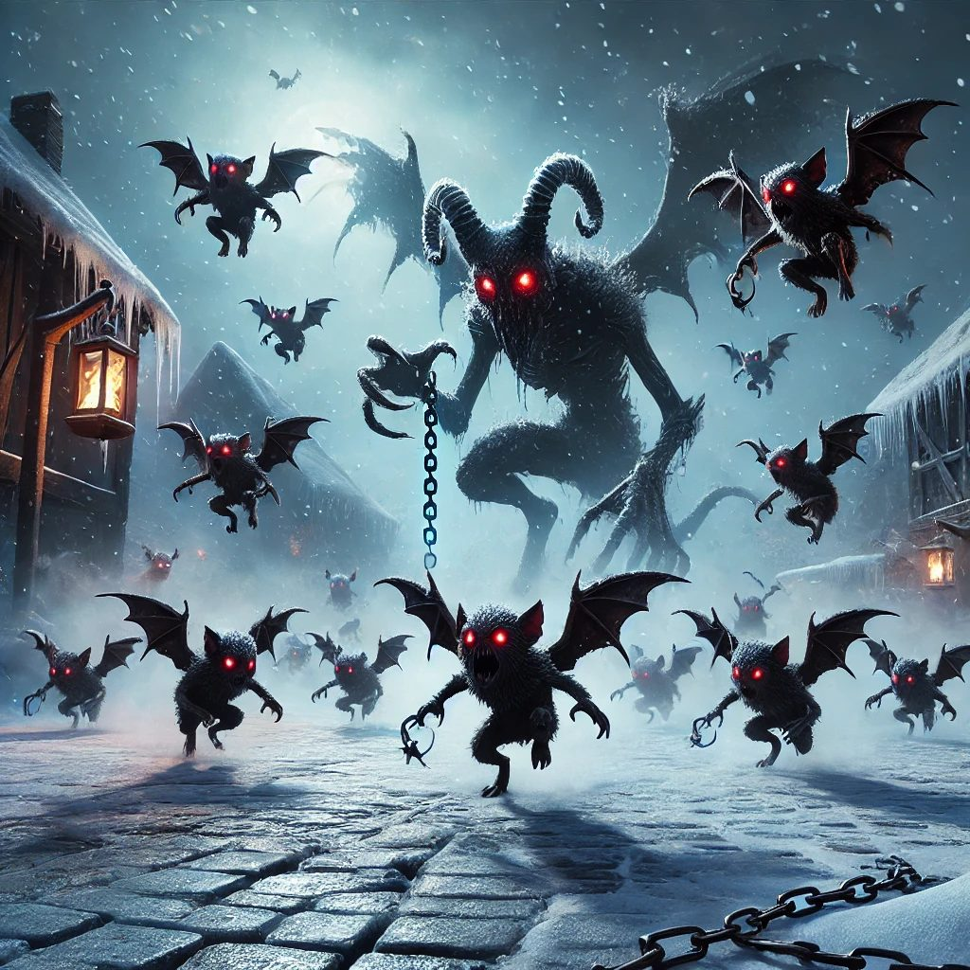
Krampusshade Minion
Small fiend, chaotic evil

Armor Class 15 (natural armor)
Hit Points 33 (6d6 + 12)
Speed 40 ft., fly 30 ft.

Skills Stealth +6, Sleight of Hand +6
Damage Resistances cold, necrotic; bludgeoning, piercing, and slashing from nonmagical attacks
Senses darkvision 120 ft., passive Perception 12
Languages Common, Infernal
Challenge 2 (450 XP)

Actions
Shadow Claw. Melee Weapon Attack: +6 to hit, reach 5 ft., one target. Hit: 9 (2d4 + 4) slashing, and the target must succeed on a DC 13 Wisdom save or be frightened until the end of its next turn.
Steal Object. The minion tries to snatch a small item; the target must succeed on a DC 14 Dexterity save or lose the item.

The gift-box mimics were the season's cruelest joke: presents that bit back, and stuck fast to any hand that reached for them.
Mimic (Gift Box)
Medium monstrosity (shapechanger), neutral

Armor Class 12 (natural armor)
Hit Points 58 (9d8 + 18)
Speed 15 ft.

Skills Stealth +5
Damage Immunities acid
Condition Immunities prone
Senses darkvision 60 ft., passive Perception 11
Languages none
Challenge 2 (450 XP)
Shapechanger. The mimic can use its action to polymorph into an object (a wrapped gift box, most often) or back into its true, toothy form.

Actions
Bite. Melee Weapon Attack: +5 to hit, reach 5 ft., one target. Hit: 7 (1d8 + 3) piercing plus 4 (1d8) acid.
Adhesive. The mimic adheres to anything that touches it; a creature grappled by the mimic must succeed on a DC 13 Strength check to escape.


Frozen Wolf
Medium beast, neutral evil

Armor Class 15 (natural armor)
Hit Points 45 (6d10 + 12)
Speed 40 ft.

STR 16 (+3) DEX 15 (+2) CON 14 (+2) INT 3 (-4) WIS 12 (+1) CHA 6 (-2)

Damage Immunities cold
Senses darkvision 60 ft., passive Perception 14
Languages understands Sylvan but cannot speak
Pack Tactics. Advantage on attacks against a creature if an ally is within 5 ft. of it and not incapacitated.
Icy Terrain. The ground within 10 ft. of the wolf is difficult terrain for other creatures.

Actions
Bite. Melee Weapon Attack: +5 to hit, reach 5 ft. Hit: 12 (2d6 + 3) piercing plus 4 (1d8) cold, and a DC 13 Constitution save or speed reduced by 10 ft. until end of its next turn.
Frost Breath (Recharge 5-6). A 15-ft. cone of icy air. Each creature makes a DC 13 Dexterity save, taking 18 (4d8) cold on a fail (half on a success); those who fail are slowed until end of next turn.


Frostbite Pixie
Tiny fey, chaotic neutral

Armor Class 15
Hit Points 14 (4d4 + 4)
Speed 20 ft., fly 60 ft.

STR 3 (-4) DEX 20 (+5) CON 12 (+1) INT 14 (+2) WIS 11 (+0) CHA 16 (+3)

Skills Stealth +7
Damage Immunities cold
Languages Sylvan, Common
Challenge 1/4 (50 XP)

Actions
Ray of Frost. Ranged Spell Attack: +5 to hit, range 60 ft. Hit: 7 (2d8) cold, and the target's speed is reduced by 10 ft. until end of its next turn.
Invisibility. The pixie turns invisible until it attacks or casts a spell.


Icy Specter
Medium undead, neutral evil

Armor Class 12
Hit Points 45 (10d8)
Speed 0 ft., fly 50 ft. (hover)

STR 1 (-5) DEX 14 (+2) CON 11 (+0) INT 10 (+0) WIS 10 (+0) CHA 16 (+3)

Damage Resistances cold, necrotic; bludgeoning, piercing, and slashing from nonmagical attacks
Damage Immunities poison
Condition Immunities charmed, exhaustion, grappled, paralyzed, poisoned, prone, restrained

Actions
Chilling Touch. Melee Weapon Attack: +5 to hit, reach 5 ft. Hit: 10 (3d6) cold.
Wail of Despair (Recharge 5-6). Each creature within 30 ft. makes a DC 14 Wisdom save or is frightened for 1 minute (repeat save at end of each turn).


Frost Golem
Medium elemental, neutral

Armor Class 14 (natural armor)
Hit Points 42 (5d10 + 15)
Speed 20 ft.

STR 16 (+3) DEX 10 (+0) CON 16 (+3) INT 6 (-2) WIS 10 (+0) CHA 5 (-3)

Damage Resistances cold; bludgeoning, piercing, and slashing from nonmagical attacks
Condition Immunities exhaustion, poisoned
Challenge 2 (450 XP)
Frost Aura. At the start of each creature's turn within 5 ft. of the golem, that creature takes 2 cold.

Actions
Icy Slam. Melee Weapon Attack: +5 to hit, reach 5 ft. Hit: 7 (2d6 + 3) bludgeoning plus 3 (1d4) cold.


Enchanted Snowman
Small construct, unaligned

Armor Class 13
Hit Points 30 (4d8 + 12)
Speed 20 ft.

STR 12 (+1) DEX 10 (+0) CON 16 (+3) INT 3 (-4) WIS 10 (+0) CHA 6 (-2)

Challenge 1 (200 XP)

Actions
Frostball. Ranged Weapon Attack: +4 to hit. Hit: 2d4 cold, and a DC 12 Constitution save or speed halved until end of its next turn.


Yule Cat
Large fey beast, neutral

Armor Class 15 (natural armor)
Hit Points 52 (7d10 + 14)
Speed 40 ft., climb 30 ft.

STR 18 (+4) DEX 16 (+3) CON 14 (+2) INT 6 (-2) WIS 14 (+2) CHA 10 (+0)

Skills Perception +4, Stealth +6
Damage Resistances cold
Senses darkvision 60 ft., passive Perception 14
Challenge 3 (700 XP)

Actions
Frost Claw. Melee Weapon Attack: +6 to hit, reach 5 ft. Hit: 10 (2d6 + 3) slashing plus 3 (1d6) cold.
Frostbite Pounce. If the Yule Cat moves 20 ft. and hits with Frost Claw, the target makes a DC 14 Strength save or is knocked prone; if prone, the cat makes another Frost Claw as a bonus action.
Chilling Gaze (Recharge 5-6). One target within 30 ft. makes a DC 14 Constitution save or takes 9 (2d8) cold and is paralyzed until end of its next turn.


Frost Hag (disguised)
Medium fey, neutral evil

Armor Class 15
Hit Points 52
Speed 30 ft.

STR 14 (+2) DEX 14 (+2) CON 14 (+2) INT 13 (+1) WIS 12 (+1) CHA 14 (+2)

Challenge 4 (1,100 XP)
Kindly Guise. The hag appears as a sweet old woman offering sugared pastries; those who eat them make a DC 13 Constitution save or are poisoned for 1 hour, taking 1d4 cold.

Actions
Icy Claw. Melee Weapon Attack: +6 to hit, reach 5 ft. Hit: 10 (2d6 + 3) slashing plus 4 (1d6) cold.
Frostbite Breath (Recharge 5-6). A 15-ft. cone; DC 14 Constitution save, 16 (4d6) cold (half on a success); on a fail the target is slowed until its next turn.
Misty Step (Bonus Action). The hag teleports 30 ft.


Ice Spider
Medium beast, unaligned

Armor Class 14 (natural armor)
Hit Points 26 (4d10 + 4)
Speed 30 ft., climb 30 ft.

STR 12 (+1) DEX 14 (+2) CON 12 (+1) INT 2 (-4) WIS 11 (+0) CHA 4 (-3)

Challenge 1 (200 XP)

Actions
Bite. Melee Weapon Attack: +5 to hit, reach 5 ft. Hit: 9 (1d8 + 1) piercing plus 4 (1d6) cold, and a DC 13 Constitution save or poisoned for 1 minute.
Web (Recharge 5-6). Ranged Weapon Attack: +4 to hit, range 30 ft. On a hit the target is restrained by webbing (DC 13 Strength to escape).


Frozen Will-o'-Wisp
Tiny undead, chaotic evil

Armor Class 15
Hit Points 22 (5d8)
Speed 0 ft., fly 50 ft. (hover)

STR 1 (-5) DEX 18 (+4) CON 10 (+0) INT 10 (+0) WIS 12 (+1) CHA 11 (+0)

Damage Resistances cold, lightning; bludgeoning, piercing, and slashing from nonmagical attacks
Damage Immunities poison
Condition Immunities exhaustion, grappled, paralyzed, prone
Challenge 2 (450 XP)

Actions
Icy Shock. Melee Spell Attack: +5 to hit, reach 5 ft. Hit: 9 (2d8) lightning plus 4 (1d6) cold.
Invisibility. The wisp turns invisible until it attacks.


Snowbound Bandit Leader
Medium humanoid, neutral

Armor Class 14
Hit Points 32
Speed 30 ft.

STR 14 (+2) DEX 13 (+1) CON 12 (+1) INT 10 (+0) WIS 11 (+0) CHA 11 (+0)

Desperate, Not Cruel. Driven mad by the cold; kindness (food, warmth) or a DC 14 Intimidation check can end the fight before it begins.

Actions
Scimitar. Melee Weapon Attack: +5 to hit, reach 5 ft. Hit: 7 (1d6 + 3) slashing.
Dagger. Melee or Ranged Weapon Attack: +5 to hit. Hit: 5 (1d4 + 3) piercing.
Frostbite Strike (Recharge 5-6). +5 to hit; an extra 1d6 cold, and a DC 13 Constitution save or speed reduced by 10 ft. until its next turn.

Snowbound Bandit
Medium humanoid, neutral

Armor Class 12
Hit Points 20
Speed 30 ft.

Desperate, Not Cruel. Like their leader, the bandits fight out of hunger and cold; kindness can end the fight before it begins.

Actions
Scimitar. Melee Weapon Attack: +4 to hit, reach 5 ft. Hit: 5 (1d6 + 2) slashing.
Shortbow. Ranged Weapon Attack: +4 to hit. Hit: 5 (1d6 + 2) piercing.

Kinder meetings walked the same roads: a resting reindeer whose glowing nose blessed kind travelers, a friendly caribou that healed the weary, and Aurora Spirits, gentle messengers of Elaria who traded a prophecy for a moment's respect. None of these gentle ones has statistics; they were never for fighting.
Session 5: The Flying Dutchman
Aboard the ghost-ship of Davy Jones the party fought a drowned crew of smugglers and spirits, all of them (like the Captain) undone by cold and by the sea taking back its own.

Davy Jones, Captain of the Flying Dutchman
Medium undead (formerly humanoid), chaotic evil

Armor Class 17 (barnacle armor)
Hit Points 85 (10d10 + 30)
Speed 30 ft., swim 30 ft.

STR 18 (+4) DEX 12 (+1) CON 16 (+3) INT 14 (+2) WIS 12 (+1) CHA 16 (+3)

Saving Throws Con +6, Wis +4, Cha +6
Skills Intimidation +6, Perception +4, Athletics +7, Survival +4
Damage Resistances bludgeoning, piercing, and slashing from nonmagical attacks
Condition Immunities charmed, frightened, poisoned, exhaustion
Senses darkvision 60 ft., passive Perception 14
Languages Common, Aquan
Challenge 6 (2,300 XP)
Barnacle Armor. Nonmagical melee attacks against him deal half damage.
Legendary Resistance (3/Day). If Davy fails a save, he can choose to succeed instead.
Amphibious. He can breathe air and water.

Actions
Multiattack. Two Tentacle Slams and one Hook Strike.
Tentacle Slam. Melee Weapon Attack: +7 to hit, reach 10 ft. Hit: 10 (2d6 + 4) bludgeoning, and the target is grappled (escape DC 15).
Hook Strike. Melee Weapon Attack: +7 to hit, reach 5 ft. Hit: 8 (1d6 + 4) piercing plus 7 (2d6) necrotic.
Soul Siphon (Recharge 5-6). One creature makes a DC 14 Constitution save or takes 18 (4d8) psychic; Davy heals half the damage dealt.

Legendary Actions
Tentacle Strike. Davy makes one Tentacle Slam.
Raise Tide (2 actions). A 20-ft. line; DC 14 Dexterity save or 13 (3d8) bludgeoning.

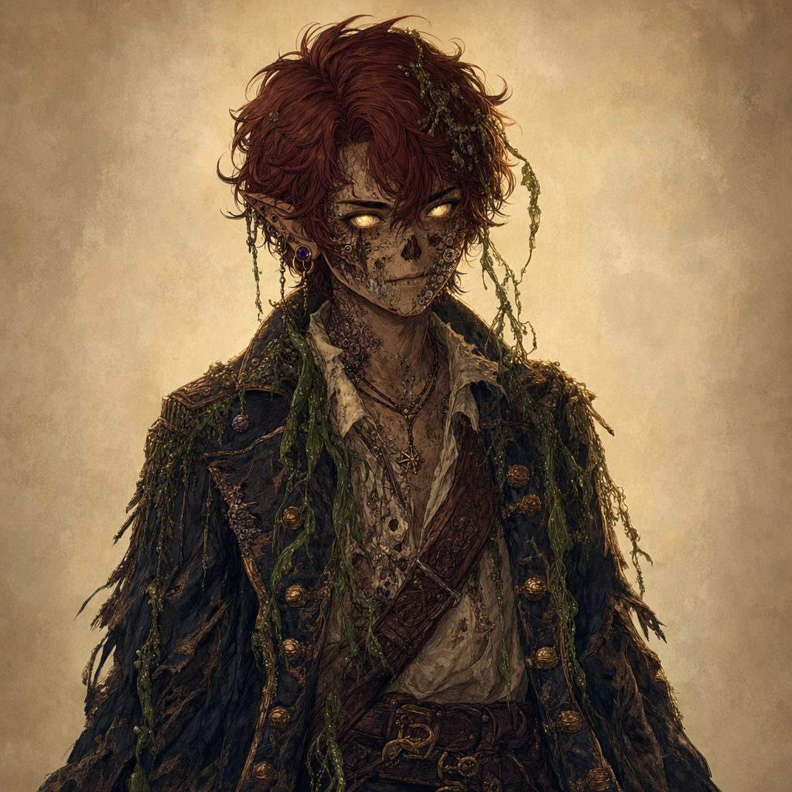
Drowned Pirate
Medium undead, chaotic evil

Armor Class 14 (studded leather or chain shirt)
Hit Points 58 (9d8 + 18)
Speed 30 ft., swim 30 ft.

STR 18 (+4) DEX 14 (+2) CON 14 (+2) INT 6 (-2) WIS 10 (+0) CHA 7 (-2)

Saving Throws Wis +2
Skills Perception +2
Damage Resistances bludgeoning, piercing, and slashing from nonmagical attacks
Damage Immunities poison
Condition Immunities charmed, exhaustion, frightened, paralyzed, poisoned
Senses darkvision 60 ft., passive Perception 12
Languages understands Common but can't speak
Challenge 1 (200 XP)
Amphibious. The pirate can breathe air and water.
Undead Fortitude. If reduced to 0 HP (not by radiant or a crit), a DC 5 + damage Constitution save drops it to 1 HP instead.

Actions
Multiattack. Two melee attacks.
Cutlass. Melee Weapon Attack: +6 to hit, reach 5 ft. Hit: 8 (1d8 + 4) slashing.
Harpoon. Melee or Ranged Weapon Attack: +6 to hit, reach 10 ft. or range 30/120 ft. Hit: 9 (1d10 + 4) piercing, and the target is grappled (escape DC 14).

Reactions
Death Burst. When the pirate dies it bursts; each creature within 5 ft. makes a DC 12 Constitution save or takes 5 (2d4) cold and gains one level of exhaustion.


Spectral Helmsman
Medium undead, chaotic evil

Armor Class 12
Hit Points 45 (6d8 + 18)
Speed 0 ft., fly 50 ft. (hover)

STR 6 (-2) DEX 14 (+2) CON 16 (+3) INT 10 (+0) WIS 12 (+1) CHA 11 (+0)

Saving Throws Wis +3, Cha +2
Skills Perception +3, Stealth +4
Damage Resistances acid, fire, lightning, thunder; bludgeoning, piercing, and slashing from nonmagical attacks
Damage Immunities cold, necrotic, poison
Condition Immunities charmed, exhaustion, grappled, paralyzed, petrified, poisoned, prone, restrained
Senses darkvision 60 ft., passive Perception 13
Languages understands Common but can't speak
Challenge 1 (200 XP)
Incorporeal Movement. Can move through creatures and objects as difficult terrain.
Sea-Wraith Aura. At the start of each of its turns, creatures within 5 ft. make a DC 12 Wisdom save or are frightened until their next turn.

Actions
Multiattack. Two Spectral Scimitar attacks.
Spectral Scimitar. Melee Weapon Attack: +4 to hit, reach 5 ft. Hit: 7 (1d6 + 4) force.
Harpoon Throw. Ranged Weapon Attack: +4 to hit, range 20/60 ft. Hit: 9 (1d10 + 4) piercing and the target is pulled up to 10 ft.

Reactions
Phantom Helm Block. When attacked, it imposes disadvantage on one weapon attack roll.


Smuggler's Golem
Large construct, unaligned

Armor Class 14 (natural armor)
Hit Points 85 (10d10 + 30)
Speed 30 ft.

STR 19 (+4) DEX 9 (-1) CON 16 (+3) INT 3 (-4) WIS 10 (+0) CHA 5 (-3)

Damage Resistances fire, lightning, acid
Damage Vulnerabilities cold
Damage Immunities poison, psychic; bludgeoning, piercing, and slashing from nonmagical attacks
Condition Immunities charmed, exhaustion, frightened, paralyzed, petrified, poisoned, prone
Senses darkvision 60 ft., tremorsense 30 ft., passive Perception 10
Languages understands the commands of its creator but can't speak
Challenge 2 (450 XP)
Immutable Form. Immune to effects that would alter its form.
Magic Resistance. Advantage on saves against spells.
Siege Monster. Deals double damage to objects.

Actions
Multiattack. Two Slam attacks.
Slam. Melee Weapon Attack: +7 to hit, reach 10 ft. Hit: 2d8 + 5 bludgeoning.
Crush Crate (Recharge 5-6). One object or creature takes 6d6 (DC 15 Dexterity save for half); a creature that fails is knocked prone.

Reactions
Reinforced Hide. +2 AC against one melee attack.


Arcane Corsair
Medium humanoid, chaotic neutral

Armor Class 14 (studded leather)
Hit Points 52 (7d8 + 21)
Speed 30 ft.

STR 16 (+3) DEX 16 (+3) CON 16 (+3) INT 12 (+1) WIS 11 (+0) CHA 14 (+2)

Saving Throws Dex +5, Cha +4
Skills Acrobatics +5, Perception +2
Damage Resistances fire, lightning
Damage Vulnerabilities cold
Condition Immunities frightened
Languages Common, Thieves' Cant
Challenge 1 (200 XP)
Sneak Attack (1/turn). +2d6 damage when it has advantage or an ally is adjacent to the target.
Parry. +2 AC against one melee attack.

Actions
Multiattack. Two Arcane Saber attacks.
Arcane Saber. Melee Weapon Attack: +5 to hit. Hit: 1d8 + 3 slashing plus 1d6 force.
Riposte (Recharge 5-6). A reaction attack after an enemy misses it in melee.

Reactions
Evasive Step. It Disengages, moving without provoking opportunity attacks.


Ghost-Light Engineer
Tiny undead, neutral evil

Armor Class 15 (natural armor)
Hit Points 27 (6d4 + 12)
Speed 0 ft., fly 50 ft. (hover)

STR 1 (-5) DEX 18 (+4) CON 14 (+2) INT 12 (+1) WIS 14 (+2) CHA 16 (+3)

Saving Throws Wis +4, Cha +5
Skills Arcana +3, Perception +4, Stealth +8
Damage Resistances acid, fire, lightning, thunder; bludgeoning, piercing, slashing from nonmagical attacks
Damage Vulnerabilities cold
Damage Immunities necrotic, poison, psychic
Condition Immunities charmed, exhaustion, frightened, grappled, paralyzed, petrified, poisoned, prone, restrained
Senses darkvision 60 ft., passive Perception 14
Languages Common, its creator's languages
Challenge 2 (450 XP)
Invisibility (Recharge 4-6). Turns invisible until it attacks, casts, or its concentration ends.
Glowing Core. A faint glow is visible within 5 ft. even while invisible.

Actions
Shock Touch. Melee Spell Attack: +6 to hit. Hit: 2d6 + 2 lightning.
Arcane Pulse (Recharge 5-6). A 10-ft. cone; DC 13 Dexterity save, 4d6 force (half on a success).

Reactions
Engineered Reflexes. Halves the damage from one attack or harmful spell.

Session 6: The False Hydra of Wraithpine
The worst monster the Guardians ever faced, because no one knew it was there. Beneath the Old Theater of Wraithpine, its endless song made the whole village forget the people it took. Beeswax in the ears let the truth through.

False Hydra: Tavern Head
Large aberration (one head and neck), unaligned

Armor Class 14
Hit Points 70 (9d10 + 18)
Speed 10 ft., climb 10 ft.

STR 16 (+3) DEX 12 (+1) CON 14 (+2) INT 6 (-2) WIS 14 (+2) CHA 7 (-2)

Damage Resistances psychic
Condition Immunities charmed, frightened, prone
Senses blindsight 10 ft., tremorsense 30 ft., darkvision 60 ft., passive Perception 14
Mind-Humming Aura. Creatures without beeswax that start their turn within 30 ft. make a DC 13 Wisdom save or have disadvantage on attack rolls that turn. Beeswax grants advantage on the save.
Segmented Neck. The head ignores forced movement and prone unless it chooses otherwise. When it takes 20+ damage in a turn, it recoils 5 ft. (no opportunity attacks) and can't take reactions until the start of its next turn.

Actions
Bite. Melee Weapon Attack: +6 to hit, reach 10 ft. Hit: 13 (2d8 + 4) piercing, and the target is grappled (escape DC 14). While grappling it can't bite a different target.
Lurch & Drag. A grappled target is dragged 5 ft. toward the trapdoor and, on a failed DC 13 Wisdom save, loses a word or thought for a heartbeat.

Reactions
Recoil from Flame. When it takes fire damage, it has disadvantage on its next attack.

Deeper still, in the drowned orchestra pit, waited the true body and its four heads, all singing as one. The moment the song stopped, every stolen name came flooding home.

False Hydra (Adult): Body
Huge aberration, unaligned

Armor Class 15
Hit Points 130 (12d12 + 48)
Speed 10 ft., climb 10 ft.

STR 18 (+4) DEX 10 (+0) CON 18 (+4) INT 7 (-2) WIS 14 (+2) CHA 8 (-1)

Saving Throws Con +8, Wis +5
Damage Resistances psychic
Condition Immunities charmed, frightened, prone
Senses tremorsense 60 ft., darkvision 60 ft., blindsight 10 ft., passive Perception 12
Song of Unremembering. While any head lives, creatures without earplugs that start their turn within 60 ft. make a DC 15 Wisdom save or have disadvantage on attacks and can't take reactions until their next turn. Beeswax grants advantage and no reaction-lock.
Many-Minds. For each head alive, the body has 1 Legendary Action (max 3 per round).
Vital Link. While at least one head lives, the body has resistance to all weapon damage; each head destroyed removes one instance of this protection.

Actions
Thrash. Melee Weapon Attack: +7 to hit, reach 10 ft. Hit: 13 (2d8 + 4) bludgeoning.
Regurgitate Remnants (Recharge 5-6). A 15-ft. cone of bone and cloth; DC 14 Dexterity save, 13 (3d8) necrotic and slowed (speed -10) until end of next turn. A shattered skull and ribbon clatter free.

Legendary Actions
Hum Surge. One creature within 60 ft. (no earplugs) makes a DC 15 Wisdom save or loses concentration and can move only 10 ft. on its next turn.
Bone Shift. Move the body 5 ft. and reshape a 10-ft. square within 20 ft. into (or out of) difficult terrain.
Coordinate Strike. One head makes a Snap.


False Hydra Head (x4)
Large aberration (an extension of the body), unaligned

Armor Class 14
Hit Points 45 (6d10 + 12)
Speed 30 ft. (platforms, tunnels), climb 20 ft.

STR 16 (+3) DEX 12 (+1) CON 14 (+2) INT 6 (-2) WIS 14 (+2) CHA 7 (-2)

Saving Throws Wis +4
Damage Resistances psychic
Condition Immunities charmed, frightened, prone

Actions
Bite. Melee Weapon Attack: +7 to hit, reach 15 ft. Hit: 14 (2d10 + 3) piercing and grappled (escape DC 14). While grappling it can't bite a different target.
Reel. A creature grappled by the head makes a DC 14 Strength save or is pulled 10 ft. toward the port and knocked prone.

Reactions
Snap. When a creature moves within 15 ft., the head makes one Bite against it.

Festival frights. Before the theater, the hydra's hungry song had stirred lesser echoes all over Wraithpine: animated Scarecrows and rustling Strawlings on Pumpkin Row, rats and rat swarms in Maera's cellar, and restless Zombies (and, if things went loud, Skeletons) at the graveyard rite.

Animated Scarecrow
Medium construct, neutral

Armor Class 11
Hit Points 36 (8d8)
Speed 30 ft.

STR 16 (+3) DEX 12 (+1) CON 11 (+0) INT 10 (+0) WIS 10 (+0) CHA 10 (+0)

Damage Resistances bludgeoning, piercing, and slashing from nonmagical attacks
Damage Vulnerabilities fire
Condition Immunities charmed, frightened, paralyzed, poisoned
Senses darkvision 60 ft., passive Perception 10
Languages understands its creator's languages but can't speak
Challenge 1 (200 XP)
Terrifying Glare. One creature within 30 ft. must succeed on a DC 11 Wisdom save or be frightened for 1 minute (repeat save at end of each turn).
Heart-Gourd. A coin-sized gourd charm is sewn under its ribs; snipping it (an action within 5 ft., no roll) makes the scarecrow fall limp.

Actions
Claw. Melee Weapon Attack: two claws, +5 to hit, reach 5 ft. Hit: 6 (2d4 + 1) slashing.


Strawling
Medium plant, neutral

Armor Class 12
Hit Points 11 (2d8 + 2)
Speed 30 ft.

STR 12 (+1) DEX 12 (+1) CON 12 (+1) INT 4 (-3) WIS 10 (+0) CHA 3 (-4)

Senses passive Perception 10
Challenge 1/4 (50 XP)

Actions
Needles. Melee or Ranged Weapon Attack: a bristle of straw-needles; easily bowled over by a hay cart or a kicked pumpkin stack.

The cellar vermin were ordinary Rats (AC 12, HP 7, CR 1/8) and a Swarm of Rats (AC 10, HP 24, CR 1/4). The graveyard undead were standard Zombies (AC 8, HP 22, CR 1/4; Undead Fortitude) and, only if the rite went loud, Skeletons (AC 13, HP 13, CR 1/4).
Session 7: Gearhaven, the Clockwork City
In the clockwork city, the enemy was no monster at all but corruption bleeding up through the cracks, reaching INTO the machines the people loved. Note the rotation: the lightning eaters and the fire eaters trade off. Freed, not killed: these were innocents.

Rogue Servitor
Small construct, unaligned

Armor Class 15
Hit Points 39 (6d6 + 18)
Speed 30 ft.

STR 13 (+1) DEX 16 (+3) CON 16 (+3) INT 3 (-4) WIS 8 (-1) CHA 5 (-3)

Damage Resistances poison; bludgeoning, piercing, and slashing from nonmagical attacks
Condition Immunities charmed, frightened, poisoned, exhaustion
Senses darkvision 60 ft.
Challenge 2
Overclocked Death-Spark. At 0 HP, each creature within 10 ft. makes a DC 13 Dexterity save or takes 7 (2d6) lightning.
Shutdown Switch. An action within 5 ft. plus a DC 14 Arcana or Sleight of Hand check shuts it down instantly, no kill needed.

Actions
Multiattack. Two Flailing Slams.
Flailing Slam. Melee Weapon Attack: +5 to hit, reach 5 ft. Hit: 8 (1d10 + 3) bludgeoning.
Spark Lash (Recharge 5-6). Ranged Attack: +5 to hit, range 30 ft. Hit: 10 (3d6) lightning; the target's speed is halved until end of its next turn.

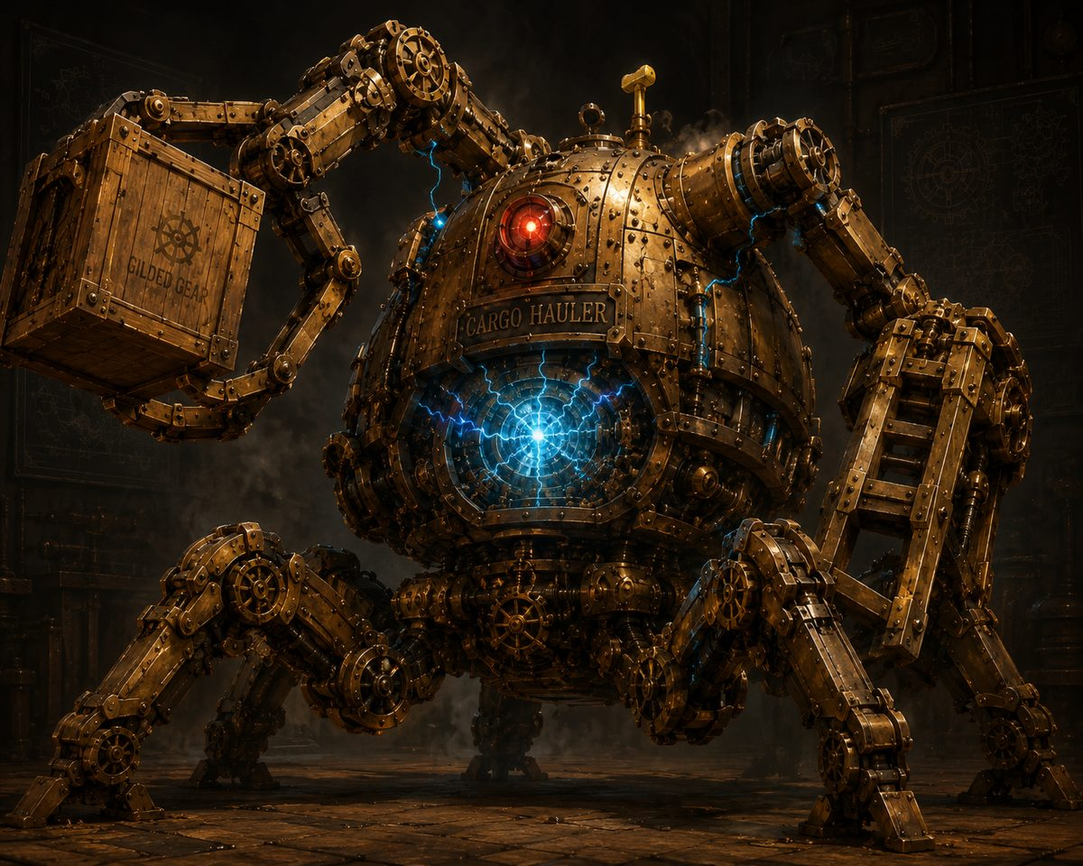
Cargo Hauler
Large construct, unaligned

Armor Class 16
Hit Points 76 (8d10 + 32)
Speed 30 ft.

STR 19 (+4) DEX 8 (-1) CON 18 (+4) INT 3 (-4) WIS 8 (-1) CHA 5 (-3)

Damage Resistances bludgeoning, piercing, and slashing from nonmagical attacks
Damage Vulnerabilities lightning (overloaded core; telegraph the crackling blue!)
Condition Immunities charmed, exhaustion, frightened, paralyzed, petrified, poisoned
Challenge 3
Out-of-Reach Switch. Its shutdown lever is 15 ft. up on its back; reaching it (climb DC 13 or flight) plus an action and a DC 15 Arcana or Sleight of Hand check disables it.

Actions
Multiattack. Two Forklift Slams, or one Slam and one Hurl Crate.
Forklift Slam. Melee Weapon Attack: +6 to hit, reach 10 ft. Hit: 13 (2d8 + 4) bludgeoning, and a DC 14 Strength save or knocked prone.
Hurl Crate. Ranged Weapon Attack: +6 to hit, range 60 ft. Hit: 14 (3d6 + 4) bludgeoning.
Grab & Crush (Recharge 5-6). One creature within 10 ft. makes a DC 14 Dexterity save or is grappled (escape DC 14), taking 10 (3d6) at the start of each of its turns until it escapes.

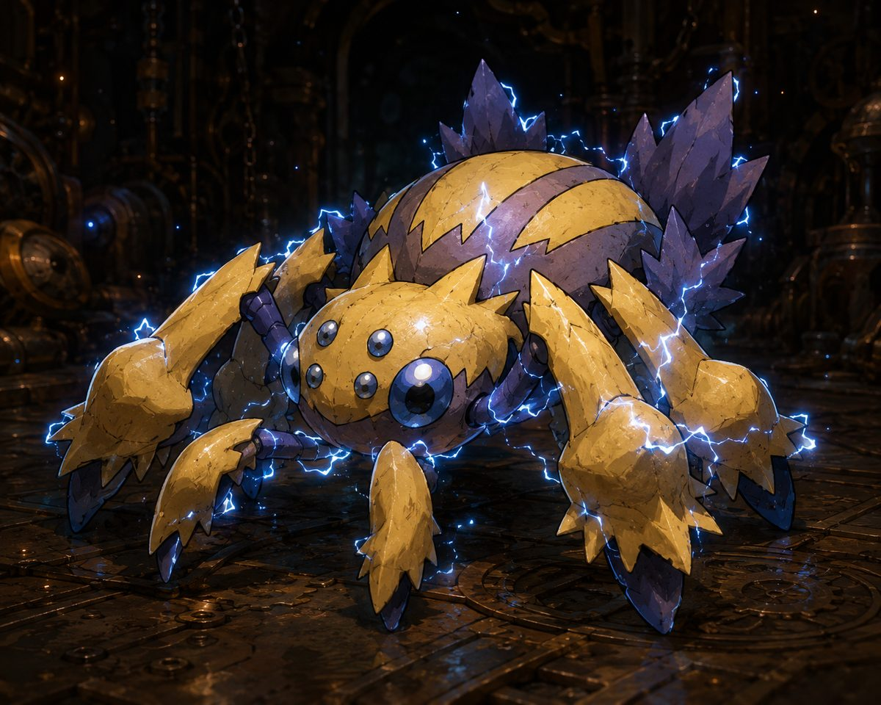
Voltcrawler
Small aberration (planar intruder), unaligned

Armor Class 15
Hit Points 22 (5d6 + 5)
Speed 30 ft., climb 30 ft.

STR 7 (-2) DEX 17 (+3) CON 13 (+1) INT 5 (-3) WIS 10 (+0) CHA 6 (-2)

Damage Resistances lightning
Senses darkvision 60 ft.
Phase-Blink. At the start of its turn, roll a d6: on a 1-2 it goes Unreal, resisting all damage except force and radiant, and attacks against it have disadvantage; it can't be webbed or grappled and must become Real to attack. (Force and radiant are the counter.)
Static Cling. The first time it hits a creature each turn, that target's lightning resistance is ignored and its allies have advantage on their next attack against it.

Actions
Spark Bite. Melee Weapon Attack: +5 to hit, reach 5 ft. Hit: 1d6 + 3 piercing plus 1d6 lightning.
Arc (Recharge 5-6). A 15-ft. line; DC 13 Dexterity save, 2d8 lightning (half on a success). Two or more Voltcrawlers within 15 ft. can chain into one 3d8 line.

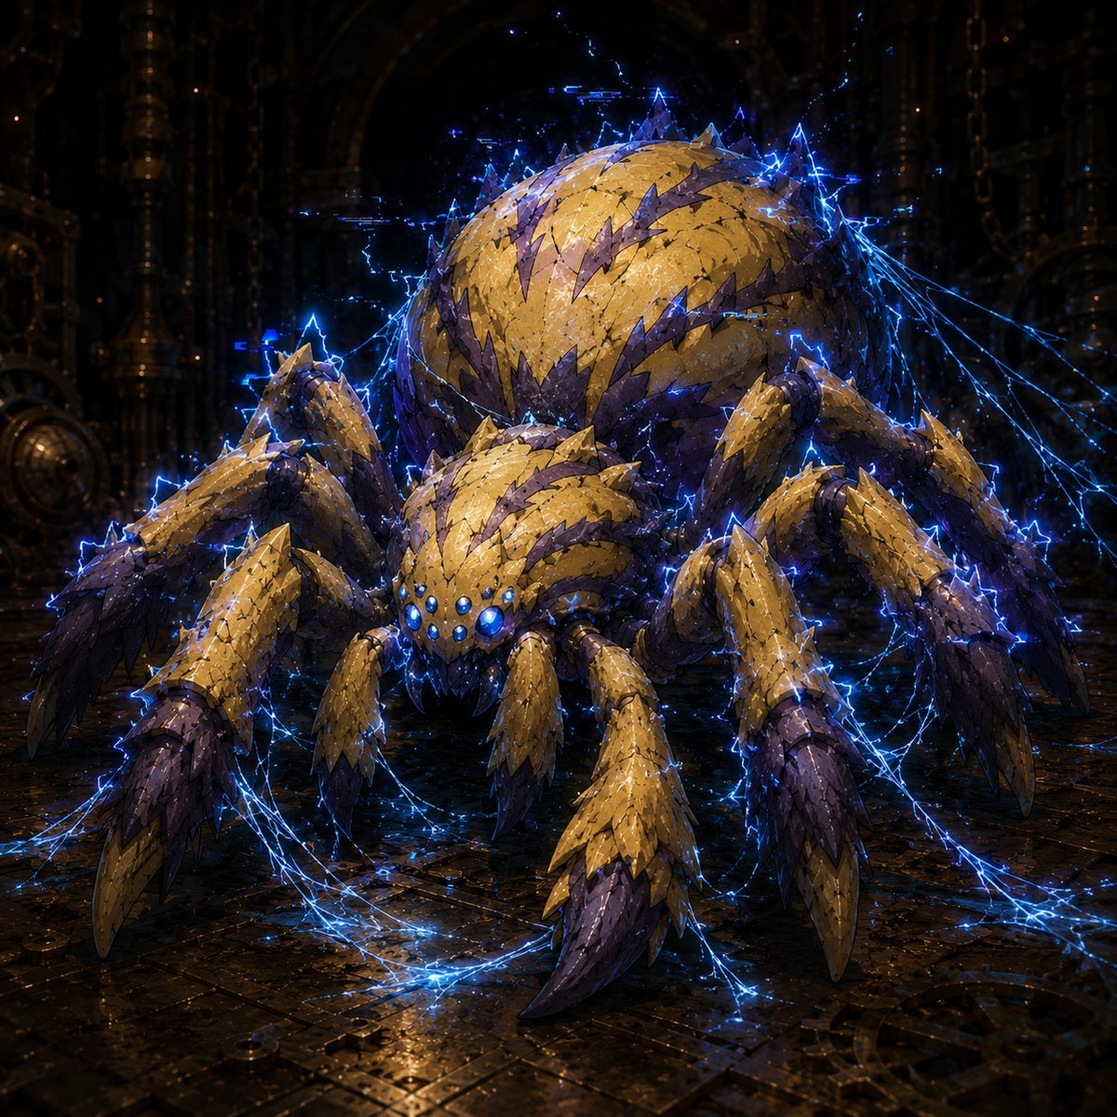
Voltcrawler Broodmother
Medium aberration (planar intruder), unaligned

Armor Class 16
Hit Points 95 (10d8 + 50)
Speed 40 ft., climb 40 ft.

STR 14 (+2) DEX 18 (+4) CON 20 (+5) INT 6 (-2) WIS 12 (+1) CHA 8 (-1)

Saving Throws Dex +7, Con +8
Damage Resistances lightning; bludgeoning, piercing, and slashing from nonmagical attacks
Senses darkvision 60 ft.
Phase-Blink (greater). She chooses to go Unreal as a free action once per round (no roll).
Crackling Web. At the start of her turn, one creature she sees within 30 ft. makes a DC 15 Dexterity save or is restrained by planar silk (action plus DC 15 Strength to break; web AC 12, 15 HP, immune lightning, VULNERABLE fire and cold).

Actions
Multiattack. Two Lash attacks.
Lash. Melee Weapon Attack: +7 to hit, reach 10 ft. Hit: 1d10 + 4 slashing plus 1d8 lightning.
Overcharge (Recharge 6). A 20-ft.-radius burst; DC 15 Constitution save, 4d8 lightning (half on a success). On a fail the target also can't take reactions until end of its next turn.


Iron Drudge
Large construct (planar-corrupted), unaligned

Armor Class 17
Hit Points 68 (8d10 + 24)
Speed 25 ft.

STR 19 (+4) DEX 8 (-1) CON 17 (+3) INT 3 (-4) WIS 8 (-1) CHA 1 (-5)

Damage Resistances bludgeoning, piercing, and slashing from nonmagical attacks
Damage Vulnerabilities fire (corrupted wood and vine in its joints; telegraph the smoke!)
Condition Immunities charmed, frightened, exhaustion, poisoned
Senses darkvision 60 ft.
Challenge 3
Slow but Unstoppable. Can't be knocked prone; ignores difficult terrain. It is slow enough to outrun, but it keeps coming.
Corruption Leak. At 0 HP the blue light gutters out and it slumps, harmless. No death-burst: these were innocent worker-machines, freed rather than destroyed.

Actions
Multiattack. Two Cargo-Arm Slams.
Cargo-Arm Slam. Melee Weapon Attack: +6 to hit, reach 10 ft. Hit: 2d8 + 4 bludgeoning.
Sweep (Recharge 5-6). A wide swing; each creature within 10 ft. makes a DC 14 Dexterity save, taking 2d6 + 4 bludgeoning (half on a success) and shoved 10 ft. on a fail.


Corrupted Sproutling
Small plant (planar-corrupted), unaligned

Armor Class 12
Hit Points 7 (2d6)
Speed 10 ft., climb 10 ft.

STR 8 (-1) DEX 14 (+2) CON 10 (+0) INT 2 (-4) WIS 6 (-2) CHA 4 (-3)

Damage Vulnerabilities fire
Senses darkvision 30 ft.
Weak but Many. Dies to almost any solid hit; an area effect clears several at once (reward AoE).
Group Turn & Spawn. All Sproutlings act together on one shared initiative. While the engine runs corrupt, a new one crawls from a crack each time one dies.

Actions
Thorn-Lash. Melee Weapon Attack: +4 to hit, reach 5 ft. Hit: 1d6 + 2 piercing.
Latch. Instead of attacking, it grabs a hero (no damage); the next attack against that hero has advantage.

And then the boss: not a monster, but the city's beloved gentle giant, possessed and grieving inside its own iron. The Guardians broke its legs to bring the core into reach, and the last blow drained the corruption away rather than killing it. A gentle death, never an execution.

The Grand Custodian (possessed)
Gargantuan construct (planar-possessed), unaligned

Armor Class 17 (Body); Legs (x2) AC 15
Hit Points 220 (Body); Legs 90 each
Speed 30 ft.

STR 24 (+7) DEX 6 (-2) CON 22 (+6) INT 3 (-4) WIS 10 (+0) CHA 5 (-3)

Damage Resistances bludgeoning, piercing, and slashing from nonmagical attacks
Condition Immunities charmed, frightened, exhaustion, poisoned, paralyzed, petrified
The Core Is High. Standing, the core is 40-50 ft. up: only 60-ft.+ ranged attacks and flyers reach it. The legs are ground-level and anyone can strike them.
Topple. Drop both legs (90 HP each) and it crashes to its knees (Phase 2), stops rampaging, and the core drops to 15-20 ft. within everyone's reach. It may slowly repair a leg (to 25 HP) to rise; re-topple it.

Actions
Crushing Stomp. Melee: +8 to hit, reach 15 ft. Hit: 2d10 + 5 bludgeoning, and a DC 15 Dexterity save or knocked prone. (Phases 1 and 2.)
Sweeping Backhand (Recharge 5-6). (Phase 1) A 15-ft. cone; DC 15 Dexterity save, 3d8 and shoved 10 ft. (half and no shove on a success).
Corrupt Bolt. (Phase 1) +8 to hit, range 60 ft. Hit: 3d8 lightning, once per round at someone hanging back.
Clockwork Barrage (Recharge 4-6). (Phase 2) Three projectiles, +8 each. Hit: 2d8 + 3 bludgeoning.
Chain Lightning Burst (Recharge 5-6). (Phase 2) +8 to hit, 4d8 lightning, arcing to two more within 15 ft. for 2d8 (DC 15 Dexterity save for half). Meant to be ANSWERED, not to drop a hero.
Core Flare. (Phase 2, body below half HP) Each creature within 20 ft. makes a DC 15 Constitution save or takes 2d6 force and is blinded until end of its next turn.

Part II: Treasures & Relics
Every treasure of the Guardians' road, from a mother's parting gift to the relics of a sleeping goddess. Items marked with the seven-point star are Elaria's own.
The Great Mysteries
The Essence Sphere
Brass and crystal, warm as a heartbeat, made by the deep-gnome masters of Glimmerspire BEFORE the cracks ever opened (how they knew is a question nobody has answered). It holds Pikachu's sleeping spark, and it is a GATHERER: it pulls loose planar motes to itself and survives holding them, which no other vessel can. It is the missing anchor of Vane's Rift Portal, and it never leaves the party's keeping. Gained Planar Attunement at the Whispering Glade (advantage on Arcana concerning planar magic).

The Essence Sphere, a gatherer of loose motes.
The Three Enchanted Potatoes

The three enchanted potatoes: Healing, Transformation, Insight.
Ash Catchum's legacy to his son: three unassuming potatoes that are anything but. The goddess named them remnants of a shattered covenant, safeguards bound from her own essence in the old lore (Healing, Transformation, Insight). They pulse when the world thins. Their hour has not yet come.
Stabby's Idol

Stabby's Idol, cold to the touch near a rift.
A small carved figure Stabby found tucked in his bag after Wraithpine, though nobody saw who put it there. It goes ice cold near rifts, and corruption recoils from it. It has dreams in it. That is all anyone knows, yet.
Relics of Elaria (the Wraithpine Chest)
One half-buried chest, bound in vines of silver and root, opened by Ghostbloom's song beneath the Old Theater. Inside, three gifts, each bearing the seven-point star.

The Wraithpine chest, bound in silver vines.
Staff of Waking Constellations (Ursa)
Staff of Waking Constellations
+1 quarterstaff, druidic focus. 5 charges, regain 1d4 + 1 at dawn: guiding bolt (1), faerie fire (1), moonbeam (2).
Starseed. Once per turn, +1d4 radiant when Ursa deals radiant damage with a druid spell (house rule: druid spells only).
Starlight. Bonus action: 10 ft. dim light; advantage on night navigation.
The counter-weapon: after every great victory, one new star brightens on its haft. The enemy puts stars out; the Staff lights them.
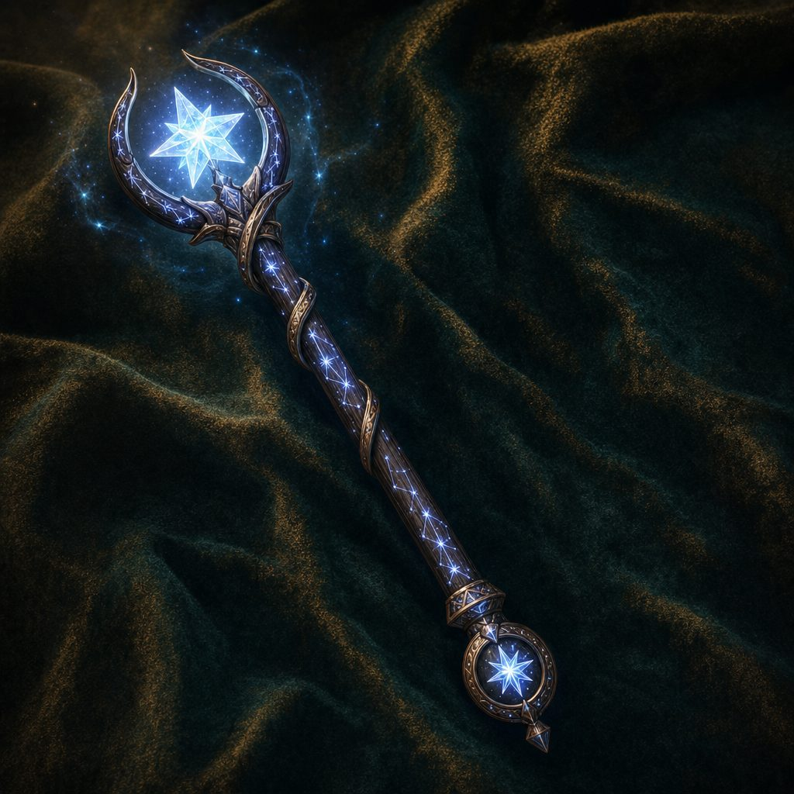
The Staff of Waking Constellations.
Sash of the Swift Current, Rewoven (Stabby)
Sash of the Swift Current (Rewoven)
Scarlet stage-silk rewoven with theater rigging thread. +1 AC (stacks with Unarmored Defense).
Fleetstep. +10 ft. walking speed. Air Dance. 1/day bonus action: fly speed equal to walking, 1 minute.
Feather Fall. 1/day, no components. Its star sigil is cupped by a pair of wings.

The Sash of the Swift Current, rewoven.
Glimmerspire Pocket Dynamo, Mk II (Lilly)
Glimmerspire Pocket Dynamo (Mk II)
A thumb-sized brass core stamped PROP ROOM in stage-engraver script (a mystery unexplained).
Pocket Arsenal. Deploy or recall the Eldritch Cannon as a free action. Endurance Overhaul. Cannon lasts 24 hours.
Power Sync. Cannon deals +2 damage. Reformat. 1/long rest, action: change the cannon's model.
Near Ghostbloom, the core glows soft ghost-green, like a stage cue waiting for its moment.
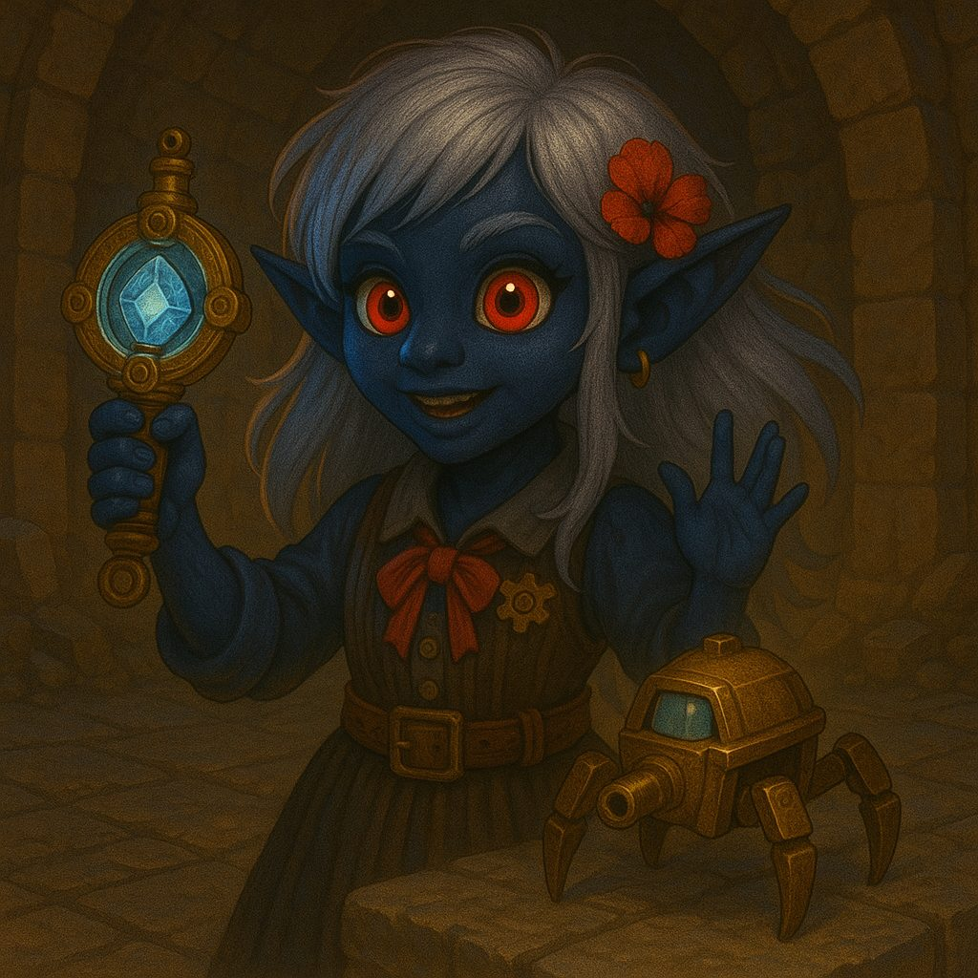
Lilly with the Pocket Dynamo and its brass frame.
Gifts of Faelan (Havenmoor, Session 4)
Frostbite Shard Dagger (Lilly)
Frostbite Shard Dagger
Rare, attunement by an Artificer. Crystalline ice that never melts. 1d4 piercing + 1d4 cold, +1 to attack.
Spell focus and Arcane Firearm. +1d8 frost to one spell damage roll cast through it; +2 frost on spell damage.

The Frostbite Shard Dagger, ice that never melts.
Amulet of Guiding Light (Ursa)
Amulet of Guiding Light
Rare, attunement by a Circle of Stars druid.
Guiding Light. Sheds light; allies gain +1 to attacks and saves while Ursa is in Starry Form.
Starry Glow. Reaction, 1/long rest: 2d8 radiant, DC 15 Con or blinded. Celestial Resilience. Reroll natural 1s, 2/long rest.
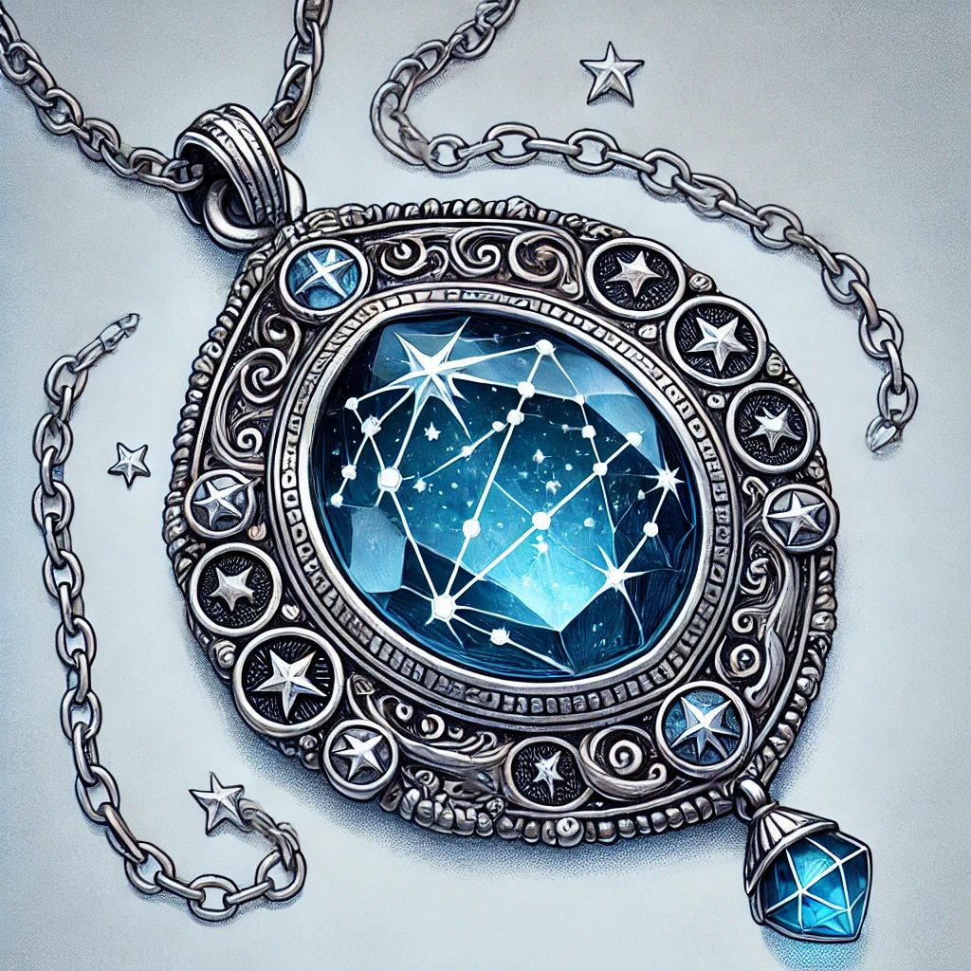
The Amulet of Guiding Light.
Candyfang Katana (Stabby)
Candyfang Katana
Rare, attunement by a Monk. A katana of impossible candy-cane steel. 1d8/1d10 slashing, +1 attack and damage.
Sugar Rush. Bonus action lick, 1/long rest: 2d8 + Con temporary HP. Frostbite Infusion. +2 frost on hit.
Destined to become a Bloodfang heirloom when the Nichirin blade comes.
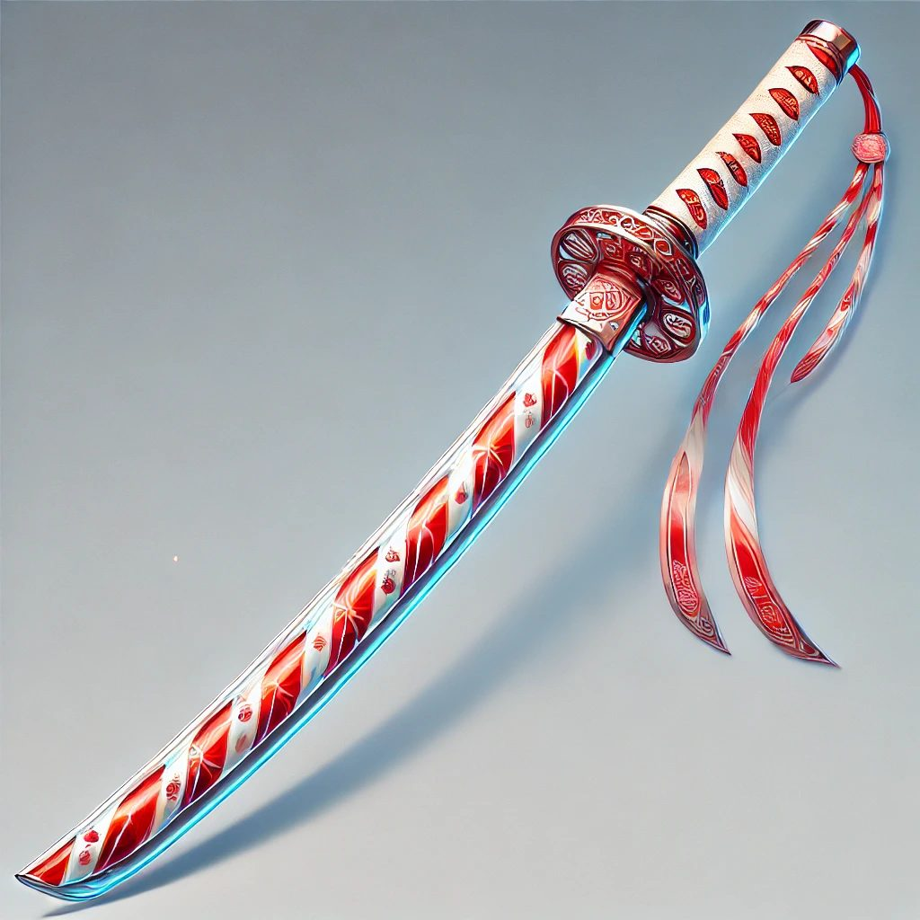
The Candyfang Katana, candy-cane steel.
Boons, Baubles & Blessings
Elaria's boons (the Whispering Glade, Session 2): Ursa, Planar Awareness (sense planar disturbances, 24 hours); Lilly, the Sphere's Planar Attunement; Stabby, Glimpse of Possibility (one reroll, because the goddess smiled at the goblin).
The eight Winter Bells (Session 4). C, D, E, F, G, A, B, High C: relics of Elaria's light hidden across Havenmoor. Rung in harmony they unmade the Krampusshade. Faelan's Frosted Cookies: 2d8 healing, a short rest's comfort, and one spell slot, in cookie form.
Curios of the road. The Shadow-Touched Rune Fragment (advantage vs fear, 1 hour); the Dark Fragment of Stormwatch Cliffs (crystallized chaos, evidence of sabotage); Terranox's stone fragments and the elemental mud samples of the Grove of Elemental Waters; beeswax earplugs that beat a monster's song; a bell-handled blue lantern from Pumpkin Row; Alwen's flasks of lucky seawater.

A frost-bound carol tablet, the Winter Bells' song set in stone.

Part III: Custom Content
Homebrew and rulings of this table: the paths the heroes may walk after the year apart, and the standing rules of the campaign. 2024 rules throughout; house rules override the books.
House Rules & Standing Rulings
1. Ursa's Starseed +1d4 applies only to actual druid spells, never the Starry Form Archer's luminous arrow.
2. Patient Defense grants a free Disengage (add Dodge by spending 1 Focus).
3. Shillelagh replaces Primal Savagery on Ursa's sheet (2024 rules).
4. Goodberry: eating a berry is a Bonus Action (2024).
5. Ursa's summoned Air spirit has 20 HP.
6. Deep gnome uses the current 2024-era printing (Svirfneblin Camouflage, Disguise Self and Nondetection 1/long rest each).
7. Lilly's cannon picks its mode on EVERY activation (Forge of the Artificer rule).
8. Potent Spellcasting rides the kindled staff once per turn (Ursa, from level 7).
The Three Doors
At the close of the Gearhaven chapter the Guardians parted for a year: a year of workshops and roads and night skies, each hero following their own heart home. Before each of them stand three doors, three ways that year apart might be spent, and behind every door waits a different gift.
The chapters that follow set down what waits behind all nine: Stabby's three breathing styles, Ursa's three paths of the stars, and Lilly's three artifacts. Each Guardian will choose exactly one door, and none of the three has chosen yet. When they do, the doors not taken will remain in these pages, roads not walked, ready for other heroes in other tellings.
Warrior of Breathing (Stabby's Path)

Water Breathing: the flowing style.
A homebrew monk subclass taken at level 7 in place of Kensei (full document: characters/path_rewards/warrior_of_breathing_v2.pdf). A Warrior of Breathing kindles an inner style, a visible breath that wreathes the blade. All roads grant the Nichirin Katana (+2, finesse, monk weapon, glows when breath is kindled, Cleansing Edge against corrupted creatures), and the First Form replaces Flurry of Blows.
Water Breathing (the Whispering Breeze Monastery road): pale blue breath, +2 cold damage, Flowing Guard (+2 AC against the first attack each round), First Form: Flowing Strike (3d8 + Dex cold, knocks prone).
Beast Breathing (the reform-the-Bloodfang road): blood-red breath, +2 force damage, Beast Sense, advantage on Dexterity saves and +10 speed while ignited, First Form: Devour (3d8 + Dex force; a felling blow refunds the Focus).

Beast Breathing: the blood-red style.
Shadow Breathing (the Idol's Dreams road): violet-black breath, +2 necrotic damage, permanent darkvision 60 ft. and Stealth advantage, half cover against ranged attacks while ignited, First Form: Umbral Slash (teleport, a cube of darkness, 3d8 + Dex necrotic with advantage).

Shadow Breathing: the violet-black style.
Paths of the Stars (Ursa's Path)
Chosen at level 7 (full document: characters/path_rewards/ursa_path_rewards_v2.pdf).
Starlit Channeler (the Circle road): learns Shillelagh; the Starry Form gains a FOURTH constellation, the Warden: kindle the staff as part of the same bonus action, radiant +1d6 rider (2d6 at 11, 3d6 at 17), lasting as long as the form. The Staff wakes further: 6 charges, brighter starlight.
Reader of Omens (the Father's Trail road): Weal and Woe, a pool of Wisdom-modifier omens applied AFTER a d20 is rolled; and Ash's Sigil-Stone, 1/long rest Aura of Vitality without a slot, carrying a half-finished sigil of Elaria that has more to say.
Beast Handler (the Living World road): Summon Beast always casts at the highest level Ursa can cast, Wild Speech with his summons, and the Wildheart Token: a named beast-friend whose shape the spirit always takes, and who refuses to die (1/day drops to 1 HP instead of 0).
Glimmerstone Artifacts (Lilly's Path)

The Boomstick, if Lilly walks the Glimmerspire road.
Chosen at level 7 (full document: characters/path_rewards/glimmerstone_artifacts_v2.pdf). Every road keeps her at exactly three attunements.
The Sentinel (the stay-and-build road): the Pocket Dynamo rebuilt into a Medium construct guardian. AC 18, HP 5 + 5 per level, no duration. Force Blast (120 ft., 2d8 + INT) or Electric Pulse (15 ft., jolts Reactions away); Guardian Protocol (reaction temp HP); self-mending; reboots with a spell slot if destroyed. Replaces the Eldritch Cannon while attuned.

The Sentinel, the Pocket Dynamo rebuilt as a guardian.
The Boomstick (the Glimmerspire road): +2 repeating pistol, 1d10 thunder, never reloads; a Wand of the War Mage and Arcane Firearm (+1d8 thunder) in one; Concussion knockback; channels True Strike.
The Awakened Essence Sphere (the researcher road): Mote Channeling (2/short rest shared pool): a base Aether Ward (2d8 + INT temp HP to allies within 15 ft.) and five LOCKED elemental discharges, one unlocking per Mote installed in the Rift Portal's ring.

The Awakened Essence Sphere.
Marks & Mysteries
Ursa's Mark of Handling. A dragonmark that woke when he was six: it prickles near frightened animals, grants Speak with Animals and Animal Friendship, and has become the channel through which sleeping and possessed things speak to him (Pikachu, the Grand Custodian). It has never once stirred for a machine.
The seven-point star. Elaria's sigil, wrapped in a leafed vine (or cupped in wings, on the Sash), found on every gift along the Guardians' path. When you see it, she saw you coming.

The seven-point star of Elaria, held close.

Elaria, the sleeping goddess who lit the way.

