✦ ✦ ✦
THE GUARDIANS OF ELARIA
SESSION 6
Lanterns in the Fog
An illustrated adventure. Read the gold boxes aloud; the purple boxes are for the DM.

Wraithpine from the coastal ridge: Lantern Night glowing through the fog.
Previously, on The Guardians of Elaria...
The sea took almost everything. The Stormwind capsized in a storm with a voice in it, and the heroes woke aboard the Flying Dutchman, where Davy Jones harvested the essences of living things into Guild-stamped crates bound for somewhere south and secret. The heroes won a dice game they were meant to lose, fought a battle across a cursed deck, and destroyed Davy Jones; the Dutchman split apart beneath them and sank into the dark. They escaped on a little cutter called the Vigil.
And through all of it, Floraburst slept. Aboard the ghost ship Lilly had drawn a drifting ghost-essence into a vial, and their small fey friend had breathed it in and folded up like a flower at dusk. All through the long row to shore she lay curled in the bottom of the boat, glowing faintly, changing shape by the hour, dreaming some long pale dream none of them could follow.
▶ The heroes are level 5 as of this session. Full creature statistics for this session live in the compendium; a DM run sheet and bestiary close this session.
Part One: The Village of Lanterns
The Vigil ground ashore at dawn on an unfamiliar coast, and the heroes climbed out of the sea's cold hand and started walking.
Landfall
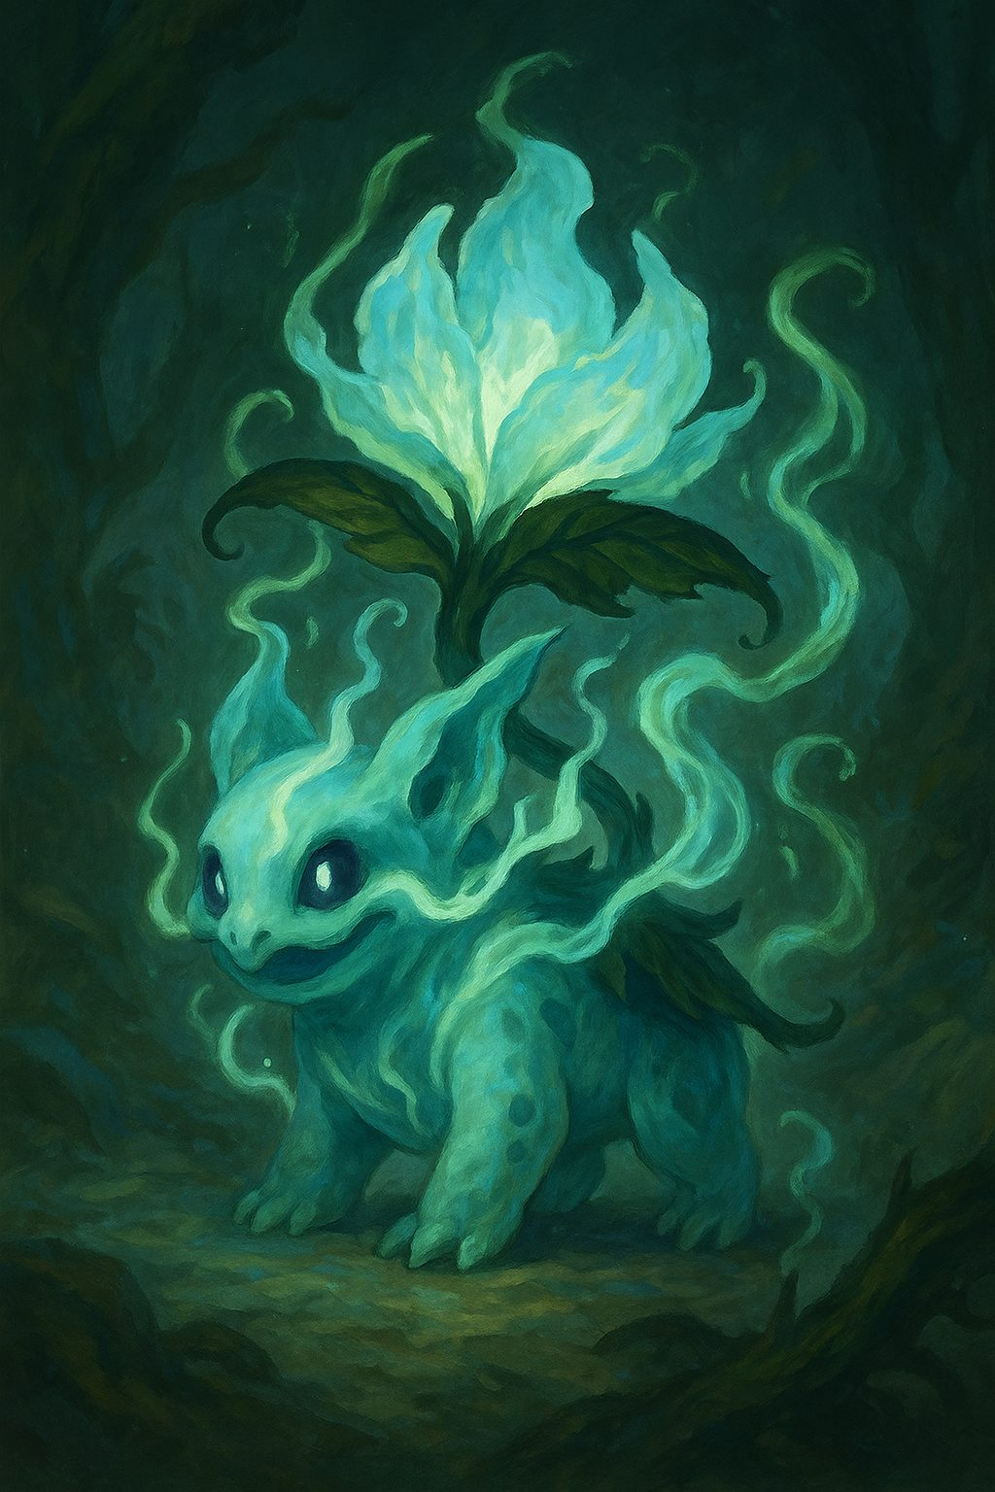
The surf leaves salt on lips and sand in boots. Morning fog burns slowly to pearl as the Guardians of Elaria follow a narrow footpath along wind-gnarled pines, gulls wheeling far below, the whole world smelling of brine and cold green needles. Ahead, where the coast dips into a hollow, lanterns glow through the mist like a braid of ember eyes.
She Wakes Changed
On the path beneath the pines, the sleeping bundle in Ursa's arms stirs at last. Petals unfold, but they are not Floraburst's petals anymore: they are pale and translucent now, like flower glass, and when the sea wind moves through them they chime, a tiny frost-cold music. She lifts free of Ursa's arms and simply stays there, floating at shoulder height, blinking at the fog with eyes full of soft white light. The ghost essence she drew in aboard the Flying Dutchman has finished its long, quiet work: Floraburst has evolved into a creature of the ghost kind. She is new. She is still, unmistakably, their friend.
▶ The sealed roll comes due. The blind essence roll from Session 5 is finally revealed: the d12 gave Ghost. Floraburst evolved into a ghost type by the ghost essence taken from the Dutchman, and nobody at the table knew until she woke.
Lilly, very quietly: “She is not Floraburst now, is she. Look at her. She is like a bloom made of ghost-light.” The little creature chimes, pleased, and turns a slow circle in the air. And so, on a fog-bound footpath above the sea, she is named: Ghostbloom. All that day, and all the strange night to come, her glow leans gently toward trouble, the way a compass leans north.
Lantern Night
The footpath crests a rise, and the village of Wraithpine pools below in a hollow of slate roofs and cedar eaves. Pumpkins watch from every doorstep. Paper moons and cat masks sway above a square of harvest stalls, steam rises from copper kettles, and a fiddle finds its first notes. The air is cider, beeswax, damp leaves. It is Lantern Night, the village's own festival, and everything about it is warm and bright and welcoming.
Almost everything. As boots cross under the first lantern arch, a pressure pricks at the ears, like a mountain pass without a mountain. A thin note is drifting through the chimney flues and cellar grates. Wind, perhaps. Or the tail of a song that refuses to end.
▶ Group Wisdom save, DC 13, the first time the thin note finds their ears. On a miss, one small fresh memory slips away, just enough to feel wrong; on a success, an ear-pop and a strange clarity.
The Gasping Gull
The Gasping Gull throws wide its shutters and its hearth breathes softly. Behind the bar, the keeper, Maera, wipes an already spotless counter and calls out, “Finally, rush hour! Squeeze in where you can!” The room holds exactly three customers and one old spaniel asleep by the stove: Brindle, gray about the muzzle, twitching through comfortable dreams.
The wrongness is quiet, and it is everywhere. Maera sets a fourth place at a table laid for three, without seeming to notice. Twelve bowls of stew steam in her ledger, but two sit cooling on a tray that nobody comes for. Her ledger skips a line, the numbers hopping neatly over the gap as if something had been neatly erased, or neatly never was. Keys for every room gleam untouched on their hooks.

Out in the square it is the same song in different keys. A chandler presses a sugared chip into Lilly's palm, “for remembering,” then blinks, the thought sliding off her face like rain. A curio-mender dusts a bundle of old theater playbills; on one of them a performer's name has been scrubbed so hard the paper has thinned to lace. “Moths,” the mender mutters, and ties the twine tighter. Black ribbons hang everywhere, knotted to gates and wrists and lantern posts, and nobody can quite say why. Villagers forget what they are saying in the middle of saying it.
Ghostbloom drifts near a lantern, and the flame dims, then swells, as if testing harmony with the thin hidden note. In Lilly's pocket, the Essence Sphere gives a heartbeat: two tones seeking each other, failing, seeking again.
The Bellkeeper of Bellshadow
Beneath the belltower, in the old quarter the villagers call Bellshadow, an old man stands apart from the festival with a slate under his arm and beeswax glistening in his ears. His eyes are winter-sharp, the only pair in Wraithpine that seem to be looking at things. He taps his ear. He taps his slate. Then he writes three words with a patient hand and holds them up:
WRITE. DON'T LISTEN.
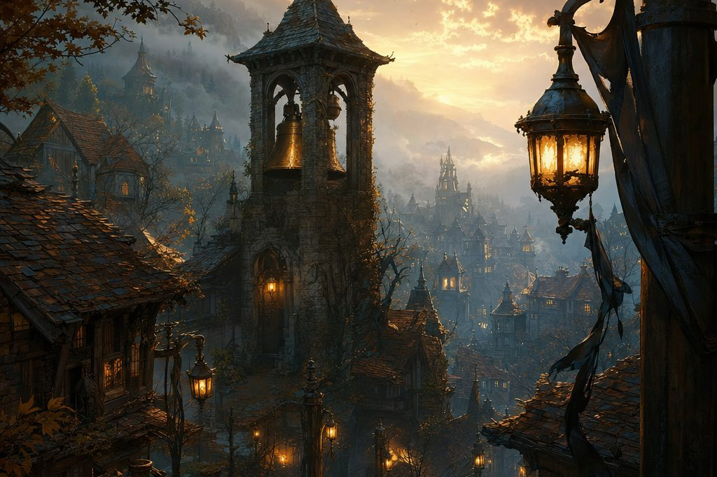
Bellshadow, the old quarter beneath the belltower, where the bellkeeper keeps watch.
Above him the bell gives a single accidental chime. Across the square, in the Gasping Gull, a fourth bowl of stew cools untouched, and Maera smiles at a chair the village cannot quite hold in mind.
Three Tugs at Once
The square pulls at the heroes from three directions at once. Behind the bar, Maera sighs toward the trapdoor: “If only someone would scare the pests from the cellar. Ruined a whole pot this morning.” On the hill path, a couple with black ribbons at their wrists climbs toward the graveyard, flowers in hand and eyes downcast. And along Pumpkin Row, a carver heaves a hay bale toward a waiting cart while two scarecrows watch from their posts with button-bright stares.
▶ Three threads, any order. Let the party choose which thread to pull first; all three point, each in its own way, at the old theater. The song eats clues, so reward heroes who write things down.
Part Two: Three Threads in the Fog
Something was wrong in Wraithpine, and it had left threads hanging everywhere. The heroes pulled three of them: a cellar, a lane of pumpkins, and a hill of leaning headstones.
▶ The clue chain (keep it unbroken). Cellar: a chewed dog collar, a drag mark, a black ribbon thread on the stew pot, and a breathing seam with a hum inside the hill. Pumpkin Row: every carved face turns toward the theater, and the heart-gourd map is stamped PROP ROOM, OLD THEATER. Graveyard: a scraped-away name, a stage-mask maker's mark, and a parcel slip addressed to a man nobody remembers. Those lead to 3 Lantern Lane, then to the bellkeeper (beeswax, and the mouthed words UNDER THEATER), then to the reveal at the Gasping Gull. If the table stalls, escalate in order: the Essence Sphere pulls toward the theater like a compass needle; the chandler murmurs about the black ribbons and the hill; at last the bellkeeper crosses the square himself and presses his slate into a hero's hands.
Maera's Cellar
“If you've stomachs for it,” Maera says, sliding a key from its hook, “give the pests down there a scare. Ruined a whole pot this morning.” The trapdoor groans. Stone steps breathe up a cool draft that smells of earth, spilled stew, and, faintly, the tide. Barrels crouch in the dark like sleeping oxen. Something chitters, and something else answers a half-beat late, like an echo that forgot its place.
Then the burlap sacks erupt. A gray tide of rats hits the floor, claws skittering, a hundred pinprick eyes catching the lantern light, and from the rafters something heavier drops straight for the heroes' shoulders.
▶ The cellar fight. 2 Swarms of Rats and 4 Giant Rats with Pack Tactics, in a tight aisle of barrels and shelves (book statistics; see the appendix note). One swarm lurks in the rafters and drops on a hero's shoulders: DC 13 Dexterity or it lands on you.
▶ Going in. Torch held high: passive Perception 13 notices the flame leaning toward a hairline seam in the far wall, as though the crack is quietly inhaling. Quiet boots: Stealth against the swarms' passive Perception 10 to take position before the rush. Ghostbloom forward: her chiming petals grant advantage on the next Perception or Insight check to clock the seam.
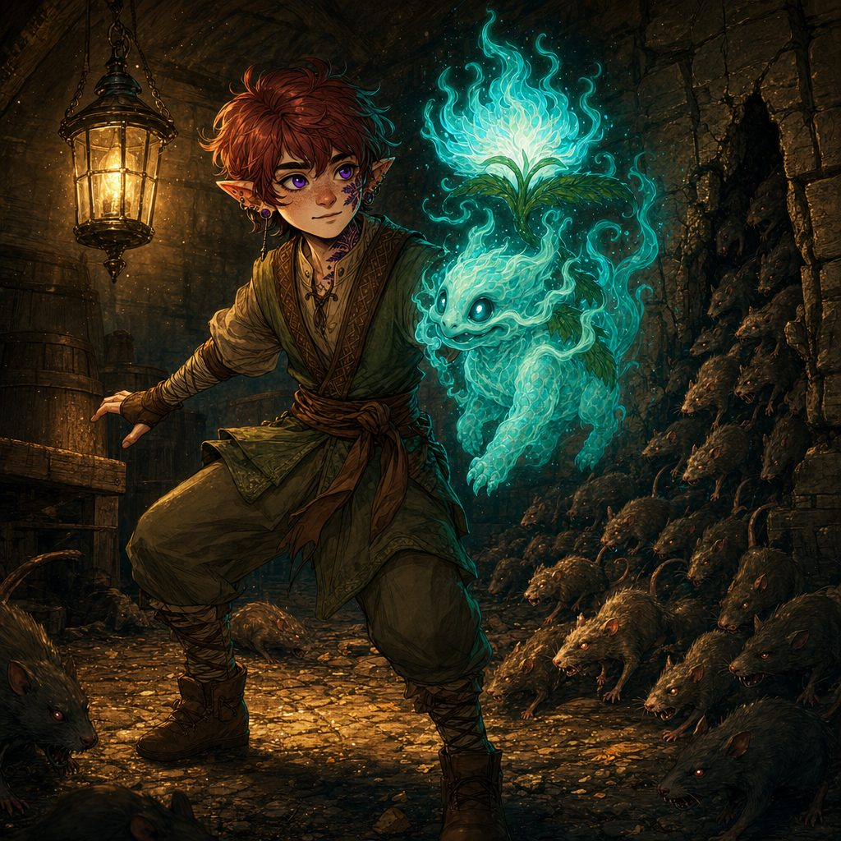
▶ Cellar toys. Shove a shoulder-high cask down the tight aisle (once, Strength DC 12): 1d4 bludgeoning and prone to whatever fails a DC 12 Dexterity save. Pull down the rickety shelf (an Action): an adjacent creature makes a DC 13 Dexterity save or is restrained under broken wood until the end of its next turn.
When the last tail goes still, the cellar gives up its stranger secrets. Under the shelves lies a chewed dog collar. On the prep table a dented stew pot sits with its ladle gnawed to splinters, and a single black ribbon thread clings to the rim, the same black as the ribbons knotted all over town. A thin drag-mark crosses the dust to the far wall, and there, when Ursa holds the lantern close, the flame leans toward a hairline seam in the stone, as though the crack is quietly inhaling. Pressing an ear to the rock, the heroes catch it: a faint humming tone hanging inside the hill like a thread. From above, Maera calls down cheerfully, “Any luck? These old cellars touch caves beneath the town, you know. Wells to the sea. Smugglers' tales.”
Pumpkin Row
Pumpkin Row climbs a low hill between cottages, hay bales stacked two high, jack-o'-lanterns grinning from every fence post and windowsill. As the heroes walk it, the wind dies. Fog pools like spilled milk. A carver's lantern flares, and in that flare every carved face along the lane turns in the same breath, all of them looking toward the dark peak of the old theater roof.
Two scarecrows creak down from their posts. Straw whispers across the furrows and gathers itself into small, hunched walkers with button eyes. The thin note in the fog swells, steady as a bow drawn across the rim of a glass.
✦ PUMPKIN ROW: TURN THE FACES ✦
The straw only walks while the carved faces watch. Three ways to win; the Guardians may mix all three.

Say this plainly. Three big key pumpkins, one on the north post, one on the cart, one on the south post, keep trying to face the theater. Every scarecrow has a coin-sized gourd charm stitched under its ribs. The hay cart could bowl strawlings over, and the pumpkin stack could be kicked down to make a glorious mess.
A. Turn the faces (the puzzle). As an Action, a hero turns or snuffs one key pumpkin, no check needed. While any two key pumpkins face away from the theater at the same time, every scarecrow skips its next turn. Manage it in two different rounds and the magic fizzles: the straw collapses, and the fight is over.
B. Clip the charm. From within 5 feet, snip a scarecrow's heart-gourd, no roll: that scarecrow falls limp on the spot.
C. Fight it out. 2 Scarecrows and 6 Strawlings (appendix), a solid scrap among the flickering jack-o'-lanterns.

The spoils. A clean or clever end earns the carver's bell-handled lantern (1 use: advantage on one Investigation check in Wraithpine while it is lit). A split heart-gourd holds a map scrap with the old theater and the town well circled, stamped PROP ROOM, OLD THEATER.
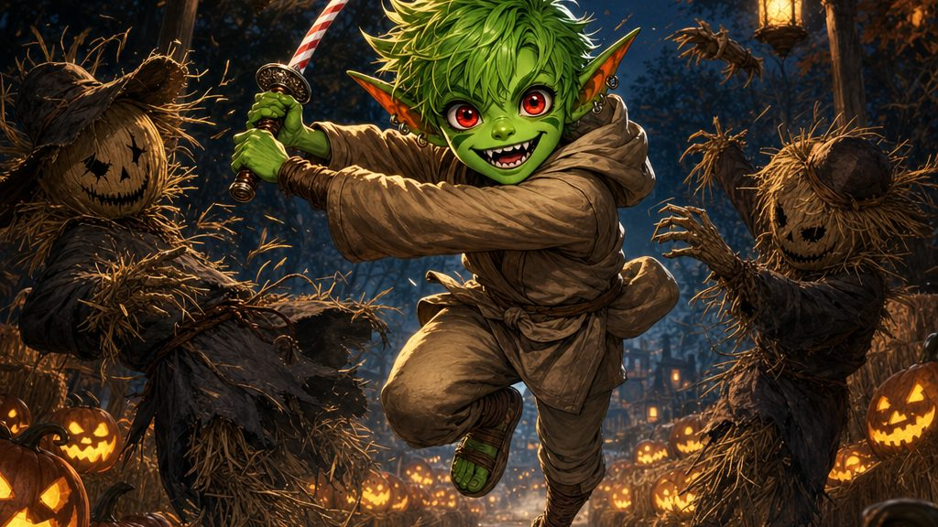
Pumpkin Row: every carved face along the lane turns toward the old theater roof.
It is a wild, whirling scrap among the pumpkins, candy-striped steel flashing, sparks and starlight scattering straw in every direction. When the last strawling collapses into a harmless heap, Stabby cuts open the heart-gourd charm stitched under a scarecrow's ribs. Inside, folded small, is a scrap of a map with the old theater and the town well circled, and a stamp in stage-engraver script: PROP ROOM, OLD THEATER. The shaken carver, freed of whatever had his lane, presses a bell-handled lantern into the heroes' hands in thanks.
The Graveyard: Lay a Ribbon
The path climbs the hill behind Wraithpine into a wind-crooked cemetery ringed by cypress, where headstones lean together like old neighbors sharing secrets and black ribbons hang from the iron gate in neat, whispering knots. Fresh flowers lie on a plot near the crest. The headstone's name line is a scraped scar: someone has carefully chiseled the name away, chisel dust still pale in the letters. In one corner is a maker's mark, small and strange for a gravestone: a stage mask. The blue glass of the bell-handled lantern brightens here, all on its own.
As the heroes study the stone, the churned earth stirs. The recently quiet do not wish to be laid twice, and a pair of the restless dead claw up out of the soil, moaning, drawn to the same wrongness that scraped the name away.

✦ LAY A RIBBON: THE RITE OF THE FORGOTTEN NAME ✦
A grave whose name has been chiseled away will not stay quiet: the dead do not wish to be laid twice. The rite has four steps, and any hero may perform them.

1. Raise the letter ghosts. Rub charcoal across the scraped line: Intelligence (Investigation) DC 12 to make out the ghosts of the letters, faint as footprints in frost.
2. Restore the name. Re-inscribe it with chalk, charcoal, or knife tip, set at the top of the stone the way a rite demands: Intelligence (Religion) or (History) DC 12.
3. Ring the bell. Untie the black thread from the post bell's clapper and ring three times, speaking the name aloud (or a vow to remember). Ring one: the fog shivers. Ring two: the cypresses hush. Ring three: the ground answers with a sigh from deep below.
4. Tie the Remembrance Knot. As an Action: make a loop, wrap twice, pull through once more, so a small tail points toward the sea. A hero who learned Captain Brynn's knots aboard the Stormwind ties it with advantage. If the knot is wrong, the ribbon loosens by itself and coils like a sleeping snake.

If the name is wrong or unknown, the dead stir: 2 Zombies claw free (3 Zombies and 2 Skeletons if the rite is begun loud and careless). Lay them gently down; the rite can always be tried again.
The blessing. When the knot takes hold, the soil settles and the stone warms in the palm. Every hero who took part gains Hold Fast: once this session, advantage on one Wisdom save against forgetfulness or the song.
The heroes put them gently back to rest, and one risen hand, ash-pale, is found clutching a scrap of something stiff. Stabby pries it free: a parcel slip, creased and dirt-stained but legible, made out in tidy ink. To HARLAN WICKE, 3 Lantern Lane. Nobody in Wraithpine remembers any Harlan. Stabby pockets the slip.
▶ [DM CHECK: the original document never records whose grave this is or what name the heroes restored. The stage-mask maker's mark points to a performer the creature took long ago. Any remembered name, laid with care, satisfies the rite.]
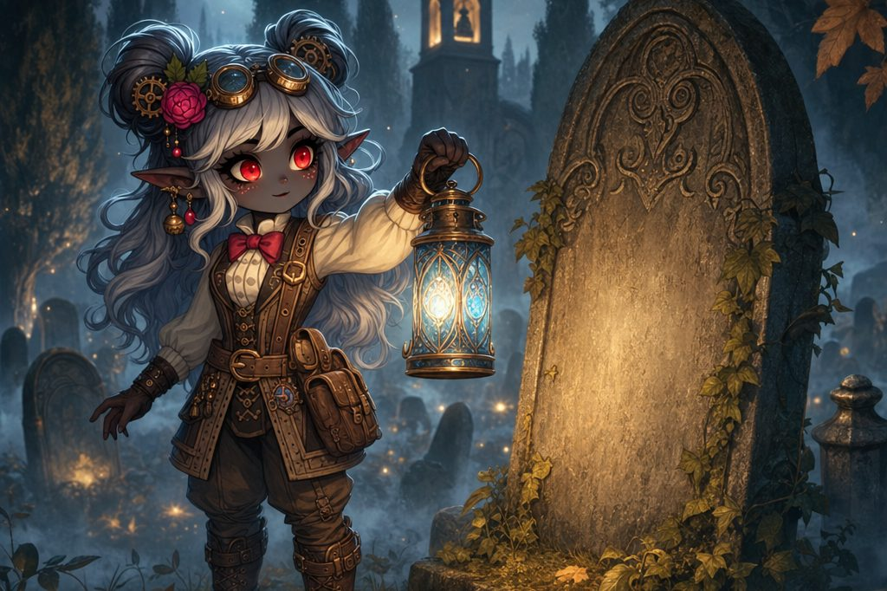
Lilly lights the blue lantern and begins the rite of the forgotten name.
Then they do the older, kinder work. Charcoal rubbed across the blank line raises the ghosts of letters, like footprints in frost. The name is written back where it belongs. The post bell's clapper is untied and rung three times, and at the third ring the ground answers with a sigh from deep below. Last comes the ribbon: loop, wrap twice, pull through, a small tail pointing toward the sea, tied exactly the way Captain Brynn Wavewarden taught them aboard the Stormwind, laughing at their tangles all the while. The knot tightens. The soil settles. For a breath the fog pulls back, and the grave looks ordinary again: just a stone, with a name, remembered.
Part Three: Names the Stone Won't Keep
Three threads, one knot. A cellar that breathed, a field of straw that pointed at the theater, a grave that forgot its name. And in Stabby's pocket, the parcel slip pried from the churned earth of the hill, made out to a man nobody in Wraithpine could remember.
3 Lantern Lane
The parcel slip crinkles in the hand: To HARLAN WICKE, 3 Lantern Lane. The houses on Lantern Lane press close like people whispering. A brass 3 is screwed to a green door, a thin line of light shows under the threshold, and somewhere inside a kettle ticks as it cools. Ms. Wicke opens the door slowly, a small steady woman with a cloth folded in her hands. “Evening. Oh, visitors. Come in, you'll catch cold.”
The room is neat in the obvious ways and wrong in the quiet ones. On a side table sits a family portrait: a woman with wind-tossed hair, two children in matching scarves, and a tall man with a stagehand's smile and coal dust on his cuff. Children's toys sleep in a basket, waiting. And yet one cup and one plate stand washed and drying by a window that looks out on an empty street.
Shown the slip, she reads it twice, and a tremor crosses her face. Ms. Wicke: “Harlan? That's... that is my name, Wicke, yes. But I live alone.” Her eyes travel, snag on the portrait, and skitter away, the way a hand skitters off a hot pan. “You will think me foolish, but most mornings I wake up crying, and I cannot say why. I wash my face and it stops. Then the day begins.” She hands the slip back with a gratitude like a bow. “If you meant to find this Harlan, try the theater; they keep props there, deliveries and such. And please, be careful at night. The fog keeps... thoughts.”
The Belltower
The square is nearly empty now, stalls shuttered, lanterns burning down to puddles of wax. Under the belltower of Bellshadow the old bellkeeper is waiting, as if he knew they would come. “Mouths moving,” he says, too loudly, tapping the wax in his ears. “Can't hear you. Won't hear it, either.” He scratches fast on his slate and turns it around: YOU HEAR THE SONG?
And as if the question summoned it, the note swells, rising through the square like a seam opening, a whistle from two streets away that cannot be placed, a lullaby with no words and no end, pressing gently, gently, on the inside of every skull.
The bellkeeper sees the wobble in their eyes and moves fast, pressing small curls of beeswax into every palm, wax that smells of summer and smoke. He pulls one of his own plugs half out, just long enough to speak, and his voice is grave. “Put it in. All the way. Don't be brave about it. The song is not for bravery.” He reseats the plug, and then he mouths two words, slow and exaggerated, so there can be no mistake: UNDER. THEATER.

✦ THE SONG OF UNREMEMBERING ✦
Something under Wraithpine is singing, and to hear the song is to forget. It has been eating the village one name at a time, and it will happily eat the heroes' clues too. These rules run for the rest of the session.

When the song swells, every hero makes a Wisdom save, DC 13. Failure: one fresh memory slips away, just enough to feel wrong, and the day's clues soften like a dream on waking. Success: a pop behind the eyes, and the sense of something trying to smooth the mind flat.
In battle it is worse. A lone head's hum: start your turn within 30 feet, DC 13 Wisdom save or your attacks that turn have disadvantage. The full creature's song: within 60 feet, DC 15, and failure also locks your reactions until your next turn.
The beeswax remedy. Soft curls of wax, seated all the way in: a plugged hero has advantage on every save against the song, and its hum can never lock their reactions. Do not be brave about it. The song is not for bravery.
The bellkeeper's law: WRITE. DON'T LISTEN. Ink and chalk do not forget. Anything written down (a slate, a ledger, one word on a page) stays true even when minds wobble, and with wax in the ears the writing keeps its edge.
▶ From this moment the heroes wore their beeswax to the very end of the session.
The Reveal at the Gasping Gull
With the beeswax seated, the world sharpens. Lantern light cuts cleaner. The air feels thick, like the moment before thunder. The heroes cross the square to the Gasping Gull, where Maera is laying out bowls and humming, and the moment they step inside they finally, truly, see.
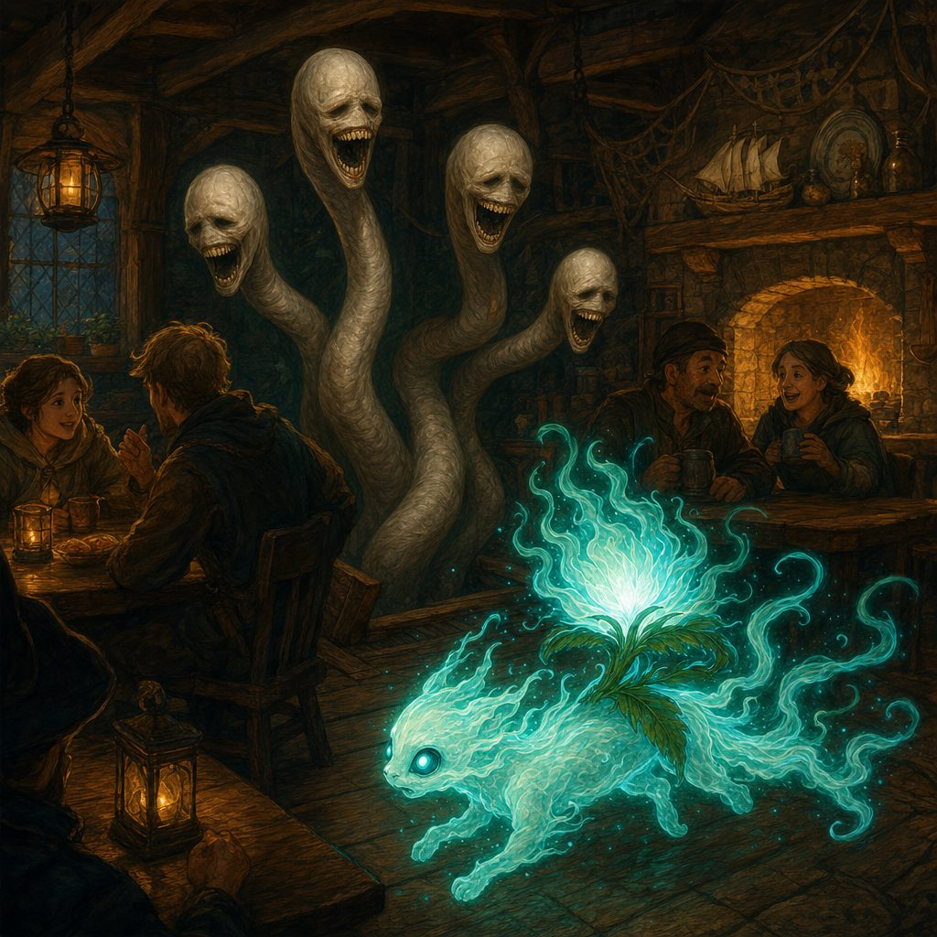
There has always been a head in this room. That is the terrible, simple truth the song has been singing over, night after night. A long pale neck rises out of the open trapdoor behind the bar, and atop it sways a face that is almost a person's face and is not, smooth and calm, with rows of small slate teeth. It has been here all along, drinking up names, and every eye in Wraithpine has slid off it the way Ms. Wicke's eyes slid off her own portrait. Of poor old Brindle there is no sign at all: only his bowl by the stove, and two clean tracks in the dust leading to the trapdoor, and none leading back.
Maera, smiling at her ledger, not looking at the door: “What a quiet night. Sometimes it's nice to hear yourself think.” The head turns. Not toward Maera. Toward the heroes. Its eyes aim at the place where their thoughts are, not the place where their bodies stand.
▶ The tavern fight. One False Hydra Tavern Head (appendix), in a room full of tables, stew pots, and one oblivious innkeeper to keep out of harm's way. It bites, grapples, and drags victims toward the trapdoor; 20 or more damage in a single turn makes it recoil and lose its reactions.
▶ Tavern toys. Kick the stew pot: DC 12 Dexterity or 1d6 fire and disadvantage on the victim's next attack. Flip the long table: half cover for a round, or shove it (Strength DC 13) to pin the neck, restrained until it writhes free. Drop the lantern rack: DC 13 Dexterity or 1d4 slashing, and the burning square puts the head's next attack at disadvantage. Slam the trapdoor on the neck: Strength DC 14, and the head makes a DC 13 Dexterity save or takes 1d6 and loses its reactions until its next turn.
The fight is close and crashing: tables flipped for cover, the neck writhing between the rafters, Ghostbloom's chime splitting the hum like frost splitting stone. Candyfang steel cracks slate teeth, emerald fire skates along the pale neck, and starlight strikes true. With a final shudder the head sags, the light goes out of its wrong eyes, and it is destroyed. Across the room a second pale neck, one nobody had seen, snaps back beneath a loose floorboard and pours itself away down a slime-rimmed tunnel into black stone, and the hum below deepens, like a choir trying to sing through the floor.
Maera stands frozen at the bar, staring at the word LOOK the heroes have written across her ledger, and her breath catches on something with no name left in it. Maera: “Br... where is my...?” The fog tries to soften her eyes again; she grips the bar until it passes. “Forgive me. I... I'll fetch more bowls.”
Part Four: Where the Song Lives
A trail led from the tavern's broken floor into the dark beneath Wraithpine, and the thin note grew into a pressure, a hand laid gently on the inside of the skull. The heroes plugged their ears, lit their lanterns, and followed it down.
The Descent
The tunnel curls beneath the village like a rib: wet timber props, black nails, and, strangest of all, faint chalk marks scrawled on the rock in a stagehand's quick hand: Upstage. Hold. Places. The passage opens at last into the drowned orchestra pit below the Old Theater, crossed by catwalks of beam and rope, stage machines jutting up like broken ribs.
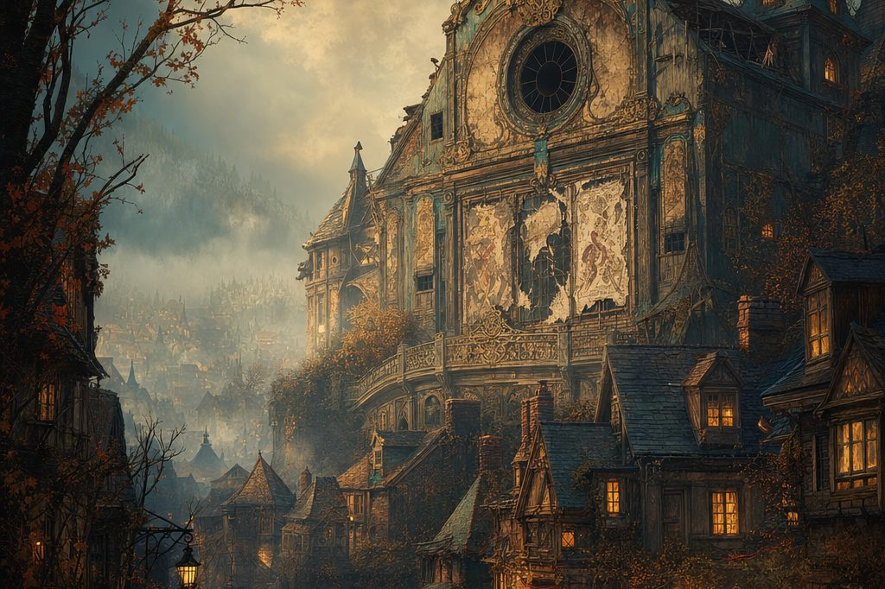
The Old Theater, shuttered and dark, with the song living beneath it.
And in the center, filling the pit, it waits. The False Hydra entire: a pale bulk resting on a mound of remembrances, boots and playbills, keepsakes and ribbons, every ribbon black, with four long necks coiled up through round ports in the theater floor above. The faces at the ends of the necks are almost featureless, calm as sleep. The song pours off the creature in slow waves; even through beeswax the heroes feel it, pressing, patient, asking them nicely to forget they ever came.
On a ledge among the props lies a leather toolbelt with a torn name tag: HARLAN WICKE. Beside it, worn smooth by decades of a workman's pocket, a small carved whistle: Harlan's own, kept since his boyhood, carried all his life. Ursa picks it up and holds it a long moment, and nobody says anything at all.
The Lair Battle
▶ The lair battle. The False Hydra Adult: body plus four heads (appendix). A quiet approach along the high catwalks (Stealth against passive Perception 14) earned a surprise round, and a focused strike from the high ground dropped the first head before the song even turned.
▶ The battlefield. Three elevations: catwalks 10 to 20 feet up, the broken stage at 5 feet, the bone mound below. Four neck-ports open in the theater floor; a head can withdraw and re-emerge from any port on its turn, reaching 15 feet from its hole. Prop flats (AC 12, 12 HP) and sandbag clusters give cover; a pinned neck (table, rope, tackle) needs Strength against DC 14 to writhe free.
▶ Hazards. Rotted beams: DC 12 Dexterity or fall 10 feet for 1d6. Bone scree around the mound is difficult terrain. A pulley cluster can be dropped (Strength DC 13): 2d6 bludgeoning in a 10-foot line.
▶ Lair actions (initiative 20, one per round): Stage Drop, sandbags crash in a 10-foot line, DC 13 Dexterity or 2d6 and prone. Mask of Memory, playbills flutter like moths through a 15-foot radius; an unplugged hero makes a DC 15 Wisdom save or cannot target the body this round. Gasping Vent, a floor grate hisses open: 10-foot radius of difficult terrain where words are muffled and verbal spells need a DC 10 Constitution check.
▶ Vital Link. The body resists weapon damage while heads remain; each destroyed head strips one layer of that protection, and the body acts more often the more heads still sing.
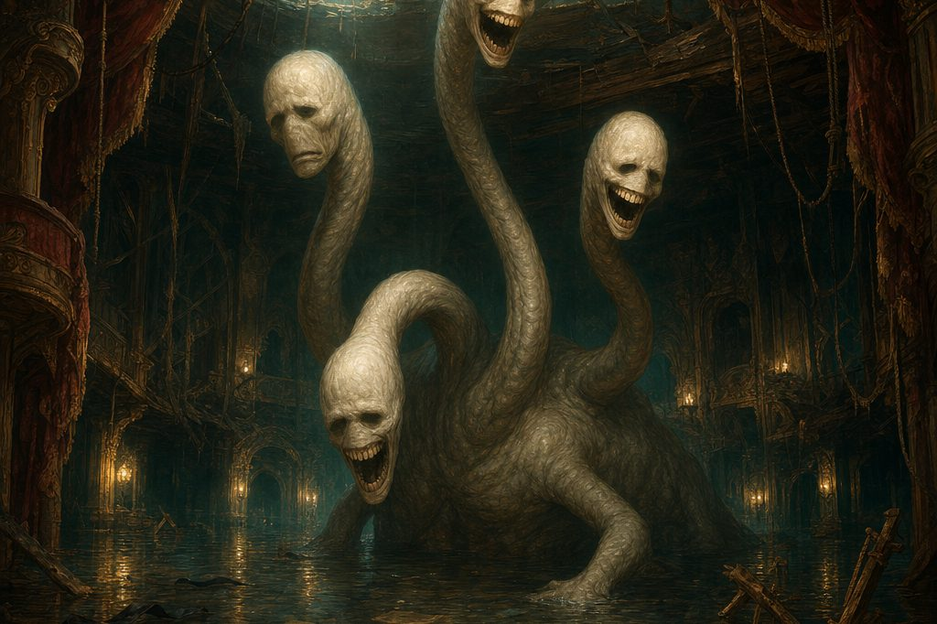
The False Hydra entire, in the drowned orchestra pit below the Old Theater.
It is the hardest fight since the Dutchman. Necks lash up through the floor ports and slither between them, hunting; the mound shifts under pale limbs to open and close the ground; sandbags and pulleys crash down from the fly loft. But the heroes have wax in their ears and a plan in their heads, and one by one, the heads begin to fall. With the second, the song falters, as if someone cut a harmony, and blades bite deeper. With the third, the great body's pale flesh loses its strange stubbornness altogether. Lilly's cannon roars, Stabby dances along a swaying catwalk, Ursa calls down the light of stars this deep place has never seen, and Ghostbloom blazes like a lantern in a window, calling everyone home.
The last head rears back to sing, and the Candyfang Katana and a lance of starlight meet it together. It falls. And the song does not fade. It simply stops, all at once, like a metronome switched off. The great body sinks down into its mound and is still. Air rushes into the space where the note used to live.
The Song Ends
Then the remembering begins. Ribbons all over the lair untie themselves and drift to the floor. Somewhere overhead, muffled through stone, voices rise, bewildered, calling names, more and more of them, a whole village's worth of names flooding back like riverwater breaking a dam. The bell of Bellshadow rings, properly this time, three clean notes. And on the ledge beside Harlan's toolbelt, a ledger page that had lain blank for months finishes its own sentence in tidy ink:
HARLAN WICKE, HOME.
Part Five: The Light Beneath the Earth
The song was dead, the village was waking, and in the quiet under the theater, something golden stirred.
The Chest
As the last echo dies, silence settles thick as velvet, and Ghostbloom's glow changes: not a battle light now, but something gentler, pulsing like a heartbeat. A seam of golden light opens through the settling remains of the mound, and there, half buried, rests a chest bound in vines of silver and root.
Ghostbloom drifts to it first, drawn by an unseen will, the pale flower on her back bending toward the light. She sings, one low melodic tone, and the silver vines part like curtains and the lid swings open: without sound, without resistance, as if it had been waiting all along for exactly this moment and exactly these heroes.
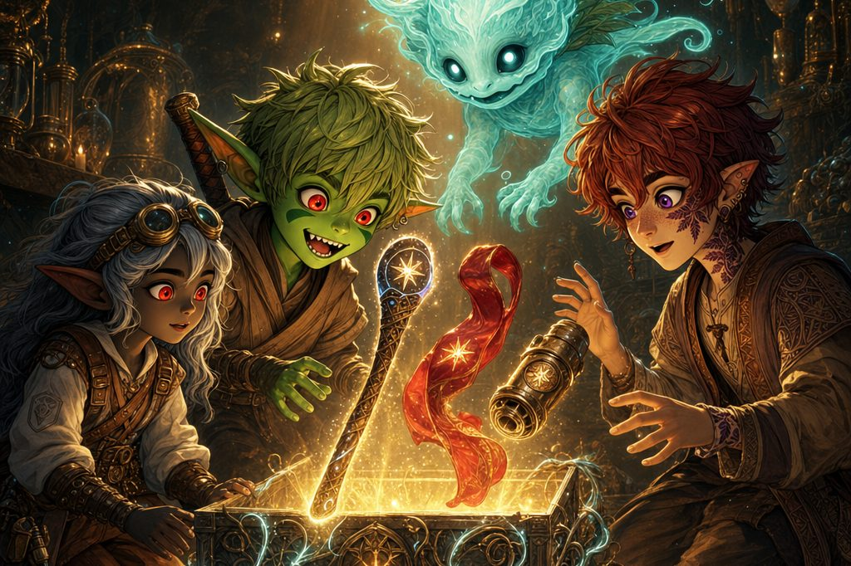
Elaria's gift: the chest bound in silver vines opens without a sound.
Three Relics
Inside rest three objects, each radiating a faint, familiar magic. A slim staff etched with constellations, silver inlays tracing star maps down midnight-dark wood, a crystal glowing softly at its crown: for Ursa. A shimmering crimson sash of rewoven stage-silk that hangs in the air a heartbeat too long when tossed, as if water were holding it up: for Stabby. And a polished brass core, thumb-sized, filigreed with folding micro-gears, humming with the same energy as Lilly's cannon: for Lilly. On each of them, worked small and deliberate, the same sigil: a seven-point star wrapped in a leafed vine. Elaria's mark.
Lilly kneels beside the chest, hands trembling. Lilly: “These aren't ordinary relics. They were made for us.” She looks up at Ursa, eyes wide and glassy with realization. “It is Elaria. She is guiding us. Testing us. Making us stronger.” Ghostbloom lets out a low, melodic tone, and for a heartbeat the golden light swirls upward like petals in a breeze, then fades. The chest turns dull and ordinary, its purpose fulfilled.
REWARDS: THE RELICS OF WRAITHPINE
One chest, three relics: Elaria's gift, opened by Ghostbloom's song beneath the Old Theater. Each bears the same sigil, a seven-point star wrapped in a leafed vine.
Staff of Waking Constellations (Ursa). +1 quarterstaff and druidic focus. 5 charges, regain 1d4 + 1 at dawn: guiding bolt (1 charge), faerie fire (1), moonbeam (2). Starseed. Once per turn, +1d4 radiant damage when Ursa deals radiant damage with a druid spell (house rule: druid spells only). Starlight. Bonus action: 10 ft of dim light; advantage on night navigation. After every great victory, one new star brightens on its haft: the enemy puts stars out; the Staff lights them.
Sash of the Swift Current, Rewoven (Stabby). Scarlet stage-silk rewoven with theater rigging thread. +1 AC (stacks with Unarmored Defense). Fleetstep. +10 ft walking speed. Air Dance. 1/day, bonus action: a fly speed equal to walking speed for 1 minute. Feather Fall. 1/day, no components. Its seven-point star sigil is cupped by a pair of wings.
Glimmerspire Pocket Dynamo, Mk II (Lilly). A thumb-sized brass core filigreed with folding micro-gears, stamped PROP ROOM in stage-engraver script (a mystery unexplained). Pocket Arsenal. Deploy or recall the Eldritch Cannon as a free action. Endurance Overhaul. The cannon lasts 24 hours. Power Sync. The cannon deals +2 damage. Reformat. 1/long rest, as an action: change the cannon's model. Near Ghostbloom, the core glows soft ghost-green, like a stage cue waiting for its moment.

Dawn Over Wraithpine
When the heroes climb back into the world, dawn is breaking, and Wraithpine is waking into grief and gratitude at once. The fog burns away, and with it the gentleness of forgetting. People stand in doorways staring at spaces where loved ones should be, remembering, all at once, everyone the creature took. A man turns over a child's toy he does not remember carving. A woman kneels at the grave on the hill, saying a name that only just came back to her, and the Remembrance Knot holds.
At the Gasping Gull, Maera meets them with shaking hands and dry, clear eyes. Maera: “They're calling it a false hydra. A creature that eats not just people, but the memory of them. All this time we lived with it and never knew. My dog. My friends. I didn't even know what I'd lost.” She wipes her eyes and finds a small, real smile. “Thank you, Guardians. You freed us. And I don't think we will ever forget again.”
And down Lantern Lane comes the morning's one perfect mending: a cart from the next village, and two children in matching scarves tumbling out of it, home from their kin's house where they had stayed through the festival, running up the lane and into their mother's arms. Ms. Wicke holds them so tightly their hats fall off, weeping for Harlan and for joy in the same breath, and this time no fog comes to take the feeling away. Ursa steps forward and presses something small into her hand: Harlan's carved whistle, worn smooth by a lifetime in his pocket, carried up out of the dark. Her children are safe. Their father will be remembered. The family grieves together, which is the only way grief ever gets lighter.
Stabby, watching from the end of the lane, hand resting on the Candyfang Katana: “Let's not stick around for this part.” Ursa nods, glancing east toward the hills where the road winds away. “The road to Gearhaven won't walk itself.”
✦ ✦ ✦
And so they went, past the village, past the graves, following the rising sun, three heroes with three star-marked relics and one small ghost-light friend sailing along above their packs. Wraithpine rang its bell behind them, three clean notes, remembering. The Guardians of Elaria walked east, guided, it seemed, by something greater than fate.
Next: Session 7, in which the heroes reach Gearhaven, the clockwork city, where the Essence Sphere's makers have answers, a locksmith has a ten-year secret, and the stars themselves turn out to be part of the story.
APPENDIX
DM Run Sheet: The Day at a Glance
Every DC, dial, and spotlight, in play order. Keep this page at your elbow.
The Shape of the Session
▶ One day and one night in Wraithpine. Landfall: GHOSTBLOOM WAKES (the sealed d12 from Session 5 pays off: Ghost) → Lantern Night: the wrongness tour, the first song save, the bellkeeper's slate (WRITE. DON'T LISTEN.) → THREE THREADS, any order, all pointing at the old theater: the cellar (FIGHT 1 + the breathing seam), Pumpkin Row (FIGHT 2, or the puzzle win) and the graveyard rite (FIGHT 3 only if it goes wrong; the parcel slip) → 3 Lantern Lane (Ms. Wicke) → the belltower: BEESWAX in every ear → the reveal at the Gasping Gull (FIGHT 4) → the descent → the lair (BOSS) → the song stops: the chest, three relics, dawn over Wraithpine. Natural break point: the belltower.
RUNS ALL SESSION: the Song of Unremembering. Whenever the song swells, every hero makes a Wisdom save, DC 13 (fail: one fresh memory slips). In battle: a lone head's hum is 30 ft, DC 13 Wis or attacks at disadvantage; the full creature's song is 60 ft, DC 15, and failure also locks reactions. BEESWAX = advantage on every save and no reaction lock. Ink and chalk do not forget: anything WRITTEN stays true.
Fights at a Glance
FIGHT 1: Maera's Cellar (Easy; a warm-up hiding a clue). 2x Swarm of Rats (AC 10, HP 24; resist B/P/S; Bites +2, 2d6, or 1d6 at half HP) + 4x Giant Rat (AC 12, HP 7; Pack Tactics; Bite +4). One swarm drops from the rafters: DC 13 Dex or it lands on a hero's shoulders. Toys: shove the cask (Str DC 12: 1d4 and prone, Dex DC 12), pull the shelf (an action: Dex DC 13 or restrained). The real prize: torch held high, passive Perception 13 clocks the breathing seam in the far wall.
FIGHT 2: Pumpkin Row (Medium; three ways to win, let the kids mix all three). 2x Scarecrow (AC 11, HP 36; VULNERABLE FIRE; Terrifying Glare DC 11 Wis, frightened) + 6x Strawling (AC 12, HP 11; Straw Lash grapples, escape DC 12). THE RULE: the straw only walks while the carved faces watch; turn key pumpkins (an action, no check): two facing away skips every scarecrow's turn, twice in different rounds ends the fight; a clipped heart-gourd drops a scarecrow, no roll. Spoils: the bell-handled lantern (1 use) and the PROP ROOM map scrap.
FIGHT 3: The Graveyard Risen (Easy; happens only if the rite goes wrong). 2x Zombie (AC 8, HP 22; Undead Fortitude: Con save, DC 5 + damage taken) if the restored name is wrong or unknown; 3x Zombie + 2x Skeleton (AC 13, HP 13; VULNERABLE BLUDGEONING) if the rite is begun loud and careless. The rite: Investigation DC 12 → Religion or History DC 12 → three rings → the Remembrance Knot (advantage for Brynn's students). Payout: HOLD FAST, advantage on one Wisdom save against the song, once this session.
FIGHT 4: The Tavern Head (Hard; the reveal is the point). 1x False Hydra Tavern Head (AC 14, HP 70; hum: 30 ft, DC 13 Wis or attacks at disadvantage, beeswax = advantage; Bite +6, grapple escape DC 14, then Lurch and Drag toward the trapdoor and Wrench, Str DC 14). 20+ damage in a single turn = it recoils and loses reactions; fire puts its next attack at disadvantage. Toys: stew pot, long table, lantern rack, slam the trapdoor (Str DC 14). Keep Maera out of harm's way; the second neck ALWAYS escapes down the tunnel.
BOSS: The False Hydra Entire (the hardest fight since the Dutchman). Body (AC 15, HP 130) RESISTS ALL WEAPON DAMAGE while heads live; Vital Link: each dead head strips one layer. 4x Head (AC 14, HP 45; reach 15 ft from a floor port; withdraws and re-emerges from any port). Song: 60 ft, DC 15 Wis or disadvantage and no reactions (beeswax: advantage, no lock). Lair actions on initiative 20 (Stage Drop / Mask of Memory / Gasping Vent); legendary actions one per living head, max 3 a round. Catwalk Stealth vs. passive 14 buys a surprise round. Kill heads first.
The Resource Picture
▶ One long day and night with no long rest inside it, so the spend is hit points, Wisdom saves, and nerve rather than slots. BEESWAX is the resource that actually matters: seat it at the belltower and the song mostly stops taxing the table (do not let anyone be brave about it). HOLD FAST from the graveyard rite banks one more save; the bell-handled lantern is one Investigation with advantage in Wraithpine. If the party wants a breather, the natural short rest sits after the belltower: the tavern head and the lair land back to back. Lilly's cannon runs all day; watch Ursa's concentration in the lair (one thing at a time) and Stabby's focus across as many as five fights.
Spotlights & Seeds: every kid shines, every door gets planted
Lilly: she names GHOSTBLOOM on the landfall path (“a bloom made of ghost-light”) → the chandler's sugared chip, “for remembering” → the Essence Sphere's heartbeat; it pulls toward the theater when the table stalls → emerald fire along the pale neck in the lair → at the chest, the session's thesis is hers: “They were made for US. It is ELARIA.” (Door: Elaria's guidance) → her new Dynamo core is stamped PROP ROOM (Door: a mystery nobody explains).
Stabby: he carries the clue chain: he cuts the heart-gourd open (the PROP ROOM map scrap) and pries the parcel slip from a risen hand and pockets it → Candyfang steel cracks the slate teeth at the Gull → the last head falls to the Katana and a lance of starlight together → at dawn, “Let's not stick around for this part”: let him keep the goodbye light. The Sash of the Swift Current is his.
Ursa: Ghostbloom wakes in his arms → his lantern finds the breathing seam in the cellar → the rite is his kind of work: the knot ties with advantage for anyone Captain Brynn taught → he picks up Harlan's whistle in the lair and says nothing at all → starlight this deep place has never seen → at dawn he presses the whistle into Ms. Wicke's hand: the session's heart, let it land. The Staff of Waking Constellations is his (Door: a new star after every victory).
Foreshadow Tracker: say it, then say it again
▶ The tells, in order. The thin note under the festival (the first DC 13 save) • Maera's fourth place at a table laid for three; two cooling bowls; a skipped ledger line • black ribbons on gates and wrists, and nobody can say why • the playbill name scrubbed to lace (“moths”) • the slate: WRITE. DON'T LISTEN. • Ghostbloom's glow leaning toward trouble; the Essence Sphere's heartbeat • every carved face turning toward the theater; the PROP ROOM stamp • the chiseled gravestone with a stage-mask maker's mark • the parcel slip: HARLAN WICKE, 3 LANTERN LANE • Ms. Wicke's eyes skittering off her own portrait • UNDER. THEATER. • the second neck escaping the Gull • chalk stage-marks in the tunnel: Upstage. Hold. Places.
APPENDIX
Bestiary: Enemy Stat Blocks
All five encounters of Session 6, in the order the party meets them.
ENEMIES, Fight 1: Maera's Cellar
The Gasping Gull cellar ✦ Difficulty: Easy ✦ 2x Swarm of Rats + 4x Giant Rat
SWARM OF RATS  Medium swarm of Tiny beasts, unaligned ✦ CR 1/4 (50 XP) ✦ 2 in the cellar  AC 10 HP 24 (7d8 - 7) Speed 30 ft  STR 9 DEX 11 CON 9 INT 2 WIS 10 CHA 3  Resist bludgeoning, piercing, slashing  Imm. charmed, frightened, grappled, paralyzed, petrified, prone, restrained, stunned  Senses darkvision 30 ft, passive Perception 10  Challenge 1/4 (50 XP)  Traits  Keen Smell. The swarm has advantage on Wisdom (Perception) checks that rely on smell.  Swarm. The swarm can occupy another creature's space and vice versa; it cannot regain hit points or gain temporary hit points.  Actions  Bites. Melee Attack: +2 to hit, reach 0 ft, one creature in the swarm's space. Hit: 7 (2d6) piercing damage, or 3 (1d6) if the swarm is at half its hit points or below. | GIANT RAT  Small beast, unaligned ✦ CR 1/8 (25 XP) ✦ 4 in the cellar  AC 12 HP 7 (2d6) Speed 30 ft  STR 7 DEX 15 CON 11 INT 2 WIS 10 CHA 4  Skills Perception +2  Senses darkvision 60 ft, passive Perception 12  Challenge 1/8 (25 XP)  Traits  Keen Smell. Advantage on Wisdom (Perception) checks that rely on smell.  Pack Tactics. Advantage on attack rolls if an ally is within 5 ft of the target.  Actions  Bite. Melee Attack: +4 to hit, reach 5 ft. Hit: 4 (1d4 + 2) piercing damage.

Tactics: One swarm lurks in the rafters and drops straight for a hero's shoulders: DC 13 Dexterity or it lands on you. The rest come as a gray tide down the tight barrel aisle, where Pack Tactics does the work. Fight the room: shove a cask down the aisle (once, Strength DC 12: 1d4 bludgeoning and prone, Dexterity DC 12) or pull down the rickety shelf (an action: Dexterity DC 13 or restrained). The real prize is the hairline seam in the far wall, quietly inhaling, with a hum inside the hill.
ENEMIES, Fight 2: Pumpkin Row
Pumpkin Row ✦ Difficulty: Medium (or no fight at all) ✦ 2x Scarecrow + 6x Strawling
SCARECROW  Medium construct, neutral ✦ CR 1 (200 XP) ✦ 2 in the lane  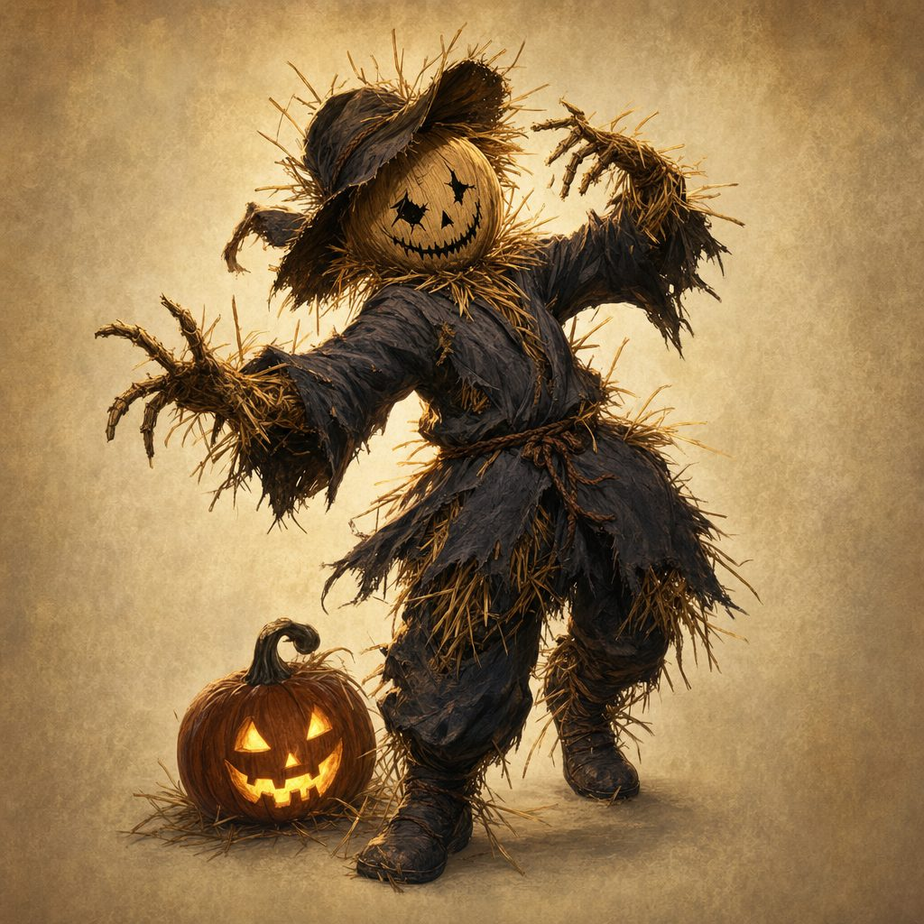  AC 11 HP 36 (8d8) Speed 30 ft  STR 16 DEX 12 CON 11 INT 10 WIS 10 CHA 10  Vulnerable fire Resist nonmagical bludgeoning, piercing, slashing  Imm. charmed, frightened, paralyzed, poisoned  Senses darkvision 60 ft, passive Perception 10  Challenge 1 (200 XP)  Traits  Heart-Gourd Charm. A coin-sized gourd charm is stitched under its ribs. From within 5 ft, a hero can snip it, no roll: the scarecrow falls limp on the spot.  Actions  Terrifying Glare. One creature within 30 ft: DC 11 Wisdom save or frightened for 1 minute (repeat the save at the end of each of its turns).  Claws. Melee Attack: +3 to hit, reach 5 ft. Hit: 9 (2d4 + 4) slashing damage. | STRAWLING  Medium plant, neutral ✦ CR 1/4 (50 XP) ✦ reskinned Needle Blight ✦ 6 in the lane  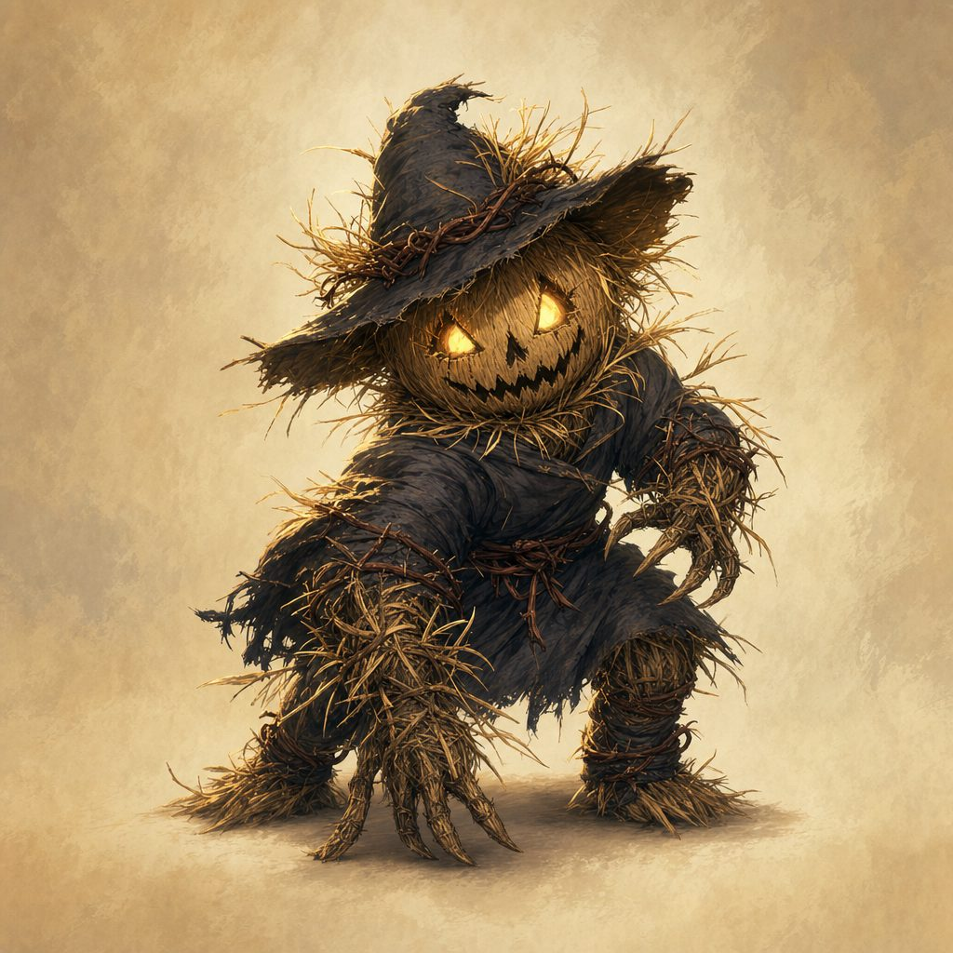  AC 12 HP 11 (2d8 + 2) Speed 30 ft  STR 12 DEX 12 CON 12 INT 4 WIS 10 CHA 3  Senses passive Perception 10  Challenge 1/4 (50 XP)  Actions  Straw Lash. Melee Attack: +4 to hit, reach 5 ft. Hit: 4 (1d6 + 1) bludgeoning damage, and the target must succeed on a DC 12 Strength save or be grappled (escape DC 12).  Chaff Burst. Ranged Attack: +4 to hit, range 30/60 ft. Hit: 6 (2d4) piercing damage (a spray of straw flechettes).

Tactics: The straw only walks while the carved faces watch. Three ways to win, and the Guardians may mix all three: turn or snuff the three key pumpkins (an action, no check; while any two face away from the theater every scarecrow skips its next turn, and managing it in two different rounds collapses the straw for good), clip the heart-gourds, or fight it out among the flickering jack-o'-lanterns. The hay cart bowls strawlings over, the pumpkin stack can be kicked into a glorious mess, and fire is the scarecrows' bad night.
ENEMIES, Fight 3: The Graveyard Risen
The hilltop graveyard ✦ Only if the rite goes wrong ✦ 2x Zombie (3x Zombie + 2x Skeleton if loud and careless)
ZOMBIE  Medium undead, unaligned ✦ CR 1/4 (50 XP)  AC 8 HP 22 (3d8 + 9) Speed 20 ft  STR 13 DEX 6 CON 16 INT 3 WIS 6 CHA 5  Senses darkvision 60 ft, passive Perception 8  Challenge 1/4 (50 XP)  Traits  Undead Fortitude. When damage drops it to 0 HP (unless the damage is radiant or from a critical hit), it makes a Constitution save, DC 5 + the damage taken; on a success it drops to 1 HP instead.  Actions  Slam. Melee Attack: +3 to hit, reach 5 ft. Hit: 4 (1d6 + 1) bludgeoning damage. | SKELETON  Medium undead, unaligned ✦ CR 1/4 (50 XP) ✦ only if the rite is begun loud and careless  AC 13 (armor scraps) HP 13 (2d8 + 4) Speed 30 ft  Vulnerable bludgeoning  Challenge 1/4 (50 XP)  Actions  Shortsword. Melee Attack: +4 to hit, reach 5 ft. Hit: 5 (1d6 + 2) piercing damage.  Shortbow. Ranged Attack: +4 to hit, range 80/320 ft. Hit: 5 (1d6 + 2) piercing damage.

Tactics: These are the recently quiet, not villains: they rise only if the restored name is wrong or unknown, and the bigger roster answers a rite begun loud and careless. Lay them gently back down; the rite can always be tried again. When the Remembrance Knot finally takes hold, every hero who took part gains Hold Fast: once this session, advantage on one Wisdom save against forgetfulness or the song.
ENEMIES, Fight 4: The Reveal at the Gasping Gull
The Gasping Gull ✦ Difficulty: Hard ✦ 1x False Hydra Tavern Head
FALSE HYDRA, THE TAVERN HEAD
Large aberration (one head and neck), unaligned ✦ it has been in the taproom all along
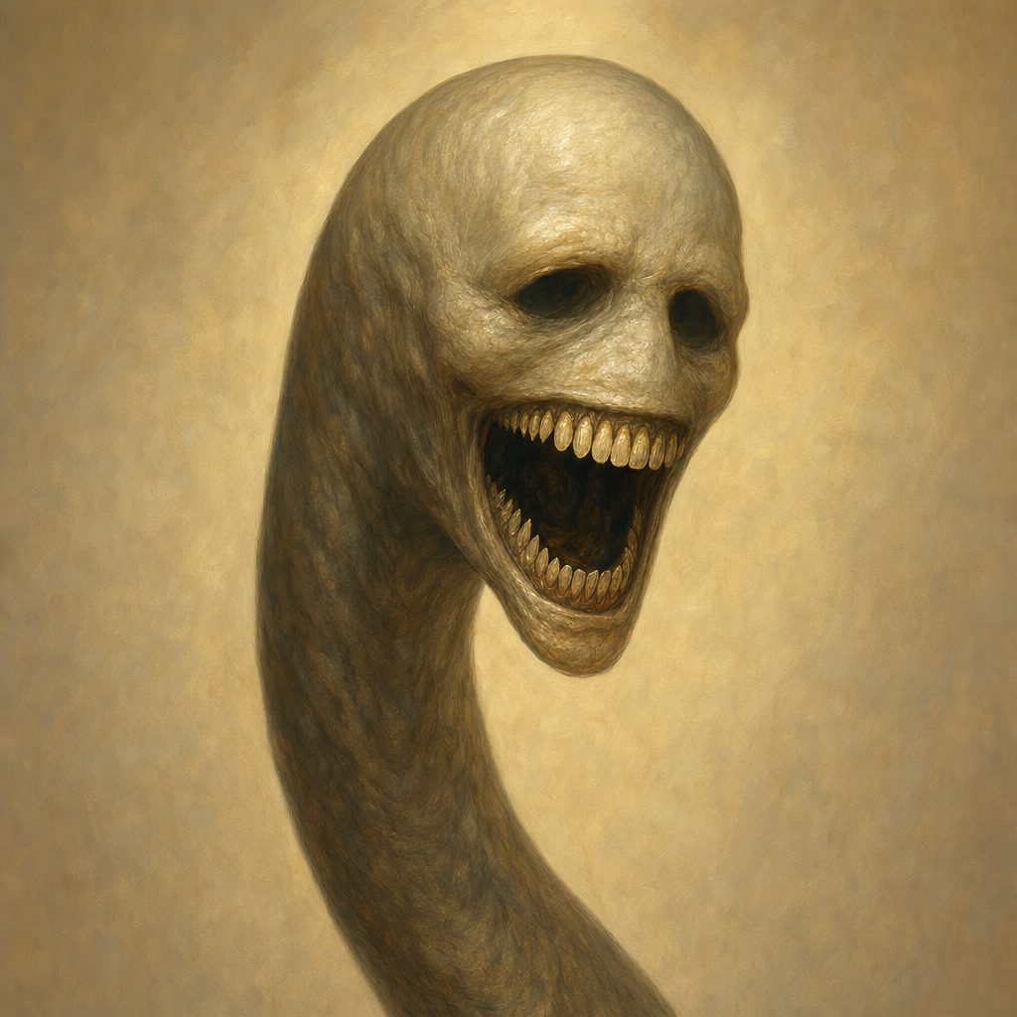
AC 14 HP 70 (9d10 + 18) Speed 10 ft, climb 10 ft
STR 16 DEX 12 CON 14 INT 6 WIS 14 CHA 7
Resist psychic Imm. charmed, frightened, prone
Senses blindsight 10 ft, tremorsense 30 ft, darkvision 60 ft, passive Perception 14
Traits
Mind-Humming Aura. A creature without beeswax that starts its turn within 30 ft makes a DC 13 Wisdom save or has disadvantage on attack rolls that turn; beeswax grants advantage on the save.
Segmented Neck. The head ignores forced movement and prone unless it chooses otherwise. After taking 20 or more damage in a single turn, it recoils 5 ft and loses its reactions until the start of its next turn.
Actions
Bite. Melee Attack: +6 to hit, reach 10 ft. Hit: 13 (2d8 + 4) piercing damage, and the target is grappled (escape DC 14). While it has a creature grappled, the head cannot bite a different target.
Lurch and Drag. The head drags a creature it is grappling 5 ft toward the trapdoor; the creature makes a DC 13 Wisdom save or loses a word or a thought for a heartbeat.
Wrench (Bonus Action). A creature the head is grappling makes a DC 14 Strength save or is knocked prone and takes 5 (1d6 + 2) bludgeoning damage as the jaw grinds it against the floorboards.
Reactions
Recoil from Flame. When the head takes fire damage, it has disadvantage on its next attack roll before the end of its next turn.

Tactics: It bites, grapples, and drags victims toward the trapdoor, and its eyes aim at the place where thoughts are. Fight the room: kick the stew pot (Dexterity DC 12: 1d6 fire and disadvantage on the victim's next attack), flip the long table (half cover, or Strength DC 13 to pin the neck, restrained until it writhes free), drop the lantern rack (Dexterity DC 13: 1d4 slashing, and the burning square puts the head's next attack at disadvantage), or slam the trapdoor on the neck (Strength DC 14; the head saves Dexterity DC 13 or takes 1d6 and loses its reactions). Keep Maera out of harm's way, and when the head dies, the second neck always escapes: the hum below deepens.
ENEMIES, BOSS: The False Hydra
The orchestra pit below the Old Theater ✦ The hardest fight since the Dutchman ✦ 1x Body + 4x Head
FALSE HYDRA, ADULT
Huge aberration, unaligned ✦ the boss of Session 6 ✦ one body, four singing heads
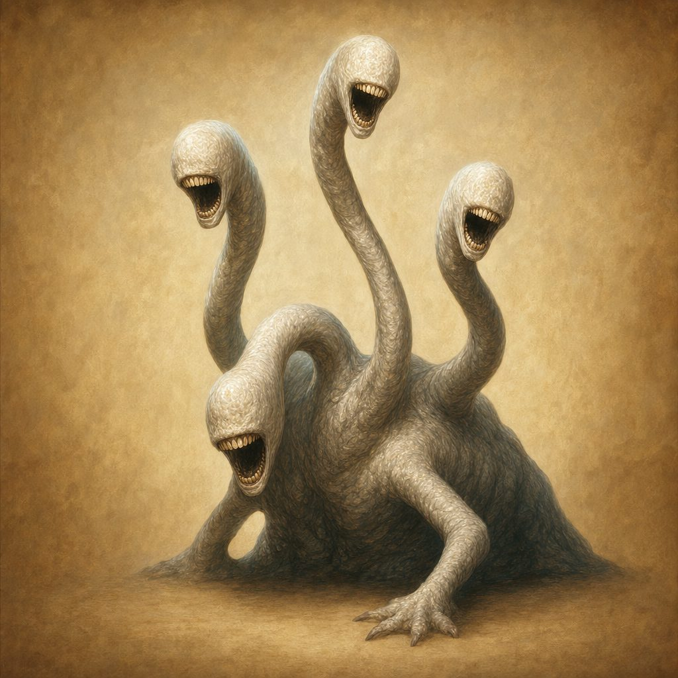
Body: AC 15 HP 130 (12d12 + 48) Speed 10 ft, climb 10 ft
Heads (4): AC 14 HP 45 (6d10 + 12) each Speed 30 ft through the under-floor tunnels, climb 20 ft reach 15 ft from a floor port
Body STR 18 DEX 10 CON 18 INT 7 WIS 14 CHA 8 Saves Con +8, Wis +5 (heads Wis +4)
Resist psychic Imm. charmed, frightened, prone
Senses tremorsense 60 ft, darkvision 60 ft, passive Perception 12
Traits
Song of Unremembering. While any head lives, a creature without earplugs that starts its turn within 60 ft makes a DC 15 Wisdom save or has disadvantage on attack rolls and cannot take reactions until its next turn. Beeswax: advantage on the save, and no reaction lock.
Vital Link. While at least one head lives, the body has resistance to all weapon damage. Each head destroyed removes one instance of this protection; with no heads it has none.
Head Movement. A head may withdraw (no opportunity attacks), move up to 30 ft through the tunnels, and re-emerge from any floor port; a pinned neck (table, rope, tackle) needs Strength vs. DC 14 to writhe free.
Lair Actions. On initiative count 20, one per round: Stage Drop (a 10-ft sandbag line: DC 13 Dexterity or 2d6 and prone), Mask of Memory (playbills in a 15-ft radius: an unplugged hero saves Wisdom DC 15 or cannot target the body this round), Gasping Vent (a 10-ft radius of difficult terrain where verbal spells need a DC 10 Constitution check).
Actions
Thrash (Body). Melee Attack: +7 to hit, reach 10 ft. Hit: 13 (2d8 + 4) bludgeoning damage.
Regurgitate Remnants (Body; Recharge 5-6). A 15-ft cone of bone and cloth: DC 14 Dexterity save or take 13 (3d8) necrotic damage and lose 10 ft of speed until the end of the target's next turn. A shattered skull and a black ribbon clatter free (a clue).
Bite (Head). Melee Attack: +7 to hit, reach 15 ft. Hit: 14 (2d10 + 3) piercing damage, and the target is grappled (escape DC 14); while grappling, that head cannot bite a different target.
Reel (Head). A creature grappled by a head makes a DC 14 Strength save or is pulled 10 ft toward the port and knocked prone.
Reactions
Snap (Head). When a creature moves within 15 ft of a head, that head makes one Bite against it.
Legendary Actions
One per living head, maximum 3 per round, at the end of another creature's turn.
Hum Surge. One creature within 60 ft without earplugs: DC 15 Wisdom save or lose concentration and move only 10 ft on its next turn.
Bone Shift. The body shifts 5 ft and reshapes the mound: one 10-ft square within 20 ft becomes difficult terrain or clears.
Coordinate Strike. One head makes one Bite.

Tactics: A quiet catwalk approach (Stealth vs. passive Perception 14) earns a surprise round; a focused strike from the high ground can drop the first head before the song even turns. Two heads pressure the front line, one hunts the backline, one harasses from a different port; Bone Shift reshapes the ground and Regurgitate Remnants punishes clusters. Hazards: rotted beams (Dex DC 12 or fall 10 ft, 1d6), bone scree, a droppable pulley cluster (Str DC 13: 2d6 in a 10-ft line); prop flats (AC 12, 12 HP) give cover. Kill heads first: each one down quiets the song and thins the body's armor.

