✦ ✦ ✦
THE GUARDIANS OF ELARIA
SESSION 2
The Road to Ravenstone
An illustrated adventure. Read the gold boxes aloud; the purple boxes are for the DM.
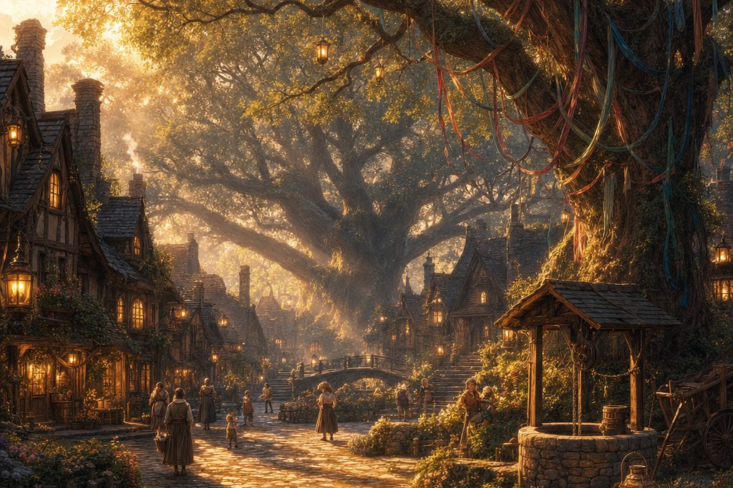
Dawn breaks over Oakshade Village, and the mist lets go at last.
Previously, on The Guardians of Elaria...
Three young heroes collided at the Gilded Acorn Tavern in Eldridge Village: Lilly Glimmergear, a deep gnome artificer carrying the humming Essence Sphere and the sleeping spark of a creature called Pikachu; Ursa Catchum, the star reading son of the vanished druid Ash Catchum; and Stabby Sharpblade, a goblin monk with sharp teeth and a sharper grin. One friendly tavern brawl later, they were a party.
In the Forest of Whispers they befriended Lickgloom, a gentle fey creature with a heroic tongue, bested the leek wielding guardian Duckleaf and the patient water guardian Cognifin, and scattered the fog cloaked Mist Stalkers on the road. Every strange creature left behind a glowing mote: a little piece of another plane, loose in the world. At Oakshade Village, Elder Merwin asked the party to find the young herb gatherers lost in the forest, for fifty gold and the village's gratitude. The heroes slept in warm beds above the Old Oak Tavern. And then, morning.
Part One: Morning in Oakshade
Dawn breaks soft and silver over Oakshade Village. A last ribbon of mist clings to the square, curling around the great ribbon hung oak and the old well beside it. The village is waking: shutters open, chimneys breathe, and folk go about their morning with wary glances at the treeline, as they have every morning since the forest began to whisper.
Down the tavern stairs come four travelers, one of them licking the banister. Behind the bar, Alwen watches them descend with an approving gleam; word of their deeds in Eldridge arrived ahead of them, the way word always does.
Alwen, setting down plates of warm bread and fresh berries: “Mornin', young ones! Word is already spreading about the lot of you. Folk around here could use a touch of bravery, I will say that much.” She leans in, lowering her voice. “Say, you would not be interested in the professor, by any chance? Rumor is you came looking for strange creatures. The professor has got his fair share, and then some. Professor Aelwyn is the name. A peculiar one, that fellow: studies critters and strange energies, trying to understand what has been going on with the forest. He keeps a place called Ravenstone Laboratory out in the wilds, but not many are brave enough to go looking.” She glances toward the square. “If you are truly interested, talk to a few folks here in the village first. Some have seen things, strange things, while he has been poking about.”
The Lost Come Home
Before the last berry is eaten, a shout rings across the square. Then another, and another, and suddenly half the village is running. Through the thinning mist come three young figures with leaves in their hair and empty herb baskets on their arms, blinking at the morning light like children waking from a long nap. The lost herb gatherers have come home: footsore, muddled, and completely unharmed.
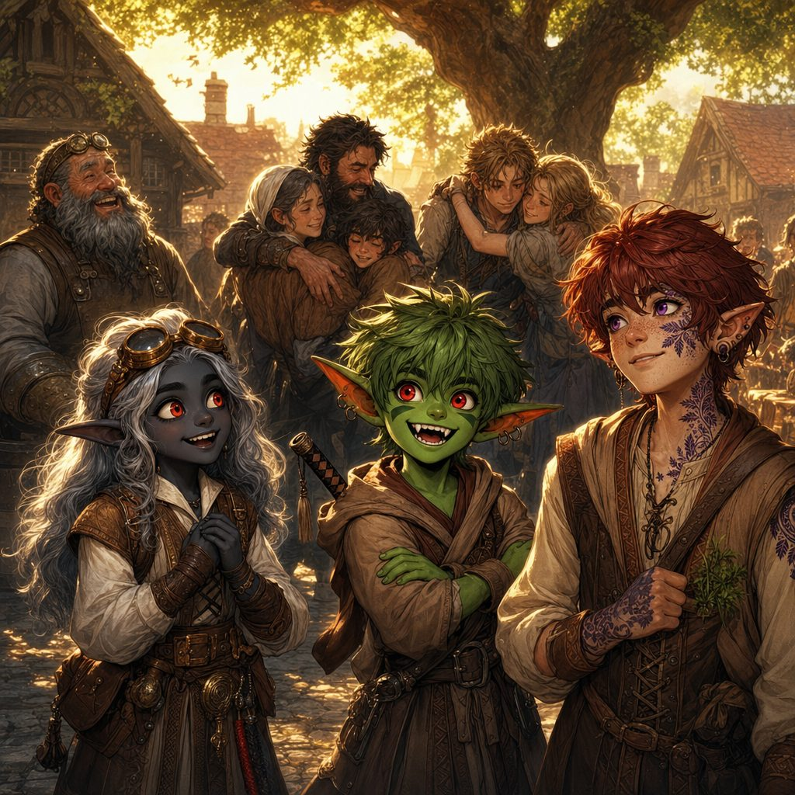
Their story spills out in pieces while mothers cry and neighbors cheer. The forest fog had turned them around, and around, and around; every path bent back on itself, and something in the whiteness kept howling, so they hid. Then last night, all at once, the howling stopped and the fog simply... let go. The paths ran straight again, and they walked out by starlight.
Elder Merwin works it through aloud, one smith's thought at a time. “Last night, you say. The very night these four put down those mist beasts on the road.” He turns to the party, and his weathered face folds into a rare smile. “That fog was no weather. It died with the creatures that wore it. Oakshade owes you more than coin, but coin is what I promised.” And in front of the whole square he counts fifty gold pieces into their hands, proud as if he were knighting them.
▶ Quest closed: the missing herb gatherers came home dazed but unharmed; the misdirecting fog lifted when the Mist Stalkers died. Merwin pays the promised 50 gp.
Whispers in the Square
With the morning suddenly festive, tongues loosen, and the party decides to take Alwen's advice and spend an hour listening. By the central well, Nina the herbalist, elderly and warm, with weathered hands that never stop sorting leaves, waves them over to her stall.
Nina: “It is that forest, see? The air feels different. Heavy. Like it is breathing. I have seen the professor come by in the dead of night, arms full of odd things: stones, jars of glowing water, plants that do not grow here. Says he is studying it. I say it is not for mortal minds to meddle in such things. Lately he goes further out, beyond where the trees are thickest. I only hope he knows what he is dealing with.”
Near the forge, Merwin adds his own measured warning. “Aelwyn is brilliant, no doubt. I would also say he is a tad reckless. Always pushing the boundaries of what is safe to know. If you find him, ask him how far he is willing to go. Tell him to remember what is at stake here. We cannot afford for Oakshade to become a ground for planar... experimentation.”
And at the village edge, a knot of children playing tag stops mid game. A bright eyed girl darts over. “You are looking for the professor, are you not? We see things at night. Creatures. Glowing lights. Some of them talk, even though there is nobody there. My mom says it is just stories, but we saw it with our own eyes: a floating shadow, whispering in the trees.” Another child pipes up: “One of them looked like a giant fox, all made of sparks! And another like a... like a big fluffy cloud!” The children trade uneasy looks and scatter back to their game.
Tamsin's Map
As the party compares rumors by the well, a half elf woman with a heavy satchel and a determined look crosses the square to meet them. “You are asking after the professor,” she says, scanning the rooftops as if the words might carry. “My name is Tamsin. I work with him. Sort of.”
Tamsin: “Professor Aelwyn studies what is happening out here, things most people would not dare go near. He believes the planar boundaries, the thin walls between our world and others, are shifting. Letting things through. He has been collecting samples, researching the... anomalies. Lately it has become an obsession. I could mark the laboratory on your map, if you are set on going. But I warn you: the road is not safe.” The party is set on going. She unrolls their map on the well stones and marks a spot in the western wilds: Ravenstone Laboratory. “Follow the western path and watch for the fork. When you start feeling like the trees are watching you, you are almost there.” Her grim smile fades. “The professor says the creatures are harmless. But I have seen how some of them act. Like they are protecting something. Whatever is happening, it will not stop here.”
The party shoulders their packs in the bright morning square. Alwen waves from her doorway: “Good luck to you! And watch out for the strange ones out there!” Lickgloom flicks its tongue at a butterfly, misses, and trots after its friends, and Oakshade watches its newest heroes walk west into the trees.
Part Two: The Western Road
Fifty gold richer and one mystery deeper, the party followed Tamsin's map into the wilds, where the road itself seemed to grow stranger with every mile.
The Mudskip Ambush
Half a mile out, the forest thickens and the path turns soggy underfoot. Little streams wander across the trail, the air hangs humid and close, and somewhere nearby water bubbles where no stream should be. The trees open on a clearing pocked with shallow pools of murky brown water.
One of the larger pools ripples. Not the way wind ripples water: the other way. Then three creatures burst from the mud in a fan of brown spray, part salamander, part fish, slick and blue green, with fin feet, waggling tails, and wide grins full of tiny needle teeth. Their eyes gleam with mischief and a flicker of light that does not belong to this world. Mudskips: creatures of the Plane of Water, slipped through the thinning walls, and absolutely delighted to see travelers.
▶ The ambush. Three Mudskips (CR 1/2 each, appendix). The mud is difficult terrain for everyone but them: they dart in, splash, and dive back into the pools, flanking through the water to isolate whoever moves slowest. Resistant to fire, vulnerable to lightning: the fire tricks Lilly and Ursa lean on need rethinking.
▶ Terrain that fights back. Each Mud Splash (15-foot cone) leaves fresh slick ground behind, reshaping the battlefield round by round; a hero blinded by the spray fights the terrain as much as the ambushers.
▶ Talk, flee, or scale. A hero who tries talking (or splashing back) can tell the Mudskips are confused, displaced far from the Plane of Water: mischief, not malice. If the party withdraws to dry ground, the Mudskips do not pursue past their pools. Too easy? A fourth Mudskip surfaces from a hidden pool. XP: 100 each (300 total).

The fight is half battle, half mud wrestling. The Mudskips spit gobs of muck, slap with their tails, and skate across the wet ground while the heroes' boots sink and stick. Stabby goes down face first exactly once and comes up spitting mud and declaring war. But Lilly's sparks find the water, Ursa's magic pins the pools, and one by one the giggling ambushers are beaten, until the last Mudskip collapses into a plain brown puddle with an almost apologetic blorp.
Where each creature fell, a small mote of water energy rises, pulsing with faint blue light, hovering just long enough to be seen before it thins into the air. The pattern from the Forest of Whispers holds: the strange creatures are not invaders. They are leaks. Lilly bottles a few samples of the shimmering elemental mud; the professor, she suspects, will want to see this.
▶ Intelligence (Arcana) or Wisdom (Nature) DC 13: the motes are fragments of elemental energy from the Plane of Water, more proof the boundaries are weakening. On a failure the motes thin away before anything can be read; Professor Aelwyn can identify the samples later. Loot: Elemental Mud Samples for the professor.
For a mile or two the road is kind. The party hauls itself back onto dry ground, Stabby scraping mud from his ears and loudly declaring the marsh his sworn enemy, and there is a little while of easy walking and easier laughter, the warm quiet of friends who have just won something together.
The Grimfang War Band
Beyond the marsh the path narrows, dense brush pressing close on either side: the kind of road that makes a traveler's neck prickle. The birdsong stops. A branch cracks. And then the brush is full of eyes.
Goblins melt out of the shadows on every side, rough faced and hostile, weapons ready. With them come worse things: a snarling worg straining to pounce, a thick shouldered orc with a club like a fence post, and a hobgoblin settling a crossbow on a branch further back. At their center stands a stocky goblin boss with a scar across his face, and when his eyes find Stabby, he grins like a trap snapping shut. These are the Grimfang, a rival clan with an old grudge against Stabby's people.
Grimfang boss: “Well, well. If it is not one of the Bloodfang Clan, wandering far from home! You are bold, bringing friends. Shame they will make such a tasty meal!”
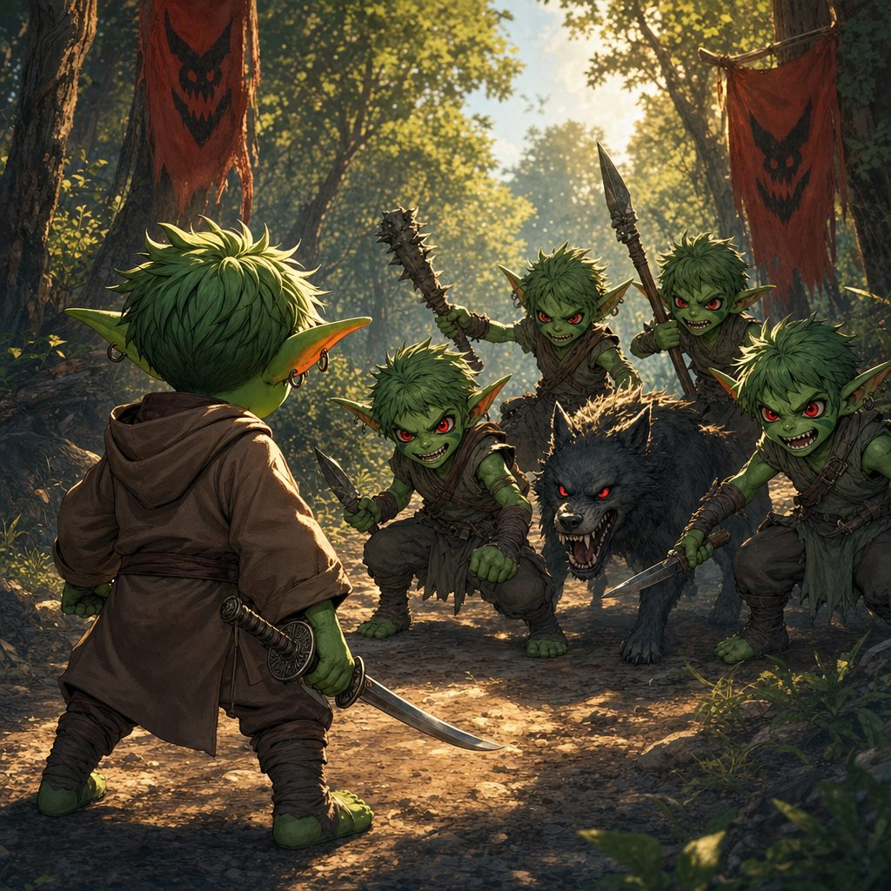
▶ The Grimfang war band: 2 goblin archers on the flanks, a worg and an orc in the melee, a hobgoblin sniping from the rear, and a goblin boss barking orders. The boss coordinates: archers focus the party's back line while the worg and orc press the front, and the hobgoblin's covered position hands Stabby a perfect chance to catch an arrow out of the air with Deflect Attacks. The boss taunts Stabby about the Bloodfang all through the fight. Beaten, the survivors flee.
▶ If it goes wrong. The Grimfang want to humble the Bloodfang runaway, not finish anyone: fallen heroes wake at the roadside, bruised and lighter by their shiniest valuables, with goblin laughter fading in the brush. If you track XP, award standard 2024 Monster Manual values for the roster.
The ambush is coordinated, vicious, and very unlucky in its choice of victims. Arrows hiss from both flanks; Stabby plucks one out of the air an inch from Lilly's hat and twirls it like a prize. The worg lunges and meets Ursa's magic head on. The orc swings his great club in whistling arcs while the boss dances behind him, shouting insults about the Bloodfang Clan, about weakness, about the little monk who left. Stabby's grin never moves. His feet do. Between the monk's flashing strikes, the artificer's crackling bolts, and the druid's starlight, the war band's courage leaks out of it like sand from a torn sack.
The boss is last, back pedaling, still snarling. “This is not over, Bloodfang!” he spits, and then the Grimfang are gone into the brush, dragging their pride behind them. The party stands a long moment in the quiet. Stabby picks up the arrow he caught and tucks it in his sash, and says nothing at all about home.
Part Three: The Whispering Glade
Bruised, muddy, and victorious twice over, the party pressed on as the sun sank low, and the road repaid them with wonder.
Toward sunset the path opens into a serene clearing the Oakshade folk call the Whispering Glade. Ancient trees ring it round, their leaves rustling softly in air that holds no wind at all, so that the whole glade seems to murmur. At its center stands an old stone monument, cloaked in moss, carved with runes that glow faint as embers.
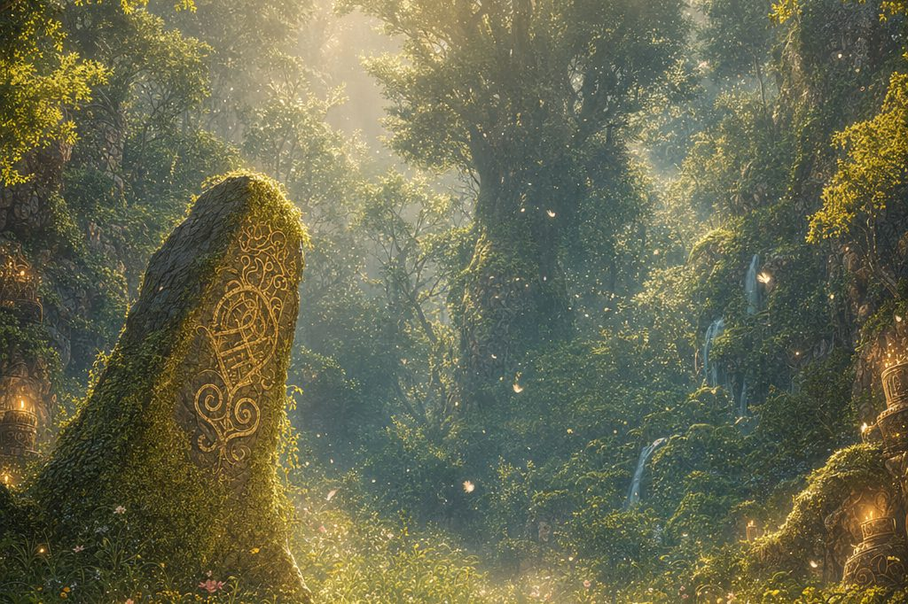
The Whispering Glade murmurs in windless air around its rune carved monument.
A calm settles over the party the moment they step inside. Time feels slower here; the forest's sounds arrive muffled, as if from another room. Then, one by one, strange things begin to hum. The Essence Sphere in Lilly's arms wakes with a soft glow and a note like a struck glass. The three enchanted potatoes in Ursa's pack grow warm as fresh bread. And along Ursa's arm, his Dragonmark tingles, the way it does when something living and frightened is near. But nothing here is frightened. Something here is waiting.
Ursa feels the pull before he understands it: a quiet insistence, drawing his hand toward the monument. When his palm touches the mossy stone, the runes flare to life, gentle light washing across the glade. The Sphere answers in Lilly's arms. The potatoes pulse, all three in unison, like little buried heartbeats. And the world folds softly away.
The Vision of Elaria
The glade is gone. The party stands together in a vast, ethereal expanse of swirling mist and drifting lights, and out of the luminescence a figure gathers: a radiant being woven of intertwining vines, starlight, and flowing water, vast and gentle at once, her eyes holding the depth of the night sky. This is Elaria, and though none of them has ever heard her name, all of them somehow know it.
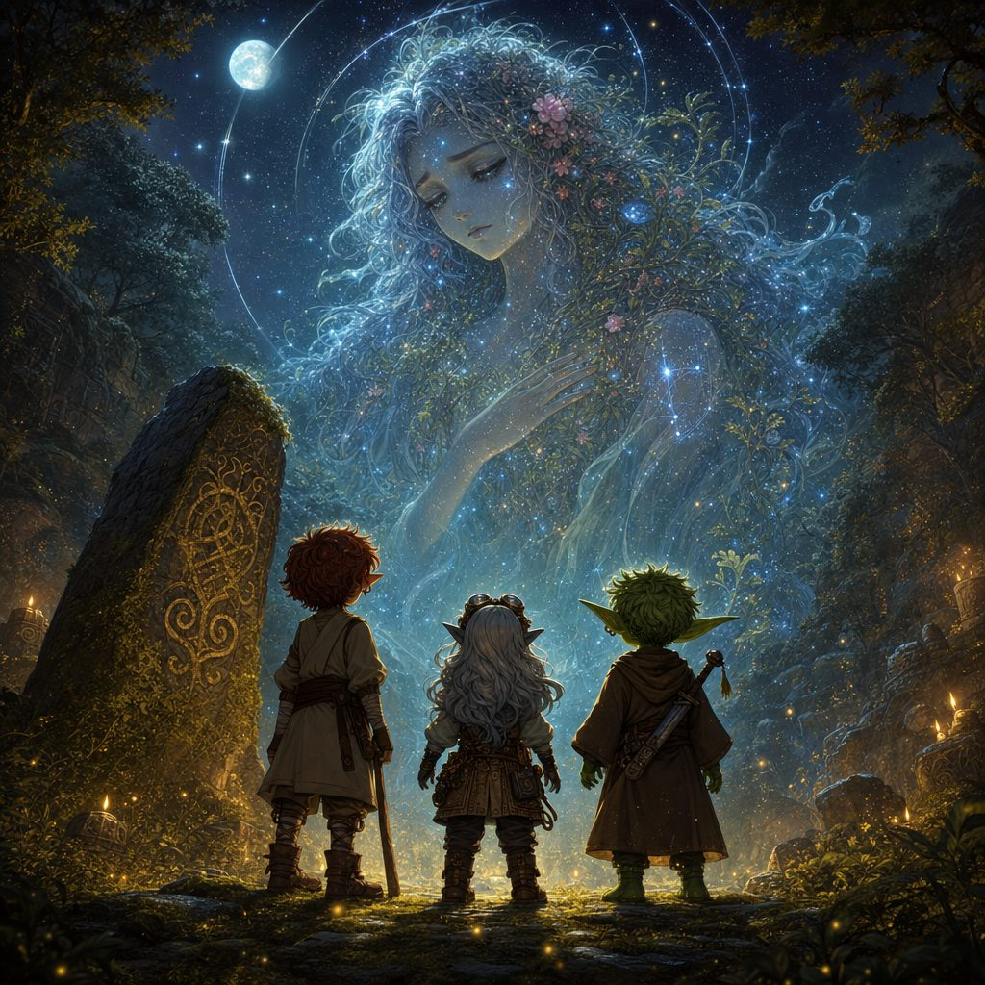
Elaria, guardian of the planes, gathers out of starlight and vine above the three heroes.
Elaria: “Seekers of truth. You have touched the threads that bind the realms. I am Elaria, guardian of the planes and of the balance that sustains them. A great disturbance ripples through existence, and the boundaries between worlds grow thin.”
Her gaze turns to Ursa, and it is warm as summer. “Child of Ash. Your father delved into mysteries few dare to explore. The enchanted potatoes you carry are remnants of a shattered covenant, a safeguard against the unraveling. They hold the key to restoring what was lost.”
To Lilly: “Ingenious artificer. The Essence Sphere you bear, once a mere power core, now resonates with energies beyond its making. It can channel and stabilize the motes of wayward creatures caught between planes.”
And to Stabby, with something almost like a smile in the starlight: “Wanderer of shadows. Your path is interwoven with chaos and choice. Your actions may sway the tides toward harmony, or deepen the discord.”
Around them the mists flash with visions: landscapes cracking like ice, elemental fire and flood, creatures of every plane tumbling through gaps in the world. Elaria: “The disturbances are but a symptom of a greater malady. An ancient entity seeks to exploit this weakness, consuming the essence of worlds. Unite your strengths. Restore the safeguards. Mend the fractures, before all is lost.”
The expanse dissolves like breath off a mirror, and the party is standing in the Whispering Glade again, hands and hearts still tingling. Evening has fallen while no time passed at all, and the first stars overhead burn with extraordinary brilliance, as if someone up there knows they are being watched. On the monument, the runes dim slowly to a patient glow.
Ursa, quietly: “My father was trying to protect the balance of the planes. These potatoes are more than heirlooms. We have to finish what he started.”
Lilly, turning the Sphere over in her hands: “The power core was never just a gift. If it can stabilize these planar energies, we might save more than Pikachu.”
Stabby, grinning at the stars: “So causing a bit of chaos might actually help this time. Good. I am very qualified.”
✦ BOONS OF THE WHISPERING GLADE ✦
Elaria's gift settles over the heroes as the vision fades, each boon granted then and there in the glade.

Ursa: Planar Awareness. For the next 24 hours, Ursa senses planar anomalies within 1 mile.
Lilly: Planar Attunement. The Essence Sphere permanently grants advantage on Intelligence (Arcana) checks concerning planar magic and creatures.
Stabby: Glimpse of Possibility. Advantage on one saving throw or ability check, spent whenever he chooses.
▶ The glade is safe ground: the party took a short rest here, talking the vision through before pressing on.
✦ LORE OF ELARIA ✦ The Warden's Price
Elaria spent her power the way a candle spends itself: all at once, on purpose, so others could see. When Maldrith was sealed beyond the last wall, the Warden had nothing left but her name and her sign, the seven-pointed star wrapped in a leafed vine. She scattered what remained into small safeguards and lay down to sleep.
Part Four: The Stone Serpent
Rested and lit from within by what they had seen, the party climbed on toward Ravenstone through the deepening dusk, and the mountain itself rose to meet them.
The last stretch to Ravenstone climbs through rugged country, the path narrowing between steep cliffs with loose stones rolling underfoot. The party is picking their way single file when the ground begins to shake. Pebbles dance. Cracks race along the trail. And with a deep, resonant rumble, the path ahead heaves upward and becomes a creature.

The last stretch to Ravenstone climbs between crystal studded cliffs.
Terranox rises: a great serpent of living stone and packed earth, rocky scales glinting in the last purple light, eyes glowing from within like windows onto slow magma. It regards the party the way a mountain regards weather, and then it strikes. There is no talking to it, no bargaining, no clever password. Some guardians test. This one only defends.
▶ Terranox, CR 4 elemental of the Plane of Earth (appendix). No parley. Immune to fire, so flame tricks fail again. It opens on the nearest intruder, uses Earthquake Stomp to scatter the party's formation, and saves Stone Coil for spellcasters and ranged attackers, squeezing them out of the fight early.
▶ The battlefield. Loose rocks litter the narrow path and make natural cover. Each round, roll a d6: on a 5 or 6, rocks shake free of the cliffs, DC 12 Dexterity save or 1d10 bludgeoning. The longer the battle roars, the more attention it risks drawing.
✦ LORE OF ELARIA ✦ The Grove Roads
The wild country between the cliffs and the coast has never been tamed, only crossed. The old grove roads are kept by creatures rather than kingdoms, and travelers of the Long Peace learned the etiquette that still holds: walk through singing, take nothing green, and leave a bite of supper at the trailhead.
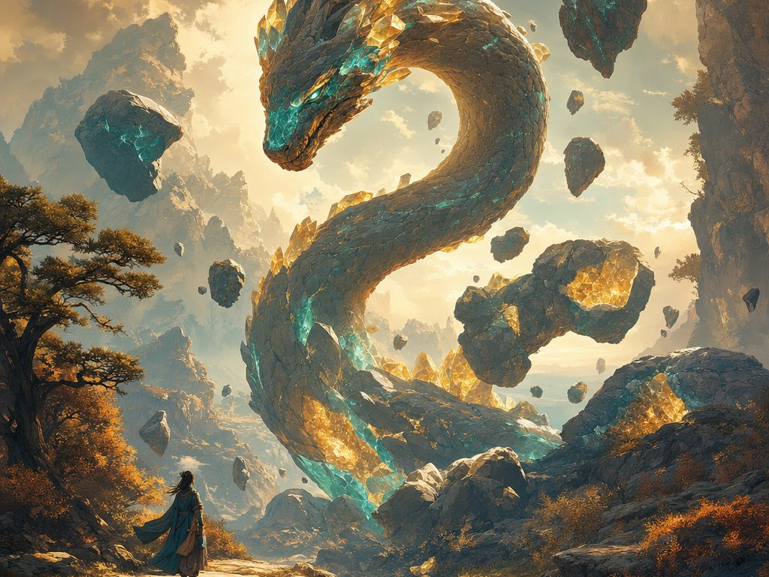
Terranox, the stone serpent of the Plane of Earth, rises from the mountain path.
▶ Victory, defeat, scaling. Victory: Terranox collapses into inert stone with the Earth Mote in the rubble. XP: 1,100. Defeat: it leaves fallen heroes unconscious but alive and burrows away; they wake hurt, free to recover and try the pass again. Easier: 75 HP, save DCs 13, Stone Coil restrains without damage. Harder: 110 HP, rockfalls on 4 to 6.
It is the hardest fight of their young lives. Terranox's tail sweeps like a falling tree; its stone coils catch Ursa mid spell and squeeze until Stabby's flurry of blows cracks the grip loose. Fire splashes off the creature like rain off a roof, so Lilly rewires her cannon on her knees in the dark while Ursa calls down starlight instead of flame. Chip by chip, crack by crack, the heroes carve the mountain down, until at last the great serpent shudders, sighs a long gravel sigh, and collapses into a heap of inert stone and settling dust.
In the rubble where its heart was, the party finds an Earth Mote: a small crystalline fragment pulsing with elemental energy, heavy with the raw strength of the Plane of Earth. This one does not drift away. Lilly wraps it carefully with the mud samples and a few glittering stone fragments of the serpent's hide. The professor is going to have questions. So do they.
✦ LORE OF ELARIA ✦ The Clockmaker's Gift
The oldest tale says the world was wound like a clock: five planes set turning around the Material world, each cradled by a star lit for it alone. Elaria was not the clockmaker. She was the one who stayed behind to keep it wound.
Part Five: Ravenstone Laboratory
Dusty, weary, and carrying pieces of three planes in their packs, the party crested the last wooded hill as twilight fell.
Below them, nestled in a tranquil valley of ancient oaks and shimmering ponds, stands Ravenstone Laboratory: a graceful structure of stone and glass, its turrets spiraling upward like reaching fingers, capped with metal domes that catch the last orange and purple of the sky. Warm light glows from every window. The path down is lined with luminescent flowers that sway gently in the still air, and among the trees flit small, impossible creatures: some with wings like leaves, some like tiny mammals traced in glowing lines.
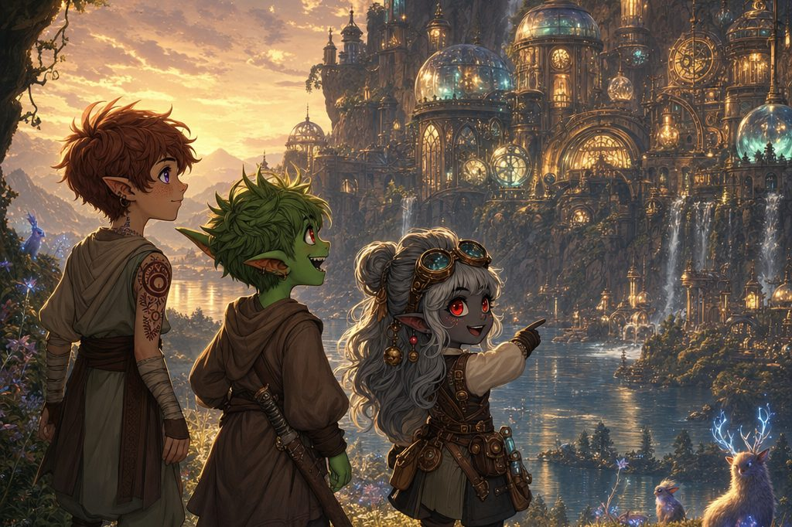
Lilly points the way as Ravenstone Laboratory glitters awake in the dusk below.
The creatures are not shy. A little fox with a leaf shaped tail pads right up to Lilly, sniffs her boot with great scholarly interest, and darts back into the foliage.
Lilly, eyes sparkling: “Did you see that? I have never encountered wildlife like this before!”
Ursa: “There is something special about this place. The veil between worlds feels thinner here.”
Stabby: “Or maybe the critters just know a friendly face when they see one.”
The grand wooden doors swing open on their own as the party approaches, breathing out the scent of old books, fresh parchment, and a crackle of ozone. Inside, wooden beams arch beneath ceilings painted with stars and mythical beasts; shelves of books and artifacts climb the walls between tall windows. And everywhere, creatures. A rabbit with fur like blooming flowers dozes on a windowsill. A bird with feathers that flicker like small flames preens on a perch. A turtle drifts past at ankle height, its shell swirling with what looks like captive seawater. A tiny dragon whelp with shimmering scales flutters up to the party, studies them with keen eyes, chirps a melodious greeting, and zips away up a spiral staircase, clearly expecting to be followed.
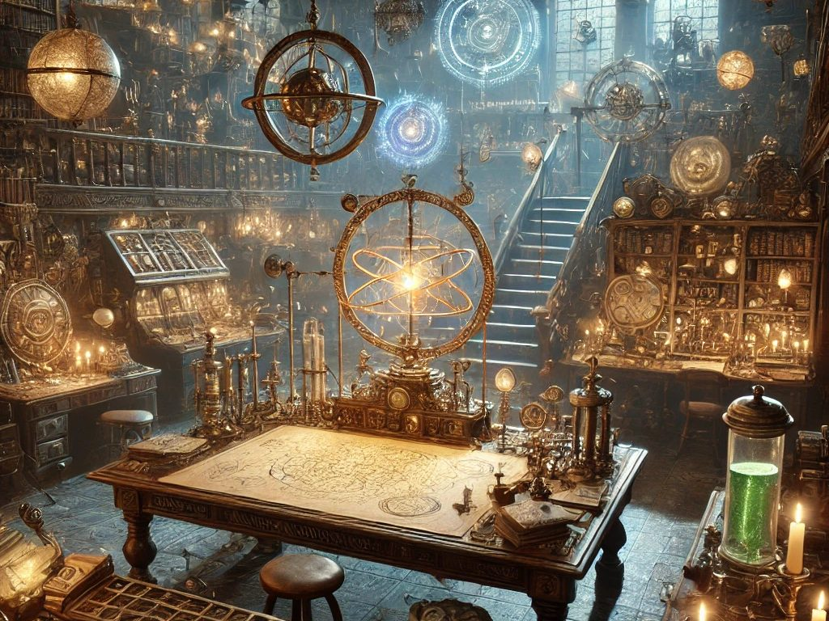
The great hall of Ravenstone Laboratory, where every shelf has a tenant.
Professor Aelwyn Ravenstone

The staircase winds around an atrium of hanging plants and softly glowing crystals, opening into a vast study where bookshelves rise to a domed ceiling painted as the night sky. At a great wooden desk buried in open tomes, scrolls, and peculiar brass instruments stands the master of the house: a tall high elf with long silver hair, sharp emerald eyes, and robes that split the difference between a scholar's gown and a field jacket. He looks up, and his whole face lights with delight.
Aelwyn: “Ah, visitors! How wonderful. I do not get many these days.”
Introductions are made all around: Lilly Glimmergear, Ursa Catchum, Stabby Sharpblade. “Please, call me Aelwyn,” the professor says, spreading his hands to the creatures perched on cushions and chandeliers around the study. “Any friend of these marvelous creatures is a friend of mine.” Then his gaze falls on the fourth traveler, currently tasting a bookshelf, and his emerald eyes go wide. “My word. Is that a Lickgloom you have there? I have only read of them in the ancient texts. Remarkable!”
Stabby: “You would not believe the day we have had. Mud creatures, rock serpents, a goddess made of stars, and now this place. It is like stepping into a storybook.”
Aelwyn, chuckling: “I can imagine. The world is full of wonders, especially now, with the boundaries between realms becoming... flexible.” He waves them into deep chairs by the hearth, and a small bipedal salamander with a cheerful flame flickering on its tail trots over with a tray of steaming herbal tea, entirely unbothered by its own job title. “Not originally from here, most of my companions,” Aelwyn says, sipping. “They have appeared over the past few years, from adjacent planes intersecting with ours. I have devoted my research to understanding the shifts in our world's fabric. It sounds as though you four have been doing field work on my behalf.”
The party talks late into the evening: the motes, the guardians of the forest, the Grimfang, the vision in the glade. Aelwyn listens the way a dry garden drinks rain. And more than once, the party notices his sharp eyes drifting to the Essence Sphere in Lilly's lap, where it hums its soft, sleeping note.
Guest Quarters
At last Aelwyn notices the road weariness under their excitement and rises. “Forgive me. You must be exhausted. I insist you stay the night; there is much I would like to discuss, and none of it improves after midnight.” A small owl like creature with luminous eyes swoops down at his soft clap and leads the party through corridors hung with tapestries of distant realms, to adjoining rooms with plush beds, moonlit garden windows, and floating crystal lamps that brighten at a touch. On a small table in each room, a tiny luminescent sprite hovers beside a tray of fruit, bread, and cheese, in case anyone should need a midnight snack.
Stabby flops onto his bed with a contented sigh. “Now this is more like it. Beats the hard ground any day.” Lilly touches a crystal lamp and watches it glow, already reverse engineering it in her head. Ursa stands at the window, looking up at stars that seem to look back. Lickgloom curls at the foot of a bed and is asleep in seconds, tongue out.
At the door, the professor pauses, candle in hand, his gaze resting one more moment on the Essence Sphere glowing gently on Lilly's nightstand. “Rest well, my young friends,” he says. “Tomorrow, we begin.”
✦ ✦ ✦
Their second day together held a quest completed, two ambushes weathered, a goddess's charge laid upon them, a mountain taught respect, and a warm bed in a house full of impossible creatures. Whatever the professor saw when he looked at the Sphere, morning would tell.
Next: Session 3, in which the professor examines the Essence Sphere, three small creatures roam his laboratory, and a dark figure watches from the top of Stormwatch Cliffs.
APPENDIX
DM Run Sheet: The Day at a Glance
Every DC, dial, and spotlight, in play order. Keep this page at your elbow.
The Shape of the Session
▶ Five parts, three fights, one vision. P1 Oakshade morning: quest closed (the gatherers walked out when the fog died; 50 gp), rumors at the well (Nina, Merwin, the children), Tamsin marks the map. P2 the western road: FIGHT 1 Mudskips in the wet fields, then FIGHT 2 the Grimfang ambush. P3 the Whispering Glade: the monument, the VISION OF ELARIA, three boons + the built-in SHORT REST. P4 the mountain pass: BOSS Terranox, the Earth Mote. P5 Ravenstone Laboratory: Aelwyn, tea served by a salamander, guest quarters, overnight. Natural break point: the glade.
Fights at a Glance
FIGHT 1: The Mudskip Ambush (Medium; mischief, not malice). 3× Mudskip (AC 13, HP 22; resist FIRE, VULNERABLE LIGHTNING; Mud Splash rech 5-6: 15-ft cone, DC 12 Dex, 2d6+2 + blinded). The mud is difficult terrain for everyone but them, and every Splash lays fresh slick ground; they dive and flank through the pools to isolate the slowest hero. The out: withdraw to dry ground and they do not pursue; talking (or splashing back) reveals confusion, not malice. Too easy? A 4th surfaces. XP 100 each (300 total).
FIGHT 2: The Grimfang War Band (Hard; they humble, they do not kill). 2× Goblin archer on the flanks + Worg and Orc in the melee + Hobgoblin sniping from cover + Goblin Boss barking orders (standard 2024 MM stats for all). The boss coordinates: archers on the back line, worg and orc on the front; the hobgoblin's covered shot is Stabby's Deflect Attacks moment, and the boss taunts the Bloodfang all fight. The out: fallen heroes wake at the roadside robbed, not dead; beaten, the survivors flee.
BOSS: Terranox (Hard; no parley). CR 4 (AC 16, HP 95; IMMUNE FIRE, resist nonmagical B/P/S; Stone Coil rech 5-6: DC 15 Dex or restrained, 1d8+5/turn, aimed at casters; Earthquake Stomp rech 6: 20-ft radius, DC 15 Dex, 4d6 + prone). Rockfalls: d6 each round, on 5-6 DC 12 Dex or 1d10. Dials: easier, 75 HP and save DCs 13, Stone Coil restrains without damage; harder, 110 HP and rockfalls on 4-6. Defeat is survivable: it leaves them unconscious and burrows away. XP 1,100.
The Resource Picture
▶ One long road day with one safe pause. The party leaves Oakshade on a full night's sleep and 50 gp richer; Fights 1 and 2 land back to back, then the Whispering Glade is the built-in SHORT REST (safe ground, talk the vision through) before the boss. The day's rules lesson: fire fails twice (Mudskips resist it, Terranox is immune), so steer Lilly and Ursa toward lightning and starlight and reward the switch. Elaria's boons arrive right before the boss: Stabby's Glimpse of Possibility is a pocket advantage he can cash against Stone Coil, Ursa senses planar anomalies for 24 hours, Lilly's Arcana edge is permanent. The night ends in real beds at Ravenstone: full rest, and Session 3 starts fresh.
Spotlights & Seeds
Lilly: P2 her sparks find the water (lightning is the Mudskip answer); she bottles the elemental mud, and later the Earth Mote and stone fragments, for the professor → P3 the Essence Sphere wakes at the monument; Elaria: the Sphere can stabilize wayward motes (permanent Arcana advantage on planar magic), and her takeaway is bigger: “we might save more than Pikachu” → P4 she rewires her cannon on her knees in the dark when fire fails → P5 the leaf tailed fox sniffs HER boot first, Aelwyn's eyes keep finding the Sphere (Door: the professor's interest), and she falls asleep reverse engineering the crystal lamps.
Stabby: P2 the Grimfang boss knows his clan: Bloodfang taunts all fight, and the caught arrow goes in his sash while he says nothing about home (Door: the clan grudge; “This is not over”) → P3 Elaria's “wanderer of shadows”: chaos and choice, plus the pocket advantage; his read: “So causing a bit of chaos might actually help this time. Good. I am very qualified.” → P4 his flurry cracks the Stone Coil off Ursa → P5 “the critters just know a friendly face,” and a real bed at last: “Beats the hard ground any day.”
Ursa: P3 the glade calls HIM: the Dragonmark tingles, his palm wakes the monument; Elaria: “Child of Ash,” the potatoes are a shattered covenant (Door: his father's work), and his quiet vow after: “We have to finish what he started” → P4 Terranox's coil catches him mid spell, and he answers with starlight instead of flame to carve the serpent down → P5 he stands at the window under stars that seem to look back.
Foreshadow Tracker: say it, then say it again
▶ The tells, in order. Every fallen creature leaves a MOTE: the forest tally, the Mudskips' blue water motes, then Terranox's Earth Mote, the first one that STAYS • Nina: the air feels heavy, “like it is breathing,” and the professor “goes further out” hauling odd things by night • the children have seen glowing creatures that talk: a floating whispering shadow, a giant fox made of sparks • Merwin's warning: Oakshade must not become a ground for “planar... experimentation” • Tamsin: “like they are protecting something... it will not stop here” • Elaria names the big bad: an ancient entity consuming the essence of worlds • Aelwyn's gaze drifts to the Essence Sphere, at the hearth and once more at the door • “Tomorrow, we begin.”
APPENDIX
Bestiary: Enemy Stat Blocks
All three encounters of Session 2, in the order the party meets them.
ENEMIES, Fight 1: The Mudskip Ambush
The Wet Fields ✦ Difficulty: Medium ✦ 3× Mudskip (a 4th if it runs easy)
MUDSKIP
Small elemental (Plane of Water), neutral ✦ CR 1/2
AC 13 (natural armor) HP 22 (4d6 + 8) Speed 20 ft., swim 30 ft.
STR 12 DEX 14 CON 14 INT 6 WIS 12 CHA 8
Skills Stealth +4, Perception +3
Resistances fire Vulnerabilities lightning
Senses darkvision 60 ft. Languages understands Aquan
Challenge 1/2 (100 XP)
Traits
Amphibious. The mudskip can breathe air and water.
Mud Dweller. Ignores difficult terrain made of mud or shallow water.
Slippery. Advantage on ability checks and saving throws made to escape a grapple.
Actions
Multiattack. The mudskip makes one Mud Spit attack and one Tail Slap attack.
Mud Spit. Ranged Attack: +4, range 30 ft. Hit: 1d6 + 2 bludgeoning, and the target must succeed on a DC 12 Dexterity save or its speed is reduced by 10 ft. until the end of its next turn.
Tail Slap. Melee Attack: +4, reach 5 ft. Hit: 1d8 + 2 bludgeoning.
Mud Splash (Recharge 5-6). 15-foot cone; DC 12 Dexterity save. Failure: 2d6 + 2 bludgeoning and blinded until the end of its next turn. Success: half damage.
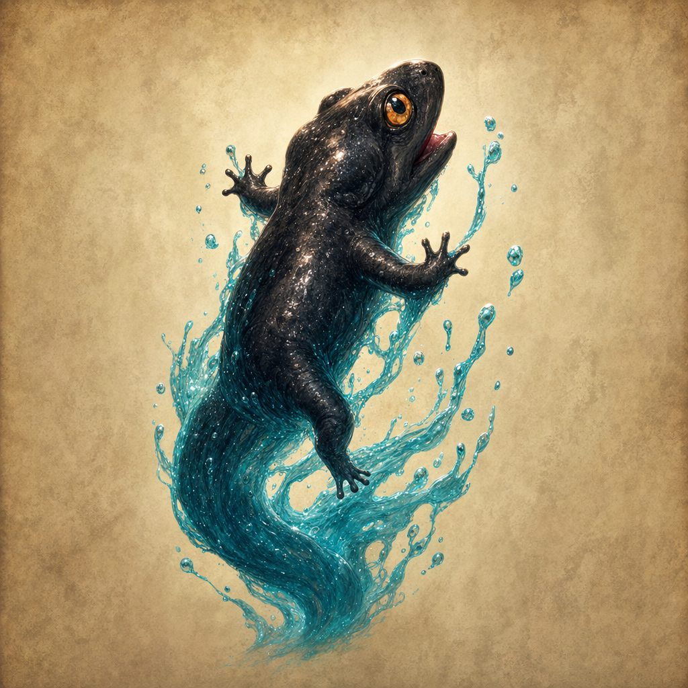
Tactics: They dart in, splash, and dive back into the pools, flanking through the water to isolate whoever moves slowest; every Mud Splash leaves fresh slick ground, reshaping the battlefield round by round. Mischief, not malice: a hero who talks (or splashes back) can tell they are confused, displaced far from the Plane of Water, and if the party withdraws to dry ground they do not pursue. Too easy? A fourth Mudskip surfaces from a hidden pool.
ENEMIES, Fight 2: The Grimfang War Band
The Western Road ✦ Difficulty: Hard ✦ 2× Goblin + Worg + Orc + Hobgoblin + Goblin Boss
THE GRIMFANG WAR BAND
Rival goblin clan raiders ✦ standard 2024 Monster Manual roster
The roster. 2× Goblin with shortbows on the flanks, 1× Worg and 1× Orc with a great club in the melee, 1× Hobgoblin with a crossbow at the rear, and 1× Goblin Boss (scarred; taunts the Bloodfang) at the center.
Statistics. Standard 2024 Monster Manual values for each creature. If you track XP, award the standard amounts for the roster.
Traits
The Grudge. The Grimfang are a rival clan with an old score against Stabby's people; the boss taunts the Bloodfang runaway all through the fight, about weakness, and about the little monk who left.
If It Goes Wrong. The Grimfang want to humble the Bloodfang runaway, not finish anyone: fallen heroes wake at the roadside, bruised and lighter by their shiniest valuables, with goblin laughter fading in the brush.
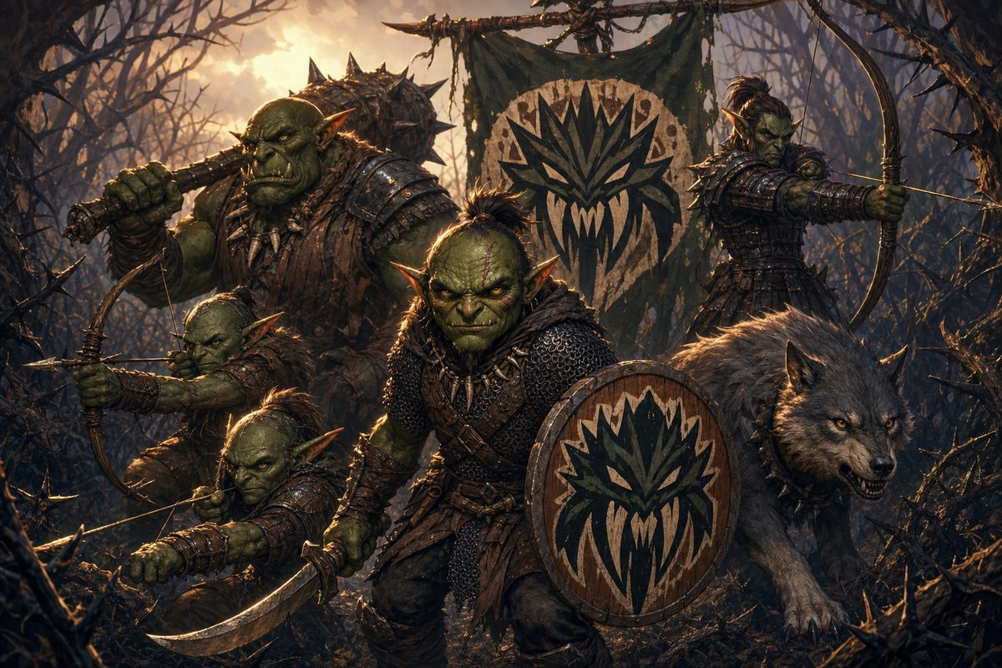
Tactics: The boss coordinates: archers on the flanks focus the party's back line while the worg and orc press the front, and the hobgoblin's covered position hands Stabby a perfect chance to catch an arrow out of the air with Deflect Attacks. Beaten, the survivors flee into the brush. The Grimfang remember.
✦ LORE OF ELARIA ✦ The Thorn Clans
Goblins tell it plainly: when the world was woven, some threads stuck out, quick and bright and impossible to trim flat. Those threads became goblins. The briar-maze of Bloodthorn Hollow grew up around the clans, they say, because even the thorns wanted to keep them.
ENEMIES, BOSS: Terranox
The Mountain Pass ✦ Difficulty: Hard (no parley) ✦ Fight 3 ✦ the stone serpent boss
TERRANOX
Large elemental (Plane of Earth), unaligned ✦ CR 4 ✦ the boss
AC 16 (natural armor) HP 95 (10d10 + 40) Speed 30 ft., burrow 30 ft.
STR 20 DEX 10 CON 18 INT 5 WIS 11 CHA 6
Immunities fire, poison; exhaustion, paralyzed, petrified, poisoned, prone
Resistances nonmagical bludgeoning, piercing, slashing (non adamantine)
Senses darkvision 60 ft., tremorsense 60 ft.
Challenge 4 (1,100 XP)
Traits
Earth Glide. Terranox can burrow through nonmagical, unworked earth and stone without disturbing the material it moves through.
Immutable Form. Immune to any spell or effect that would alter its form.
Elemental Resilience. Advantage on saving throws against spells and other magical effects.
Siege Monster. Deals double damage to objects and structures.
Actions
Multiattack. Terranox makes one Bite attack and one Tail Slam attack.
Bite. Melee Attack: +7, reach 10 ft. Hit: 2d10 + 5 piercing.
Tail Slam. Melee Attack: +7, reach 15 ft. Hit: 2d8 + 5 bludgeoning, and the target must succeed on a DC 15 Strength save or be knocked prone.
Stone Coil (Recharge 5-6). One creature must succeed on a DC 15 Dexterity save or be grappled and restrained (escape DC 15), taking 1d8 + 5 bludgeoning at the start of each of Terranox's turns.
Earthquake Stomp (Recharge 6). 20-foot radius; DC 15 Dexterity save. Failure: 4d6 bludgeoning and knocked prone. Success: half damage.
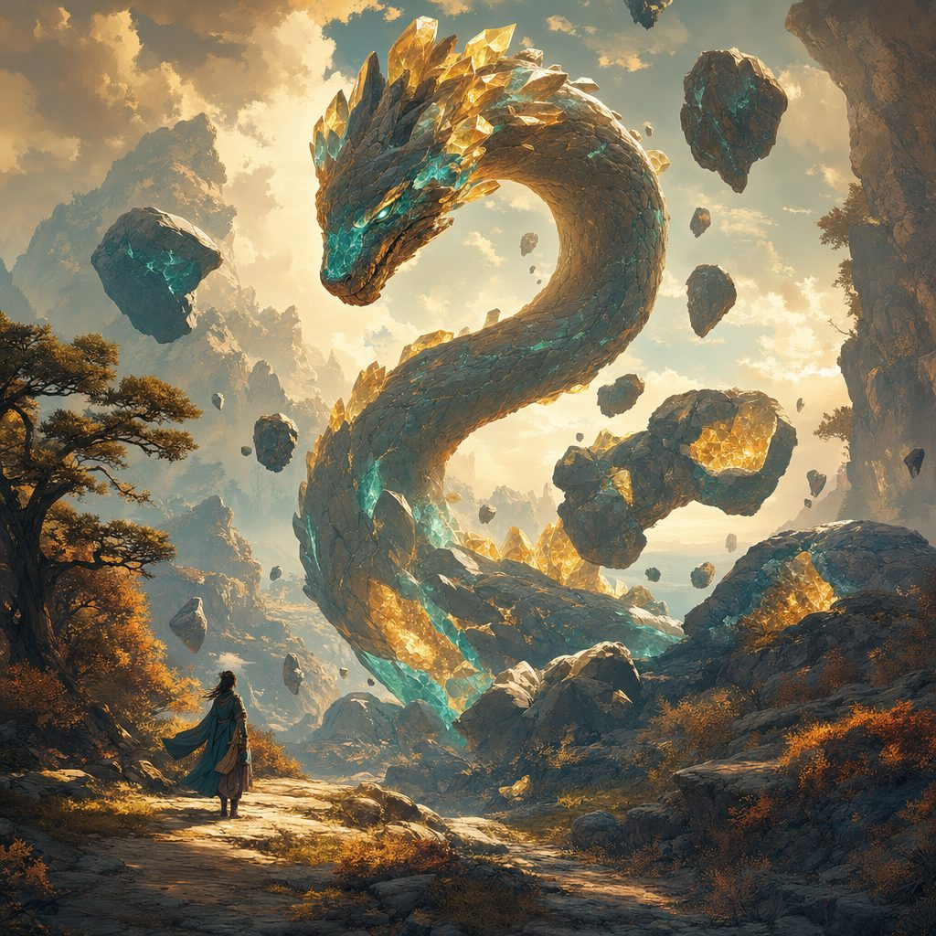
Tactics: No parley: it opens on the nearest intruder, uses Earthquake Stomp to scatter the party's formation, and saves Stone Coil for spellcasters and ranged attackers. Fire splashes off it, so the flame tricks fail again. The battlefield fights too: loose rocks make natural cover, and each round on a d6 roll of 5 or 6 rocks shake free of the cliffs (DC 12 Dexterity save or 1d10 bludgeoning); the longer the battle roars, the more attention it risks drawing. Dials: easier, 75 HP, save DCs 13, Stone Coil restrains without damage; harder, 110 HP, rockfalls on 4 to 6. Defeat is survivable: it leaves fallen heroes unconscious but alive and burrows away; they wake hurt, free to try the pass again. Victory: it collapses into inert stone with the Earth Mote in the rubble.

