✦ ✦ ✦
THE GUARDIANS OF ELARIA
SESSION 8
Gearhaven, the Clockwork City
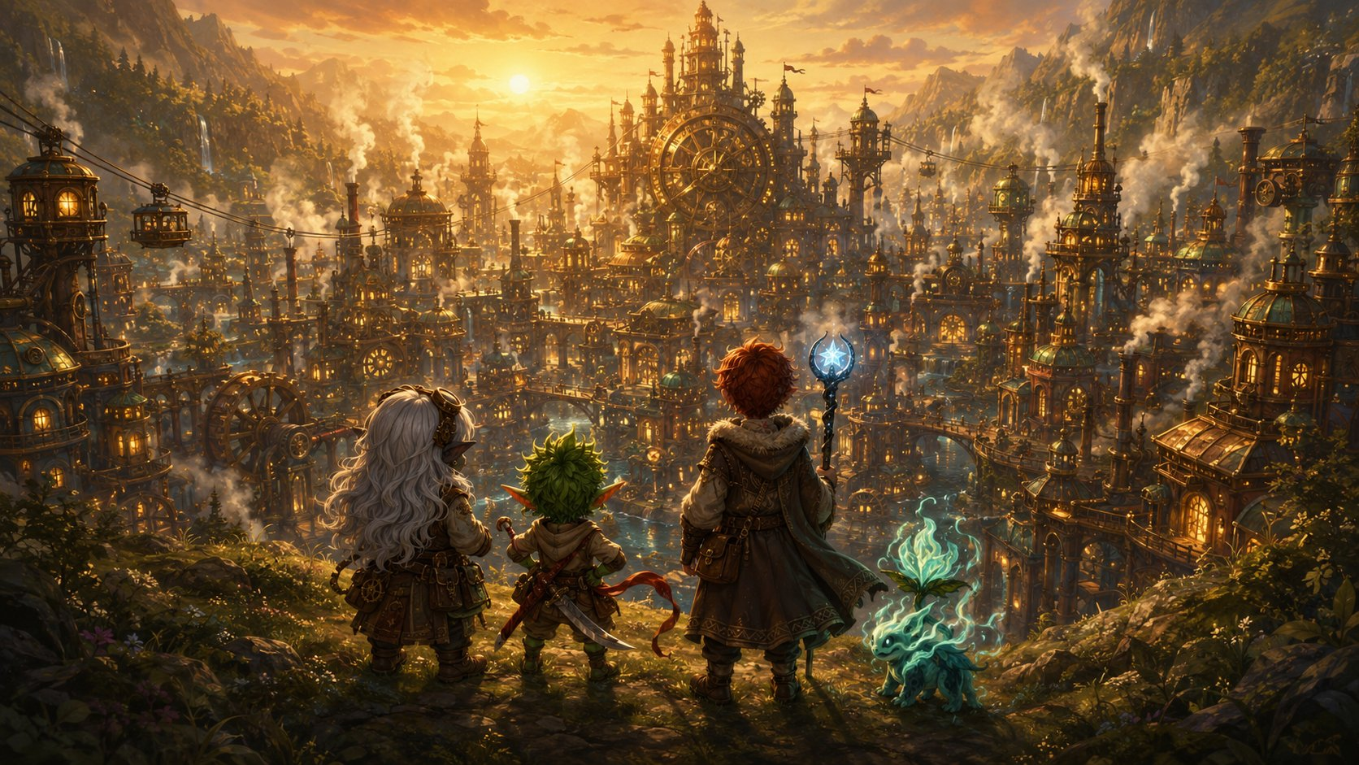
Part One: The Road to Gearhaven

An illustrated adventure. Read the gold boxes aloud; the purple boxes are for the DM.

Previously, on The Guardians of Elaria…
Last time, our heroes did something amazing. In the haunted town of Wraithpine, a monster called the False Hydra sang a secret song, a song that made everyone forget the people it ate. Families were vanishing, and nobody even remembered they were gone. But you remembered. You followed the song down into the dark beneath the old theater, and you cut that monster’s heads off one by one until its song finally went silent. The whole town woke as if from a bad dream, and remembered the people they’d lost, and the three heroes who saved them.
Deep in the lair, you found a chest wrapped in silver vines and starlight. Inside were three gifts, each marked with a seven-pointed star, the sign of the sleeping goddess Elaria. A staff of constellations for Ursa. A swift silk sash for Stabby. A pocket-sized cannon-core for Lilly. And your little plant-friend Floraburst breathed in a wisp of ghost-light and changed, into the pale, glowing, chiming spirit who floats beside you now. Ghostbloom.
You have questions. Big ones. What are the cracks splitting the world? What is the Sphere that holds Pikachu’s spark, and how do you bring him back? There’s one place famous enough to hold the answers: a great city of inventors called Gearhaven, where they say the artificers can build anything. So you pointed yourselves east, and you walked.

The Journey
The road to Gearhaven took three days.
The first day was forest, soft and green. The second, the land turned to rolling farmland, and you started to see signs of the city long before the city itself, fence-posts that ticked like clocks, a scarecrow with brass joints, a farmer’s cart that rolled on its own little gears. The third day, the air began to taste different. Like hot metal and coal-smoke and something sharp, like the smell right before a thunderstorm.
You traveled the way you always do. Stabby ranged far ahead and far behind, never still for a second, scouting every noise and turning every walk into a race, he climbed three separate trees just to see if he could. Ursa walked quietly, watching the night skies each evening, reading the stars like a map and pointing the way east when the road forked. And Lilly filled the silence with ideas, tinkering as she walked, taking apart one of those little brass farm-gadgets to see how it worked and putting it back together better. Ghostbloom drifted along above you all, chiming whenever the wind changed.
By the third evening, your feet ache, your packs feel heavy, and you’re hungry for a hot meal and a real bed. And then, the trees suddenly end.

The Reveal
You’re standing on a high ridge, and the whole valley below is full of city.

The Guardians crest the ridge and see Gearhaven for the first time.
Towers of brass and copper stretch toward the sky, breathing ribbons of white steam. Rooftops shine like a field of gold coins in the last of the sunset. Little carriages made of gears and cable zip between the buildings on humming wires, high above the streets. And right in the heart of it all, something enormous turns, slow, steady, patient, so big you feel its heartbeat in your chest before you ever hear it. Boom. Boom. Boom.
Ghostbloom’s petals dim, then flare bright. And in Lilly’s pack, the Essence Sphere does something it has never done before: it gives one warm, gentle pulse. Like a heartbeat answering a heartbeat. Like it knows this place. Like it’s coming home.
Welcome to Gearhaven.

Through the Gate
A wide road winds down the ridge to the city’s eastern gate, where two enormous brass doors stand open, carved all over with gears and stars. Above them, a great clock face shows not just the hour but tiny moving pictures, the moon, the tides, the turning seasons, all ticking along together.
A guard steps forward to meet you, but the guard isn’t quite a person. It’s polished copper and brass, shaped like a stout little gnome, with a soft blue glow behind its eyes and a voice like a wind-up music box. It taps its chest-plate twice.
“Welcome, travelers. Steady gears to you.”
It looks the three of you up and down, a gnome, a goblin, a boy with a glowing staff, and a little ghost-flower bobbing in the air, and tilts its head with a soft, curious whirr.
“Hmm. Not your usual merchant caravan. Gate-logs, if you please: what names do I write, and what brings such an unusual little company to Gearhaven?”
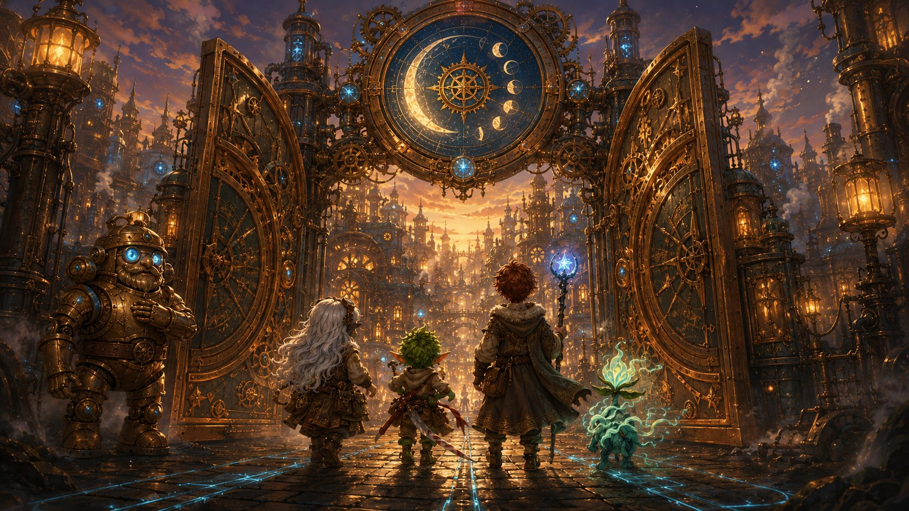
The eastern gate of Gearhaven, and its clockwork gnome gatekeeper.

▶ First talk-opening. Let each kid answer in their own words, or read them their suggested line. This is where the group says who they are and why they’ve come.
Lilly: “Lilly Glimmergear, artificer. I’m carrying something special, and I need the Guild’s help to understand it.”
Stabby: “Name’s Stabby. We’re here for answers. And snacks. Mostly answers. Definitely snacks.”
Ursa: “Ursa Catchum. We’ve followed the cracks in the world, and the stars, a long way. We’re looking for the Artificer’s Guild.”
The Mechagnome’s quill scratches busily across a brass tablet, then pauses at the word “cracks.” Its blue eyes flicker, just for a second, like a candle in a draft, before brightening again.
“The Guild, yes. Everyone’s bound for the Guild this week. Up Cogtooth Hill, ask for Guildmaster Vane. Mind the machines, though. They’ve been… restless. Steady gears to you, travelers. You may need them.”
Then the city swallows you up in noise and color. Steam hisses up warm from grates in the cobblestones. Glowing blue lines run through the streets like the whole place is lit from underneath. Trams hum by overhead on humming cables. And everywhere, under everything, that giant heartbeat. Boom. Boom. Boom.

The Street of Small Wonders
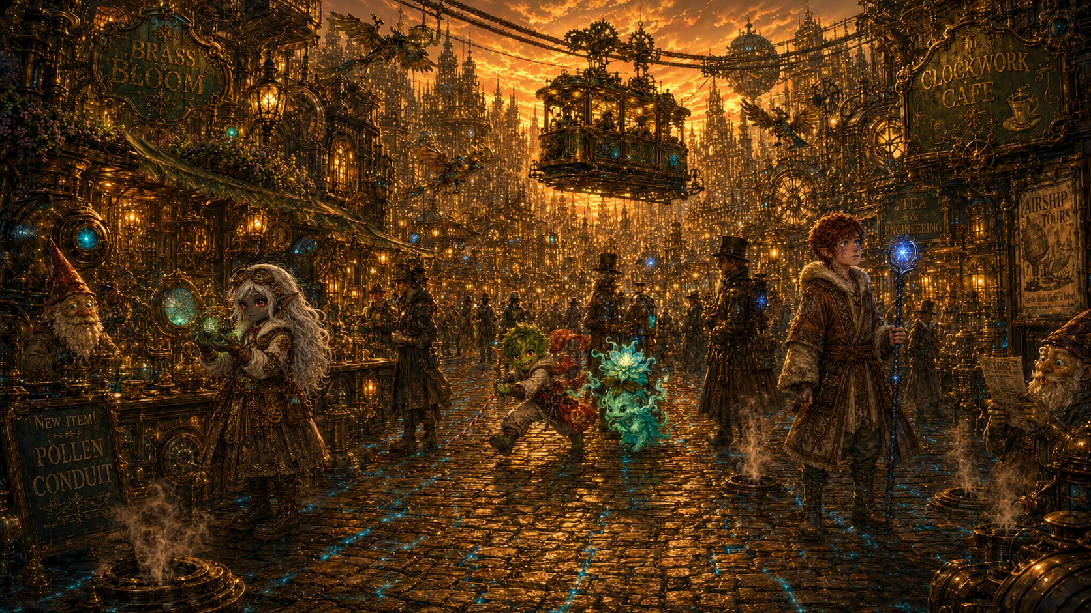
Wandering the Street of Small Wonders at golden dusk.
The main road is called the Street of Small Wonders, and it earns the name. You barely know where to look first.
A cluttered little shop called Sprocket & Sons spills gadgets onto the street, self-winding music boxes, mechanical songbirds, a clock that runs backward. The owner, a soot-smudged gnome woman named Mara Sprocket, spots Lilly’s tools and lights right up.
“Oho, a maker! I can always tell. Those are good tools, little one, but what’s a young artificer doing all the way out here? What’re you building?”
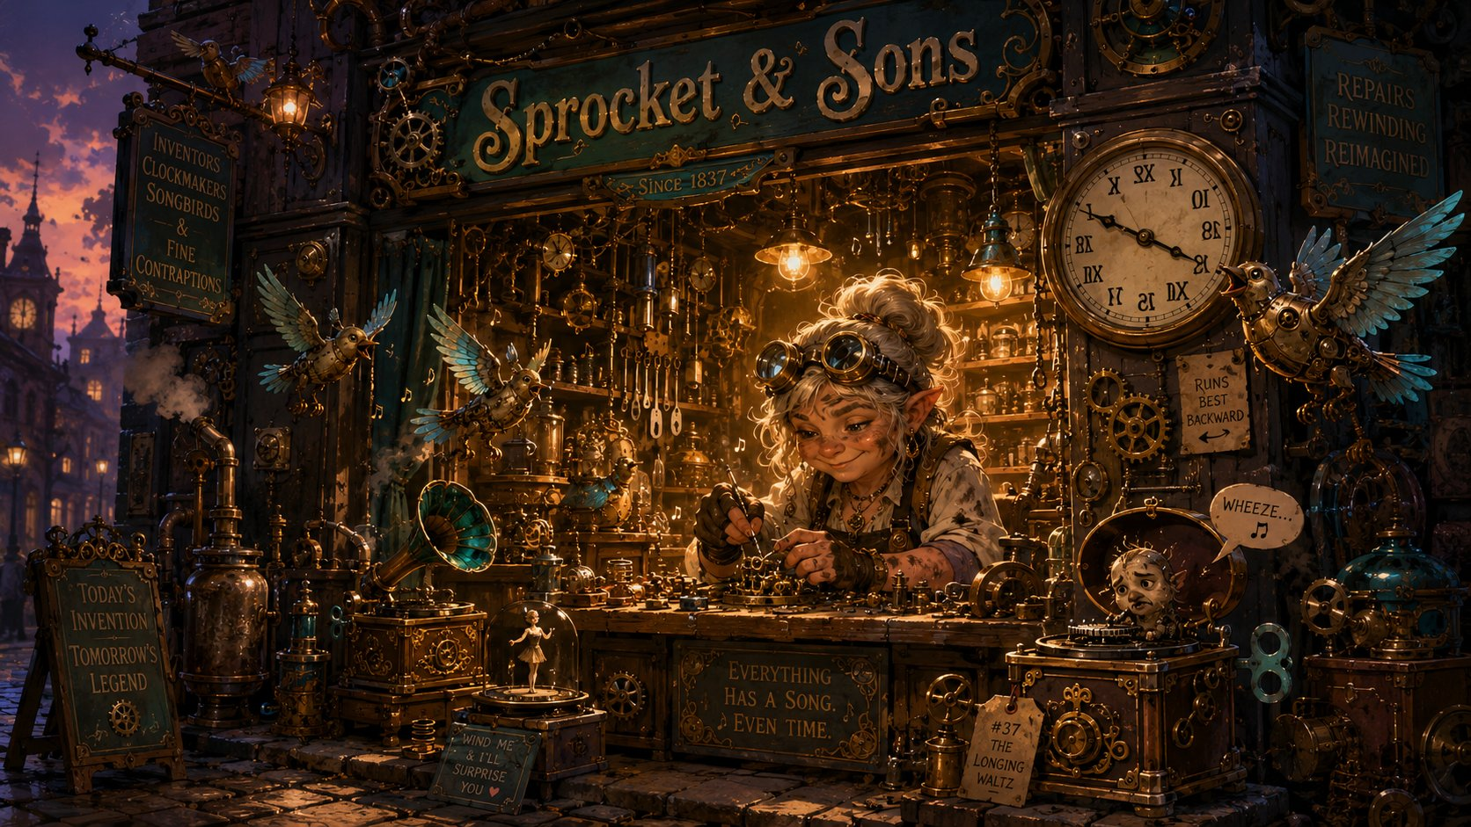
Lilly: “I’m not building it, I’m trying to understand it. It’s called an Essence Sphere. The Guild’s supposed to be able to help.”
Sprocket & Sons, Mara at her cluttered workbench.
Mara’s eyebrows shoot up at those words.
“An Essence Sphere! Now there’s a word I haven’t heard outside of old Glimmerspire books. You’ll want Vane, then, Guildmaster, up on Cogtooth Hill. Brilliant fellow. Working on something big, they say, something that pokes holes in the sky, if you believe the rumors.”
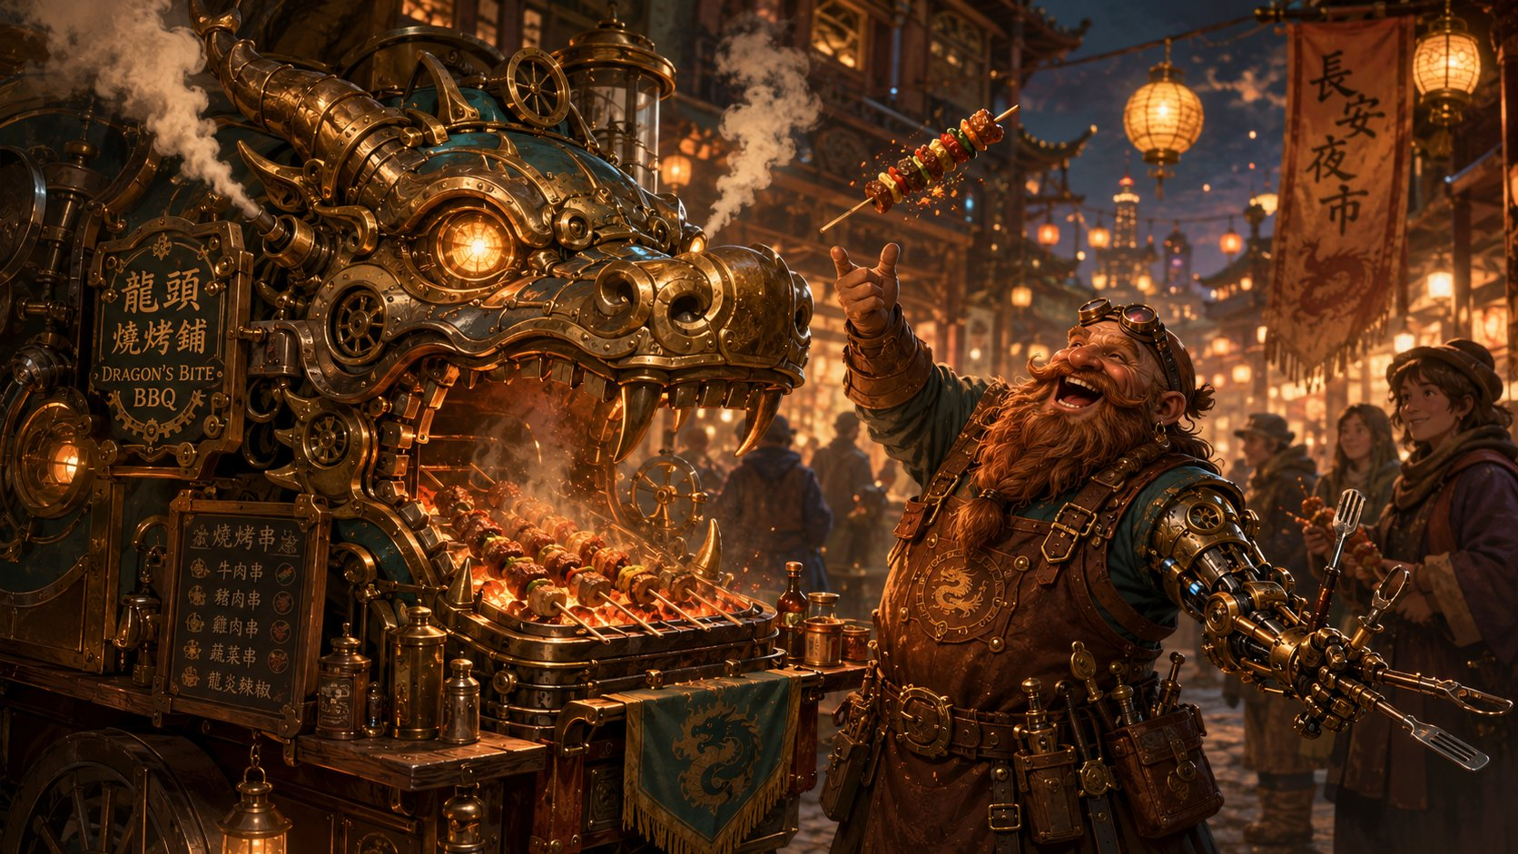
She winks, then thumps a sputtering music box. It plays three notes and dies with a sad little wheeze. “Mind how you go, though. Half the gadgets in this city have gone wonky this week. Even mine.”
Burl and the Dragon’s Bite BBQ cart.

A little farther on, a food cart shaped like a dragon’s head puffs real steam from its nostrils, frying skewers of spiced meat. The cook, a one-armed dwarf with a brass replacement arm full of cooking tools, catches Stabby eyeing the skewers and flips him one, fast as a dart.
“Quick eyes! Quick hands too, I’ll bet. Here, on the house. So what’s a sharp little thing like you doing in my city? Trouble, I hope?”
Stabby: “Always trouble. But today? We’re hunting answers. My friends have got big mysteries, and I’ve got a big sword. It works out.”
The dwarf roars with laughter.
“Hah! I like you. Name’s Burl. You three want answers, you want the Guild, and you want that scatterbrained Vane up the hill. Tell him Burl says he still owes me for three skewers and a singed eyebrow!”

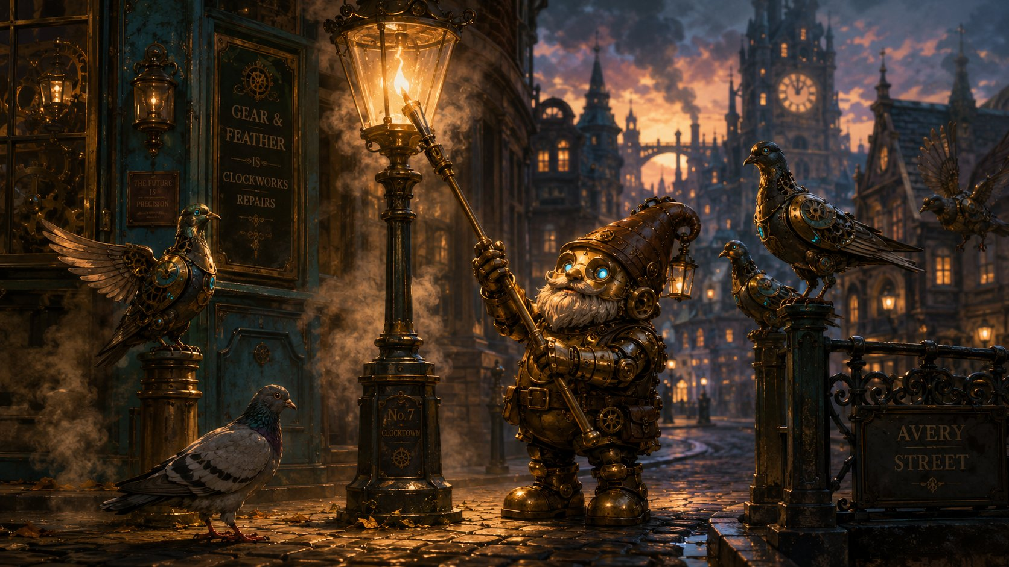
Tock the lamplighter, and a pigeon that won’t leave Ursa’s staff.
Then a flock of clockwork pigeons clatters down from a rooftop, and so does one real one, a scruffy gray bird that lands right on Ursa’s staff, tilts its head, and refuses to leave. Its owner, an old Mechagnome lamplighter named Tock, shuffles over, peering with softly glowing eyes.
“Well now. She doesn’t take to just anyone. Animals know a kind heart when they see one.”
His gaze drifts to the seven-pointed star on Ursa’s staff, and his voice goes quiet.
“…And that’s Elaria’s mark. Haven’t seen it in a long, long while. Tell me, star-child, what is it you’re really looking for, all the way out here?”
Ursa: “My father. He disappeared chasing the cracks between worlds… and I think the answers are here, somewhere. In the stars, or in the Guild’s records.”
Tock is quiet a moment, the little gray pigeon ruffling on the staff.
“Old questions, then. The deepest kind. You’ve come to the right city, the Guild keeps records older than this whole street. Ask for the archives. Ask for Vane. And mind the machines on your way. They’ve not been themselves this week.”
He shuffles off to light the next lamp, glancing back once.
Three different people, three different shops, and every single one says the same things: the machines have been acting strange all week… and whatever you’re after, you’ll find it at the Artificer’s Guild, with a brilliant, scatterbrained inventor named Guildmaster Vane.
But it’s getting dark. As you wonder where to sleep, a tram glides to a stop beside you, and its conductor leans out, a nervous, fidgety Mechagnome with fluttering brass hands.
“Oh, visitors! You look lost, dearies. The Guild’s shut till morning, I’m afraid, locked up tight, strange week we’re having.”
Her blue eyes flicker, just once.
“I’m Pinion, by the way. If it’s a warm bed you’re wanting, you tell Henna at the Gilded Gear that Pinion sent you. Best stew in the district!”
Pinion returns tomorrow , she’s the conductor wrestling the malfunctioning servitors in Part 2. Her flickering eyes (like the gatekeeper’s) are the Mechagnomes quietly sensing the planar trouble before anyone understands it.

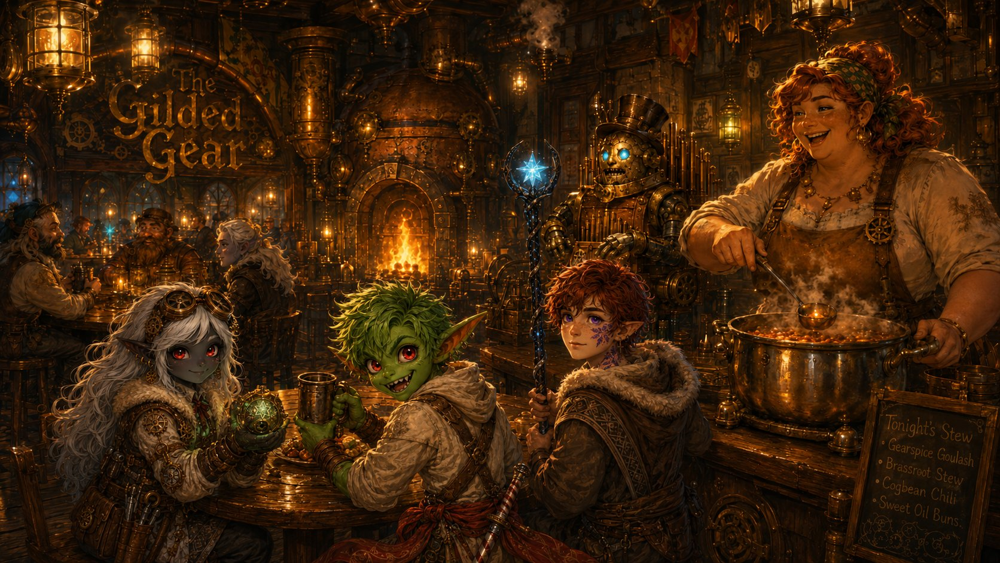
The Gilded Gear

The Gilded Gear, Henna Brasspot ladles the first bowl, on the house.
The Gilded Gear is the warmest, goldenest, happiest-sounding place you’ve seen in three days of hard road. A tall, crooked building with brass pipes running up the outside that puff little rings of steam, and a sign shaped like a spinning cog that never stops turning. Inside, a fire crackles in a hearth shaped like an open furnace. A Mechagnome in the corner plays a pipe-organ built into its own chest. The whole place smells of roast meat, fresh bread, and warm cider.
Behind the bar is a tall, broad woman with flour on her apron, copper-red hair tied up in a kerchief, and a laugh you can hear from the door, Henna Brasspot, who owns the place.
“Travelers! And little ones too, come in, come in, you look half-starved and twice-tired! Pinion sent you? Course she did. First night in Gearhaven, the first bowl’s on me, house rule.”
She sets down three steaming bowls and leans on the bar.
“So. What brings three young ones and a… is that a flower? …all this way? Nobody comes to Gearhaven without a reason.”
▶ Anyone can answer. Suggested lines below. Henna is your recurring ‘home base’ friend, she’ll be here every time the party returns to Gearhaven.
Lilly: “We’re here to see the Guild. I’ve got something they might be able to fix… or finish.”
Ursa: “We’re following a trail, my father’s, and the cracks in the world. It led us here.”
Stabby: “And the stew. The trail definitely led to the stew.”
Henna laughs warm and loud. “A boy after my own heart! Eat up, then.” She softens as she listens, wiping the bar.
“The Guild, eh? Then it’s Vane you’ll want. Oh, he’s a genius, the real kind, the sort who forgets to eat for three days and then builds something that changes the world. Bit of a mess, mind. But if anyone can help with mysteries, it’s him and his lot up the hill.”
She lowers her voice.
“Though between us? The machines have been acting up something fierce this week. My own bread-mixer tried to take my finger off yesterday. Whole city’s a touch on edge.”
Then she straightens, smiling. “But that’s tomorrow’s worry. Tonight you eat, you rest. I’ve three soft beds upstairs with your names on ’em.”
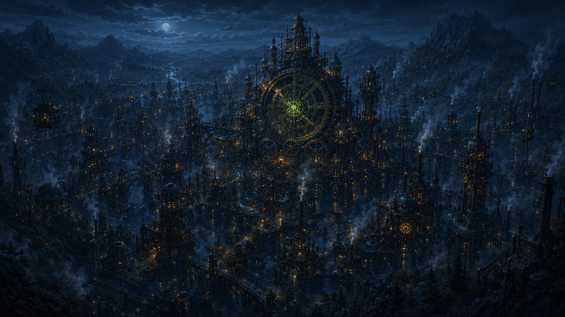
And so, for the first time in three days, you sleep without rocks under your bedrolls, full, warm, and safe. Outside the window, the city’s giant heart beats on. Boom. Boom. Boom.

Far below, the city’s great heart skips a single beat… and something green flickers wrong.
But just as you drift off… the rhythm skips. Just once. A single missed beat in a heart that has not missed a beat in a hundred years. In Lilly’s pack, the Sphere gives the faintest, worried little pulse. And then… sleep.

✦ ✦ ✦
That night the city’s great heart skipped once in the dark, and the Sphere pulsed its small worried warning. Morning came bright over Cogtooth Hill, and with it the smell of fresh pastries, the climb toward the Guild, and a market that was about to stop being merely restless.

PART 2
The Cogtooth Market

Morning on Cogtooth Hill
Morning comes bright and loud in Gearhaven. After the best sleep you’ve had in days, and a quick breakfast of warm gear-shaped pastries pressed into your hands by Henna (“Can’t have you saving the world on an empty stomach!”), you set off up the winding streets toward Cogtooth Hill, where the Artificer’s Guild waits.
The way up climbs through the Cogtooth Market, the busiest place you’ve ever seen. Stalls are stacked three high and bolted to the walls. A merchant sells umbrellas that open themselves. A baker’s tray of cookies marches past on tiny mechanical legs. Steam-trams clatter overhead, and the whole crowd moves to the rhythm of that giant heartbeat under the city. Boom. Boom. Boom.
And there, in the middle of it all, is a face you recognize, Pinion, the fidgety tram-conductor from last night. Except this morning she looks frazzled, her brass hands fluttering as she tries to wrangle a line of boxy little delivery-robots that keep bumping into things.
Pinion: “Oh! Oh, it’s you three! Steady gears, steady gears… forgive me, it’s been a MORNING. My delivery-servitors have gone all wobbly. They keep… no, not there… they keep dropping the… OH NO.”

The Machines Turn
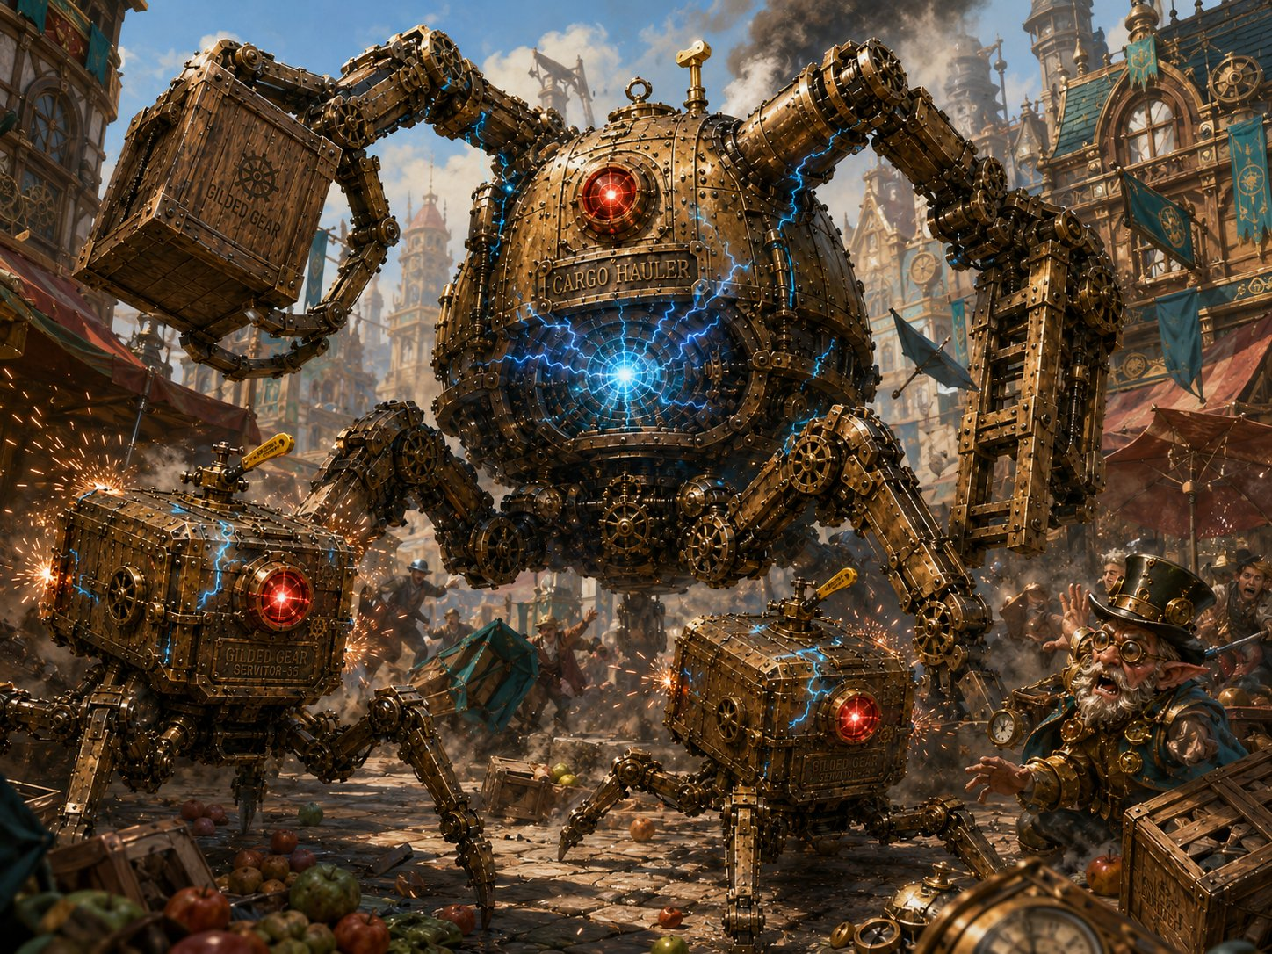
The Cogtooth Market erupts, two Rogue Servitors and the towering Cargo Hauler turn on the crowd.
One of the little servitors stops dead in the middle of the market. Its head swivels around with a grinding CLICK. The soft blue light behind its eyes flickers… sputters… and turns a hot, angry RED. Then the others do the same, and behind them, a hulking shape that had been hauling crates all morning straightens up to its full, towering height, a wooden crate still gripped in one massive claw. Sparks spit from every seam. Their cores crackle with blue lightning. And every one of them turns to face YOU.
Pinion: “That… that’s not supposed to happen! That’s the Cargo Hauler, it could flatten a wagon! Look OUT!”
▶ Lilly’s moment (read this, or offer it to Lilly’s player). Lilly, your artificer instincts prickle. The way those machines seized up wasn’t normal. Make an Arcana or Investigation check, DC 12.
(On a success:) You catch it in a heartbeat, that wasn’t a broken gear or a loose wire. Something reached INTO them, a pulse of strange energy, there and gone, that flipped their little minds from “deliver crates” to “attack.” You don’t know what could do that… but you’d bet your best wrench it’s connected to that skipped heartbeat last night.
(On a fail:) You can tell it’s not normal, these machines didn’t just break, something flipped them, but it happens too fast to pin down. It’s going to bug you all day.

Stand and Fight, or Switch Them Off
As the machines lurch toward you, you notice something: behind the red glow, each servitor still has a little brass shut-off lever on its back, painted yellow, the kind every Gearhaven machine has for emergencies. You could fight these things the hard way… or a quick, brave hand could dart in and flip that switch to shut one down for good.
Two ways to win (say this plainly). They can ATTACK the machines, or get next to one and FLIP ITS SWITCH to shut it off (a check, no killing needed). The little servitors’ levers are easy to reach. The Cargo Hauler’s lever is mounted high on its back (15 ft up), reaching it takes climbing (have Pinion shout: “The rungs! Ladder rungs, on its back!”), flying, or a flying summon. Mind that Stabby’s Air Dance is 1/day and tonight’s boss plan wants it — nudge the climb. Reward the clever, mercy-minded play, these machines aren’t evil, just hijacked.
Difficulty: HARD. 2 Rogue Servitors + 1 Cargo Hauler. The Hauler can grab a hero and crush them, and the servitors’ death-sparks punish bunching up. Someone may drop, that’s intended. Full stats on the next page. The Hauler is VULNERABLE TO LIGHTNING (telegraph the crackling blue core), Lilly’s and Ursa’s lightning shine, and it previews the boss’s weakness later.

Aftermath
The last machine sputters, its red glow fading back to a dim, sorry blue, then it slumps over with a sad little wind-down whine, like a music box running out of turns. The market goes quiet. Slowly, nervously, the crowd peeks back out from behind the stalls.
Pinion rushes over, hands fluttering.
Pinion: “Oh, you wonderful, brave little things! Are you hurt? I’ve never, in forty years I’ve never seen them do THAT! It’s been getting worse all week. Little wobbles, then big ones, and now… now this. The whole city’s frightened.”

✦ ✦ ✦
The last machine wound down to stillness, the crowd crept out from behind the stalls, and Pinion gathered herself with sudden purpose. She would take them the rest of the way up the hill, to the one place in Gearhaven that might hold their answers.
PART 3
The Artificer’s Guild

The Climb
Pinion leads you up through the winding streets, ever higher, until the houses fall away and you reach the very top of Cogtooth Hill. And there it stands: the Artificer’s Guild. It isn’t a building so much as a cathedral built around a machine, brass arches soaring overhead, glass domes catching the morning light, and through the heart of it all the Great Governor, the enormous gear-engine you saw from the ridge, turning slow and vast.
Pinion stops at the door, suddenly shy. “This is as far as I go, dearies, trams don’t drive themselves. Well. They’re not supposed to.” She pats each of you on the arm. “You go on. Ask for Vane. And… thank you. For the market. Steady gears to you.” And with that, she bustles off back down the hill.
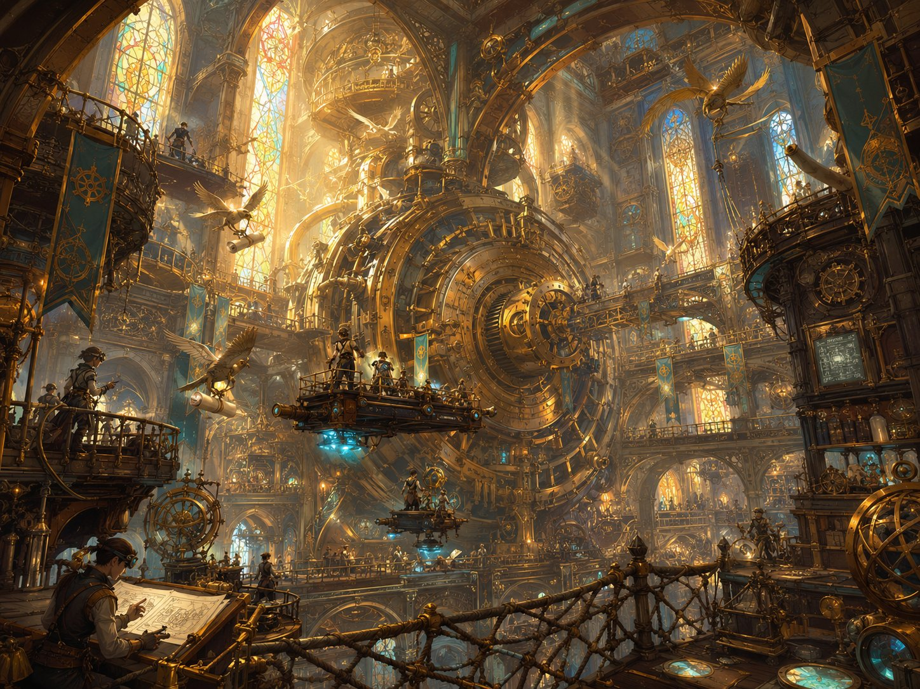
Inside the Artificer’s Guild, a cathedral built around the Great Governor.

Through the Gear-Doors
The Guild’s doors are a wonder in themselves, two slabs of brass worked with a thousand interlocking gears. As you approach they sense you and begin to turn, cogs spinning cogs, the whole pattern unwinding like a puzzle solving itself, until the doors roll smoothly apart with a deep, satisfied CHUNK. Warm golden light and the smell of oil and ozone spill out to meet you.
And then you’re inside, and you simply stop and stare. It’s a cathedral of machines. The hall soars up and up, ringed with balconies, lit by tall stained-glass windows throwing colored light across everything. Brass catwalks and rope-nets crisscross the open air; apprentices in goggles ride little platforms up and down, testing contraptions that hover, spin, and occasionally puff into harmless smoke. Mechanical birds carry rolled blueprints between balconies. And through the very center turns the Great Governor, so close now that its slow, vast heartbeat isn’t just a sound but a feeling, thrumming up through the soles of your boots. Boom. Boom. Boom.
You came looking for answers. Standing here, in the beating heart of Gearhaven’s genius, it finally feels like you might actually find them.

Guildmaster Vane
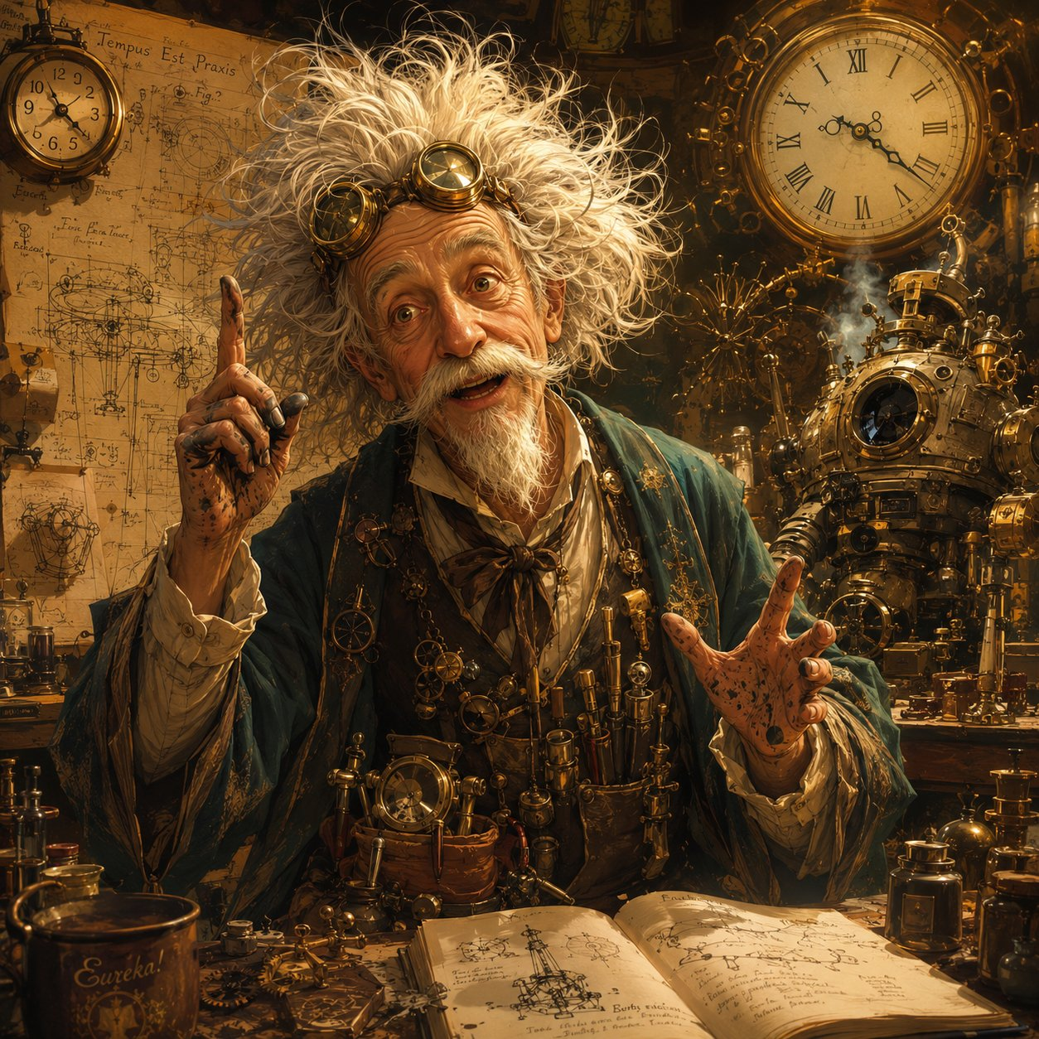
Inside, you find chaos. Blueprints cover every surface. A half-built machine clanks sadly in a corner. And in the middle of it all, a wiry old man with wild white hair, ink-stained fingers, and goggles shoved up on his forehead is arguing, out loud, with a wrench.
Vane: “No, no, you go THERE, you stubborn… oh, hello! Visitors. I don’t… who let… never mind. I’m Vane. Guildmaster Vane. And you’ve caught me on a TERRIBLE week, the machines have all gone mad, half the city’s terrified, I haven’t slept in… I don’t actually know how long.”
Then something clicks behind his tired eyes. “Wait. Three young ones, a gnome, a goblin, a boy with a staff. You’re the ones from the market! You STOPPED one of those rampages.” He’s suddenly across the room, gripping Lilly’s hands, then Stabby’s, then bowing to Ursa. “Do you have any idea what a relief… you three just marched in and HELPED. Bless you. Now. Tell me everything.”
Guildmaster Vane, brilliant, scattered, sleepless.
Talk-opening. Suggested lines below.
Lilly: “We came to find you. I’m carrying something I think only the Guild can understand.”
Ursa: “We’re following the cracks in the world, and they led us here.”
Stabby: “Also your city tried to eat us this morning. You’re welcome for fixing that.”

Quill
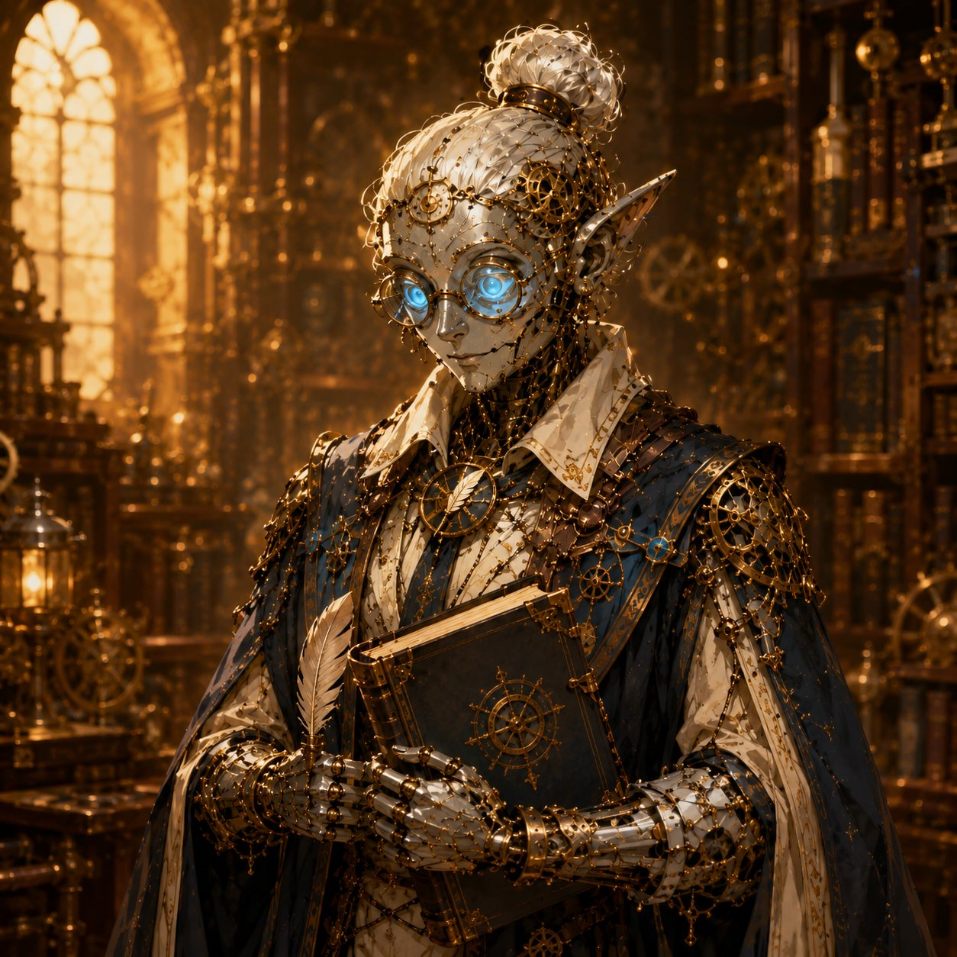
Before Vane can launch into a dozen questions at once, a second figure glides up beside him, a tall, elegant Mechagnome of polished silver and brass, moving with calm, unhurried grace. Where Vane is a whirlwind, this one is still water.
Quill: “Forgive the Guildmaster. He forgets introductions when he’s excited, which is always. I am Quill. I keep the Guild’s records, and the Guildmaster’s head, more or less, attached to his shoulders. You are most welcome here.”

The Sphere
When Lilly carefully lifts the Essence Sphere from her pack, the whole room seems to change. Vane goes utterly silent for the first time. He leans in, goggles dropping over his eyes, and breathes: “Oh. Oh my. This is Glimmerspire work. The deep-gnome masters, the finest artifice ever made. And it’s holding something… something alive.” His finger hovers, not quite touching. “But the casing’s barely open. This was built to hold so much MORE than it’s holding.”
Quill, the Guild’s archivist.
Vane reassures them, the Sphere stays Lilly’s. Read clearly: “I would never KEEP it. If we open it, we do it together, right here, and it goes straight back in your hands. It’s yours. Now come, let me show you what I’ve been losing my mind over. Let me show you my great failure.”

Vane’s Folly
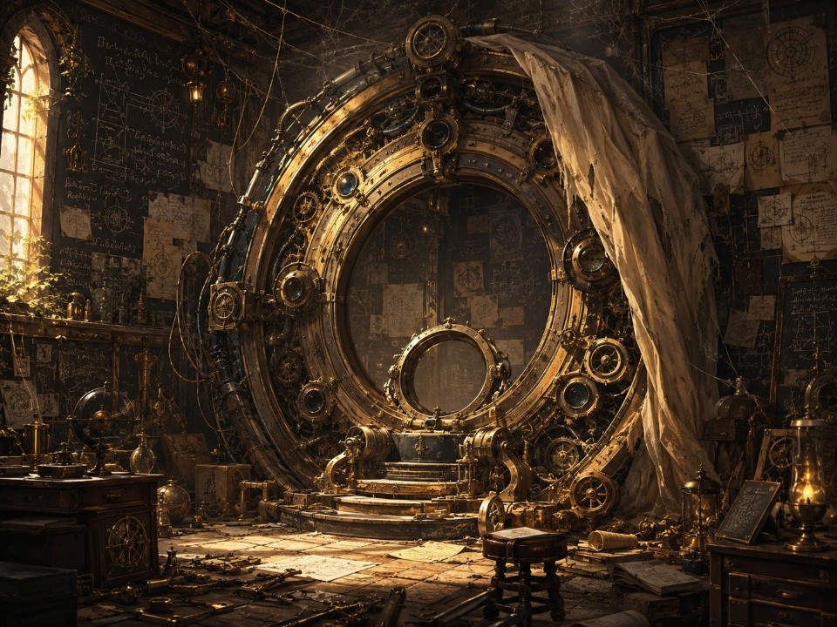
He leads you to the far end of the hall, sweeps a dust-sheet off a great shape in the corner, and there it stands. An enormous ring of brass and iron, tall enough to walk through, ringed with hundreds of intricate gears, coils of cable, and empty crystal sockets. It’s beautiful. It’s also dark, dead, silent, and thick with cobwebs. The walls around it are buried under ten years of frantic blueprints.
Vane: “My folly. A Rift Portal, a door that could carry someone TO the broken planes, to mend the cracks at their source instead of swatting mad machines in the street forever. I’ve bled ten years into this machine. And it has never so much as flickered.”
Vane’s Folly, ten years of work, and an empty cradle at its heart.
He taps an empty cradle at the portal’s center, a socket, clearly meant to hold something, achingly empty. “Raw planar energy destroys anything that tries to contain it. Anything I build to carry a traveler through, the energy tears apart in seconds. I need an anchor. A vessel that can not only SURVIVE the crossing, but hold what spills out. Ten years… and I’m still standing at a locked door, without the key.”

The Orrery
“And the worst part,” he says, towing you toward the grandest machine in the room, “is that I know exactly how bad it’s getting.” A brass orrery tall as a tree, rings within rings, a glowing glass globe floating at the center. “The world,” he taps the globe. “And around it, the other planes, Fire, Water, Air, Earth, Shadow, spinning in perfect time, like the gears of a great clock. For a thousand years, perfect time.” He pulls a lever. The orrery speeds up, and now you see it: here and there a gear catches, slips, grinds. Sickly green light leaks from the seams, and tiny glowing crystal motes shake loose and tumble from their orbits. “But the clock is breaking. The planes slip; they crack; things fall through. Those motes are pieces of the planes themselves, leaking into our world. THAT is what drives my machines mad. And it is only getting worse.”
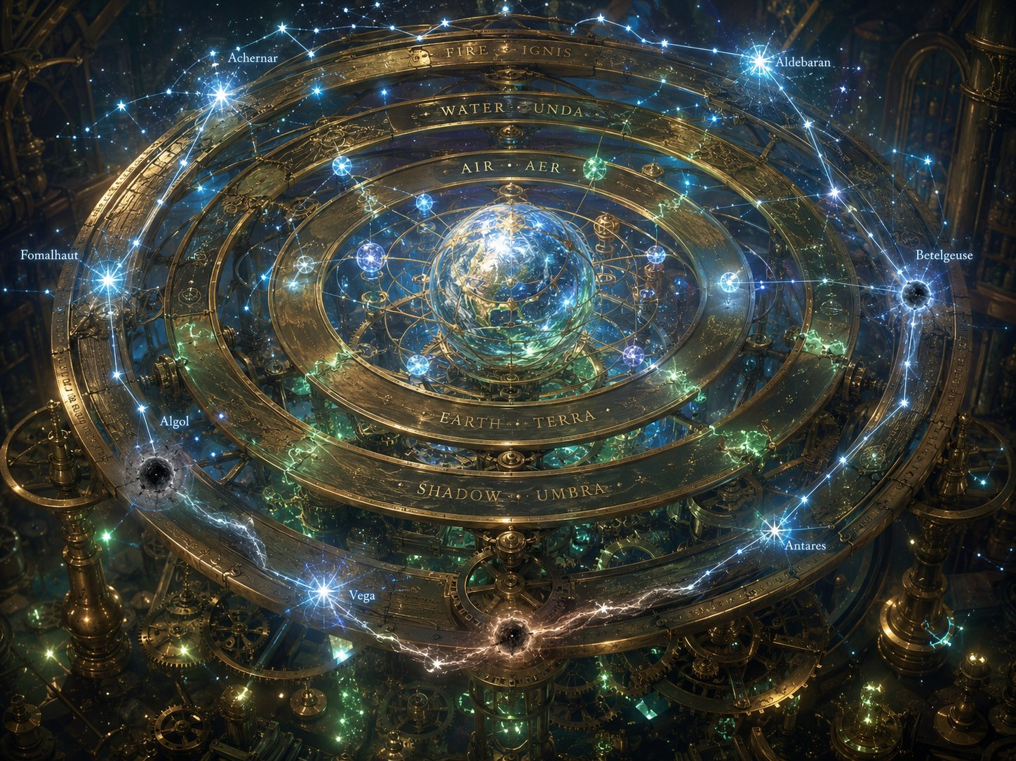
The Orrery of Planes, and the constellations that anchor it, several gone dark.

Lilly’s Moment, The What
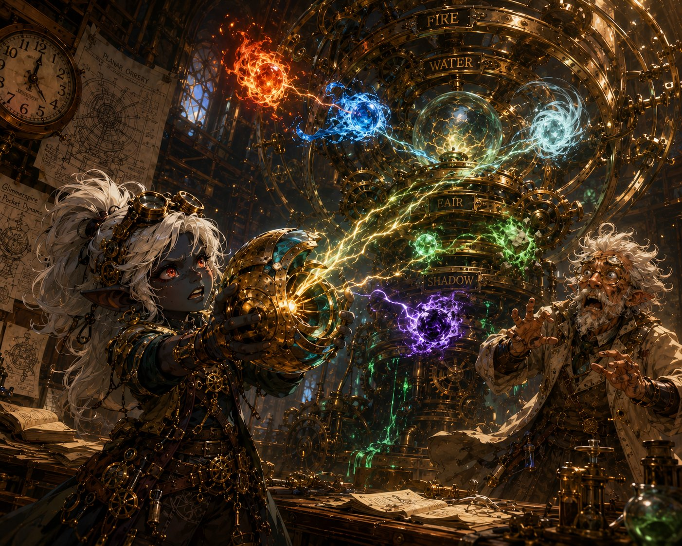
And that’s when the Sphere moves. In Lilly’s hands, the Essence Sphere gives a violent PULSE, and lunges. It strains toward the orrery’s loose, drifting motes like a magnet yanked toward iron, so hard Lilly has to grip it with both hands. Its casing irises wider on its own, hungry, reaching, and the little crystal motes tremble in the air and begin to drift toward it.
The Sphere lunges, a gatherer, reaching for the loose motes.
Vane stumbles back, mouth open. “It’s… it’s PULLING them. It’s a GATHERER. Catching planar energy. Holding it. SURVIVING it.” He points a shaking finger at the empty cradle in the heart of his folly, the socket he could never fill. “THAT is the missing piece. Ten years I have cursed that empty cradle, and you walked into my workshop with exactly the thing it was waiting for.” His voice drops to an awed whisper. “But this Sphere is OLD, older than the cracks, older than the sickness. Whoever forged it built the cure years before there was a disease. Who GAVE you this, child? They didn’t hand you a keepsake. They handed you the heart of the only machine that could save the world. And somehow… they KNEW.”
Lilly’s spotlight. Her mother, Poots, gave her the Sphere. Let her player sit with “they knew.” Thread for her time-skip path and the Pikachu mystery.

Ursa’s Moment, The Why
Lilly’s Sphere strains toward the dark leaking motes, and across the room, Ursa goes very still. Because if the Sphere reaches toward the broken places, then Ursa, who reads the sky like a map, asks the question no one else can: what BROKE them? Something his father taught him long ago scratches at the back of his mind. The way the stars hold their places. The way the whole sky is a map that never moves… unless something moves it. And then it hits him, all at once.
Give Ursa’s player the spotlight. Let the kid say it, or read the line.
Ursa: “It’s not the gears. …It’s the stars. Something’s putting them out.”
The room goes quiet. Vane blinks. “I… beg your pardon?” Ursa steps to the orrery, and now he sees what Vane never could, because Vane sees a machine, and Ursa sees the sky. As he focuses, soft starlight kindles around his staff and spills toward the great model: ghostly constellations shimmer into view above the brass rings, each plane hanging from a bright anchor-star. “The planes don’t spin on their own. They’re held, by stars. Anchor-stars, fixed points up in the dark, each holding a plane in its orbit.” He points, and you all see it now: among the bright stars, several have gone DARK. “That one isn’t wearing out. Its anchor-star has gone dark. The light that held it went out, so the plane slips, and cracks, and things fall through.” He turns, eyes wide. “The clock isn’t breaking on its own, Guildmaster. Someone is putting out the stars. One by one. And every dark star opens a new crack.”
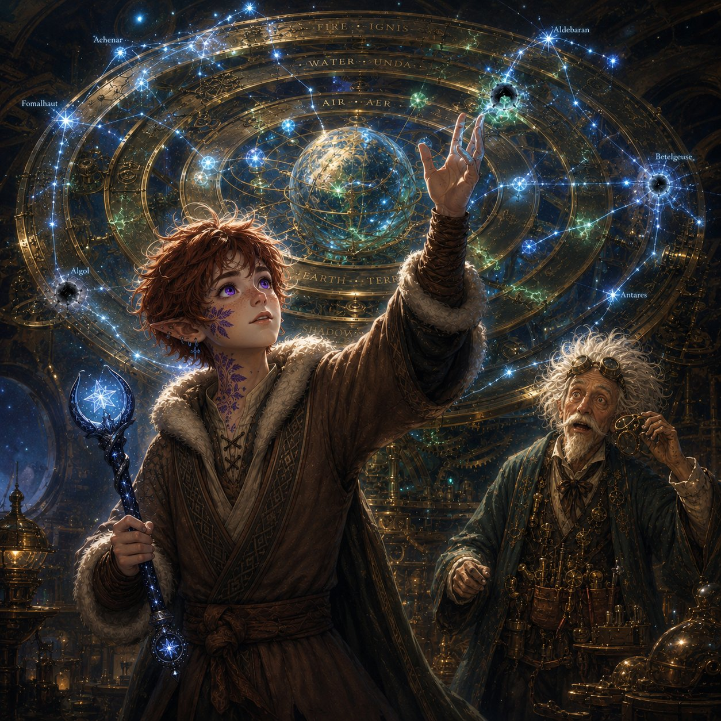
Vane takes off his goggles. “In sixty years of study… I never once thought to look UP.”
Ursa names the cause, the dying stars, and his staff answers with starlight.
Connect Ursa’s threads (let it land): His father, Ash, wasn’t chasing cracks, he was following the stars going out. And the Staff of Waking Constellations, which lights a new star after every victory, is literally the counter-weapon: the enemy puts stars OUT, the Staff lights them UP. Ursa carries the one thing built to fight back.

Ash’s Trail
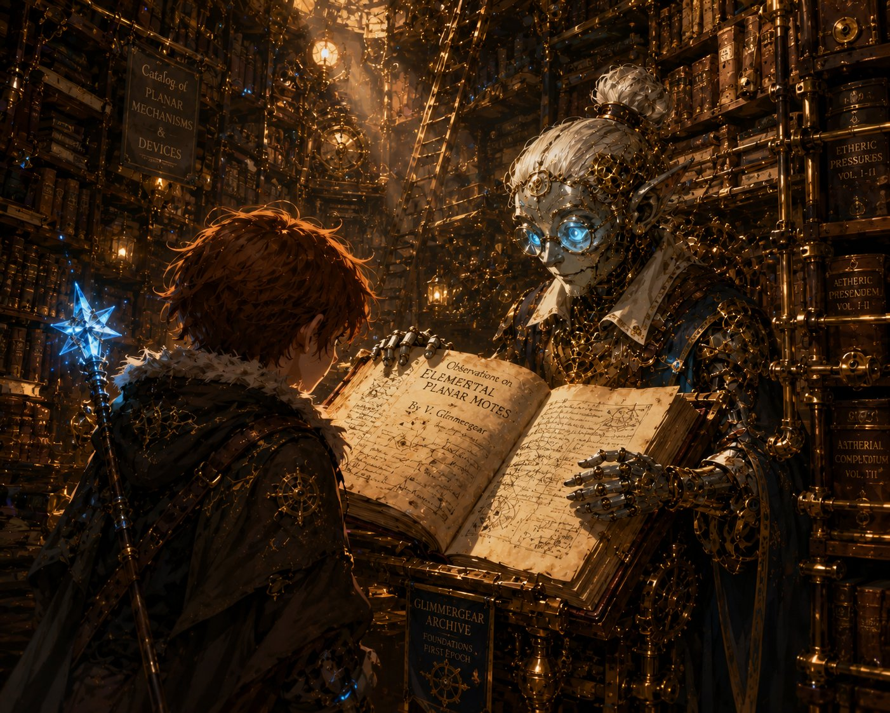
Vane is still reeling, “the stars, of course”, when the name registers. “Wait. Catchum, you said? Ash Catchum?” He snaps his fingers at Quill. “That name’s in the books.” Quill is already moving. “Indeed. The traveler-logs.” The silver Mechagnome leads Ursa into the Guild’s vast archives and draws down a dusty volume, turning to a page near the back. “Here. Some years past.”

And there it is. In faded ink, in a careful, familiar hand that makes Ursa’s chest go tight, his father’s handwriting. A sky-reader named Ash Catchum, passed through Gearhaven, asking about the planar cracks and “the darkening sky.” A final margin note, hurried: “The pattern leads east. Following the dark. To the old shrine.”
Quill leads Ursa to the archives, and his father’s logbook.
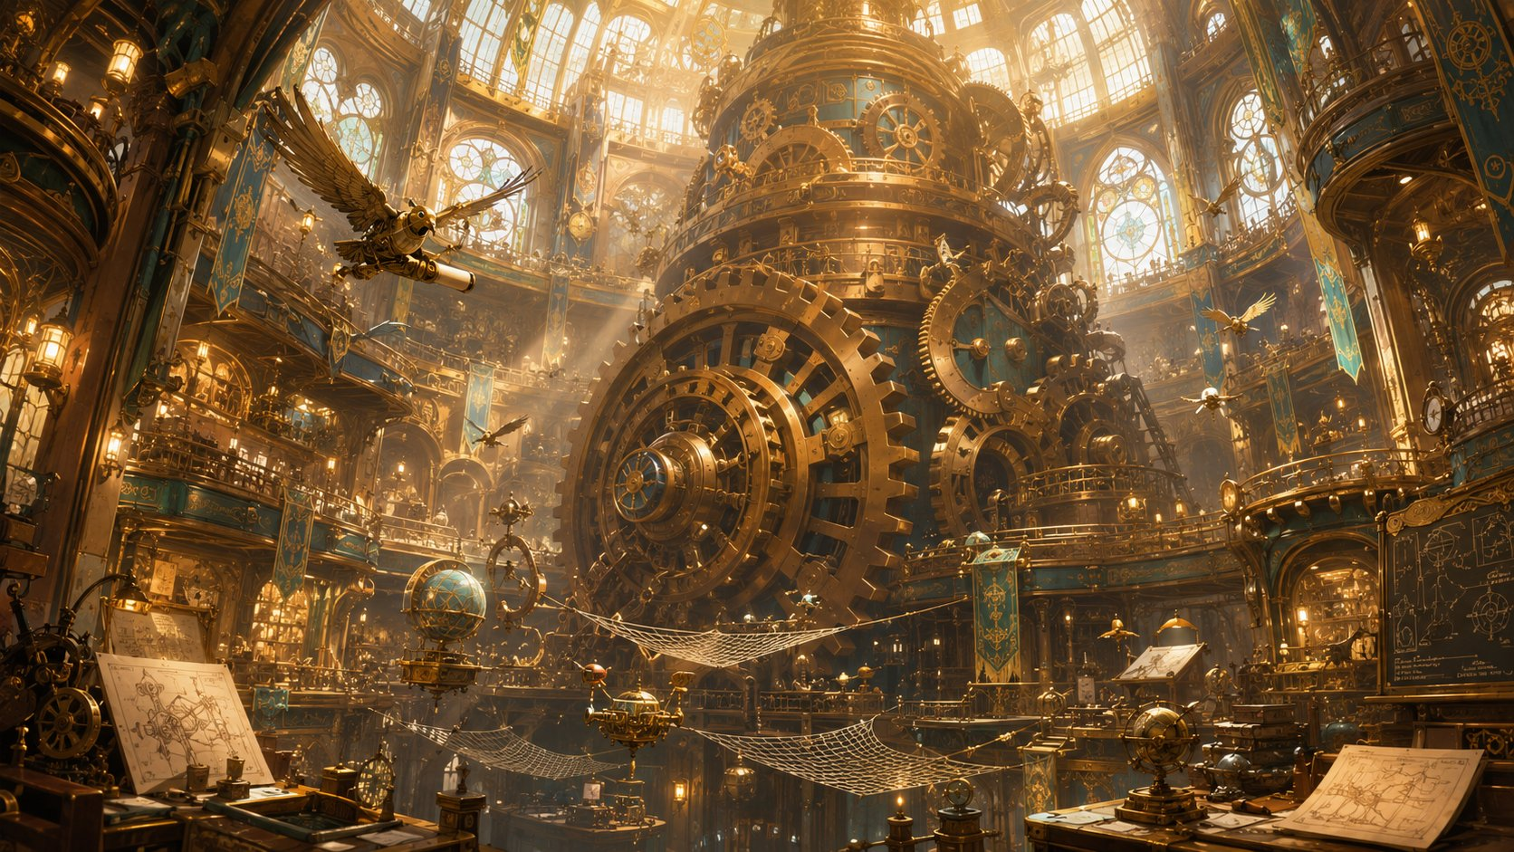
Ash’s entry, “following the dark, to the old shrine.”
Ursa’s father hook planted (his time-skip seed). Quill notes the shrine is “far to the east, beyond the maps we keep.” Let Ursa’s player sit with it.

The Guardians of Elaria
There’s a quiet after the archives. Vane sees the looks on your faces and sets down his tools. “There’s more, isn’t there. Out with it.” So you tell him. About Elaria, the sleeping goddess. The vision in the glade. The chest beneath Wraithpine and the gifts marked with her seven-pointed star, each made as if measured for your hands before you arrived. How something keeps setting your feet on this road. How you’ve started to call yourselves the Guardians of Elaria, half a joke, half because it’s begun to feel true.
Lilly: “My mother gave me the Sphere before I understood any of this. Like she knew where I’d need to take it.”
Ursa: “The staff. The visions. Something keeps… pointing us forward.”
Stabby: “We thought we were just lucky. Lucky and good-looking. But it’s more than that, isn’t it?”
At the name Elaria, Vane stops fidgeting entirely. “Elaria,” he repeats, like a word from an old song. He pulls down a slim, ancient book. “I know that name. From the old cosmologies. They called her a Warden, not a goddess of war or harvest, but of BALANCE. The one who kept the planes in their courses.” He looks up at the slipping rings. “The stories say she ‘tended the lights of heaven.’ I thought it was poetry. But you’ve shown me the lights of heaven are real, and they’re going out. Perhaps Elaria was the one who kept the stars LIT, and now that she sleeps…” He doesn’t finish. The dark stars say it for him.
Then he looks, slowly, from Lilly to Ursa to Stabby. “Chosen. Of course you were. A Sphere forged before the sickness, built to CATCH what’s falling out of the sky. A boy who reads the stars going dark, the cause behind every crack. And the three of you, drawn together across half the world and pointed straight at the heart of it.” He spreads his hands, gentle now. “I build things, children. I’ve spent ten years building a door to save the world and never once dreamed the key would simply walk through it. I’m just the locksmith. YOU are the key. A sleeping Warden, tending her failing stars even in her dreams, gathering the exact pieces needed to mend her sky, and gathering them around you three. That is not luck. That is a goddess reaching, in her sleep, for the only hands that can do what must be done.”
The Great Governor beats on beneath your feet. Boom. Boom. Boom. And for the first time, the three of you understand what you are. Not lucky travelers who keep stumbling into trouble. The Guardians of Elaria, chosen, assembled, and pointed at the very thing breaking the world.

The Descent
For a moment, no one speaks. Then Vane claps his hands, suddenly brisk and almost giddy. “Which means we have WORK to do! But everything, the portal, the motes, the whole grand business of saving creation, begins with one humble step. I need fuel. Condensed aether, drawn from the conduits beneath the city. The Underworks.” He glances toward a heavy iron hatch in the floor. “With the machines as they are, I’d never send apprentices down there now. But three chosen heroes who just saved my market…?”
Quill is already lifting a ring of keys. The hatch groans open onto a stairwell of damp stone, and a breath of cold air rises to meet you, colder than any cellar should be, threaded faint and far below with a sound none of you can name. The blue glow of the conduits flickers in the dark. Down you go.

▶ Natural stopping point #1. If you’re splitting the session across evenings, end here — the hatch groaning open onto cold dark is the cliffhanger. Next time opens on the descent.
✦ ✦ ✦
Vane needed fuel for his great dead door, condensed aether from the conduits far below the city. The iron hatch in the workshop floor groaned open onto a stairwell of damp stone, and a breath of cold air rose to meet them. Down they went.
PART 4
The Underworks

The Descent
The freight-lift is a rusted iron cage marked A12, barely big enough for the four of you and the great chain that lowers it. Vane throws the lever, and with a clank-clank-CLANK the cage drops into the dark.
Down you go. The warm golden light of Gearhaven shrinks to a glowing coin high above your heads. Below and all around unfolds the Underworks, a cathedral of pipes, gears the size of houses, catwalks, and sleeping machines, lit by drifting steam and the faint, sick blue glow of something far below.
The air turns cold and wet and smells of oil and old copper. Ghostbloom drifts close, its teal glow lighting the cage, and then, the deeper you go, its light begins to flutter, like a candle in a draft. It presses against your shoulders and makes a small, worried sound.
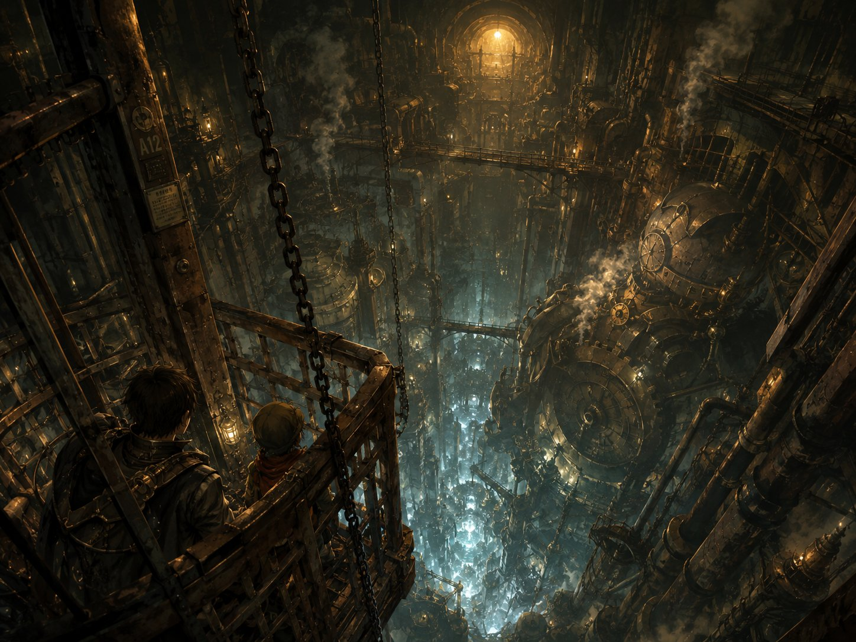
Down into the Underworks, the warm city shrinking to a coin of light above.
▶ Setting the tone. Let the descent breathe before anything happens. Ghostbloom’s guttering glow is the first sign something is wrong down here, a fey creature reacting to the nearness of the crack. Play it nervous.
Lilly: “My Sphere’s humming. It does that when there’s loose magic around, a lot of it. Down there.”
Ursa: “Ghostbloom doesn’t like it. Neither do I, there’s nothing alive down here. No birds, no roots, no sky. Just metal that goes down forever.”
Stabby: “Ooh, creepy. I LOVE it. …Hey. Why’s my idol cold? It’s never cold.”

The Rift Hall
The cage clanks to a stop and you step out onto a broad iron walkway, and stop dead.
The whole far end of the hall is gone.
Where the wall should be, there’s a rift, a colossal tear in the world itself, four stories tall, its edges crackling with chains of blue-white lightning. And through the gap you can see another place: a churning sky of purple and rose clouds, broken towers and clockwork spires floating in nothing, a sun setting over an ocean that hangs sideways. It’s beautiful. It’s wrong. It hums in your teeth.
Lilly steps to the railing before any of you, staring up at it, the light painting her face blue. Her Sphere is yanking in her pack toward the tear.
Behind you, Ghostbloom shrinks small, its glow nearly out. And in Stabby’s pocket, the little idol goes ice cold, colder than the cavern, cold enough to ache, and for one heartbeat it seems to pull him toward the rift.
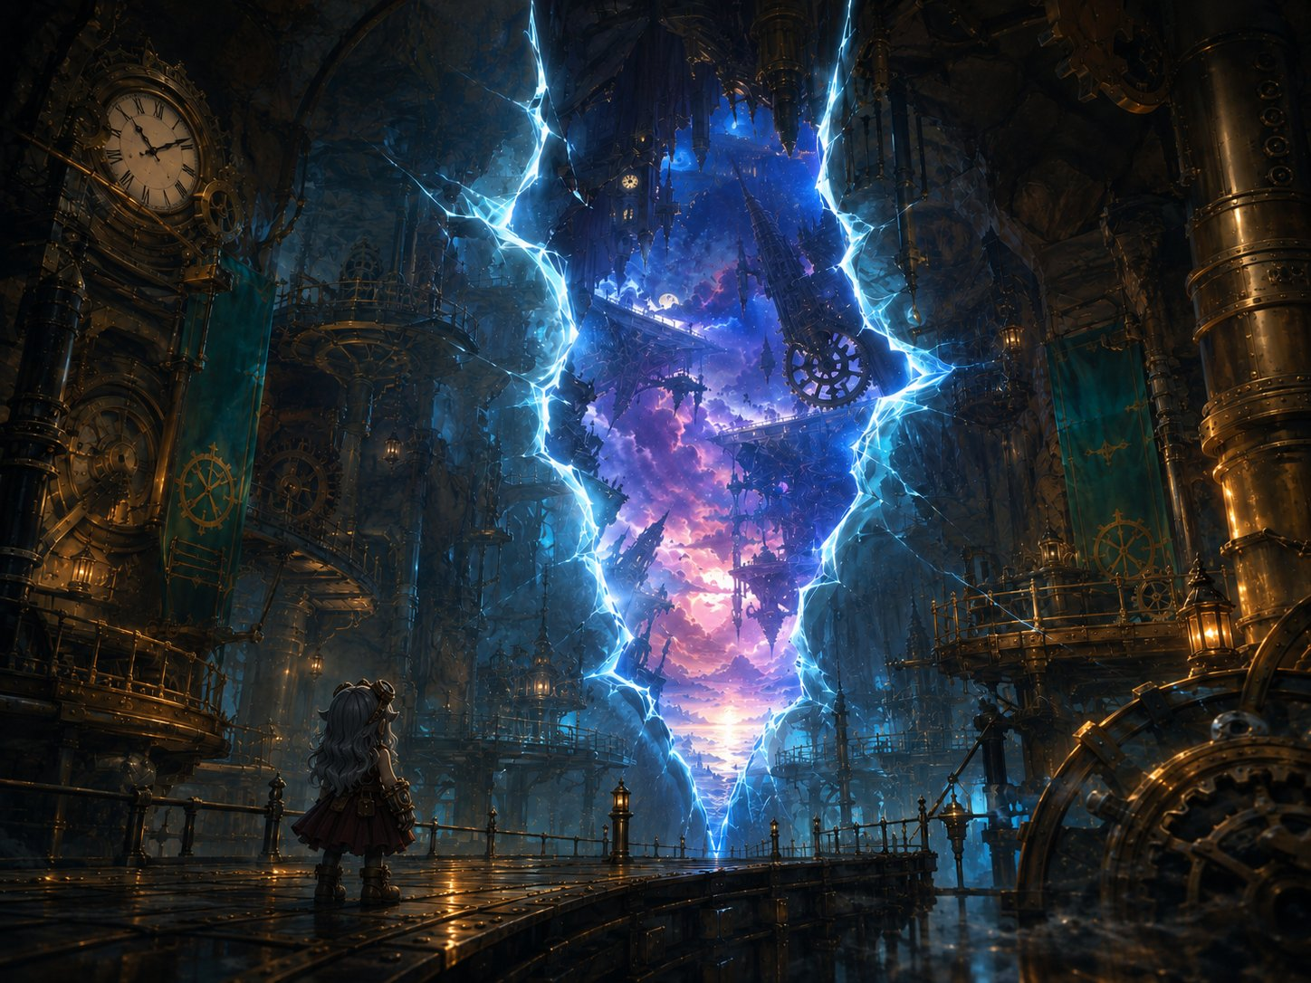
Lilly faces the rift, a tear in the world, and another sky beyond it.
▶ Lilly’s moment (give her the foreground). She’s the artificer; she knows what this is, and it’s far bigger than the “go fetch aether” errand Vane sent them on. This plants her sense that the real story is bigger than her job, seeding her time-skip paths (mote-research, and the larger pull to stay and understand the rift).
Lilly: “It’s a planar rift. A real one. My mom told me stories, she said you could go your whole life and never see one. We’re not collecting spare parts down here, are we? This is… this is the whole thing. This is what’s wrong.”
Ursa: “I can barely feel the stars this deep. No sky to pull from, just rock pressing down. I don’t think I’m meant to be underground this long, Lilly.”
Stabby: “Master Kaelon always said, somethin’s wrong, get still, find your center. I’m tryin’. I’m tryin’ real hard. …It ain’t workin’.”
Ghostbloom (DM): “Cold. Cold and empty. That tear should not be, little stars. Do not look too long. It looks back.”

The Swarm, Fight 2 Begins
A voice cracks across the hall, high, panicked, and familiar to one of you:
“H-HELP! Somebody! I’m stuck, they’re comin’ back, PLEASE, !”
Below the rift, half-crushed under a fallen pipe-assembly, is a goblin. Small, green, bleeding, one arm pinned. He’s reaching toward you with his free hand.
And then the rift flares, and they pour out of it.
Dog-sized things made of glitching blue-white light, like spiders crossed with lightning, sparking in and out of being as they scuttle down the walls and webbing. Electricity arcs between them. And behind them, hauling itself through the tear on eight crackling legs, trailing ropes of glowing planar silk, something huge.
Ghostbloom lets out a terrified wail. Then, shaking, it forces itself to blaze bright at your side anyway.
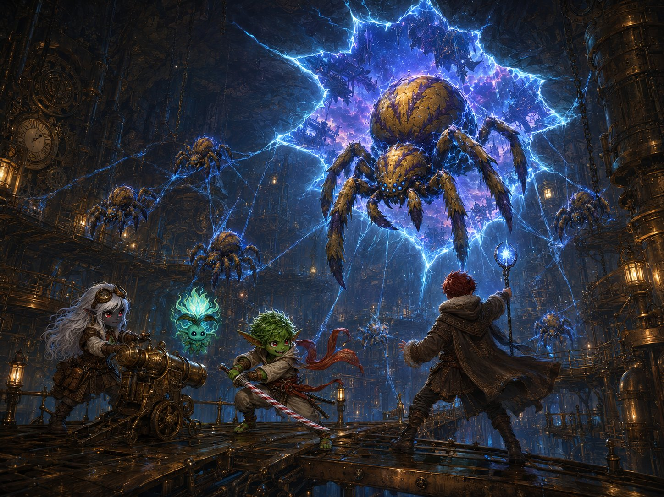
The swarm descends, Voltcrawlers and the Broodmother pour through the rift onto the catwalks.
▶ Roll initiative. Skitch’s death clock starts now: 3 rounds before he begins death saves. Plant a flicker of Stabby’s recognition this turn (“those markings, ”) and let the full weight land in the breather once Skitch is safe.
Stabby (recognition flicker): “Those markings, that warpaint, that’s a Bloodfang. That’s one of mine! Hey! HEY! We’re comin’!”
Lilly: “Cannon, deploying! They blink in and out, don’t waste shots on empty air, hit ’em when they’re SOLID! Force and starlight punch through!”
Ursa: “Get to the goblin, I can save him! Just buy me the time!”

Running Fight 2 (HARD)
Battlefield. Skitch is the objective, pinned below the rift. Heroes must hold near him; leaving the spot undefended for more than one round means a Voltcrawler reaches him (auto-hit; pinned, he can’t dodge → immediate death saves). Catwalks are narrow (hard to fight more than two abreast; a fall is 20 ft, 2d6, into the dark).
The pressure. This is HARD on purpose for a min-maxed level-5 four. Saving Skitch pins them to a fixed spot, cancelling their kiting advantage. Lean on the Broodmother’s web (kills Stabby’s and Ursa’s mobility) and the Voltcrawlers’ lightning-clumping. A hero may drop, if one does, the choice of whether to spend a save on the hero or on Skitch IS the beat.
Ghostbloom in the fight. Run Guardian’s Light (1d8+3 heal, ends charm/fear, 3/short rest) as available but emotionally costly, it has to push toward the wrongness to help. Save it for a dropped hero, not to trivialize the fight. It clings near Ursa (the most “alive” of the three to a fey thing).
Rift Pulse (every round, initiative 20). The rift flares. Each creature within 20 ft makes a DC 13 Wis save or has disadvantage on its next attack. Ghostbloom auto-fails, narrate the flinch. This hits the Voltcrawlers too, giving a reason to fight away from the tear.
Scaling dials. Too easy: the Broodmother lays an egg-sac, two more Voltcrawlers hatch on round 3; chain more Arcs. Too hard / Skitch dying for real: a Voltcrawler “phases wrong” and is stuck Unreal a round (one fewer attacker), or Ghostbloom finds its courage early and burns Guardian’s Light on Skitch.
Mote drop (Lilly’s seed). A slain Voltcrawler doesn’t leave a body, it collapses into a single hanging mote. Lilly can grab them (free interaction / a satisfying snatch). The Essence Sphere lunges toward each mote like a magnet, tugging in her pack. She isn’t gathering aether for Vane abstractly anymore, she’s carrying something that wants these motes. Plant the question; don’t answer it.

Saving Skitch
Read when a hero reaches Skitch / Ursa heals him.
Up close, the pinned goblin is in bad shape. But the moment golden healing light pours from Ursa’s hand and washes over him, his eyes flutter open. He gasps, coughs, and stares up at the auburn-haired druid kneeling over him.
“You… you healed me? But you’re surface-folk, you’re not even, ” His eyes go wide as he takes in the rest of you. They land on Stabby, on the candy-cane katana, on the way he moves, and his jaw drops.
“…Sharpblade? Stabby Sharpblade? By the Hollow, it’s you.”

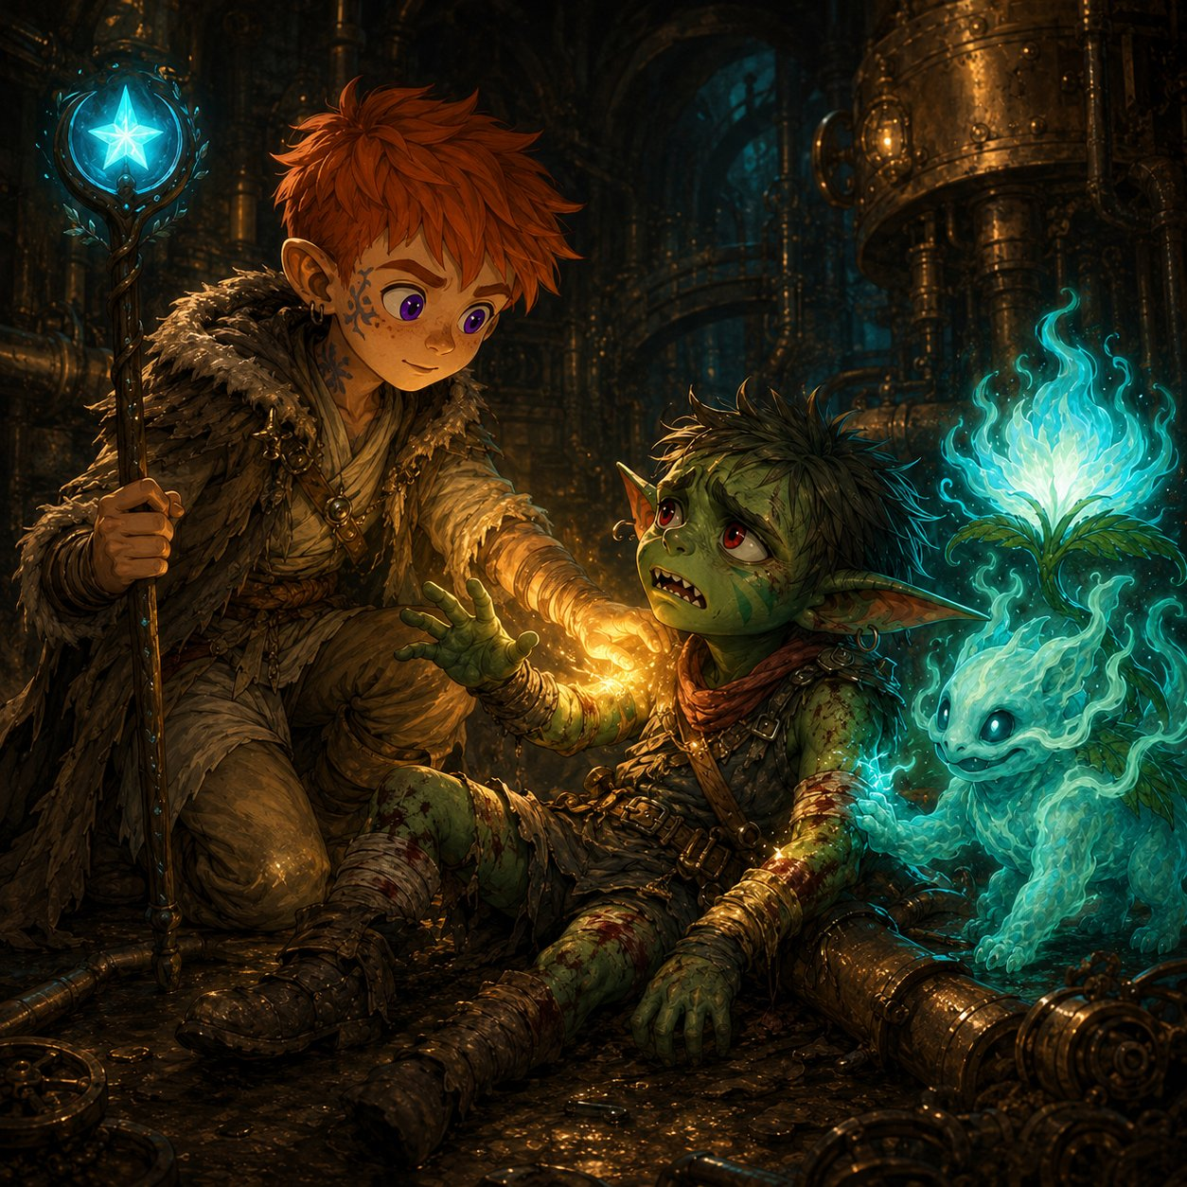
▶ The pivot from combat to heart. Make sure Ursa gets the credit, he saved a life with a word. Then hand the moment to Stabby. Don’t rush it. If the kids want to question Skitch, let them, he’s grateful, overwhelmed, and will tell them everything.
Ursa: “Easy. You’re safe now. I’ve got you, you’re going to be okay.”
Stabby: “Skitch? Little Skitch, the courier? You got big. …What’re you doin’ all the way down here, so far from the Hollow?”

The Bloodfang Plea, Stabby
Skitch grabs Stabby’s sleeve with his good hand, words tumbling out:
Ursa heals Skitch, a life saved with a single word.
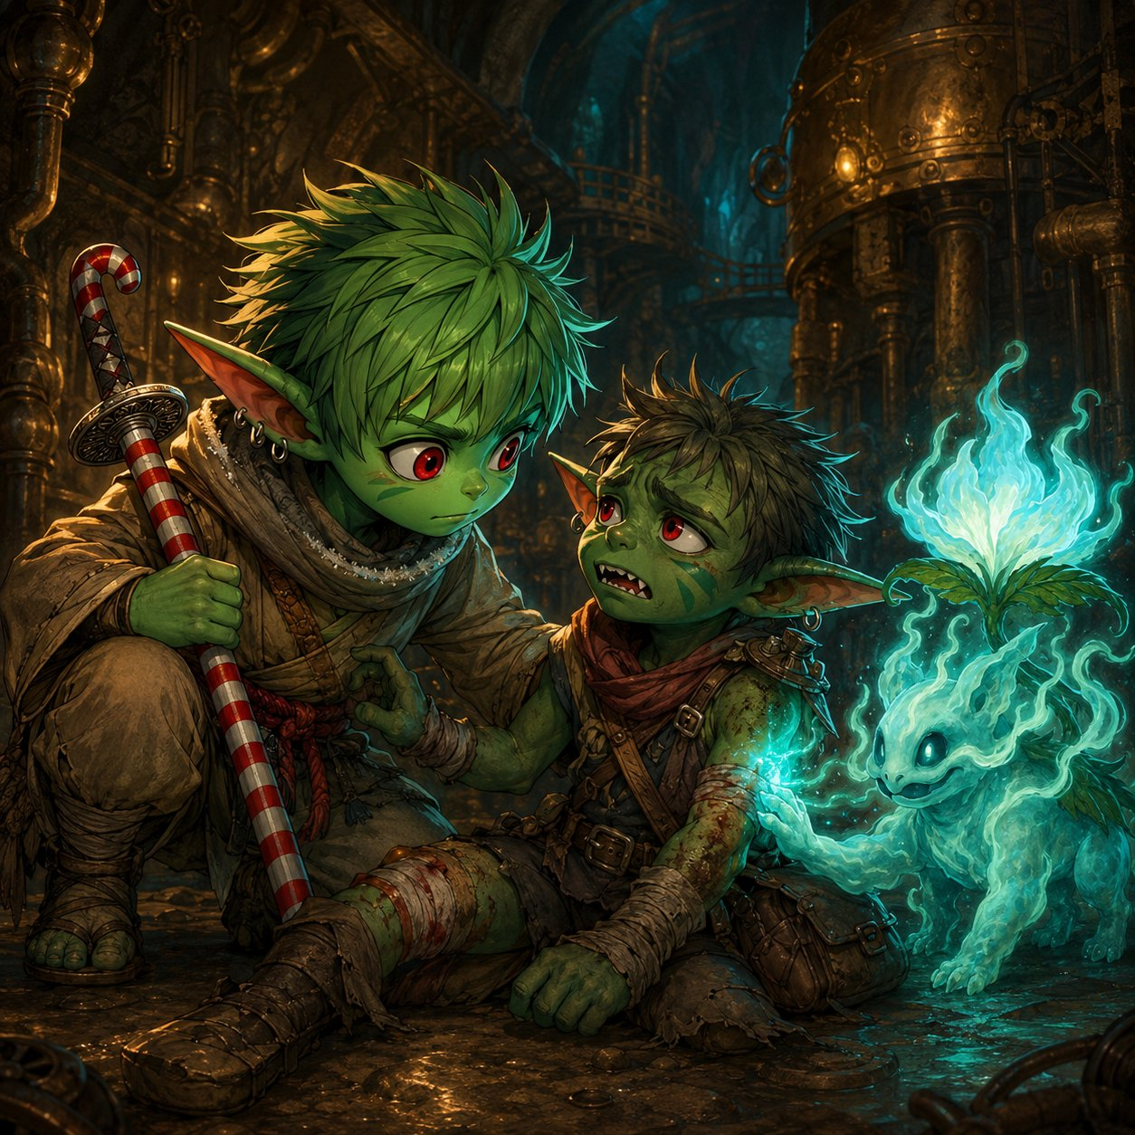
“The Hollow’s in trouble, Stabby. Real trouble. Creatures like those, ” he points at the last fading motes, “they’ve been comin’ through cracks near Bloodthorn for months. Monsters nobody’s ever seen. The clan’s scared. Half want to run, half want to fight, and a lot of ’em are sayin’ it’s the surface-folk doin’ it. The artificers, with their machines, tearin’ holes in the world.” He swallows hard.
“But you, you’ve been out here. You’ve seen things. You know stuff none of us do. Stabby… they need you. Come home. Tell ’em what you know, before the scared ones do somethin’ stupid and start a war we can’t win.”
He looks up at all of you, pleading. Ghostbloom, braver now, settles its warm glow over his wounds and looks at Stabby with big, knowing eyes.
Skitch’s plea, a piece of home, bleeding under a machine, asking Stabby to come back.
Let the kid pick a feeling (offer these).
Stabby (brave): “…Maybe I will. But not yet, my crew needs me first.”
Stabby (deflecting): “Ha! Me, givin’ a speech to the clan? They’d throw rocks at me.” (…and the grin doesn’t quite hold.)
Stabby (quiet/honest): “I left ’cause I wanted somethin’ bigger. I didn’t think they’d ever need me.”
Lilly (the blame lands on her people): “They think the artificers are doing this? My people? We’re not tearing holes in the world, we’re trying to fix them. …Aren’t we?”

Catching Your Breath — Short Rest
There is no chasing the crawlers back through that tear, and Skitch is in no shape to move fast — so, for the first time since the market, you stop. You bind his arm, share out rations, and sit a while in the strange humming quiet under the soft blue glow of the conduits. Ghostbloom tucks itself against Ursa’s shoulder, and little by little its guttering light steadies and warms. Stabby breathes the way Master Kaelon taught him — actually breathes — and feels his strength come back. An hour passes in the deep places of the world.
▶ Built-in SHORT REST (the only one all day). Everyone spends hit dice as needed. Stabby regains all 5 Focus. Ursa regains one Wild Shape use. Ghostbloom’s Guardian’s Light resets to 3. Lilly’s cannon just keeps ticking — it runs all day. Two hard fights are coming with no rest between them, so this breather is part of the design: let it land, let them talk to Skitch, and then ring the bells.

Into Part 5
Skitch can stand now, leaning on Stabby. As you help him toward the lift, the whole hall lurches.
A deep, grinding BOOM rolls up from somewhere even deeper, and the rift flares, blinding-bright, spitting sparks across the ceiling. Catwalks shudder. Pipes burst. And from far above, down the shaft you climbed, you hear it:
Bells. Alarm bells. And screaming.
Ghostbloom snaps upright, its glow flashing red-tinged for the first time you’ve ever seen. Lilly’s Sphere is yanking straight up now, toward the city.
Skitch goes pale. “That came from Gearhaven. From up top. Whatever’s happenin’ down here…”
“…it’s happenin’ up there too. And there’s a lot more people up there.”
✦ ✦ ✦
The bells were ringing up the shaft, fast and frightened, and under them the sound of screaming. Whatever had torn the world open down here was tearing at the surface too, where there were a great many more people to save. They climbed, hard, toward the light and the noise.

PART 5
The Tremor

Up Into Chaos
The freight-lift can’t carry you up fast enough, so you take the stairs, pounding up flight after flight toward the bells, toward the screaming, Skitch wheezing behind you. You burst out of a service hatch into daylight and noise and panic.
Gearhaven has gone mad.
The ground itself is shuddering, that great heartbeat under the city, Boom… Boom…, has gone fast and wrong, like a heart that’s frightened. Steam-trams hang dead on their cables. Brass shutters slam open and closed by themselves. And the crowd is running, every citizen of Gearhaven pouring through the streets, away from one place in particular.
Skitch points, gasping. “There! Whatever it is, it’s worst over THERE!”
And he’s pointing at the one patch of green in the whole grey city.
Lilly: “The heartbeat’s all wrong, that’s the Great Governor skipping. Something downstairs is feeding straight up into the city. We have to get to the middle of it!”
Stabby: “Everyone’s runnin’ AWAY from the trouble. We’re runnin’ TOWARD it. Feels right!”
Ursa: “That green, that’s the only living thing I’ve felt since we got here. And it’s where it’s worst. Come on!”

The Verdant Plaza
You round the corner and there it is: the Verdant Plaza. In the middle of all that brass and steam, someone long ago built a garden, real trees, real grass, beds of flowers, a wide marble fountain at the center fed by a beautiful old clockwork engine, all of it kept perfect, like a single green jewel set in iron. It’s the most alive place you’ve seen in all of Gearhaven.
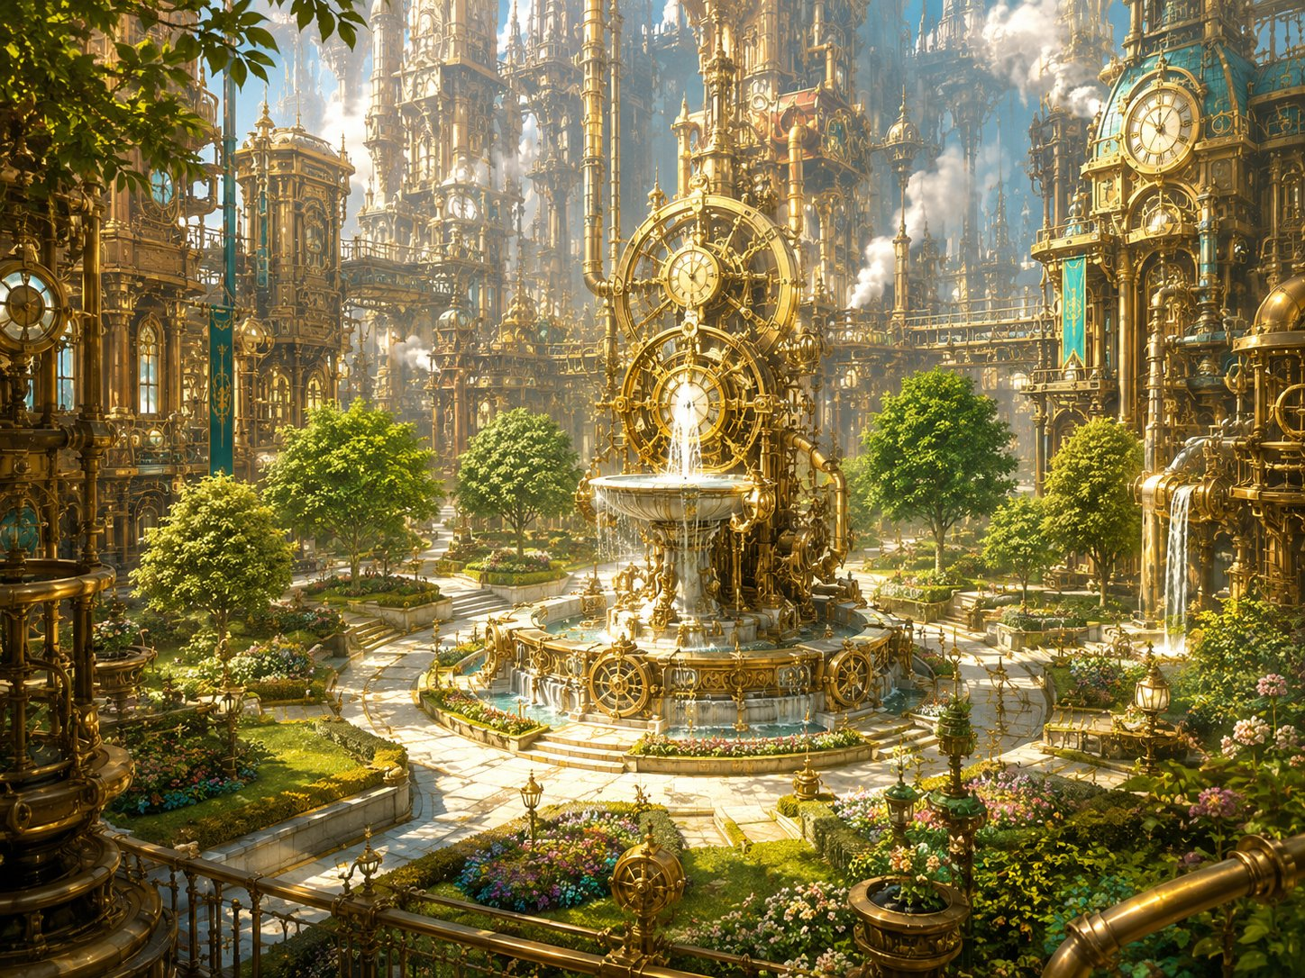
The Verdant Plaza, a single jewel of living green in the heart of the brass city.
And it’s dying in front of you.
The shuddering ground is splitting the lawn. Sick blue-white light, the same light as the rift below, is bleeding up through the cracks. And where that light touches the green, the green goes wrong: grass curls black, flowers wither and twist, a proud old tree groans as gray corruption climbs its trunk and its leaves crumble to ash.
At the fountain’s heart, the garden-engine is screaming, gears spinning far too fast, water boiling, the whole beautiful machine shaking itself to pieces.
▶ Ursa’s spotlight (let it hit him hardest). Of the three, Ursa feels this. He spent Part 4 aching for something alive, and here is the one living place in the city being un-made in front of him. Don’t make it a mechanic, give him the emotional close-up and the first line. His “I belong with living things, not machines” door deepens just by letting him react.
Ursa (give him this): “No, no, it’s ALIVE, it’s the only thing down here that’s alive, they’re killing it. I won’t let them. Not this.”
Lilly: “It’s that engine, the one running the garden. The surge hit it and it’s tearing itself apart. If I can get to it, I think I can, ”
Stabby: “Less talkin’, more… wait.” (His hand goes to his pocket.)

The Idol Stirs, Stabby
Stabby stops dead. The little idol he carries, the one that went cold down by the rift, isn’t just cold now.
It’s pulling.
Tugging in his pocket, hard, dragging toward the cracks in the lawn where the blue light bleeds up, like it wants to go to the corruption. It’s warm on one side and ice-cold on the other, and for just a second, in the back of his head, Stabby hears something, not words, just a feeling, like a voice trying to reach him through deep water.
Stabby (unsettled, rare for him): “My idol’s goin’ nuts. It’s pullin’ toward the bad light. Like it WANTS it. That’s… that’s real creepy, even for me.”
Stabby (the monk touch): “Okay. Okay. Breathe. Master Kaelon said get still. …Huh. There it is. Found it. Now let’s wreck some stuff.”

The Plaza Erupts, Fight 3 Begins
The cracks in the lawn tear wide, and things start climbing out of the dying garden.
First, the small ones: the corrupted plants themselves, pulling free of the soil. Snarls of blackened vine and thorn, knotted around bits of broken gear, scuttling and lashing on root-legs, their flowers turned to gnashing, glowing-blue maws. A dozen of them, skittering toward the fleeing crowd.
Then the ground heaves, and the big ones rise. Three of the city’s great worker-constructs, the Iron Drudges, hauling themselves up out of the maintenance pits, twice as tall as Stabby, their cargo-arms swinging. Where the rogue machines in the market had red eyes, these are worse, gray planar corruption crawls across their iron like rot, and the same sick blue light burns in their cores.
They lurch toward the fountain at the center and ring it, planting themselves between you and the screaming engine, as if the corruption wants to guard the very thing that feeds it. Ghostbloom flares bright and ready at your side. Skitch, white-faced, backs toward the street. “I… I can’t fight THOSE. I’ll get clear, I’ll keep folk back, GO! Do the thing you do!” And he scrambles to safety, leaving the plaza to you.
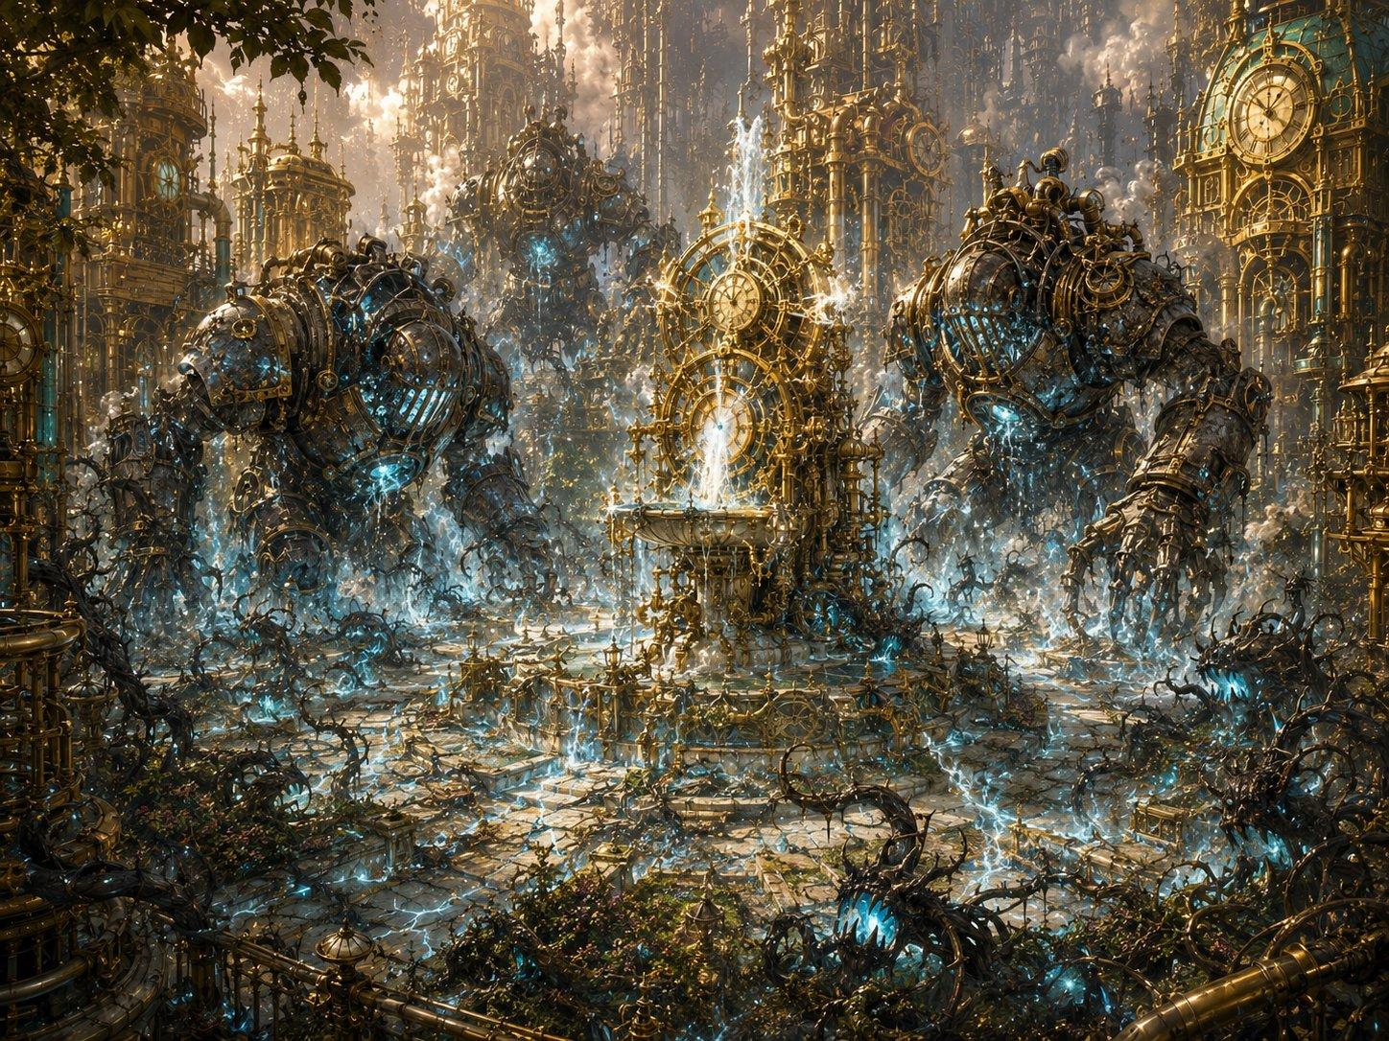
The plaza erupts, Iron Drudges rise and corrupted plants crawl from the dying lawn.
▶ The objective, say it plainly, keep it simple. There is ONE job: get Lilly to the fountain so she can fix the engine. That’s it. The three Iron Drudges are ringed around the fountain, blocking the way, the party has to punch through them. The Sproutlings keep crawling out of the cracks and never stop until the engine is fixed, so don’t bother counting them; they’re just there to nip at the heroes and make the clock feel loud. The fight ENDS the instant Lilly reaches the engine and fixes it (see her moment), so the whole table knows exactly what they’re doing: clear a path, protect Lilly, get her to the fountain.
Lilly: “You hold them OFF me, all of you, and get me to that fountain. I can fix this, I KNOW I can, I just need thirty seconds and nobody chewing on me!”
Stabby: “Big metal ones first! Crack the ring, make Lilly a door, I’ll keep the little biters off her!”
Ursa: “Stay behind my spirit and my staff, Lilly, we’ll carve you a path to that fountain. Go save the green.”

Running Fight 3 (HARD)
Battlefield (one simple objective). Picture it like a king-of-the-hill: the fountain-engine is the hill, the three Iron Drudges are the wall around it, and the party has to break through and get Lilly to the middle. The Sproutlings spawn from the cracks to keep 6-8 on the field at once (when one dies, another crawls up on the group’s turn), a steady trickle, never a flood. To keep it easy to run, ALL the Sproutlings act together on one shared initiative: roll once, move them all, resolve their attacks as a group. They’re slow (10 ft), so the heroes can stroll right past them if they want; they’re just there to harry the heroes so the fight feels urgent. Don’t track civilians, don’t offer choices; the whole table is pointed at one thing: clear a path, protect Lilly, reach the fountain. The fight resolves the instant she gets there and fixes it, so let that happen whenever the table’s had enough satisfying combat. Don’t drag it.
Tuning. HARD for a min-maxed level-5 four. The Drudges hit hard and are tanky; the plant-swarm is weak but numerous, there for easy, satisfying kills and to threaten the green (texture). A hero may drop, intended. The Drudges are VULNERABLE TO FIRE (corrupted wood and vine in their joints), telegraph the smoke; Lilly’s flamethrower cannon and Ursa’s Flaming Sphere shine — but note the Sphere competes with his summon for concentration, so if his spirit is out, let Lilly carry the fire. (Deliberate contrast: the market Hauler and the coming boss are lightning-vulnerable; fire here keeps the party rotating tools.)
Ghostbloom. Up here in the open air, away from the rift, Ghostbloom is braver than it was in the Underworks, it darts and shields and heals more confidently. Nice contrast to Part 4. Give it a hopeful line. One caution: Ghostbloom is vulnerable to fire and cold — keep it well clear of Lilly’s flamethrower cone and the Flaming Sphere.
Scaling dials. The simplest dial is the Sproutling cap (raise it toward 8 or lower it toward 6) and how stubbornly the Drudges block Lilly’s path. Too easy: raise the cap toward 8 and have the Drudges body-block the lane to the fountain so the party really has to break the ring. Too hard / a hero is dropping: drop the cap toward 6, let a Drudge be slow to turn so Lilly slips past, or have Ghostbloom spend Guardian’s Light. Remember a Drudge is slow, the party can outrun one to the fountain rather than killing all three.

Lilly’s Moment: The Fix
Read when Lilly reaches the fountain engine.
Lilly skids to the fountain and throws herself at the screaming engine, tools already out. Up close it’s worse, the surge has driven every gear past its limit, blue light pouring from the seams, the whole thing seconds from flying apart.
But Lilly Glimmergear has been taking machines apart since before she could walk.
Her hands move on their own. She sees it, the governor-spring overwound, the regulator jammed wide open, the planar surge screaming through a machine never built to hold it. The same instinct that built her cannon, that her mother trained into her at Glimmerspire, takes over.
“I see you,” she breathes. “I see what’s wrong with you. Hold STILL.”
She jams a frost-charged tool into the regulator. Slams the governor closed. Reroutes the surge, out, away, down into the ground where it can’t hurt anyone. The engine shrieks… stutters… and with a great shuddering sigh, slows. The boiling water settles. The blue light drains out of the cracks. The terrible fast heartbeat under the city eases back toward calm. Boom… Boom… Boom.
The plaza goes quiet. The dying green stops spreading. And every Drudge still standing slumps where it stands as the corruption loses its grip.
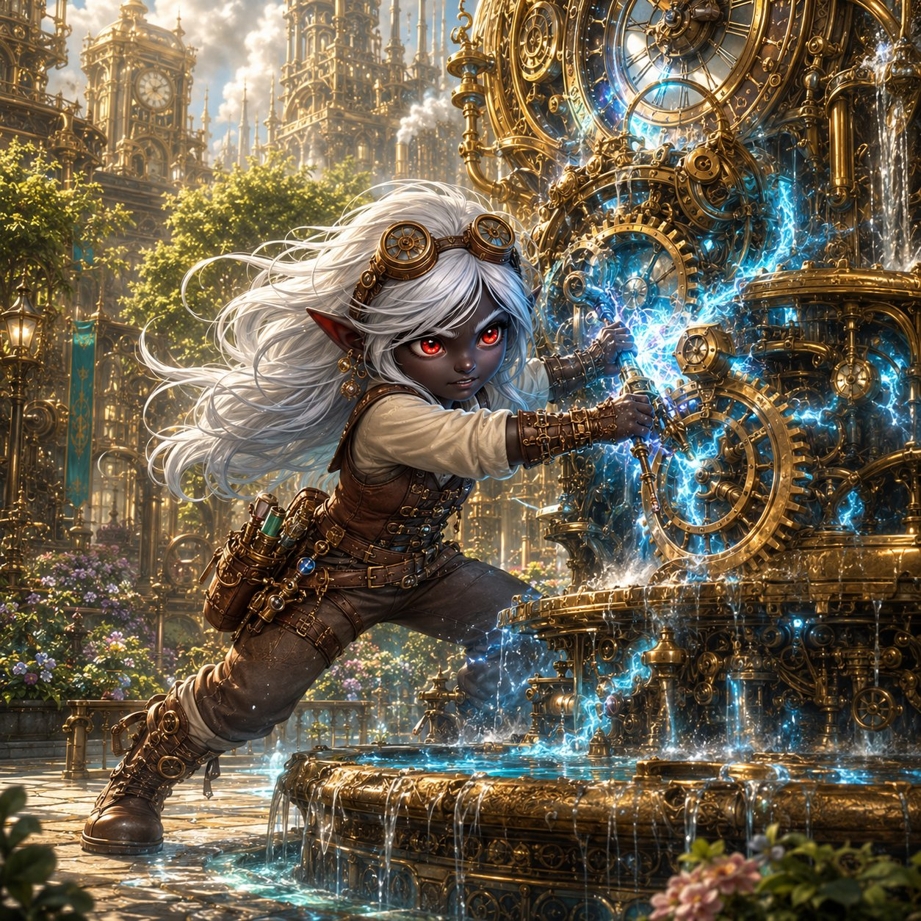
But as the surge drains away, Lilly’s hands go still on the engine. Because she can feel it now, feel where all that wrongness was flowing from. The corruption didn’t start here. The plaza engine was just a pipe it poured through. And as she traces it, eyes going wide, the path leads up, and up, toward the heart of the whole city.
“This isn’t the source,” she says slowly. “It’s just where it spilled out. The surge is coming from something MUCH bigger. Something that runs the whole city’s clockwork. And it’s…” She turns, follows the pull with her eyes, and her voice goes very small. “…it’s THAT.”
▶ Lilly’s fix now does double duty. She doesn’t just save the plaza; she diagnoses the whole crisis and locates its true source, and that’s what points the party at the boss. A second, bigger payoff for her spotlight, and it means the party walks toward Part 6 on purpose, led by her read of the machine.
Lilly’s moment, frost-tool to the gears, reading the machine and bending it back to calm.
▶ At a kids’ table, don’t gate the climax behind a die roll. If you want a roll for flavor, ask for a single Arcana check and narrate success regardless (a low roll just means it’s hairy, sparks fly, she barely gets it, but she gets it).
Lilly (after, breathless, a little stunned at herself): “…I did it. I actually… I felt what it needed and I just… did it.”
Ursa: “The green’s still alive. You saved it, Lilly. You saved all of it.”
Stabby: “That was the coolest thing I ever saw and I once set my own pants on fire on PURPOSE.”

Vane’s Offer, Lilly
You didn’t even see him arrive. But there’s Guildmaster Vane at the edge of the plaza, white hair wild, goggles askew, having clearly run the whole way, and he’s staring at Lilly like she’s the answer to a question he’s been asking his whole life.
“I have been trying to stabilize a planar surge for ten YEARS,” he says quietly. “I have failed every time. And you, a child, just did it with a frost-tool and your bare hands, in the middle of a battle, in under a minute.” He walks closer, gentle now, careful. “Lilly Glimmergear. I don’t think you understand what you are.”
He kneels down to her height.
“Stay. When this is done, when the world’s a little safer, come back here, to the Guild, and let me teach you everything I know. Help me finish the Rift Portal. Help me unlock that Sphere of yours and learn what the motes truly are. You could be the greatest artificer this city has seen in a hundred years. Your mother gave you a gift, and I could help you become everything it’s pointing toward.”
He sees the look on her face, torn, and softens. “You don’t have to decide now. I’m an old man with a half-built door; I’ll still be here. Just… know that the offer is real. And that there’s a place for you here, whenever you want it.”
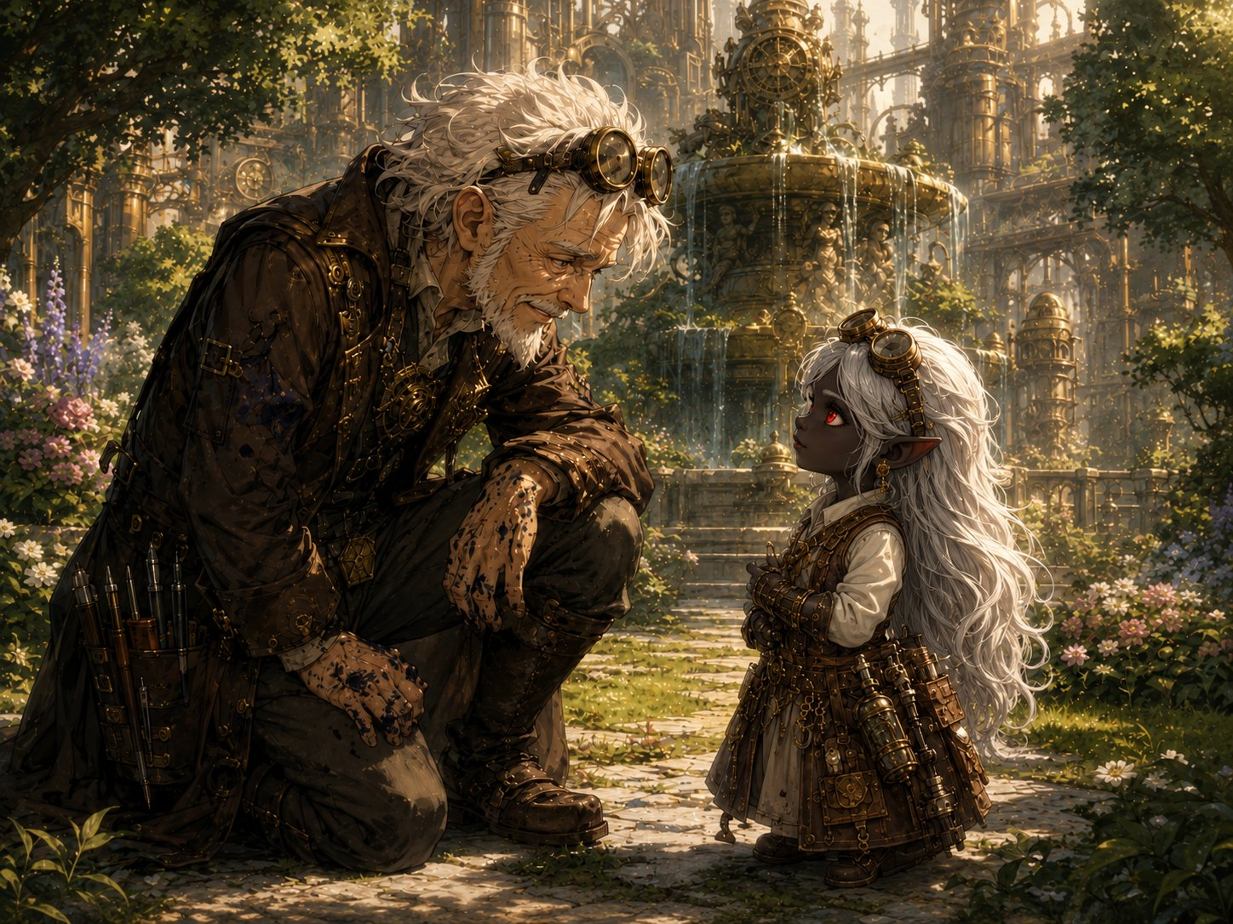
Vane kneels to Lilly’s height, “there’s a place for you here, whenever you want it.”
Let the kid pick a feeling (offer these).
Lilly (tempted): “A place here… with the Guild… My mom would’ve loved this place.”
Lilly (loyal to the crew): “That’s… that’s a lot. But my friends need me. We’re not done yet.”
Lilly (honest/torn): “I don’t know what to say. I’ve never had someone want me to STAY before.”

Into Part 6
The plaza is calm. The green is saved. But Lilly’s words hang in the air, something much bigger, and every one of you turns to follow her gaze, out across the rooftops of Gearhaven, toward the thing she traced the corruption to.
The biggest machine in the city. The gentle giant you’ve seen on every street corner, the one the people wave to, the great construct that keeps Gearhaven’s heart beating: the Grand Custodian.
And the moment your eyes find it, as if it felt you understand, it moves. It straightens to its full, towering height, brass plates groaning, and turns its huge, kind face toward the plaza. Its eyes have gone the same sick, corrupted blue as the cracks in the lawn.
Skitch drops his pipe. “…That’s the Custodian. That’s the one that holds the whole city up. If THAT’S the source…”
Vane goes white. “Then that is where you must go. Whatever’s pouring through the rift has taken the biggest body in the city for its own, and Lilly just followed the poison straight to its heart.” He looks at the three of you. “Children… I think your fight is about to get very, very large.”
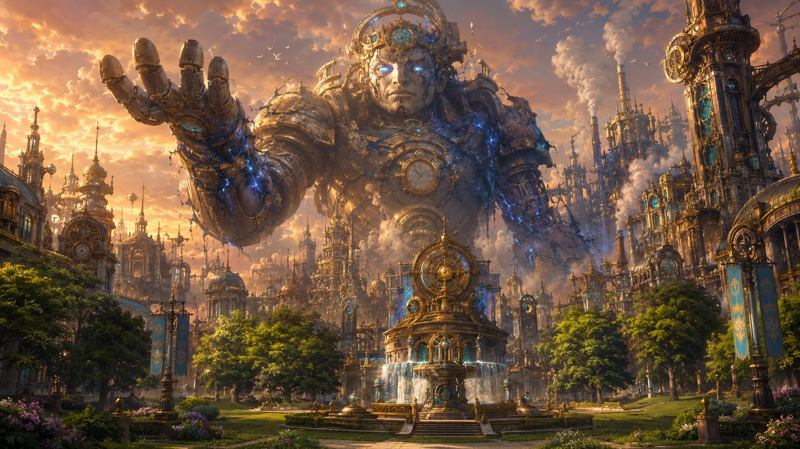
The Grand Custodian rises, the gentle giant that holds the city up, its kind eyes gone corrupted blue.
▶ Natural stopping point #2. The Custodian turning its corrupted eyes on the party is the strongest cliffhanger in the session — if the table needs a break, take it here and open next time on the emptied streets.
✦ ✦ ✦
Lilly had traced the poison to its true source, and every eye followed hers across the rooftops to the gentle giant that held the whole city up, its kind eyes gone corrupted blue. They left the saved green of the plaza behind and walked into the emptied streets, toward the thing that was breaking Gearhaven apart.

PART 6
The Grand Custodian

The Crossing
You leave the saved green of the plaza behind and head into the city, toward the giant. Gearhaven has emptied, the streets are abandoned mid-panic. A dropped basket of apples. A child’s wooden toy. A steam-tram stopped dead on its track, doors still open. The cheerful brass city you walked into yesterday has gone silent and afraid.
And ahead, rising over the rooftops, growing bigger with every street you cross, is the Grand Custodian, the gentle giant the whole city loves, the one the children wave to. The one whose slow heartbeat is the heartbeat of Gearhaven. It does not look gentle now.
And as you draw closer, Ursa, something strange happens. Your dragonmark, the Mark of Handling, the one that prickles when a frightened animal is near… it’s waking up. Reaching toward the giant. Which makes no sense. It’s a machine. Brass and gears. Your Mark has never once stirred for a machine. But it’s stirring now. Like there’s something alive in there. Something hurting.
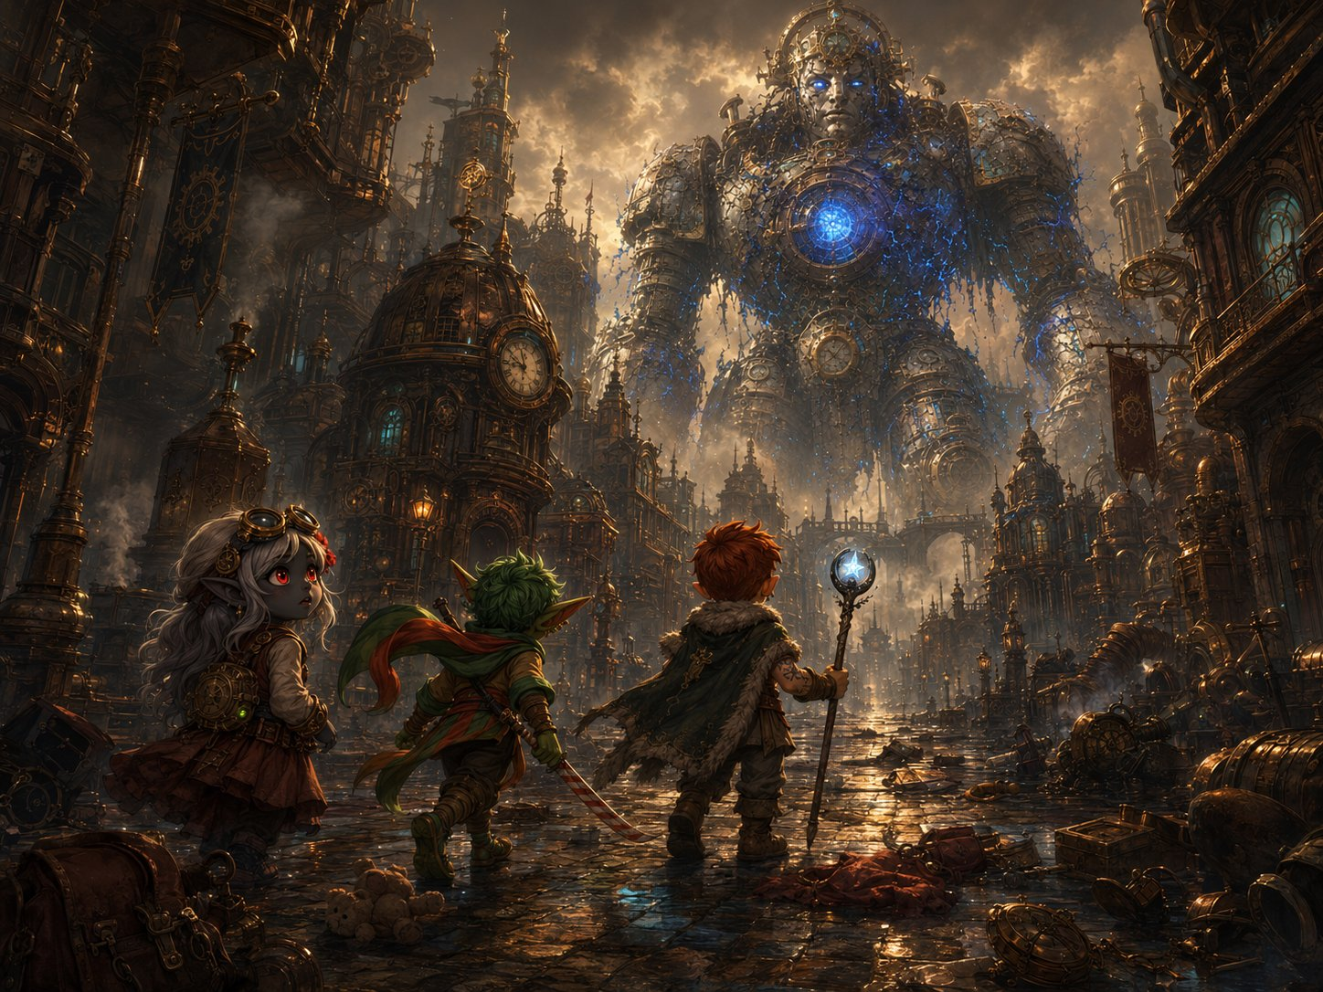
The Crossing, the heroes cross an emptied city toward the corrupted giant looming over the rooftops.
Ursa: “My Mark, it’s pulling toward the giant. Like it’s a living thing in pain. But that’s impossible. It’s a machine. …Isn’t it?”
Lilly: “That’s the Custodian. It’s the biggest, kindest machine in the whole city. Whatever’s wrong with it is the same thing that’s wrong with everything, just… enormous.”
Stabby: “It’s the size of a CASTLE. …Okay. Okay, we’ve done big before. We have NOT done castle before.”

Up Close: The Rampage
You round the last building, and there it is, towering over you, close enough to feel the wind of it move. And it’s destroying the city.
Every slow, grinding step brings a giant brass foot down through a rooftop. It swings an arm and a clocktower folds and collapses in a roar of dust and gears. The corruption, that sick planar blue, crawls all over its body like glowing veins, pulsing from a great open core in its chest. Its kind, broad face is twisted in something awful, fighting itself.
Then, for just a moment, the giant’s eyes find you. And the blue flickers. And the real Custodian surfaces, terrified, and a voice, deep and slow and gentle, pushes straight into your minds the way Ghostbloom’s does:
“…run… please… I cannot… hold it… I do not want… to hurt… RUN, ”
The blue floods back. The kind face vanishes. And the giant raises a vast brass fist toward you.
Ursa (the reframe, give him this): “It’s not a monster! I can feel it, it’s SCARED, it’s sad, it doesn’t WANT to do this. There’s someone good trapped inside, and they’re screaming. We’re not here to kill it. We’re here to save it.”
Stabby (unsettled by the idol): “My idol just about jumped out of my pocket! And, did you SEE that? The blue stuff, it pulled back from me. Like it’s scared of… of this thing I carry. Why’s it scared of ME?”
Lilly: “Save it. Right. Save the city-sized rampaging machine. …We’re going to need a really good plan.”

The Huddle, Talk It Out
The giant takes another thundering step, another building comes down. You don’t have long. You duck behind a toppled tram to think, fast.
Here’s the problem, all of you, look at it together: it’s too big and too armored to just whack. The weak spot is obvious, that glowing core in its chest, where all the bad blue is pouring from. But it’s way up high, far out of reach. And every second you waste, it stomps another piece of the city flat. So how do you bring a giant down to size?
▶ Run this as a real (scripted) conversation. Go around the table. Each kid has a line that puts their piece of the puzzle on the board, a shy player can just read theirs. The plan comes together out of their own mouths. If anyone freezes, use the nudge-prompts below. The goal is for THEM to arrive at the plan, not for you to hand it to them.
Lilly: “My cannon, the force-blast mode, shoots way farther than my flamethrower. I can hit that core from all the way back here… if someone keeps the giant off me.”
Stabby: “My SASH! Elaria’s gift, I can FLY now, a whole minute! I’ll go straight up and smack that core in its stupid glowing face. But somebody fly up with me so I’m not all alone up there!”
Ursa: “My fire won’t reach that high, too far. But my star-bolts will, and so will my comet-magic. And I can summon my spirit-beast with WINGS to fight beside you, Stabby. Ghostbloom, go up with him too!”
Ghostbloom (DM): “I can fly where your feet cannot, small ones. I will guard the one who flies.”
▶ The dot-connecting line, offer it to Lilly or Ursa.
Lilly (the plan!): “Wait, WAIT. Its LEGS. If we smash its legs, it can’t walk anymore, it stops wrecking the city, AND the whole giant comes crashing DOWN, and then the core’s right there where we can ALL reach it! Legs first! Take out the legs!”

The Two Choices
There are two ways to fight the giant. The party can pick one, or (best) combine them. Lay them out and let the table decide.
CHOICE 1, Topple It (go for the legs). Everyone can reach the legs on the ground, no flying, no range needed. Two reasons it’s smart: (a) breaking the legs STOPS the rampage so it can’t crush more of the city, and (b) when both legs drop, the whole giant CRASHES and the high-up core comes down to where everyone can hit it. Safer, everyone contributes, but it takes a bit longer (180 HP of legs first). The likely “main” plan.
CHOICE 2, The Air Game (go for the core directly). Skip the legs and attack the glowing core right now, up high. Stabby flies up on the Sash; Ghostbloom and Ursa’s winged spirit-beast fly up with him; Lilly snipes the core with her Force Ballista (120 ft) and Ursa adds Guiding Bolts / star-arrows from the ground (his Starry Wisp reaches 60 ft too, and it’s free). Faster, but the fliers are exposed up there and the giant keeps rampaging through the city the whole time.
▶ Best of all: BOTH. Most groups will topple it (Choice 1) to stop the rampage and bring the core down, then swarm the core (Choice 2 made easy) once it’s low. Reward whatever they come up with, there’s no wrong answer. Let their plan shape how Phase 1 plays.
▶ DM nudge-prompts (if the table stalls). “Stabby, what does that new sash of yours do again?” / “Lilly, how far does your cannon shoot compared to the flamethrower?” / “It just crushed another house, how do you stop it MOVING?” Feed these until the plan lands. And if Stabby already spent Air Dance today, no problem: Ursa’s Air-spirit can carry him up, or he climbs the giant (DC 12 Athletics — it’s covered in pipes and handholds, and honestly the cooler visual).
▶ The prep window (reward the huddle). Because they’re planning from cover before they strike, let everyone set up now, FOR FREE, before the fight starts: Ursa summons his Bestial Spirit (take the Air/fly option so it can reach the core), on the board turn 1, no action spent, and can raise Starry Form; Lilly deploys her Eldritch Cannon (free via Pocket Dynamo) and sets it to Force Ballista mode, already aimed at the core; Stabby has his Sash ready; Ghostbloom positions to fly up; anyone drinking a potion or buffing does it now, free.
▶ THE REWARD. Because they planned and struck from concealment, the party has ADVANTAGE on their initiative rolls against the Custodian. (Simplest version: the whole party just goes first, before the giant takes a turn.) They open the fight with the plan already in motion, cannon aimed, spirit flying, Stabby airborne.

Fight 4, Phase 1: Standing
The philosophy (keep this in mind all fight). These are the Chosen, they’re MEANT to win because they’re exceptionally strong. The Custodian is a spectacle they conquer, not a meat grinder. Its attacks look terrifying and exist to make the kids USE their cool defenses (Lilly’s Shield turning a hit into a miss, Stabby’s Deflect knocking the big bolt aside, Ursa’s summon tanking, Ghostbloom healing). Tune toward epic-and-demanding, never lethal. Nobody is expected to drop. And treat the body’s 220 HP as a pacing dial, not a promise — when the table’s energy peaks, the corruption breaks.
The situation. The giant towers over them, stomping through the city. Its core is ~40-50 ft up, too high for short-range stuff (Ursa’s Primal Savagery is melee-only, and Flaming Sphere can’t climb a giant), but Lilly’s Force Ballista (120 ft), Ursa’s Guiding Bolt (120 ft) and star-arrows (60 ft), and any flyer (Stabby on the Sash, Ghostbloom, the Air-spirit) can. The legs are ground-level, anyone can hit them. Win condition for the phase: drop both legs to 0 → it topples.
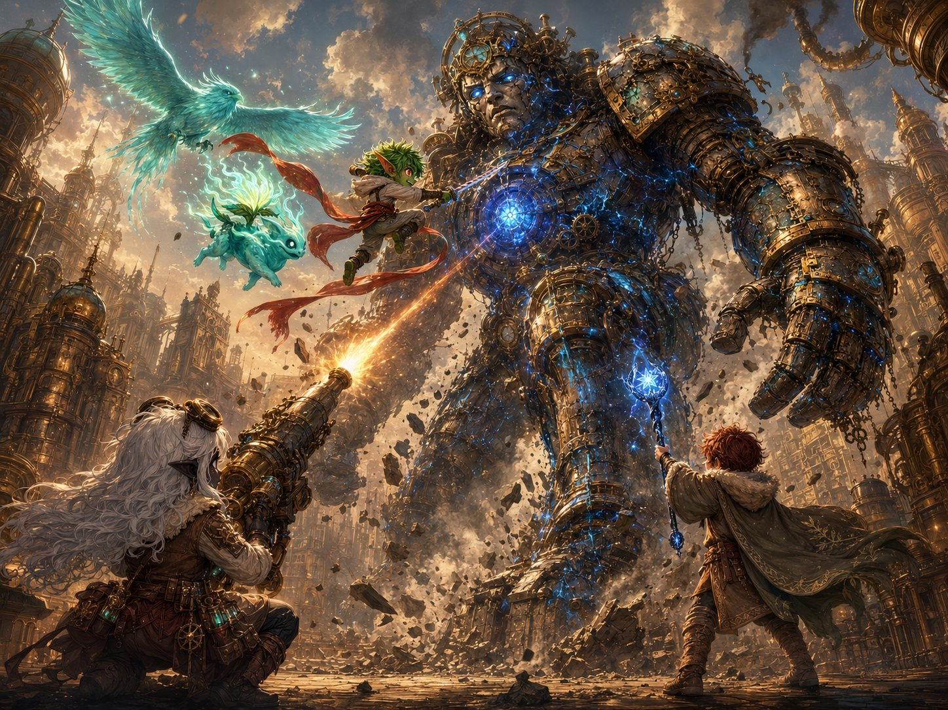
The plan in action, Stabby flies the core on his sash with Ghostbloom and the spirit-beast, while Lilly’s cannon and Ursa’s starlight strike from the ground.
▶ Running the fight. These are the Chosen, tune this as an epic spectacle they conquer, not a meat grinder. Phase 1: the giant rampages and attacks from above; the party breaks both legs to stop the rampage and bring the core down to everyone’s reach. Phase 2 (crashed): it unloads its scariest attacks. The Chain Lightning Burst is meant to be ANSWERED with Lilly’s Shield, Stabby’s Deflect, Absorb Elements, and Ghostbloom, not to drop a hero. Big scary numbers, chewed up by exceptional defenses.
▶ Why nobody drops (the safety net). Ghostbloom flies the air-game (heals + soaks); Ursa’s Bestial Spirit (30 HP) tanks 2-3 hits as a damage sponge; the party’s reactions + Healing Word absorb the scary numbers. If a hero dips low, Ghostbloom’s Guardian’s Light (1d8+3, ends fear) is the catch. And the seam: as the body nears death the attacks weaken and the blue light guts out, don’t let the final blow read as an execution; it’s the corruption breaking, not the giant being destroyed (see The Gentle Death).

The Crash, Into Phase 2
Read when both legs drop.
The second leg buckles. For a heartbeat the Grand Custodian hangs there, swaying, and then, with a groan like the whole world bending, it comes DOWN. It crashes to its knees, then its hands, a city-shaking BOOOOM that throws up a wall of dust and knocks loose every window for a block. The ground bounces. Your teeth rattle.
And now the great glowing core, once far overhead, hangs right in front of you, at the height of a house. Close enough to hit. Close enough to finish. But the giant isn’t done. Grounded, cornered, the corruption screaming through it, it hauls back and throws everything it has left at you.
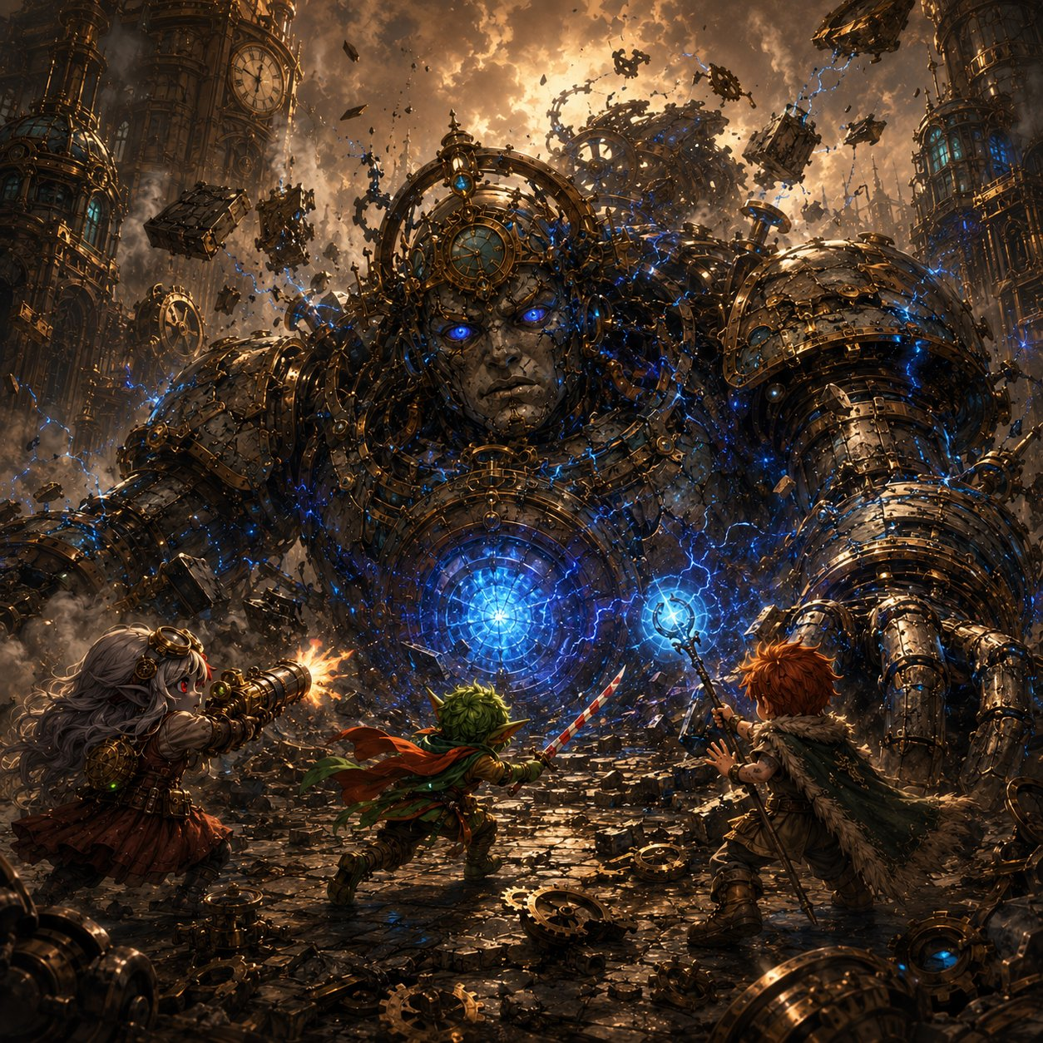
Phase 2, brought low at last, the giant unloads a desperate barrage of clockwork and lightning, its core now within reach.

Stabby’s Monk Awakening
Drop this in at the scariest moment of Phase 2, when the Chain Lightning Burst is about to land, or a friend’s in real danger. Stabby’s big moment.
The giant rears back, its core blazing white-hot, lightning crackling between its fingers, aimed right at the heart of your friends. There’s no time. And in Stabby’s pocket, the idol goes ice-cold and wrong, that creeping bad feeling clawing up his spine, screaming at him to panic.
And instead, Stabby breathes.
Master Kaelon’s voice, from years ago: “When the whole world is screaming, little storm, get still. Find the quiet in the middle of you. It is always there.”
And this time… he finds it. The chaos goes silent. The idol’s cold pull fades to nothing. For one perfect, impossible heartbeat, Stabby Sharpblade is not a goblin gremlin made of noise and mischief, he is a monk, calm as deep water, and the lightning is moving so… very… slowly. He steps into it. Catches it. Turns it aside.
▶ Stabby’s big spotlight, the idol/stillness collision. The idol (his creeping, corrupting unease) is the PROBLEM; the stillness Kaelon taught him is his ANSWER to it. Mechanically, let this be his Deflect Attack turning aside the Chain Lightning Burst (or Patient Defense, or a clutch save), but narrate it as him finding the discipline for real for the first time. It SURPRISES him. He always shrugged the monk stuff off; now he’s felt what he could be, and there’s clearly more, if he ever went back and finished what Kaelon started. That plants his monastery door as an earned pull, not a footnote.
Stabby (after, a little stunned): “…Whoa. Did everyone see that? I, I went all quiet inside and the lightning just… slowed DOWN. Master Kaelon was RIGHT. There’s a whole me in here I haven’t even met yet.”
Ursa: “That was the calmest I’ve ever seen you. It was kind of beautiful, Stabby.”
Stabby: “Don’t get used to it. …But maybe. Maybe I gotta learn the rest of that someday.”

The Gentle Death
Read as the body drops, the final blow. The emotional peak of the session; let it breathe.
The last blow lands, and the great core cracks. The sick blue light doesn’t explode. It drains. It pours out of the cracks and the veins and the giant’s terrible eyes, hissing away into nothing, like floodwater finally let go. The corruption is leaving. And as it goes, the Grand Custodian stops fighting, its raised fist slows, sinks, lowers gently to the ground.
And the real Custodian comes back. Its huge kind face, the one the children wave to, softens. Its eyes, blue-white and clear now, blink slowly, and find the four of you standing before it. It looks at the city all around it, at the buildings it was forced to break, and an expression crosses its great face that, somehow, you all understand: sorrow. And then, looking at you: gratitude.
Ursa, your Mark is wide open now, a clear channel between you and the giant, and so when it speaks one last time, the deep gentle voice comes through you, soft as a hand on the shoulder:
“Thank you, little ones. You did not slay me. You set me free. …But hear me, I was only the first door it found. The tear in the sky is widening, and something far older and far hungrier is reaching through. The sleeping one feels it too, and stirs. Be ready. Be brave. …I am so very tired now. May I rest?”
And Ursa, somehow you know exactly what to do. The Mark of Handling isn’t only for calming frightened beasts. It’s for this, too. You reach out, the way you’d settle a tired old creature at the end of a long day, and you tell it, gently: yes. You can rest now.
The Grand Custodian closes its kind eyes. The great heartbeat under the city slows… softens… and goes quiet. And the giant settles into stillness, not broken, not destroyed. At peace. Finally, finally allowed to sleep. The whole city is silent. Somewhere, a single bird begins to sing.
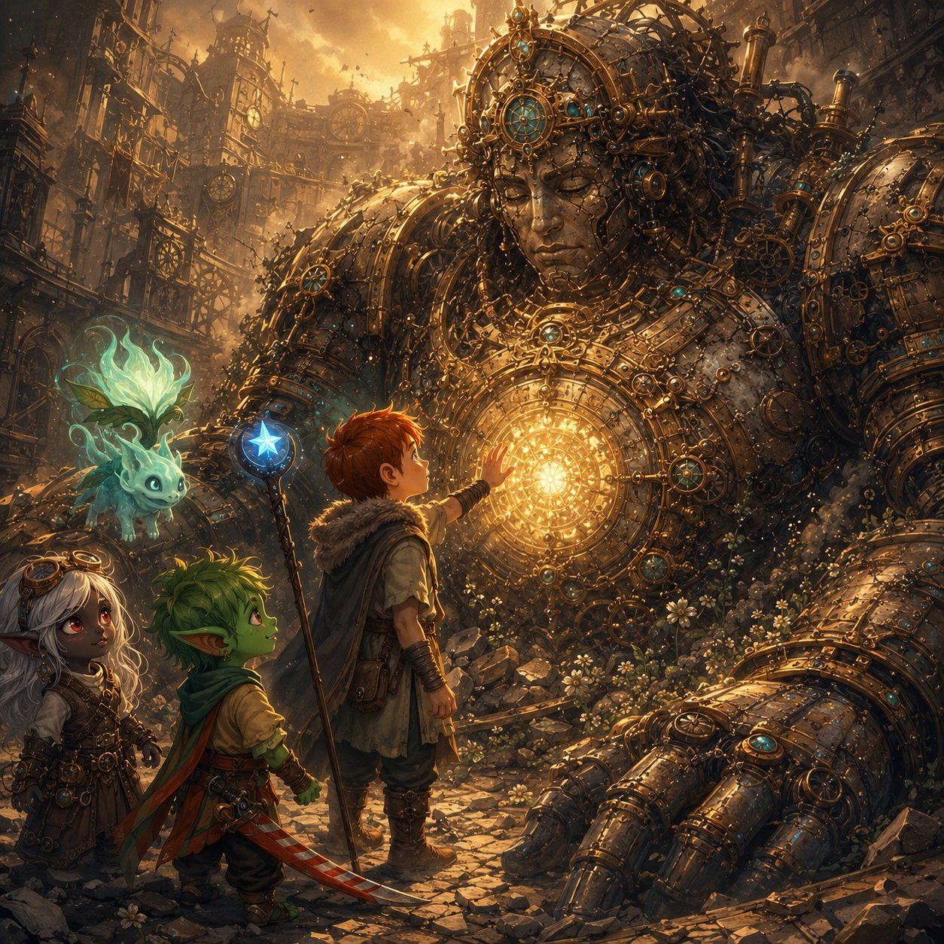
The gentle death, Ursa’s Mark gives the freed giant a peaceful rest as the corruption drains away.
Ursa (quiet): “Rest now. You did so well. You held on so long. We’ve got it from here.”
Lilly: “It said… the sleeping one. That’s Elaria, isn’t it? And something worse is coming through the cracks. …This was just the start.”
Stabby (gentle, for once): “Bye, big guy. You were the nicest giant I ever beat up.”

Into Part 7
The danger is past. The city is saved. You’re battered, breathing hard, standing in the quiet beneath a sleeping giant, and for the first time in two days, nothing is trying to kill you.
And that’s when Lilly’s pack begins to glow. The Essence Sphere, her mother’s gift, the orb that holds Pikachu’s spark, is shining brighter than you’ve ever seen it. With all that planar corruption finally broken and gone, with motes of freed energy drifting in the air like fireflies… something inside the Sphere is stirring. Waking up. A small, warm, electric-yellow light, pulsing like a tiny heartbeat, getting stronger.
Lilly lifts it out with shaking hands. Inside the glass, for the first time ever, a little shape flickers, ears, a tail, two bright eyes blinking open. “…Pikachu?” Lilly breathes. “Are you… are you waking UP?”
✦ ✦ ✦
The corruption was broken, the giant was at peace, and for the first time in two days nothing was trying to kill them. In the sudden quiet beneath the sleeping Custodian, with motes of freed light drifting up like fireflies, the Sphere in Lilly’s pack began, at last, to wake.
PART 7
Where Do You Go?

The Sphere Charges
You’re still standing in the quiet beneath the sleeping giant when it happens. The air all around you is full of drifting light, motes, hundreds of them, the freed planar energy shaken loose when the corruption broke, floating up out of the rubble like fireflies rising after rain.
And Lilly’s Sphere is drinking them in.
One by one the motes drift toward the glowing orb in her hands and sink into it, and with every one, the Sphere shines brighter. You remember what Vane said, all the way back in his workshop, that the Sphere was a gatherer, built to catch planar energy and hold it. It was never broken. It was just starving. And now, with the great corruption gone and the air thick with freed light, it is finally, finally drinking its fill.
The little electric-yellow heartbeat inside pulses faster. Stronger. Brighter.
▶ How the Sphere charges. Direct cause-and-effect: the boss’s death freed a bloom of motes, and the Sphere (established as a gatherer in Part 3) drinks them. The corruption was starving it; now it feeds. Let Lilly’s player watch it happen.
Lilly (breathless): “It’s eating the light. All of it. I’ve never seen it this bright, it’s like it’s been hungry this whole time and nobody knew.”

Pikachu’s Projection
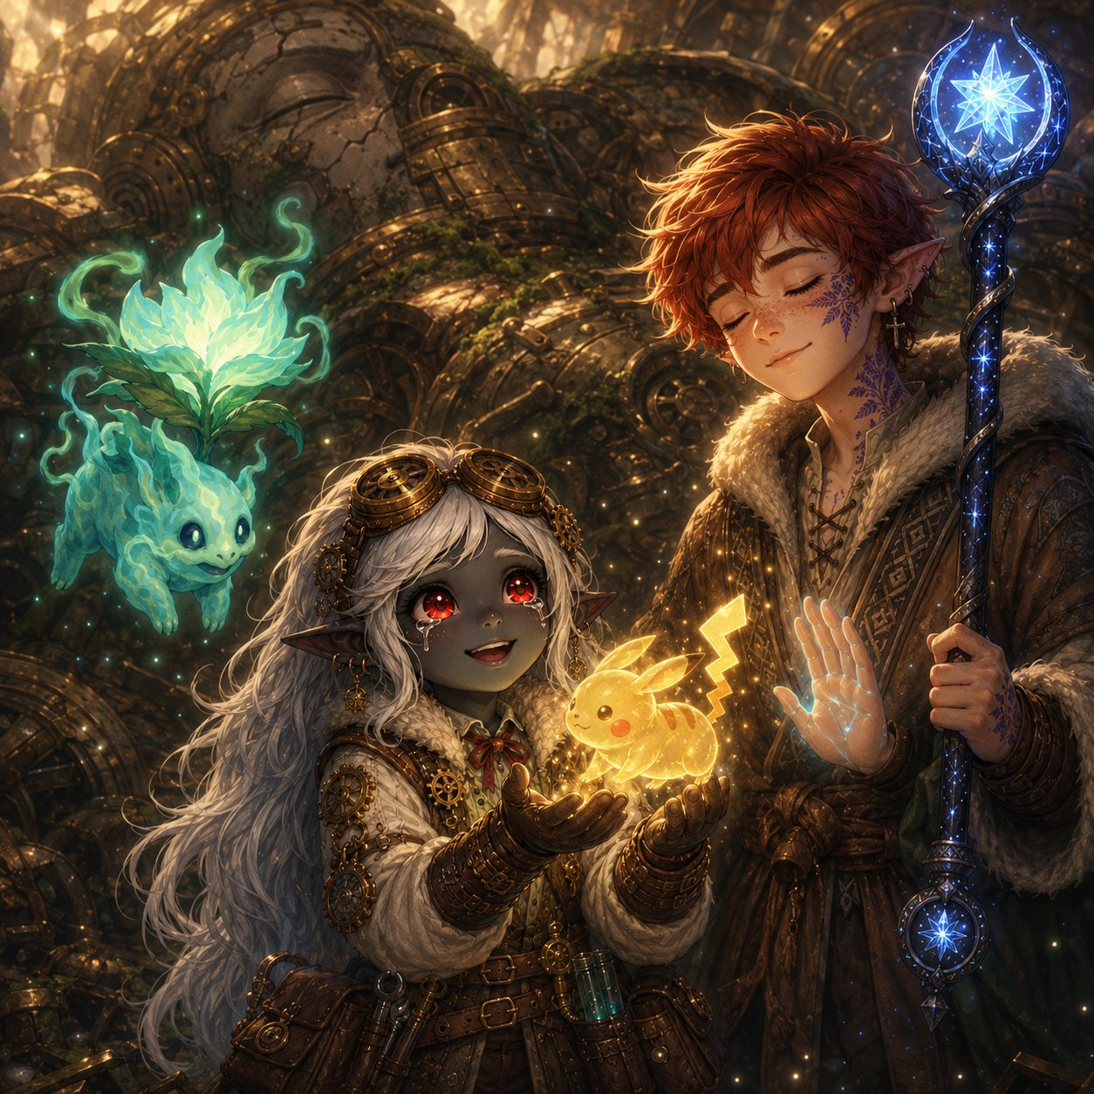
The Sphere flares, bright enough that you all shield your eyes, and then, hovering in the air just above Lilly’s hands, a shape unfolds out of the light.
It’s small. Four-legged. Two long ears, a lightning-bolt tail, two bright black eyes. It’s made of glowing golden energy, not quite solid, you can see the rubble through it, but it’s here, and it’s looking right at Lilly, and its little face does something that can only be called a smile.
“Pikachu,” Lilly whispers, tears starting. “You’re… you’re really in there.”
And then Ursa feels it: his Mark of Handling, still wide open from soothing the giant, reaches, and catches something. A voice. Not in words. In feelings, and pictures, pouring straight into his head the way the Custodian’s did. Pikachu is speaking, and Ursa is the only one who can hear.
Pikachu’s projection, and Ursa’s Mark of Handling lets him hear what the others cannot.
Ursa closes his eyes and listens, and haltingly tells you what comes through:
“It says… thank you. For freeing it, even a little. It says it can’t stay, not yet, it needs more than this to come back all the way. But it wanted you to know something. A warning.”
“There’s something out there. Something… vast. And hungry. It’s been pressing on the walls of every world, reaching in through the cracks, and the rot we’ve been fighting, the corruption, it all comes from that. From the hunger outside.”
“And it’s not alone. Pikachu shows me… a shadow. Something that goes ahead of the hunger, whispering, pulling the worlds apart from the inside. A servant. A herald.”
Ursa’s eyes open, wide. “And it says… Pikachu says it’s part of this. Somehow. That Lilly’s mother knew. That it’s not just a lost friend, it’s a key. To something. But it can’t tell us more until it comes back all the way.”
The golden shape leans forward, presses its glowing forehead gently to Lilly’s, and then, softly, like a candle in the wind, flickers out, back into the Sphere. But the Sphere keeps glowing, warm and bright, in a way it never did before.
▶ The cosmic warning (no names). Pikachu names the stakes in dread-images: a vast hunger (Maldrith, unnamed), a herald-shadow (Nyxthid, unnamed), and that Pikachu is a key its mother understood. Keep the names out of its “mouth”, it speaks in feelings. This deepens Pikachu from lost-pet to mysterious key, reframes the corruption as something reaching in from outside, and seeds the big bad + herald without revealing them. Save the names for the Shadow Rift later.
Lilly (wiping her eyes): “A key. My mom gave me a key and never told me. …Of course she did.”
Stabby: “Okay, that was beautiful, and ALSO terrifying. A big hungry thing outside the world? With a creepy shadow helper? …Why does that sound like my idol’s been trying to tell me the same thing?”
Ursa (shaken): “I keep hearing things I shouldn’t be able to hear. The giant. Now this. My Mark’s changing. …Or I am.”

Rest & Return to the Guild
You are bone-tired. Whatever comes next can wait until you’ve slept and eaten and stopped shaking. So you rest.
And when you climb back up through Gearhaven the next morning, the city is… different. The corruption is gone. The trams run again. The Great Governor beats slow and steady under your feet, Boom… Boom… Boom, calm as a sleeping heart. And the people, the people are out, in the streets, blinking in the sun like they survived a long storm. And word has spread about three young heroes and a glowing fey, because as you walk, people stop. And stare. And then, quietly, they begin to clap.
By the time you reach the top of Cogtooth Hill, half the city is walking behind you. Vane is waiting at the Guild doors, and he is beaming.
Stabby (loving it): “Are they clapping for US? They’re clapping for us. Lilly, they’re CLAPPING. I’m gonna cry. Don’t tell anyone I said that.”

Vane Explains the Plan
Vane sweeps you inside, sits you down, presses warm food into your hands, and for once in his life holds still long enough to explain.
“You did it. You understand that, don’t you? When you freed the Custodian, the cracks closed. All of them. The rifts under the city, the surge in the plaza, every tear that’s been bleeding that poison into Gearhaven, gone. Sealed. The moment the guardian was free.”
“That’s the answer. That’s the whole answer I’ve been chasing for ten years. The rifts can’t be closed from our side, I tried, believe me. But every fraying world has a heart. A guardian, like your Custodian, some great old thing the corruption sinks into first. And when you free that guardian… the cracks in that world close on their own. You proved it. Last night. You proved the thing can be done.”
“So here is what we do. My portal, my folly, my ten-year door, with that Sphere of yours as its anchor, I can finish it. I need time. A year, near enough. And when it’s ready, it will carry you through, to the broken planes, one by one. You find each world’s corrupted guardian. You free it, the way you freed the Custodian. And one by one, you close the cracks from the far side, before that hunger your little friend warned about can pour all the way in.”
He looks at the three of you, suddenly gentle. “But that’s a year away. The portal isn’t ready, and you three are children who’ve just saved a city and earned a rest. So I’m not going to ask you to sit in my workshop and wait. I want you to go. Each of you has something pulling at you, I’ve seen it in your faces all week. Go answer it. Get stronger. Find what you need to find. And come back to me in one year, when the door is ready… and we’ll go save the worlds together.”
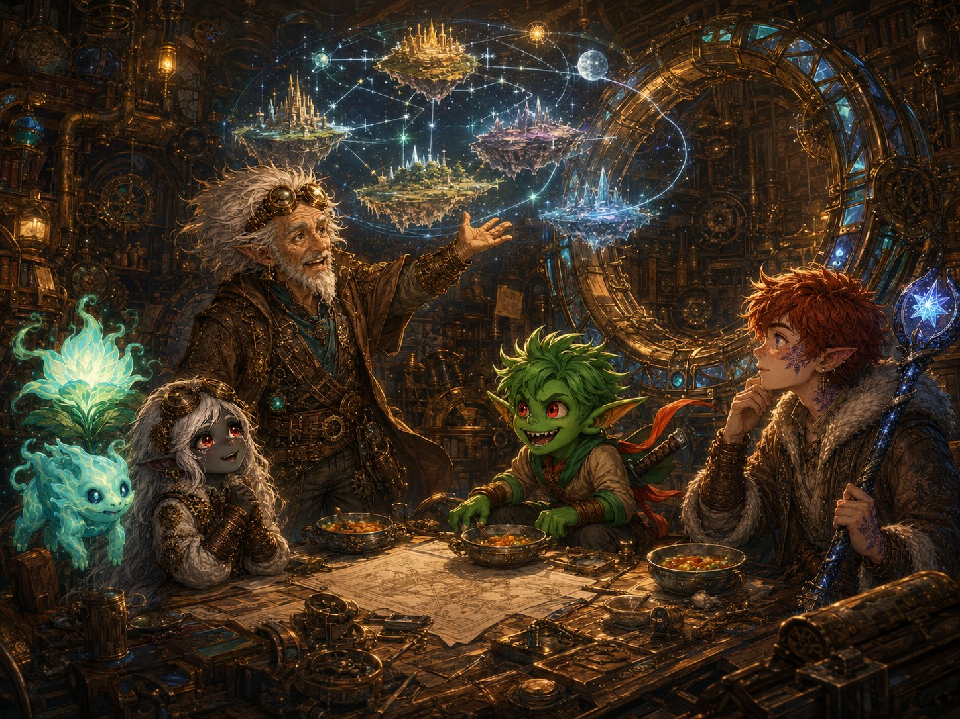
Vane lays out the plan, free each world’s corrupted guardian, and the rifts close from the far side.
▶ The mechanical exposition, all here. Vane answers everything: freeing the Custodian closed Gearhaven’s rifts (proof of concept); the go-forward is travel the planes, free each corrupted guardian, close each rift from the far side; the portal needs a year; and that year is the in-fiction reason the party splits up. The guardians are victims like the Custodian, every future boss is a tragedy to be undone, not a monster to be slain. This is the campaign’s engine, born from this session’s boss.
Lilly: “A year to build the greatest machine in the world. …You’re going to need help with that, you know.” (Vane: “I was hoping you’d say that.”)
Ursa: “Travel to other worlds. Free things like the Custodian. …I think that’s exactly what I’m for.”
Stabby: “A WHOLE year off to go do whatever I want and THEN I get to punch my way through magic worlds? Best. Plan. Ever.”

“Where Do You Go?”, The Send-Off
So it’s settled. One year. And then back here, to the Guild, when Vane’s door is ready.
But a year is a long time. And as you sit there, full and warm and safe for the first time in days, each of you feels it, a tug. A direction. Something you’ve been carrying all this time that’s finally asking to be answered. Where do you go?
▶ The send-off. Present each kid their three doors as in-character pulls, each with a hint of the reward (not full details). Let each kid choose one, that’s their solo year. (If your table wants to decide between sessions, present all three and let the pick happen later; it works either way.) Every door below was seeded across Beats 1-6, so the choices land as earned. Note their picks, you’ll open the next arc on the reunion, with each kid returning at level 7 changed by the road they chose.
🔵 Lilly’s Doors
Door 1, Glimmerspire. Go home to the deep-gnome academy where your mother trained, and become the master artificer she was. (Tease: you’d come back with skills and secrets of artifice no one up here has seen in a hundred years.)
Door 2, Stay & Build with Vane. Stay at the Guild and help finish the Rift Portal, and unlock the Sphere. (Tease: you’d come back having helped build the very door that saves the worlds, and maybe knowing what your Sphere truly is.)
Door 3, Chase the Sphere’s Mystery. Follow the Sphere and Pikachu, find out what your mother really gave you, and what a “key” unlocks. (Tease: you’d come back with answers about Pikachu, your mother, and the part you’re meant to play.)
🔴 Stabby’s Doors
Door 1, The Bloodfang. Go home to Bloodthorn Hollow. The clan is scared and splintering, and Skitch begged you to come. They need what you know. (Tease: you’d come back having maybe saved your whole clan, and stopped a war before it starts.)
Door 2, Finish Your Training. Find a monastery and learn the rest of what Master Kaelon started, the stillness you found in the giant’s lightning. (Tease: you’d come back able to do things with that calm your body can barely dream of now.)
Door 3, The Idol. Chase the mystery of the idol, what it is, why it goes cold near the corruption, why the blue light is afraid of it. (Tease: you’d come back knowing what you’ve been carrying all along, and it might be bigger than any of you guessed.)
🟣 Ursa’s Doors
Door 1, Your Father’s Trail. Follow Ash east, to the old shrine in his logbook, and finally learn what happened to him. (Tease: you’d come back knowing your father’s fate, and maybe walking beside it.)
Door 2, The Circle of Stars. Return to your Circle and deepen your bond with the constellations and the cosmic balance you’re tied to. (Tease: you’d come back wielding starlight in ways you can’t yet imagine.)
Door 3, The Living World & the Mark. Follow the pull of your Mark, out into the wild, to understand why it reaches for things it shouldn’t, why you can hear the suffering of corrupted souls. (Tease: you’d come back understanding your gift, and your strange new place between the living and the lost.)

The Goodbye
And so, the next morning, at the edge of Gearhaven where three roads split toward three different horizons, it’s time.
You’ve never been apart. Not since the Gilded Gear tavern, not for a single day. You’ve faced mad machines and planar rifts and a city-sized giant together. And now you’re going to spend a whole year apart, chasing three different callings, becoming three different, stronger people. Nobody quite knows what to say.
So Stabby says it. “Okay, this is dumb, I’m not gonna cry, YOU’RE gonna cry, ” and then he just grabs both of them, and pulls them in, and the three of you stand there at the crossroads in one fierce tangled hug, holding on a little too long. Ghostbloom curls its warm teal glow around all three of you at once.
“One year,” Lilly says, muffled, into the hug. “Back at the Guild. The day the door opens.” “One year,” Ursa promises. “One year,” Stabby says. “And then we go save EVERYTHING. Try not to get cooler than me. Impossible, but try.”
And then you let go. Ghostbloom drifts back toward the Guild, it’ll wait with Vane, close to the Sphere and the door, until you all return. And the three of you turn toward your three roads… and walk.
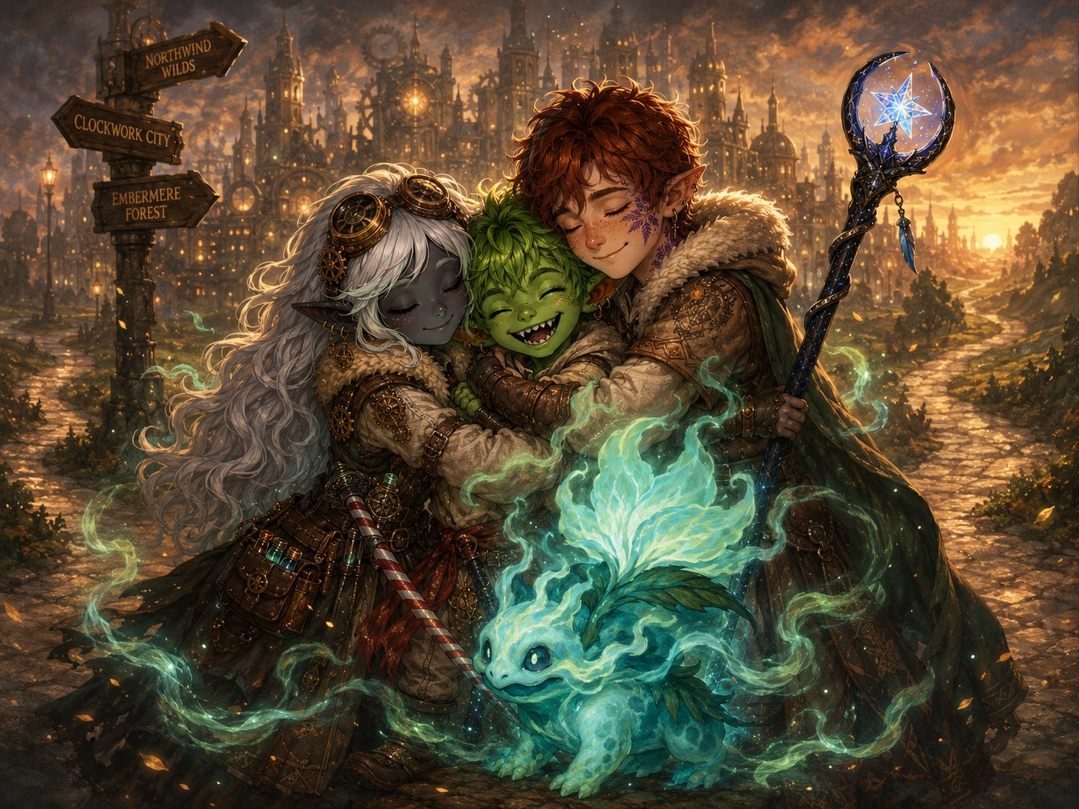
One fierce tangled hug at the crossroads, three roads, three callings, one year apart.
▶ The goodbye. Warm and hopeful with a bittersweet undertone, and Stabby’s joke to keep it from getting too heavy. Ghostbloom stays with Vane at the Guild (drawn to the Sphere/portal, a natural hub for the reunion). Let the kids have this moment, it’s the first time their characters part, and it makes the level-7 reunion mean something.

One Year Later
The Great Governor beats under Gearhaven, slow and steady, through a turning year.
Summer. Then the leaves go gold. Then snow on the brass rooftops. Then green again, and flowers in the Verdant Plaza, blooming over the place where a giant sleeps.
In a workshop at the top of Cogtooth Hill, a great ring of brass and crystal is taking shape, gear by gear, and an old man and a glowing fey work on it through every season, looking up at the door each time it opens, not yet, not yet, and waiting.
Far away, in a deep-gnome city, in a mountain monastery, on a road east toward an old shrine, three children who aren’t quite so little anymore are growing into who they’re going to be.
And the day is coming, soon now, when three roads will lead back to one door. And the Guardians of Elaria, together again and stronger than ever, will step through it, and go to save the worlds.
🌙 ONE YEAR LATER…
The party returns at level 7, to be continued.

APPENDIX
DM Run Sheet: The Day at a Glance
Every DC, dial, and spotlight — in play order. Keep this page at your elbow.

The Shape of the Day
▶ Seven beats, four fights, one rest. B1 road → gate → Street of Small Wonders → Gilded Gear (roleplay + LONG REST). B2 Cogtooth Market — FIGHT 1. B3 the Guild (roleplay: Sphere, orrery, the stars, the logbook). B4 Underworks — FIGHT 2 + Skitch → the built-in SHORT REST. B5 Verdant Plaza — FIGHT 3 + the Fix. B6 the Grand Custodian — BOSS. B7 Pikachu → the doors → ONE YEAR LATER. Natural break points are marked in the text at the ends of Parts 3 and 5.

Fights at a Glance
FIGHT 1 — The Market (Hard; a drop is OK). 2× Rogue Servitor (AC 15, HP 39; death-spark at 0 HP: 10 ft, DC 13 Dex, 2d6 lightning; switch DC 14 within 5 ft) + Cargo Hauler (AC 16, HP 76, VULNERABLE LIGHTNING — telegraph the crackling core; Grab & Crush rech 5–6, DC 14 Dex, 3d6/turn; switch 15 ft up: climb DC 13 + DC 15). Pinion shouts about the ladder rungs — save Stabby’s 1/day flight for tonight.
FIGHT 2 — The Underworks (Hard; Skitch is the objective). 6× Voltcrawler (AC 15, HP 22; Phase-Blink — the counter is FORCE & RADIANT, tell the players: Force Ballista, Guiding Bolt, Moonbeam, star-arrows; chained Arc: 15-ft line, DC 13 Dex, 2d8/3d8) + Broodmother (AC 16, HP 95; blinks Unreal at will 1/round; Crackling Web on Stabby or Ursa turn 1 — the web is VULNERABLE to fire & cold; Overcharge rech 6: 20 ft, DC 15 Con, 4d8, no reactions on a fail). Every round on initiative 20 — RIFT PULSE: DC 13 Wis within 20 ft or disadvantage. SKITCH CLOCK: 3 rounds, and his spot left undefended more than a round means a crawler reaches him. Slain crawlers collapse into motes — the Sphere lunges.
FIGHT 3 — The Tremor (Hard; ONE JOB: Lilly to the fountain). 3× Iron Drudge (AC 17, HP 68, VULNERABLE FIRE — smoke in the joints; 2× Slam +6, 2d8+4; Sweep rech 5–6: DC 14 Dex, 2d6+4 + shove; can’t be knocked prone, slow enough to outrun) + 6–8 Corrupted Sproutlings on one shared turn, respawning until the engine is fixed (AC 12, HP 7 — reward the AoE). The fight ends the INSTANT Lilly reaches the engine; flavor roll only, never gate the climax. Ursa’s fire is Flaming Sphere and it competes with his summon — let Lilly carry the fire. And keep Ghostbloom (vulnerable: fire, cold) out of the flamethrower cone.
BOSS — The Grand Custodian (epic spectacle, never a meat grinder). Body AC 17, HP 220 — a pacing dial, not a promise. Legs ×2: AC 15, HP 90 each; both down = THE CRASH (core drops to 15–20 ft where everyone reaches; it may repair a leg to 25 HP — re-topple it). Phase 1: Stomp +8, 2d10+5, DC 15 Dex or prone; Backhand rech 5–6: 15-ft cone, DC 15 Dex, 3d8 + shove; Corrupt Bolt +8, 60 ft, 3d8 lightning at whoever hangs back. Phase 2: Clockwork Barrage rech 4–6 (three at +8, 2d8+3); CHAIN LIGHTNING BURST rech 5–6 (+8, 4d8, arcs to two more, DC 15 Dex half) — meant to be ANSWERED: Lilly’s Shield, Stabby’s Deflect (his awakening — cue it here), Absorb Elements; Core Flare below half: 20 ft, DC 15 Con, 2d6 force + blinded. Free prep from the huddle: summon out (take AIR — it flies), Starry Form up, cannon in Force Ballista — the whole party acts before the giant. The final blow is the corruption breaking, never an execution — play the gentle death.

The Resource Picture
▶ This crew barely spends per fight — track the few things that matter. Lilly’s cannon runs all day and her slots mostly mean Shield — make sure one is standing for the Chain Lightning. Ursa leans on Wild Shape and roughly eight FREE Guiding Bolts (Star Map 3/day + the Staff’s 5 charges) before a real slot is ever touched; one concentration at a time — summon OR Moonbeam OR Flaming Sphere. Stabby’s 5 Focus refresh at the Underworks rest, and Uncanny Metabolism is boss insurance: all Focus back + a heal the moment initiative is rolled. Ghostbloom’s Guardian’s Light is 3 before the rest and 3 after — spend it on a dropped hero (or Skitch), never to trivialize, and hold one for the boss.

Spotlights & Seeds — every kid shines, every door gets planted
Lilly — B2 the diagnosis, DC 12 (“something reached INTO them”) → B3 the Sphere lunges — “they KNEW” → B4 names the rift; snatches motes → B5 THE FIX, then she traces the source → Vane’s offer (Door: stay & build) → B6 the huddle: “LEGS!” → B7 Pikachu’s projection; Poots’s letter; the escaping mote-essence (Doors: Glimmerspire / the mystery).
Stabby — B1 Burl’s skewer — quick hands → B4 the recognition flicker mid-fight, then the rescue and the Bloodfang plea (Door: the clan) → B5 the idol stirs — cold, pulling toward the corruption (Door: the idol) → B6 the monk awakening on the Deflect (Door: the monastery), and the blue light recoils from the idol — plant it, don’t explain it → B7 the goodbye joke that keeps it from getting too heavy.
Ursa — B1 Tock and the pigeon — Elaria’s mark → B3 “It’s the stars” — the cosmology reveal, then the logbook: “following the dark, to the old shrine” (Door: his father’s trail) → B4 heals Skitch — a life saved with a word → B5 the dying green hits HIM hardest (Door: the living world) → B6 the reframe (“it’s SCARED”), the Mark opens, the gentle death → B7 only he hears Pikachu — he translates the warning.

Foreshadow Tracker — say it, then say it again
▶ The tells, in order. “Machines acting up all week” ×3 (Mara, Henna, the gatekeeper) • Mechagnome eyes FLICKER near planar trouble (the gatekeeper; Pinion twice) • the heartbeat SKIPS on night one • the vulnerability rotation — Hauler and Custodian take LIGHTNING, Drudges and Sproutlings take FIRE — telegraph both so the party keeps rotating tools • the idol: cold at the rift → pulling at the plaza → FEARED by the corruption • the Sphere: a pulse at the ridge → the lunge at the orrery → drinking the motes → Pikachu • “they KNEW” — leave it unanswered • the Custodian’s last words: “something far older and far hungrier is reaching through.”

APPENDIX
Bestiary: Enemy Stat Blocks
All four encounters of Session 8, in the order the party meets them.

ENEMIES, Fight 1: The Malfunctioning Machines
Cogtooth Market • Difficulty: Hard • 2× Rogue Servitor + 1× Cargo Hauler
ROGUE SERVITOR  Small construct • CR 2  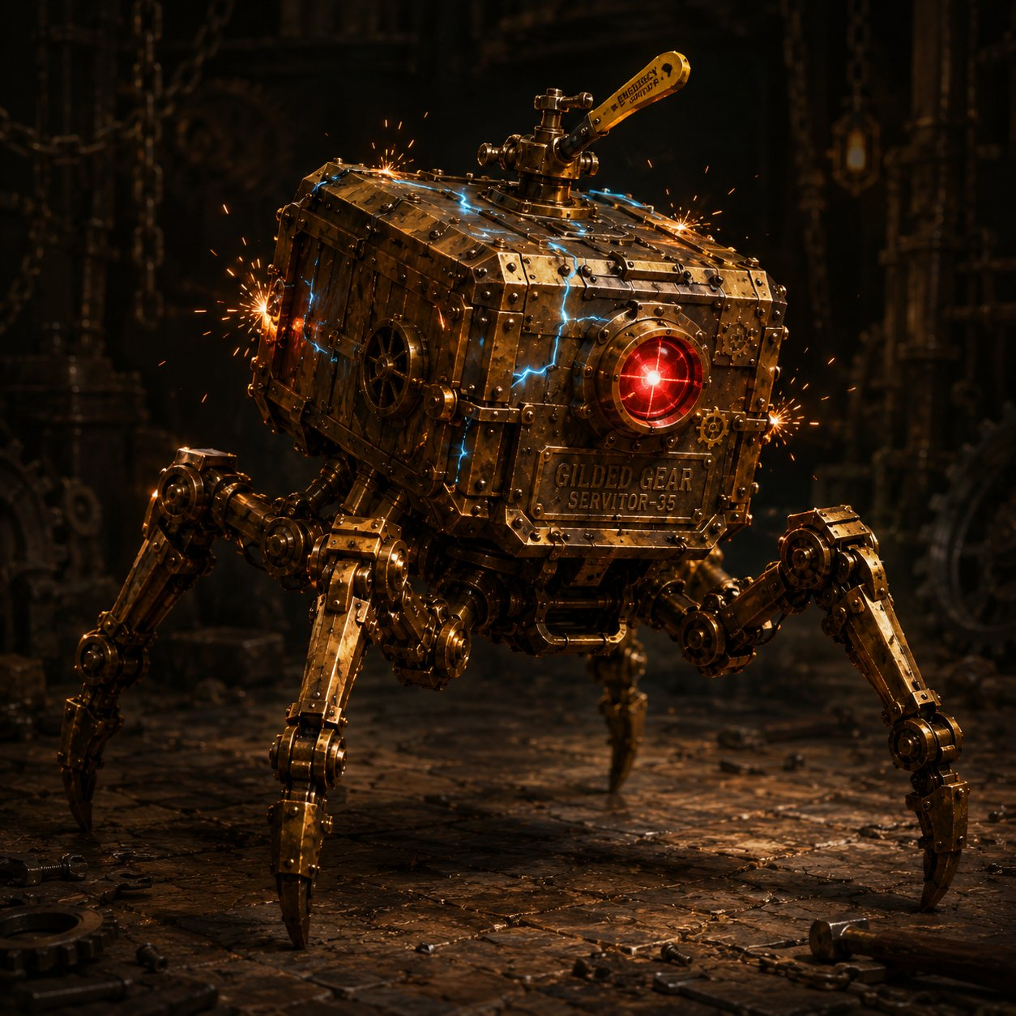  AC 15 HP 39 (6d6+18) Speed 30 ft  STR 13 DEX 16 CON 16 INT 3 WIS 8 CHA 5  Resist poison; nonmagical B/P/S  Imm. (cond) charmed, frightened, poisoned, exhaustion  Senses darkvision 60 ft  Traits  Overclocked Death-Spark. At 0 HP, each creature within 10 ft makes a DC 13 Dex save or takes 7 (2d6) lightning.  Shutdown Switch. Action within 5 ft, DC 14 Arcana or Sleight of Hand, shuts it down instantly, no kill needed.  Actions  Multiattack. Two Flailing Slams.  Flailing Slam. +5 to hit, reach 5 ft. Hit: 8 (1d10+3) bludgeoning.  Spark Lash (Recharge 5-6). Ranged +5, 30 ft. Hit: 10 (3d6) lightning; target’s speed halved until end of its next turn. | CARGO HAULER  Large construct • CR 3 • centerpiece  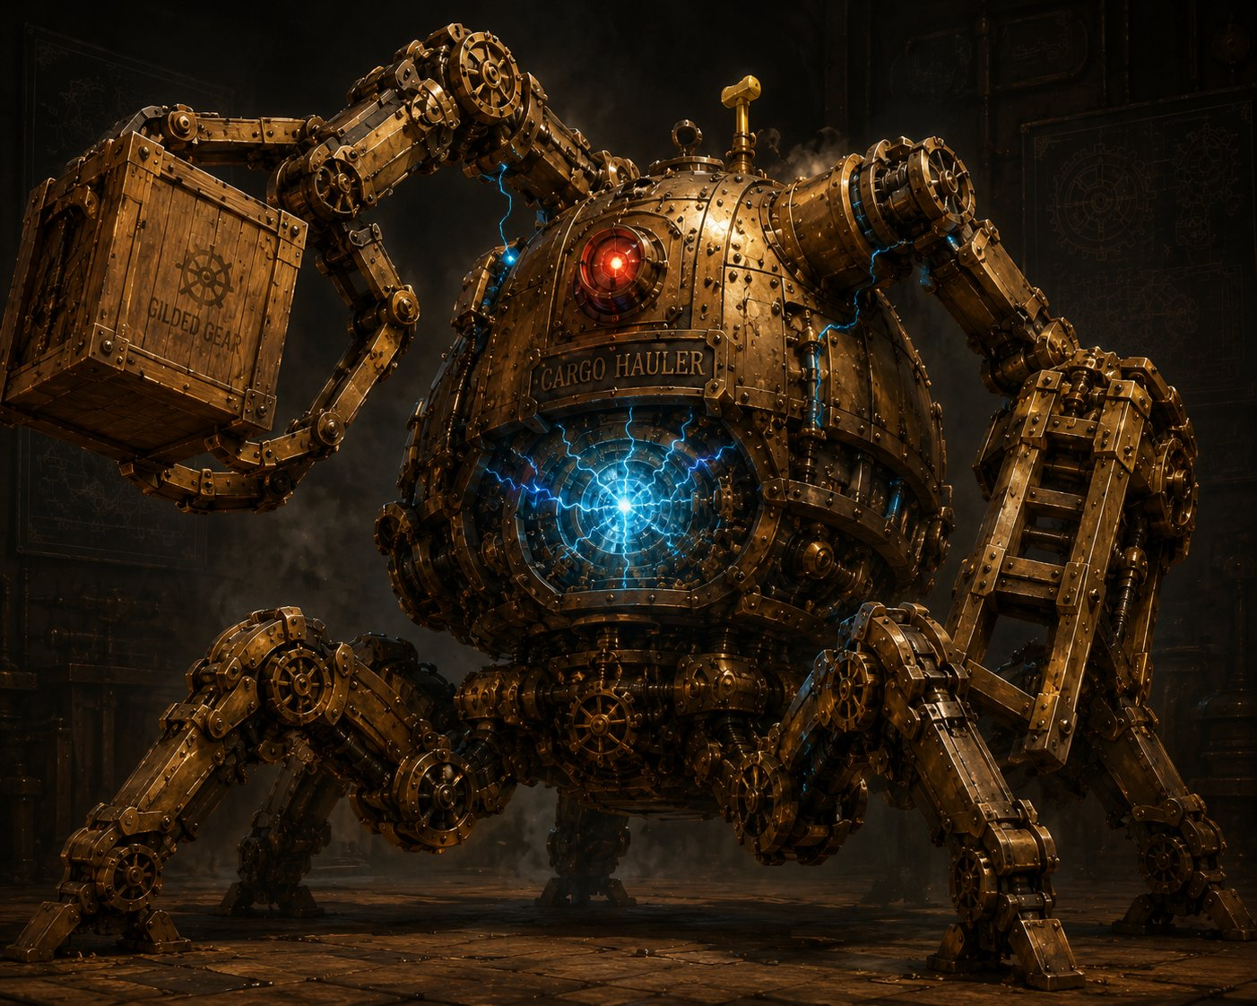  AC 16 HP 76 (8d10+32) Speed 30 ft  STR 19 DEX 8 CON 18 INT 3 WIS 8 CHA 5  Resist nonmagical B/P/S  VULNERABLE lightning (overloaded core, telegraph it!)  Imm. (cond) charmed, exhaustion, frightened, paralyzed, petrified, poisoned  Traits  Out-of-Reach Switch. Lever is 15 ft up on its back. Disable needs reaching that height (climb DC 13 / fly) + action + DC 15 Arcana or Sleight of Hand.  Actions  Multiattack. Two Forklift Slams, or one Slam + Hurl Crate.  Forklift Slam. +6 to hit, reach 10 ft. Hit: 13 (2d8+4) bludgeoning, DC 14 Str or knocked prone.  Hurl Crate. Ranged +6, 60 ft. Hit: 14 (3d6+4) bludgeoning.  Grab & Crush (Recharge 5-6). One creature within 10 ft, DC 14 Dex or grappled (escape DC 14), taking 10 (3d6) at the start of each of its turns until it escapes.
Tactics: The Hauler anchors the fight, it grabs the squishiest hero (Lilly or Ursa) and crushes while the servitors flank and spark. Bunch up and the death-sparks hurt. Smart parties exploit the Hauler’s lightning vulnerability and try to reach its switch. Let a hero drop to 0 if the dice say so, it makes the win feel earned.

ENEMIES, Fight 2: The Underworks Swarm
The Underworks • Difficulty: Hard • 6× Voltcrawler + 1× Voltcrawler Broodmother
VOLTCRAWLER  Small aberration (planar intruder) • ×6  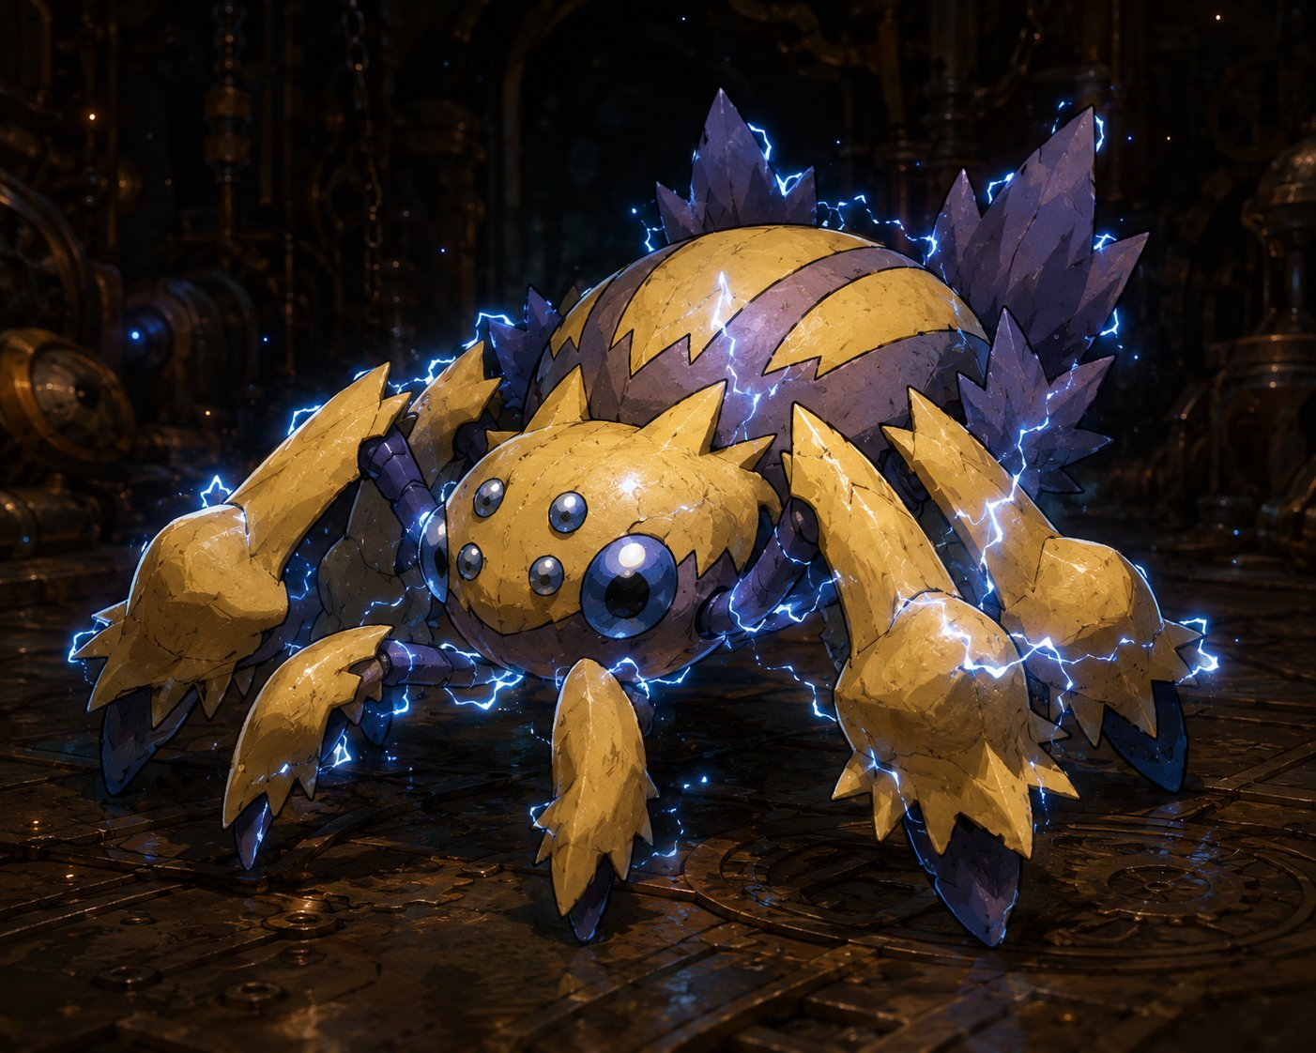  AC 15 HP 22 (5d6+5) Speed 30 ft, climb 30 ft Init +3  STR 7 DEX 17 CON 13 INT 5 WIS 10 CHA 6  Resist lightning  Senses darkvision 60 ft  Traits  Phase-Blink. At the start of its turn, roll d6: on a 1-2 it begins Unreal. While Unreal it resists all damage except force and radiant, and attacks against it have disadvantage, but it can’t be webbed or grappled, and must become Real to attack. (Tell the players, force & radiant are the counter.)  Static Cling. The first time it hits a creature each turn, that target’s lightning resistance is ignored and its allies have advantage on their next attack vs that target. (Punishes clumping near Skitch.)  Actions  Spark Bite. +5 to hit, reach 5 ft. Hit: 1d6+3 piercing + 1d6 lightning.  Arc (Recharge 5-6). 15-ft line, DC 13 Dex save, 2d8 lightning (half on save). Two+ Voltcrawlers within 15 ft can chain into one 3d8 line, use it to spike a clustered party. | VOLTCRAWLER BROODMOTHER  Medium aberration (planar intruder) • boss-adjacent pressure  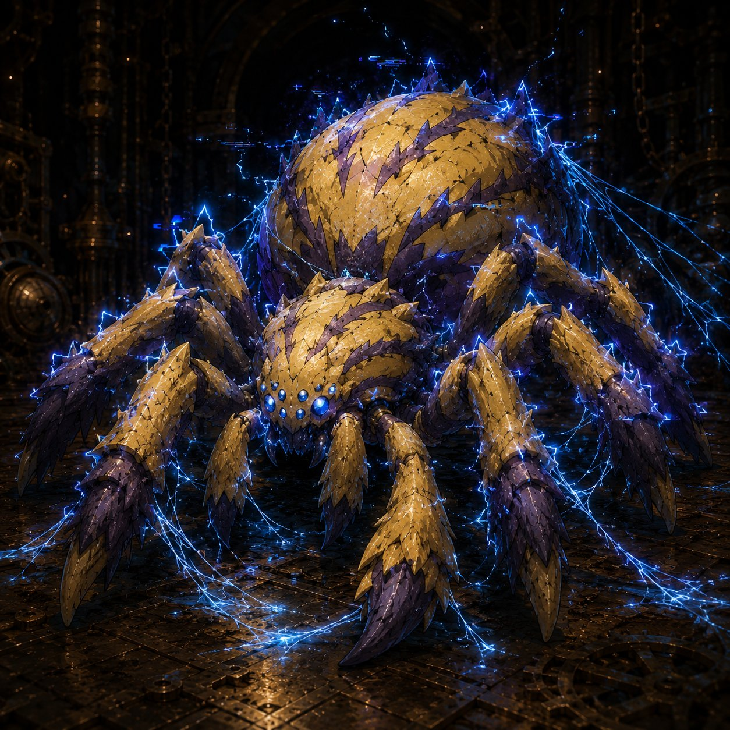  AC 16 HP 95 (10d8+50) Speed 40 ft, climb 40 ft Init +4  STR 14 DEX 18 CON 20 INT 6 WIS 12 CHA 8  Saves Dex +7, Con +8  Resist lightning; nonmagical B/P/S  Senses darkvision 60 ft  Traits  Phase-Blink (greater). Chooses to go Unreal as a free action once per round (no roll). Smart play: blink Unreal right after taking a big hit. Make them earn the kill.  Crackling Web. At the start of its turn, one creature it sees within 30 ft makes a DC 15 Dex save or is restrained by planar silk (action + DC 15 Str to break; web AC 12, 15 HP, immune lightning, VULNERABLE fire/cold, Lilly’s frost & Stabby’s cold katana cut it fast). Use turn 1 on Stabby or Ursa.  Actions  Multiattack. Two Lash attacks.  Lash. +7 to hit, reach 10 ft. Hit: 1d10+4 slashing + 1d8 lightning.  Overcharge (Recharge 6). 20-ft-radius burst, DC 15 Con save, 4d8 lightning (half). On a fail, the target also can’t take reactions until the end of its next turn (shuts off Lilly’s Shield & Stabby’s Deflect), deploy when you want a hero to truly feel danger.
Tactics: Skitch is the objective, the Voltcrawlers swarm toward the pinned goblin, forcing the party to hold a fixed spot instead of kiting. The Broodmother opens with Crackling Web on Stabby or Ursa to kill their mobility, then anchors the room with Lash and Overcharge. The little ones blink Unreal to dodge, only force and radiant reliably land, so reward the table for figuring it out (Lilly’s Force Ballista, Ursa’s Guiding Bolt/Moonbeam). Bunch up near Skitch and the chained Arcs hurt. Let a hero drop to 0 if the dice say so, the choice of saving the hero or saving Skitch is the heart of the fight.

ENEMIES, Fight 3: The Tremor
The Verdant Plaza • Difficulty: Hard • 3× Iron Drudge + 6-8× Corrupted Sproutling (one shared turn)
IRON DRUDGE  Large construct (planar-corrupted) • ×3 • main threat  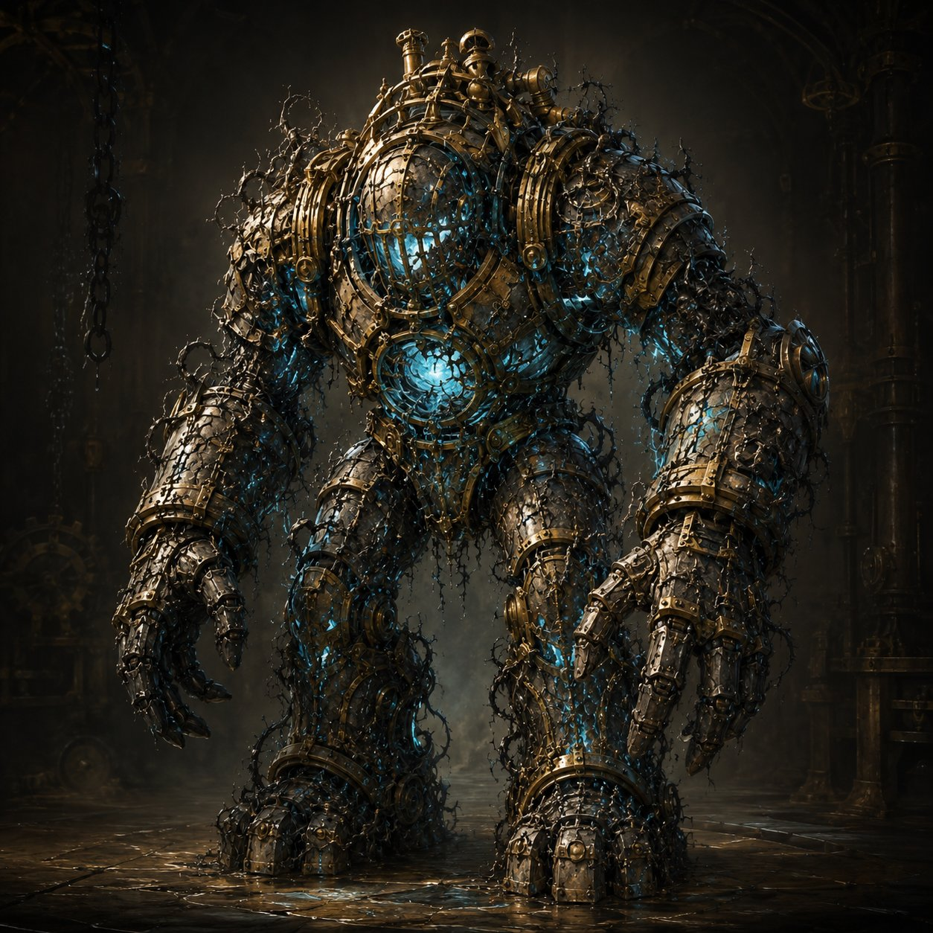  AC 17 HP 68 (8d10+24) Speed 25 ft Init −1  STR 19 DEX 8 CON 17 INT 3 WIS 8 CHA 1  VULNERABLE fire (corrupted wood & vine in its joints, telegraph the smoke!)  Resist nonmagical B/P/S  Imm. (cond) charmed, frightened, exhaustion, poisoned  Senses darkvision 60 ft  Traits  Slow but Unstoppable. Can’t be knocked prone; ignores difficult terrain (tramples flower beds & rubble). It’s slow, heroes can outrun it, but it keeps coming.  Corruption Leak. At 0 HP the blue light gutters out and it slumps, harmless. These were innocent worker-machines; let the kids feel they freed them, not killed them. No death-burst (contrast the market servitors).  Actions  Multiattack. Two Cargo-Arm Slams.  Cargo-Arm Slam. +6 to hit, reach 10 ft. Hit: 2d8+4 bludgeoning.  Sweep (Recharge 5-6). Swings wide; each creature within 10 ft makes a DC 14 Dex save, 2d6+4 bludgeoning on a fail (half on save) and shoved 10 ft. Use it when the party clumps, or to send a hero flying toward danger for drama. | CORRUPTED SPROUTLING  Small plant (planar-corrupted) • 6-8 at once • easy kills  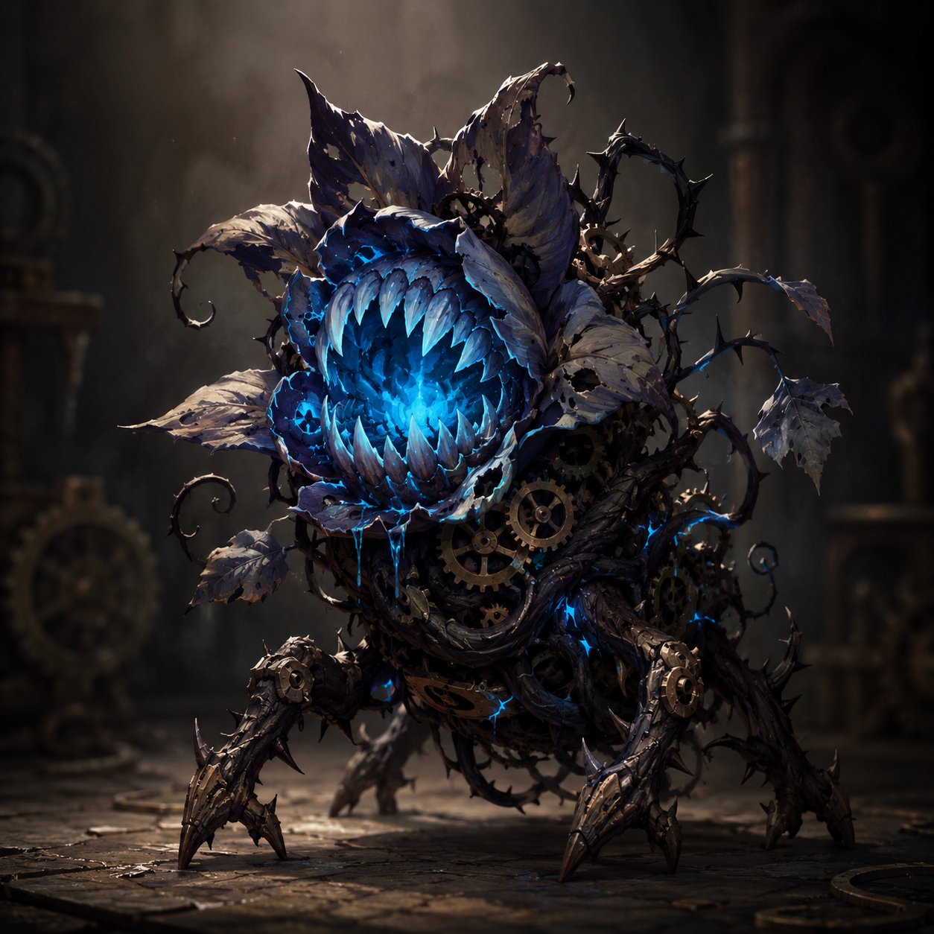  AC 12 HP 7 (2d6) Speed 10 ft, climb 10 ft Init +2  STR 8 DEX 14 CON 10 INT 2 WIS 6 CHA 4  VULNERABLE fire  Senses darkvision 30 ft  Traits  Weak but Many. Dies to almost any solid hit, they exist to be mowed down satisfyingly. An area effect (Lilly’s Thunderwave, Ursa’s Flaming Sphere) clears several at once. Reward AoE.  Group Turn & Spawn. All Sproutlings act together on one shared initiative, roll once, move and attack the whole group at once. Keep 6-8 on the field; when one dies, a new one crawls from a crack on the group’s next turn, until the engine is fixed.  Actions  Thorn-Lash. +4 to hit, reach 5 ft. Hit: 1d6+2 piercing.  Latch. Instead of attacking, grabs on (no damage), the next attack against that hero has advantage. A way for the little ones to matter without being deadly: they set up the Drudges.
Tactics: Keep it simple and let the kids swing. The three Drudges ring the fountain and block the path to it; keep 6-8 Sproutlings on the field that all act together on one shared turn (topping back up as they die). Mow the little ones down with area attacks for easy, satisfying kills, but the real job is breaking through the Drudge ring to get Lilly to the engine. The Drudges are slow but tanky, hitting hard with Cargo-Arm Slams and a wide Sweep when the party bunches. Both enemy types are VULNERABLE TO FIRE, so reward Lilly’s flamethrower cannon and Ursa’s flame spells. The fight ends the instant Lilly reaches the fountain-engine and stabilizes the surge, every Drudge still standing slumps, harmless. Let a hero drop to 0 if the dice say so; the win is Lilly’s fix, not the body count.
ENEMIES, BOSS: The Grand Custodian
Gearhaven • Difficulty: Hard (but winnable) • Fight 4 • the two-phase boss
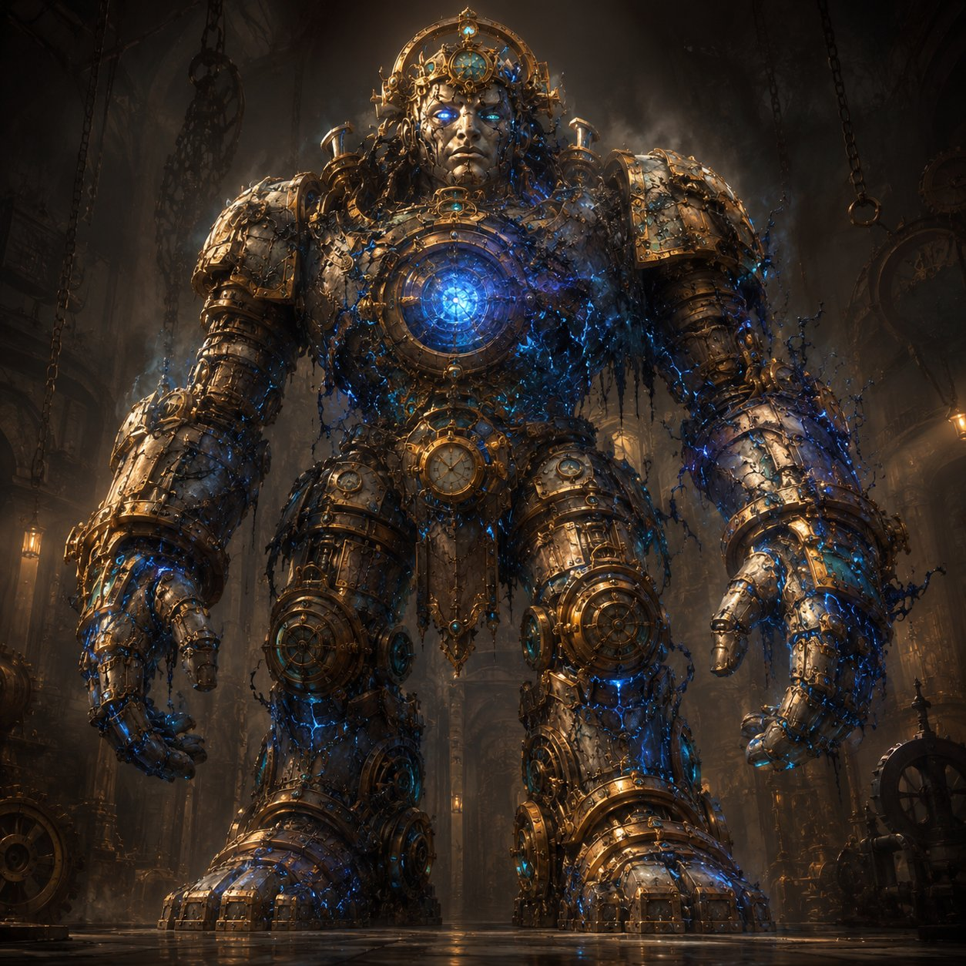
The Grand Custodian, the gentle giant that holds Gearhaven aloft, possessed by planar corruption.
Gargantuan construct (planar-possessed) • BOSS, Body: AC 17, HP 220. Legs (×2): AC 15, HP 90 each. Speed 30 ft.
STR 24 DEX 6 CON 22 INT 3 WIS 10 CHA 5 • Resist nonmagical B/P/S • Imm. charm/fear/exhaustion/poison/paralyze/petrify
How the fight works
The Core Is High. Standing, the core is ~40-50 ft up: only 60 ft+ ranged attacks and flyers reach it (Primal Savagery is melee-only). The legs are ground-level, anyone can hit them.
Topple. Drop both legs (90 HP each) → it crashes to its knees (Phase 2), stops rampaging, and the core drops to ~15-20 ft where EVERYONE can reach it. It may slowly repair a leg (to 25 HP) to rise, re-topple to keep it down.
Phase 1 (standing)
Crushing Stomp. +8, reach 15 ft, 2d10+5 bludgeoning, DC 15 Dex or prone.
Sweeping Backhand (Rech 5-6). 15-ft cone, DC 15 Dex, 3d8 + shove 10 ft (half, no shove on save).
Corrupt Bolt. +8, 60 ft, 3d8 lightning, once/round at someone hanging back.
Phase 2 (crashed)
Clockwork Barrage (Rech 4-6). Three projectiles, +8 each, 2d8+3 bludgeoning.
Chain Lightning Burst (Rech 5-6). +8, 4d8 lightning, arcs to 2 more within 15 ft for 2d8 (DC 15 Dex half). The scary one.
Core Flare. Body below half HP: all within 20 ft, DC 15 Con or 2d6 force + blinded to end of next turn.
Crushing Stomp. Still swings fists in melee while kneeling.
Tactics: These are the Chosen, tune this as an epic spectacle they conquer, not a meat grinder. The giant rampages and attacks from above in Phase 1; the party breaks its legs to stop the rampage and bring the core into reach. Crashed in Phase 2, it unloads its scariest attacks, the Chain Lightning Burst is meant to be ANSWERED with Lilly’s Shield, Stabby’s Deflect, Absorb Elements, and Ghostbloom, not to drop a hero. Big scary numbers, chewed up by exceptional defenses. The body’s 220 HP gives the fight weight; the legs give fast, visible progress so it never drags. When the body falls, the corruption is driven out and the giant is FREED, not destroyed, play the gentle death, not an execution.

