Session 3: The Quest for Knowledge

Setting: Ravenstone Laboratory and the Journey to the Coastal Town of Havenmoor

Session 3, Act 1: Encounter 1 — Meeting Professor Aelwyn

Setting:
The party steps into the expansive Ravenstone Laboratory, a structure where magic and science blend seamlessly. The walls are lined with shelves of ancient tomes, glowing crystals, and devices of intricate gears and shimmering runes. Soft, multicolored lights drift through the air, each one a captured mote of magical essence. The air hums with barely-contained energy, the scent of ozone and old parchment filling their senses.
Tables are strewn with half-finished gadgets, glass tubes filled with swirling energies, and cages housing strange, Pokémon-like creatures. Small automatons scurry between the tables, carrying tools or scribbling notes on parchment.
In the center of the room stands Professor Aelwyn Ravenstone, a tall, silver-haired high elf with sharp emerald eyes. His long coat shimmers with faint enchantments, and he holds a delicate tool resembling a magnifying glass laced with arcane runes.

Introduction:
Professor Aelwyn turns as the party enters, his gaze immediately locking onto the Essence Sphere that Lilly holds. His eyes widen with a mix of excitement and reverence.
Aelwyn:
“By the Spheres! I can scarcely believe my eyes… an Essence Sphere, and a fully functional one at that! Who among you crafted this marvel?”
Lilly steps forward, her small fingers clutching the sphere tightly. She lifts her chin with pride.
Lilly:
“My mom made it — Poots Glimmergear. But… Pikachu’s essence is trapped inside, and I need to find a way to give him a body again.”
Aelwyn takes the Essence Sphere from her gently, examining it closely, the light reflecting off his glasses. The arcane runes glow brighter as he turns it.
Aelwyn:
“Poots Glimmergear… a true genius of her craft. This device — it’s beyond what I thought possible. The energy within is stable, but there isn’t enough to manifest a corporeal form.”
He gestures toward a cluttered workbench and sets the Essence Sphere down carefully.

Exposition and the Greater Mystery:
Aelwyn:
“There is hope yet. The Artificer’s Guild in Gearhaven City has access to power core technology far more advanced than my own resources here. If we can upgrade the Essence Sphere, it may hold multiple essences and provide enough energy for your Pikachu to materialize.”
He pauses, glancing at the motes of energy the party has collected — faint orbs of water, air, and earth.
Aelwyn:
“These motes… they’re not just stray magical anomalies. They’re fragments of planar essence, torn from their realms. The balance of the planes is unraveling, and these creatures are slipping through the cracks.”
Ursa clenches his fists, the memory of the vision from the road still fresh in his mind.
Ursa:
“We saw something… a goddess, I think. Her name was Elaria. She said her power was fading and that we needed to restore it.”
Aelwyn’s face grows somber, his usual scientific detachment replaced by deep concern.
Aelwyn:
“Elaria… the Guardian of Balance. If her power is waning, the planar boundaries will collapse completely. The motes you’ve found — they’re evidence of a world teetering on the brink.”
He walks to a large, ancient map on the wall depicting the realms of Elaria. Lines of light crisscross the map, and several points glow with unstable energy.
Aelwyn:
“If you want to restore Elaria, you’ll need more than just this sphere. You’ll need knowledge, allies, and tools forged with the precision of magic and technology. The Artificer’s Guild can help with the sphere, yes, but it may also have records or schematics that hint at how to stabilize the planes.”

Magical Creatures and Their Significance:
As he speaks, a small, bird-like creature with flames dancing along its wings flits past — an Emberpaws. A turtle-like creature with a watery aura — an Aqualump — waddles by, peering curiously at the party. A leafy dinosaur with a bud on its back — a Floraburst — lounges in a sunbeam near the window.
Aelwyn gestures to the creatures.
Aelwyn:
“These creatures are manifestations of the unstable planar boundaries. Each one embodies a fragment of elemental essence. They are not just curiosities — they are clues. If you can study them, learn their nature, you may unlock the secrets needed to restore balance.”
He turns back to the party, his expression resolute.

The Mission:
Aelwyn:
“Here is what I propose: Journey to Gearhaven City and upgrade the Essence Sphere. Along the way, gather as much planar energy and knowledge as you can. The more essences you collect, the better your chances of unraveling this mystery. And take one of these companions with you — they can sense planar anomalies and might prove invaluable.”
He kneels down to the trio of creatures — Floraburst, Aqualump, and Emberpaws — and gives a gentle smile.
Aelwyn:
“Choose wisely. These little ones are eager to help, and they may be the key to understanding the forces that threaten our world.”

Concluding the Scene:
As the party takes in the magnitude of their mission, the laboratory seems to pulse with potential — a place where science, magic, and destiny intertwine.
Aelwyn:
“Rest here tonight. Tomorrow, you’ll begin the next leg of your journey — one that may determine the fate of Elaria itself.”

Scene: Morning at Ravenstone Laboratory

The morning sun filters through the high, arched windows of Ravenstone Laboratory, casting golden beams of light across the wooden tables cluttered with strange instruments and arcane diagrams. The faint scent of herbs and parchment lingers in the air, mingling with the cool breeze wafting in from the surrounding forest.
As the party stirs from their rest, Professor Aelwyn Ravenstone enters the room with a thoughtful expression, a rolled-up map in his hands. His silver hair glimmers in the sunlight, and his emerald eyes shine with a mixture of concern and determination.

Professor Aelwyn’s Dialogue
“Good morning, my young friends,” Aelwyn says with a gentle smile. “I trust you rested well after yesterday’s trials. You have proven yourselves more than capable, and now your journey must continue if we are to unravel the mysteries of these planar disruptions.”
He unrolls the map on a nearby table, the parchment crackling softly. With precise movements, he traces a route with his slender finger.
“You must head toward Gearhaven City to reach the Artificer's Guild. The guild can help you refine the Essence Sphere and perhaps give Pikachu a chance to manifest once more. The path to Gearhaven is not easy, but it is a path of discovery.”
He taps various points along the route:
- Brambleshadow Thicket – “You’ll first pass through Brambleshadow Thicket, a dense, thorny woodland known for its hidden pathways and mischievous fey. Stay alert; illusions are common here.”
- Whisperwind Meadow – “Next, you’ll come to Whisperwind Meadow, a place of serene beauty but treacherous winds. It’s said the planar veil is thin there, and sometimes creatures from the Elemental Plane of Air wander through.”
- Ironroot Hills – “From there, the Ironroot Hills await you—a region of jagged rock formations and abandoned mines. These hills are home to creatures who don’t take kindly to visitors.”
- Stormwatch Cliffs – “Finally, you’ll reach Stormwatch Cliffs, a rugged coastal area where lightning storms are frequent. Beyond the cliffs lies Brightshore Harbor, a bustling coastal town.”
Aelwyn straightens up, his eyes meeting each of theirs.

Aelwyn’s Final Instructions
“Brightshore Harbor will be your gateway to the seas. From there, you’ll need to take a ship north to continue your journey. The waters beyond the coast are known for their challenges, but also for their secrets. I believe your path will lead you to answers—about the creatures, the planar disruptions, and the goddess Elaria herself.”
He places a comforting hand on Lilly's shoulder. “Trust in your bond with these magical creatures. Each step brings you closer to solving this crisis.”
Turning to Ursa, he nods with respect. “Your connection to the stars and your father’s legacy will guide you through the unknown.”
And finally, to Stabby, he grins. “Your spirit, wild and free, will cut through the chaos. Keep your blade sharp and your wit sharper.”

Narrative Transition
The professor hands them the map, carefully rolled and tied with a crimson ribbon.
“Go now, Guardians of Elaria. The road to Gearhaven awaits.”
With the map in hand and determination in their hearts, the party steps out of the laboratory, ready to face the wildlands ahead. The wind carries a whisper of adventure—and the promise of revelations yet to come.
Session 3, Act 1: Encounter 2 — Shadowflame’s Ambush in Brambleshadow Thicket

Setting the Scene: The Journey into Brambleshadow Thicket
The sun barely rises above the horizon as the party sets off from Ravenstone Laboratory. The morning air is crisp, carrying the scent of dew-soaked leaves and moss. Following the path the professor marked for them, they enter Brambleshadow Thicket, a dense woodland known for its twisting trails, thorny undergrowth, and illusions whispered to be the work of mischievous fey.
The trees close in around the narrow path, their gnarled branches forming a dark, twisting tunnel. Shafts of pale sunlight struggle to pierce the dense canopy, and the air grows damp and cold. The earthy scent of moss mixes with something faintly metallic, like a storm that’s yet to break.
As they venture deeper, the party’s footsteps are muffled by the damp ground. The rustling of leaves and distant bird calls fade away. A strange silence settles over the forest, heavy and unnatural. The shadows seem to stretch and cling to the trees, dark tendrils reaching toward the party.

Skill Checks:

Perception Check (DC 14):
Characters who succeed notice the abrupt silence. The birds have stopped singing, the rustling of small creatures in the undergrowth has ceased, and the air itself feels thick and expectant. A prickle of unease creeps up their spines.

Arcana Check (DC 15):
Characters who succeed sense a disturbance in the weave of magic. The shadows seem infused with necrotic planar energy. The cold mist swirling around their feet hums with an unsettling resonance — something unnatural lurks just beyond sight.
Ursa:
Whispering, his breath misting in the cold air.
“This doesn’t feel right… something’s here. The forest itself feels sick.”

The Shadowflame Emerges
The mist thickens until vision is limited to 20 feet. The temperature plummets, and a hollow, bone-chilling laughter echoes through the trees, vibrating through the very ground beneath their feet.
From the swirling shadows, two glowing, malevolent eyes appear. The air shivers with dread as a twisted, ethereal form materializes — a Shadowflame. Its body is a swirling mass of dark purple and black energy, a jagged mouth curled into a sinister grin. Wisps of shadow trail from its limbs, flickering like ghostly flames.
Shadowflame:
In a whispery, disembodied voice.
“Your fears are tasty… let me see them… let me taste them!”

Combat Encounter: Shadowflame (CR 4)
Battlefield:
- The party is in a 30-foot-wide clearing surrounded by dense, thorny brambles.
- The thick mist causes everything to be lightly obscured, imposing disadvantage on ranged attacks and perception checks that rely on sight.

Shadowflame’s Tactics
- Illusions of Fear:
The Shadowflame creates three identical illusions of itself, positioned in a triangle around the party. Each illusion moves in sync with the real Shadowflame.
Mechanic:
  - When a party member attacks a Shadowflame, they must roll an Arcana (DC 18) or Perception (DC 18) check to identify it as an illusion.
  - On a failure, the attack passes through harmlessly, and the illusion remains.
  - When identified, an illusion dissipates into a swirl of shadow.
- Shadow Claw:
The Shadowflame strikes out with a claw of pure darkness, dealing necrotic damage to vulnerable targets.
- Terror Wave:
The Shadowflame releases a wave of fear in a 15-foot cone, forcing all creatures in the area to make a Wisdom Saving Throw (DC 14) or become frightened until the end of their next turn.
- Shadowmeld:
If the Shadowflame is cornered or heavily damaged, it uses the mist to teleport up to 30 feet to an unoccupied space.

Combat Dynamics
Round 1:
- The Shadowflame creates three illusions.
- It targets a vulnerable party member with Shadow Claw.
Round 2:
- The illusions confuse the party, making attacks uncertain.
- The Shadowflame uses Terror Wave to frighten as many party members as possible.
Round 3 and Beyond:
- The Shadowflame continues to weave between the illusions and uses Shadowmeld to reposition, keeping the party disoriented.

Aftermath
When the Shadowflame is finally defeated, it lets out a bone-chilling screech as its form dissolves into the mist. In its place, a Dark Mote lingers, swirling with shadowy energy. The mote hovers for a moment, pulsing faintly before dissipating into the cold air.
As the chill fades, the oppressive mist begins to lift, and the natural sounds of Brambleshadow Thicket tentatively return.

Ursa:
Shivering slightly, his eyes fixed on the spot where the Shadowflame vanished.
“These motes… it’s like each one is a piece of something much bigger.”
Lilly:
Examining the Essence Sphere, which seems to faintly respond to the dissipating energy.
“If we can figure out what these motes mean, maybe we can fix everything… and bring Pikachu back.”
Stabby:
Grinning, his red eyes gleaming with excitement.
“More shadows, more fights! We’re gonna need bigger swords, or maybe just sharper ones!”

Session 3, Act 2: Encounter 3 — Displacer Beasts in the Mistwood Path

Setting the Scene: The Mistwood Path
After the unsettling encounter with the Shadowflame in Brambleshadow Thicket, the party continues their journey along the Mistwood Path. The trail winds through a dense, ancient forest where twisted trees loom overhead, their gnarled branches intertwined to block most of the sunlight. A persistent fog clings to the ground, curling around their ankles and muffling their footsteps. The air is damp and carries a faint scent of wet earth and decaying leaves.
The silence is profound here, broken only by the occasional rustling of unseen creatures in the underbrush. The path ahead fades into the fog, offering little visibility beyond 30 feet.

Skill Checks:

Perception Check (DC 15):
Characters who succeed notice subtle disturbances in the mist — faint, shifting shapes that seem to flicker in and out of existence. Something is moving parallel to them, shadowing their progress.

Survival Check (DC 14):
A successful check reveals claw marks on nearby trees and traces of large, padded footprints that vanish abruptly, as if whatever made them simply disappeared.
Ursa:
Eyes narrowing as he examines the tracks.
“These tracks… they stop suddenly. Something isn’t right. These creatures are moving in ways they shouldn’t be.”

Arcana Check (DC 16):
Characters recognize a distortion in the magical weave of the area — a telltale sign of planar instability. The distortion seems to be causing creatures to manifest unusual abilities.
Lilly:
Whispering while examining the mist.
“This magic… it’s not just natural fog. There’s something else, something pulling at the threads of reality.”

The Ambush
As the party proceeds cautiously, the mist thickens, reducing visibility even further. A sudden chill runs down their spines. Out of the fog, a low growl rumbles, followed by a sharp whip-crack sound.
Without warning, two Displacer Beasts emerge from the mist, their feline bodies sleek and black, with six legs and long, barbed tentacles. Their forms shimmer and shift, appearing slightly to the left or right of where they actually are, making them incredibly difficult to pinpoint.
Displacer Beast 1:
Snarling as it flickers in and out of sight.
“Fresh prey… too easy.”
Displacer Beast 2:
Lashing its tentacles, a cruel glint in its eyes.
“They’ll never see it coming.”

Combat Encounter: Displacer Beasts (CR 4)
Battlefield:
- The encounter takes place in a 40-foot-wide clearing bordered by dense, twisted trees and thick fog.
- Lightly obscured terrain imposes disadvantage on Perception checks and ranged attacks.
- Fallen logs and roots provide opportunities for cover and difficult terrain.

Displacer Beast Tactics
- Displacement Aura:
Each Displacer Beast’s shimmering form makes it difficult to hit.
  - Mechanic: Attack rolls against a Displacer Beast are made with disadvantage until it takes damage.
- Tentacle Whip:
Each Displacer Beast lashes out with its barbed tentacles, attacking targets within 10 feet. The tentacles deal piercing damage and can entangle prey.
- Coordinated Ambush:
The beasts use hit-and-run tactics, darting in and out of the mist, attempting to flank the party and isolate weaker members.
- Mist Cover:
The Displacer Beasts use the mist to their advantage, moving into obscured areas to hide and reposition between attacks.

Combat Dynamics
Round 1:
- The Displacer Beasts emerge from the mist and lash out with their tentacles, focusing on whoever appears least armored.
- Ursa’s ranged spells can help bypass their displacement, especially if he uses abilities like Faerie Fire to negate the disadvantage.
Round 2:
- The Displacer Beasts reposition, using the mist to obscure their movements.
- Lilly can use her inventions or spells to identify patterns in their movement or slow them down.
Round 3:
- Stabby’s agility allows him to evade their tentacles and strike with precision. If he catches one of the tentacles mid-swing (using his deflect missiles reaction), it could turn the tide of the fight.

Aftermath
When the Displacer Beasts are finally defeated, their bodies shimmer and fade, leaving behind faint outlines of their forms on the ground. Each one dissolves into a wisp of mist, and in their place, the party finds strange runes etched into the forest floor — symbols that pulse with a dark, planar energy.
Arcana Check (DC 15):
Characters who examine the runes realize they are tears in the fabric of reality, allowing creatures from other planes to seep into the Material Plane.
Lilly:
“These symbols… they’re like cracks in a mirror. The boundaries between planes are breaking down.”
Ursa:
Traces a finger over the rune, his eyes reflecting the starlight.
“If this keeps happening, more creatures — maybe worse ones — are going to come through.”
Stabby:
“More shadows, more beasts. Good thing we’re here to stop them!”

Narrative Transition
As the party catches their breath, the path ahead continues to wind toward the coast. The distant sound of crashing waves can just be heard over the whispering trees. The encounter leaves them with a growing realization that the planar disturbances are worsening, and time is running out to fix them.
The need to reach Gearhaven and seek the Artificer's Guild’s help becomes ever more urgent.

Session 3, Act 2: Encounter 4 — The Shroomyte Ambush in Ironroot Hills

Setting the Scene: Ironroot Hills
As the party travels onward, the path gradually ascends into the Ironroot Hills — a rugged expanse of rolling terrain dotted with ancient, gnarled trees. The hills get their name from the thick, iron-hard roots that twist through the earth like veins of metal. The air is damp, and the ground underfoot is a mixture of rocky soil and dense patches of moss. The scent of wet earth and decaying leaves fills the air.
The higher they climb, the denser the plant life becomes. Strange, bulbous mushrooms sprout between rocks, their caps glowing with an eerie bioluminescent light. The ambient glow gives the landscape a surreal, dreamlike quality.
Low-hanging fog clings to the ground, curling around the party’s feet. The rustling of leaves and the occasional drip of water are the only sounds that accompany them.

Perception and Arcana Checks
Perception Check (DC 14):
Characters who succeed notice subtle movements among the mushrooms. The ground seems to pulse faintly, and the roots shift ever so slightly, as if responding to their presence.
Arcana Check (DC 15):
Characters who succeed sense a faint, residual energy from the Feywild. The mushrooms are not just plants — they are suffused with planar magic, their luminescence reacting to the disturbances in the boundaries between worlds.

Ursa:
His eyes narrow as he examines the shifting roots and glowing mushrooms.
“The ground... it’s alive. Something here is pulsing with magic.”
Lilly:
Adjusting her goggles, eyes wide with fascination.
“These mushrooms aren’t just glowing. They’re responding to us. Be ready for anything.”
Stabby:
Grinning mischievously, twirling his shortsword.
“Living mushrooms? Bet they’re not ready for a good stabbing.”

The Ambush
As the party steps into a clearing flanked by clusters of glowing mushrooms, the ground shudders beneath their feet. The mushrooms begin to vibrate, their glow intensifying until it feels like the entire grove is alive with light.
Suddenly, with a series of wet, tearing sounds, four Shroomytes pull themselves free from the soil. Their squat, fungal bodies pulse with an inner light, tendrils of mycelium writhing like grasping fingers. A faint, melodic hum rises from them, growing louder and more menacing.
Shroomyte (in a vibrating, melodic tone):
“Intruders... the grove... must be protected!”

Combat Encounter: The Shroomyte Ambush
The Shroomytes waste no time, spreading out to encircle the party. The uneven terrain and dense clusters of mushrooms make movement tricky.
Battlefield Details:
- The clearing is 40 feet wide, with patches of dense mushrooms and twisted roots providing half cover.
- The ground is damp and uneven, with 5-foot-radius zones of difficult terrain scattered throughout.
- The glowing mushrooms emit dim light, casting long, shifting shadows that can obscure vision.

Combat Dynamics
Round 1:
- The Shroomytes use their Spore Blasts from range, aiming to confuse and weaken the party.
- The damp ground and tangled roots make it difficult to dodge, forcing the party to rely on careful positioning.
- The Shroomytes close in, attempting to use their Mycelium Tendrils to entangle and slow their enemies.
Round 2:
- One of the Shroomytes releases a cloud of spores, obscuring vision and poisoning anyone caught within it.
- Ursa relies on his druidic magic to strike from a distance, while Lilly adjusts her gadgets to bypass the Shroomytes’ resistance to fire.
- Stabby’s agility becomes crucial, allowing him to dodge tendrils and strike with precision.
Round 3:
- The Shroomytes attempt to flank the party, using the dense mushrooms for cover.
- The party must adapt, working together to avoid being overwhelmed by the Shroomytes’ coordinated assault.

Aftermath
When the last Shroomyte falls, its body collapses into a heap of glowing spores. The air is filled with a soft, shimmering luminescence as the spores drift gently to the ground. A faintly glowing Fungal Mote hovers in the center of the clearing, pulsing with an otherworldly energy.
Ursa:
Reaching out to the mote, his eyes reflecting its glow.
“This energy... it feels like the Feywild is bleeding into our world.”
Lilly:
Holding up the Essence Sphere, watching it respond to the mote’s presence.
“These motes are clues. Each one takes us closer to solving this — and to restoring Pikachu.”
Stabby:
Brushing off glowing spores, a gleeful grin on his face.
“Mushrooms didn’t stand a chance! But I bet there’s more where they came from.”

Narrative Transition
As the grove settles into an uneasy silence, the path ahead winds higher into the Ironroot Hills. The encounter has left them with more questions and a growing sense of urgency. The need to reach the Artificer’s Guild in Gearhaven has never been clearer.
The journey continues, the air thick with the promise of danger and discovery. The echoes of the Feywild linger in the hills, a reminder that the balance of the world is teetering on the brink.

Session 3, Act 2: Encounter 5 — Secrets of Stormwatch Cliffs
Setting:
The party reaches the windswept Stormwatch Cliffs, jagged formations overlooking the crashing waves of the sea. The cliffs are notorious for their treacherous paths, violent winds, and unpredictable lightning storms. Dark clouds loom overhead, and the air crackles with latent energy, hinting at ancient power long hidden within the stone.
The cliffs are dotted with strange runes etched into the rocks, glowing faintly with a pale blue light. A narrow path snakes along the edge, perilous and unstable, with sheer drops to the ocean below.

Part 1: The Precarious Path (Skill Challenge)
As the party traverses the cliffs, they face a series of obstacles requiring careful navigation.
Skill Checks:
- Dexterity (Acrobatics) Check (DC 14):
The path narrows to a ledge barely wide enough for one person. A sudden gust threatens to knock the party off balance.
  - Success: The character nimbly crosses to safety.
  - Failure: The character slips and must make a Strength (Athletics) Check (DC 12) to grab the ledge. On failure, they take 1d6 bludgeoning damage from a fall.
- Wisdom (Perception) Check (DC 15):
A section of the path ahead looks unstable.
  - Success: The character notices the crumbling rock and warns the group in time to avoid it.
  - Failure: The section collapses, forcing a Dexterity Saving Throw (DC 13) to avoid falling. On failure, they take 2d6 bludgeoning damage.
- Intelligence (Arcana) Check (DC 15):
Glowing runes on the cliffs seem to pulse when the lightning strikes. A character with arcane knowledge may recognize their purpose.
  - Success: The runes are connected to an ancient magical defense system protecting a hidden chamber. This knowledge will help in solving the puzzle later.

Part 2: The Lightning Puzzle
After navigating the path, the party discovers a circular stone platform carved into the cliffside. At its center stands a monolith, etched with runes identical to those along the cliffs. A lightning rod juts from the monolith's peak, periodically struck by lightning. Four smaller pedestals surround the monolith, each inscribed with different symbols representing elements: Air, Water, Earth, and Fire.

The Puzzle:
The party must correctly align the symbols on the pedestals to unlock the monolith’s secrets. Each pedestal has a rotating stone ring with symbols corresponding to the elements.
Clues: The following phrases are etched into the base of the monolith:
- “The winds whisper first.” (Air)
- “The tide rises after.” (Water)
- “Stone stands firm next.” (Earth)
- “Flame seals the fate.” (Fire)
The correct order is: Air → Water → Earth → Fire.
Skill Checks:
- Intelligence (Investigation) or Wisdom (Insight) Check (DC 15):
Characters can use this to deduce the correct sequence of elements based on the clues.
- Intelligence (Arcana) Check (DC 16):
Determines the magical nature of the puzzle and the need for precision in timing the alignment with the lightning strikes.

Solution:
Aligning the symbols in the correct sequence while a lightning strike hits the rod activates the monolith. If the alignment is incorrect, a bolt of magical energy deals 2d6 lightning damage to those standing near the monolith.

Part 3: The Vision and Revelation
Upon solving the puzzle, the monolith hums with energy, and a beam of light shoots into the storm clouds above. The air crackles, and a deep rumble resonates through the cliffs. The beam refracts into a shimmering portal of energy.
Suddenly, a holographic vision appears within the beam — a shadowy figure cloaked in darkness, their presence exuding malice and despair. The figure’s voice echoes in the minds of the party:

Dark Figure:
"You meddle with forces beyond your comprehension. The boundaries between realms are mine to shatter and shape. The goddess’s light fades, and chaos will reign. The motes you gather are but embers of a dying flame. You cannot stop the unraveling."

The vision fades, and the portal dissipates. In its place, the party finds a Dark Fragment, a shard of crystallized energy swirling with elemental chaos.
Arcana Check (DC 15):
- Success: This fragment is a piece of the same power that corrupted the planar boundaries. It’s a remnant of an ancient force tied to the weakening of the goddess Elaria.
Narrative Clues:
The party now understands that someone or something is intentionally destabilizing the planar boundaries. The motes they’ve been gathering are part of a larger mystery connected to the goddess Elaria and the growing chaos in the realms.

Aftermath
As the storm begins to clear, the path forward reveals a winding descent down the cliffs, leading toward the distant glow of Havenmoor, the coastal town. The party steels themselves, knowing that their journey will take them to the Artificer's Guild in Gearhaven to unlock the secrets of the Essence Sphere and restore Pikachu’s corporeal form.
Ursa:
"That figure… they want to unravel everything. We have to stop them."
Lilly:
"The Artificer’s Guild might be our best chance to figure this out — and bring Pikachu back."
Stabby:
"Whoever they are, they’re gonna get a taste of my blade!"
With renewed determination, the Guardians of Elaria press on toward their next adventure.

Session 3, Act 2: Encounter 6 — Havenmoor's Festive Welcome

Setting the Scene: Arrival in Havenmoor
As the party descends the winding cliffs of Stormwatch Cliffs, the roar of the sea gradually fades, replaced by the sound of distant laughter, jingling bells, and the faint melody of festive music. The path opens into a cobblestone road flanked by pine trees dusted with frost. The air is crisp and carries the mingling scents of salty sea breeze, pine needles, and something sweet — cinnamon, nutmeg, and freshly baked cookies.
Ahead lies Havenmoor, a picturesque coastal town that seems to have sprung from a holiday fairytale. Small, stone-and-timber buildings line the streets, each adorned with wreaths, garlands, and twinkling lights. Red ribbons are tied around lamp posts, and festive banners flutter gently in the breeze. A light dusting of snow covers the rooftops, and the warm glow of lanterns and hearths spills onto the cobbled streets.

The Great Pine of Havenmoor
In the town square, a towering pine tree stands proudly, its branches heavy with glimmering ornaments — glass baubles, delicate snowflakes, and shimmering ribbons. Tiny enchanted lights flicker among the branches, casting a warm, magical glow. A golden star rests at the top, glowing brightly. Children run around the tree, tossing snowballs and laughing, while townsfolk bustle about, spreading cheer and sharing treats.
A festive signpost reads:
"Welcome to Havenmoor! May your hearts be warm and your spirits bright!"

Meeting the Guide
As the party takes in the festive scene, a small figure approaches with a wide grin and twinkling eyes. Standing barely three feet tall, the figure is a gnome-like elf, clad in a green tunic, red-striped leggings, and a pointed red hat tipped with a jingle bell. His cheeks are rosy, and he exudes an infectious, mischievous energy.
Festive Elf:
"Ho there, travelers! Welcome to Havenmoor, where the chill may bite, but the cheer warms all! You must be weary after your journey. Come, come! The Sugarplum Hearth awaits you — hot cocoa, cookies, and a warm fire!"
He winks and gestures with a gloved hand, beckoning the party to follow him.

The Sugarplum Hearth Tavern
The Sugarplum Hearth is a cozy, two-story tavern with a thatched roof and windows glowing with warm light. The door is adorned with a garland of holly and a wooden sign featuring a steaming mug and a sugarplum. As they step inside, the scent of cocoa, baked goods, and pine fills the air.
The interior is a haven of comfort:
- A roaring hearth crackles at the far end, its mantel decorated with pine branches and stockings.
- Round wooden tables are set with plates of frosted cookies, small pastries, and mugs of steaming hot cocoa topped with whipped cream.
- Soft, festive music plays from a small enchanted harp in the corner.
- Lanterns hang from the ceiling, casting a golden glow that makes the tavern feel like a refuge from the cold outside.
The tavern is filled with townsfolk laughing, chatting, and sharing stories. A few travelers sit by the fire, warming their hands and relaxing.

A Place to Rest and Restore
The elf guide ushers the party to a table by the fire.
Festive Elf:
"Sit, sit! You’ve earned a rest. The cocoa’s on the house, and the cookies never run out. The shipwright, old Master Bramblebeard, will be by in the morning. For now, relax and enjoy the warmth!"
As the party settles in, plates of gingerbread cookies, peppermint bark, and spiced pastries are brought to the table. Mugs of rich, velvety hot cocoa are placed before each of them.

Interaction and Dialogue Opportunities
NPCs to Interact With:
- Tavern Keeper — Greta Frostbough:
A stout dwarf woman with silver hair and a warm smile. She greets the party with cheer and offers them extra marshmallows for their cocoa.
  - Greta: “A bit of sweetness warms the soul, don’t you think? You lot look like you’ve seen some excitement. Tell me, what brings you to Havenmoor?”
- Local Storyteller — Elda Merrywhistle:
A half-elf bard with a lute, telling festive tales to a group of children. She might share local legends or rumors about strange sightings at sea.
  - Elda: “They say the sea’s been restless of late. Ships vanish in the fog, and lights dance on the waves. If you’re setting sail, beware the spirits of the deep.”

Night Falls and the Adventure Beckons
As the night deepens, the tavern begins to quiet. The festive cheer lingers in the air, and the party finds themselves enveloped in warmth and camaraderie. They’re given comfortable rooms upstairs, each with a feather bed, warm blankets, and a window overlooking the softly lit town square.
Before they drift off to sleep, the flickering light of the great pine tree outside serves as a gentle reminder that hope and warmth endure even amidst uncertainty.

Closing Hook
The following morning, the party will meet Master Bramblebeard, the gruff but kind-hearted shipwright, who will arrange their passage to Gearhaven. The path ahead promises new challenges and revelations, but for now, they rest — their hearts buoyed by the festive spirit of Havenmoor.
Narrative Hint:
Beneath the festive cheer, the party can’t shake the feeling that the planar disturbances and Elaria’s plight are tied to something greater — a storm gathering on the horizon, both figuratively and literally.

Shadowflame
Medium Undead, Chaotic EvilArmor Class: 14 (Natural Armor)
Hit Points: 58 (9d8 + 18)
Speed: 0 ft., fly 40 ft. (hover)
STR | DEX | CON | INT | WIS | CHA
8 (-1) | 18 (+4) | 14 (+2) | 12 (+1) | 15 (+2) | 18 (+4)
Skills: Stealth +8, Intimidation +6
Damage Resistances: Acid, Fire, Lightning, Necrotic, Piercing, Bludgeoning (from non-magical weapons)
Damage Immunities: Poison, Psychic
Condition Immunities: Charmed, Frightened, Grappled, Paralyzed, Poisoned, Prone, Restrained
Senses: Darkvision 60 ft., Passive Perception 12
Languages: Understands Common, Sylvan, and Abyssal (does not speak)
Challenge Rating: 4 (1,100 XP)
Proficiency Bonus: +2
Traits
- Illusions of Fear: At the start of combat, the Shadowflame creates three identical illusions of itself within 30 feet. Each illusion has an AC of 14 and lasts until it is destroyed or the Shadowflame dismisses it as a bonus action.
  - When a creature attacks an illusion, they must succeed on a DC 18 Arcana or Perception check to recognize it as fake. On a failure, the attack misses, and the illusion remains.
  - When an illusion is identified, it dissipates in a swirl of shadow.
Actions
- Shadow Claw. Melee Weapon Attack: +6 to hit, reach 5 ft., one target.
Hit: 13 (2d8 + 4) necrotic damage. The target must succeed on a DC 14 Wisdom saving throw or be frightened until the end of its next turn.
- Terror Wave (Recharge 5–6). The Shadowflame releases a burst of dark energy in a 15-foot cone. Each creature in the area must make a DC 14 Wisdom saving throw or take 16 (3d10) necrotic damage and be frightened for 1 minute. A frightened target can repeat the saving throw at the end of each of its turns, ending the effect on itself on a success.
Reactions
- Shadowmeld. When hit by an attack, the Shadowflame can teleport up to 20 feet to an unoccupied space it can see, becoming lightly obscured until the start of its next turn.
Shroomyte
Small Plant, Neutral
Armor Class: 13 (Natural Armor)
Hit Points: 27 (5d8 + 5)
Speed: 20 ft.
STR | DEX | CON | INT | WIS | CHA
12 (+1) | 12 (+1) | 14 (+2) | 6 (-2) | 12 (+1) | 7 (-2)
Saving Throws: Con +4, Wis +3
Skills: Stealth +3, Perception +3
Damage Resistances: Poison
Condition Immunities: Poisoned
Senses: Darkvision 60 ft., Passive Perception 13
Languages: Understands Sylvan but can’t speak
Challenge: 2 (450 XP)
Proficiency Bonus: +2Traits
- Bioluminescent Glow. The Shroomyte emits dim light in a 10-foot radius. It can suppress or reactivate this glow as a bonus action.
- Fungal Resilience. The Shroomyte has advantage on saving throws against being charmed, frightened, or stunned.
Actions
- Multiattack. The Shroomyte makes two attacks: one with its Spore Blast and one with its Mycelium Tendrils.
- Spore Blast. Ranged Spell Attack: +4 to hit, range 30 ft., one target.
Hit: 9 (2d6 + 2) poison damage. The target must succeed on a DC 13 Constitution saving throw or be poisoned until the end of its next turn.
- Mycelium Tendrils. Melee Weapon Attack: +4 to hit, reach 10 ft., one target.
Hit: 7 (2d4 + 2) bludgeoning damage, and the target must succeed on a DC 13 Strength saving throw or be restrained until the end of its next turn.
Reactions
- Fungal Retribution. When a creature within 5 feet of the Shroomyte hits it with a melee attack, the Shroomyte can release a burst of spores. The attacker must succeed on a DC 13 Constitution saving throw or take 5 (2d4) poison damage.

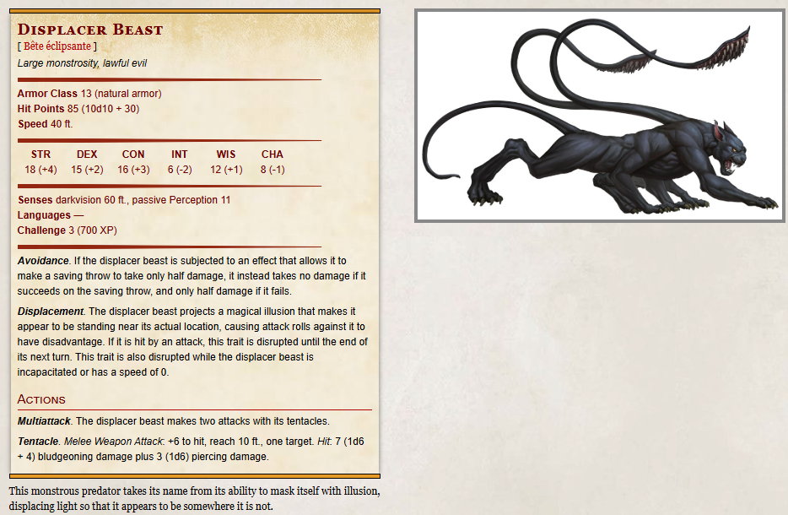

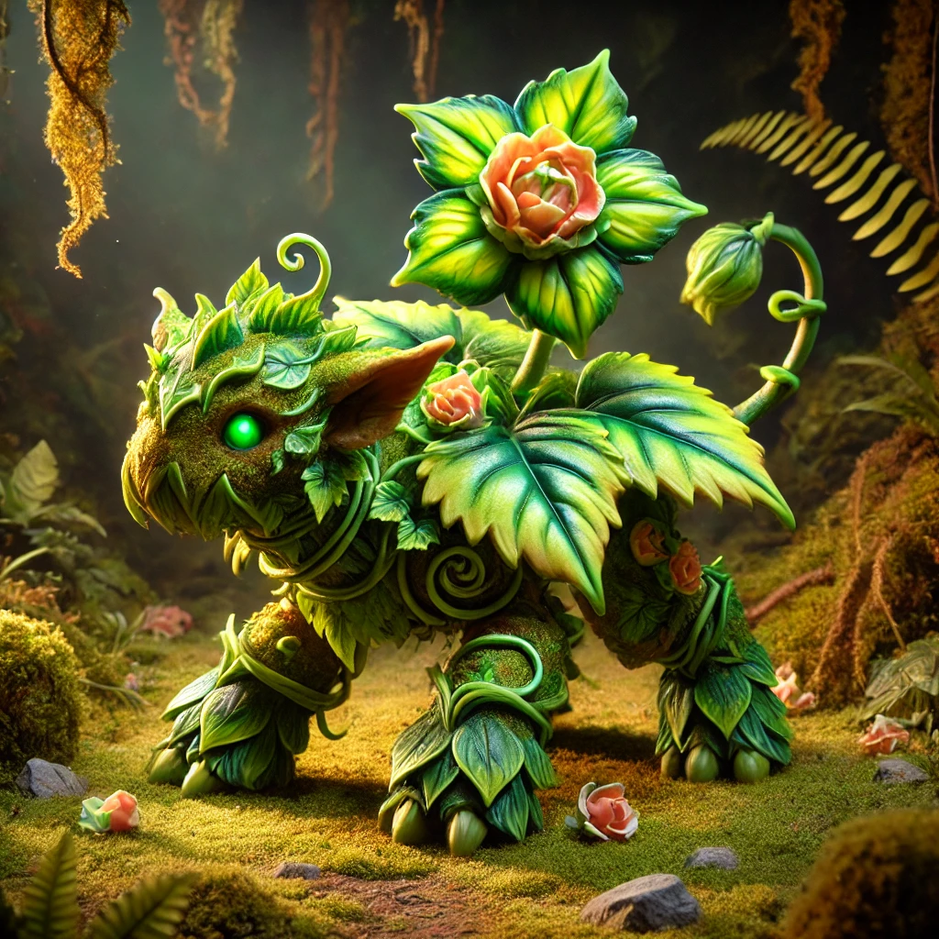

🌿 Floraburst
Small Fey, Neutral Good
Armor Class: 14 (Natural Armor)
Hit Points: 45 (6d6 + 18)
Speed: 30 ft.
STR | DEX | CON | INT | WIS | CHA
14 (+2) | 12 (+1) | 16 (+3) | 10 (+0) | 14 (+2) | 10 (+0)
Skills: Nature +4, Survival +4
Damage Resistances: Poison
Senses: Darkvision 60 ft., Passive Perception 12
Languages: Understands Sylvan and Common but cannot speak

Abilities
- Plant Camouflage. Floraburst has advantage on Stealth checks made to hide in terrain with heavy foliage.
- Photosynthesis. During a short or long rest in sunlight, Floraburst recovers an additional 10 hit points.

Actions
- Razor Leaf. Ranged Weapon Attack: +4 to hit, range 30 ft., one target.
Hit: 10 (2d8 + 2) slashing damage.
- Vine Lash. Melee Weapon Attack: +4 to hit, reach 15 ft., one target.
Hit: 8 (1d10 + 2) bludgeoning damage, and the target must succeed on a DC 13 Strength saving throw or be restrained until the end of their next turn.
- Floraberry (3/Day). Floraburst produces 1d4+1 magical berries. A creature can use an action to eat a berry, which restores 3 hit points.

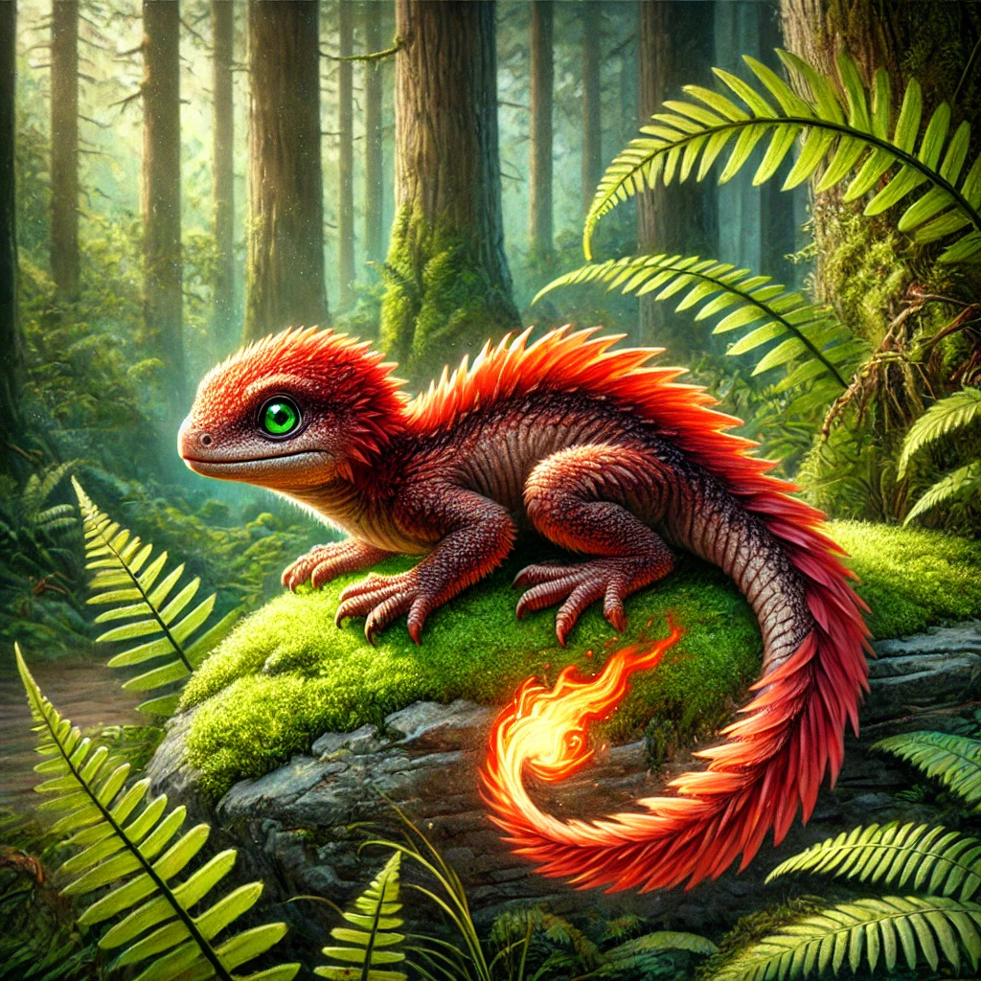

🔥 Emberpaws

Small Elemental, Chaotic Good
Armor Class: 15 (Natural Armor)
Hit Points: 42 (6d6 + 15)
Speed: 30 ft.
STR | DEX | CON | INT | WIS | CHA
13 (+1) | 16 (+3) | 15 (+2) | 10 (+0) | 12 (+1) | 12 (+1)
Skills: Acrobatics +5, Perception +3
Damage Immunities: Fire
Senses: Darkvision 60 ft., Passive Perception 13
Languages: Understands Ignan and Common but cannot speak

Abilities
- Fiery Spirit. When Emberpaws is reduced to 0 hit points, it can release a burst of flame. Each creature within 10 feet must make a DC 13 Dexterity saving throw, taking 7 (2d6) fire damage on a failed save, or half as much on a success.
- Heatwave (3/Day). As a bonus action, Emberpaws can radiate intense heat. For the next minute, any creature that hits Emberpaws with a melee attack takes 4 (1d8) fire damage.

Actions
- Ember. Ranged Weapon Attack: +5 to hit, range 30 ft., one target.
Hit: 9 (2d6 + 2) fire damage.
- Bite. Melee Weapon Attack: +5 to hit, reach 5 ft., one target.
Hit: 8 (1d8 + 3) piercing damage.
- Tail Flame Whip. Melee Weapon Attack: +5 to hit, reach 10 ft., one target.
Hit: 10 (2d6 + 3) fire damage, and the target must succeed on a DC 13 Dexterity saving throw or be ignited, taking 2 (1d4) fire damage at the start of each of its turns until it or another creature uses an action to extinguish the flames.



💧 Aqualump
Small Elemental, Neutral Good
Armor Class: 16 (Natural Armor, Shell Defense)
Hit Points: 54 (7d6 + 21)
Speed: 25 ft., Swim 30 ft.
STR | DEX | CON | INT | WIS | CHA
15 (+2) | 14 (+2) | 17 (+3) | 10 (+0) | 13 (+1) | 11 (+0)
Skills: Athletics +4, Perception +3
Damage Resistances: Cold
Senses: Darkvision 60 ft., Passive Perception 13
Languages: Understands Aquan and Common but cannot speak

Abilities
- Shell Defense. As a bonus action, Aqualump can withdraw into its shell, gaining +4 AC until the start of its next turn. While in its shell, its speed is reduced to 0.
- Water Veil. Aqualump cannot be set on fire and has advantage on saving throws against being ignited or burned.

Actions
- Water Bolt. Ranged Weapon Attack: +4 to hit, range 30 ft., one target.
Hit: 10 (2d8 + 2) bludgeoning damage, and the target must succeed on a DC 14 Strength saving throw or be knocked prone.
- Surf (Recharge 5-6). Aqualump releases a 15-foot cone of water. Each creature in the area must make a DC 14 Dexterity saving throw, taking 14 (4d6) cold damage on a failed save, or half as much damage on a successful one. Creatures that fail the save are also knocked prone.
- Frost Shell. Ranged Weapon Attack: +4 to hit, range 20 ft., one target.
Hit: 8 (1d10 + 2) cold damage, and the target's speed is reduced by 10 feet until the end of its next turn.

