✦ ✦ ✦
THE GUARDIANS OF ELARIA
THE BESTIARY
Creatures of the Chronicle
A running reference for The Guardians of Elaria. Updated as the chronicle grows.
Every strange creature the Guardians have faced, befriended, or freed. Motes mark the planar wanderers: when one falls, a gleam of its home plane rises and fades. Compact statistics live with each session's appendix; this volume gathers the whole menagerie with its lore.
Companions
Ghostbloom (formerly Floraburst)
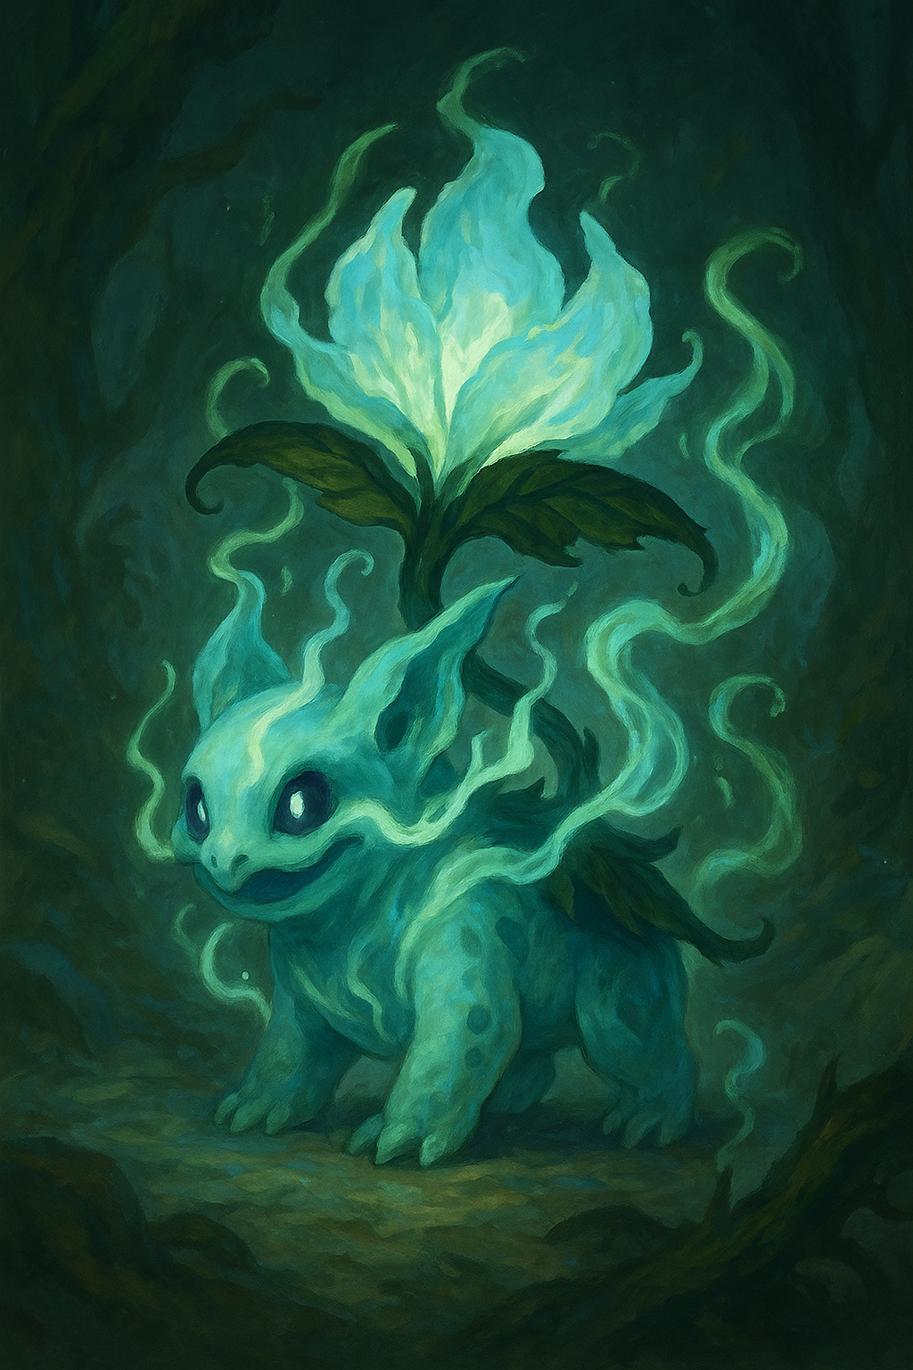
Ghostbloom, Elaria's little voice.
Tiny fey, chaotic good. The party's companion since Session 3, chosen from Professor Aelwyn's three wards as Floraburst, a leafy sprout-backed creature that loved sunlight and berries. Aboard the sinking Dutchman (Session 5) Lilly infused her with a Ghost essence drawn from the harvest jars; the change began there and completed in Wraithpine's ghost-light (Session 6). Now her petals are glass-pale and chime like frost, she floats, speaks in soft telepathy, and glows brighter near planar wounds: Elaria's voice, some say.
Ghostbloom
Tiny fey (Ghost/Grass), chaotic good. AC 15, HP 52 (8d4 + 32), fly 30 ft. (hover).
Vulnerable fire AND cold (mind the friendly fire). Resistant necrotic, poison, nonmagical weapons.
Guardian's Light. Reaction, 3/short rest: heal an ally 1d8 + 3; ends charm or fear; sheds light.
Vine Lash / Ghostly Wail. See the v3 statblock (characters/ghostbloom_statblock_v3.pdf).
Pikachu, the Spark Fox
The spark in the Sphere. An old friend of the Glimmergear family, bodiless since before the chronicle began, sleeping inside the Essence Sphere. His golden projection first appeared in Gearhaven (Session 8): two long ears, a lightning-bolt tail, and a warning carried through Ursa's Mark. He is more than a lost friend; he is a key. His full return is coming.
Lickgloom
Small fey of the pond (CR 1). Befriended on the party's first night (Session 1): round bodied, endlessly curious, with a tongue longer than it is tall and a telepathic voice of feelings (Food? Friend?). Traveled with the party to Ravenstone Laboratory, where it chose to stay among Professor Aelwyn's creatures. Visits are owed.
Session 1: The Forest of Whispers
Duckleaf (CR 4). Elemental Air. A sturdy duck with a leek for a sword, wind-quick and proud, guardian of the rune-stone circle. Its gusts died with the circle's stones. Left a green air mote.
Cognifin (CR 3). Elemental Water. The psychic guardian of the Grove of Elemental Waters; tested the party with waves and whirlpools, and yielded with grace. Left a blue water mote.
Mist Stalkers (CR 2). Feywild predators of fog and fear, hunting the Oakshade road. Their howls scatter the timid; the party stood back to back and did not scatter.
Session 2: The Road to Ravenstone
Mudskips (CR 1/2). Slick little water elementals ambushing from a muddy clearing; dissolved into water motes.
The Grimfang war band. A rival goblin clan with an old grudge against the Bloodfang: two goblins, a worg, an orc, a hobgoblin, and a scar-faced boss who taunted Stabby and regretted it. Driven off, not destroyed; grudges keep.
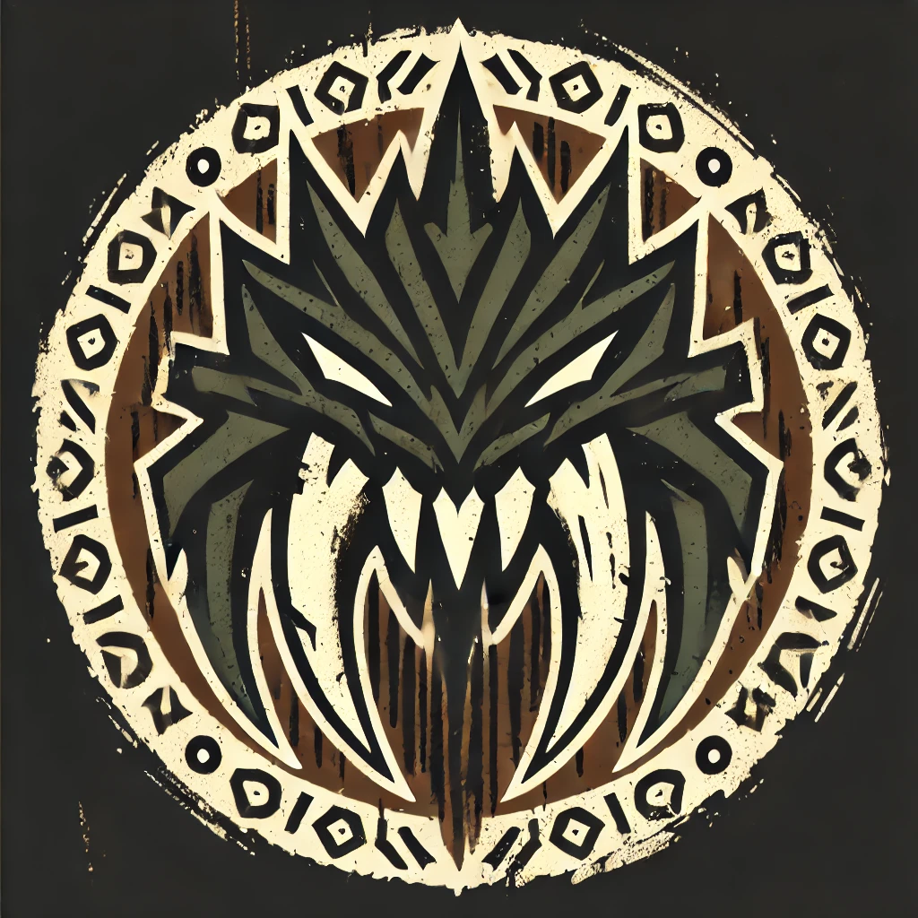
The Grimfang, the rival clan.
Terranox (CR 4). A serpent of living stone from the Plane of Earth, blocking the mountain path with no interest in parley. Collapsed into inert rock; left an Earth Mote and fragments the party still carries.
Session 3: The Road South
Shadowflame (CR 4). A shadow wreathed in cold fire, fighting behind three illusory duplicates in Brambleshadow Thicket. Left a dark mote that felt wrong to hold.
Displacer Beasts (pair). Six-legged, tentacled, and impossibly, TALKING ("Fresh prey... too easy."): planar distortion gives old monsters new tricks. Their fall revealed rune-tears in the forest floor.
Shroomytes (CR 2, four). Fungal wardens of a glowing grove in the Ironroot Hills ("The grove... must be protected!"). Left a fungal mote.
Session 4: The Longest Night of Havenmoor
The Krampusshade (CR 5). Once a guardian of winter, twisted by bitterness into a ten-foot goat-horned fiend with chains of frost and a burlap sack that swallowed children's laughter. His power hid behind three barriers of darkness; eight holiday bells rung in harmony unmade him, and every child came home safe.
Krampusshade
Large fiend, chaotic evil. CR 5. AC 15, HP 102.
Claw and Chains of Despair multiattack; Gift of Despair (fear); Icy Retaliation (reaction);
Shadow Step (legendary). Weakened by the eight Winter Bells rung together.
His winter court. Shadow imps (CR 2), Frozen Wolves, Frostbite Pixies, an Icy Specter at the Whispering Hollow, Enchanted Snowmen, Frost Golems, a Yule Cat, a Frost Hag, Ice Spiders, Frozen Will-o'-Wisps: the frozen roads bred dangers all that week. Friendlier meetings too: a resting reindeer whose glowing nose blessed kind travelers, and Aurora Spirits, messengers of Elaria.
Session 5: The Flying Dutchman
Davy Jones (CR 6). Captain of the Flying Dutchman: barnacle armor, a hook hand, tentacled beard, and a hold full of stolen magic. He harvested essences and caged magical creatures for shipment south in crates stamped with a guild sigil. He gambled for souls (Seven-Eyes, target 77) and lost; he fought, and lost; and when the Dutchman split and sank, he went down with it, for good.
Davy Jones, Captain of the Flying Dutchman
Medium undead, chaotic evil. CR 6. AC 17 (barnacle armor), HP 85.
Soul Siphon, hook and tentacles, Legendary Resistance, lair actions aboard the Dutchman.
His drowned crew. Drowned Pirates (CR 1, burst when destroyed), a Spectral Helmsman (CR 1), a Smuggler's Golem (CR 2), Arcane Corsairs (guild artificers gone pirate), and a Ghost-Light Engineer: all vulnerable to cold, all gone down with the ship.
Session 6: The False Hydra of Wraithpine
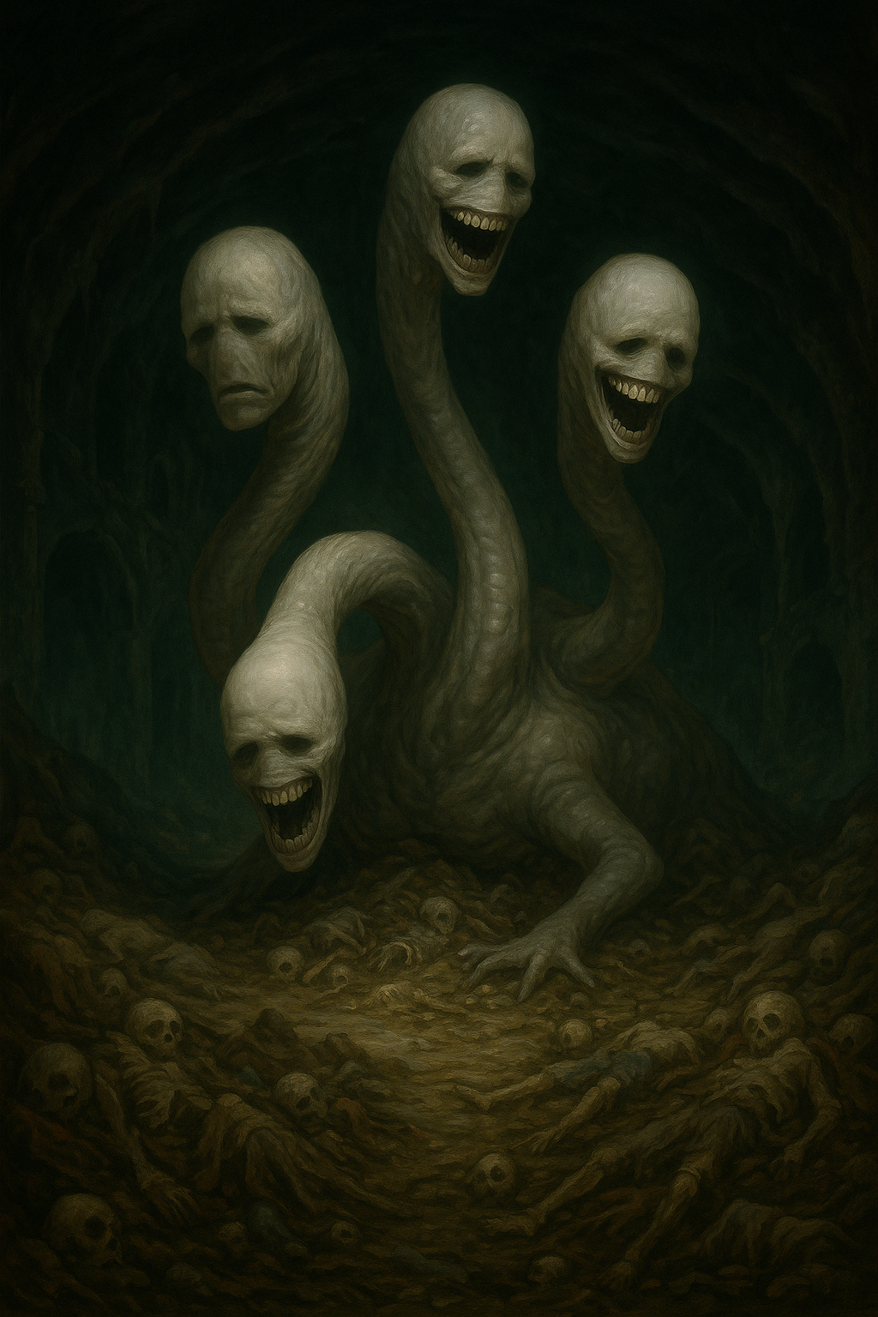
The False Hydra beneath the Old Theater.
The False Hydra. The worst monster the Guardians have faced, because no one knew it was there: a pale many-necked thing beneath the Old Theater whose endless song made the whole village forget the people it took. Beeswax in the ears let the truth through. The tavern head died in the Gasping Gull; the body and its four heads died in the drowned orchestra pit; and the moment the song stopped, every stolen name came flooding home.
False Hydra (adult)
Huge aberration, unaligned. Body AC 15, HP 130; Heads AC 14, HP 45 each (tavern head HP 70).
Song of Unremembering. DC 15 Wisdom within 60 ft.; beeswax earplugs grant advantage.
Vital Link. The body resists weapons while any head lives. Legendary actions per living head.
Festival frights. Animated Scarecrows and six Strawlings on Pumpkin Row; rats and rat swarms in Maera's cellar; restless Zombies at the graveyard rite. All echoes of the hydra's hungry song.
Session 8: Gearhaven, the Clockwork City
Rogue Servitors (CR 2) and the Cargo Hauler (CR 3). Pinion's delivery constructs with red-lit eyes, seized by something that reached INTO them. Shut-off levers ended it kindly. The Hauler hated lightning.
Voltcrawlers (swarm of 6) and the Broodmother. Skittering planar intruders pouring from the Underworks rift, phase-blinking between strikes (force and radiant pinned them down). Slain crawlers collapsed into motes; the Sphere drank them.
Iron Drudges (three) and Corrupted Sproutlings. The Verdant Plaza's own caretaker machines and garden, turned by corruption bleeding up through the cracks. Vulnerable to fire; freed, not killed: corruption leaks out of a felled Drudge like smoke.
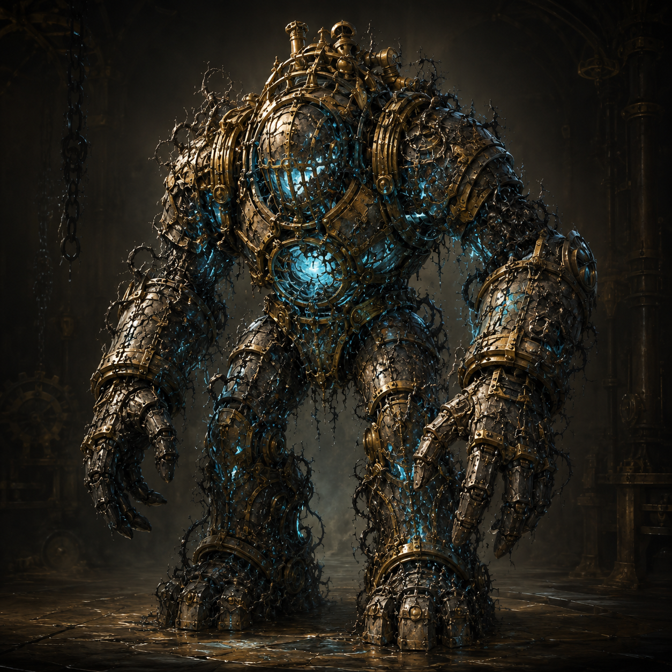
An Iron Drudge in the Verdant Plaza.
The Grand Custodian. Gearhaven's beloved gentle giant, keeper of the Great Governor, possessed by the corruption and grieving inside it. Legs toppled, core reached, and with the last blow the corruption drained away; the freed Custodian warned of something old and hungry reaching through, and Ursa's Mark granted it rest. Its freedom closed every rift in the city.
The Grand Custodian (possessed)
Gargantuan construct. Body AC 17, HP 220; Legs (x2) AC 15, HP 90 each. Two phases: Standing, Crashed.
Chain Lightning Burst (deflected by Stabby's awakening). A gentle death, never an execution.

