✦ ✦ ✦
THE GUARDIANS OF ELARIA
THE CUSTOM COMPENDIUM
Subclasses, Paths & House Rules
A running reference for The Guardians of Elaria. Updated as the chronicle grows.
Homebrew and rulings of this table: the paths the heroes may walk after the year apart, and the standing rules of the campaign. 2024 rules throughout; house rules override the books.
House Rules & Standing Rulings
1. Ursa's Starseed +1d4 applies only to actual druid spells, never the Starry Form Archer's luminous arrow.
2. Patient Defense grants a free Disengage (add Dodge by spending 1 Focus).
3. Shillelagh replaces Primal Savagery on Ursa's sheet (2024 rules).
4. Goodberry: eating a berry is a Bonus Action (2024).
5. Ursa's summoned Air spirit has 20 HP.
6. Deep gnome uses the current 2024-era printing (Svirfneblin Camouflage, Disguise Self and Nondetection 1/long rest each).
7. Lilly's cannon picks its mode on EVERY activation (Forge of the Artificer rule).
8. Potent Spellcasting rides the kindled staff once per turn (Ursa, from level 7).
Warrior of Breathing (Stabby's Path)
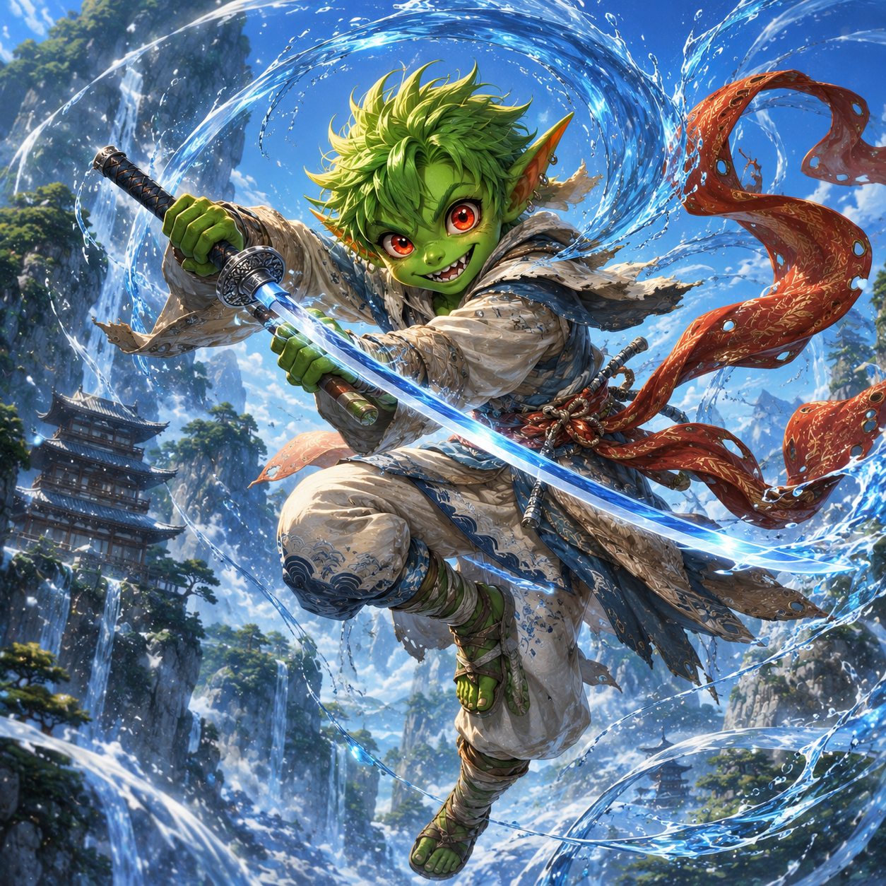
Water Breathing: the flowing style.
A homebrew monk subclass taken at level 7 in place of Kensei (full document: characters/path_rewards/warrior_of_breathing_v2.pdf). A Warrior of Breathing kindles an inner style, a visible breath that wreathes the blade. All roads grant the Nichirin Katana (+2, finesse, monk weapon, glows when breath is kindled, Cleansing Edge against corrupted creatures), and the First Form replaces Flurry of Blows.
Water Breathing (the Whispering Breeze Monastery road): pale blue breath, +2 cold damage, Flowing Guard (+2 AC against the first attack each round), First Form: Flowing Strike (3d8 + Dex cold, knocks prone).
Beast Breathing (the reform-the-Bloodfang road): blood-red breath, +2 force damage, Beast Sense, advantage on Dexterity saves and +10 speed while ignited, First Form: Devour (3d8 + Dex force; a felling blow refunds the Focus).
Shadow Breathing (the Idol's Dreams road): violet-black breath, +2 necrotic damage, permanent darkvision 60 ft. and Stealth advantage, half cover against ranged attacks while ignited, First Form: Umbral Slash (teleport, a cube of darkness, 3d8 + Dex necrotic with advantage).
Paths of the Stars (Ursa's Path)
Chosen at level 7 (full document: characters/path_rewards/ursa_path_rewards_v2.pdf).
Starlit Channeler (the Circle road): learns Shillelagh; the Starry Form gains a FOURTH constellation, the Warden: kindle the staff as part of the same bonus action, radiant +1d6 rider (2d6 at 11, 3d6 at 17), lasting as long as the form. The Staff wakes further: 6 charges, brighter starlight.
Reader of Omens (the Father's Trail road): Weal and Woe, a pool of Wisdom-modifier omens applied AFTER a d20 is rolled; and Ash's Sigil-Stone, 1/long rest Aura of Vitality without a slot, carrying a half-finished sigil of Elaria that has more to say.
Beast Handler (the Living World road): Summon Beast always casts at the highest level Ursa can cast, Wild Speech with his summons, and the Wildheart Token: a named beast-friend whose shape the spirit always takes, and who refuses to die (1/day drops to 1 HP instead of 0).
Glimmerstone Artifacts (Lilly's Path)
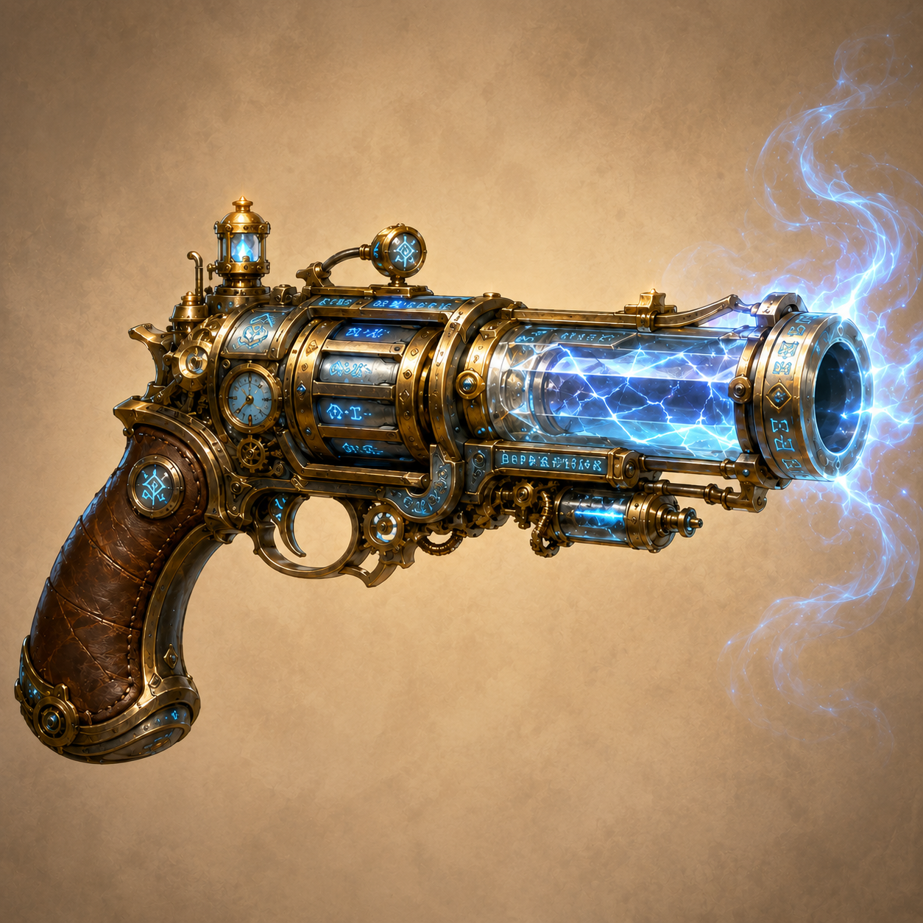
The Boomstick, if Lilly walks the Glimmerspire road.
Chosen at level 7 (full document: characters/path_rewards/glimmerstone_artifacts_v2.pdf). Every road keeps her at exactly three attunements.
The Sentinel (the stay-and-build road): the Pocket Dynamo rebuilt into a Medium construct guardian. AC 18, HP 5 + 5 per level, no duration. Force Blast (120 ft., 2d8 + INT) or Electric Pulse (15 ft., jolts Reactions away); Guardian Protocol (reaction temp HP); self-mending; reboots with a spell slot if destroyed. Replaces the Eldritch Cannon while attuned.
The Boomstick (the Glimmerspire road): +2 repeating pistol, 1d10 thunder, never reloads; a Wand of the War Mage and Arcane Firearm (+1d8 thunder) in one; Concussion knockback; channels True Strike.
The Awakened Essence Sphere (the researcher road): Mote Channeling (2/short rest shared pool): a base Aether Ward (2d8 + INT temp HP to allies within 15 ft.) and five LOCKED elemental discharges, one unlocking per Mote installed in the Rift Portal's ring.

The Awakened Essence Sphere.
Marks & Mysteries
Ursa's Mark of Handling. A dragonmark that woke when he was six: it prickles near frightened animals, grants Speak with Animals and Animal Friendship, and has become the channel through which sleeping and possessed things speak to him (Pikachu, the Grand Custodian). It has never once stirred for a machine.
The seven-point star. Elaria's sigil, wrapped in a leafed vine (or cupped in wings, on the Sash), found on every gift along the Guardians' path. When you see it, she saw you coming.

