✦ ✦ ✦
THE GUARDIANS OF ELARIA
SESSION 5
The Curse of Davy Jones
An illustrated adventure. Read the gold boxes aloud; the purple boxes are for the DM.
Previously, on The Guardians of Elaria...
Winter came early to Havenmoor, and it came wrong. The Krampusshade slipped out of a crack between worlds and began stealing the town's children into its great creaking sack, one frosted window at a time. But three young heroes rang the eight Winter Bells, broke the three barriers, and drove the shadow back through its own door: banished, beaten, and thoroughly embarrassed. Every child came home. Grateful beyond words, the lorekeeper Faelan opened an old chest and gave the heroes three gifts: a Frostbite Shard Dagger for Lilly, a Candyfang Katana for Stabby, and an Amulet of Guiding Light for Ursa.
And down at the harbor, riding gently at anchor, a tall ship called the Stormwind waited to carry the Guardians east across the open sea, toward the clockwork spires of Gearhaven, where Professor Aelwyn said the Essence Sphere might finally be understood. The sea, as it turns out, had other plans.
▶ The heroes sail into this session at level 4. Full creature statistics live in the compendium; a compact appendix closes the session.
Part One: Fair Winds from Havenmoor
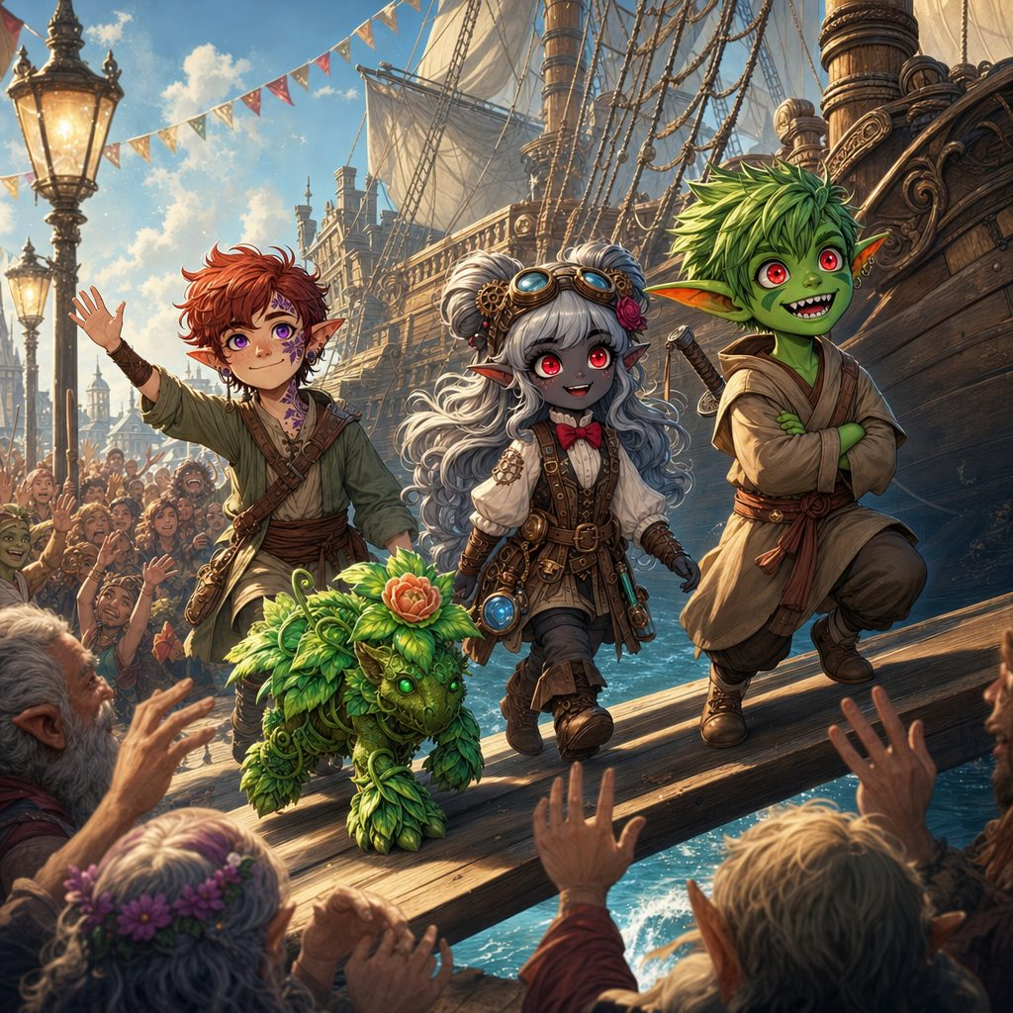
A grateful Havenmoor cheers the Guardians up the Stormwind's gangplank.
Rosy dawn light spills over Havenmoor's busy harbor. Fishing boats lie tethered beside merchant galleys, sails unfurling in the sea breeze, and salt spray drifts across the docks with the cries of gulls. On every lamppost flutters a brightly painted banner, and every banner says the same thing: “Thank You, Guardians of Elaria!” Half the town has come down to the quay to see the heroes off.
Greta Frostbough presses warm sugarplum buns into every free hand. Sister Merida stands with a whole row of waving orphans, tears bright in her eyes. And some faces have traveled a long way for this morning: Alwen, keeper of the Old Oak Tavern in Oakshade, and Garrick and Evelyn, old friends from Eldridge Village, who heard what the three young strangers from the Gilded Acorn had become and could not stay away.
Master Doran Bramblebeard, shipwright and lighthouse keeper, strides up with his great booming laugh. Doran: “Not bad for a bunch of landlubbers! Saved half this town, you did!” He claps Lilly on the shoulder and ruffles Ursa's hair. Alwen hugs Stabby so hard he nearly tumbles into a barrel, then presses a small flask of fresh seawater into each hero's hands. “For luck,” she says. “Old sailor's custom. Do not ask me why, just keep it close.”
Captain Brynn Wavewarden
At the top of the Stormwind's gangplank waits a tall, steely eyed woman in a weathered naval coat, brass buttons gleaming, salt streaked hair tied back in a knot so tight it could moor a ship. Captain Brynn Wavewarden looks the three small heroes over exactly once, and misses nothing.
Brynn: “Listen up. These waters run on shifting currents and hidden shoals; one misstep and we founder. I need eyes aloft, hands on the helm, strength below decks, and quick fingers on the sails. Keep your stations, follow orders to the letter, and you will make Gearhaven in one piece.”
Learning the Ship
The Stormwind casts off, and the crew takes the heroes in hand. High in the crow's nest perches Old Marla, squinting at the horizon: “Keep a weather eye, or we'll be fish bait.” At the wheel stands First Mate Breesh, steady as a lighthouse: “A firm hand, young'un. This wheel is trickier than it looks, like steering a wild stallion.” Up in the ropes swings Rigging Master Hugo: “Mind your knots! A broken line in a gale will send you flying overboard faster than a cannonball.” And down in the bilge sloshes Quartermaster Sline with his bucket: “Muck and bilge water will rot this deck in a week if you slack off. Don't let her drown.”
For two bright days the heroes learn the ship from keel to masthead. Ursa takes to the crow's nest like he was born aloft, reading the water the way he reads the sky. Stabby scrambles through the rigging faster than Hugo can shout instructions. Lilly falls in love with the helm, the pumps, the pulleys, every clever working piece of the vessel. In the evenings, Captain Brynn herself teaches them knots by lantern light: bowline, clove hitch, and a curious looping knot she says her grandmother called a keepsake knot. The heroes' small hands learn every one.
▶ Ship stations. Lookout: Wisdom (Perception) DC 12. Helm: Dexterity (Acrobatics) DC 13. Rigging: Strength (Athletics) DC 14. Bilge: Constitution DC 13. From the crow's nest, Survival (Navigation) DC 17 plotted the safer channel into the storm.
▶ Brynn's knot lessons are not just color. They matter again, one session from now.
On the second night, the captain takes a private word with the party at the stern rail, her voice low under the creak of the rigging. Brynn: “Old sailors say Davy Jones's curse hangs on these currents. Ships found empty, crews never found at all. I do not truck with ghost stories. But keep your lucky flasks close, little ones, and do not let the sea hear you boasting.”
Part Two: The Storm in Three Great Blows
On the third day the sky went the color of old iron, and the sea rose to meet it.
Dark clouds boil up from the horizon, turning the sky into a rolling cauldron of steel and shadow. The wind shrieks like a living thing, whipping the spray into stinging needles. Captain Brynn lashes herself to the wheel beside Breesh and roars over the gale: “We ride every blow together! Fight this storm as one, or we all go down!” Every hero takes a station. The storm comes on in three great blows.
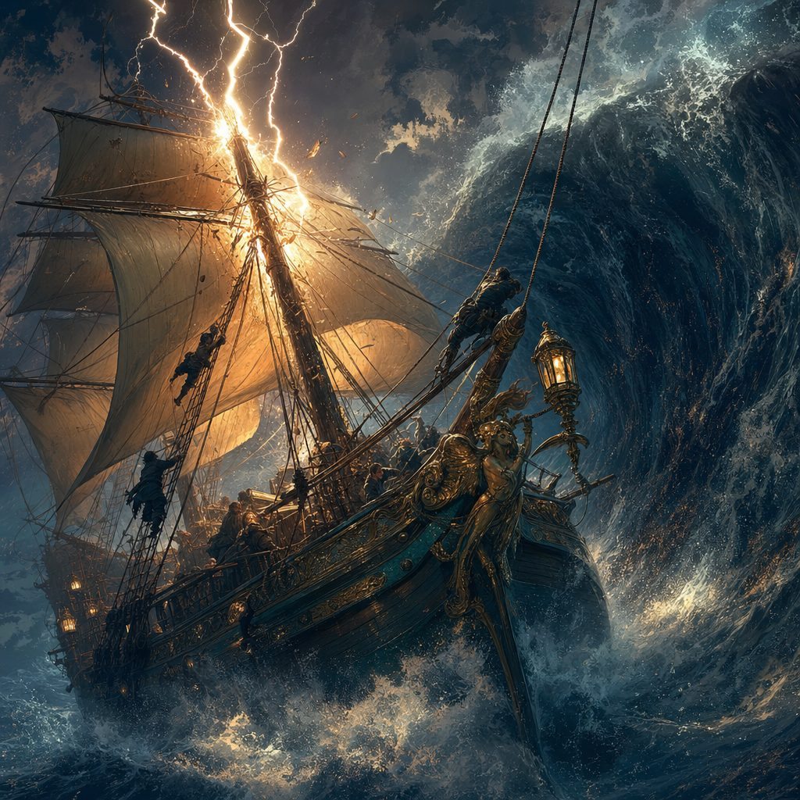
The Stormwind fights for her life in the heart of the tempest.
The First Blow: The Wall of Water
A monstrous swell rises off the port bow, its crest glowing with strange pale foam. Time slows as the wave arches high above the masts, hangs there like a held breath, then crashes down in a thunder that shakes the whole world. Marla's warning cry from the crow's nest, Ursa hauling a sailor clear of the rail, Stabby knotting a snapped line with hands quicker than the wind: the Stormwind staggers, shudders, and rises streaming from the foam. Still afloat.
The Second Blow: The Sky Splits
Then the lightning comes. A white hot bolt cleaves the sky and strikes the main mast with a crack like the world's biggest whip. Wood shatters. Sparks hiss and arc along the wet rigging, and the great mast groans, leans, and splits. Lilly is everywhere at once, hands full of rope and clever fixes, shouting over the thunder which lines to cut and which to save. The Stormwind fights on, wounded but game.
The Third Blow: The Maelstrom
But the sea saves its worst for last. The water itself begins to turn, slow and huge and horribly patient, and the ship's prow dips into the rim of a swirling maelstrom. The wind plunges to a howling shriek. The wheel spins free of Breesh's hands. The world tilts, and keeps tilting, and Captain Brynn's last order is swallowed whole by the roar as the Stormwind heels over, over, over: and capsizes.
▶ The storm ran as three group checks at ship stations (the three blows), bruising but survivable; the maelstrom flipped the ship no matter how well the party rolled. Dexterity save DC 12 to grab a beam as she went over.
The Air Pocket
Cold. Dark. The rush and boom of water. Then, gasping, the heroes surface inside a cramped pocket of trapped air under the upturned hull, hearts hammering, soaked to the bone. Darkness presses in, pierced by a ghostly green glow seeping through barnacle choked cracks. Brine laps at their ankles. Broken crates and dangling ropes swing in the gloom, and somewhere in the dark a sailor coughs, and another answers, and another: the crew, alive, clinging to the ribs of their poor drowned ship.
Stabby: “Everyone always says goblins sink. Ha! Still floating!”
And then, through the largest crack, the heroes see it. Far below, in the inky deep, something is rising. Ghost white sails unfurl in water where no wind blows. A barnacle crusted keel, vast and old and glowing sea sick green, climbs toward the wreck like a whale rising for air. The Flying Dutchman is coming up directly beneath them.
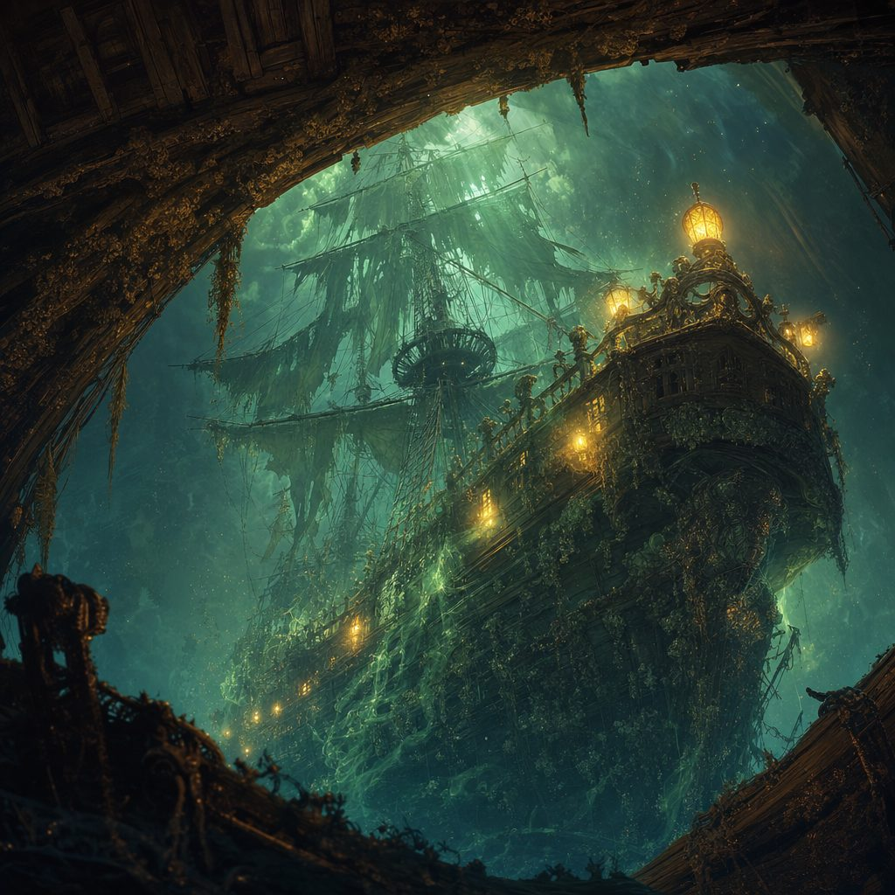
Ghost sails unfurl in the deep as the Flying Dutchman climbs toward the wreck.
Part Three: Aboard the Flying Dutchman
A deep, resonant groan rolls through the wreck as the Dutchman's hull slides beneath it and lifts. Water sheets away. Cold luminescence floods the hold. And then, without warning, spectral chains snake up through the broken planks, glowing links coiling around arms and ankles like living serpents, and haul every soul aboard the wreck, heroes and sailors alike, up into the green light of the ghost ship's deck.
The crew of the Dutchman shuffles out to meet them, and they are the funniest frightening things the heroes have ever seen: drowned sailors gone all barnacled and green, crabs riding in their beards, seaweed for hair, one with a starfish stuck to his face exactly where a starfish should not be. They herd Captain Brynn and her sailors toward the brig with mossy politeness, and march the three small heroes, still dripping, toward the hold.
The Hold of Harvested Magic
Below decks, the Dutchman is not a ship. It is a collection. Crystal jars line the walls in racks, each one holding a captive glimmer: feywild motes swirling like caught fireflies, elemental sparks crackling in vials, soft pulsing threads of raw magic. Iron cages hold living prisoners: a dripping water sprite pressed against the bars, a shivering flame salamander burning low and frightened, an owl-kin with great hollow eyes that follow the heroes across the room. And stacked to the ceiling stand rows of battered crates, every one stamped with the same sigil: the mark of the Gearhaven Artificers' Guild.
From the shadows between the racks he comes: tall, tentacle bearded, hook handed, barnacles glowing along his arms like embers, each one holding some little trapped spark of life. Davy Jones taps one hooked fingertip, very gently, against the Essence Sphere at Lilly's belt, and smiles like a shipwreck.
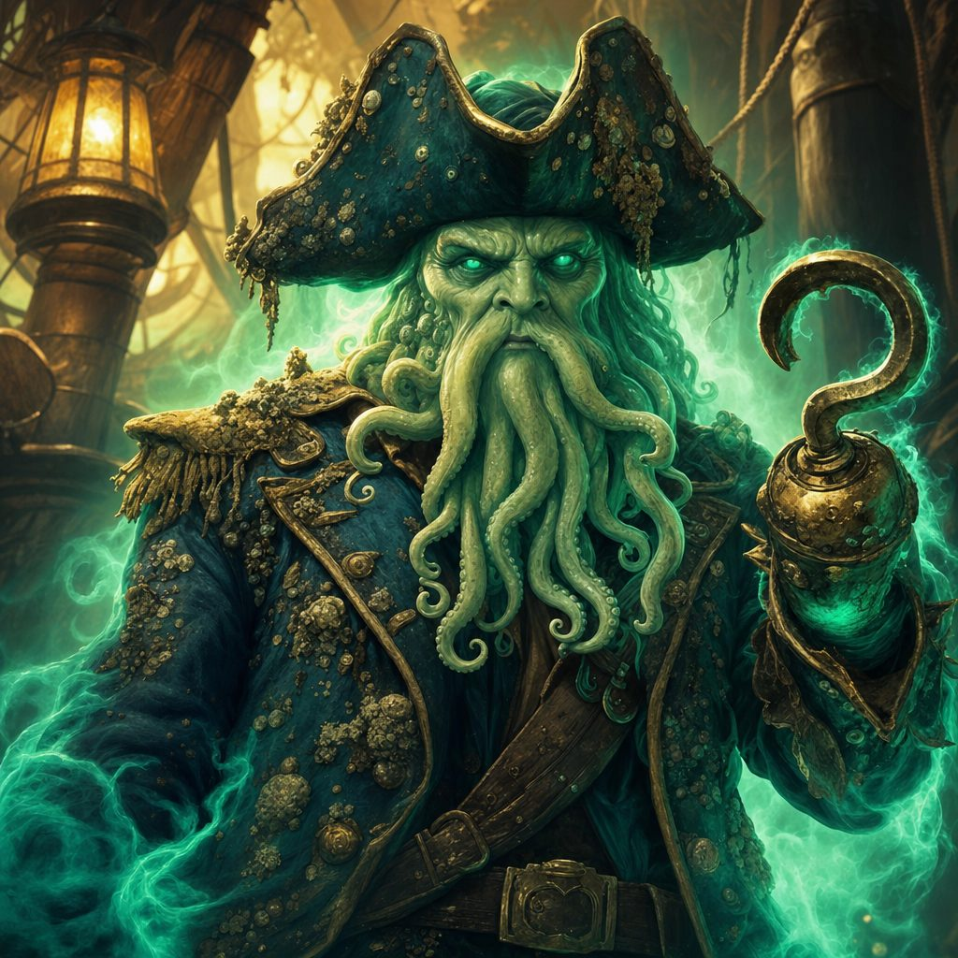
Davy Jones, captain of the Flying Dutchman, come to collect.
Davy Jones: “Ah. The bright spark of little Floraburst. Feywild sunlight, bottled and carried right to my door. The perfect spark to ignite my anchor and rend the veil open. Surrender her essence... or I shall harvest it by force.”
Lilly: “You will not touch her. Not one petal.”
The captain's smile widens. He gestures with the hook, and the mess deck hatch creaks open below. Davy Jones: “Force, then. But I am a sporting man, after my fashion. Welcome aboard, Guardians. Your souls now belong to Davy Jones... unless you can win them back. Let our game begin.”
Part Four: The Dice Game of Souls
The mess deck is lit by lanterns burning a sick green. At its center stands a scarred oak table, and every scar is a name: the names of sailors who sat here, and gambled, and lost. The heroes are set on rough benches, chains clinking at their wrists, while Davy Jones looms opposite, tentacles curling around the roof beams like patient serpents. Onto the table clatter seven dice of ivory and bone: a d4, a d6, a d8, two d10s, a d12, and one yellowed old d20 that seems to watch you back.
Davy Jones: “Three rounds of Seven-Eyes, target seventy and seven. Win, and your chains fall and your little friend keeps her light. Lose, and I snuff out every spark of your souls... and her fey light with them.”
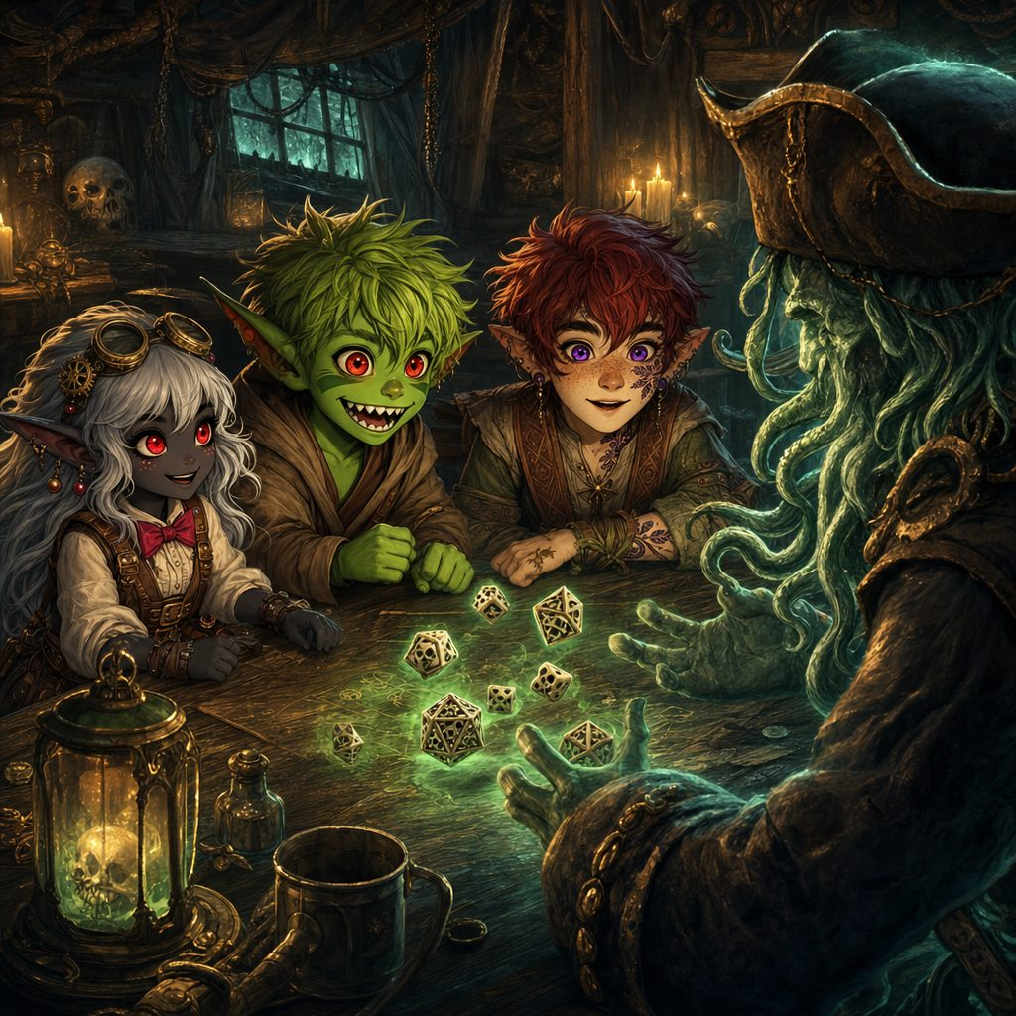
Seven dice of ivory and bone, and three small souls on the table.
▶ Seven-Eyes, target 77. Each player rolls all seven dice twice, summing toward 77 without going over; between tosses they may gift one die's value to a teammate. Davy rolls three times and may discard a die after each roll. Beat his total or bust him; he needed 5 points over three rounds to win. The party won the game.
The first round is terror. The dice feel cold as drowned stones, and when Ursa's second toss threatens to burst past seventy seven, the whole table holds its breath until Lilly quietly slides her lowest die across and saves him. The second round is arithmetic and nerve: Stabby, who cannot sit still in a classroom to save his life, turns out to be terrifying at dice, counting faces and gifting exactly the right pips at exactly the right moment. Davy's grin gets thinner. His discards get angrier.
The third round comes down to the last toss of the last die. Davy Jones sits at seventy six, one smug point from feasting. The heroes' running totals hang just beneath his. Then the old yellowed d20 tumbles across the scarred names, teeters on one corner, and lands: and the heroes' total stands at seventy seven exactly, and the captain of the Flying Dutchman is beaten at his own table.
Stabby: “Seven-Eyes! Pay up, fish-beard!”
Davy Jones rises so fast his chair goes through the wall. The lanterns gutter green, the chains fall from the heroes' wrists like dead eels, and the captain snarls one promise as he dissolves into cold mist: “This isn't over...” He was wrong about that.
Part Five: No Flesh Leaves This Ship
The heroes had won their souls back fairly. They could have slipped away quietly. Instead, they thought about the cages.
Two skeletal wardens, bound by the game's result and clearly disgusted about it, bow and usher the heroes toward the guest chambers to rest. But through the bulkheads comes a muffled clinking: jars being packed, cages being rattled, prisoners being made ready for shipment. And through a salt streaked porthole, Lilly spots a trim little cutter lashed near the Dutchman's rail, seaworthy and forgotten, with a name painted on her stern: the Vigil.
Lilly: “They are rounding up every magical being aboard. If these essences ship south, the whole coast will suffer. We are not leaving without those cages open.”
The heroes step out onto the weather deck, and the ghost ship's crew is waiting. Drowned pirates haul themselves over the rails, cutlasses dripping, barnacles clacking. At the wheel, a Spectral Helmsman turns its lantern eyed head all the way around and wails: “No flesh leaves this ship alive!”
The deck fight is wild and slippery and loud. The pirates fight like the tide, slow and heavy and everywhere; Stabby fights like the spray, bright and quick and impossible to hold. Ursa's starlight punches clean holes in the sea fog, and when the helmsman swoops down shrieking, Lilly's cannon knocks it clean through its own wheel. When each drowned pirate finally drops, it bursts in a last cold slap of seawater, which Stabby declares is “rude, even for dead people.”
▶ The deck fight: 3 Drowned Pirates and the Spectral Helmsman, on a slippery deck (Acrobatics DC 12 at turn's end or fall prone). Death Burst on each pirate: DC 12 Con or 2d4 cold. The party won the deck and pressed below.
Into the Heart of the Hold
The iron bound hatch groans open and stale, salty air rushes out. Below, the hold stretches away into gloom: the racks of jars, the cages, the Guild stamped crates, and now, waking one by one, the things that guard them. The timbers themselves hum with stolen magic.
Ursa: “This is not Davy's doing alone. Something darker haunts this ship.”
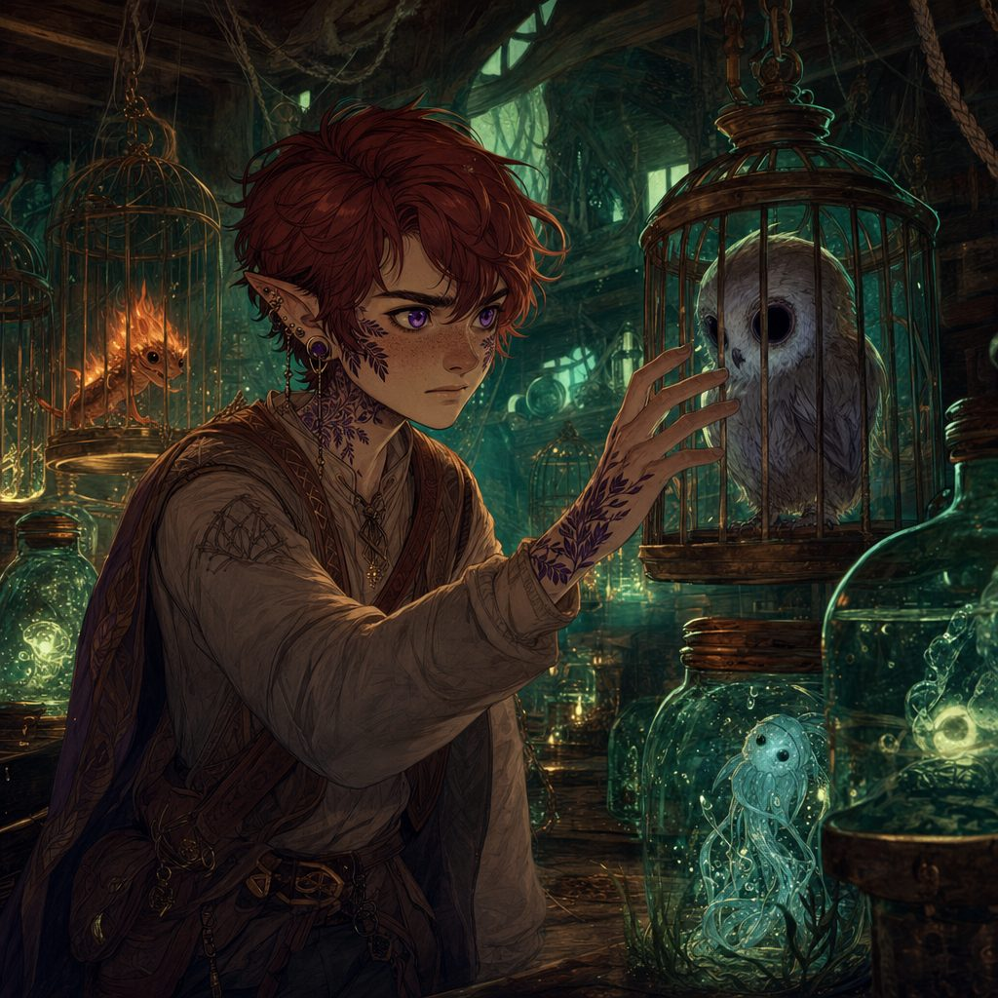
Racks of caged magic: an owl-kin, a flame salamander, a frightened water sprite.
Lilly draws her Frostbite Shard Dagger, frost curling off its edge into the green dark, and her eyes narrow. Lilly: “Then we cut it out at the source.”
The guardians of the hold come all at once: a hulking Smuggler's Golem patched with metal plates and powered by stolen essences, two Arcane Corsairs, guild artificers turned pirate with enchanted sabers and no shame at all, and a Ghost-Light Engineer, a flickering spirit bound to the ship's arcane engines, blinking in and out of sight with lightning crawling between its fingers. Every one of them flinches from the cold. The heroes notice.
Frost becomes the whole battle plan. Lilly's dagger bites chunks from the golem's hide while Ursa's magic rimes the corsairs' sabers with ice. The engineer blinks invisible, but its glowing core betrays it, and Stabby tracks the glow through the dark and puts it out with three quick strikes. At the center of the hold pulses a great arcane orb, drinking power from every jar; Ursa raises his amulet and the party shatters the orb in one blinding burst of radiance that staggers every undead thing aboard.
▶ The hold fight: Smuggler's Golem, 2 Arcane Corsairs, Ghost-Light Engineer, all vulnerable to cold. Arcane fissures leaked 1d6 lightning; the central orb broke to a Strength or Arcana DC 15 check, dealing 3d6 radiant and stunning the undead.
As the last foe dissolves into drifting motes, Stabby sheathes his blade and looks up at the ceiling, toward the captain's quarters. Stabby: “That was the heart of his operation. Now we face the head.”
Part Six: The Captain Goes Down with the Ship
Lantern light pools on warped floorboards as the final hatch swings open. Davy Jones's own chambers pulse with stolen power: jars of glowing motes line the walls, and seawater drips slow and endless from a vaulted skylight onto a raised dais. On the dais, reassembled from mist and malice and very much out of patience, stands the captain himself. His hook drips brine. His tentacles curl in quiet menace.
Davy Jones: “Brave... or foolish. You beat my dice. You broke my hold. But the sea only knows one ending, little Guardians. Your light... my feast. Let us begin.”
He is the worst thing the heroes have ever fought. Cold sea fog crawls across the floor and drinks their courage. Barnacles bristle along the dais like teeth. His tentacles strike from ten feet away, his hook rings off Stabby's blade, and again and again his Soul Siphon reaches out, a pulling green hunger, trying to drain three small souls and the bright sphere they guard. Each time, a hero throws themselves in the way of the others. Each time, the light holds.
At half strength he only laughs louder. Davy Jones: “I have swallowed storms older than your lifetimes! You cannot drown me!”
Ursa: “We are not here to drown you. We are here to let everything you stole go free.”
It is Lilly's frost that cracks his barnacle armor, Ursa's radiance that burns through the crack, and Stabby, running up a falling tentacle with his candy red sash streaming, who lands the last blow. Davy Jones, captain of the Flying Dutchman, comes apart the way a wave does: all at once, and forever. There is no scream. There is only a long green sigh, and then every barnacle on the walls goes dark, and the curse of Davy Jones is over for good.
All through the ship, jars crack open and cages spring wide. The freed essences rise through the broken skylight in a spiral of soft lights, hundreds of them, like stars going home. The water sprite bows to the heroes before melting gratefully into the sea. The flame salamander leaves happy little scorch marks down the corridor. The owl-kin lands once on Ursa's shoulder, hollow eyes gone warm and round, and is gone into the night air. Below, cell doors swing open, and Captain Brynn Wavewarden leads her whole crew blinking up into the strange light: every sailor of the Stormwind, alive.
The Ghost Essence
One light does not fly away. A pale, drifting essence, cold and gentle as sea mist, circles down out of the spiral and hangs before Floraburst, who has ridden out the whole battle tucked in Lilly's pack, and who now reaches up toward it with every leaf and petal she has. Lilly cups her hands around the little ghost light, steady as her mother taught her, and guides it home.
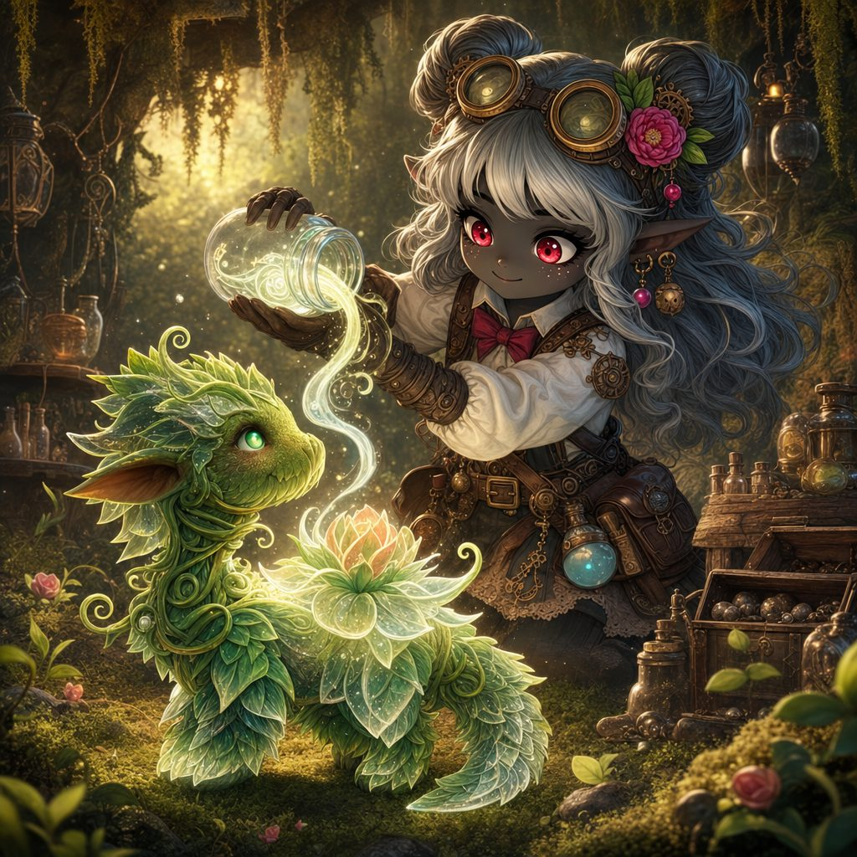
Lilly guides the pale ghost essence home into Floraburst.
Floraburst drinks in the essence, shudders once from root to petal, and collapses. For one terrible heartbeat she is still. Then a slow pulse begins inside her, deep and rhythmic as a sleeping heart, and before the heroes' eyes each petal comes away etched in strange new patterns of frost and fire. She is not hurt. She is changing, into what, not even Lilly can say.
Lilly: “She is... shifting. I can see new patterns in her petals. Hold on, little one. We have got you.”
The Vigil
A low rumble rolls through the floorboards, and cracks spiderweb up the barnacled walls. With its captain gone and its stolen power flown, the Flying Dutchman is dying. The heroes and the Stormwind's crew race for the rail, cut the little cutter Vigil free of her lashings with Brynn's own knots, and swing her down into the black sea. Everyone piles in, Lilly cradling the sleeping, changing Floraburst against her chest, and the oars bite deep.
Behind them, the great ghost ship groans, lists, and with a sound like a very old door finally closing, splits in two and slides beneath the swirling foam. The green glow fades from the water. The sea rolls flat and clean, as if something that had been wrong with it for a hundred years had just been put right.
Ursa, gazing back: “Good riddance.” Stabby, panting at his oar: “Aim east! Gearhaven is that way!”
They row east through the small hours, trading the oars, humming Old Marla's watch songs, while the sky slowly lightens ahead of them. And as dawn comes up gold over the water, the heroes see it at last on the horizon: the faint, gleaming silhouette of clockwork spires. In Lilly's arms their little friend sleeps on, pulsing gently, petals etched with frost and fire, becoming whatever she is going to be.
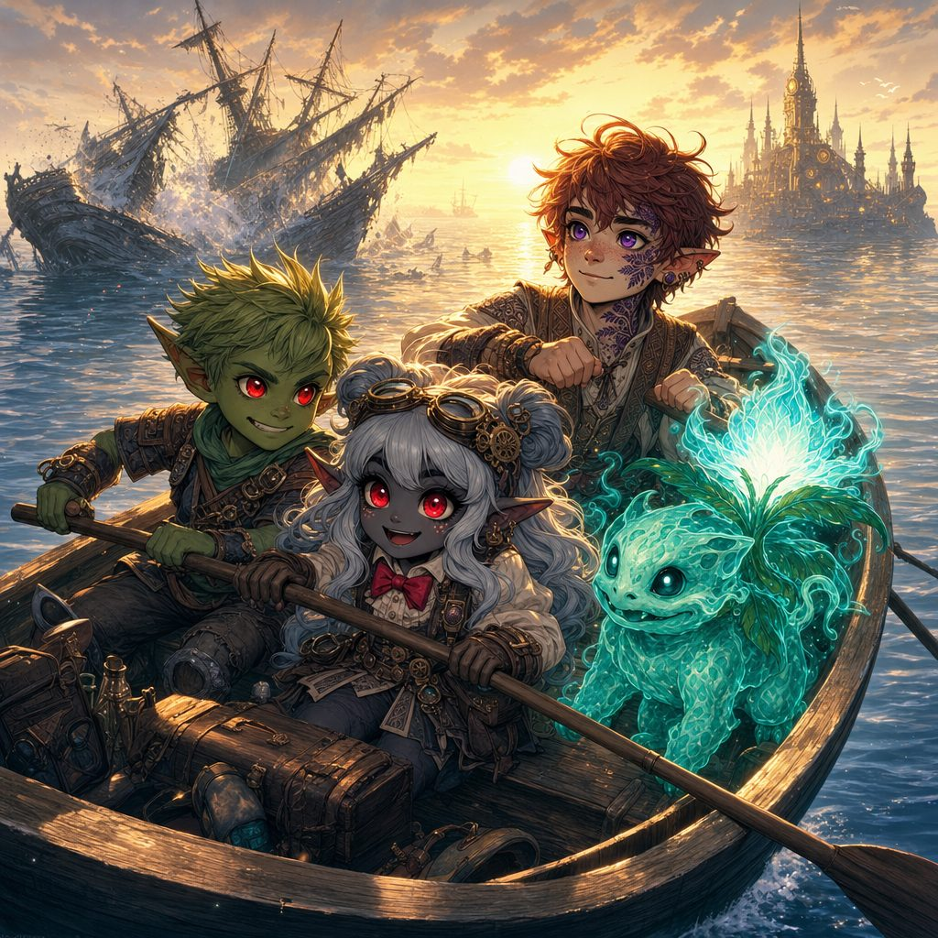
The Vigil rows east at dawn, Gearhaven's spires gleaming on the horizon.
✦ ✦ ✦
The curse of Davy Jones was ended, the stolen magic freed, and every soul of the Stormwind saved. But the crates in that hold had worn the sigil of the Gearhaven Artificers' Guild, and somebody, somewhere south, was expecting a shipment that would never come. The Vigil ran east toward Gearhaven's spires, but the coast between held one more port: a fogbound little town of lanterns and pumpkins where, strangely, no one seemed to remember anything wrong at all. And in Lilly's arms, Floraburst went on quietly changing.
▶ Ending this voyage carried the heroes to level 5. They return at level 5 next session.
Next: Session 6, in which the fog rolls in over Wraithpine, the Guardians learn why you should always tie a keepsake knot, and their sleeping little friend finally opens her eyes.
Appendix: Creatures of Session Five
Compact statistics for the table. The full bestiary, with lore and pictures, lives in the compendium.
Davy Jones, Captain of the Flying Dutchman
Medium undead (formerly humanoid), chaotic evil. CR 6 (2,300 XP). AC 17 (Barnacle Armor), HP 85 (10d10 + 30), Speed 30 ft., swim 30 ft.
STR 18, DEX 12, CON 16, INT 14, WIS 12, CHA 16. Saves Con +6, Wis +4, Cha +6; Intimidation +6, Athletics +7, Perception +4.
Resistances nonmagical B/P/S. Immune to charmed, frightened, poisoned, exhaustion. Darkvision 60 ft. Amphibious.
Barnacle Armor. Nonmagical melee attacks deal half damage. Legendary Resistance (3/Day).
Multiattack. Two Tentacle Slams and one Hook Strike.
Tentacle Slam. +7, reach 10 ft., 10 (2d6 + 4) bludgeoning and grapple DC 15.
Hook Strike. +7, reach 5 ft., 8 (1d6 + 4) piercing plus 7 (2d6) necrotic.
Soul Siphon (Recharge 5-6). DC 14 Con or 18 (4d8) psychic; Davy heals half the damage dealt.
Legendary Actions (2/round). Tentacle Strike (one slam); Raise Tide (2 actions): 20-ft. line, DC 14 Dex or 13 (3d8) bludgeoning.
Drowned Pirate
Medium undead, chaotic evil. CR 1. AC 14, HP 58 (9d8 + 18), Speed 30 ft., swim 30 ft.
Resistant to nonmagical B/P/S; immune to poison; immune to charmed, frightened, exhaustion. Amphibious; Undead Fortitude.
Multiattack. Two melee attacks. Cutlass. +6, 8 (1d8 + 4) slashing. Harpoon. +6, reach 10 ft. or range 30/120 ft., 9 (1d10 + 4) piercing and grappled (escape DC 14).
Death Burst. When the pirate dies it bursts: each creature within 5 ft., DC 12 Con or 5 (2d4) cold damage.
Spectral Helmsman
Medium undead, chaotic evil. CR 1. AC 12, HP 45 (6d8 + 18), fly 50 ft. (hover).
Incorporeal Movement. Immune to cold, necrotic, poison and to most conditions.
Sea-Wraith Aura. Start of its turn, creatures within 5 ft.: DC 12 Wis or frightened until their next turn.
Multiattack. Two Spectral Scimitars: +4, 7 (1d6 + 4) force. Harpoon Throw. +4, range 20/60 ft., 9 (1d10 + 4) piercing and pulled 10 ft.
Phantom Helm Block (Reaction). Imposes disadvantage on one weapon attack.
Smuggler's Golem
Large construct, unaligned. CR 2. AC 14 (natural armor), HP 85 (10d10 + 30), Speed 30 ft. Vulnerable to cold.
Immutable Form; Magic Resistance; immune to poison, psychic, nonmagical B/P/S.
Multiattack. Two Slams: +7, reach 10 ft., 2d8 + 5 bludgeoning.
Crush Crate (Recharge 5-6). 6d6 damage, DC 15 Dex half; creatures hit are knocked prone.
Reinforced Hide (Reaction). +2 AC against one melee attack.
Arcane Corsair
Medium humanoid, chaotic neutral. CR 1. AC 14 (studded leather), HP 52 (7d8 + 21), Speed 30 ft. Vulnerable to cold. Guild artificers turned pirate.
Saves Dex +5, Cha +4; resistant fire, lightning; immune to frightened.
Sneak Attack (1/turn). +2d6 with advantage or an adjacent ally. Parry. +2 AC against one melee attack.
Multiattack. Two Arcane Sabers: +5, 1d8 + 3 slashing plus 1d6 force.
Riposte (Recharge 5-6). Reaction attack after a missed melee attack.
Ghost-Light Engineer
Tiny undead, neutral evil. CR 2. AC 15 (natural armor), HP 27 (6d4 + 12), fly 50 ft. (hover). Vulnerable to cold.
Immune to necrotic, poison, psychic; resistant to nonmagical B/P/S, acid, fire, lightning, thunder.
Invisibility (Recharge 4-6). Invisible until it attacks or casts; its Glowing Core still shines faintly within 5 ft.
Shock Touch. +6, 2d6 + 2 lightning. Arcane Pulse (Recharge 5-6). 10-ft. cone, 4d6 force, DC 13 Dex half.
Engineered Reflexes (Reaction). Halves the damage from one attack or spell.

