✦ ✦ ✦
THE GUARDIANS OF ELARIA
SESSION 3
The Quest for Knowledge
An illustrated adventure. Read the gold boxes aloud; the purple boxes are for the DM.
Previously, on The Guardians of Elaria...
In Oakshade Village, the missing herb gatherers wandered home dazed but safe the morning after the Mist Stalkers fell, and Elder Merwin paid his fifty gold with pride. On the road east the rival Grimfang goblins sprang their ambush and learned, loudly, why nobody ambushes Stabby Sharpblade twice. At the Whispering Glade, a sleeping goddess opened her eyes inside a vision: Elaria, her light fading, asking three young heroes for help, and leaving each of them a gift of her grace. The stone guardian Terranox tested their mettle and let them pass. And as the sun set over the cliffs, the party reached Ravenstone Laboratory, where the planar researcher Professor Aelwyn Ravenstone welcomed them among his impossible creatures and gave them warm beds for the night.
Part One: A Morning of Marvels
The heroes woke on their first morning at Ravenstone Laboratory, in a tower where magic and science share every shelf.
Morning sun filters through the high, arched windows of Ravenstone Laboratory, laying golden beams across tables cluttered with strange instruments and arcane diagrams. Soft, multicolored lights drift through the air, each one a captured mote of magical essence. Shelves climb the walls, crowded with ancient tomes, glowing crystals, and devices of intricate gears and shimmering runes. Small automatons scurry between the tables carrying tools, and somewhere below, one of the laboratory's remarkable creatures is snoring.
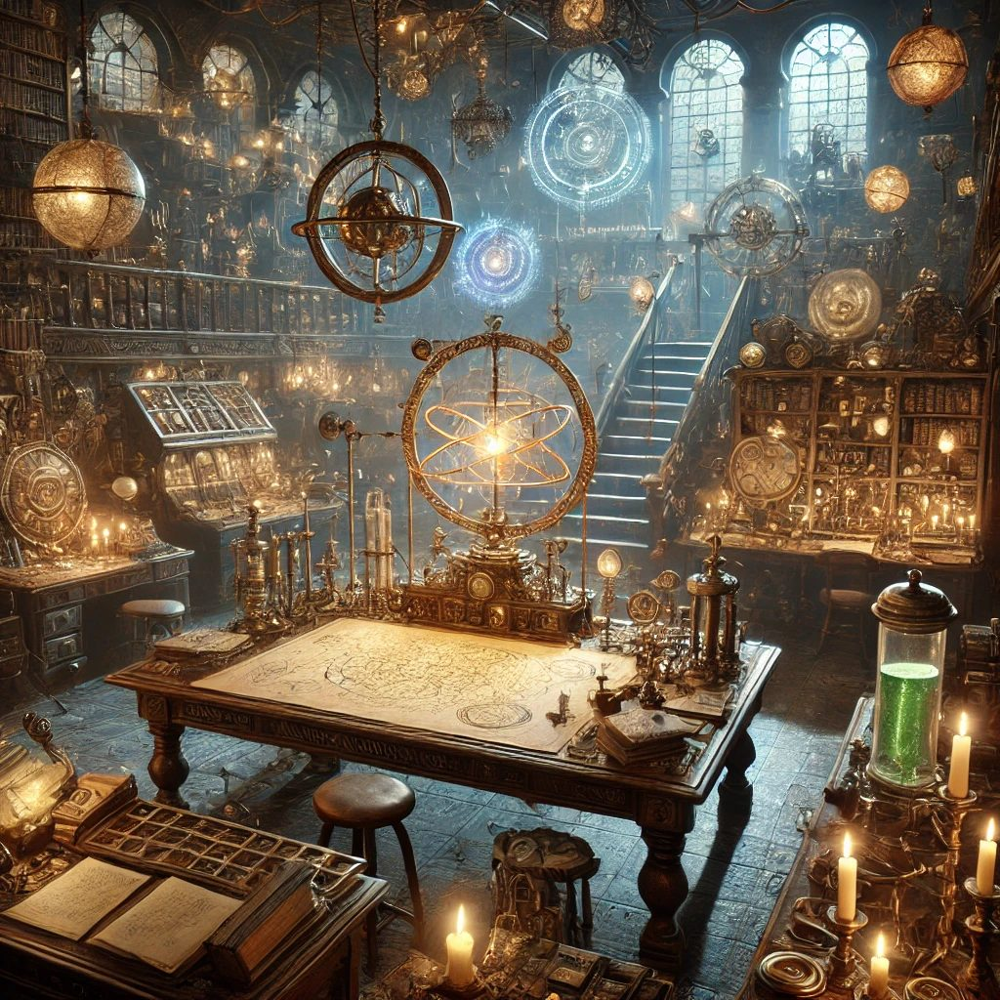
Ravenstone Laboratory in the morning light.
The Essence Sphere Under the Glass
Professor Aelwyn Ravenstone is already at his workbench, a delicate tool like a magnifying glass laced with arcane runes in one hand, and the Essence Sphere glowing gently before him. He has clearly been up since dawn. His silver hair glimmers in the sunlight, and his emerald eyes are wide with wonder.
Aelwyn: “By the Spheres! Even after a whole morning's study I can scarcely believe it. A fully functional Essence Sphere! Poots Glimmergear is a true genius of her craft. This device is beyond what I thought possible.”
Lilly, hovering at his elbow: “But can you help him? Pikachu is trapped in there. He needs a body again.”
Aelwyn turns the Sphere slowly, and the runes along his lens glow brighter. His face is kind, and honest, and that is exactly the problem: Lilly can read the answer in it before he speaks.
Aelwyn: “The energy within is stable, wonderfully stable. Your friend is safe. But there simply is not enough of it to weave him a body. I cannot do it here.” He raises a finger before Lilly's face can finish falling. “But there is hope. The Artificer's Guild in Gearhaven City commands power core technology far beyond my little tower. Upgraded with a proper core, this Sphere could hold many essences at once, more than enough for your Pikachu to step back into the world.”
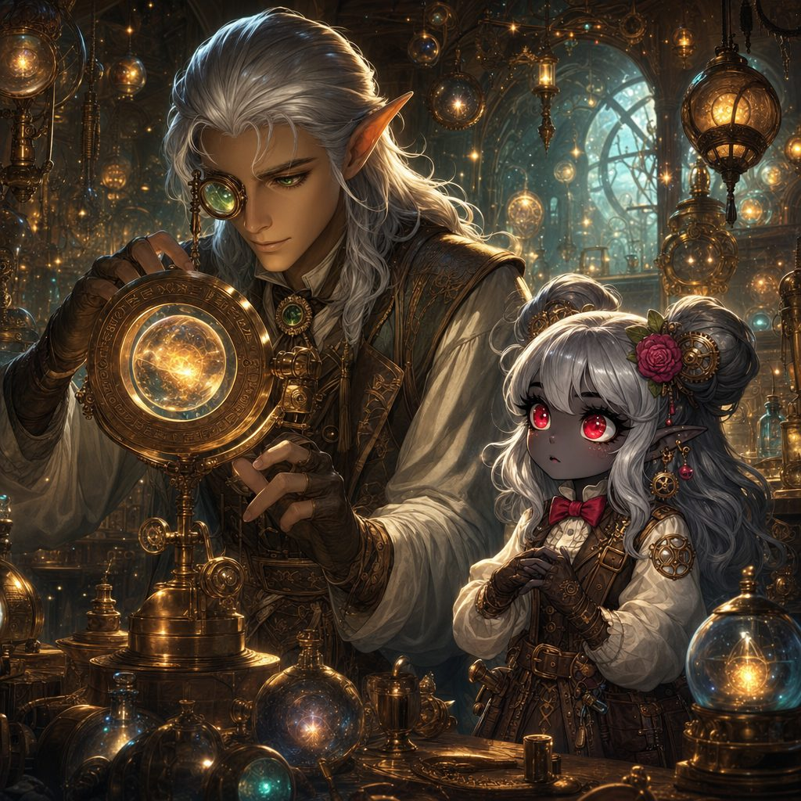
The morning study of the Essence Sphere at Aelwyn's workbench.
The Guardian of Balance
Aelwyn's gaze drifts to the little collection the party has gathered on their travels: faint captured orbs of water, air, and earth, each one humming softly in its jar.
Aelwyn: “These motes of yours are not stray magical oddities. They are fragments of planar essence, torn loose from their home realms. The balance of the planes is unraveling, and creatures are slipping through the cracks.”
Ursa, quietly: “We saw something on the road. A goddess, I think. Her name was Elaria. She said her power was fading, and that we needed to restore it.”
The professor goes very still. When he speaks again, the scientist's excitement is gone, and something older and graver has taken its place.
Aelwyn: “Elaria. The Guardian of Balance. Children, if her power is waning, then the boundaries between the planes will not merely leak. They will collapse. Everything you have seen, the motes, the strange creatures, the thin places in the forest, all of it is a world teetering on the brink.”
He crosses to a great ancient map on the wall, the realms of Elaria drawn in faded ink. Lines of light crisscross it like threads in a loom, and here and there a point pulses with unstable energy, like a fraying knot.
Aelwyn: “If you would restore the goddess, you will need more than courage. You will need knowledge, allies, and tools forged where magic and technology meet. The Artificer's Guild can upgrade your Sphere, yes. But its archives may also hold the secret of how to stitch a world back together.”

Professor Aelwyn Ravenstone, planar researcher.
Part Two: Three Small Wonders
Before the road, the professor had one more gift to offer: a choice that would change the party forever.
As Aelwyn speaks, the laboratory's smallest residents come out to investigate the visitors. A leafy little dinosaur with a folded flower bud on its back lounges in a sunbeam by the window: a Floraburst. A round turtle-like creature wrapped in a shimmering watery aura waddles past, peering up curiously: an Aqualump. And a small fox-like creature with flames dancing harmlessly along its paws and tail darts between the table legs, chasing an automaton twice its size: an Emberpaws.
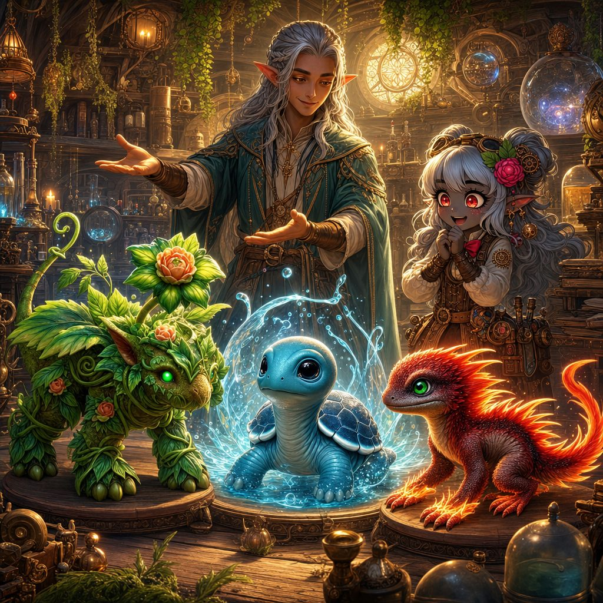
Aelwyn presents the three little wonders: Floraburst, Aqualump, and Emberpaws.
Aelwyn: “These little ones are manifestations of the unstable boundaries, each one carrying a fragment of elemental essence. They are not curiosities. They are clues. And they can sense planar anomalies long before you or I could.” He kneels among the three creatures and smiles. “Take one of them with you. Choose wisely; these little ones are eager to help, and one of them may be the key to understanding the forces that threaten our world.”
The party crouches down among the three wonders. Aqualump blows a solemn bubble. Emberpaws sets a very small patch of nothing important on fire, then looks proud. And the little Floraburst rises from her sunbeam, pads straight across the floor, and rests her leafy head against Lilly's knee, her bud swaying like a tiny banner. Some choices make themselves.
Lilly, softly: “Hello, Floraburst. Want to come save the world with us?”
▶ Floraburst joins the party (statistics in the appendix). She senses planar anomalies, produces healing Floraberries, and is, by unanimous ruling, a very good dinosaur.
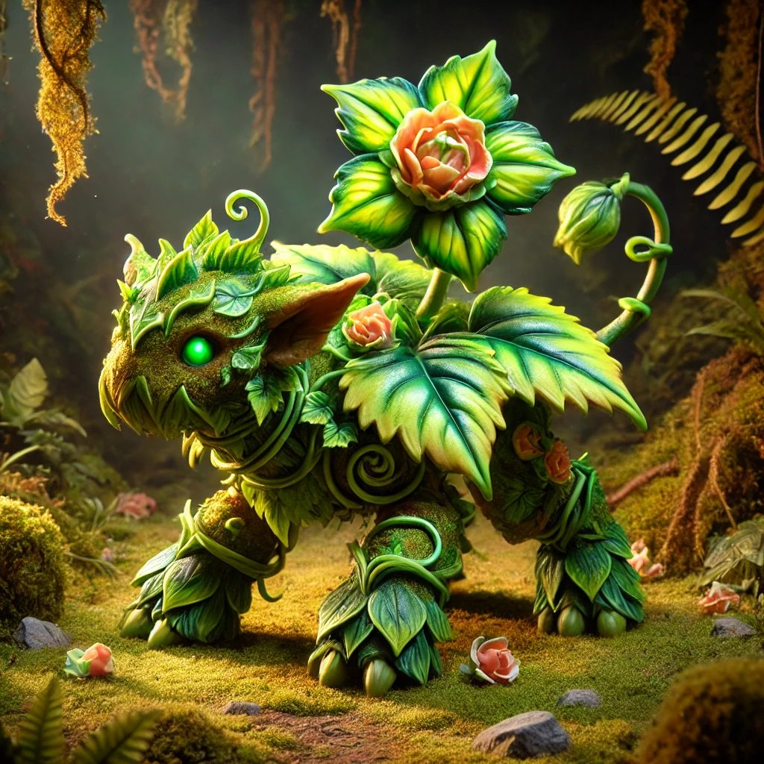
Floraburst, the party's chosen companion.
A Farewell to Lickgloom
One companion arrives, and one stays behind. All morning Lickgloom has been everywhere at once: tasting beakers, startling automatons, trading tongue flicks with creatures no book has ever named. The little fey has not looked this happy since the night at the pond. Aelwyn watches it herd a family of glimmering hatchlings across the floor and chuckles.
Aelwyn: “You know, the road to Gearhaven is long, and a laboratory full of planar creatures could use a friendly guide who speaks their language. Lickgloom would have a home here. Friends here. And you would always know where to find it.”
The party gathers around their first friend of the wilds. Lickgloom tilts its head, looks once at the door and the long road beyond it, then at the warm, wonder-crowded laboratory, and a feeling arrives in everyone's minds at once, wordless and content: Home. Friends. Visit?
Ursa kneels and presses his forehead gently to Lickgloom's. “Visit. We promise. Every time we pass this way.” One long tongue wraps the whole party in a single ridiculous hug, and that is that. Guardians look after their friends, even when looking after them means letting them stay somewhere happy.
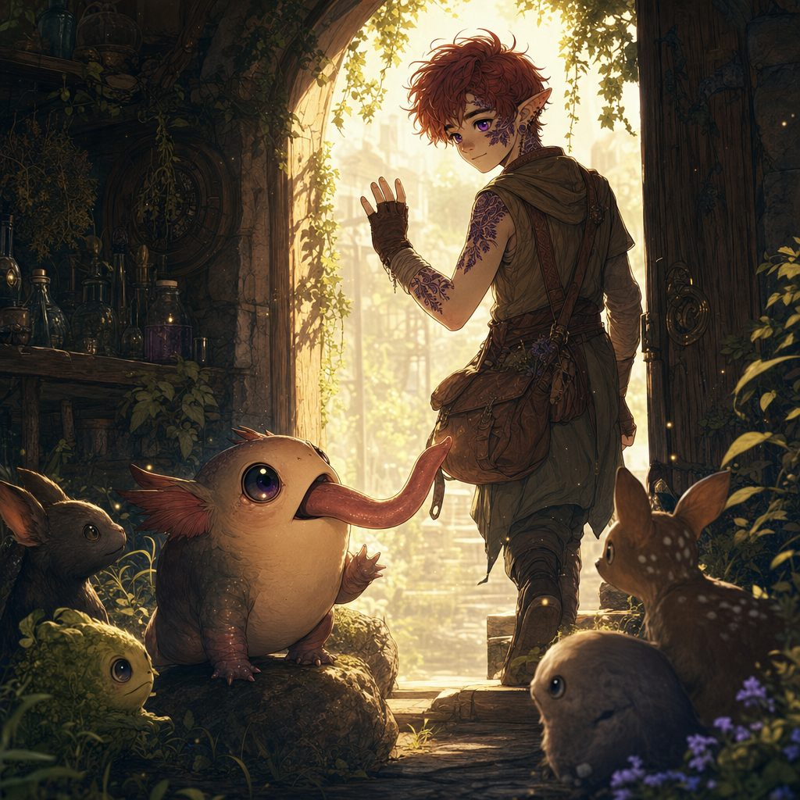
Lickgloom finds a home among Ravenstone's wonders.
The Road to Gearhaven
Aelwyn unrolls a traveling map across the table, the parchment crackling, and traces the southward road with one slender finger.
Aelwyn: “First, Brambleshadow Thicket, a dense and thorny woodland of hidden pathways and mischievous fey. Stay alert; illusions are common there. Then Whisperwind Meadow, serene to look at, but the planar veil runs thin, and things from the Elemental Plane of Air sometimes wander through. Beyond that rise the Ironroot Hills, jagged rock and abandoned mines, home to creatures who do not take kindly to visitors. And at the last, Stormwatch Cliffs, where the lightning storms never quite end. Past the cliffs lies Havenmoor, a friendly coastal town. That will be your gateway to the seas: from Havenmoor you must take a ship onward toward Gearhaven.”
He rolls the map, ties it with a crimson ribbon, and presses it into their hands. Then he looks at each of them in turn. A hand on Lilly's shoulder: “Trust your bond with these magical creatures. Each step brings you closer.” A respectful nod to Ursa: “Your connection to the stars, and your father's legacy, will guide you through the unknown.” And a grin for Stabby: “Your spirit, wild and free, will cut through the chaos. Keep your blade sharp and your wit sharper.”
Aelwyn: “Go now, Guardians of Elaria. The road to Gearhaven awaits.”
With the map in hand, a leafy dinosaur trotting at their heels, and one last wave to a small fey creature in a laboratory window, the party steps out into the morning. The wind carries a whisper of adventure, and the promise of revelations to come.
Part Three: The Wild Road
The road south proved everything the professor promised: beautiful, strange, and increasingly full of teeth.
Shadowflame in Brambleshadow Thicket
Brambleshadow Thicket closes around the path like a dark, twisting tunnel. Gnarled branches knit overhead, thorny undergrowth crowds close, and shafts of pale sunlight struggle through the canopy. The air grows damp and cold, smelling of moss and something faintly metallic, like a storm that has not broken yet. Then, all at once, the birds stop singing.
▶ Wisdom (Perception) DC 14 to notice the unnatural silence; Intelligence (Arcana) DC 15 to sense necrotic planar energy soaked into the shadows.
Ursa, whispering, his breath misting: “This does not feel right. Something is here. The forest itself feels sick.”
The mist thickens until the party can see barely twenty feet. The temperature plummets. A hollow laughter echoes through the trees, vibrating up through the ground, and from the swirling shadows two glowing eyes open. A twisted, flickering shape gathers itself out of dark purple flame: a Shadowflame, its jagged mouth curled into a grin, wisps of shadow trailing from its limbs like ghostly fire.
Shadowflame, in a whispery, disembodied voice: “Your fears are tasty... let me see them... let me taste them!”
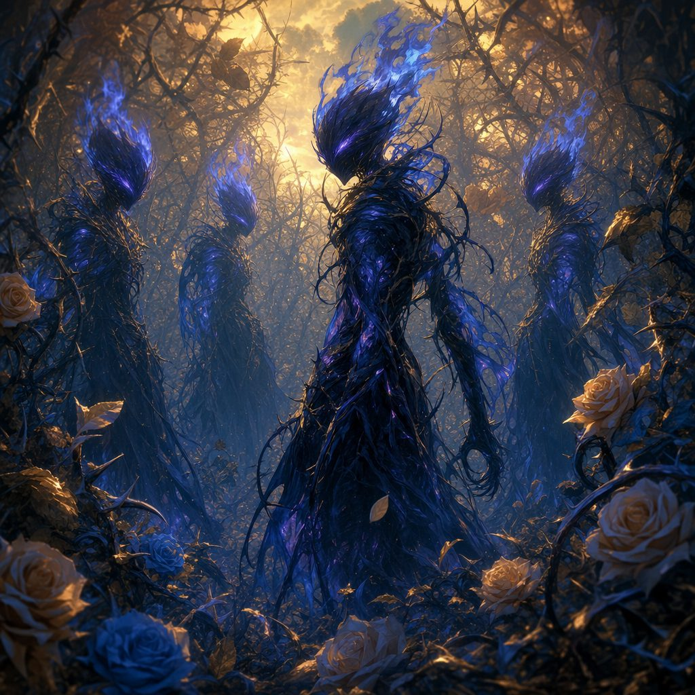
The Shadowflame splits into a hall of grinning illusions.
▶ The fight. Shadowflame, CR 4 (appendix). It splits into three identical illusions; Intelligence (Arcana) or Wisdom (Perception) DC 18 to pick the real one. Terror Wave in a 15 foot cone (Wisdom DC 14 or frightened); Shadowmeld to teleport through the mist.
The clearing becomes a hall of dark mirrors. Four grinning shadows circle the party, moving as one, and blades pass through two of them before Lilly starts calling out which flame casts no light. Stabby is frightened for exactly one round, which he later denies. Floraburst's very first act as a companion is to snap a Razor Leaf through an illusion, and her second is to hit the real one. When the Shadowflame finally comes apart with a bone-chilling screech, the mist unravels with it.
Where it fell, a Dark Mote lingers, swirling with shadowy energy, pulsing faintly before it fades into the cold air. It does not feel like the others.
Ursa, shivering: “These motes... it is like each one is a piece of something much bigger.” Lilly, watching the Essence Sphere stir faintly in response: “Then we keep collecting the pieces. For the world, and for Pikachu.” Stabby, grinning: “More shadows, more fights! We are going to need sharper swords!”
Whisperwind Meadow
Beyond the thicket the land opens into Whisperwind Meadow, and for one golden afternoon the road is kind. The grass runs in long silver waves, and the wind moving through it truly does whisper, half-words in no language anyone knows, as if the air itself is talking in its sleep. The veil is thin here; everyone can feel it, a hum behind the breastbone. But nothing wicked wanders through today. Floraburst dozes on Ursa's pack with her bud turned to the sun, and the Guardians let the meadow's strange lullaby carry them south.
The Talking Beasts of the Mistwood Path
Where the meadow meets the old forest, the trail dives into the Mistwood Path, and the fog comes back with a grudge. Twisted trees knit out the sun, the mist curls around ankles, and every footstep lands muffled, as if the forest is holding a pillow over the sound.
▶ Wisdom (Perception) DC 15: shapes flickering in the fog, pacing the party. Wisdom (Survival) DC 14: padded tracks that stop abruptly, mid-stride. Intelligence (Arcana) DC 16: planar distortion is warping the creatures here, granting them abilities they should not have.
Ursa, crouched over the tracks: “They just... stop. These creatures are moving in ways they should not be.”
A low growl rolls out of the fog, then a sharp whip-crack. Two Displacer Beasts flow out of the white: sleek, six-legged, black as spilled ink, long barbed tentacles lashing over their shoulders. Their outlines shimmer and slide, each one standing a step to the left of wherever it actually is. And then comes the thing that makes the party's blood run colder than the fog. The beasts speak.
First beast, flickering in and out of sight: “Fresh prey... too easy.” Second beast, tentacles lashing: “They will never see it coming.”
Displacer beasts do not talk. Everyone knows displacer beasts do not talk. The fog suddenly feels less like weather and more like a doorway someone left open.
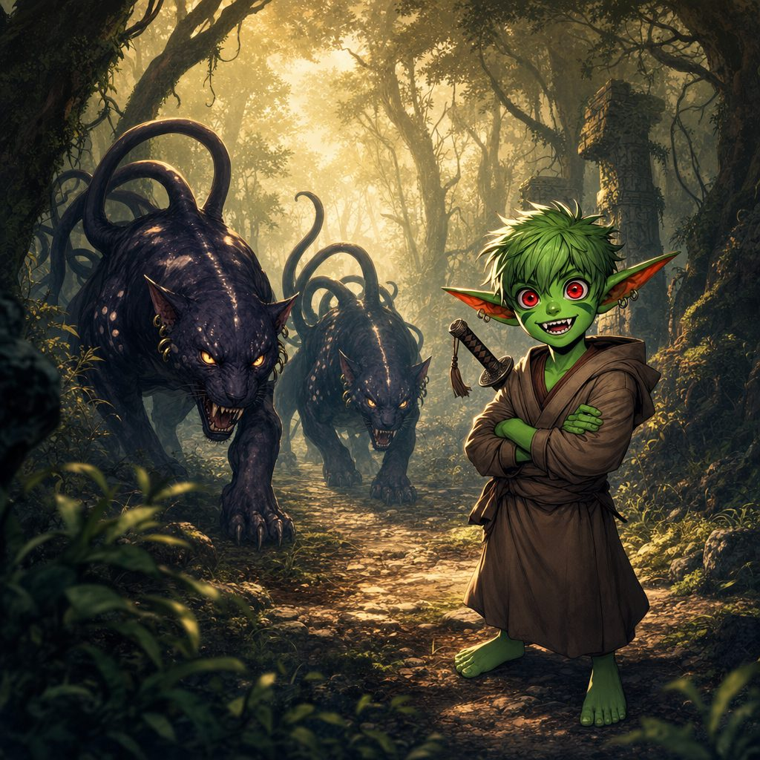
The talking Displacer Beasts flow out of the Mistwood fog.
▶ The fight. Two displacer beasts (appendix). Displacement: attacks against each beast have disadvantage until it takes damage. Ursa's Faerie Fire stripped the trick away, and Stabby deflected a tentacle mid-swing to turn the tide.
When the beasts finally fall, their bodies shimmer and dissolve into wisps of mist, leaving only faint outlines on the ground. And beneath where they fell, strange runes lie etched into the forest floor, pulsing with a dark planar light.
▶ Intelligence (Arcana) DC 15: the runes are tears in the fabric of reality, seams where creatures from other planes seep into this one.
Lilly, tracing the air above the runes: “These symbols are like cracks in a mirror. The boundaries between the planes are breaking down.” Ursa: “Then worse things than talking cats are going to come through.” Stabby: “Good thing we are here to stop them!”
The Shroomyte Grove
The path climbs into the Ironroot Hills, named for the iron-hard roots that twist through the earth like veins of metal. The higher the party climbs, the stranger the hills grow: bulbous mushrooms sprout between the rocks, their caps glowing with eerie blue-green light, until the whole hillside shines like a dream having a dream.
▶ Wisdom (Perception) DC 14: the ground pulses faintly; the roots shift. Intelligence (Arcana) DC 15: the mushrooms are suffused with Feywild energy, reacting to the party's presence.
Lilly, adjusting her goggles: “These mushrooms are not just glowing. They are responding to us. Be ready for anything.” Stabby, twirling his sword: “Living mushrooms? Bet they are not ready for a good stabbing.”
The moment the party steps into a clearing ringed with glowing caps, the ground shudders. With a series of wet, tearing sounds, four Shroomytes pull themselves free of the soil, squat fungal bodies pulsing with inner light, tendrils of mycelium writhing like grasping fingers. A melodic hum rises from them, beautiful and menacing at once.
Shroomyte, in a vibrating, musical tone: “Intruders... the grove... must be protected!”
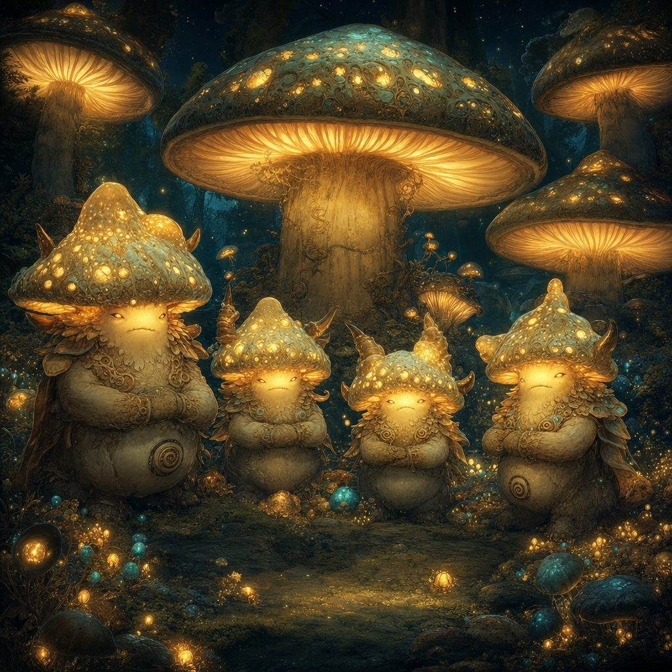
The Shroomytes rise from the glowing grove of the Ironroot Hills.
▶ The fight. Four Shroomytes, CR 2 each (appendix). Spore Blasts from range, Mycelium Tendrils to entangle, difficult terrain everywhere. Lilly's fire found their weakness; Stabby simply refused to be caught.
It is a strange, glowing battle among the toadstools, and when the last Shroomyte folds gently back into the earth, the air fills with drifting, luminous spores, falling like warm snow. In the center of the clearing hovers a Fungal Mote, pulsing with otherworldly light.
Ursa, reaching toward it, its glow reflected in his eyes: “This one feels like the Feywild, bleeding into our world.” The Essence Sphere in Lilly's pack hums in quiet agreement. The collection grows, and so does the mystery.
Part Four: Stormwatch Cliffs
By the time the hills gave way to open sky, the party could hear the sea, and the storm that lived above it.
Stormwatch Cliffs rise at the edge of the world: jagged stone ramparts above crashing waves, crowned with black clouds that flicker and grumble with lightning that never quite rests. The air crackles against the skin, tasting of salt and thunder. Etched into the rocks along the clifftop, strange runes glow with a pale blue light, brightening with every distant strike.
The Cliff Path
The only way forward is a narrow path snaking along the cliff's edge, with sheer drops to the hungry ocean below. The wind shoves like a rude giant. Stone crumbles where stone should hold. The Guardians rope together, watch each other's feet, and inch along the ledge while the storm booms overhead.
▶ Skill challenge: Dexterity (Acrobatics) DC 14 on the narrow ledge; Wisdom (Perception) DC 15 to spot the crumbling section before it fell; Intelligence (Arcana) DC 15 to recognize the runes as an ancient magical defense, knowledge that pays off at the monolith. Falls dealt bruises (1d6 to 2d6), not tragedies.
The Monolith of Four Elements
Past the worst of the ledge, the path opens onto a circular stone platform carved into the cliffside. At its center stands a monolith, etched with the same runes as the cliffs, a lightning rod jutting from its peak. Every few minutes the storm reaches down and strikes the rod, and the whole platform glows. Around the monolith stand four smaller pedestals, each crowned with a rotating stone ring of symbols: Air, Water, Earth, and Fire.
Etched into the monolith's base, half-worn by centuries of storms, four phrases: The winds whisper first. The tide rises after. Stone stands firm next. Flame seals the fate.
▶ The puzzle: align the pedestals Air, then Water, then Earth, then Fire, timed to a lightning strike. Intelligence (Investigation) or Wisdom (Insight) DC 15 to read the sequence from the clues; a wrong alignment discharged 2d6 lightning. The party solved it on the storm's next breath.
Stone rings grind into place: wind, tide, stone, flame. The storm inhales. Lightning hammers the rod, and this time the monolith drinks it, humming louder and louder until a beam of pure light lances up into the clouds and blooms into a shimmering curtain of energy above the platform.
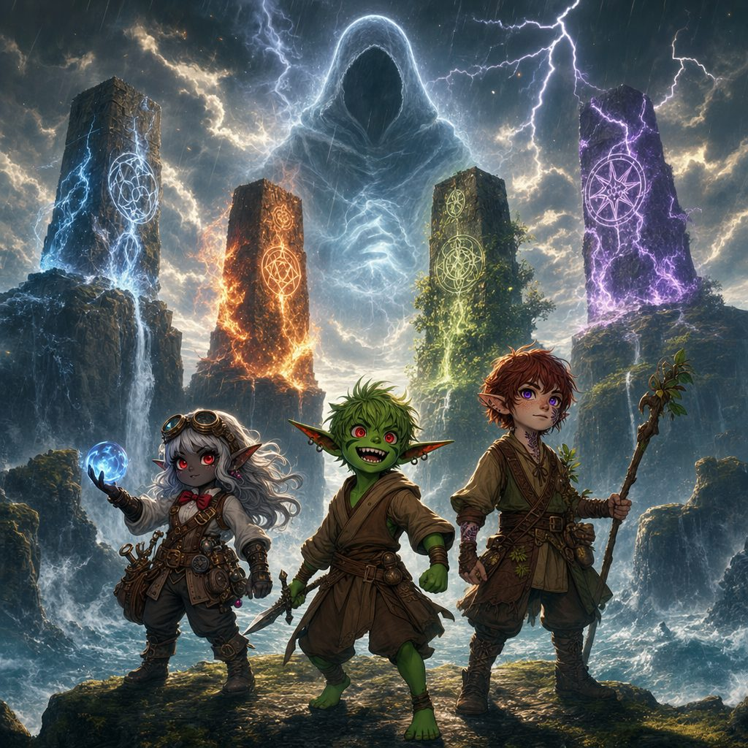
The Dark Figure looms over the monoliths of the Stormwatch Cliffs.
The Dark Figure
Within the curtain of light, a vision takes shape: a towering figure cloaked in darkness, its face hidden, its presence pressing down on the platform like a cold hand. The storm itself seems to lean away from it. When it speaks, the voice does not come through the air. It arrives directly inside their minds.
The dark figure: “You meddle with forces beyond your comprehension. The boundaries between realms are mine to shatter and shape. The goddess's light fades, and chaos will reign. The motes you gather are but embers of a dying flame. You cannot stop the unraveling.”
The vision collapses into darkness, and the light curtain blows out like a candle. Where it stood, something small falls to the stone with a crystalline chime: a Dark Fragment, a shard of crystallized energy swirling with elemental chaos, cold to the touch and heavier than it looks.
▶ Intelligence (Arcana) DC 15: the fragment is a remnant of the same power corrupting the planar boundaries, tied directly to the weakening of Elaria. The party keeps it, carefully wrapped.
Until this moment, the breaking of the world might have been an accident: a storm, a sickness, a slow unlucky fraying. No longer. Someone stood in that light and called the boundaries mine. Someone is doing this on purpose.
Ursa: “That figure... they want to unravel everything. We have to stop them.” Lilly: “The Artificer's Guild might be our best chance to figure this out, and to bring Pikachu back.” Stabby: “Whoever they are, they are going to get a taste of my blade!”
Part Five: The Lights of Havenmoor
The storm broke behind them, and the path wound down from the cliffs toward the glow of a town that smelled like cookies.
As the party descends, the roar of the sea softens, and new sounds drift up to meet them: distant laughter, jingling bells, a thread of festive music. The path becomes a cobblestone road flanked by frost-dusted pines, and the cold air fills with the mingled scents of sea salt, pine needles, cinnamon, nutmeg, and fresh-baked cookies.
Ahead at dusk lies Havenmoor, a coastal town sprung whole from a holiday fairytale. Stone and timber houses wear wreaths and garlands and twinkling lights. Red ribbons wrap the lamp posts, snow dusts the rooftops, and warm hearth-glow spills out of every window onto the cobbles. In the town square towers the Great Pine of Havenmoor, its branches heavy with glass baubles and shimmering ribbons, enchanted lights flickering among the boughs, a golden star burning at its top. Children pelt each other with snowballs beneath it. A painted signpost reads: Welcome to Havenmoor! May your hearts be warm and your spirits bright!
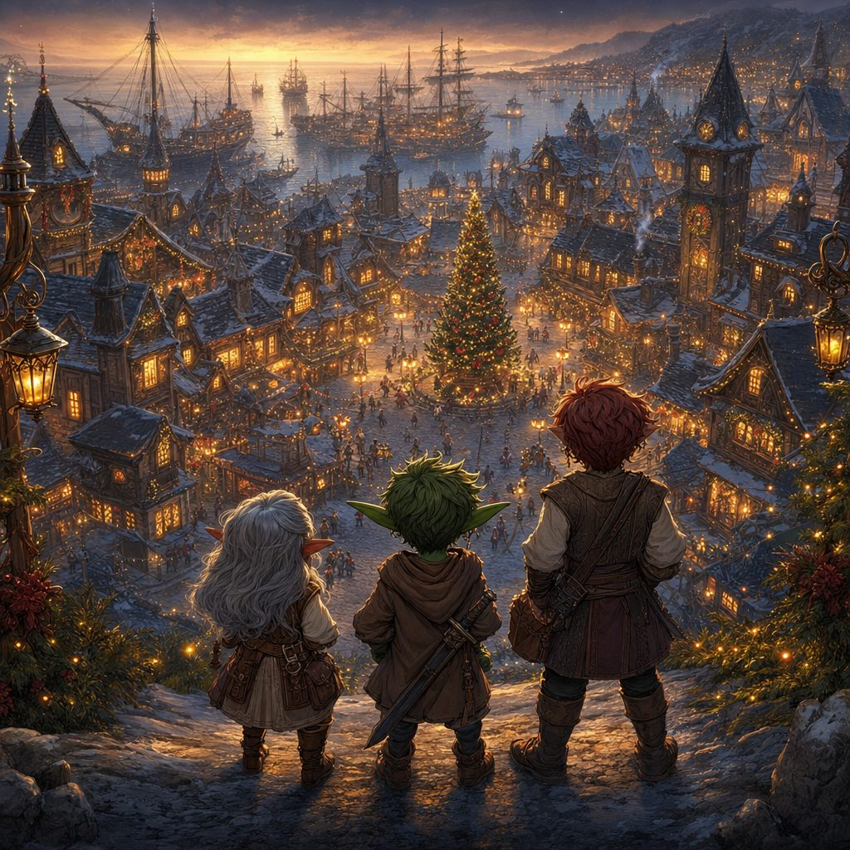
The Guardians descend to festive Havenmoor at dusk.
A small figure comes bustling up, barely three feet tall, in a green tunic, red-striped leggings, and a pointed red hat tipped with a jingle bell. His cheeks are rosy and his grin is enormous.
Festive elf: “Ho there, travelers! Welcome to Havenmoor, where the chill may bite, but the cheer warms all! You must be weary after your journey. Come, come! The Sugarplum Hearth awaits: hot cocoa, cookies, and a warm fire!”
The Sugarplum Hearth
The Sugarplum Hearth is a cozy two-story tavern with a thatched roof, holly on the door, and a wooden sign bearing a steaming mug and a sugarplum. Inside, a hearth roars beneath a mantel hung with stockings, an enchanted harp plays softly in the corner, and every table carries frosted cookies, peppermint bark, and mugs of hot cocoa crowned with whipped cream. Floraburst is an immediate celebrity; three children and one grandmother declare her the best dinosaur they have ever met.
Greta Frostbough, the tavern keeper, a stout dwarf woman with silver hair and a warm smile, appears with extra marshmallows unasked. “A bit of sweetness warms the soul, do you not think? You lot look like you have seen some excitement. Tell me, what brings you to Havenmoor?”
By the fire, Elda Merrywhistle, a half-elf storyteller with a lute, spins tales for a knot of wide-eyed children. Between songs she leans toward the party, and her voice drops low. “They say the sea has been restless of late. Ships vanish in the fog, and lights dance on the waves. If you are setting sail, beware the spirits of the deep.”
Night settles over Havenmoor like a quilt. The party is given warm rooms upstairs, feather beds and thick blankets, each window overlooking the softly glittering square. In the morning, they are promised, Master Bramblebeard the shipwright will come by to talk of passage north. Below the window, the Great Pine glows on through the dark: a small, stubborn light against a gathering storm, which is, after all, exactly what Guardians are.
✦ ✦ ✦
Their third adventure was done: a professor's warning, a leafy new companion, a farewell to a fey friend, four battles on the wild road, and a shadowy figure who wanted the world's walls broken. The Guardians of Elaria slept warm in Havenmoor, and did not yet know how much this bright little town was about to need them.
▶ After this session the heroes reached level 4.
Next: Session 4, in which Havenmoor's festive lights flicker, a horned shadow comes creeping for the children of the town, and eight winter bells hold the key to driving it back into the dark.
Appendix: Creatures of Session Three
Compact statistics for the table; the full bestiary lives in the compendium.
Shadowflame
Medium undead, chaotic evil. CR 4. AC 14 (natural armor), HP 58 (9d8 + 18), Speed 0 ft., fly 40 ft. (hover).
STR 8, DEX 18, CON 14, INT 12, WIS 15, CHA 18. Skills Stealth +8, Intimidation +6.
Resistances acid, fire, lightning, necrotic, nonmagical piercing and bludgeoning. Immunities poison, psychic; charmed, frightened, grappled, paralyzed, poisoned, prone, restrained. Darkvision 60 ft.
Illusions of Fear. Creates three identical illusions of itself (AC 14); DC 18 Arcana or Perception to spot a fake, or the attack misses.
Shadow Claw. +6, reach 5 ft., 2d8 + 4 necrotic; DC 14 Wisdom save or frightened one turn.
Terror Wave (Recharge 5-6). 15 ft. cone, DC 14 Wisdom save; 3d10 necrotic and frightened 1 minute (repeat save each turn).
Shadowmeld (Reaction). When hit, teleports up to 20 ft. and becomes lightly obscured.
Displacer Beast
Large monstrosity, unaligned. CR 3. AC 13 (natural armor), HP 85 (10d10 + 30), Speed 40 ft.
STR 18, DEX 15, CON 16, INT 6, WIS 12, CHA 8. Darkvision 60 ft.
Displacement. Projects an illusion of standing beside itself; attack rolls against it have disadvantage until it takes damage.
Tentacles (Multiattack x2). +6, reach 10 ft., 1d6 + 4 bludgeoning plus 1d8 force.
The two on the Mistwood Path spoke aloud, which displacer beasts never do: a planar strangeness, warped by the tears in reality found beneath them.
Shroomyte
Small plant, neutral. CR 2. AC 13 (natural armor), HP 27 (5d8 + 5), Speed 20 ft.
STR 12, DEX 12, CON 14, INT 6, WIS 12, CHA 7. Saves Con +4, Wis +3; Stealth +3, Perception +3.
Resistance poison; immune to the poisoned condition. Darkvision 60 ft. Understands Sylvan.
Bioluminescent Glow. Dim light in a 10 ft. radius; can suppress it as a bonus action. Multiattack. One Spore Blast and one Mycelium Tendrils.
Spore Blast. +4, range 30 ft., 2d6 + 2 poison; DC 13 Constitution save or poisoned one turn.
Mycelium Tendrils. +4, reach 10 ft., 2d4 + 2 bludgeoning; DC 13 Strength save or restrained one turn.
Fungal Retribution (Reaction). A melee attacker within 5 ft. takes 2d4 poison (DC 13 Constitution negates).
The Professor's Companions
Floraburst (the party's companion)
Small fey, neutral good. AC 14 (natural armor), HP 45 (6d6 + 18), Speed 30 ft.
STR 14, DEX 12, CON 16, INT 10, WIS 14, CHA 10. Skills Nature +4, Survival +4. Resistance poison. Darkvision 60 ft. Understands Sylvan and Common.
Plant Camouflage. Advantage on Stealth checks in heavy foliage. Photosynthesis. Recovers 10 extra HP when resting in sunlight.
Razor Leaf. +4, range 30 ft., 2d8 + 2 slashing.
Vine Lash. +4, reach 15 ft., 1d10 + 2 bludgeoning; DC 13 Strength save or restrained one turn.
Floraberry (3/Day). Produces 1d4 + 1 magical berries; eating one restores 3 HP.
Aqualump and Emberpaws (the two who stayed with Aelwyn)
Aqualump. Small water elemental, neutral good. AC 16 (shell), HP 54, Swim 30 ft. Water Bolt (2d8 + 2, knockdown), Surf (Recharge 5-6, 15 ft. cone, 4d6 cold), Shell Defense (+4 AC as a bonus action).
Emberpaws. Small fire elemental, chaotic good: a fox-like creature with flame-wreathed paws and tail. AC 15, HP 42, Speed 30 ft. Immune to fire. Ember (2d6 + 2 fire), Tail Flame Whip (2d6 + 3 fire, may ignite), Heatwave (3/Day, melee attackers take 1d8 fire).

